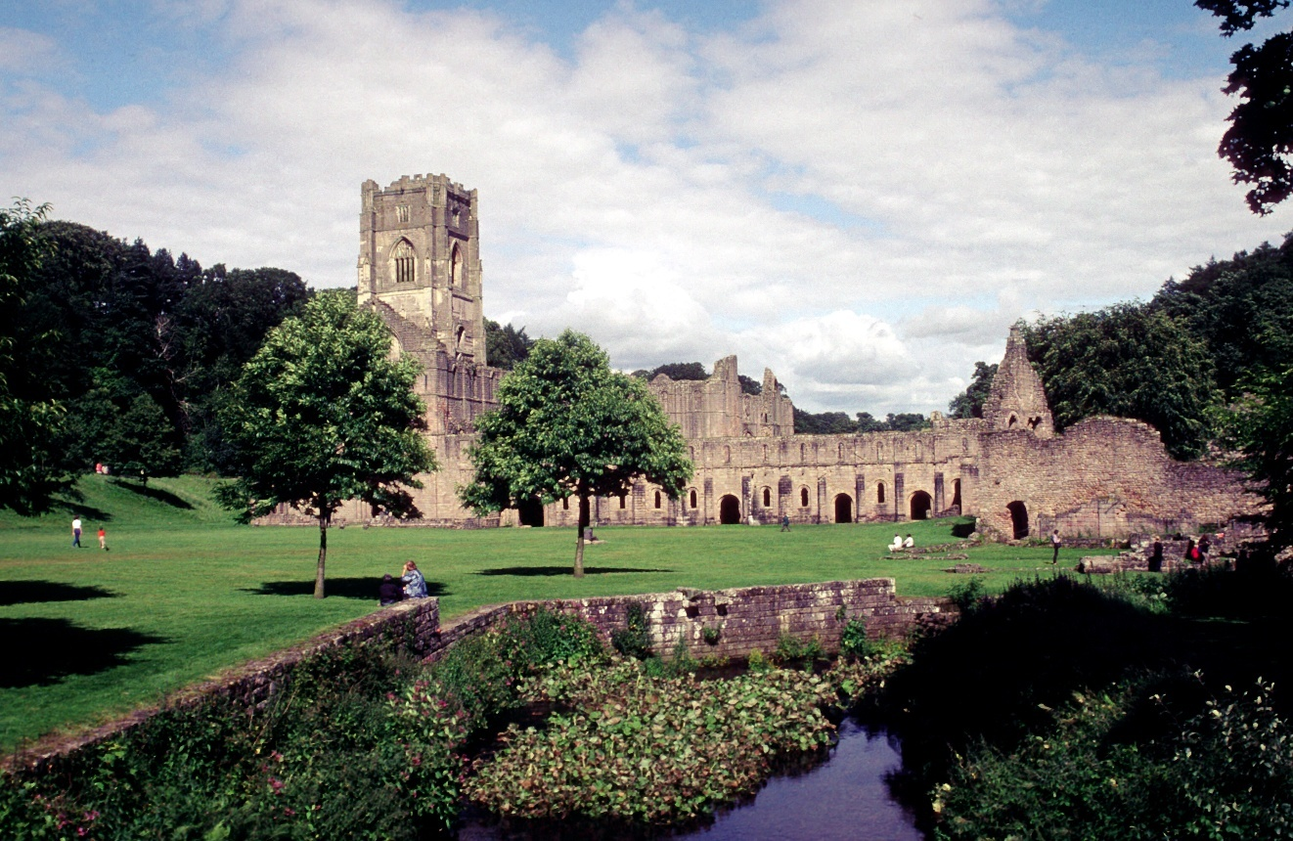

As seen in the image above, Fountains Abbey is situated upon the bank of a small river, snug in between a secluded valley not so far from Ripon, in North Yorkshire. The abbey stands between the rising uplands of the Pennine hills, and the fertile plain of the vale to its east – making this Abbey an excellent choice, whether it was hasty or calculated. In regards to the founding of the Abbey, there is one pre-dissolution extant from the first half of the 15th century, which was a copy of the Narratio. Michael Spence claims that the copy of the Narratio makes an attempt to ‘Cistercianize’ the origins of the Abbey, through a process of redaction in emphasising events, and omitting others, by introducing analogies with Citeaux itself. Despite the potential propaganda of content in the Narratio, it does allow a determination that there was a monastic settlement at the location that was founded at the end of 1132, under the protection of Archbishop Thurstan of York. Spence also argues that the foundations of Fountains Abbey was not initially Cistercian, and had a precarious existence up until autumn in 1133/4 when it had become admitted to the Cistercian Order. After which benefactors began to support the abbey, particularly the Mowbray and Percy families – again, another Cistercian feat for Fountains Abbey.
The founding community of Fountains Abbey was a group of dissident monks, which may have been ejected from the Benedictine St. Mary’s Abbey, or had left of their own volition. In the Narratio a group of 13 monks had gone into the ‘desert’, and when doing so, Archbishop Thurstan had created the ‘Charter of Foundation’ which was witnessed by William, the Dean of York, William the treasurer, Hugh the precentor, Robert and William the archdeacons, five canons of St. Peters, five canons of St. Wilfrid, and nine laymen. Despite the abbey seeming arable today, the narrative of the foundation of Fountains Abbeys described its origins in a very Cistercian way; ‘it was full of thorns and rocks, and seemed a better dwelling for wild beasts than for men’. However, this may not be the case due to the potentiality that the abbey may have been carefully chosen due to its location in the valley in which it sits upon, and the potentiality that the abbey was not originally Cistercian. Additionally, the chosen number of 13 monks founding an abbey/monastery can be seen as a Cistercian ideal, harkening back to the time of the Apostles – because the Abbey may not originally be Cistercian, this can cause the story to hold a lack of truths in its foundation, which can be seen in other abbeys across the Cistercian sphere.
Cistercian architecture is not specific in any way, but the monasteries of the Order do have commonalities between one another. Firstly, Le Thoronet is seen as one of the finest of Cistercian abbeys – in which it embodies the Cistercians Orders essence of simplicity and uniformity. Cistercian monasteries also abandoned meaningless embellishments, in which they declared that the lack of ornamentation is a sign of intellectual power. One must also take into account the factors of modernity with Fountains, as during the 18th century Rievaulx and Fountains were integrated as authentic follies within the landscape gardens of the landed gentry – therefore, we must ensure that it is understood the Abbey has changed through the course of time since the dissolution of the monasteries. As seen in Fountains Abbey, it follows a characteristic many other Cistercian abbeys also exhibit, which is the spatial traits which grew out of the Order’s reforming ethos. The spatial characteristics of the Abbey can be divided into two distinct categories, one of which can be seen as topographic, which relates to the landscape and the layouts of conventual buildings, and secondly iconographic – which is related to the adoption of architectural restraint. Fountains Abbey exhibits both in some regard, as initially the Abbey was not Cistercian, which leads a narrative that the Order chose to take the dissident monks into their Order, because of the commonalities between them, and in turn they put restraints in the building of the Abbey leading to iconographic characteristics. The building of Fountains Abbey also exhibits the use of the Bernadine plan, which follows that of Clairvaux.
Although there are many ‘Cistercian’ features on abbeys such as: Fountains and Le Thoronet, there is no written explanation that can define the architectural norms of the Order – however, there is evidence from decisions the general chapter had made, where they condemned buildings that did not conform to Forma Ordinis. The Cistercians did, however, have a strict architectural design during the orders inception, in which they implemented: a nave with or without isles, square at the east end, and a transept with two or more rectangular eastern chapels. The design came across as anti-Cluniac because of the lack of towers, lantern at the crossing, crypt and rounded apse as well as many other characteristics.
In conclusion, Fountains Abbey despite its ambiguous foundations exhibits many Cistercian features, with its simple yet beautiful design, its location away from habitation, and the location of buildings and features it has. The history of the Abbey is also full of mystery, and the Narratio can be misleading – but using it effectively and understanding the Cistercians need to ensure their Abbeys are ‘Cistercian’ allows more clarity in understanding the Abbey.

Bibliography
Primary Sources:
The foundation of Fountains Abbey (Moodle)

Secondary Sources:
Coomans, Thomas, ‘Cistercian Architecture or Architecture of the Cistercians?’, in The Cambridge Companion to the Cistercian Order (Cambridge University Press, 2012), pp. 151–70, doi:10.1017/CCO9780511735899.015
Hodges, George, Fountains Abbey: The Story of a Mediæval Monastery (Project Gutenberg)
Southern, R. W, Western Society and the Church in the Middle Ages (Penguin, 1990)
Spence, Michael, The Late Medieval Cistercian Monastery of Fountains Abbey, Yorkshire : Monastic Administration, Economy, and Archival Memory (Brepols Publishers, 2020)
Sternberg, Maximilian, Cistercian Architecture and Medieval Society (Brill, 2013)

Michael, Spence, The Late Medieval Cistercian Monastery of Fountains Abbey, Yorkshire : Monastic Administration, Economy, and Archival Memory (Brepols Publishers, 2020), p. 13
Ibid
Ibid p. 22
Ibid
Ibid
Ibid p. 23
Ibid
Ibid p. 22
George, Hodges, Fountains Abbey: The Story of a Mediæval Monastery (Project Gutenberg), p. 12
Ibid p. 13
Maximilian, Sternberg, Cistercian Architecture and Medieval Society (Brill, 2013), p. 17 – 18
R.W, Southern, Western Society and the Church in the Middle Ages (Penguin, 1990), p. 260
Ibid p. 26
Ibid p. 38 – 39
Ibid p. 39
Ibid p.43
Thomas, Coomans, ‘Cistercian Architecture or Architecture of the Cistercians?’, in The Cambridge Companion to the Cistercian Order (Cambridge University Press, 2012), p. 153
Ibid p. 156
Ibid

