INDEPENDENT PROJECT - Exhibition – 10%

Student Name: | James Frew
Title of Project: | Home Studio Noise Level Monitor
Supervisor: | Dr Nik Whitehead
2nd marker: | Nathan Morgan
Course: | - Applied Computing  - CNC  - DIS  ☒ Software Dev  - Games Dev  - Web Dev  - Electrical and Electronic

Exhibition
1. Poster: Clarity of Technical Description |  /40
2. Poster: Quality of Visual Display |  /40
3. Questionnaire/other materials
TOTAL |  /80 = 85%



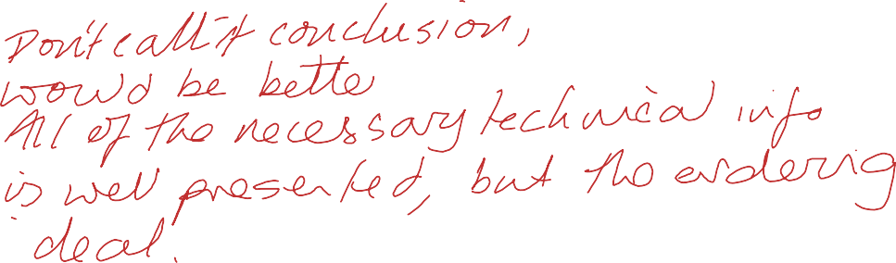
Comments:

