2 Islam Today: Muslims in the United Kingdom and Western Europe

Introduction

In order to explore the roots of Muslim communities in the UK, it is helpful to first provide an overview of the relevant factors within the wider European and ‘western’ context. For the purposes of this discussion, ‘western Europe’ refers to those countries falling in the geographical area of the European Union (including non-members). Defining ‘the west’ and ‘western contexts’ raises a number of semantic issues, some of which are discussed in the Orientalism section of this document.

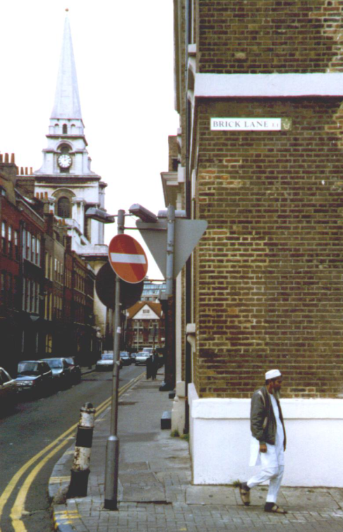

outside Jamme Masjid, Brick Lane, London (photo: Gary R. Bunt )

Islam Today in European Contexts

When discussing Islam and Muslims in ‘contemporary Western contexts’, the construction of a single model is difficult or even unnecessary. For example, in Western Europe, Muslims have diverse ethnic and ‘Islamic’ identities. There may be no communications links between or even within different ‘communities’, whose apparent homogeneity as seen from the ‘outsider’ perspective may betray the sophisticated and complex myriad of identities perceived on the ‘inside’ – as represented by issues such as culture, class, language, age, and religious affiliation (if any). There can be considerable cultural and religious differences between and within communities. Locating consensus of opinion between Muslims in Europe can raise many difficulties on some issues. There is no single organisational entity offering dialogue between different groups. Not every Muslim in Europe would want to be subject to a single authoritative body, especially if it was dictating interpretative agenda.

Discussions on Muslims in western contexts can focus on a wide range of areas, in different contexts: racism, religious freedom, censorship, ‘fundamentalism’, assimilation/integration, human rights, and legalistic interpretations(s) of ‘Islam’ are common themes.

There can be a common subtext, that Islam is perceived as not belonging in ‘the West’ - a problematic theory on historical, scientific, legal and moral grounds:

- historically, Muslims thrived in Spain from 711-1492 (whilst no means a ‘golden age’, it was an influence on European development and culture);

- scientifically, ‘western’ theories of knowledge were often stimulated by Muslim innovations (who should control knowledge?);

- legally, through Charters including the United Nations Universal Declaration of Human Rights (binding, in some EU countries, where it forms part of constitutions);

- morally, for example, through edicts encouraging religious and ethnic tolerance - such as Vatican II.

The focus in this section is on ‘Western Europe’ - which itself is not a single entity, and can be viewed in a variety of ways: perhaps geographically, linguistically, culturally, politically, historically, and/or economically. Different ‘representational’ bodies can have different perspectives on Muslims in Western Europe. Claims of pan-European representation from bodies such as the European Union (EU) can be challenged by Eastern European states.

How many Muslims are there in the EU?

In Western Europe, there may be 15 to 20 million Muslims, out of an estimated population of 378.5 million people. It is difficult to determine how many Muslims live within the European Union. No reliable statistics as to religious affiliations exist. Efforts have been made to determine religious affiliation through analysis of ‘countries of origin’ - although such data may become progressively less important as European-born generations become further established. There is also the minor (statistical) ‘problem’ of converts.

The three largest groups also represent three significant divisions of Muslims:

- in France, the majority are of North African origin;

- in Germany Muslims are primarily of Turkish ethnic origin;

- in the UK, the majority have Indian sub-continent origins.

This means that there can be considerable religious diversity: generally, between these three bands, and also within the bands themselves. Mention should also be made of the class distinctions within these groups, often betraying urban or rural origins, as well as economic and social status indicators.

Whilst there are pan-European Muslim organisations, their influence appears limited, especially when Muslim organisations at national levels have been generally unsuccessful at creating a consensus platform for discussions of Inter Faith dialogues. It would be incorrect to ‘write off’ such organisations, which are very much at the developmental stages. Some believe that, once Muslims become better established (after several generations?), a pan-European Islamic representative body could have a role to play in Europe. Some commentators believe that members and/or factions of Muslims in Britain could be the most influential in Europe - and cite their role following the Satanic Verses controversy. Whilst this argument has certain merits, no doubt Muslims in France and Germany would have different opinions.

Whilst the majority of European Muslim communities emerged after World War Two, reference should be made to the presence of a long-established Muslim (Turkish) presence in Greece (a nation which had a larger Muslim presence before population exchanges with Turkey after 1923). There have also been Muslim communities in Britain for over a century (for example, in Cardiff, Liverpool, London, and the North East of England), and France. European nationals (and their representatives) have engaged in diplomatic, trade and military dialogues with Muslims on a regular basis since the sixteenth century.

Calculating the Muslim populations in EU contexts raises specific concerns and problems, as noted in a discussion regarding France and Germany (UK will be dealt with separately):

“Scholars estimate that there are between 4 and 5 million people of Muslim extraction living in France. A specific accounting of the Muslim population is not possible, however, as religious identity, by law, cannot be employed in French census data or government documents. Accurate sampling is further frustrated by the fact that national origin, frequently employed to determine the extent of Muslim immigration, cannot account for the degree of Islamic observance among those sociologically identified as Muslim. German figures are more conclusive, with an estimated 2.9 million Muslims residing in Germany.”

Based on earlier data, the following estimates were made regarding Muslim populations in other EC states:

- Belgium, 244,000 (1990)

- Denmark, 60,000 (1990)

- Greece, 140,000 (1981)

- Italy, 250,000 (1991)

- Netherlands, 442,000 (1990)

- Portugal, 30,000 (1975)

- Spain, 20,000 (40,000).

Along with other issues relating to statistical ‘evidence’, it is acknowledged that these statistics are somewhat dated, and that – in the absence of up-to-date published statistics (at the time of writing) – re-calculations would have to be made to incorporate population and migration patterns.

EU Migration Patterns

EU research provides one indicator of trends in population movements, given that alternative ‘non-partisan’ statistics do not exist. Non-EU migrants (including Muslims) often

- bear the burdens of society
- do not receive social benefits
- live in cheap housing
- operate within clandestine labour markets
- live within a social hierarchy dominated by fellow countrymen/co-religionists with a longer history of settlement.

Many migrants of non-EU origins (and their descendants) see lack of decent housing as their greatest grievance, rather than the hostility of ‘natives’. A lack of information, incapacity to cope with administration, lack of State Aid, and limited access to financial channels are all perceived as grievances. The experiences of Muslims in Britain are reflected in the experiences of other European Muslims. Non-migrant origin Europeans may also share some of these problems.

There has been a population flow from Southern Mediterranean Europeans northwards, into the ‘European Megalopolis’ - whose boundaries encompass London, Lyon, Munich, and Copenhagen. This pattern has resulted in a ‘replacement’ population emerging from other Mediterranean countries. This includes a high proportion of Muslims. There are certain variable factors with regard to this population mobilisation, for example seasonal migrations.

It has been estimated that the one million North Africans living and working in the EU during the 1970s doubled in the 1990s. The figure of 650,000 Turkish nationals working in the EU in 1973 increased to two million. Regional pressures, and an increasing birth-rate in these regions, means that it is inevitable that more people will be seeking access to Europe in the future.

With the dissolution of the Communist bloc, greater attention was placed on this new ‘threat’ to Western Europe. Pieterese discusses a border-zone developing between the EU and its southern, Mediterranean neighbours:

“ ... a European Mexico syndrome - a border zone where economic, political, cultural, religious and democratic differences accumulate to create a gap between worlds, a zone of confrontation.”

Western Europe is still perceived by many Europeans to be modern, tolerant, and ‘open’ - a myth, perhaps - whilst ‘Islam’ is interpreted as being in ‘revolt’ against modernity. Recent events only heighten this alternative ‘gulf crisis.’

EU Legislation

The European Convention on Human Rights and its Five Protocols (1950) [related to the UN Universal Declaration of Human Rights (1948)] is one reference point, when discussing Muslim communities in the West. Relevant articles may include:

- Article 6: determining civil rights

- Article 9: concerning ‘freedom of thought, conscience and religion’

- Article 14: opposing discrimination.

Policing the borders to prevent unauthorised economic migration was given an added emphasis in Europe with the development of an autonomous pan-European force, with roots in the 1976 TREVI Group. TREVI is an acronym for Terrorism, Radicalism, Extremism, Violence: some commentators saw its remit as going beyond terrorism, towards all “policing and security aspects of free movement.” TREVI was criticised by the European Parliament’s 1991 Committee of Inquiry on Racism and Xenophobia for its independence of the EU, and being beyond European Parliamentary scrutiny. There were concerns that it was equating migration with terrorist and drug trafficking activities. Muslims in Europe could increasing be made the subjects of inquiries, if an organisation develops with powers greater than - and perhaps independent from - the domestic police forces.

In further developments, the Schengen Accord (1985) and Schengen II (1990) saw Germany, France, Belgium, Netherlands, and Luxembourg propose a harmonised visa and crime prevention policy - with special regard for information exchange on new arrivals and asylum seekers: Austria, Italy, Spain, Greece and Portugal subsequently agreed to join

“The governments justify this threat policy by pointing at the rise of the amount of refugees, intentionally forgetting to mention that Europe receives only a small fraction of all the refugees in the world, some 5% of 20 million ... most refugees are accepted by countries bordering their own, which can hardly feed their own people e.g. only in Sudan, which is one of the poorest countries in the world, there are more than two million refugees.”

Such a bureau limits options for potential immigrants and asylum-seekers, sealing borders. The Dutch Government, advised by their Council of State that the bureau was transgressing international refugee treaties and EU Law, subsequently condemned it. A 1991 conference condemned the Schengen Accord, for its independence from European Community policy, and for promoting a racist approach towards immigration issues. Some MEPs sought to liberalise and harmonise EP policy, enhancing the role played by immigrants in their development in Europe. The Schengen Accord was seen as contradicting the EU’s social obligations.

The Maastricht Treaty (1992), involving leaders of EU Member States, demonstrated that the approaches towards a Single Europe are fraught with divisions. Whilst there was emphasis on the economic nature of the EU, there were discussions on achieving a common asylum and immigration policy. In 1999, the Amsterdam Treaty provided Member States with the framework to develop asylum and immigration policies; later in 1999, there were discussions on a proposed Common European Asylum Policy; in 2000, the EU established a Charter of Fundamental Rights, based on the themes of Dignity, Freedoms, Equality, Solidarity, Citizens' rights and Justice.

Asylum

It is important to distinguish immigration from asylum issues; in the latter, physical safety and lives can be at risk, not just economic well-being. The migration of Bosnian Muslims; Kurds from Iraq, and Kuwaiti and Iraqi nationals fleeing Saddam Hussein; Iranians escaping from post-Revolutionary changes; West Africans, Afghans, Bangladeshis (from former east Pakistan), Kashmiris and Pakistanis seeking refuge from civil war - all are examples of Muslim individuals believing it was possible to find safety in the UK. However, a number of refugees and asylum seekers have been refused entry, as the government sought to tighten access - for those who would have been entitled to entry before. There is also a ‘grey area’, of asylum seekers who do not show on official statistics.

In 2001, the most prominent nationalities of asylum seekers emerging from Muslim contexts into the UK (although the countries contain populations with other religious minorities) were:
2001 2002

Afghanistan 9,190 7,380)
Iraq 6,805 14,940)
Somalia 6,500 6,680)
Turkey 3,740 2,890)
Iran 3,450 2,685)
Pakistan 2,810 2,440)

Using the same criteria, the most prominent countries of origin for refugees in the EU in 2001 were

Afghanistan 37,429
Iraq 41,249
Somalia 9,929
Turkey 27,312
Iran 11,999
Algeria 8,908
Bosnia 8,778

Negative Reactions to the Presence of Muslim Communities in the EU

It is beyond the scope of this module to fully discuss the impact of the presence of Muslim communities in the EU, although some elements are incorporated in the later references to Islamophobia. Manifestations of prejudice that focused on Muslims in the EU may be based specifically on religious prejudice, although there is a crossover with other forms of prejudice (for example, ethnic, cultural and/or racial prejudice). Muslim communities have been one focus of so-called ‘right wing’ extremist groups. Many incorporate: fascist, fascist, para-military, nationalistic, xenophobic, ‘extremist’ elements based on hatred and/or fear of non-nationals/ethnic minorities/different religions. This is often based on a pseudo-scientific rationale, and occasionally garbed as ‘legitimate politics.’ The development of these groups is not only a cause of concern for ethnic and religious minorities - but for individuals and groups across the political spectrum. One example that has impacted on Muslims in France was that of the Front National of France. There have been other examples of far-right anti-Muslim activities in Germany. However, forms of prejudice are not the preserve of so-called ‘extremists’, and Muslims in the EU have been witness to many different forms of (what they perceive to be) discrimination and prejudice based around their religious beliefs and practices. Some of these issues will be discussed in relation to the UK.
Islam Today in European Contexts

Further Reading (in module pack)

1. Bassam Tibi, ‘Muslim Migrants in Europe: Between Euro-Islam and Ghettoization’, chap. in Muslim Europe or Euro-Islam: Politics, Culture, and Citizenship in the Age of Globalization, Nezar AlSayyad and Manuel Castells (Eds.), (Boston: Lexington Books, 2002)

This chapter discusses some of the stereotypes associated with Muslims in Europe, and suggests some approaches towards identity and migration issues.

2. James Helicke, ‘Turks in Germany: Muslim Identity “between” States’, chap. in Muslim Minorities in the West, Yvonne Hazbeck Haddad and Jane I. Smith (eds.), (Walnut Creek, CA; Lanham, MD; Oxford: Altamira Press, 2002)

This chapter provides an overview of cultural and political issues in relation to Germany’s Turkish communities, emphasising shifts in religious and social identities and perspectives.

On the Internet:

3. Christopher Allen and Jorgen S. Nielsen, Summary Report on Islamophobia in the EU after 11 September 2001, (Vienna: The European Monitoring Centre on Racism and Xenophobia, 2002) http://fra.europa.eu/fraWebsite/attachments/Synthesis-report_en.pdf

This is an extensive overview of recent manifestations of prejudice post 9-11, providing a country-by-country analysis based on survey data. This resource requires Adobe Acrobat to read.

4. Monitoring Minority Protection in the EU, (Budapest and New York: Open Society Institute/EU Accession Monitoring Program, 2002) http://www.soros.org/resources/articles_publications/publications/euminority_20021125
This includes detailed reports on a country-by-country basis (scroll down for appropriate documentation). It is also referred to in the UK section.

Other material

5. Neal Robinson, ‘France’, chap. in David Westerlund and Ingvar Svanberg, Islam Outside the Arab World, (Richmond: Curzon Press, 1999)

This chapter explores the relationship between France and Muslims, highlighting contemporary trends and events, and providing a bibliography for further reading.

Muslim Communities in the UK

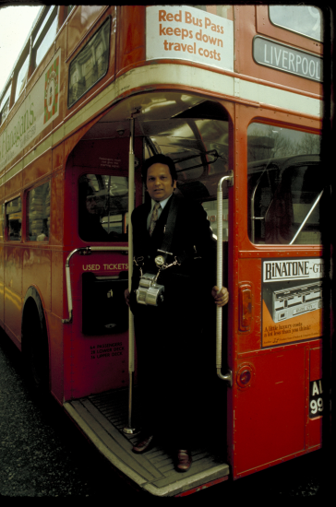

(photo: PADIA)

Migration

The majority of Muslims in the UK are linked (either directly or through ancestry) with migration after World War Two. British Commonwealth Muslims comprised a significant proportion of the two million migrants to Britain. 'Pioneer' Muslim immigrants were often young, single males - who sought to work, save, and subsequently purchase property within places of origin. These pioneers formed the basis of existing Muslim communities, remaining in the UK for diverse reasons, including acquisition of rights of residence restricted or denied to later prospective migrants. Procurement in the UK of employment, property and businesses facilitated better economic opportunities and security than in places of origin.

Certain pioneers became alienated from places of origin, through distance of time, as well as shifting cultural patterns and practices linked to 'westernisation': wars, class-clan conflicts, political shifts, and other 'crises' also influenced patterns of settlement. New family ties and networks of patronage and status influenced many pioneers to remain in the UK. The ambition of acquiring 'British' standards of education and enculturisation for their British-born (and passport-holding) children also contributed to the reticence to return to places of origin. These factors persuaded many 'temporary' migrants to stay, despite the pressures of poverty, declining employment opportunities, and manifestations of prejudice. Specific, new Islamic 'community infrastructures' were gradually formed, by migrants and their descendants who sought:

" ... to preserve religion and culture in a minority situation. It is not simply the predominance of another religion which caused concern to Muslims; they wanted to safeguard Islam from the growing secularisation of British society."

It could be disputed whether this was desire for preservation of 'Islam' per se, or preservation of specific interpretations based - for example - on varieties of cultural, religious, and traditional expression. The creation of infrastructures included the development of frameworks for Islamic decision-making processes, linked (although not exclusively) to places of origins and 'imported' decision makers and religious leaders. One reaction to the 'threat' of 'secularisation' was the creation of 'barriers' around Islamic interpretations, which endeavoured to shelter offspring from secularisation pressures. In particular, there was a fear that Muslims in the UK would be 'assimilated' into the majority non-Muslim population, especially those Muslims born, encultured and/or educated in the UK , and that there would be a subsequent loss of identity. Similar fears have been expressed in Pakistan, Malaysia and other Islamic environments regarding so-called 'Western' values 'corrupting' youth. These opinions, however rhetorical in nature, have informed the nature of Islamic decision-making in Britain, and reactions to 'modernity'. They have been expressed amongst a cross-section of Muslim opinion in the United Kingdom.

Statistical Overview

Examining statistics can contribute to research into this diversity of opinion within Muslim communities in Britain, and the contexts of decision-making. The 1991 Census introduced a question on ethnic-origin, but not religious affiliation. Calculating the Muslim proportion of the UK population using this ethnicity question is problematic: ethnicity identities are not exclusively 'Muslim'. Arab, African, Afro-Caribbean, European, Indian, Bangladeshi and Pakistani categories include non-Muslim and Muslim components; the 'Indian" category could incorporate people from East Africa or the Caribbean; 'Pakistani' could include migrants from pre-1971 East Pakistan. ‘Converts’ are also problematic, in terms of calculation on this basis. With these factors in mind, several theories and estimates have been considered, with significant variations in figures:

"Various sources estimate the Muslim population between 550,000 and 3,000,000. Any figures over 1.5 million are normally mentioned by Muslim organisations. The most common estimate of the Muslim population is about one million."

Anwar's study of the 1991 Census estimated the number of Muslims at 1.5 million in 1993. The proportionally most significant number of Muslims come from Pakistan and Bangladesh (pre-1971 East Pakistan) origins. Other Muslim populations in Britain have ancestral links with India (pre- and post-Partition boundaries), Cyprus (pre- and post-partition boundaries, including the Turkish Republic of Northern Cyprus), sub-Saharan African countries, Turkey, the Maghreb, Egypt, Somalia, Somaliland, Sudan, and Arab Gulf/'Middle East' states. Minor discrepancies occur with figures concerning non-Muslim migrants from Muslim majority countries. Migrants whose statehood have been, or continue to be, 'undefined' include: migrants of Kurdish origin, Gulf Marsh Arabs, Palestinians, Kashmiris, and Muslims from the former-Yugoslavia.

The 2001 Census included a question on religious affiliation. It was possible to glean the following data from the Census, which adds to our picture of Muslims specifically in the UK:

“Just over three-quarters of the UK population reported having a religion. More than seven out of ten people said that their religion was Christian (72 per cent). After Christianity, Islam was the most common faith with nearly 3 per cent describing their religion as Muslim (1.6 million) ...

“… The Census religion question was a voluntary question. Nevertheless, over 92 per cent of people chose to answer it.”

In a separate analysis, relating specifically to England and Wales, further data was obtained:

“There are 37.3 million people in England and Wales who state their religion as Christian. The percentage of Christians is similar between the two countries but the proportion of people who follow other religions is 6.0 per cent in England compared with 1.5 per cent in Wales.

“In England, 3.1 per cent of the population state their religion as Muslim (0.7 per cent in Wales), making this the most common religion after Christianity.

“For other religions, 1.1 per cent in England and 0.2 per cent in Wales are Hindu, 0.7 per cent in England and 0.1 per cent in Wales are Sikh, 0.5 per cent in England and 0.1 per cent in Wales are Jewish and 0.3 per cent in England and 0.2 per cent in Wales are Buddhist.

“In England and Wales 7.7 million people state they have no religion (14.6 per cent in England and 18.5 per cent in Wales).”

Population analysis can be augmented with information on religious affiliation, to create more accurate understandings of the diverse Islamic platforms and communities within UK Islamic environments - representing varied approaches towards decision-making processes. There is no published contemporary analysis of Muslim religious affiliations in the UK. Networks of Islamic affiliation include a number of Sufi movements and orders, political parties, and religious factions and affiliations (between, within and outside of forms of Sunni and Shia Islam).
Historical Background

It is not proposed here to provide a detailed history of Muslim communities in Britain. Much is un-chronicled, and the diversity within Muslim communities in Britain means that extensive historical research is required. The following is intended as background information only:

There is evidence of Muslims living in Britain as servants, slaves and traders from the sixteenth century onwards: the history of contacts between England and Muslims is extensive, and of course not always complementary, encompassing commercial activities (from the eighth century onwards), diplomacy, the so-called ‘Crusades’, and academic exploration. The extent to which such endeavours engendered knowledge of Islam and Muslims is open to question (and perhaps another module!).

From the nineteenth century, Muslim communities existed in several ports (including Cardiff, Liverpool, London and Tyneside), centred around Indian and Arab sailors - and with strong colonial links. There were also Muslims studying and living elsewhere in Britain, and a number of converts: in Liverpool, Sheikh Abdullah (William) Quilliam encouraged missionary work through the foundation after 1889 of a mosque, Muslim Institute, and Children’s Home - which declined after he left Britain in 1908.

In 1889, an Indian-funded purpose built mosque and Institute were constructed in Woking, Surrey: although not used consistently since construction, the Shah Jehan Mosque is utilized today. The early Muslim individuals and communities in particular may not have had a central place for prayer (salat) - especially important for impartation of the sermon (khutbah), or had an imam to lead prayers.

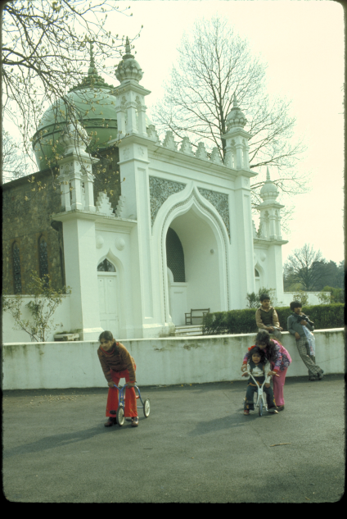

Shah Jehan Mosque, Woking (PADIA)
Mosques

The history of communities development shows a growing number of converted structures became mosques, or purpose built mosques were constructed. The London Islamic Centre was opened in 1944, and the London Central Mosque was established on the same Regent’s Park site in 1977. Significant mosques can be found in most major British cities. The Mosque Directory organised by the Muslim Council of Britain lists 1,486 mosques (May 2003). A more conservative estimated of 584 mosques was suggested in The Guardian in 1999 - ranging from purpose built mosques to converted structures/houses.

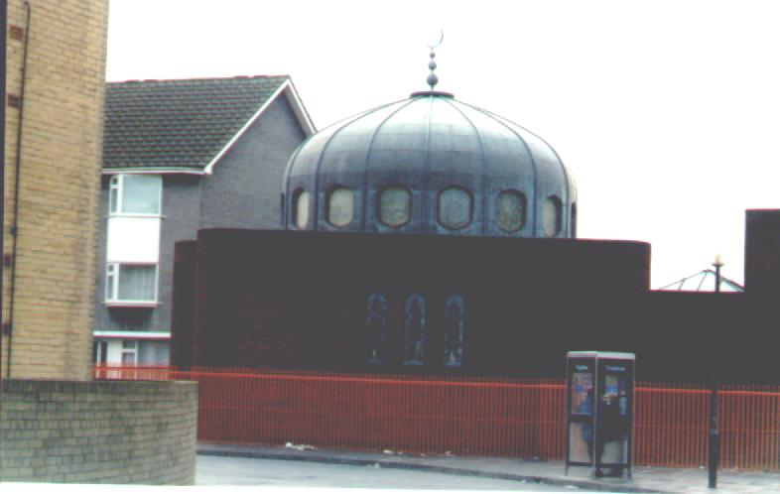
Cardiff Mosque (photo: Gary R. Bunt )

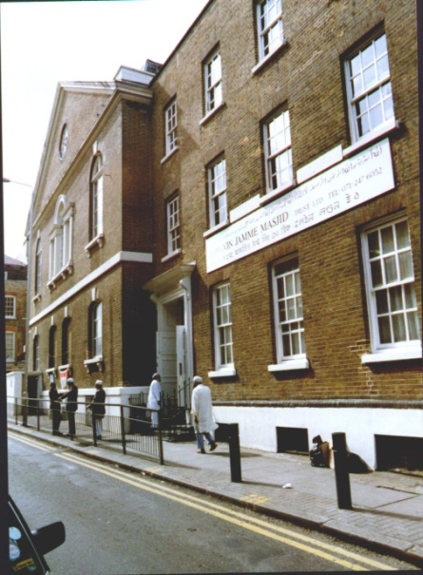
Jamme Masjid, Brick Lane, London (photo: Gary R. Bunt )

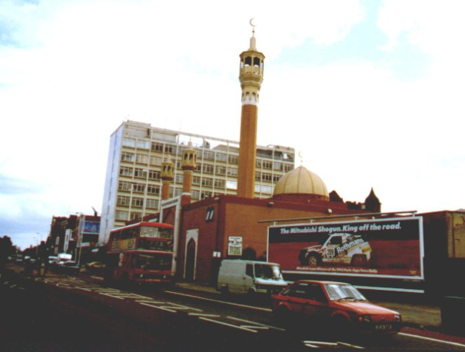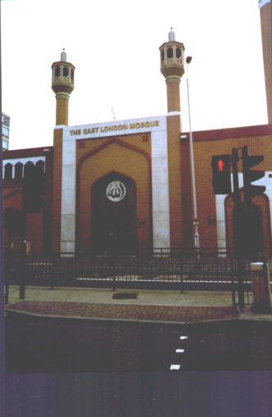

East London Mosque, 1996 (photo: Gary R. Bunt )

Issues of Identity and Leadership

The greatest proportion of Muslims in Britain today have their origins in migration that occurred after World War Two – in particular, the period dating from the 1950s to the immigration restrictions in the 1960s. Muslims from the former British Commonwealth were a significant proportion of the two million immigrants to Britain (during 1965-1975 two million people also emigrated from Britain). During Britain's 1950s economic growth, many Muslim immigrants were young, single males - who came to work, save, and subsequently buy property in their home countries. They played an important part in British industrial growth, and stayed in the UK for a number of reasons:

- Acquisition of property and businesses
- Economic opportunities
- Family ties
- Acquisition of British passport rights & changes in legislation
- Alienation from origins
- Westernisation
- Desire for education opportunities
- Birth of children in Britain

These factors persuaded many people who intended to stay temporarily in Britain to stay permanently. Specific, Muslim 'community infrastructures' were formed, by migrants who felt a need:

" ... to preserve religion and culture in a minority situation. It is not simply the predominance of another religion which caused concern to Muslims; they wanted to safeguard Islam from the growing secularisation of British society.
This desire for the ‘preservation’ of Islam has not always been successful, and Muslim communities may fear assimilation tendencies - especially of British born and raised Muslims - and the attendant loss of Muslim identity.
In both national and local British spheres, there is no "professional Muslim clergy", at least not in the same sense as church or synagogue environments. There is no single central authority offering decisions and pronouncements. Although several organisations would wish to assume that mantle, as yet there is no equivalent to the Jewish Board of Deputies or Chief Rabbi.

Attempts have been made to form national or majority Muslim platforms in Britain - which in the 1990s often failed to find common ground or become accepted by the majority of Muslims in Britain. The 'Muslim Parliament' was an important development in this area, if only because of its high media profile for initial meetings and pronouncements in the early 1990s. Critics argue that Muslims should gain access to normal channels of power - rather than form 'separatist' platforms.

The Muslim Parliament's founder and first leader, Kalim Siddiqui, directed the Muslim Institute for Planning and Research that, in 1990, published a Muslim Manifesto as a reaction to issues of concern to different Muslim communities. Leading from proposals contained in this document, initiatives included the creation of a Muslim 'House of Representatives', later known as the Muslim Parliament. The reaction of the media was generally negative, especially towards the pronouncements of Siddiqui (1931-1996), who was accused of having connections with Iran, and being influential in the imposition by Ayatollah Khomeini of the 'fatwa' against Salman Rushdie.

Prior to his death, Siddiqui had started to acquire more 'positive' coverage in the UK non-Muslim broadsheet press. Siddiqui drew upon his professional media background to publicise and promote the Parliament and his own community position, focusing on the creation of a 'Muslim platform', which intended to develop representation at grass-roots level. It publicised recruitment from all sectors in the communities, male and female. Members of the Lower House paid a financial contribution to become an MMP (Members of the Muslim Parliament), whilst the Upper House's members raised significant financial contributions to join. The Muslim Manifesto attempted to define a role for the General Assembly of Muslims in Britain (later known as the Muslim Parliament), and:

" ... to provide a framework for the healthy growth of all parts of the community as well as a common Muslim identity and purpose."

Muslims that did not consider themselves represented by Siddiqui or MMPs were often alienated by the assumptions of the 'Parliament', and its pronouncements on Islam. In terms of decision-making processes, the Parliament's influence was difficult to gauge, and its effectiveness dissipated on Siddiqui's death. As a forum for discussion, through various Committees and Conferences, the Parliament generated publicity, but not 'policy'.

The lack of interaction between groups with different interests on a national level is also reflected locally. An activist within a Muslim youth organisation suggested to this writer that this was having a harmful effect on the youth, and that some kind of mediation processes were necessary to break down the sectarian divisions. There was a fear that the cycle of 'difference' was perpetuated, because when youngsters attended mosques, they often heard sectarian speeches and sermons. This created an impression, according to some commentators, of serious divisions within the Muslim communities.

Other significant platforms to emerge have included the Muslim Council of Britain, founded in 1997, which describes itself as an ‘umbrella organisation’ representing over 250 platforms and affiliates. These include various mosque committees and councils, such as the influential Bradford Council of Mosques, and various charitable and educational organisations. There have been representative organisations for specific religious interests, reflecting ethnic, cultural and linguistic affiliations, such as the Khoja Shi’a Ithna Ashari World Federation (representing a specific branch of Shi’ism) and the Naqshbandi Haqqani Sufi Order UK (representing a form of Islamic ‘mysticism’). Specific world views have been articulated through organisations primarily funding from overseas Muslim platforms, such as the Islamic Foundation and the World Muslim League. Marginal, ‘radical’ voices such as Hizb-ut-Tahrir, al-Muhajiroun, and Supporters of Shariah have presented alternative, activist perspectives which do not necessarily reflect the mainstream’ of Muslim public opinion in the UK.

Muslims in the UK have had to devise infrastructures and approaches towards any desired 'Islamic decision-making' in relatively-short periods of time, synthesising or introducing a wide range of influences both from within and outside of the 'Islamic world.' Muslims in Britain have frequently been represented in UK sources - for example, within academic, media, political and social welfare contexts - as possessing a homogenous identity. This is influential in discussions of Islam and Islamic issues in Britain (by Muslims and non-Muslims), and has had an impact in the form of direct and indirect discrimination, prejudice, and anti-Islamic bias. It also has an impact upon the varied Islamic decision-making processes, associated with interpretations of primary sources (such as the Qur’an), which can be found within the UK. Despite a prevalent societal view that persists of Islamic homogeneity, Muslims in Britain do not have a fixed, national representative platform. The debate on relevant issues within Muslim communities incorporates wide views and diverse platforms.

Events such as the Satanic Verses controversy, the Gulf War, 9-11 and its aftermath, and the 2003 invasion of Iraq have focused attention on the Muslim communities in the UK. These issues have combined with domestic issues, such as economic and social exclusion, gender, education, political representation, asylum, ethical agendas, legislation, media representation, inter-faith dialogue, leadership, and social and cultural diversity.

Specific issues can have an immediate personal impact on living life 'Islamically' for a Muslim in Britain. 'Being a Muslim' has many different meanings and levels of practice. A 'secularised' Muslim may not be concerned with issues of interpreting Islamic primary sources in a contemporary context, or in observing boundaries outlined by 'authorities'.

Occasionally, prejudices have contributed towards organisations advancing their aims, through the catalyst of indignation and anger mobilising action – such as during the initial flash point and aftermath following publication of Salman Rushdie's 'The Satanic Verses'. The responses of the non-Muslim majority towards 'Islamic' issues influenced Muslim self-perception in the UK, and demonstrated a need for stronger or different forms of lobbying, organisation, and leadership:

"Until recently, the community was concerned only with jobs. The Labour Party was a natural ally ... During the Rushdie affair we found out that not only did our MPs not support us, but they opposed us."

The Rushdie Affair stimulated efforts within sectors of Muslim communities to promote the knowledge of Islam, even in the High Court. For example, in February 1989, the British Muslim Action Front's counsel Ali Azhar explained to the High Court's three Lord Chief Justices about details of Islamic belief and practice. The Qur’an was produced and distributed in the High Court. During proceedings, the Front's supporters were photographed in prayer, near the entrance to the Court. Despite these high profile and 'visible' activities, efforts during the 1990s in lobbying for, and analysing, the requirements of Muslims in Britain were been severely restricted by lack of funding, and organisational difficulties.

Muslims in the UK

Further Reading

You are advised to read the following documents from the Appendices in sequence:

1. Philip Lewis, ‘Britain’s Muslim Communities’, chap. from Islamic Britain: Religion, Politics and Identity among British Muslims, (London: I.B. Tauris, Revised and updated edition, 2002)

This provides a basic historical background to Muslim communities in the UK.

2. Ron Geaves, ‘Britain’, chap. from David Westerlund and Ingvar Svanberg, Islam Outside the Arab World, (Richmond: Curzon Press, 1999)

This is a more detailed and scholarly chapter, which offers delineation of key issues and contexts relating to Muslims in the UK.

3. M.M. Ahsan and A.R. Kidwai, ‘The Muslim Perspective’ in Sacrilege versus Civility: Muslim Perspectives on The Satanic Verses Affair, (Leicester: Islamic Foundation, 1991)

An overview from one Muslim perspective relating to the so-called Satanic Verses affair.

Additional Materials

The following are useful background materials.

4. National Public Radio, ‘An Islamic Journey Inside Europe
Part Two: Legacy of an Empire’, February 2003, http://www.npr.org/programs/atc/features/2003/feb/europe_muslims/two/europe_muslims_two.html

This is an online radio documentary, produced in the USA by National Public Radio, containing interviews and perspectives from Muslims in the UK. Requires RealPlayer. Duration: 9’14”

6. Muslim Council of Britain, Voices from the Minarets, London: MCB, 2006 (pdf) http://www.mcb.org.uk/uploads/vfm.pdf

Other resources

7. Tariq Modood, ‘The Place of Muslims in British Secular Multiculturalism’, chap. in Muslim Europe or Euro-Islam: Politics, Culture, and Citizenship in the Age of Globalization, Nezar AlSayyad and Manuel Castells (Eds.), (Boston: Lexington Books, 2002)
This thorough analysis has sections on Race and Equality, Politics, Racialization and Identity, and Muslim Identity Politics – in relation to so-called ‘multiculturalism’.
8. Humayun Ansari, The Infidel Within: The History of Muslims in Britain, from 1800 to the Present, (London: C. Hurst & Co, 2004). An important and detailed book on the subject.
9. Tahir Abbas, (Ed.). Muslim Britain: Communities Under Pressure. (London & New York: Zed Books, 2005) A useful collection of articles on a range of contemporary themes.
10. Fred Halliday, Britain’s First Muslims, (London: I.B. Tauris, 2010)
11. Sophie Gilliat-Rae, Muslims in Britain: An Introduction (Cambridge: Cambridge University Press, 2010)
12. Philip Lewis, Young, British and Muslim (London: Continuum, 2007)
13. A. Bayat & L. Herrera, Being Young and Muslim: New Cultural Politics in the Global South and North (Oxford University Press, 2010) [e-book]
14. Jocelyn Cesari, Muslims in the West after 9/11: Religion, Politics and Law, (London: Routledge, 2009)
15. P. Hopkins, & R. Gale, Muslims in Britain: Race, Place and Identities (Edinburgh: Edinburgh University Press, 2009)
16. Jorgen S. Nielsen, Islam in Western Europe. (Edinburgh: Edinburgh University Press, 2004)
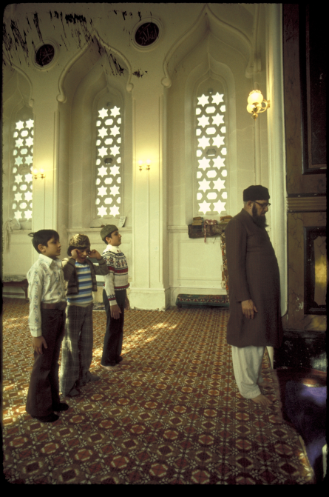
Regent’s Park Mosque, interior (photo: PADIA)

Eurostat, ‘378.5 million inhabitants in the EU and 305.1 million in the euro zone on 1 January 2003’, http:// europa.eu.int
Tariq Modood, “British Asian Muslims and the Rushdie Affair,” Political Quarterly 61(2) April 1990.
CSIS Euro-Forum, Rémy Leveau, Islam in France and Germany, March 6 1999, http://www.csis.org/europe/frm990412.html
Source: S. Vertovec and C. Peach (Eds.), Islam in Europe: The Politics of Religion and Community, (Basingstoke: Macmillan, 1997), cited in Paul Lubeck, ‘The Challenge of Islamic Networks and Citizenship Claims: Europe’s Painful Adjustment to Globalization’, chap. in Muslim Europe or Euro-Islam: Politics, Culture, and Citizenship in the Age of Globalization, Nezar AlSayyad and Manuel Castells (Eds.), Boston: Lexington Books, 2002, 84
Jan Nederveen Pieterse, “Fictions of Europe”, Race & Class No.32 Vol.3 1991
Tony Bunyan, “Towards an Authoritarian European State.” Race & Class No. 32, Vol.3, 1991
Glyn Ford (Rapporteur), Report drawn up on behalf of the Committee of Inquiry into Racism and Xenophobia: on the findings of the Committee of Inquiry. Brussels-Luxembourg, European Parliament: EUSC-EEU-EAEU, 1991
Web page of Swedish School of Social Science, University of Helsinki. “About the Schengen Agreement”, http://sockom.helsinki.fi/-hraita/antifa/jutut/fortres.2.htm
Joint Council for the Welfare of Immigrants, Annual Report 1990-91. London 1991.
Francis Whyte, “Dossier”, The Courier 129, Sept-Oct 1991, Brussels. 64-5
EU, Charter of Fundamental Rights: Home Page, http://www.europarl.eu.int/charter/default_en.htm
Refugee Council, Asylum Statistics 2001, http://www.refugeecouncil.org.uk/downloads/stats/summary_2001.pdf
Estimated figures. UNHCR, Information and Briefings, http://www.unhcr.org.uk/info/briefings/statistics/index.html, citing Home Office, ‘Home Office Asylum Statistics, 4th Quarter 2002’, http://www.homeoffice.gov.uk/rds/pdfs/asylumq401.pdf
European Council on Refugees and Exiles, EU Asylum Facts, http://www.ecre.org/factfile/realfacts.shtml (citing Population Data Unit, UNHCR, Geneva)
. Muhammad Anwar, The Myth of Return. London: Commission for Racial Equality, 2nd ed., 1978.
. Danielle Joly, “Making a Place for Islam in British Society – Muslims in Britain”, chap. in Thomas Gerholm and Y. Georg, Eds., The New Muslim Presence in Western Europe, (London: Mansell Publications, 1988), 32.
. Muhammad Anwar, Muslims In Britain: 1991 Census and other Statistical Sources, (Selly Oak: Centre for the Study of Islam and Christian-Muslim Relations, 1993), 2.
. Muhammad Anwar, 7.
For the history behind the Religion Question, see Muslim Council of Britain, ‘Campaigning for a religion question in the 2001 Census’, http://www.mcb.org.uk
National Statistics, ‘Religion In Britain’, April 2001, http://www.statistics.gov.uk/cci/nugget.asp?id=293
National Statistics Online, ‘Census 2001 - Ethnicity and religion in England and Wales’, http://www.statistics.gov.uk/census2001/profiles/commentaries/ethnicity.asp#religion
Nina Gemineans, ‘Photograph and further information: Shah Jehan Mosque’, http://www.nina.gemineans.co.uk/visitors/gardens/mosque.html
Historical information on the London Central Mosque can be found at Islamic Cultural Centre, http://www.islamicculturalcentre.co.uk
Muslim Council of Britain, http://www.salaam.co.uk/mosques/index.php, May 2003
The Guardian, Muslim Britain: the Statistics, June 17, 2002, http://www.guardian.co.uk/religion/Story/0,2763,738875,00.html
Danielle Joly, 32
. The Muslim Institute, The Muslim Manifesto - a strategy for survival, (London: The Muslim Institute, London, 1990)
. Muslim Institute, 1.
. See Institute of Contemporary Islamic Thought, "The Muslim Parliament of Great Britain 1992-1998", http://www.islamicthought.org/mp-intro.html
. For example, see: Kalim Siddiqui, "Islam and the West after Bosnia," (London, The Muslim Parliament of Great Britain, 1993). Information on Siddiqui can be found at Institute of Contemporary Islamic Thought, ‘Dr Kalim Siddiqui’, http://www.islamicthought.org/ks-home.html
Gary R. Bunt, Decision-Making and Idjtihād in Islamic Environments: A Comparative Study of Pakistan, Malaysia, Singapore, and the United Kingdom. (University of Wales, Ph.D.), fieldwork research, 1996 Ph.D.
Details on the MCB website, http://www.mcb.org.uk.about.htm
A version of this research was originally published in Gary R. Bunt, "Decision Making Processes in British Islamic Environments", Islam and Christian-Muslim Relations, Spring 1998, 103-113
See Commission on British Muslims and Islamophobia, Islamophobia: issues, challenges and action, Edited by: Robin Richardson, (Trentham Books, 2004)
. See: M.M. Ahsan and A.R. Kidwai, Sacrilege versus Civility: Muslim Perspectives on 'The Satanic Verses' Affair, Leicester, The Islamic Foundation, 1991. (extract in module pack)
. Sher Azam, Bradford Council of Mosques, interviewed by Julie Flint, "Britain's Muslims start to demand a price for their votes," The Guardian, 20 March 1992.

