Thematic mapping.

Objectives
- Express Numeric Values with a Thematic Map.
- Customize a Thematic Map and Legend.
- Express Character Values with a Thematic Map.
- Edit a Legend.
- Save a Thematic Map.
- Manage Thematic Templates.
- Understand Thematic Layers.
- Shade a Map with Data from a Separate Table.
- Use a Geographic Join.
- Embed a Legend.

MapInfo allows you to create seven different types of thematic maps. Each type has its own purpose and can add uniqueness to you GIS map layers.

Application
In order for you to use MapInfo efficiently, you must understand the concept thematic maps. With thematic mapping it is possible to create many different representations of the same data. A thematic map is a map whose appearance is altered to express some underlying information.

Understand Types of Thematic Maps

- Ranges: Each colour represents a range of numeric values.
- Bar Charts: A bar graph is placed over each object being shaded.
- Pie Charts: A pie chart is placed over each object being shaded.
- Graduated Symbol: Symbols of different sizes are used to represent the magnitude of the data. That is, large symbols represent large values and small symbols represent small values.
- Dot Density: Dots are placed in a boundary map so that the total number of dots represent that region's data value.
- Individual: Each unique value is given its own colour or symbol.
- Grid: A surface thematic interpolating point data over a region.

MapInfo allows you to express numeric values with a thematic map, such as populations.

In this type of map a single colour or style represents a user-specified range of values. For example, a country shaded red might represent a population between two and four million. Whereas, a country shaded pink could represent a population range of one to two million, and so on for each range of the thematic map.

In this first exercise you will create thematic maps based on data from the STATES table. It is possible to thematically shade the States in different ways. To get started open up the workspace to be used in this lesson:

- Open the File menu and Form the home tab select open workspace
- Select US_THEMATIC.WOR. (It is located in the Training_DataWorkspaces folder.)
- Press Open. The following map appears:

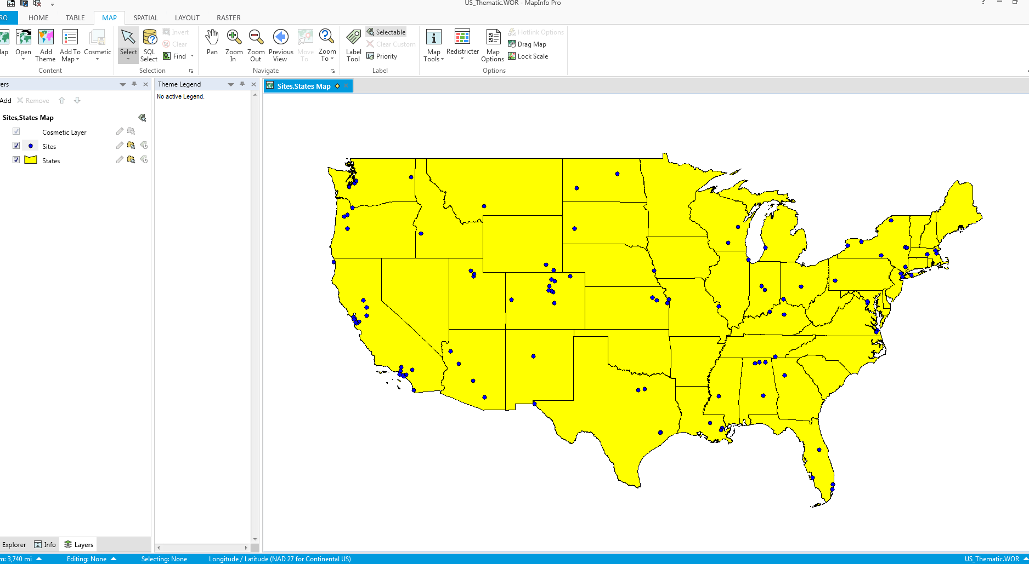

Based on the tables opened by this workspace, we can begin creating thematic maps of the States in the map above. Start by creating a ranged map. We will shade the STATES table based on the median income recorded for the States in 2000. Creating a thematic map involves three steps. Each step has its own dialog.

- Open the Map tab and select add Theme.
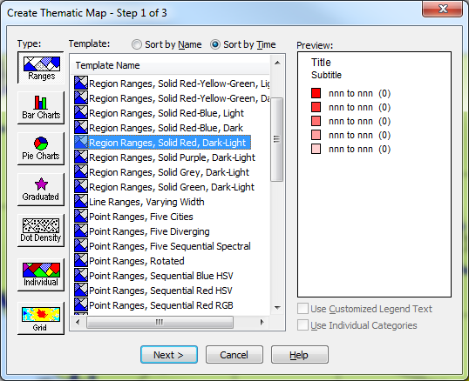

The first step is to select the type of thematic map you wish to create.

You also need to select a thematic template. A thematic template contains thematic map settings, such as colour choice, range method, and legend settings. These templates are to be used during current and future sessions. A template must be chosen each time a thematic map is created.

For each type of thematic map, there are a variety of predetermined templates to choose from. In the case of ranges or individual value thematic maps, you need to know the type of map object you wish to shade. These types of thematic maps have templates for point, line, and region type objects.
For this first map choose Ranges, using numeric information available in the underlying table. This is the default thematic map type.
- Verify the Ranges button is selected.
- Press Sort by Name to view templates alphabetically.
- Choose the template Region Ranges Default.
- Press Next.

Next, the Create Thematic Map - Step 2 of 3 dialog allows you to specify the table you are shading and the field you will get values from. The data can either be in the table that you are shading, or it can come from another table. The data we are using is in the same table.
When the dialog appears, the Table drop-down list may contain SITES because SITES is the top layer in the map. The Field drop-down list may contain SALES_03 because SALES_03 is the first numeric field in that table. We however, wish to shade the STATES table based on median income, we may need to change these options.
- Choose STATES from the Table drop-down list.
- Choose Med_Inc_2000 from the Field drop-down list.

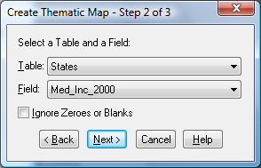
- Press Next.

Next, the Create Thematic Map - Steps allows you to specify the ranges and styles to be used. It is also possible to customize the theme legend accompanying the thematic map. For now we will look at the map with the current settings. Later we can modify the map.
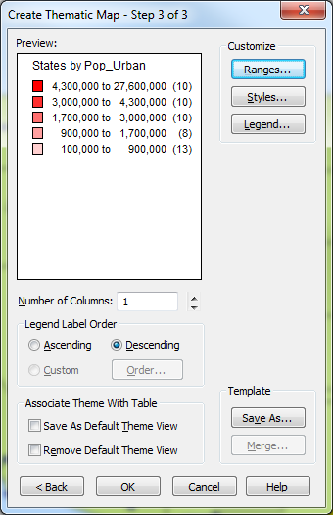
- Press OK.

The States are now shaded according to their median income figures. Note the Theme Legend window that appears. In the legend the numbers in parentheses indicate how many records are in each range. If desired, it is easy to move the legend window or resize it.
If your Theme Legend window does not appear, do one of the following:

- Choose Add to Map.

MapInfo Professional allows you to improve a thematic map and legend by making changes to the settings of the map. Thematic maps allow for the quick visualization of the data, it can be improved for the benefit of the map interpreter, using customization. For example, the foreground colours for a map.

This example will demonstrate changing the styles used in shading the map. To customize the thematic map and legend, open the MAP menu and choose MODIFY THEMATIC MAP.
From the Map menu, choose Modify Thematic Map.

Click the Styles button.

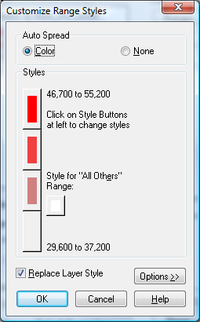

This dialog box has two sections. The first, Auto Spread, allows you to automatically spread the colours from the colour selected for the top range to the colour selected for the bottom range. You may also turn this feature off to choose your own colours for each range.
Click on the red polygon at the top of the Customize Range Styles dialog (it is marked 46,700 to 55,200).
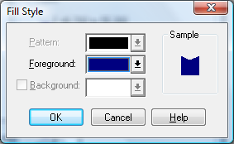

The Region Style dialog displays. You may change the pattern, foreground, and background of the shading used for the objects that fall in the selected range.
Change the foreground of the States in our top range. Click on the Foreground drop-down list.
Click on a dark blue. Remember that the colour you pick here will be used for the highest ranges; lower ranges will have lighter variations of this colour.
Press OK to close the Region Style dialog.
Notice that the colour is now spread from dark blue for the top range to gray for the bottom range. Next, the shading for the bottom range will be changed. Repeat this process for the gray polygon at the bottom.
Click the gray polygon representing the bottom range.
Click the Foreground drop down list.
Click on yellow. Note that the colour selected here will be used for the lowest range.
The map is now shaded with your new colours, graduating from yellow at the lower ranges to dark blue at the higher ranges.
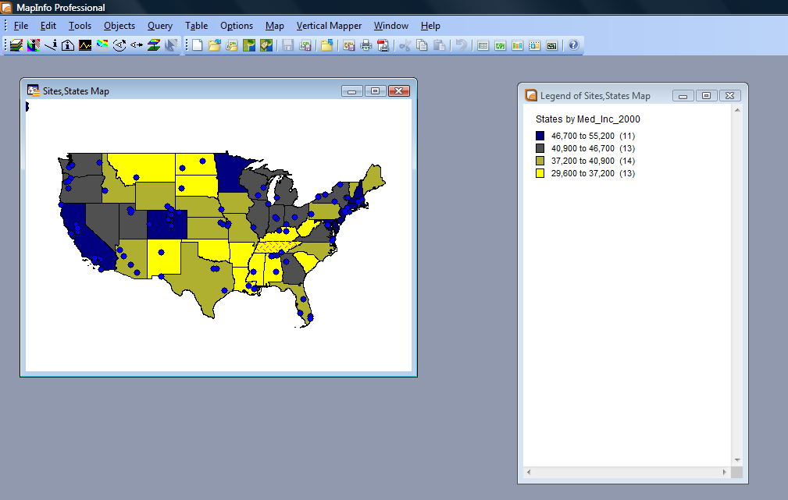
This shading reflects a general principle of thematic mapping. It is considered intuitive that darker colours often are used to represent higher values or intensities, while lighter colours are often used to represent lower values or lower intensities.
If you want to create your own colour scheme, you do not have to use the Auto Spread feature. Auto Spread may be turned off. Simply check None at the top of the Customize Range Styles dialog. Also, if you change one of the colours in the middle ranges, Auto Spread is automatically disabled.

MapInfo allows you to change the ranges themselves in order to help improve a thematic map and legend by making changes to the settings of the map. You are able to choose how many ranges there are, and how they are calculated. It is even possible to create your own custom ranges.

In this example, the number of ranges and the method by which those ranges are calculated will be changed.
To make these changes, double click the LEGEND WINDOW. This has the same effect as opening the Map menu and clicking Modify Thematic map.
Click Ranges. The Customize Ranges dialog displays:
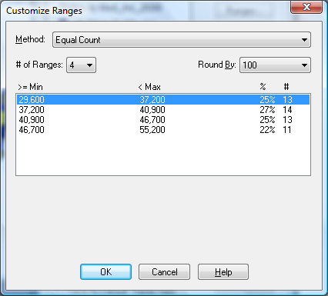

There are six different range calculation methods to choose from.
Range Calculation Methods:
- Equal Count - places the same number of records in each range. The result will be an even distribution of records in each range. The values of the ranges themselves may vary greatly in this calculation method.
- Equal Ranges - makes the magnitude of each range the same. In this method, the values of the ranges are evenly distributed, but the record count may vary greatly.
- Natural Break - makes each range contain data values that are close together.
- Standard Deviation - means that the ranges meet at the mean and at standard deviation intervals from the mean.
- Quantile - ranges are distributed across another segment of your data by a percentage.
- Custom Ranges - allow you to define your own ranges.

For this example, from the METHOD drop down select EQUAL RANGES.
Notice that the values have been removed format he range listings below because they are no longer valid. To recalculate the ranges based on the new information,
From the # of Ranges drop-down list select 5.

Click Recalc.
Pressing RECALC causes the ranges to be recalculated. Once the calculation has been performed, the RECALC button changes back to OK. This way you can experiment with many different range calculation methods before you choose the one you want.

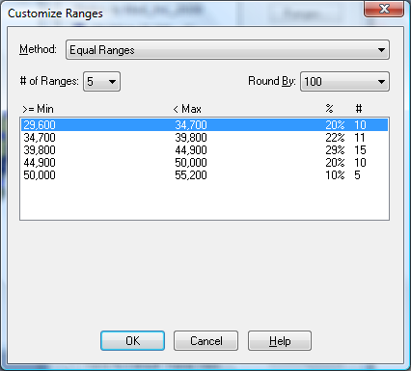

Click OK to close the Customize Ranges dialog.
Click OK to close the Modify Thematic Map dialog.

The map displays:

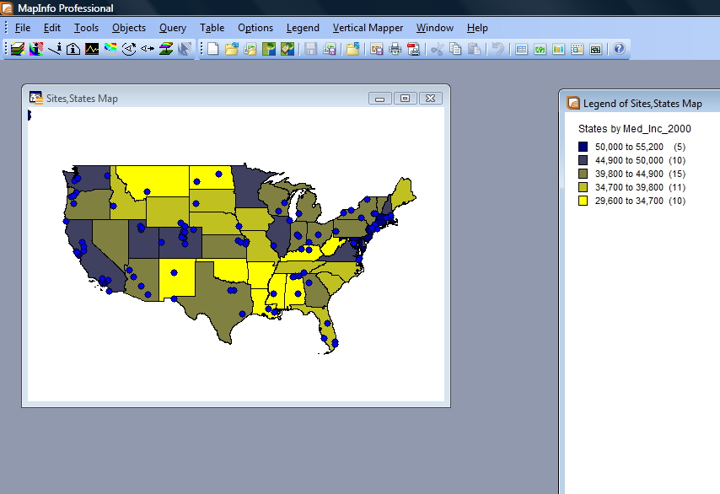

Note the difference between this map and the first. Each range is the same size according to the medium income. Previously, the top range had 11 states in it, whereas now it has only five. By changing the ranges, we have a different distribution of colours across the map.

Some of the data on which you create thematic maps will be character data. MapInfo allows you to express character values with a thematic map.

In this example, each site has been classified as being one of four different types: education, entertainment, transportation, or retail. The points representing each site will be thematically shaded so that you can quickly see the type of each site by just looking at the map.

First examine the information included in the Sites table by displaying it in a Browser window.
Notice the field called TYPE. This is the column on which we want to shade the map. For each type of site, there will be several records that are of that type. So, we want to shade on the individual value of type for each site. Each type of site will have a unique symbol representing it. Several sites will have that symbol.
From the Map menu select Create Thematic Map.
Click the Individual button in the Create Thematic Map - Step 1 of 3 dialog.

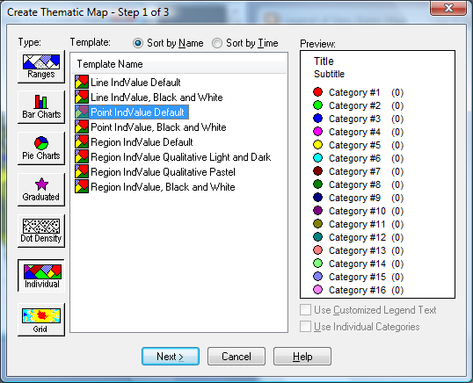

The SITES table contains point type objects. Choose Point IndValue Default from the Template Name list.
Click Next.
In the Step 2 dialog we will specify which table to thematically shade and which field to use. The Table list contains SITES because it is the top layer in the map. The Field list contains NAME because it is the first field in the table. An individual value thematic map will allow us to shade with either character or numeric information.
Choose SITES from the Table drop-down list.
Choose Type from the Field drop-down list.
Click Next.
In Step 3, we can examine how MapInfo categorizes our sites based on the Type field. The number in parenthesis is how many sites are of that particular type. It is possible to customize the map. The Style button allows you to change the type of symbol, its size and colour, while the Legend button allows you to customize the Legend window.
The STYLE button allows you to change the type of symbol, its size and colour.
Click the STYLES button and choose a different symbol for each of the categories.
Click OK to return to the Create Thematic Map - Step 3 of 3 dialog.
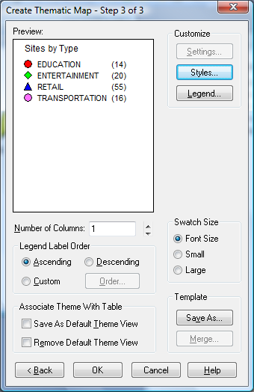
Click OK to create the map.
The MAP redraws itself with the sites shaded according to their type using the symbols that were set. If you wish to alter the thematic map at this point you can do so by double-clicking in the legend window, or choose MODIFY THEMATIC MAP from the Map Menu.

When a thematic map is created, and you wish to formally present it to someone else to read, it is a good idea to customize the Legend
While the legend provides us with enough information to understand the shading on the map, it could use some improvement so that it is more understandable to someone viewing the information for the first time. The legend can be improved by modifying the information that it contains, for example, its title

To modify a thematic legend double click the LEGEND window on the legend that you wish to modify.
Click Legend. The Customize Legend dialog displays.
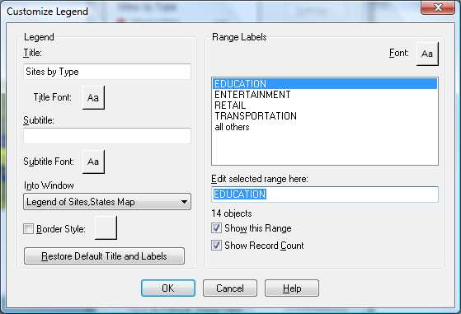
On the left side of the dialog box, you can change the title of the legend. For example, if you change it to read "Sites by Establishment Type" you will have a more descriptive and useful title.
You can also use the title and subtitle areas to quote the source of the data used in the map, if appropriate to do so. Also consider placing your name and/or the date the map was created in the legend, or elsewhere on your map.
Click inside the Title box, erase what is there and type Sites by Establishment Type .
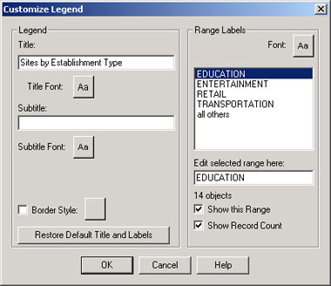
Click OK to close the Customize Legend dialog.
Click OK to close the Modify Thematic Map dialog. The Legend window changes:
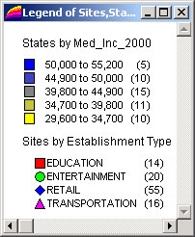

Thematic maps are temporary changes to object styles based on information in the tables. A thematic map is created in a map window. In order to save a thematic map, it must be saved so that all of the settings that created the map window and the temporary settings that created the thematic map can be saved as a collection of settings. This can be done simply by saving the workspace.

From the File menu choose Save Workspace .
Type SITE_MAP in the File Name box.
Click the Save button.
You can now safely end your MapInfo session and return where you left off by reopening the workspace. To do this:
From the File menu, Choose Close All.
All of the windows and tables in this session of MapInfo are closed.
From the File menu, Choose Open. The Open dialog displays.
From the Files of Type drop-down, choose .wor.
Select SITE_MAP.wor.
Click Open. The workspace opens all of the tables and windows from the session that you saved. All of the thematic map settings appear as before.

