
MSC PUBLIC HEALTH AND SOCIAL CARE IN PRACTICE
LCHS7008
PRACTICE-BASED RESEARCH

COMPONENT 2: WRITTEN RESEARCH PROPOSAL

PATTERNS AND CAUSES OF CHILDHOOD OBESITY AMONG UK CHILDREN

STUDENT NAME: VIDHI PRAJAPATI
STUDENT ID: 2506527
SUPERVISOR’S NAME: DR. ZENO LEUNG

Table of Contents
1.0 Research Title 3
2.0 Prevalence of the Problem 3
3.0 Introduction & Literature Background 4
Physical Inactivity and Sedentary Behaviour 4
Dietary Patterns and Nutritional Behaviour 5
Socio-Economic and Environmental Influences 6
4.0 Rationale of the Study 6
5.0 Research Aim and Objectives 8
6.0 Research Questions 8
7.0 Research Methodology 8
Research Design 8
Data Collection Method and Procedure 9
Data Sources 9
Selection Criteria 10
Data Analysis Technique 10
8.0 Ethical considerations 10
9.0 Implications of Research 11
10.0 Plan of Work (Gantt Chart) 12
References 13

Research Title
Patterns and Causes of Childhood Obesity Among UK Children.

Prevalence of the Problem
Childhood obesity has been a major public health concern in the United Kingdom. The rising cases reported in children in the recent years. Data from the National Child Measurement Programme has shown that approximately 22.1% of children aged between 10 and 11 years (Year 6) were classified as obese in the year 2023.2024 (Stiebahl, 2025). Moreover, approximately 9.6% of children in Reception year are also affected. These statistics point out the fact that excess weight starts at an early stage in childhood and increases with age. Additionally, it is suggested that national surveys show the scale of the issue across the population. This is because it is estimated in England that around one in three children in primary school is either overweight or obese. Childhood obesity is determined by various behavioural and environmental factors. It is especially unhealthy eating habits and a lack of physical activity in young individuals (Al-Ani and Al-Ani, 2024). For example, many children do not meet the Chief Medical Officer's recommendation of 60 minutes or more of physical activity of moderate-to-vigorous intensity a day. This mainly leading to increased risks of weight gain and associated health risks (Sport England, 2024).
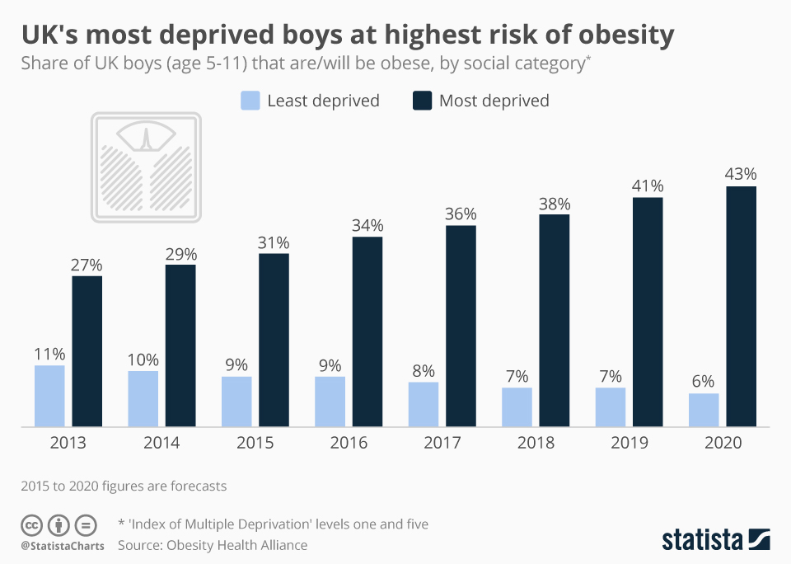
Figure 1: UK's Most Deprived Boys at Highest Risk of Obesity
(Source: Armstrong, 2024)
The prevalence of childhood obesity also shows significant inequalities across different socio-economic groups and regions in the UK. Research indicates that children living in more deprived areas experience considerably higher obesity rates compared with those in more affluent communities. Environmental factors such as a lack of access to healthy foods, an abundance of fast-food outlets and less access to safe physical activity contribute to this disparity. Dietary patterns in children also contribute further to the problem. It is mainly due to many children’s diets comprising large amounts of sugar, fat, and ultra-processed food, in addition to not putting in their recommended daily intake of fruit and vegetables (Mescoloto et al., 2024). Reports indicate that children in the UK take an average of only three portions of fruit and vegetables, whereas they are supposed to take five. If these trends continue, childhood obesity may lead to serious long-term health consequences, including increased risk of type 2 diabetes, cardiovascular disease, and other non-communicable diseases later in life (NHS Digital, 2024). Therefore, acting on the increase in childhood obesity prevalence is still a priority for public health policies and interventions. It helps to improve the well-being of children in the entire UK.

Introduction & Literature Background
Childhood obesity has become a significant public health issue in the United Kingdom with the physical, psychological and social consequences for children. The rising incidence of obesity in school-aged children have become a cause of concern for health care professionals and policy makers for the long-term risks of non-communicable diseases such as type 2 diabetes and cardiovascular disorders (World Health Organisation, 2023). Research has shown that obesity in childhood often persists into adulthood and provides long-term health and economic costs for healthcare systems. Multiple factors are involved in childhood obesity, such as lifestyle behaviours, environmental factors and socio-economic conditions. Therefore, understanding childhood obesity patterns and reasons for these issues is vital to help create strategies to stop this and aid in improving the health outcomes in children across the UK.

Physical Inactivity and Sedentary Behaviour
Physical inactivity is widely recognised as a significant contributor to childhood obesity. As per Chaput et al., (2020), public health guidelines from the Chief Medical Officer recommend that children aged 5–18 years should engage in at least 60 minutes of moderate-to-vigorous physical activity daily. However, research indicates that many children in the United Kingdom fail to meet these recommendations, with less than half achieving the required level of daily activity. The growing use of digital technologies, such as smartphones, television and online gaming, has increased sedentary behaviour among children and reduced opportunities for active play and outdoor exercise (Throuvala et al., 2021). Sedentary lifestyles contribute to energy imbalance, where calorie intake exceeds energy expenditure, ultimately leading to weight gain.
Studies also show the importance of the school and community environment in influencing children's activity levels. Schools with few offerings of physical education or inadequate facilities for sports may limit children's opportunity to stay physically active. Similarly, environments within neighbourhoods that lack safe parks or recreational areas can lead to a lack of outdoor activity by young people. Research suggests that children who live in areas of poverty, or who live in urban areas, frequently have lower opportunities to be physically active than children in more affluent communities (Khanom et al., 2020). Consequently, inactivity and sedentary behaviour in combination are the predominantly responsible mechanisms for the development of obesity in children. This remains an important area of focus for public health interventions.

Dietary Patterns and Nutritional Behaviour
As per Liberali et al., (2020), unhealthy dietary patterns represent another major factor contributing to childhood obesity in the UK. Children’s diets have increasingly shifted toward high-calorie, low-nutrient foods, including sugary beverages, fast food and ultra-processed snacks. These foods are often rich in fats, sugars and salt, which significantly increase daily calorie intake without providing adequate nutritional value. Research suggests that many children fail to meet recommended dietary guidelines, particularly the daily intake of fruits and vegetables. In the United Kingdom, children are advised to consume at least five portions of fruits and vegetables each day, yet studies show that the average intake is closer to three portions.
Food marketing and easy access to fast-food outlets also affect children's food habits. Exposure to advertising for unhealthy food products encourages children's preference of high-sugar and high-fat food, which contributes to unhealthy dietary behaviour (Finlay et al., 2024). Additionally, nutritional habits of the family play an important role in shaping children's nutritional behaviour. Parents who regularly eat convenience foods or drink sugary beverages may unintentionally shape similar behaviours in their children. Socio-economic factors also have an impact, with healthier foods such as fresh fruits, vegetables and lean proteins being more expensive and less easily accessible to families with lower incomes. These dietary behaviours are a major factor in the excess energy intake and weight gain in children.

Socio-Economic and Environmental Influences
Socio-economic and environmental conditions play an important role in the development of childhood obesity. Research consistently shows that obesity prevalence is higher among children living in socio-economically deprived areas (Lioret et al., 2023). Families with limited financial resources often face barriers in accessing healthy foods, safe recreational facilities and health education. As a result, children from disadvantaged backgrounds may rely more on inexpensive processed foods and may have fewer opportunities to engage in physical activities. This combination of unhealthy diet and reduced activity levels increases the likelihood of weight gain and obesity.
Environmental factors also play a role in what researchers call an "obesogenic environment" in which surroundings encourage unhealthy lifestyle behaviours. The concentration of fast-food outlets near schools and residential areas forms an encouragement of frequent consumption of unhealthy meals (Smagge et al., 2022). At the same time, urban environments may restrict children's ability to engage in outdoor play because of traffic safety issues and/or a lack of green spaces. Social influences such as family lifestyle habits and norms in a community can also further influence children's health behaviours. There is evidence to suggest that children with obese/overweight parents are more likely to have similar health outcomes as a result of shared environmental and behavioural factors. Understanding these socio-economic and environmental influences is the key to designing effective public health strategies that seek to reduce childhood obesity in the UK.

Rationale of the Study
Childhood obesity has become an increasing public health concern in the United Kingdom due to its rising prevalence and long-term health consequences. Recent statistics indicate that approximately 22.1% of children aged 10–11 years in England were classified as obese in 2023–2024, while around 9.6% of children in Reception year (aged 4–5 years) were also affected. In addition, studies show that nearly one in three primary school children in England are overweight or obese. This mainly demonstrating that the scale of the issue across the country. Childhood obesity is associated with several serious health conditions such as type 2 diabetes, cardiovascular disease and musculoskeletal disorders (Chung et al., 2023). Furthermore, evidence indicates that the National Health Service spends approximately £6.5 billion annually on obesity-related health conditions, with projections suggesting that the cost could increase to £9.7 billion by 2050 if the problem is not effectively addressed (Onyimadu et al., 2025).
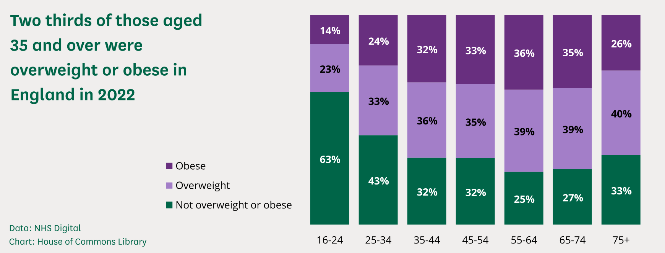
Figure 2: Adult obesity in England
(Source: Stiebahl, 2025)
The Health Survey for England for 2022 estimated that 28% of adults in England were classified as obese and a further 36% of adults were considered overweight. It was discovered that men were more likely to be overweight or obese than women at 67% and 61% were likely to be overweight or obese in women. Despite different government initiatives, such as the UK Childhood Obesity Plan and public health campaigns about healthy diets and being active, obesity levels in children are still high. Research shows that certain factors such as low physical activity levels, unhealthy dietary patterns and socio-economic inequalities, still play a role in childhood obesity (Spinelli et al., 2023). For example, many children do not meet the recommended 60 minutes of daily physical activity, and dietary studies show that the average child eats three portions of fruit and vegetables a day instead of the recommended five portions. Children living in socio-economically deprived areas are particularly vulnerable, as they often have limited access to healthy foods and safe recreational spaces. Therefore, the further research is required to better understand how environmental, family and community factors influence the children’s dietary behaviours and physical activity patterns.

Research Aim and Objectives
Research Question
How are the dietary and physical, Socio-economic status activity contributing to childhood obesity among primary school children in the United Kingdom?
Aim
The aim of this study is to explore the dietary and physical activity, Socio-economic status influence on childhood obesity among primary school children in the United Kingdom.
Objectives
The objectives of the study are:
- To identify the key factors (dietary and physical activity, Socio-economic status) contributing to childhood obesity among primary school children.
- To analyse how family, school and community environments influence children’s dietary habits and physical activity levels.
- To explore stakeholders’ perspectives, including parents, teachers and health professionals, on barriers to healthy lifestyles.
- To identify possible gaps in the literature and recommend future policy and practice children.

Research Methodology

Research Design
This study adopt a systematic literature review as the research design. It helps to explore the factors influencing childhood obesity among primary school children in the United Kingdom. A systematic approach ensures a structured, transparent and replicable process for identifying, evaluating and synthesising existing research evidence (Ghamrawi et al., 2025).
The study will follow the PECO framework to guide the research focus:
- Population (P): Primary school children in the UK
- Exposure (E): Dietary habits, physical activity
- Comparison (C): Differences across socio-economic or demographic groups
- Outcome (O): causes of childhood obesity
This design is appropriate as it allows for comprehensive analysis of existing academic literature without the need for primary data collection.

Data Collection Method and Procedure
The data collection process for this study will follow the Preferred Reporting Items for Systematic Reviews and Meta-Analyses (PRISMA) protocol to ensure a transparent and systematic approach (Nezameslami et al., 2025). Initially, relevant studies will be identified through structured searches across selected academic databases using predefined keywords and Boolean operators. All identified records will be organised, and duplicate studies will be removed. The titles and abstracts will then be screened to assess their relevance to the research topic.
Following the screening stage, full-text articles will be evaluated based on the established inclusion and exclusion criteria to determine their eligibility. Only studies that meet the criteria will be included in the final review. The PRISMA framework will guide the documentation of each stage, ensuring clarity in study selection and improving the reliability and reproducibility of the research process.

Data Sources
The data for this study will be collected from reputable academic databases to ensure the credibility and quality of sources. Key databases include PubMed, Scopus, Google Scholar and ScienceDirect, as they provide extensive coverage of public health and social care research. These platforms offer access to peer-reviewed journal articles, reports and systematic reviews relevant to childhood obesity, ensuring that the study is based on reliable and up-to-date evidence.

Selection Criteria
The selection of studies will be guided by predefined search terms, timeframe, and inclusion and exclusion criteria to ensure relevance and quality. The search will use keywords such as “childhood obesity UK”, “physical activity children obesity”, “dietary behaviour children”, and “socio-economic factors childhood obesity”, combined using Boolean operators (AND, OR) to refine results. The timeframe for included studies will be from 2015 to 2025 to ensure the use of recent and relevant evidence.
Inclusion Criteria
The inclusion criteria will consist of peer-reviewed studies focusing on children aged 4–11 years, particularly within the UK or similar high-income countries, and addressing factors such as diet, physical activity or environmental influences.
Exclusion Criteria
Exclusion criteria will include studies focused solely on adults, non-English publications, articles without full-text access, and studies not directly related to the causes of childhood obesity.

Data Analysis Technique
Data from selected studies will be extracted systematically using a structured table, including author, year, location, methodology and key findings. The analysis will be conducted using thematic analysis to identify recurring patterns and themes such as dietary behaviour, physical inactivity and socio-economic factors. Thematic analysis is used to identify and interpret recurring patterns or themes within the collected data (Ahmed et al., 2025). This approach enables comparison across studies and supports a clear synthesis of the main factors contributing to childhood obesity. This study will follow the six-phase framework proposed by Braun and Clarke (2006), which includes familiarisation with the data, generating initial codes, searching for themes, reviewing themes, defining and naming themes, and producing the final report, enabling a rigorous and systematic synthesis of the findings.

Ethical considerations
Ethical considerations remain essential in research to ensure integrity and responsible use of information. As this study is based entirely on secondary data, it does not involve direct interaction with human participants; therefore, issues such as informed consent and voluntary participation are not applicable. The research will rely solely on publicly available academic sources, ensuring that all data used is obtained ethically and in accordance with established research standards, including the principles outlined in the Data Protection Act 2018. All sources will be appropriately cited to avoid plagiarism and to maintain academic integrity (Hwang, 2023). The study will also ensure accurate, objective, and unbiased interpretation of the data. Furthermore, all information will be used strictly for academic purposes and handled responsibly throughout the research process.

Implications of Research
The results of this study can provide valuable information. It is mainly regarding the important factors that lead to childhood obesity in case of primary school children in the United Kingdom. By looking at the role of family, school and community environments on children's eating and activity, the study can help identify the major factors that impede children from leading healthy lifestyles. Understanding these factors will help public health professionals and educators recognise what areas intervention is required.
In addition, the research may make a contribution in the area of policy development and practical strategies for reducing childhood obesity either at the local and national level. The results could provide information that would be informative for schools and community organisations trying to design initiatives to increase healthy eating behaviours and increase the physical activity in children. For example, introducing better nutrition education programmes and encouraging active play and also improved the access to the physical activity opportunities in schools. The study may also be useful to parents and caregivers in terms of raising awareness to health lifestyle practices that may be enforced within the home environment.

Plan of Work (Gantt Chart)
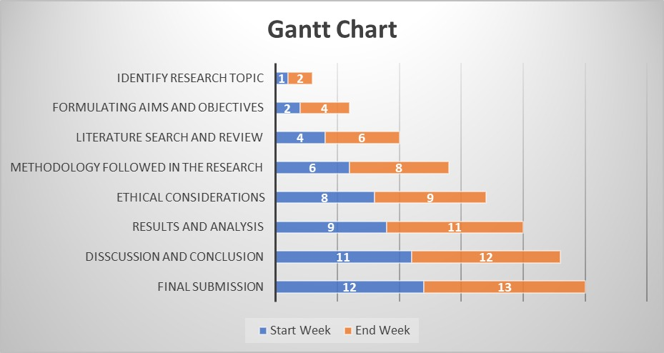

References
Ahmed, S.K., Mohammed, R.A., Nashwan, A.J., Ibrahim, R.H., Abdalla, A.Q., Ameen, B.M.M. and Khdhir, R.M., (2025). Using thematic analysis in qualitative research. Journal of Medicine, Surgery, and Public Health, 6, p.100198. https://www.sciencedirect.com/science/article/pii/S2949916X25000222
Al-Ani, O. and Al-Ani, F., (2024). Children’s behaviour and childhood obesity. Pediatric Endocrinology Diabetes and Metabolism, 30(3), pp.148-158. https://www.termedia.pl/Children-s-behaviour-and-childhood-obesity,138,54679,0,1.html
Armstrong, M. (2024). Infographic: UK’s Most Deprived Boys At Highest Risk Of Obesity. [online] Statista Daily Data. Available at: https://www.statista.com/chart/6170/uks-most-deprived-boys-at-highest-risk-of-obesity/?srsltid=AfmBOoq8fYlAua1Pg9M5WhxYIFOjopZuy0L6IiFnwhxzla6F80yZv_HQ [Accessed 16 Mar. 2026].
Chaput, J.P., Willumsen, J., Bull, F., Chou, R., Ekelund, U., Firth, J., Jago, R., Ortega, F.B. and Katzmarzyk, P.T., (2020). 2020 WHO guidelines on physical activity and sedentary behaviour for children and adolescents aged 5–17 years: summary of the evidence. International Journal of Behavioral Nutrition and Physical Activity, 17(1), p.141. https://link.springer.com/article/10.1186/s12966-020-01037-z
Chung, S.T., Krenek, A. and Magge, S.N., (2023). Childhood obesity and cardiovascular disease risk. Current atherosclerosis reports, 25(7), pp.405-415. https://link.springer.com/article/10.1007/s11883-023-01111-4
Finlay, A.H., Jones, A., Cummins, S., Yau, A., Cornelsen, L., Robinson, E. and Boyland, E., (2024). Associations between exposure to advertising of foods high in fats, salt and sugar and purchase of energy and nutrients: a cross-sectional study. Public health nutrition, 27(1), p.e207. https://www.cambridge.org/core/journals/public-health-nutrition/article/associations-between-exposure-to-advertising-of-foods-high-in-fats-salt-and-sugar-and-purchase-of-energy-and-nutrients-a-crosssectional-study/8C5FFE222E6F37EE99EE6059ED8DF116
Ghamrawi, N., Shal, T., Ghamrawi, N.A., Abu-Tineh, A., Alshaboul, Y. and Alazaizeh, M.A., (2025). A step-by-step approach to systematic reviews in educational research. European Journal of Educational Research, 14(2), pp.549-566. https://www.eu-jer.com/a-step-by-step-approach-to-systematic-reviews-in-educational-research
HWANG, H.J., (2023). The importance of anonymity and confidentiality for conducting survey research. Journal of Research and Publication Ethics, 4(1), pp.1-7. https://www.researchgate.net/profile/Eungoo-Kang/publication/370048267_The_Importance_of_Anonymity_and_Confidentiality_for_Conducting_Survey_Research/links/643aecc92eca706c8b5f9dc9/The-Importance-of-Anonymity-and-Confidentiality-for-Conducting-Survey-Research.pdf
Khanom, A., Evans, B.A., Lynch, R., Marchant, E., Hill, R.A., Morgan, K., Rapport, F., Lyons, R.A. and Brophy, S., (2020). Parent recommendations to support physical activity for families with young children: Results of interviews in deprived and affluent communities in South Wales (United Kingdom). Health Expectations, 23(2), pp.284-295. https://onlinelibrary.wiley.com/doi/abs/10.1111/hex.13020
Liberali, R., Kupek, E. and Assis, M.A.A.D., (2020). Dietary patterns and childhood obesity risk: a systematic review. Childhood obesity, 16(2), pp.70-85. https://journals.sagepub.com/doi/abs/10.1089/chi.2019.0059
Lioret, S., Harrar, F., Boccia, D., Hesketh, K.D., Kuswara, K., Van Baaren, C., Maritano, S., Charles, M.A., Heude, B. and Laws, R., (2023). The effectiveness of interventions during the first 1,000 days to improve energy balance‐related behaviors or prevent overweight/obesity in children from socio‐economically disadvantaged families of high‐income countries: a systematic review. Obesity Reviews, 24(1), p.e13524. https://onlinelibrary.wiley.com/doi/abs/10.1111/obr.13524
Mescoloto, S.B., Pongiluppi, G. and Domene, S.M.Á., (2024). Ultra-processed food consumption and children and adolescents’ health. Jornal de pediatria, 100, pp.S18-S30. https://www.sciencedirect.com/science/article/pii/S0021755723001213
Nezameslami, R., Nezameslami, A., Mehdikhani, B., Mosavi-Jarrahi, A., Shahbazi, A., Rahmani, A., Masoudi, A., Yeganegi, M., Akhondzardaini, R., Bahrami, M. and Aghili, K., (2025). Adapting PRISMA Guidelines to Enhance Reporting Quality in Genetic Association Studies: A Framework Proposal. Asian Pacific Journal of Cancer Prevention: APJCP, 26(5), p.1641. https://pmc.ncbi.nlm.nih.gov/articles/PMC12290203/
NHS Digital (2024). Health Survey for England, 2022 Part 1: Children’s health and health-related behaviours, 6 June. https://digital.nhs.uk/data-and-information/publications/statistical/health-survey-for-england/2022-part-1/childrens-health-and-health-related-behaviours
Smagge, B.A., van der Velde, L.A. and Kiefte-de Jong, J.C., (2022). The food environment around primary schools in a diverse urban area in the Netherlands: linking fast-food density and proximity to neighbourhood disadvantage and childhood overweight prevalence. Frontiers in public health, 10, p.838355. https://www.frontiersin.org/journals/public-health/articles/10.3389/fpubh.2022.838355/full
Spinelli, A., Censi, L., Mandolini, D., Ciardullo, S., Salvatore, M.A., Mazzarella, G. and Nardone, P., (2023). Inequalities in childhood nutrition, physical activity, sedentary behaviour and obesity in Italy. Nutrients, 15(18), p.3893. https://www.mdpi.com/2072-6643/15/18/3893
Sport England (2024). Active Lives Children and Young People Survey – Academic Year 2023-24, published 5 December. Available at: https://sportengland-production-files.s3.eu-west-2.amazonaws.com/s3fs-public/2024-12/Active%20Lives%20Children%20and%20Young%20People%20Survey%20-%20academic%20year%202023-24%20report.pdf
Stiebahl, S. (2025). Obesity statistics, House of Commons Library Research Briefing SN03336, UK Parliament, 10 February. https://commonslibrary.parliament.uk/research-briefings/sn03336/
Stiebahl, S. (2025). Obesity Statistics. House of Commons Library, [online] 1(3336). Available at: https://commonslibrary.parliament.uk/research-briefings/sn03336/ [Accessed 16 Mar. 2026].
Throuvala, M.A., Griffiths, M.D., Rennoldson, M. and Kuss, D.J., (2021). The role of recreational online activities in school-based screen time sedentary behaviour interventions for adolescents: A systematic and critical literature review. International Journal of Mental Health and Addiction, 19(4), pp.1065-1115. https://link.springer.com/article/10.1007/s11469-019-00213-y
World Health Organization, (2023). A primary health care approach to obesity prevention and management in children and adolescents: policy brief. World Health Organization. https://books.google.com/books?hl=en&lr=&id=xxDAEAAAQBAJ&oi=fnd&pg=PA2&dq=Increasing+rates+of+obesity+among+school-aged+children+have+raised+concerns+for+health+professionals+and+policymakers+&ots=9MKJpsydXG&sig=nLIqjhWmKTJna08mP0b7aXgyy6M

