Name: Keval Hansraj Mange
Course: MBA-Marketing (Term-3)
Student ID: 2240155
Submitted to: Tushara Balendran
Topic:
EXAMINATION OF THE IMPACT OF DIGITAL ADVERTISEMENT ON CUSTOMER BEHAVIOUR AND BRAND LOYALTY: ANALYSIS OF THE SMARTPHONE INDUSTRY

Table of Contents
1 | Introduction | 3
2 | Literature Review | 5
3 | Research Methodology | 7
4 | Data Analysis | 8
5 | Gantt Chart | 9
 | References | 10

- INTRODUCTION
Background of The Research
The title of this research is “Examination of the Impact of Digital Advertisement on Customer Behavior and Brand LOYALTY: ANALYSIS OF THE SMARTPHONE INDUSTRY.” It aims to work on themes like Digital Marketing, Customer behavior, and Brand loyalty. To examine these several models like the ABC model, Maslow’s theory of the hierarchy of needs, consumer perception, Keller’s brand equity model, and the RACE model will be discussed.
Smartphone Industry
Smartphones: a rapid integration with everyday life
Since its inception in 2008, the smartphone industry has experienced consistent growth, both in terms of market size and the variety of models and brands available. In 2022, global smartphone shipments reached approximately 1.2 billion units, although this slightly declined from the previous year. By the end of 2022, around 68% of the world's population used smartphones. However, it's important to note that many individuals own multiple smartphones, leading to more subscriptions than actual users. As of 2022, there were an estimated 6.5 billion smartphone subscriptions worldwide, a number projected to rise to nearly eight billion by 2028.

The Rationale of The Research
In this research, themes like Digital advertisements, Brand loyalty, and customer behavior will be analyzed. This research can be helpful to the industry in many ways.
- Strategic Marketing Decisions: This research can help make marketing decisions as it will explore how advertisements affect customer behavior and loyalty. Understanding how digital advertisements influence consumer perceptions and purchasing decisions will help companies to allocate resources effectively and design their marketing campaigns to engage their target audience better.
- Increasing Brand Loyalty: Understanding the factors that contribute to brand loyalty in the context of digital advertising will enable companies to develop strategies to build stronger relationships with their customers, it will increase customer retention and support.
- Increasing ROI: By gaining insights into the effectiveness of digital advertisement campaigns, smartphone companies can optimize their marketing efforts to maximize return on investment (ROI). Understanding which types of digital advertisements are most effective for customer behavior and brand loyalty.
Research Aim
This research intends to analyze the impact of digital advertisements on changing customer behavior and customer loyalty. Through the data of leading companies like Apple, Samsung, Google Pixel, OnePlus, and Nothing, this report will analyse how these companies bend customer behavior and activities toward themselves. Furthermore, this report will examine their strategies to increase customer loyalty. This proposal will use ABC and RACE models for customer attitude and digital marketing respectively.
Research Objectives
- To examine the relationship between digital advertisement exposure and customer purchasing behavior within the smartphone industry.
- To investigate the influence of digital advertisement content (e.g., visuals, messaging) on customer attitudes and perceptions towards smartphone brands.
- To explore the long-term effects of digital advertisement campaigns on customer retention and repeat purchase behavior within the smartphone industry.
- To determine the key factors contributing to digital advertisement campaigns' effectiveness in enhancing brand loyalty among smartphone consumers.
Research Questions
- What is the relationship between digital advertisement exposure and customer purchasing behavior within the smartphone industry?
- How does digital advertisement content, such as visuals and messaging, influence customer attitudes and perceptions toward smartphone brands?
- What are the long-term effects of digital advertisement campaigns on customer retention and repeat purchase behavior within the smartphone industry?
- What are the key factors contributing to the effectiveness of digital advertisement campaigns in enhancing brand loyalty among smartphone consumers?

- Literature Review
Definitions:
Customer Behaviour
- Buyer behaviour has been defined as “a process, which through inputs and their use though process and actions lead to satisfaction of needs and wants” (Enis, 1974, p.228).
- Consumer behaviour is the study of how people buy, what they buy when they buy, and why they buy. (Kotler, 1994)
- Consumer is the study “of the processes involved when individuals or groups select, purchase, use, or dispose of products, services, ideas, or experiences to satisfy needs and desires” (Solomon et al.,1995)
Brand Loyalty
- Brand loyalty is the biased (non-random) behavioral response (purchase) expressed over time by some decision-making unit with respect to one or more alternative brands out of a set of brands and is a function of psychological processes (Jacoby 1971, p25) and emotional response.
- Brand loyalty can be defined as the extent of consumer faithfulness towards a specific brand and this faithfulness is expressed through repeat purchases and other positive behaviors such as word-of-mouth advocacy, irrespective of the marketing pressures generated by the other competing brands (Kotler & Keller, 2006; Kotler, et al., 2008).

- RACE model in digital marketing communication
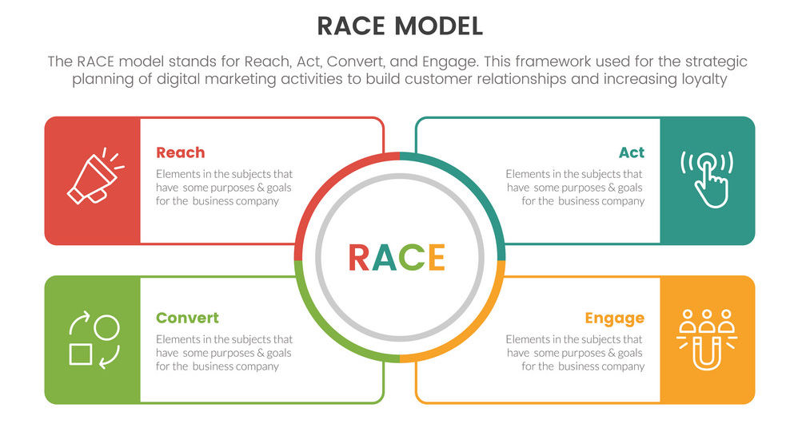
Source: VectorStock
Digital marketing has come a long way from its roots in Internet marketing. It now encompasses a wide array of online activities like websites, social media, mobile apps, search engine marketing, online ads, and e-commerce strategies. The RACE model, a strategic tool in digital marketing, has shed light on valuable insights, challenges, and opportunities by blending new media with traditional marketing methods (Sestino et al., 2021).

Using the RACE framework—Reach, Act, Convert, Engage—helps marketers craft effective digital marketing campaigns and content tailored to their audience. The Reach stage focuses on raising awareness through online advertisements and promotions, driving traffic to the products and services online. Act encourages consumers to take positive actions like inquiries or engaging with the product. Convert, the next stage, aims to turn audience members into paying customers through purchases and product preference. This step is crucial as it sets the stage for the final phase: Engage. In this phase, brands strive to foster meaningful connections and build relationships with consumers, ultimately aiming to secure their loyalty.
- Role and Importance of Behavioral Learning Theory in Digital Marketing Communication
Consumer behavior plays a crucial role in shaping digital marketing strategies. As consumers adapt their online habits, brands must adjust their digital communication accordingly. This shift in focus emphasizes the importance of adopting a consumer-centric approach rather than relying solely on data and analytics (Zhou, 2021).

Despite its relevance, behavioral theories of learning are often overlooked in marketing due to their association with psychology. However, understanding these theories is essential for marketers as they provide insights into consumer behavior and decision-making processes (Kimmel, 2010). Incorporating behavioral learning theory into marketing strategies can enhance promotional efforts and align with the overarching marketing concept, where transactions occur when customers respond to stimuli, such as products (Rothschild & Gaidis, 1981). By embracing these principles, marketers can leverage positive reinforcement to drive successful marketing campaigns.

- Research Methodology
Definitions
Qualitative Methods:
An umbrella term covering an array of interpretive techniques which seek to describe, decode, translate, and otherwise come to terms with the meaning not the frequency, of certain more or less naturally occurring phenomena in the social world. (Van Maanen, 1979)
Quantitative Methods:
Quantitative methods seek regularities in human lives, by separating the social world into empirical components called variables which can be represented numerically as frequencies or rate, whose associations with each other can be explored by statistical techniques, and assessed through researcher-introduced stimuli and systematic measurement. (Payne and Payne, 2004)
In this research, a mixed method will be used to analyze the outcomes of the survey questions.
This research will have 8-10 survey questions related to the themes, to analyse the responses of participants.

Sample Size:
This research will have a sample size of 60-70 people who use smartphones of globally recognised companies that use digital advertising campaigns.
Data Sampling
To draw valid conclusions from your results, you have to carefully decide how you will select a sample that is representative of the group as a whole. There are two types of sampling methods:
Probability sampling involves the process of selecting individuals or items without any predetermined pattern, enabling robust statistical conclusions to be drawn about the entire population. This method mitigates the potential for selection bias, enhancing the reliability of the findings.
Non-probability sampling entails the process of choosing individuals or items based on convenience or specific criteria, facilitating the ease of data collection.
In this research non-probability (Convenience) sampling will be used as the target and the ideal sample is the people who use smartphones.
Convenience Sampling
A convenience sample consists of individuals who are readily available to the researcher. While this approach is convenient and cost-effective for collecting preliminary data, it lacks assurance that the sample accurately represents the entire population. The results cannot be generalized beyond the specific group surveyed. (McCombes, 2022)
Data Collection
Plan for the survey: In this research, the plan to survey is to prepare an online questionnaire from Google Forms and circulate it through several social media platforms like WhatsApp, Instagram, Email, and others. Each person will be given 10-15 minutes to fill out the survey as it is important to understand the questions. Both, open-ended and closed-ended questions will be included.

- Data Analysis
Data analysis is important to conclude the research outcomes. To analyze data, data collection, and data interpretation is important. Graphs, statistics, and diagrams are important to analyze data. In this report, software namely Microsoft Excel will be used to analyze data and thematic analysis will be conducted for the qualitative research.
Ethical Consideration
The UK Statistics Authority has outlined six ethical principles to guide researchers in addressing the ethical considerations inherent in their work. These principles emphasize the importance of serving the public good, safeguarding the confidentiality of data, recognizing the risks and limitations associated with new research methods and technologies, adhering to legal obligations, assessing the project's acceptability to the public, and ensuring transparency throughout the data collection, usage, and sharing processes.
- Public Good
- Confidentiality, Data Security
- Methods and Quality
- Legal Compliance
- Public Views and Engagement
- Transparency
This research will be conducted considering all the research ethics which are mentioned above as all the data of participants will be kept confidential.

- Gantt Chart
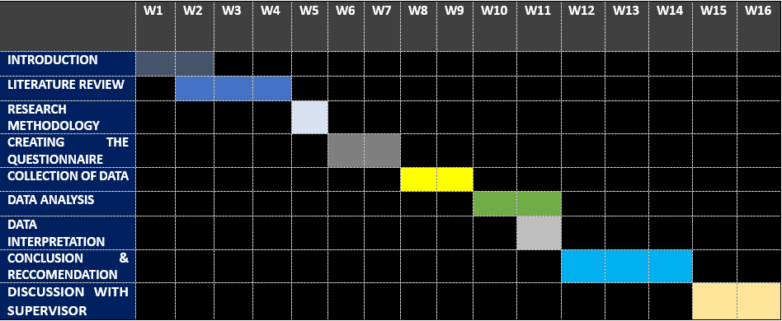
Source: Self-Generated

References:
Sestino, A., Prete, M., Piper, L., Guido, G. (2021). The future of online marketing strategies and digital tools: new challenges and contributions to RACE framework. International Journal of Trade and Global Markets. 1.1.10.1504/IJETRADE.2021.10042594
Rautela, S. (2021). Social Media for New Product Launch: A Study of Social Media Platforms Across the RACE Planning Framework. International Journal of Interactive Mobile Technologies (iJIM), [online] 15(05), p.187. doi:https://doi.org/10.3991/ijim.v15i05.18147.
Zhou, J. (2021). How consumer behaviors shape digital marketing. Advances in Economics, Business and Management Research. 203
McCombes, S. (2022). Sampling Methods | Types, Techniques, & Examples. [online] Scribbr. Available at: https://www.scribbr.co.uk/research-methods/sampling/.
UK Statistics Authority (2022). Ethical Considerations associated with Qualitative Research methods. [online] UK Statistics Authority. Available at: https://uksa.statisticsauthority.gov.uk/publication/ethical-considerations-associated-with-qualitative-research-methods/pages/2/.
Laricchia, F. (2024). Smartphones - statistics & facts.

