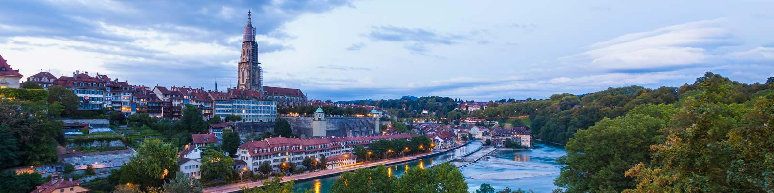
4 Breathtaking Things Must Do And See in Bern, Switzerland

How I spent an unforgettable few hours in Bern
Bern is so beautiful that it only took one day for me to fall in love with the capital city. Its beauty has encouraged me to want to visit again next year with my family. Before finally arriving in Bern, the first thing on my mind was FLUFFY BEARS. Since 1919, bears have become the most important symbol of the city's culture. While I was exploring the city I came across many interesting things such as flags which proudly feature a bear on a red and yellow background. From my point of view, Bern is a spectacular place that offers a chance to explore their culture, see monuments and discover their history. However, the only thing that might change your plan to visit this stunning country is the cost. Unfortunately, Switzerland is not a cheap destination for people who prefer to get a bargain city break holiday. In this case, make sure your wallet is full of colourful Swiss Franc currency before you get there !

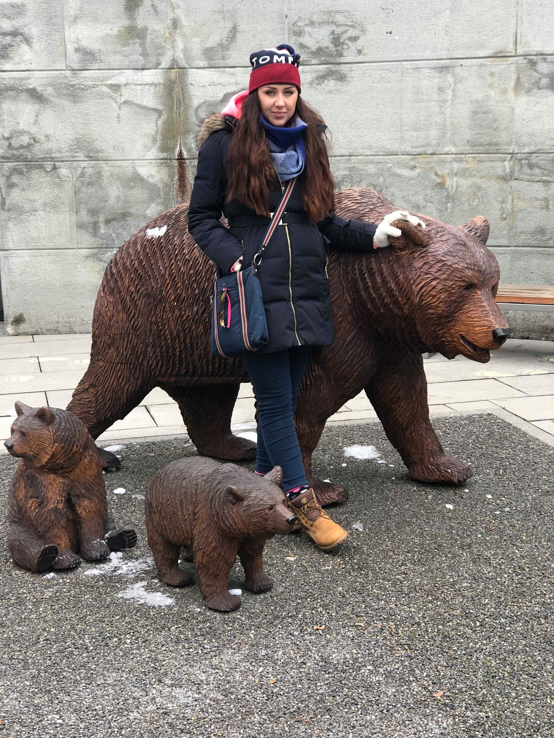

1.Bear Park
Unfortunately, I was not so lucky this time as this top exciting visitor attraction that is visited by many people every year was closed. The brown bears are in hibernation during the Winter. In spite of everything I was able to get around the park for free and read the displays with facts about the bears’ history. As a result of this the Bear Park has a long tradition of keeping live bears to entertain its visitors since 1513. This 6,500 square meter bear pit reminds us of the important role they played for the capital city. Legend has it that the first aristocratic hunt was started by Bern’s love.
Even though, I was unable to see the real bears, they can be seen on various souvenirs and monuments near the town hall.

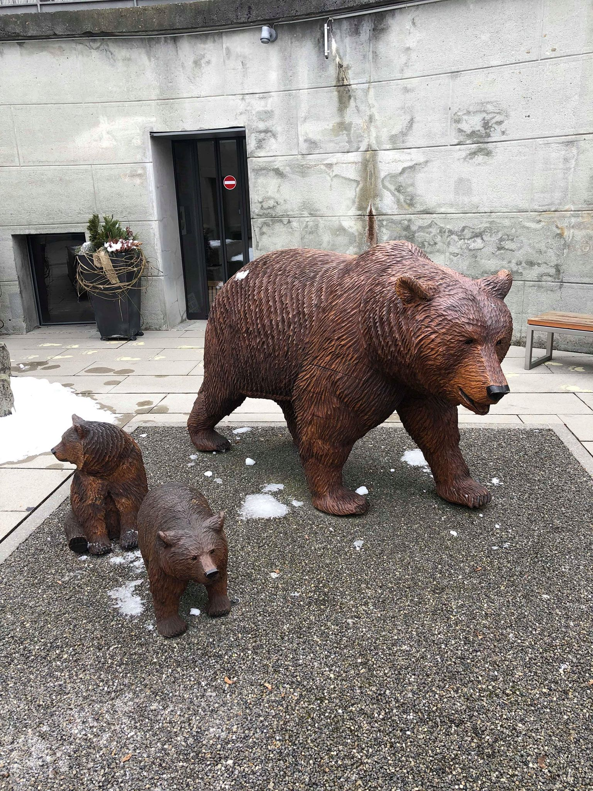

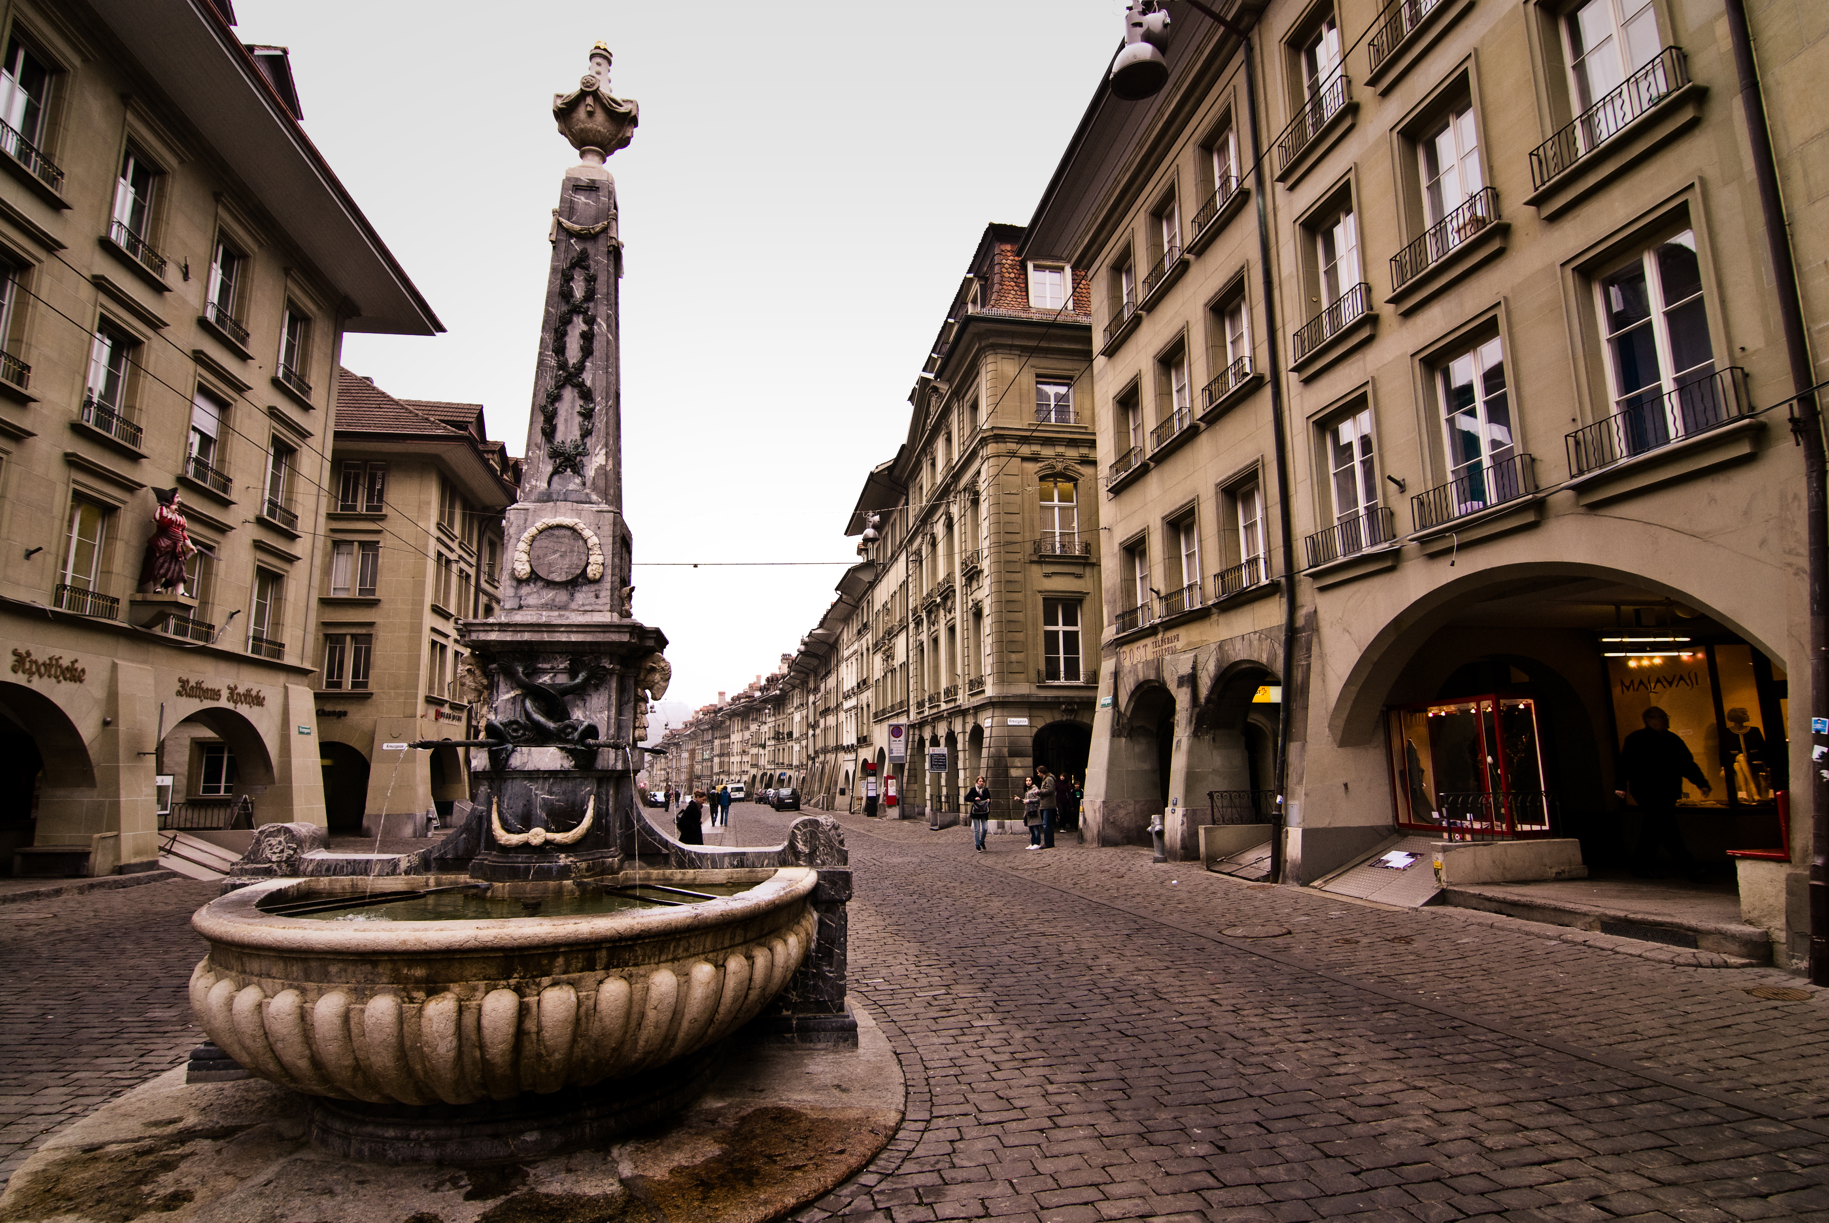
2.City of Fountains
Wherever you go in Bern, it is impossible to miss the charming city fountains. There are almost 100 fountains located around the city which all played a major role in suppling water in Bern for 140 years ago. During my visit, there were three colourful fountains that attracted my attention the most. One of them was called Zahringen which was characterised as a bear statue in full armour. These historical monuments reminds us of the events and heros of Bern from the past. In a way, the city keeps the culture alive for others to discover.

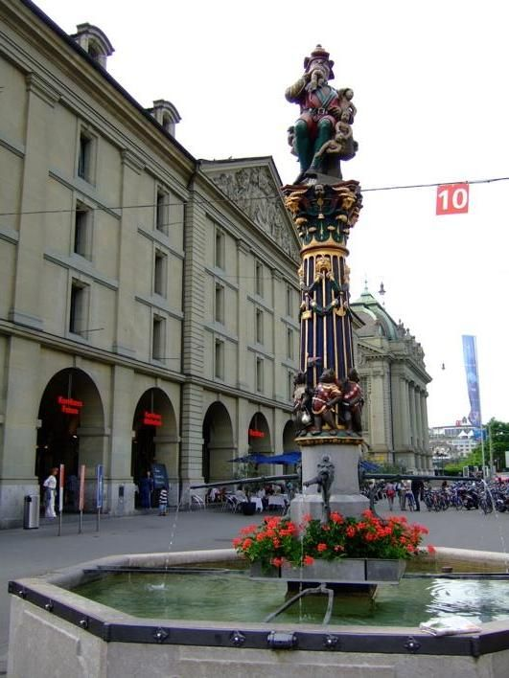

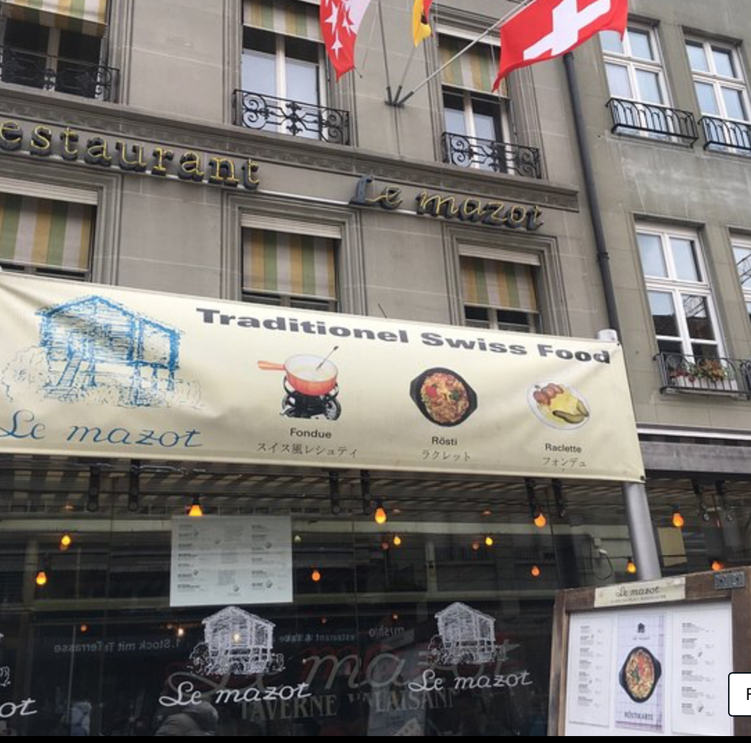
3 The Best place to taste Swiss food
- It would be a big mistake not to try some traditional Swiss food during a visit to Bern. Everyone knows that Switzerland is well known for making different types of cheese. Therefore, while I was walking in the Old Town I came across a small restaurant called Le Mazot. The interior of the place caught my attention straight away because it was simple and cosy. To be honest, I am not a fan of a cheese. However during my selection of dishes from the menu, I chose a famous cheese fondue. It was served with a hot pot of melted cheese and wine into which I had options to dip cucumbers, tomatoes, bread, and more. Believe it or not. But it was one of the best experiences in my life to try a cheese in this kind of form. The restaurant also tries to maintain the traditional appearance of the place and food at the same time. My feelings were very positive because I could feel the real Swiss culture for a moment.

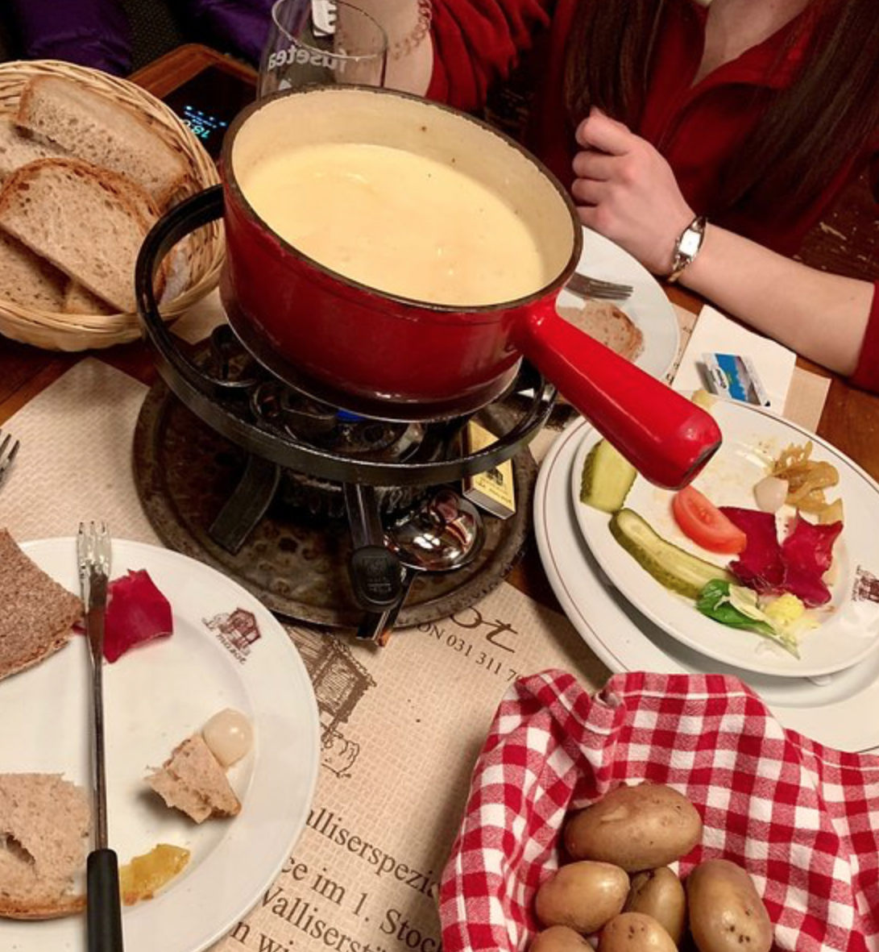

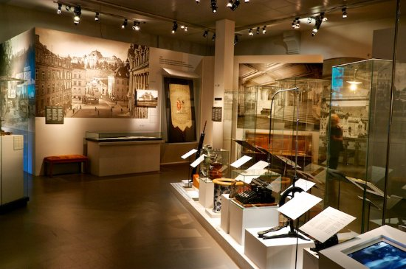
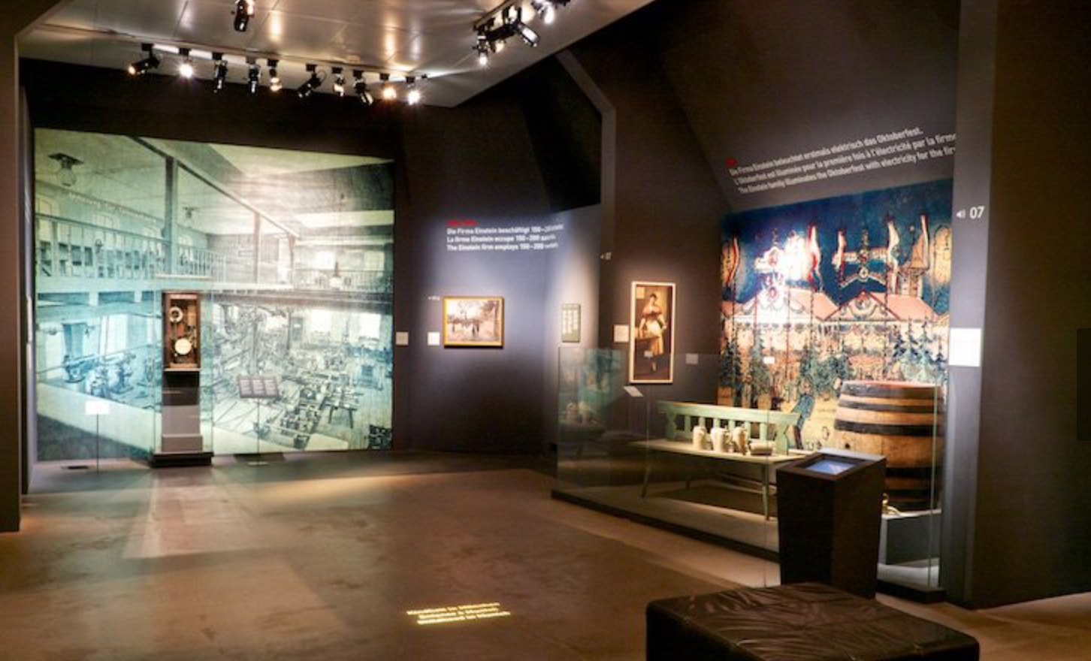
4. Bernisches Historisches Museum
In my itinerary of sightseeing the fascinating Bern, there was Bernisches Historisches Museum. In my opinion the museum looks stunning on the inside and the outside as well. I really enjoyed walking through the galleries because I could discover important cultural and historical collections that belonged to Switzerland. Also, there is a section of the Einstein’s exhibitions displaying his life and work that was very educational and well set out. The only disadvantages of this place would be the entrance fee which should be free of charge.

5. Old Town of Bern
The old Town of Bern impressed me so much. I walked 6 kilometres through a beautiful Old Town. I had a chance to see different historic buildings with a wonderful reflect the medieval character. What is more it is a great location for people who are interested to explore the cultural venues, and luxury shops with antiques and unique paintings. There is also a famous clock tower called Zytglogge which is the main recognise astronomical clock in Switzerland.



