University of Wales Trinity Saint David

13/08/2026
Network Operating Systems and Services
Assignment 2
Module Name: Network Operating Systems and Services
Module Code: ACCA5023

Student Name: Vasile-Eduard Cornila
Student ID: 2423608
Group Number: 1

Lecturer’s Name: MD Sadeque Imam Shaikh

Table of Contents
Introduction 3
1 – Routing 3
1.1 - Routing in Birmingham Network 3
1.2 - Routing in London Network 7
2 - Domain Server (Birmingham) 12
2.1 Create forest eduard.acca 12
2.2 Create A records (Birmingham + London) 14
2.3 Reverse lookup zone + PTR records 15
3 - Encrypted Connection between Birmingham and London 17
3.1 - Configure Site-to-Site VPN to London Network 17
5.1 — Join L-CD, ClientS1, ClientL1 to eduard.acca 18

Introduction
This report documents the practical implementation of Coursework 2 for NOSSLONDON2026, continuing the virtualised Birmingham–London network built in Coursework 1. The organisation operates two sites connected over a site-to-site link, with B-DC (Windows Server) in Birmingham and L-CD (Debian Server) in London, supported by ClientS1 (Windows 10) and ClientL1 (Debian GUI). The lab uses Oracle VirtualBox and a custom VLSM addressing plan within 10.60.10.0/24, with /27 LANs at each site and a /30 WAN between the servers.
The assessment requires installation and configuration of core network services and security controls, including routing (RRAS and Linux forwarding), an Active Directory forest (eduard.acca) with DNS forward and reverse records, a site-to-site VPN, domain user accounts, domain membership for all clients and the London server, centralised DHCP with relay, connectivity testing, a shared BirminghamFiles drive, IIS with Windows authentication, and Remote Desktop Services. Each task is documented with screenshots and short technical explanations, in preparation for in-person demonstration and marker script verification.
The following sections describe how these requirements were planned, implemented, tested and troubleshooted on the existing topology, with reference to industry practices such as least-privilege access, encrypted inter-site communication and centralised identity management.

1 – Routing

- Routing in Birmingham Network
Steps done to allow ICMP on system “B-DC”
- Open Windows Defender Firewall with Advanced Security
- Inbound Rules then select new rule
- Custom then next
- Protocol: ICMPv4 then Customize then tick Echo Request then Ok
- Any IP then Allow the connection then apply to domain/private/public then name Allow ICMPv4-In
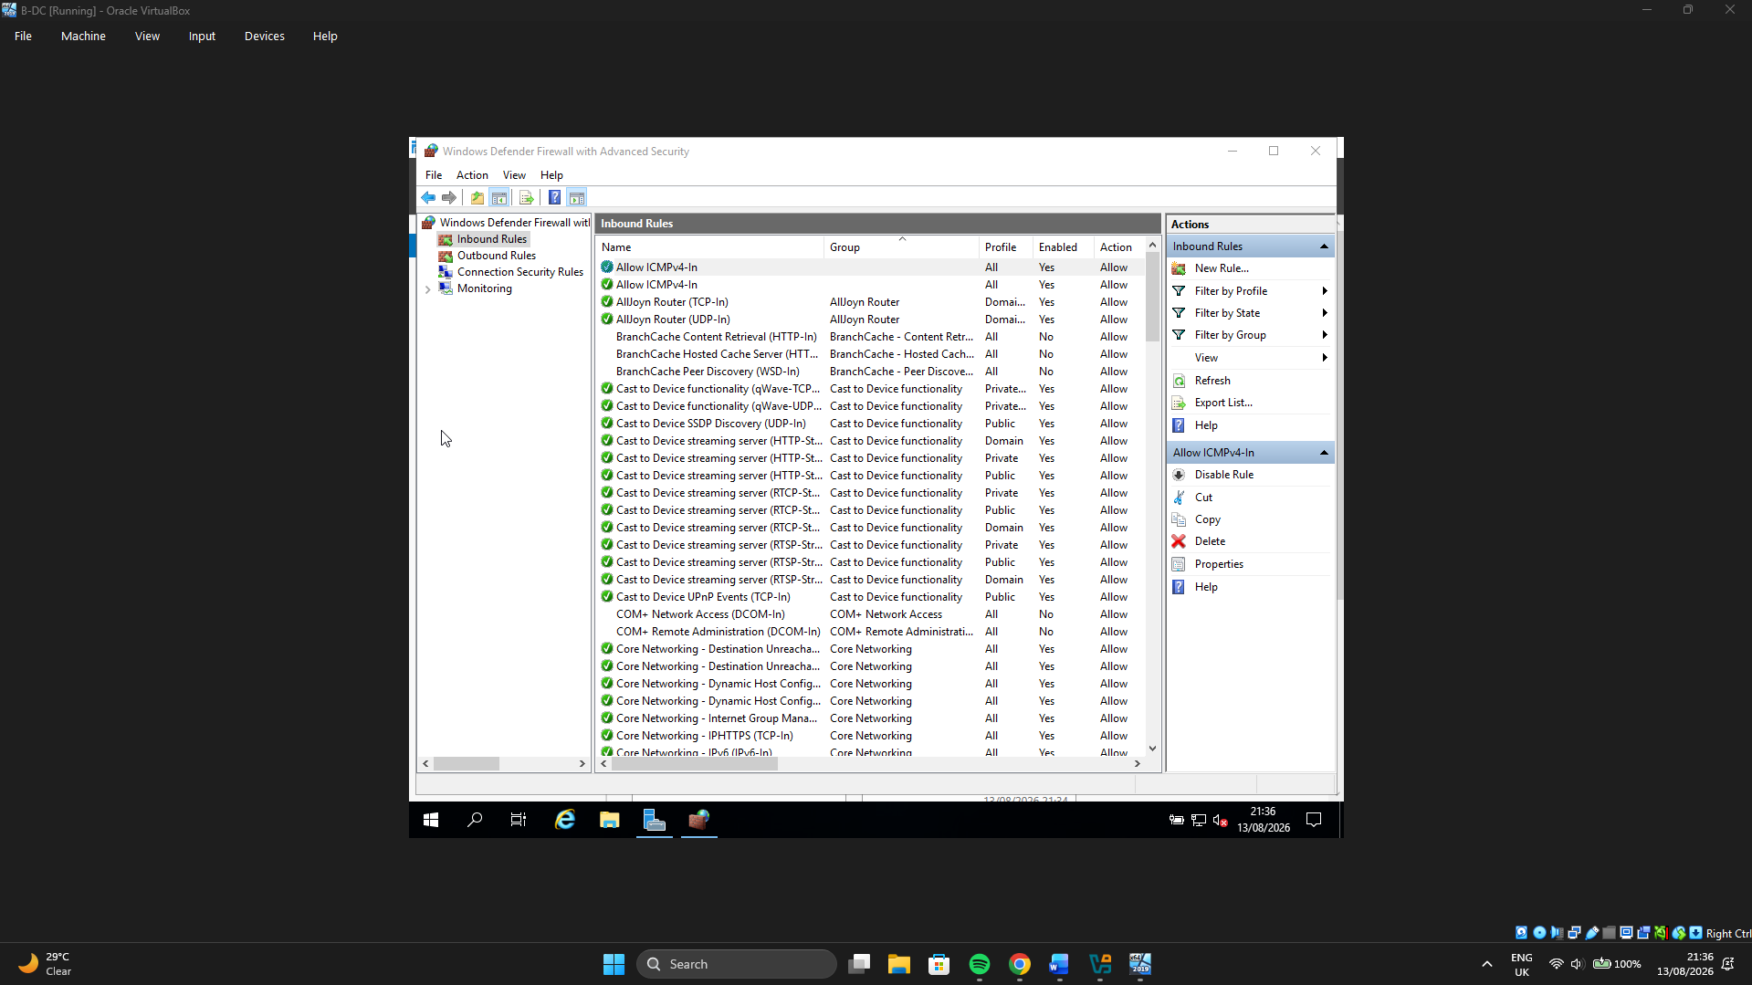
Steps done to install routing and remote access
- Open Server Manager
- Manage then Add roles and features then Next
- Role-based or feature based then Next
- Select B-DC (local) then next
- Roles: tick Remote Access then Next
- Features: Next (leave defaults)
- Remote access info page then next
- Role services: tick Routing
If prompted, also accept Remote Access Service / DirectAccess and VPN dependencies then Next
- Install then wait then Close
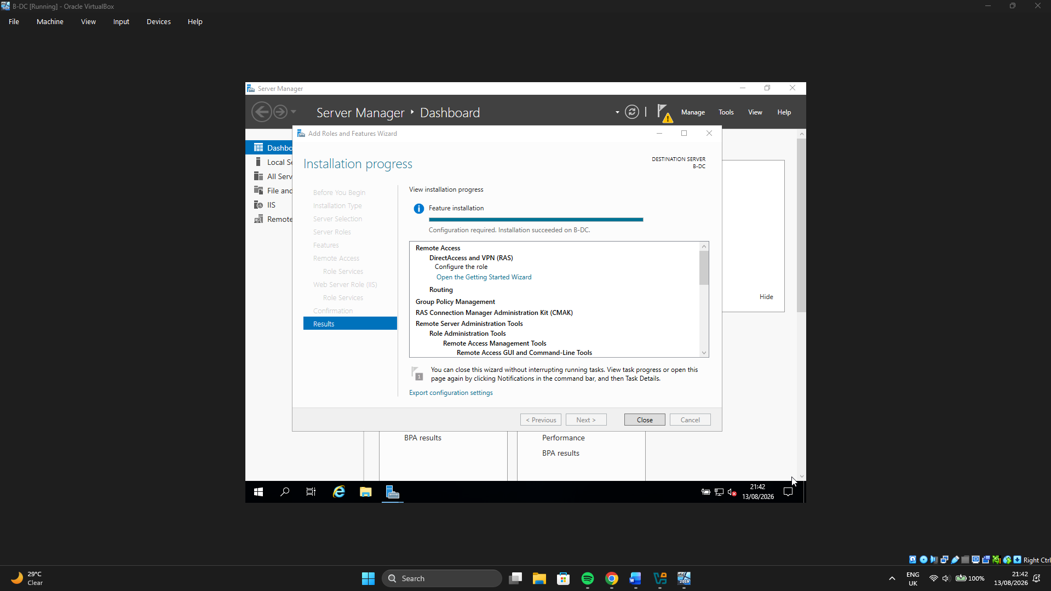
Steps done to configure and start RRAS
- Server Manager → Tools → Routing and Remote Access
- Right-click B-DC (local) → Configure and Enable Routing and Remote Access
- Welcome → Next
- Custom configuration → Next
- Tick LAN routing → Next
- Finish
- When asked to start the service → Start service
In RRAS, the server icon should show a green arrow (service running).
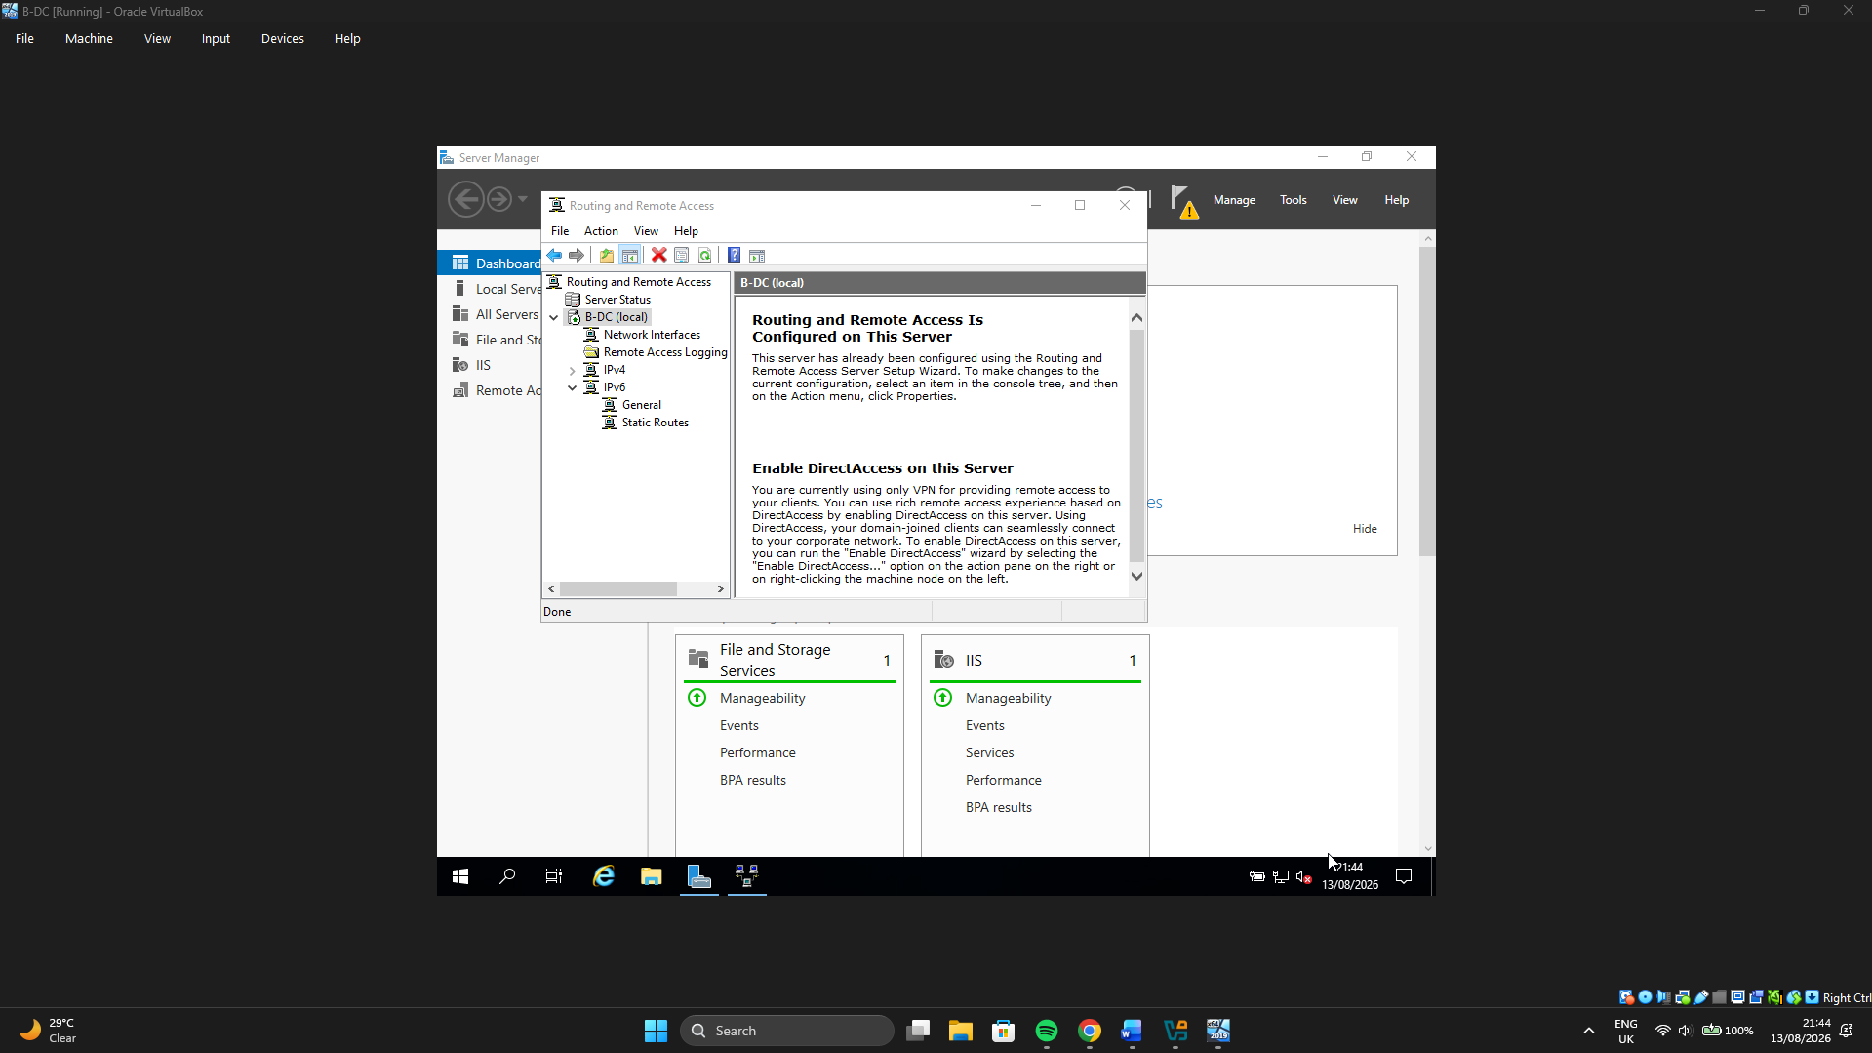
Steps done to confirm adapters RRAS can see
In RRAS:
- Expand B-DC → IPv4 → General
- Should see the LAN and WAN interfaces (e.g. BHAM-LAN / WAN-PTP)
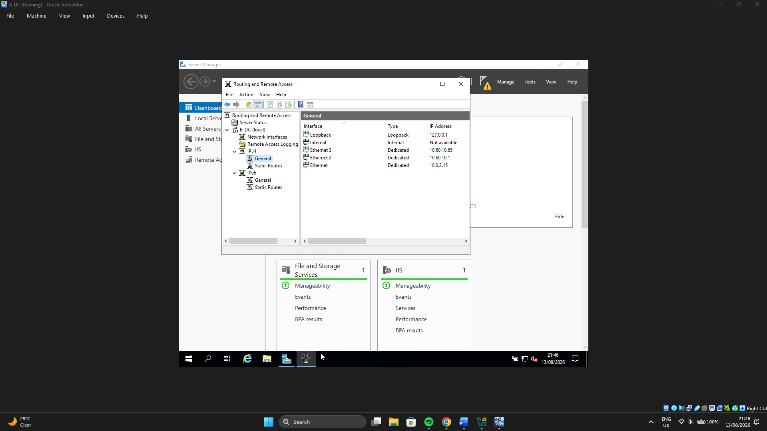

Steps done to add route to London (needed for real routing)
- Even with LAN routing on, B-DC needs a path to London’s LAN:

Get-NetAdapter

- Note the WAN adapter name (the one with 10.60.10.65).

New-NetRoute -DestinationPrefix "10.60.10.32/27" -InterfaceAlias "Ethernet 3" -NextHop "10.60.10.66"

- Replace "Ethernet 3" with your WAN adapter’s InterfaceAlias.

- Verify with:

Get-NetRoute -DestinationPrefix "10.60.10.32/27"
ping 10.60.10.66
ping 10.60.10.33

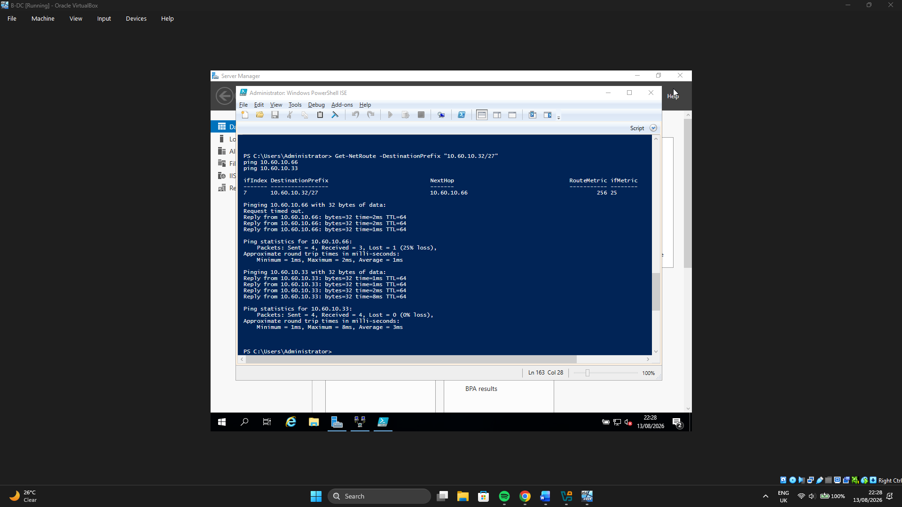

- Routing in London Network
Step 1 is Confirm current Ips using:
ip -br a
ip route

I want:
LAN: 10.60.10.33/27
WAN: 10.60.10.66/30
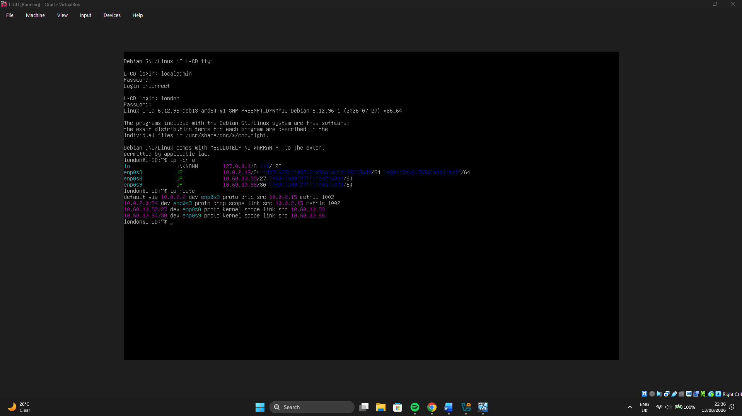

Step 2 is Persistent IP forwarding using:
echo 'net.ipv4.ip_forward=1' | sudo tee /etc/sysctl.d/99-ipforward.conf
sudo sysctl --system
cat /proc/sys/net/ipv4/ip_forward

Must print 1.
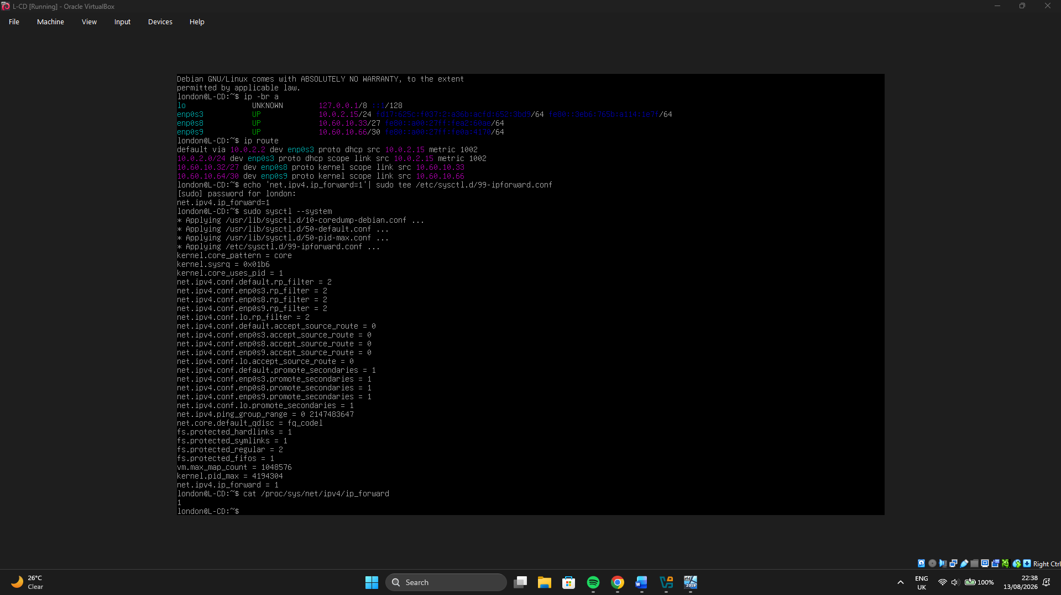

Step 3 is Route to Birmingham using:
sudo ip route add 10.60.10.0/27 via 10.60.10.65
ip route

Test:
ping -c 4 10.60.10.65
ping -c 4 10.60.10.1
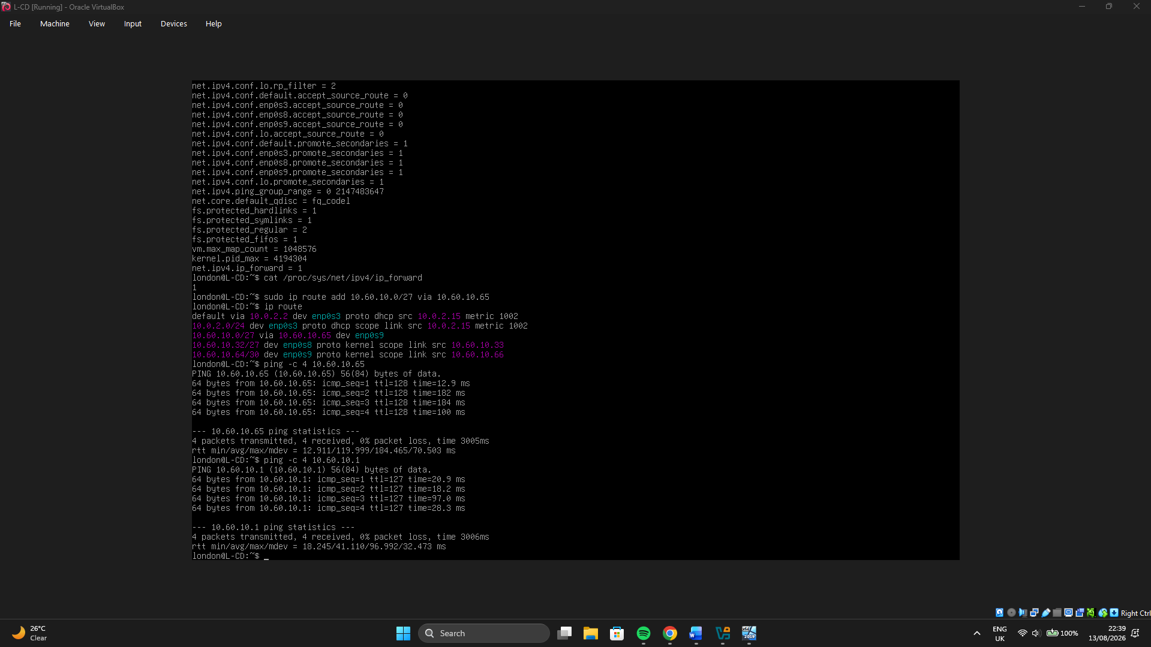

Step 4 is to make the route persistent
Edit interfaces:
sudo nano /etc/network/interfaces

On my WAN stanza (the one with 10.60.10.66), add the up line.
Example:
auto enp0s9
iface enp0s9 inet static
address 10.60.10.66
netmask 255.255.255.252
up ip route add 10.60.10.0/27 via 10.60.10.65 || true

Save → Ctrl+O, Enter, Ctrl+X.
Apply:
sudo systemctl restart networking

Confirm again:
cat /proc/sys/net/ipv4/ip_forward
ip route
ping -c 2 10.60.10.1

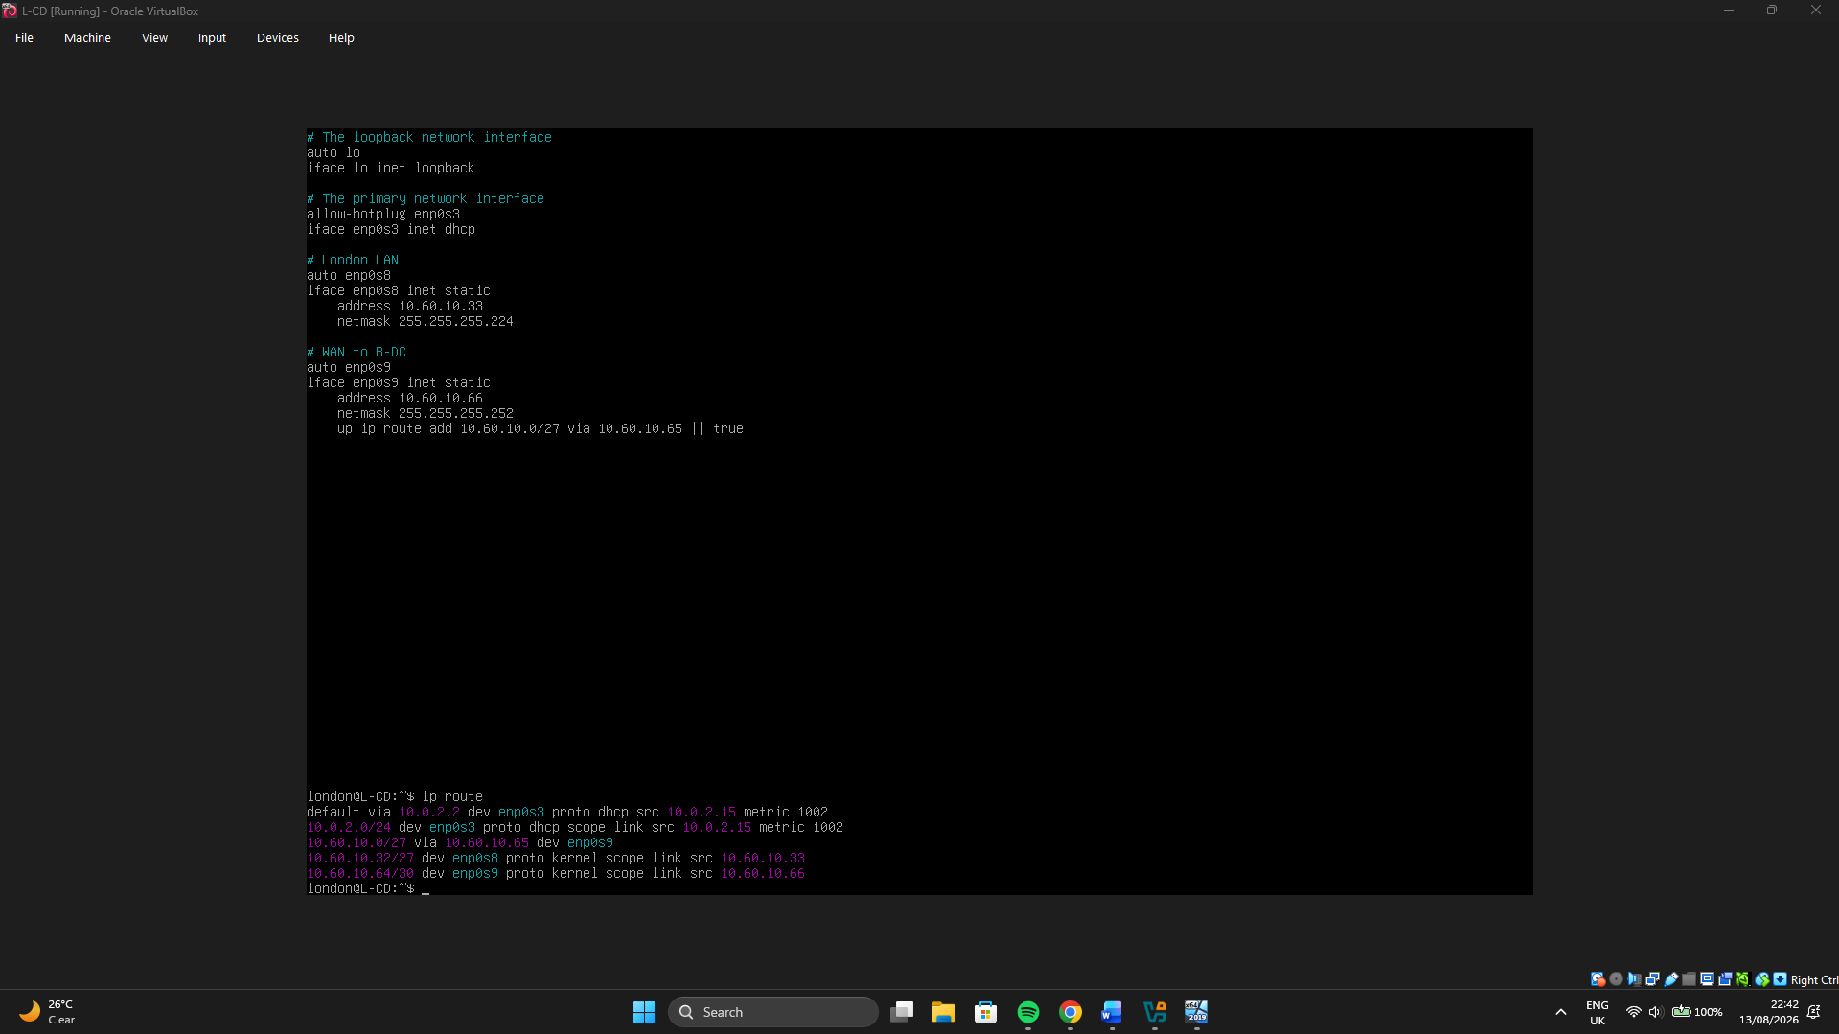

Step 5 is the Firewall
If ufw is active:
sudo ufw status
sudo ufw allow in on enp0s8 to any
sudo ufw allow in on enp0s9 to any
sudo ufw reload
sudo ufw status verbose
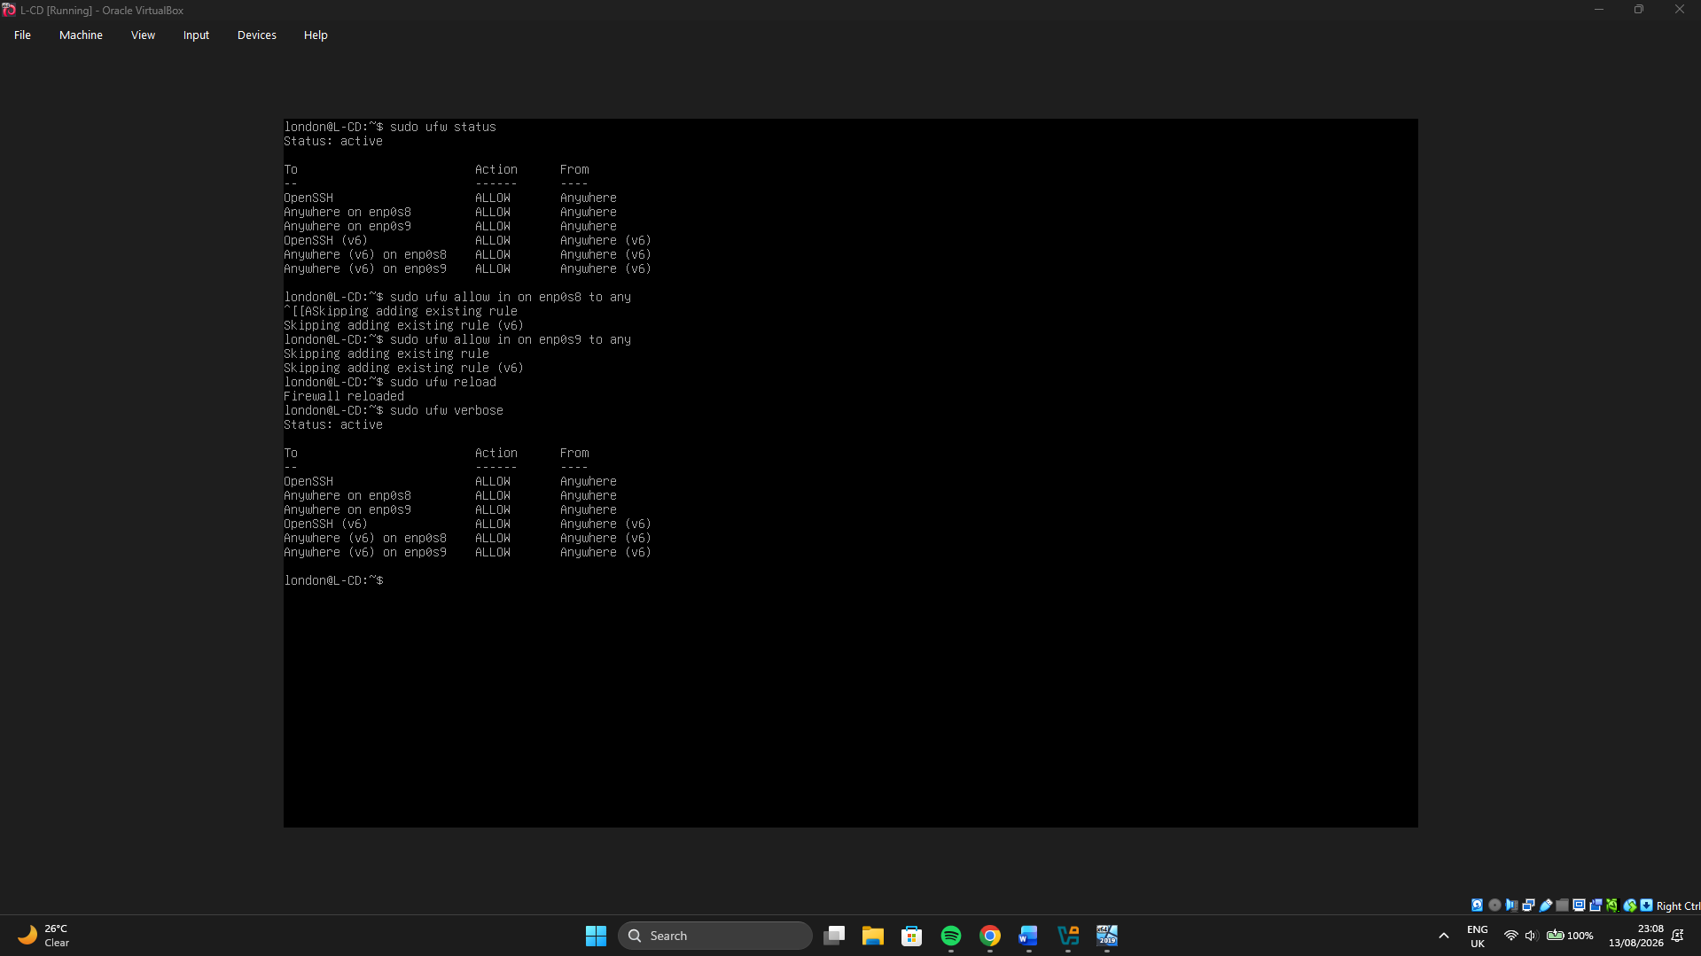

Step 6 is the End-to-end test
From ClientS1 (Windows):
ping 10.60.10.33
ping 10.60.10.42
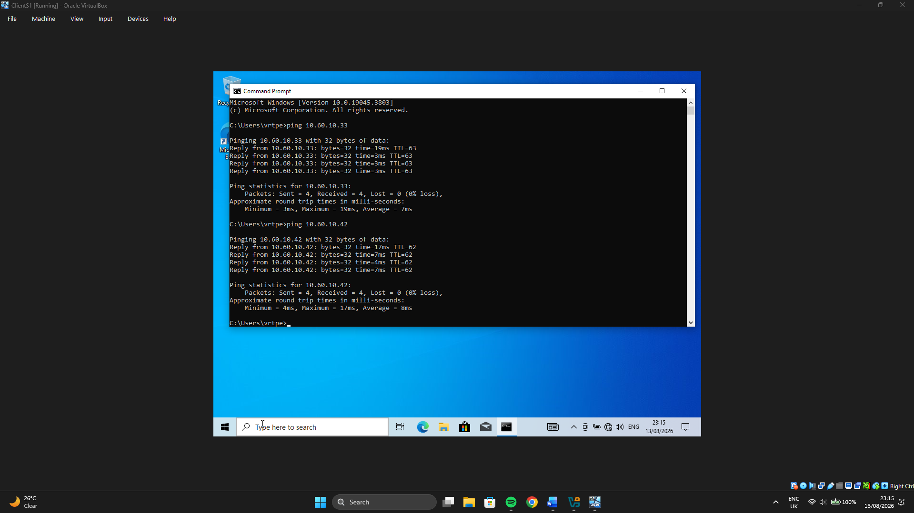

From ClientL1 (Debian):
ping -c 4 10.60.10.1
ping -c 4 10.60.10.10

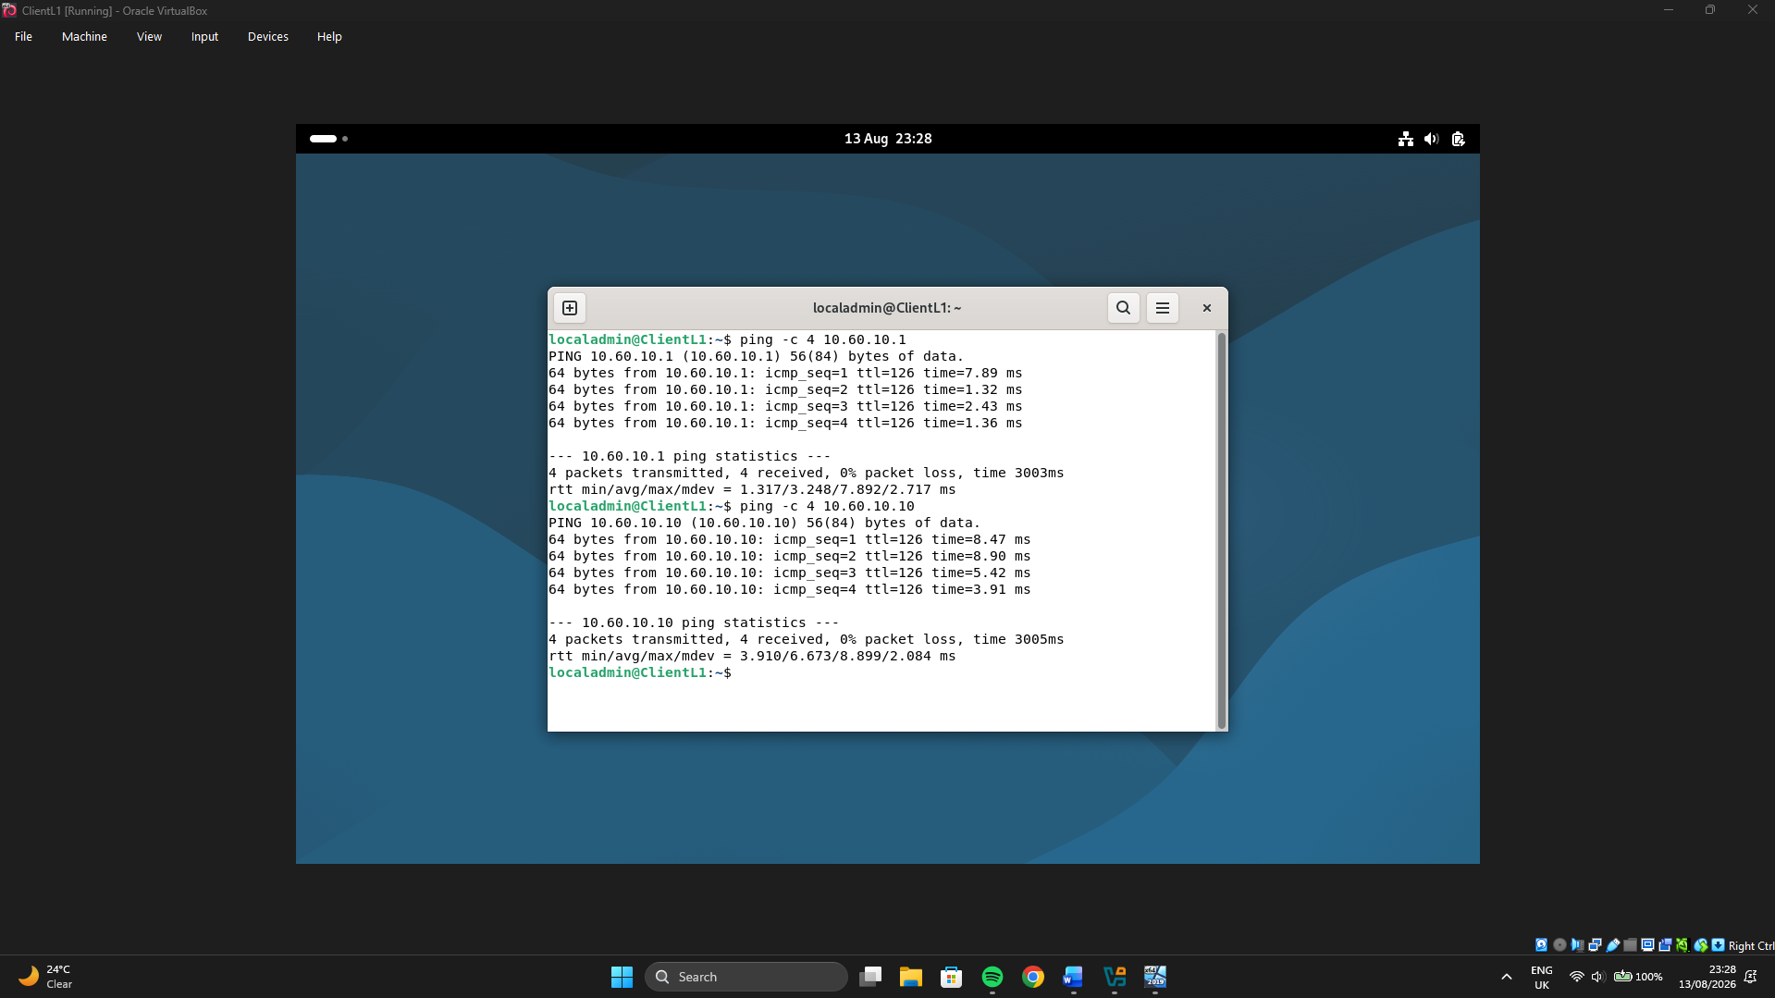

2 - Domain Server (Birmingham)

2.1 Create forest eduard.acca
First, I Install AD DS
- Server Manager → Manage → Add Roles and Features
- Role-based → select local server
- Tick Active Directory Domain Services → add features → Install
- When done, click the flag → Promote this server to a domain controller
Second is the Promotion wizard
- Add a new forest
- Root domain name: eduard.acca
- Forest/Domain functional level: Windows Server 2016 (or highest available)
- Tick Domain Name System (DNS) server (keep Global Catalog)
- DSRM password: use something you’ll remember (e.g. NotebooK@123)
- NetBIOS: EDUARD (autofills)
- Paths: leave defaults → Next → Install
- Server will reboot
After reboot
- Log on as EDUARD\Administrator (or Administrator@eduard.acca) / NotebooK@123
- Server Manager should show AD DS and DNS
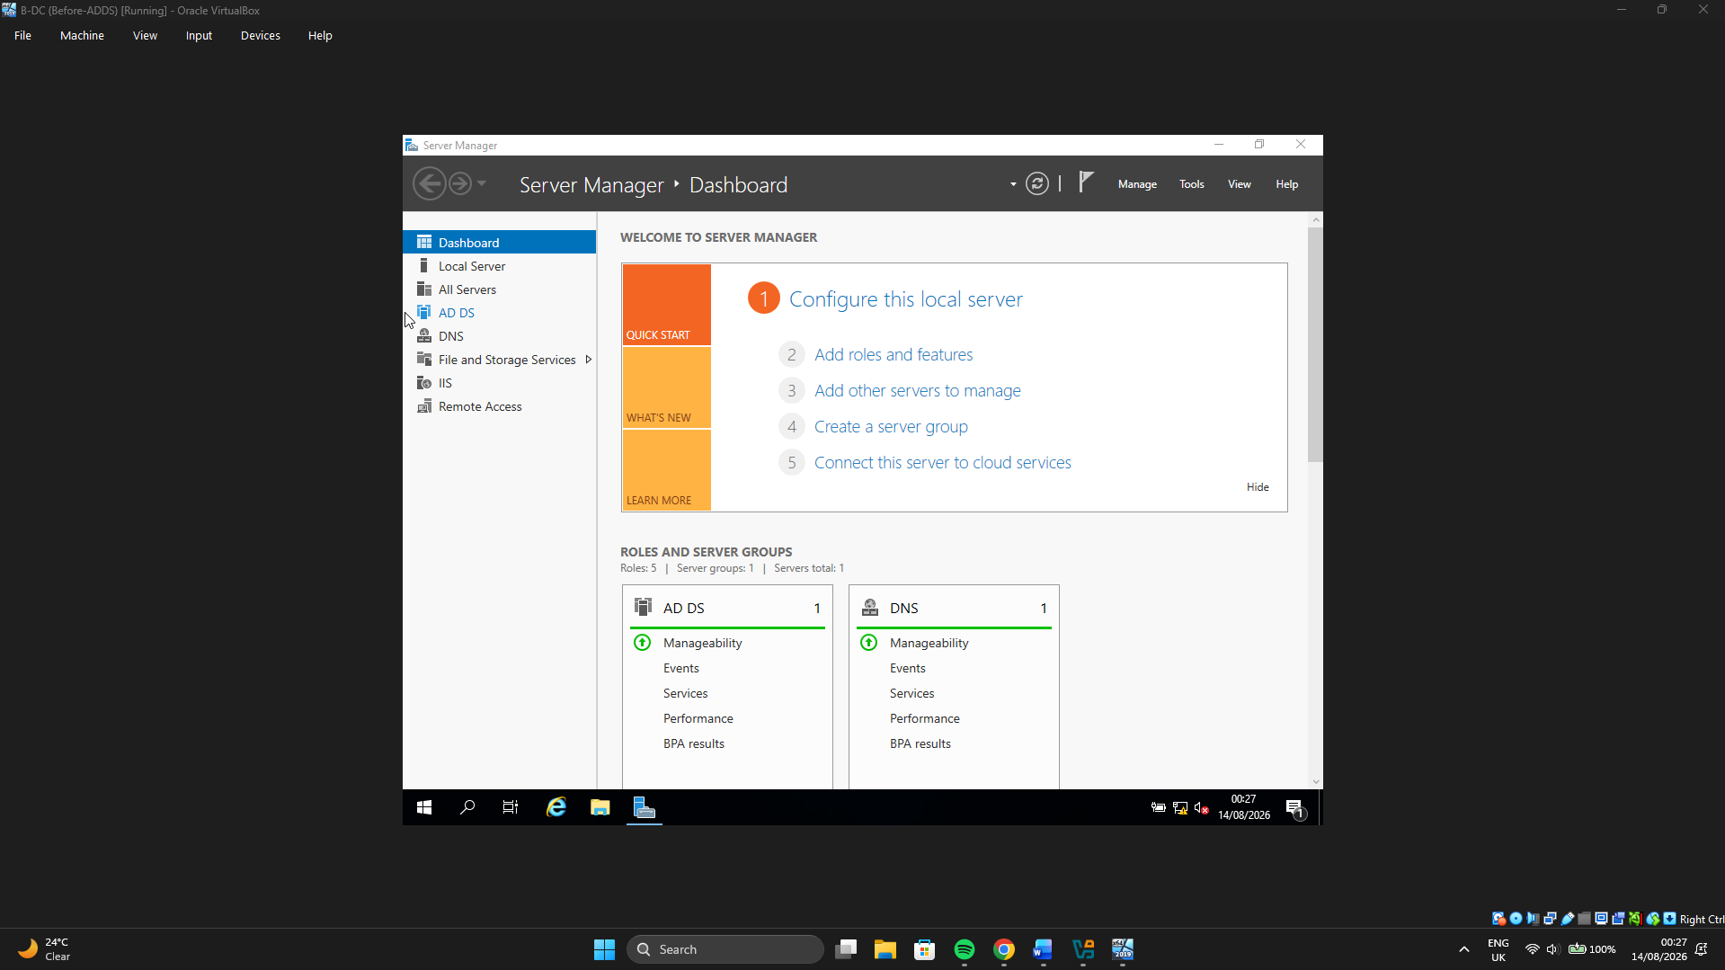
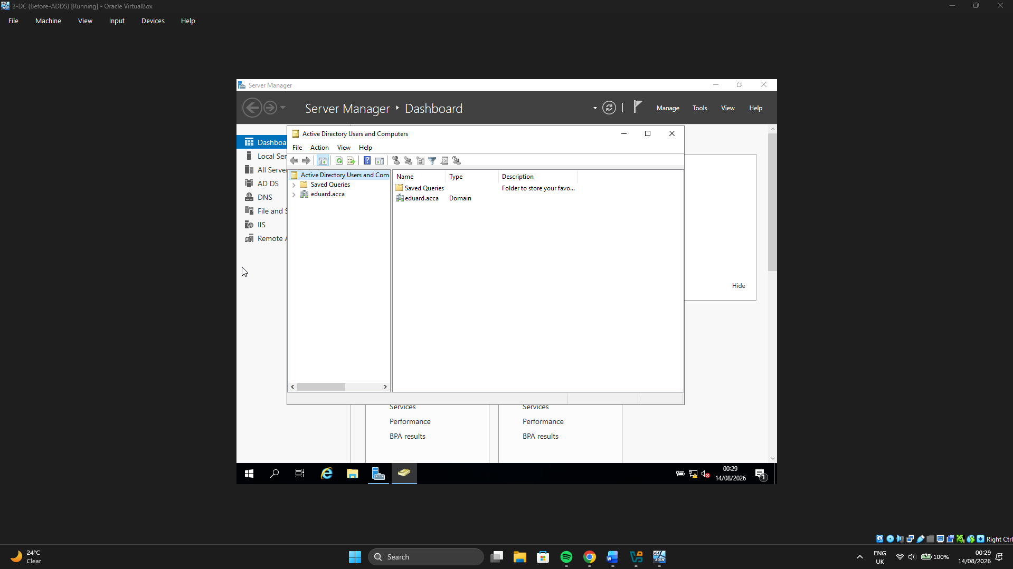
Secure password policy
- Tools → Group Policy Management
- Forest → Domains → eduard.acca → Default Domain Policy → Edit
- Computer Config → Policies → Windows Settings → Security Settings → Account Policies → Password Policy
- Example hardening:
Min length: 12
Complexity: Enabled
History: 10
Max age: 90 days
- Then:
gpupdate /force

2.2 Create A records (Birmingham + London)
An A record maps a hostname to an IPv4 address so clients can resolve names like b-dc.eduard.acca to an IP. In AD-integrated DNS, these records support logon, LDAP, file shares, IIS and RDS. Create A records for every important server (and planned services), not only the DC.

Open DNS
Tools → DNS → expand B-DC → Forward Lookup Zones → eduard.acca

You should already see something like b-dc (created by promotion). Add/verify:

B-DC
A
10.60.10.1
DC (usually exists)
L-CD
A
10.60.10.33
London server
webs
A
10.60.10.1
Excellent / Task 9
RDS
A
10.60.10.1
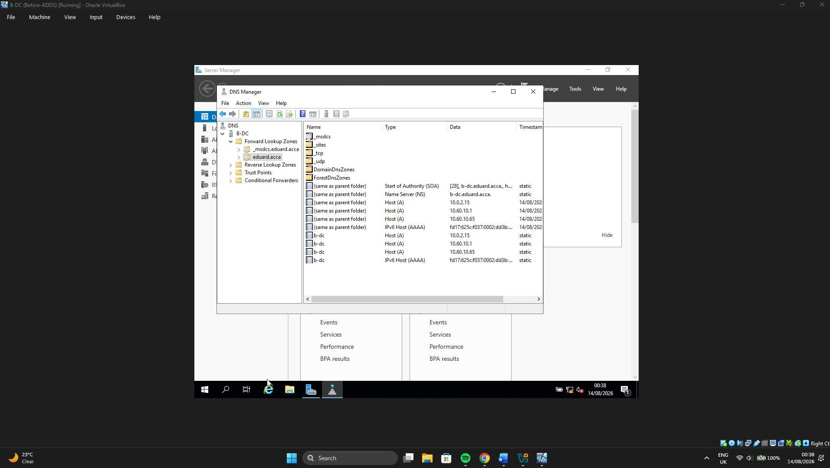

2.3 Reverse lookup zone + PTR records
A reverse lookup zone maps IP → name using PTR records. That supports logging, troubleshooting (ping -a), and some security tools. Creating a zone for 10.60.10.0/24 covers Birmingham /27, London /27 and the WAN /30, so future DHCP addresses in those subnets can get PTRs without new zones (Excellent).

Create reverse zone
- DNS Manager → right-click Reverse Lookup Zones → New Zone
- Primary → Store in Active Directory → replicate to domain/forest (default OK)
- IPv4 Reverse Lookup Zone
- Network ID: 10.60.10 → creates 10.60.10.in-addr.arpa
- Dynamic updates: Secure only → Finish
- Create PTR records
For each server IP, either:

New Pointer (PTR), or
Re-add A record with “Create associated PTR”
IP PTR name should resolve to
10.60.10.1
b-dc.eduard.acca

10.60.10.33
l-cd.eduard.acca

10.60.10.65
b-dc-wan.eduard.acca

10.60.10.66
l-cd-wan.eduard.acca
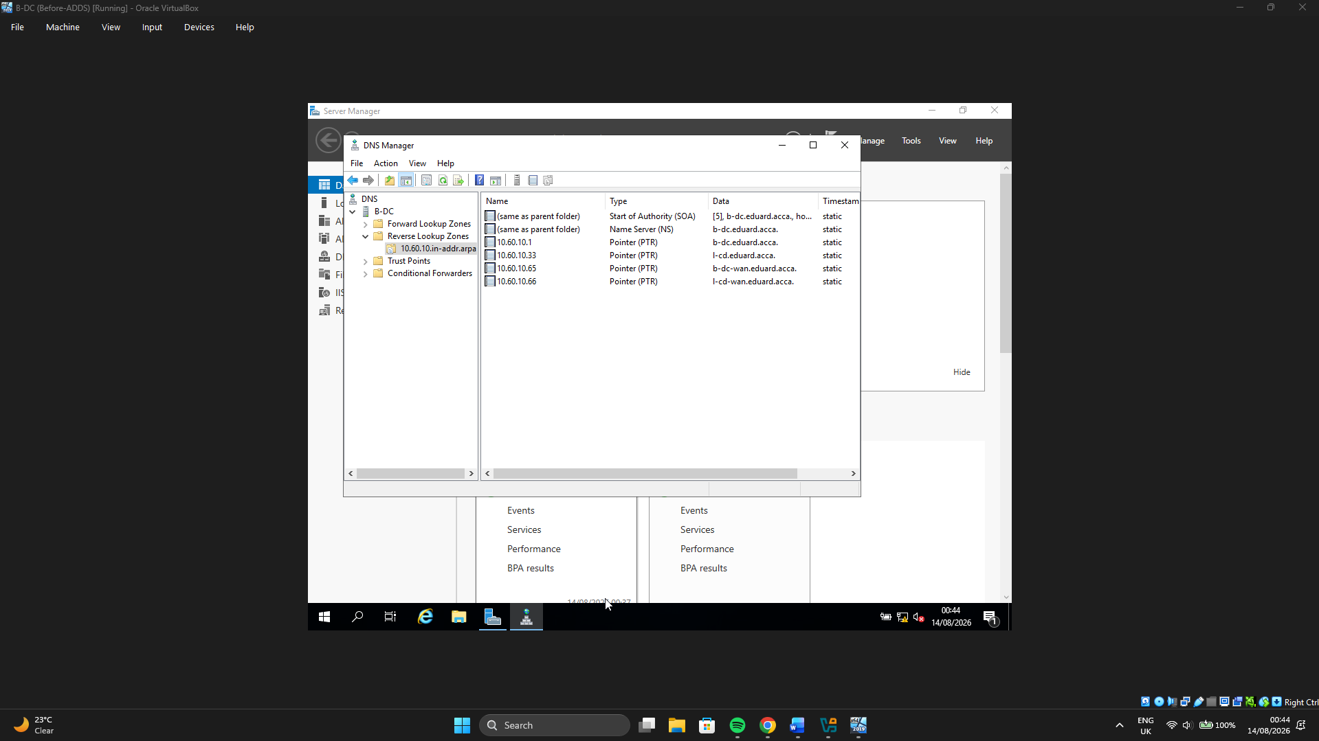

3 - Encrypted Connection between Birmingham and London

3.1 - Configure Site-to-Site VPN to London Network
A Virtual Private Network (VPN) creates an encrypted tunnel over an untrusted or shared path so private site traffic cannot be read or altered in transit. In enterprise networks it matters for confidentiality, integrity and controlled connectivity between branches without exposing full LANs to the open network. For NOSSLONDON2026, a site-to-site VPN links Birmingham (10.60.10.0/27) and London (10.60.10.32/27) through the gateway WAN addresses (10.60.10.65 ↔ 10.60.10.66). This was configured after Routing and Remote Access (RRAS) was installed on B-DC, because RRAS provides the Windows VPN/demand-dial role used for the Birmingham end of the tunnel.
Site-to-Site VPN (IKEv2 + PSK)
Endpoints:
Side: B-DC
Role: RRAS VPN
WAN IP: 10.60.10.65
Protected LAN: 10.60.10.0/27

Side: L-CD
Role: strongSwan
WAN IP: 10.60.10.66
Protected LAN: 10.60.10.32/7

5.1 — Join L-CD, ClientS1, ClientL1 to eduard.acca
Machine: ClientS1
DNS: 10.60.10.1
Gateway: 10.60.10.1
Must resolve: b-dc.eduard.acca

Machine: ClientL1
DNS: 10.60.10.1
Gateway: 10.60.10.33
Must resolve: b-dc.eduard.acca

Machine: L-CD
DNS: 10.60.10.1
Gateway: (keep routing as is)
Must resolve: b-dc.eduard.acca

6 - DHCP (definition + basic process)
Dynamic Host Configuration Protocol (DHCP) automatically assigns IP addresses and network settings (mask, gateway, DNS) to clients so administrators do not configure each device manually. A DHCP server holds scopes (address pools) and options (e.g. default gateway and DNS). When a client on a different subnet needs an address from a central server, a DHCP relay agent on the local router/server forwards broadcast requests to the DHCP server’s IP.

In this design, B-DC is the DHCP server for both sites. L-CD acts as the relay for the London LAN. Clients ClientS1 and ClientL1 are set to obtain an IP automatically.
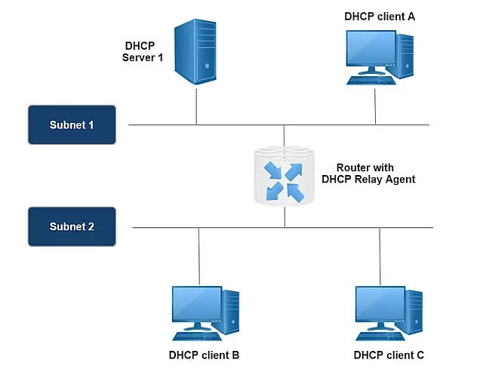

My DHCP plan
Scope: Birmingham
Network: 10.60.10.0/27
Pool (.10-.20): 10.60.10.10 – 10.60.10.20
Gateway (003): 10.60.10.1
DNS (006): 10.60.10.1

Scope: London
Network: 10.60.10.32/27
Pool (.10-.20): 10.60.10.42 – 10.60.10.52
Gateway (003): 10.60.10.33
DNS (006): 10.60.10.1
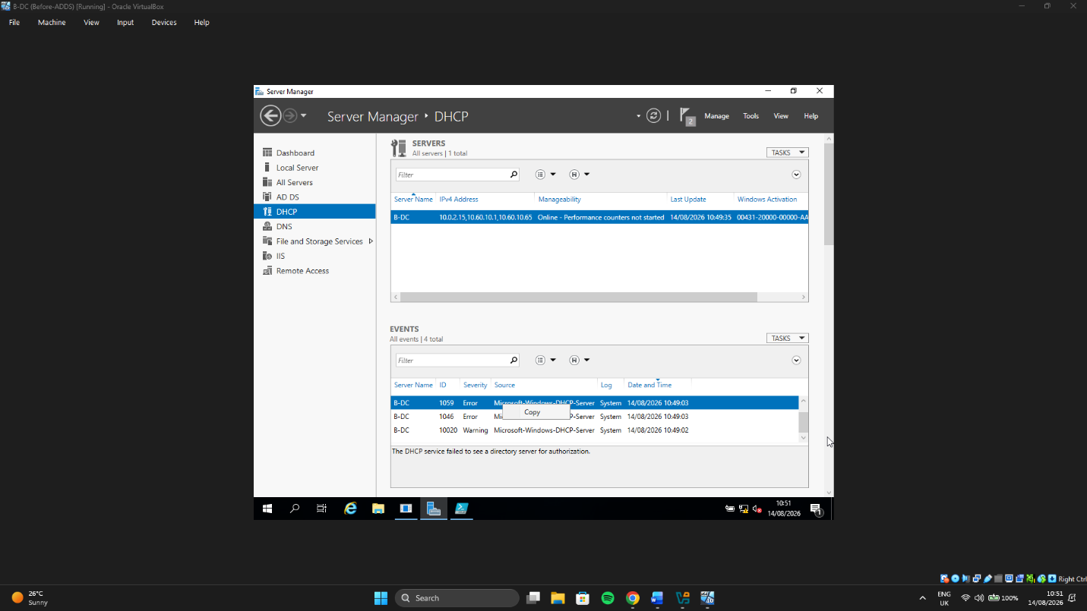

Scope 1 - Birmingham
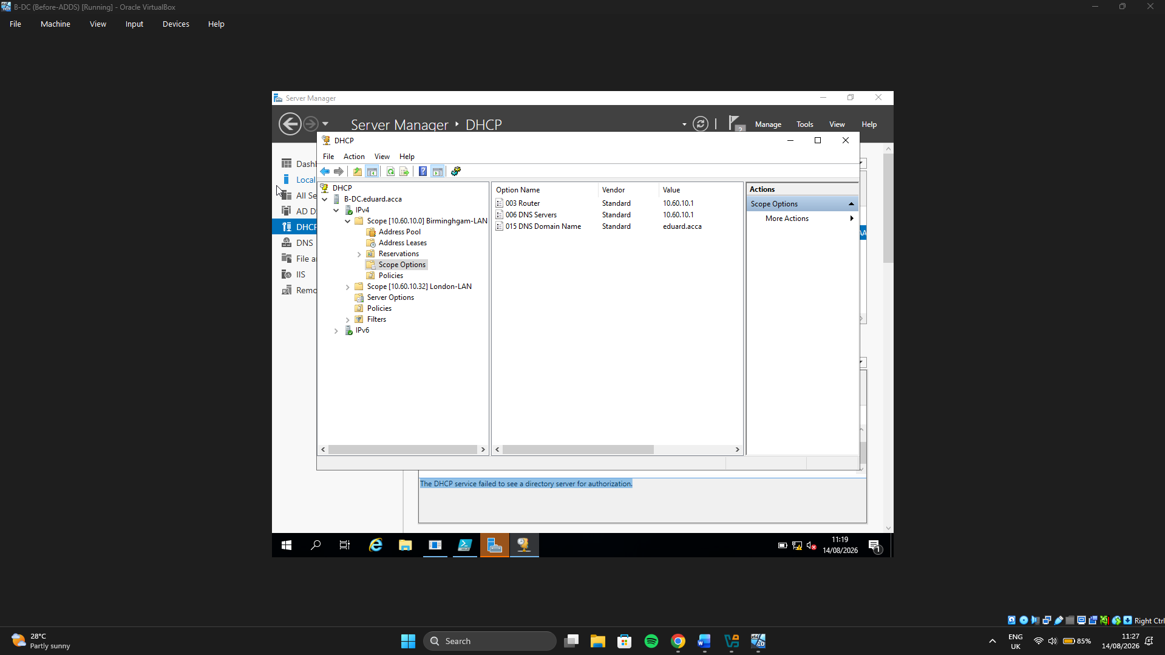

Scope 2 – London


