Strategic Management Assignment 1 2019 -
Competitive and Development Strategies of Lidl


November 2019

Module Name | M3X9111 Strategic Management and Sustainability
Name | TAN YONG QI
Student ID | 1903 859

TABLE OF CONTENTS

1.0 Executive Summary 1
2.0 Introduction 2
2.1 Report remit 3
2.2 Background of Lidl 3
2.3.1 Cost leadership 5
2.3.2 Differentiation strategy 5
2.3.3 Focus strategy 6
3.0 Main Body 7
3.1 Implementation of the strategy’s 7
3.1.1 Economics of scale 7
3.1.2 Labour cost 7
3.1.3 Tight scope 8
3.1.4 Private label and others 8
3.2 Advantages and disadvantages of the strategy 9
3.2.1 Advantages 9
3.2.2 Disadvantages 9
4.0 Conclusion 11
4.1 Recommendation 11
5.0 References 12

List of Figures

Figure 2.1 UK grocery market share from 8/10/17-6/10/19
Figure 2.2 Great Britain Grocery Market Share (%)
Figure 2.2.1 Aldi and Lidl UK groceries market share
Figure 2.3.1 Porter Generic Strategic

1.0 Executive Summary
Lidl is a discounter supermarket that using soft discounting model. In this report will talk about Lidl competitive strategy that based on porter generic strategy. Lidl is a brand that come from Germany and has its first store in UK at 1974. Lidl and its main competitor Aldi in these few years has increased their market share in UK that beat the big four supermarket down. This is because their discounter business model since 2008 financial crisis is more acceptable for consumers.
Lidl implement the cost leadership in few of ways including economic of scale, control of labours cost, tight scope, private label and others. Since every strategy have their pros and cons same goes to cost leadership strategy that used by Lidl. The advantages are increasing of profit also the market share, therefore have spare capital to expand business and growth, private label is attractive etc. While disadvantages are control cost then lack of advertising, technology innovation, perspective of low price low, quality etc.
To conclude, Lidl as a whole is doing quite well on their strategy and this is result on their market share. As suggest for Lidl to maintain the leading and increasing market share is to adapt to trend nowadays like try to implement products that suit for middle upper class as in future they are assume to be main category of the world.

2.0 Introduction
Supermarkets are place for consumers to buy daily products. In UK, top 9-supermarket share come from Tesco, Sainsbury, Asda, Morrison’s, Aldi, Co-op, Lidl, Waitrose and Iceland. Figure below shown many of supermarket like Tesco, which have most of the market, share has declined, meanwhile Lidl market share compared to other has rose.
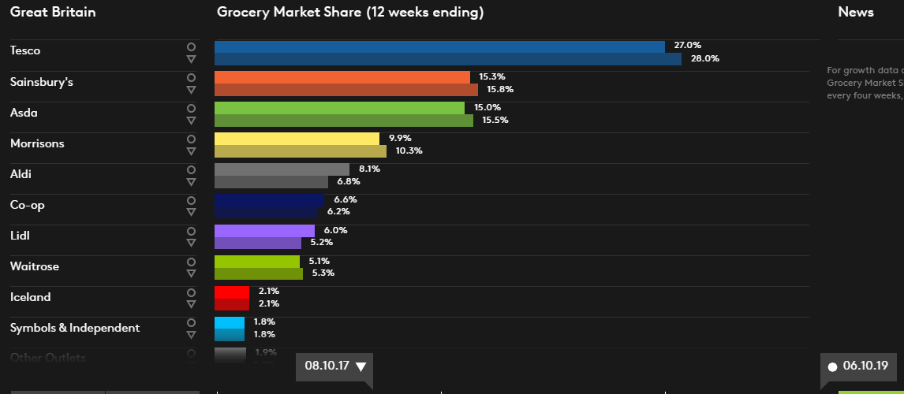
Figure 2.1 UK grocery market share from 8/10/17-6/10/19
Source: Kantar World panel 2019
Discounter supermarket difference from supermarket is it aim to sell quality product with lower price where possible. By doing so they focus to minimize cost and maximize profit such as reduce product range, cut cost on interior design and more. Lidl as a German brand discounter supermarket has rose rapidly in UK since 2008 financial crisis. As most people suffer from financial crisis, they were looking to save money by shop at discounter supermarket, Lidl therefore are attracted to shop with. According to kantar world panel, Lidl 12 week from May 2019 has increased its market share compared to 12 week from 2018 May.
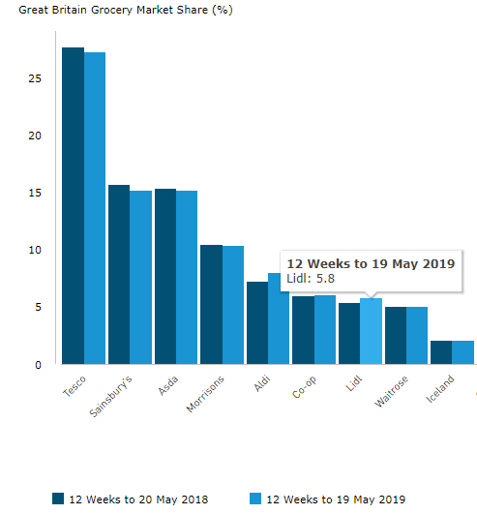
Figure 2.2 Great Britain Grocery Market Share (percentage)
Source: Kantar World panel 2019

2.1 Report remit
In this report will specific Lidl used of strategy to persuade their goal, how they implement on the strategy and what are the pros and cons of implementing thus strategy. At the end will analyse their overall strategy implementing and give some suggestions for Lidl to do in the future. This is because recent behaviour of consumers and world concept has changed rapidly. Holding a competitive strategy of cost leadership is not enough to attract for consumers in future, as more and more discounter supermarket model and concept coming out such as online shopping which hold low cost that give more options to shop.

2.2 Background of Lidl
Lidl is a brand that founded in Germany at 1973, which full name is Lidl Stiftung & Co. Kg. The founder of Lidl is a member of Schwarz family. In 1990s, Lidl has expanded their business through Europe and opened first store in UK at 1994. Today, it has become one of the largest food retailer in Europe and over 3000 stores in Germany. Besides, Lidl is now planning to expand their business outside Europe like Asia and in 2017; it has successfully entered into USA market.
In UK, 25 years later from 1994, it has more than 760 retail stores and 13 regional distributors’ centres. Lidl vision is to enhance lives of customers by providing quality products at market leading value and ensure that customer satisfaction is at the heart of everything. Mission of Lidl is to deliver outstanding customer satisfaction, ensure market leading quality and value by constantly innovating and optimising efficient processes, driven by technology and people, work with business partners in sustainable relationships, contributing positively to local communities and achieve long-term success by investing in recruitment, training and development of people.
The main competitor of Lidl is Aldi that is also a discounter supermarket of German brand. Which Aldi is the pioneer to use discounting model in Germany, which is 12 years earlier than Lidl. The difference of both of them is their business model, which Lidl use soft discounting model while Aldi use hard discounting model. Soft discount model is provide a wider range of both branded and own label products while hard discount model provide lesser range products with almost own label products.
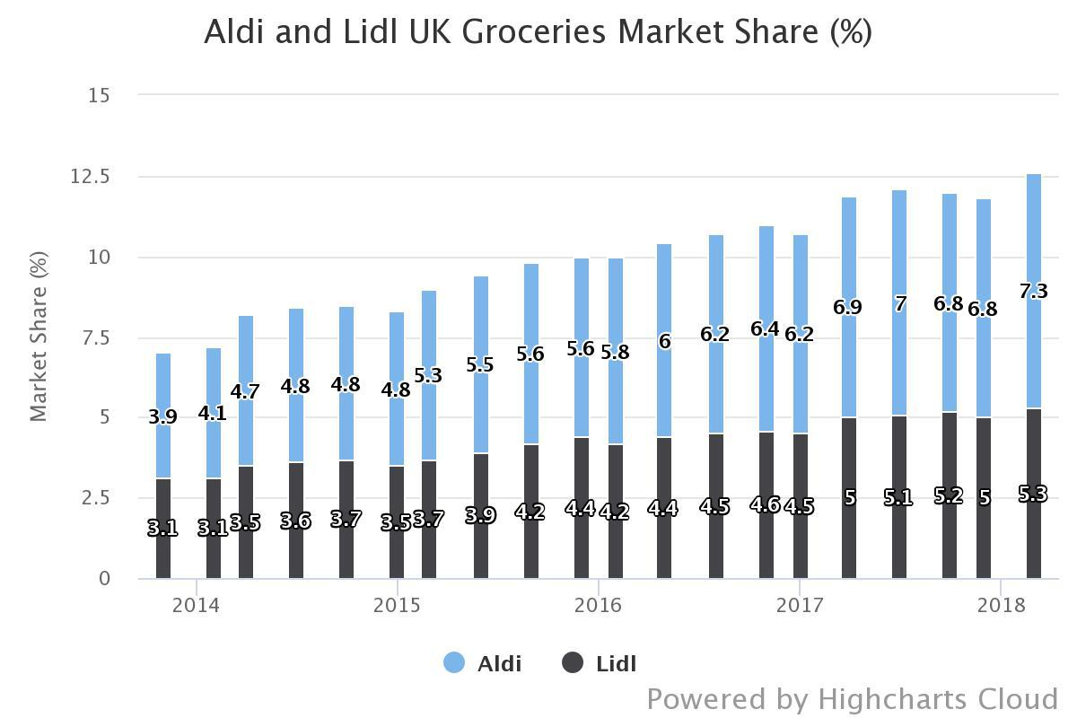
Figure 2.2.1 Aldi and Lidl UK groceries market share
Source: Kantar World panel 2018
2.3 Definitions of major concepts
Porter generic strategic that derived by Michael Porter in 1980 is a useful framework that help an organization to know where the niche they want to be with to maintain potential competitive advantage in long run.
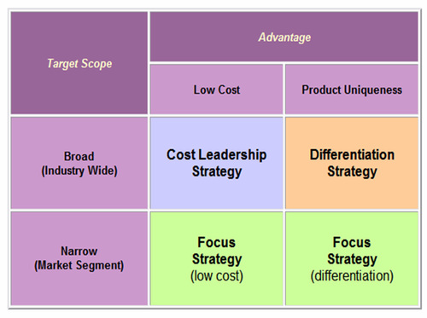
Figure 2.3.1 Porter Generic Strategic
Source: Porter‘s (1980) Generic Strategies, Performance and Risk: An Empirical Investigation with German Data 2009
According to the book of < Competitive Advantage: Creating and Sustaining Superior Performance>, Michael Porter the economic researcher examine the behaviours of competitors that lead business to success and come out with Porter generic strategies. This theory comprise of cost leadership, differentiation and focus strategy.

2.3.1 Cost leadership
An organization can either decrease cost to increase profit or charging lower price with increasing market share to maintain cost leadership, for example, decrease cost of packaging, advertising cost or by economic of scale respectively. The cons of doing so will easy involve in price war if other competitors tend to follow, low customer loyalty, as the organization strategy is not unique any other competitor that having lower price than the organization will attract your consumers etc. The ways to overcome is to make sure continuous improvement by implement new strategy and more.

2.3.2 Differentiation strategy
Organization need to create a unique and more attractive products or service to consumers to realize the differentiation. Organization therefore must make sure their products or services have specific features, brand image etc. to differentiate with their competitors. Organization, which implement this strategy, must always stay alert, as it is easy to beat down by other competitor that using focus differentiation strategy also they need to focus on innovation and research to stay with the dramatically changing trend.

2.3.3 Focus strategy
Organization concentrate on a niche market by understanding their need and want to design products or services that suit for customers is say implementing focus strategy. Besides, it can be focus on either cost or differentiation. The difference between cost and difference strategy with cost or differentiation focus strategy is the focus strategy target in specific niche market while cost and differentiation strategy spread their market widely. By doing so it built strong customer loyalty as focusing their need and want, therefore it may create barrier for competitors to enter into their market. The cons for this is cost and time consuming as organization need to invest more on research and to stay alert about change of buying trend and etc.

3.0 Main Body
Strategy is defined as a long-term plan for an organization to achieve their goal and objective also the strategy is vary depend on the organization business plan. In simple words, it is a roadmap of an organization. Lidl mission and vision that aim to deliver quality products with low price for their customers, therefore their strategy is to implement and maintain cost leadership.
By theory cost leadership seems to be simple but it is complicated when apply to a business. Lidl that implement cost leadership in ways of economic of scale, technological innovation, tight scope, private label products and others will discuss further in below.

3.1 Implementation of the strategy’s
Lidl goods have attract many of the consumers across Europe with their low price as human being people tend to buy similar products at lower price, therefore the implement cost leadership in series of ways are important for them to make profit margin.

3.1.1 Economics of scale
Economics of scale is having bulk purchase to have bargain power to lower the cost. Lidl expansion of market share boost the economics of scale because the more the need of products the higher the bargain power for bulk buying. For example, delivery 100 box of milk and 10000 box of milk consist same fixed cost which is fuel for the lorry and labour cost of driver, but the average cost is decrease when have many box of milk to deliver. Therefore, when cost decrease Lidl can either lower the product price or earn more product when sell at the same price.
Besides, consumer buying behaviour nowadays is shift from the financial crisis. People perception of buying things in discounter supermarket is for poor people, since the financial crisis middle class people has thrown their perception and rather buying things at a cheapest price. This boost the market share of Lidl as more and more people shop with them and help to increase bulk buying to cut the cost.

3.1.2 Labour cost
Labours cost is a variable cost that can be minimize in doing business as decrease of variable cost will increase the profit margin. Lidl products are display originally on the stock as they shipped in therefore need of more labours and time for displaying each item is save. Furthermore, frozen foods sold from gravity feed displays which automatically keep product in front of consumers and milks are put in wheel cart that can easily truck into stores, all of these action reduce the possibility of increasing labour cost.
Technological is changing and improving in a high pace, using technology wisely can help to cut cost. Lidl use efficient technology like using LED lights and doors for frozen display to save energy cost, automation in back room can minimize the labours cost since customer is required to weight their things by them self as example this naturally reduced the need of assistant staff. Staff of Lidl is trained to produce high productivity as they are trained to work in cross sectional, which means staffing is more efficiency.

3.1.3 Tight scope
Tight scope is mean by selling limited choice of products. This is a way to keep the cost low, as Lidl provide brand limited selection for consumers also benefit from higher sales per item that will turn into faster inventory turns and lower cost of inventory per unit sold. These will lead to strong, solid financial performance.
According to Lidl sustainability report 2017/18, Lidl work tightly with local suppliers where consumers may find up to 2300 products from British suppliers such as all own brand eggs and so on. In addition, Lidl in 5 years’ time goal is to invest over 15 million in local food, farming economy. This is a win-win strategy, which benefit Lidl on strong buying power and increase bargain power, helping to create jobs and sustainable economy. Moreover, Lidl focus on selling commodity products that people need to have everyday such as cereal, by not focus on special niche products. This is because commodity products are must for them to stay alive.

3.1.4 Private label and others
Owning private label products that produce by Lidl help to cut cost of intermediary. As Lidl have control on manufacturing process, cost can lower their cost. On the other word, processing own label products with relatively low initial cost can generate more profits. Besides, many of its own label products has won Grocer Own-Label Accreditation Scheme like its CHEF SELECT Beef Burrito etc.
Other ways establish by Lidl are cutting cost on advertising which Lidl nearly not spend advertising on social media that cost a lots. The stores are relatively small compared to other supermarket like Tesco. Moreover, Lidl to draw consumers attention place products that needed depend on the season, festival or others in the middle line. For example, when nearly Halloween Lidl will place the things needed for Halloween in the middle line so that consumers can easily to get things they need. This can say as a promotional strategy. It is also interesting to find out Lidl by minimising blank spaces and squeezing the details of each purchased item into as small a receipt as possible, claims to save more than £150,000 a year on paper. This is helping them to cut the cost.

3.2 Advantages and disadvantages of the strategy
Lidl by implement cost leadership will provide some advantages and disadvantages on this strategy as every strategy have their pros and cons, no strategy is perfect.

3.2.1 Advantages
Absolutely, cost leadership is providing Lidl better profit for the organization as the low price is the key point to attract consumers to buy their products. Words of mouth of the consumers of their low price attract more consumers to shop with. These increase the market share of Lidl. Low operating cost increase profit margin that organization can use for expanding the business and growth. Lidl for example have capital to move globalization since they already enter most of the Europe market and therefore had massive capital to sustain large-scale expansion into other countries.
Lidl with variety of private label products are targeting at different customer segments contributes to a more profitable product mix which help Lidl to reach more market segments. According to wotwine 2019, Lidl has won the wine retailer of the year, this shown Lidl has quality on their wine and can reach the wine lover market to increase market share and therefore make profit.
Economics of scale and scope increase as the market share increase, high bargain power indicated that Lidl has ability to control the price and delivery a better price for consumers. This is like a positive cycle that make sure Lidl is running in a good way.

3.2.2 Disadvantages
Seems no strategy is perfect, cons of cost leadership due to make cost lower, Lidl is force to give up in invest on advertising, technology and variety of products as it will increase the cost that make them not competitive. For example, Lidl to low the operating cost is not implement the self-checked out counter for consumers, no online buying platform and more due to limit of the cost.
Additionally, this strategy have a low customer loyalty as Lidl focus on selling commodity products that in fact is important for people to have but not having other significance or brand value in their mind. Once Lidl rise, the price consumers will then switch to shop with others, which provide lower price. Perception of low price low quality is still stick in some people mind, Lidl therefore will loss the market share of their part.
Price war is easily happened with its main competitor Aldi. According to mirror on 2018, Lidl and Aldi has price war on vegetable for Christmas dinner which they compete to lower price when knowing other is lowering the price. This action only will benefit consumers while both of them may cause loss as cost may higher than profit. Human being perception on low price is always shown low quality is ingrained. This may loss potential consumers.

4.0 Conclusion
In conclusion, Lidl is doing great in cost leadership to compete with their competitors in UK that allow them to pursue even more market share. As result, Lidl is beating the big four supermarket to increase their market share as mentioned in before. The strategies that they implement in the past and current may no longer be adequate to fit today trend and environment, so it is important for them to evaluate the trend and environment and make changes accordingly.
Brand awareness and wider the target market is strategy they need to consider in future. Undoubtedly, Lidl nowadays is becoming a market leader but there still a risk to maintain the strategy as more and more discounter supermarket is coming out.

4.1 Recommendation
Lidl targeting low class as their customers in the past few decades, as assumption of potential rise of middle class will lead to change of world trend, Lidl is suggest investing specific products that suit for middle-upper class to seize the potential market share of that specific group.
Furthermore, Lidl is suggest to adapt with trend nowadays to grasp new generation, mostly millennials and generation x prefer to shop at every time, everywhere, in simple word online shopping is their first choice. Lidl seems to introduce to online shopping according to The Sun, is now trying to adapt with the trend and is suggest putting more effort on it.
Every business must follow the law and regulation of local government, Lidl must strictly follow legal regulation to avoid legal sue or other expenses incurred by deregulation. The break of law will also worsen brand image and reputation. These include the employee-working hours, food safety and so on must be more concern on it as Lidl is a grocery supermarket that need strictly aware on the food safety.
(2628 words)

5.0 References
Andersen，M. M. et al (2009). Discount Business Strategy. Available at: https://books.google.co.uk/books?hl=zh-CN&lr=&id=iQtuQeCzHeUC&oi=fnd&pg=PT9&ots=2k9S51sDik&sig=_hVAK7MDi44a4NWEvTUWdHay_Qg&redir_esc=y#v=onepage&q=lidl&f=false [Accessed 26 Nov. 2019].
‌B. Hiriyappa (2013). Corporate Strategy. Available at: https://books.google.co.uk/books?hl=zh-CN&lr=&id=5kZ3AgAAQBAJ&oi=fnd&pg=PP1&dq=lidl+corporate+strategy&ots=s1qAV46OJA&sig=MG_4Ik5wThHT1nzepFuaSEwjYQ0&redir_esc=y#v=onepage&q&f=false [Accessed 26 Nov. 2019].
Bill Bishop (2017). Why Aldi & Lidl are so successful & what this mean. Available at: https://www.brickmeetsclick.com/digging-into-why-aldi---lidl-are-so-successful-and-what-this-means-for-the-future [Accessed 26 Nov. 2019].
Borland, H. (2019). Lidl ‘to launch online delivery service’ allowing customers finally to shop from home. Available at: https://www.thesun.co.uk/money/10097535/lidl-online-delivery-service-shop-from-home/ [Accessed 26 Nov. 2019].
Challenger to Watch 2019: Lidl — The Challenger Project (2019). The Challenger Project. Available at: https://thechallengerproject.com/blog/2019/challenger-to-watch-2019-lidl [Accessed 26 Nov. 2019].
Chambers, S. (2019). Smaller receipts help Lidl cut paper costs by £150,000.. Available at: https://www.thetimes.co.uk/article/smaller-receipts-help-lidl-cut-paper-costs-by-150-000-2sct8gs9w# [Accessed 26 Nov. 2019].
Chaney, T., 2014. The network structure of international trade. American Economic Review.
Editor, S., n.d. MIR Series in International Business Internationalization of Business Cases on Strategy Formulation and Implementation, s.l.: s.n.
Eldring, J., 2009. Porter's (1980) generic strategies, performance and risk: an empirical investigation with German data. s.l.: Diplomica Verlag.
Elliott, L. (2019). Global recession a serious danger in 2020, UN warns. Available at: https://www.theguardian.com/business/2019/sep/25/global-recession-a-serious-danger-in-2020-says-un.
Finnis, A (2015). Cost Leadership Strategy. Available at: https://globalnpsolutions.com/2015/09/cost-leadership-strategy/.
Gale, A. (2016). Why Aldi and Lidl will keep on growing. Available at: https://www.managementtoday.co.uk/why-aldi-lidl-will-keep-growing/article/1386497.
Globalnpsolutions (2015). Cost Leadership Strategy. Available at: https://globalnpsolutions.com/2015/09/cost-leadership-strategy/.
Guillén, M. F., 2015. International Business. In: International Encyclopedia of the Social & Behavioral Sciences: Second Edition. s.l.:s.n.
Hanbury, M. (2017). How Lidl keeps its prices down - Business Insider. Available at: https://www.businessinsider.com/how-lidl-keeps-its-prices-down-2017-6?r=US&IR=T#8-it-doesnt-spend-a-ton-on-ads-8.
Jorgenson, E. (2015). How Cost Leadership Builds powerful Businesses, and Why it Always Matters. Available at: https://medium.com/evergreen-business-weekly/how-cost-leadership-builds-powerful-businesses-and-why-it-always-matters-83685eb1c55e.
Kharas, H and Hamel, K. (2018). A global tipping point: Half the world is now middle class or wealthier. Available at: https://www.brookings.edu/blog/future-development/2018/09/27/a-global-tipping-point-half-the-world-is-now-middle-class-or-wealthier/.
Law, J. (2016). A dictionary of business and management. Oxford: Oxford University Press.
Levchenko, A. A., 2007. Institutional quality and international trade. Review of Economic Studies.
Lidl (2019a). Our Wine Range. Available at: https://www.lidl.co.uk/our-wine-range [Accessed 26 Nov. 2019].
Lidl (2019b). The Grocer Own Label Food & Drink Awards. Available at: https://www.lidl.co.uk/en/about-us/awards/the-grocer-own-label-food-drink-awards [Accessed 22 Nov. 2019].
Markusen, J. R., 1995. The Boundaries of Multinational Enterprises and the Theory of International Trade. Journal of Economic Perspectives.
Morschett, D., Swoboda, B. and Schramm-Klein, H. (2006). Competitive strategies in retailing—an investigation of the applicability of Porter’s framework for food retailers. Journal of Retailing and Consumer Services, [online] 13(4), pp.275–287. Available at: https://www.sciencedirect.com/science/article/pii/S0969698905000688 [Accessed 31 Jul. 2019].
Munbodh, E. and Andrews, J. (2018). Cheapest place to buy all your Christmas vegetables - and it’s not Lidl. Available at: https://www.mirror.co.uk/money/massive-vegetable-price-war-sparked-13750267 [Accessed 26 Nov. 2019].
Redding, S. & Venables, A. J., 2004. Economic geography and international inequality. Journal of International Economics.
Reportlinker (2017). UK Discounters 2017-2022. [online] Prnewswire.com. Available at: https://www.prnewswire.com/news-releases/uk-discounters-2017-2022-300516134.html [Accessed 22 Nov. 2019].
Retail Think Tank. (2018). What does the future hold for the UK grocery sector? | Retail Think Tank. Available at: http://www.retailthinktank.co.uk/whitepaper/what-does-the-future-hold-for-the-uk-grocery-sector/.
Ridaa’z Trendx (2019). Case study -aldi Case study ALDI STRATEGIC MANAGEMENT. Available at: https://www.academia.edu/35829683/Case_study_-aldi_Case_study_ALDI_STRATEGIC_MANAGEMENT [Accessed 26 Nov. 2019].
Sahar Nazir (2019). Retail Gazette. Available at: https://www.retailgazette.co.uk/blog/2019/09/big-4-grocers-shares-drop-lidl-grabs-top-spot/.
Simmonds, G., Woods, A. T. & Spence, C., 2018. “Seeing what's left”: The effect of position of transparent windows on product evaluation. Foods, 1 9.7(9).
Slávik, Š. & Hanák, R., 2017. IDENTIFICATION OF RELATION BETWEEN BUSINESS MODEL AND BUSINESS STRATEGY AND MEASUREMENT OF ITS TIGHTNESS. 12(1).
Tanwar, R. (2019). Available at: https://www.mendeley.com/viewer/?fileId=079a9f95-2110-04c5-3ee0-c18d0a1f43f9&documentId=e1f12fe9-c92d-389b-875a-bf3c14cf4367 [Accessed 26 Nov. 2019].
Tanwar, R., n.d. Porter's Generic Competitive Strategies, s.l.: s.n.
Trendx, R., n.d. Case study -aldi Case study ALDI STRATEGIC MANAGEMENT. s.l.:s.n.
Voigt, K.-I., Buliga, O. & Michl, K., n.d. Management for Professionals Business Model Pioneers, s.l.: s.n.
WorldAtlas (2018). The Largest Supermarket Chains In The United Kingdom. Available at: https://www.worldatlas.com/articles/the-largest-supermarket-chains-in-the-united-kingdom.html.

‌
‌

