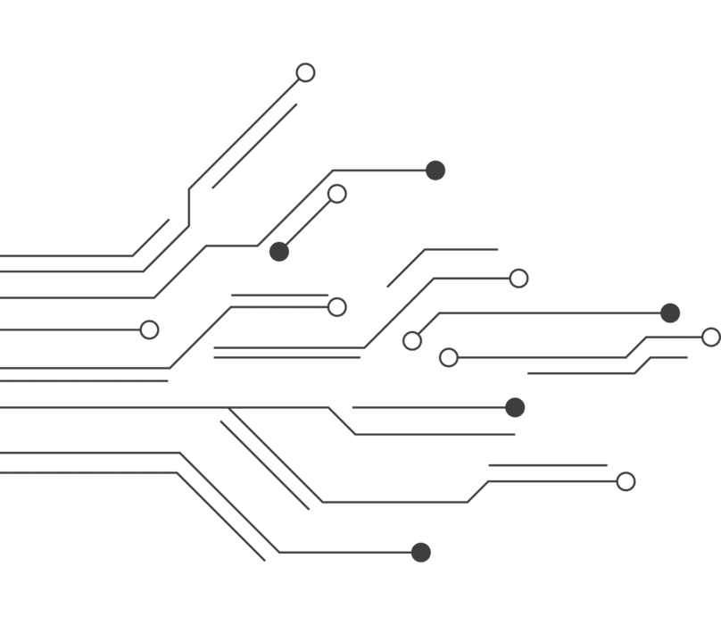
Module Name: Learning In the Digital Era
Module Code: ACCA 4025

Student Name: Jose Manuel Carneiro De Alva Noronha
Student ID: 2516682
Group: 2

Lecturer’s Name: Koushik Modak

E-Portfolio Link: Click here to open

[Cite your source here.]
LDE Assignment 1
E-Portfolio
University of Wales Trinity Saint David
London campus
Table of Contents
Introduction 2
Main Body 2
Task 1: Essential Academic and Employment Skills for the future career Path 2
Task 1 (a): Report on Essential Academic and Employment Skills 2
Task 1 (b): Evaluation of Task 1 (a) based on Similarity report 3
Task 2: Collaborative Mind Map and Individual Poster 4
Mind Map (Collaborative) 4
Poster (Individual) 5
Task 3: Virtual Collaboration and RefWorks 6
Report on Virtual Collaboration 6
Step-by-step process of using RefWorks with visuals 8
Task 4: E-Portfolio Creation and Evaluation 19
Task 4 (a): E-Portfolio Creation 19
Task 4 (b): Illustrative Review of E-Portfolio tool Selection 24
Conclusion 25
References 26
Task 1 References: 26
References 26
Task 3 References: 27
References 27
Task 4 References: 27
References 27

Introduction
This work aims to analyze the fundamental academic and professional competencies required for success in higher education and the labor market. It employs digital tools and research methodologies (such as Google Scholar), utilizing the IEEE referencing standard and validation through Turnitin similarity analysis.
Furthermore, the assignment serves to develop communication and collaboration skills through the creation of a team mind map and an academic poster. To ensure technical accuracy and efficiency in information management, the automated referencing tool RefWorks was also utilized. This portfolio, therefore, documents the integration of digital literacy, collaborative effort, and academic integrity essential for professional practice.

Main Body

Task 1: Essential Academic and Employment Skills for the future career Path

Task 1 (a): Report on Essential Academic and Employment Skills
During my research, I noted that skills are essential for professional and academic success, as they provide a competitive advantage in the job market. To develop the skills that will support my chosen career, I must focus on continuous study and improving practical techniques. In my view, the most important skills are critical thinking, problem-solving, teamwork, and collaboration. Furthermore, technical skills are vital for any student to secure a job and remain competitive. Other key competencies include leadership, communication, project management, and continuous learning.
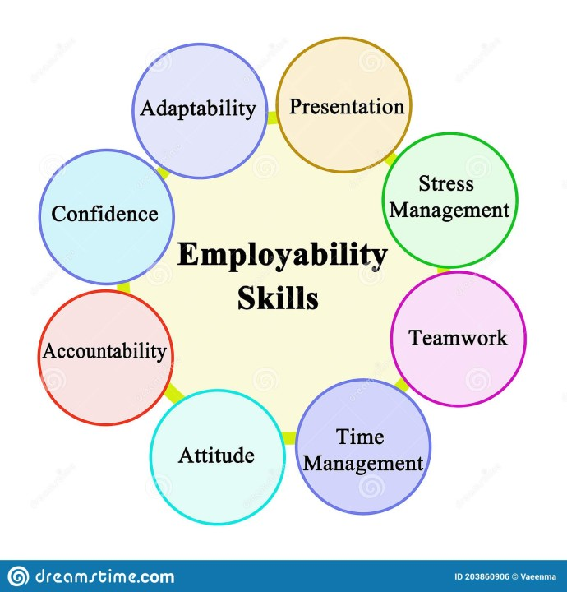
Figure 1: Essential Skills for 21st century [1]

Article [2] discusses a study on the competencies required by managers in the computing industry. This study involved 10 managers (directors and product/project managers) and used a constant comparative analysis. The study emphasizes management abilities such as leadership, candidate evaluation, collaboration, and emotional self-regulation, noting that both technical and management skills are the path to a successful career in computing.
Based on article [3], the definition of employability is “A set of skills, knowledge and personal attributes that make an individual more likely to secure and be successful in their chosen occupation(s) to the benefit of themselves, the workforce, the community and the economy.”. This article highlights that many graduates lack strong soft skills, such as oral and written communication, leadership, time management, and negotiation. It also notes that it is often more difficult for graduates to acquire soft skills than academic or technical qualifications.
Article [4], proposes an analysis of the labour market scenario in 2035. From my understanding, this study focuses on essential workplace abilities, soft skills, or cross-disciplinary skills that allow humans to collaborate, solve complex problems, and adapt to roles that automation cannot replace. Thus, the scenario points toward a reengineering of education and professional training.
In conclusion, soft skills are essential especially problem-solving, critical thinking, and teamwork. Furthermore, continuous study is fundamental for employees to remain competitive.

Task 1 (b): Evaluation of Task 1 (a) based on Similarity report
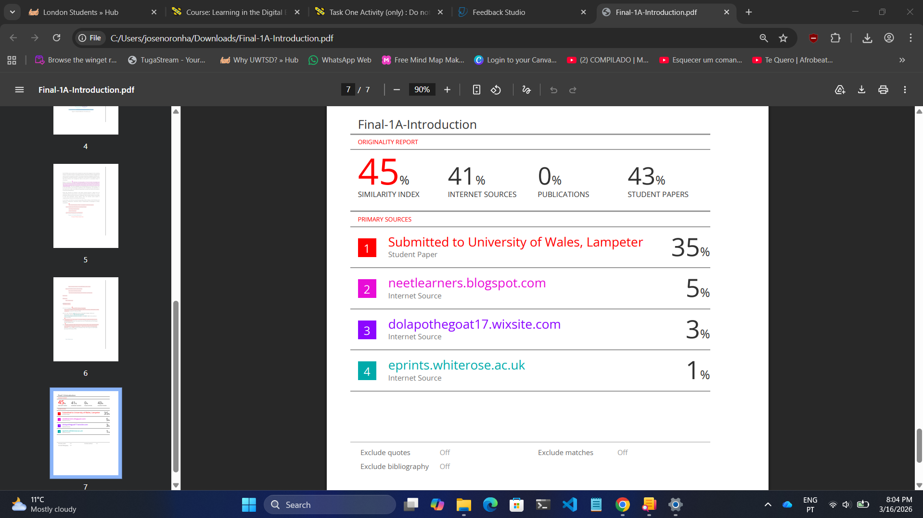
Figure 2: My Task 1 Similarity report
Evaluation of the similarity rate (45%)
The 45% similarity rate is mainly due to the use of academic and online sources. A significant portion results from common academic expressions, definitions, and referenced materials. Since quotations and the bibliography were not excluded from the similarity report, the overall percentage increased, without necessarily indicating plagiarism. The similarity detected in the passage from source number 3 occurs because it contains a direct definition taken from a referenced source. The sentence is intentionally placed in quotation marks and properly cited; therefore, it does not constitute plagiarism.
Self-assessment of the work (score out of 100)
Overall, this work can be rated 66/100. It demonstrates a good understanding of the topic and an appropriate use of sources. However, the score could be improved by adding deeper personal analysis, clearly distinguishing original ideas from referenced content, and expanding the discussion to reach the required 250 words originally defined in the assessment guideline document.

Task 2: Collaborative Mind Map and Individual Poster

Mind Map (Collaborative)
Link: Click here to open
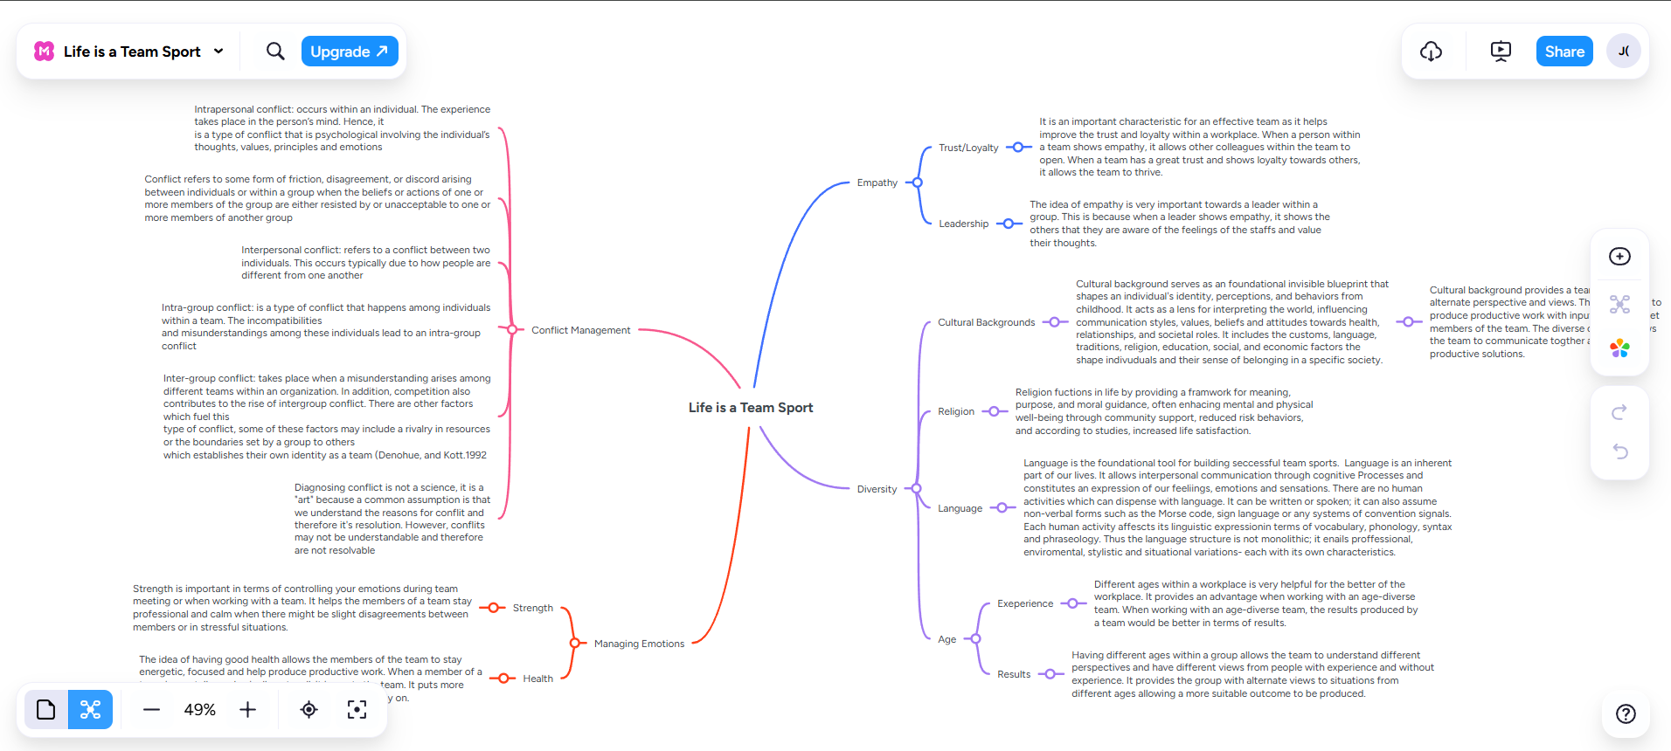
Figure 3: Mind Map Created By Team

Poster (Individual)
Link: Click here to open
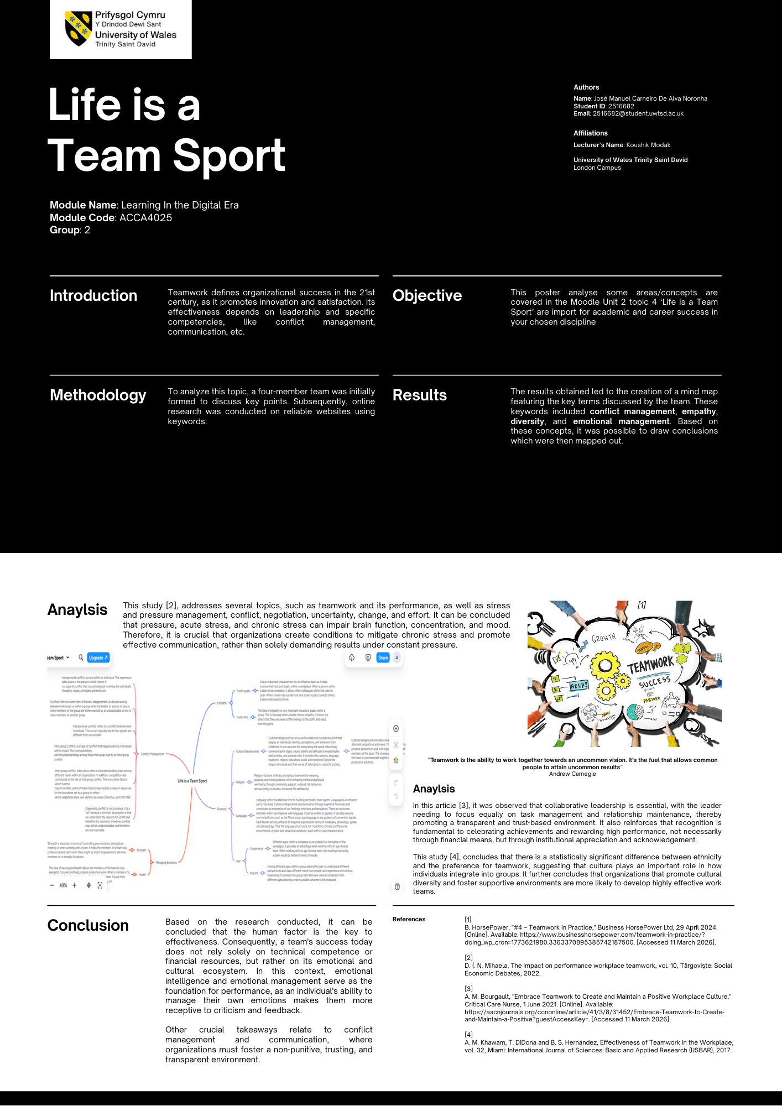
Figure 4: My Poster

Task 3: Virtual Collaboration and RefWorks

Report on Virtual Collaboration
Topic 2: Riding the storm
Since the COVID-19 pandemic, there has been a necessity for teams to work remotely.
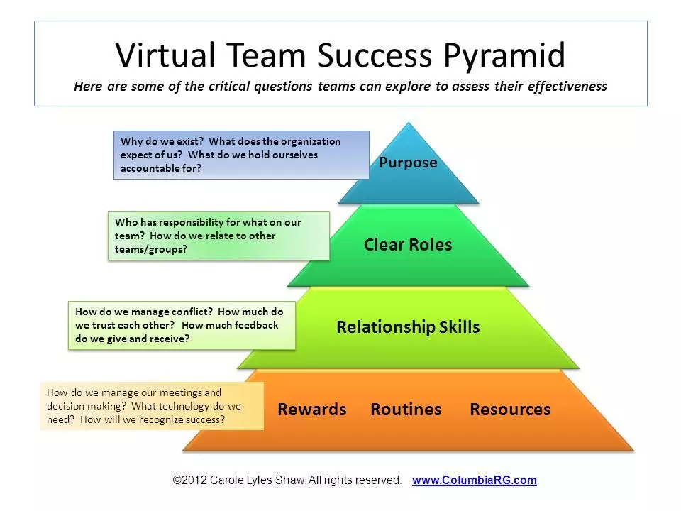
Figure 5: Effectiveness of virtual teams [1]
In this scenario, a new context and challenges for leadership have emerged, as virtual leadership is distinct from in-person leadership, given that team members rarely see each other and depend entirely on technology to collaborate. Therefore, the great challenge lies in transitioning from management based on physical proximity to one based on building relationships and trust at a distance. Consequently, the most effective leaders are those who can create and maintain a climate of trust within virtual teams, where this trust manifests at two levels:
- Swift Trust: Created at the moment of the team's formation.
- Lasting Trust: Maintained through the continuous performance of the team.
In other words, teams with high levels of trust are typically described as more proactive, optimistic, results-oriented, and capable of providing productive feedback. [2]
This article [2] also defines strategies for success across three different categories:
- Organizational Strategies: The organization must provide institutional support through clear procedures, appropriate technology, careful selection of members, and the definition of precise tasks.
- Leadership Actions: In this case, the leader must go beyond job management; the leader must attend to human needs, encourage self-efficacy, and motivate employees to seek challenging and complex tasks.
- Team Composition: In this category, success depends on choosing individuals who have a predisposition to trust and collaborate. Other important factors include team size, cultural values, and technological competencies.
This study [3] found that conflicts in virtual teams revolve around five main areas:
- Trust: In this case, researchers found that the lack of physical presence affects psychological safety and the resolution of disputes.
- Performance: It was found that conflict (both functional and dysfunctional) has a direct impact on team results.
- Cultural Diversity: At this point, it was observed that different backgrounds and languages in global teams often lead to misunderstandings.
- Knowledge Management: It was found that there is a certain difficulty in sharing information effectively through technology without generating friction.
- Team Management: Here, the role of the leader and technological tools is suggested as essential in mediating opposing interests.
One way to manage conflict is by using SWOT analysis, through which leadership can clearly visualize where the organization is failing and where it can grow. [4]
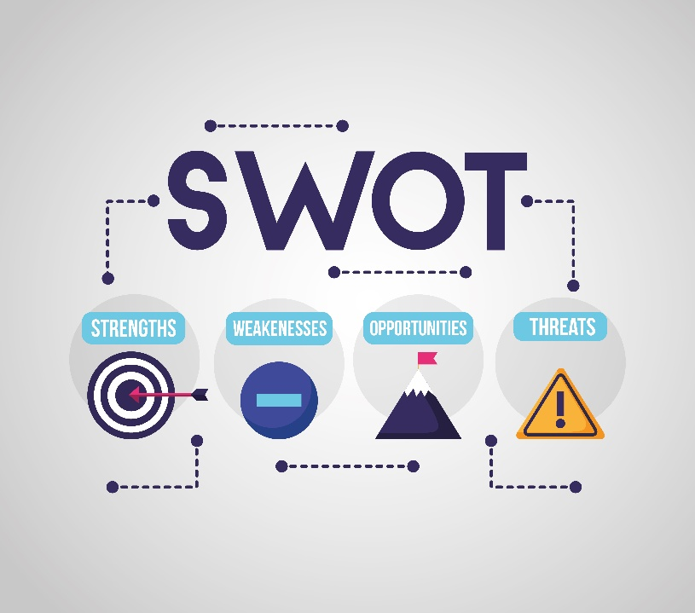
Figure 6: SWOT [5]
A direct definition for SWOT is “SWOT analysis is one of the most widely used tools in the world because it allows a rapid and effective assessment of Strengths (S), Weaknesses (W), Opportunities (O), and Threats (T) faced by any organization or company regardless of the industry where it operates or its size.” [4][6]
Therefore, I can conclude that conflict is inevitable but manageable, that is, conflict management is not about eliminating conflicts, but rather about controlling dysfunctional elements and leveraging productive aspects, such as the debate of ideas or the application of SWOT analysis. I can also conclude that the effectiveness of virtual teams depends less on 'avoiding problems' and more on creating communication infrastructures that allow for constant and transparent feedback.[2][3][4][6]

Step-by-step process of using RefWorks with visuals
To provide a step-by-step explanation of how to use RefWorks, I have included images illustrating each stage. These images contain arrows and numbers, where the numbers indicate the sequence of the numbers list to follow.
To get started, follow the steps above (each numbers corresponds to the numbers on the images):
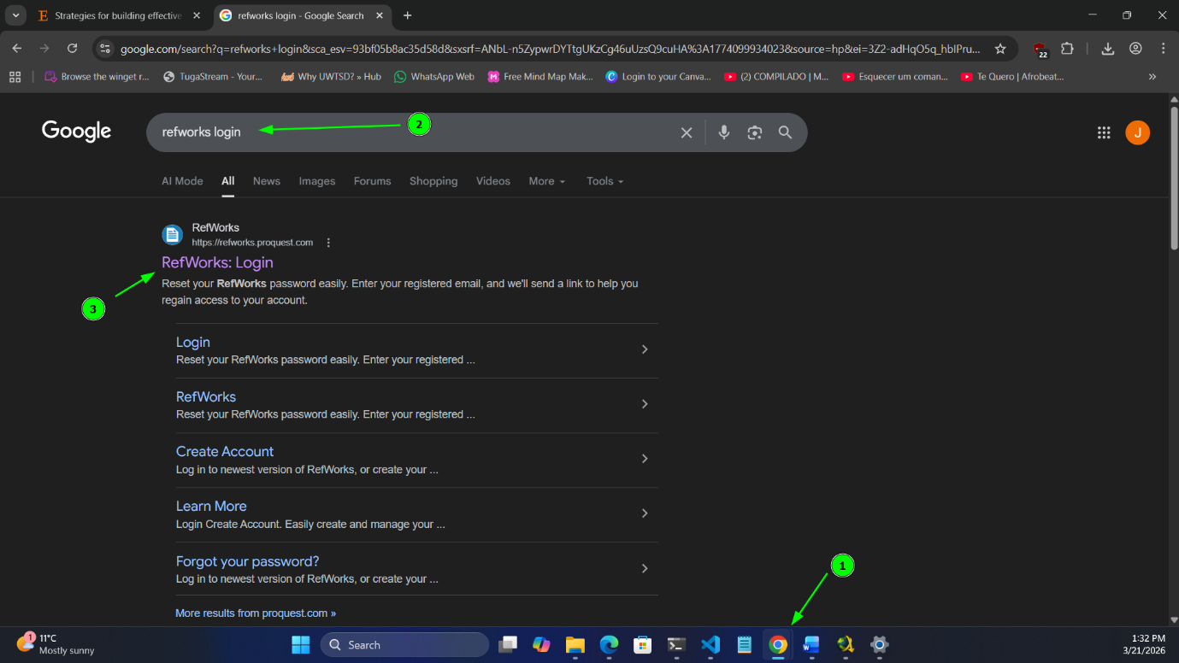
Figure 7: RefWorks Step 1
- Open your preferred web browser
- Search for “refworks login” on Google
- Once the search results appear, click on option 3
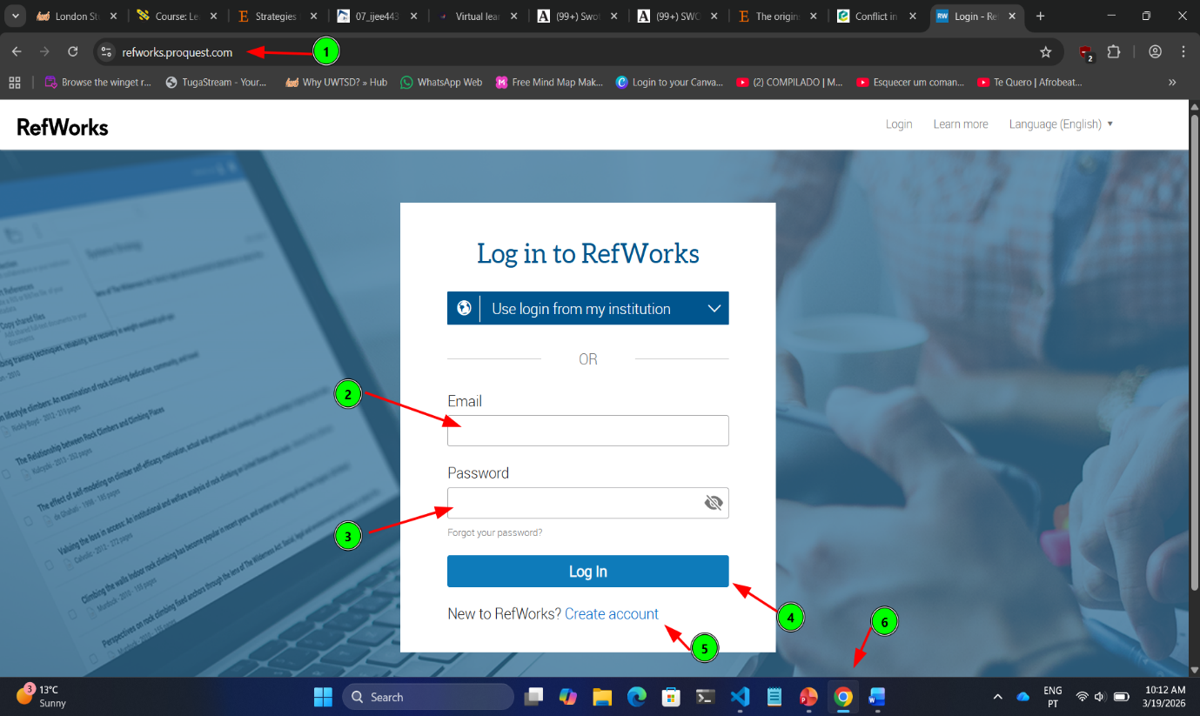
Figure 8: RefWorks Step 2
- Confirm that you are on the correct page and using the correct URL.
- In option (2), enter your email address. For university access, you must use your student email (XXXXXXX@student.uwtsd.ac.uk).
- In option (3), enter the password you created when setting up your RefWorks account.
- Click on "Log In" to access your account.
- If you do not have an account, click on option (5) and follow the instructions to create one.
- This is only to show which browser I am currently using.
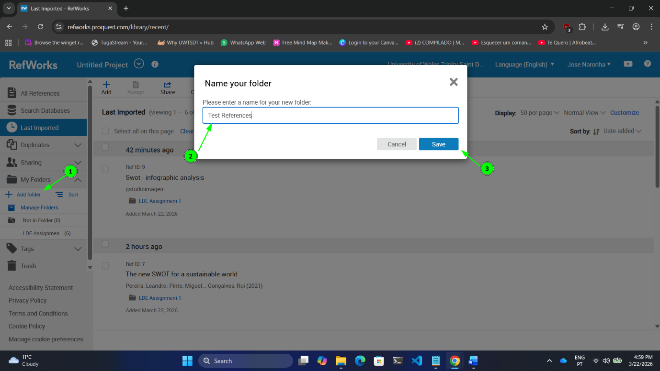
Figure 9: RefWorks Step 3
- Once you have logged in to your account, you should create a folder for your project to keep your work organized.
- Enter the name of the folder you wish to create.
- Click "Save" to finish creating the folder.
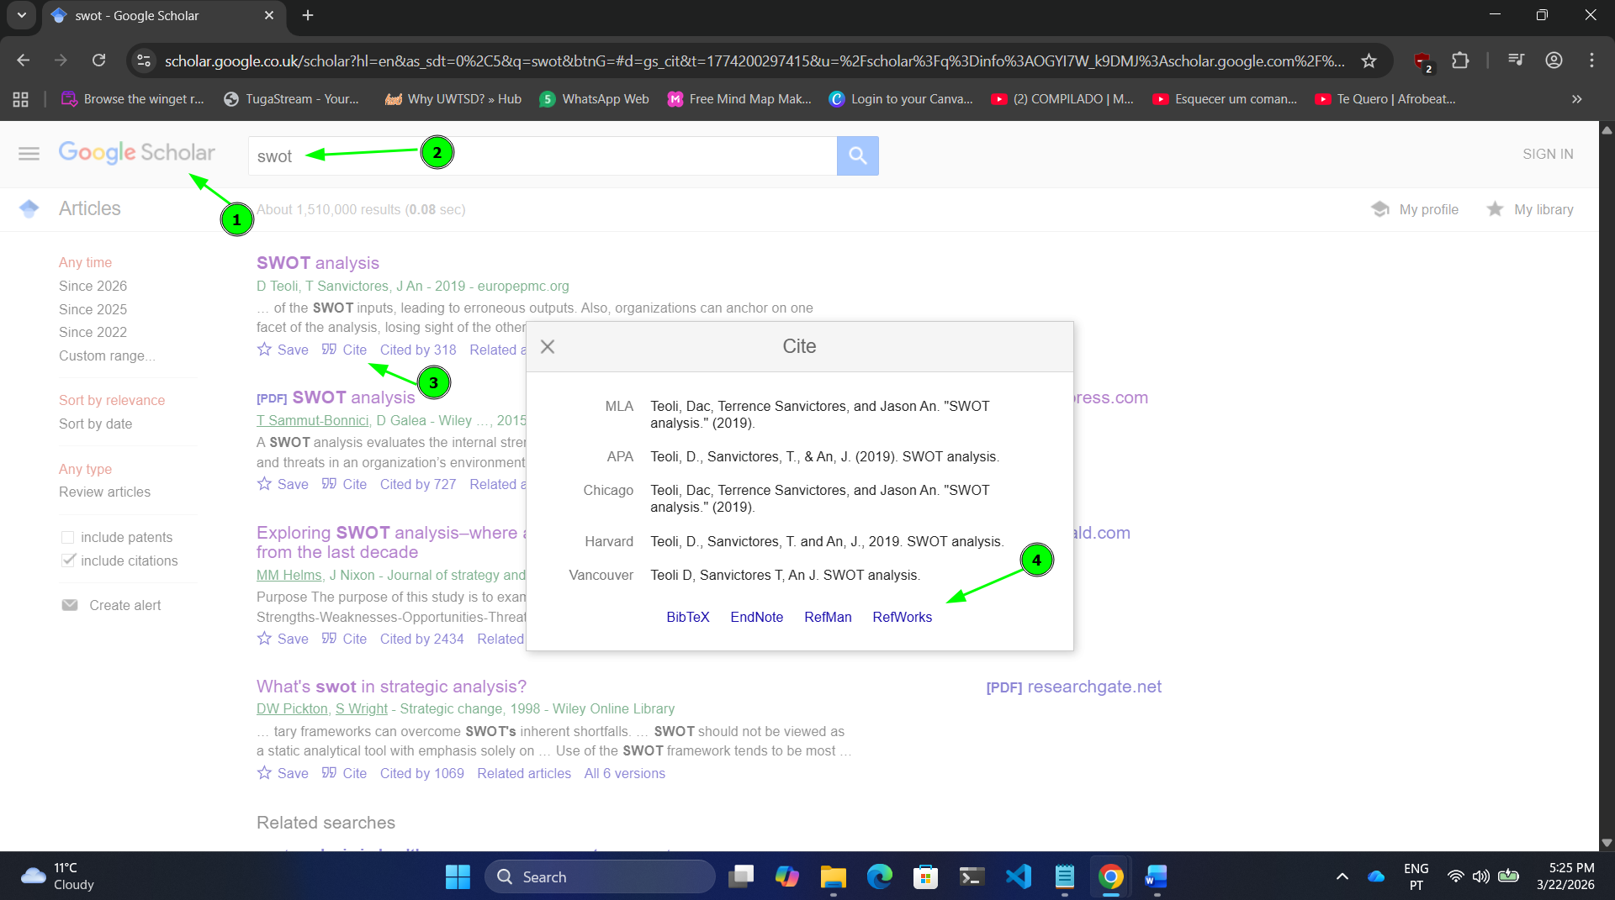
Figure 10: RefWorks Step 4
- To insert your reference, go to Google Scholar (you can search for it on Google if you don't know the URL).
- Search for the topic you are working on; in the example image above, I searched for "SWOT".
- Each search result includes a "Cite" option; you must click on this option.
- Next, click on the "RefWorks" option, and you will then be redirected to your RefWorks account.
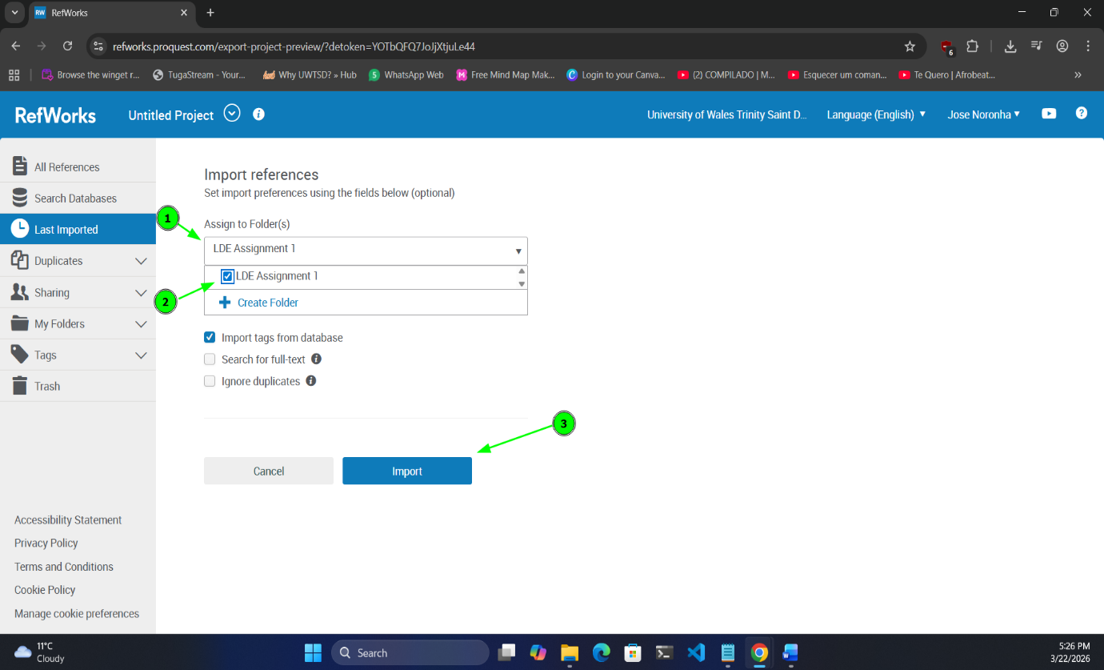
Figure 11: RefWorks Step 5
- After being redirected to RefWorks to add the reference, click on option (1) to view the list of folders you created in Step 3.
- Once you have located the destination folder, select the folder you created in Step 3.
- Click "Import" to finish adding the reference.

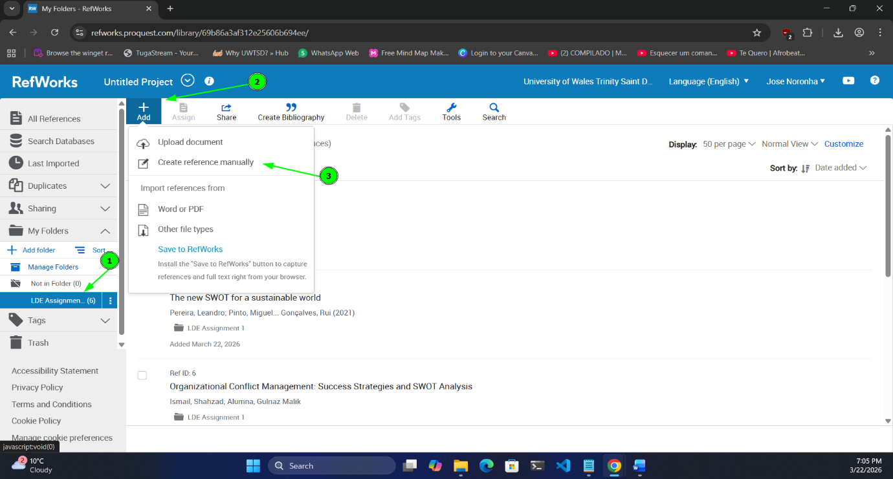
Figure 12: RefWorks Step 6(Optional – Create Reference Manually)
- If you want to add a reference manually, first select the folder where you wish to save it.
- Click on "Add".
- Click on "Create reference manually"
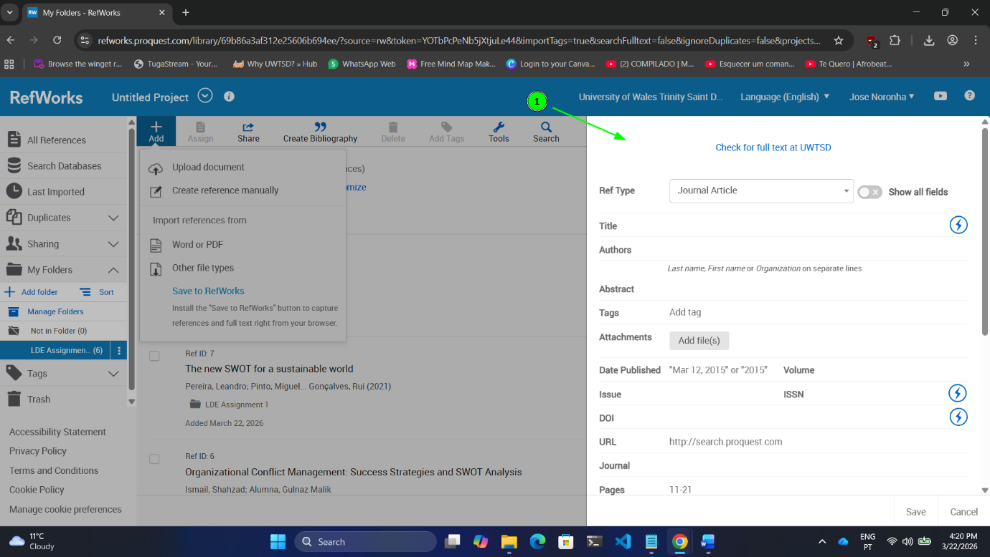
Figure 13: RefWorks Step 7(Optional – Create Reference Manually. Cont.)
After Step 6, fill in the required fields and then click "Save" to finish.
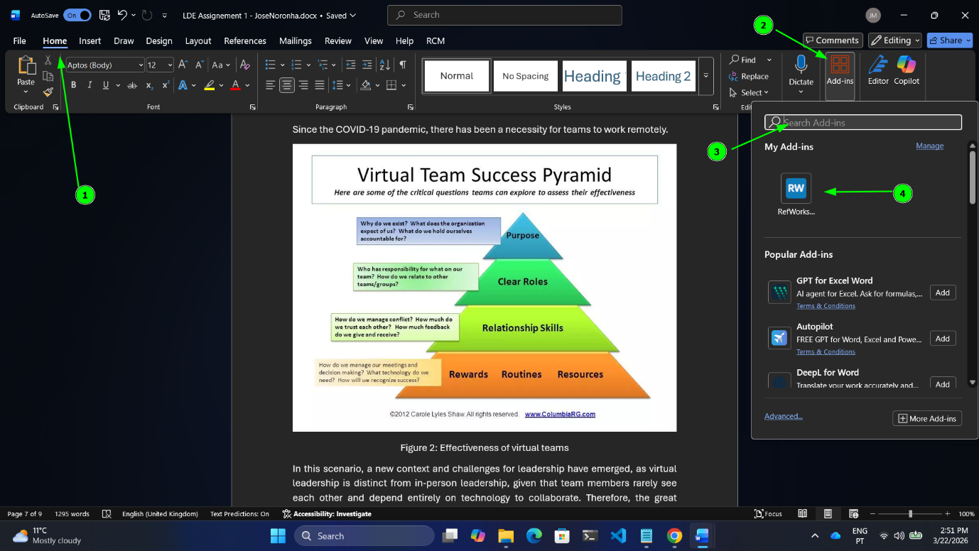
Figure 14: RefWorks Step 8 (Microsoft Word)
- After opening Microsoft Word, go to the "Home" tab.
- Select the "Add-ins" option.
- Search for "RefWorks".
- Select the "RefWorks Citation Manager" add-in.
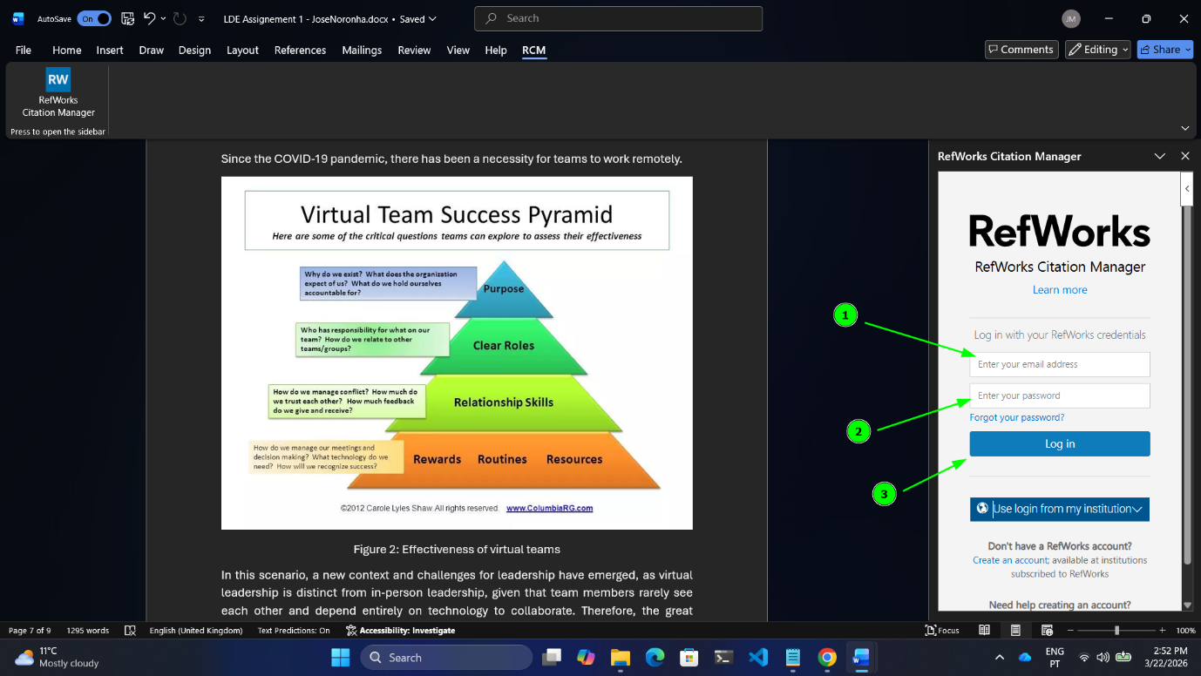
Figure 15: RefWorks Step 9 (Microsoft Word)
- Enter your email address. For university access, you must use your student email (XXXXXXX@student.uwtsd.ac.uk).
- Enter the password you created when setting up your RefWorks account.
- Click on "Log In" to access your account.
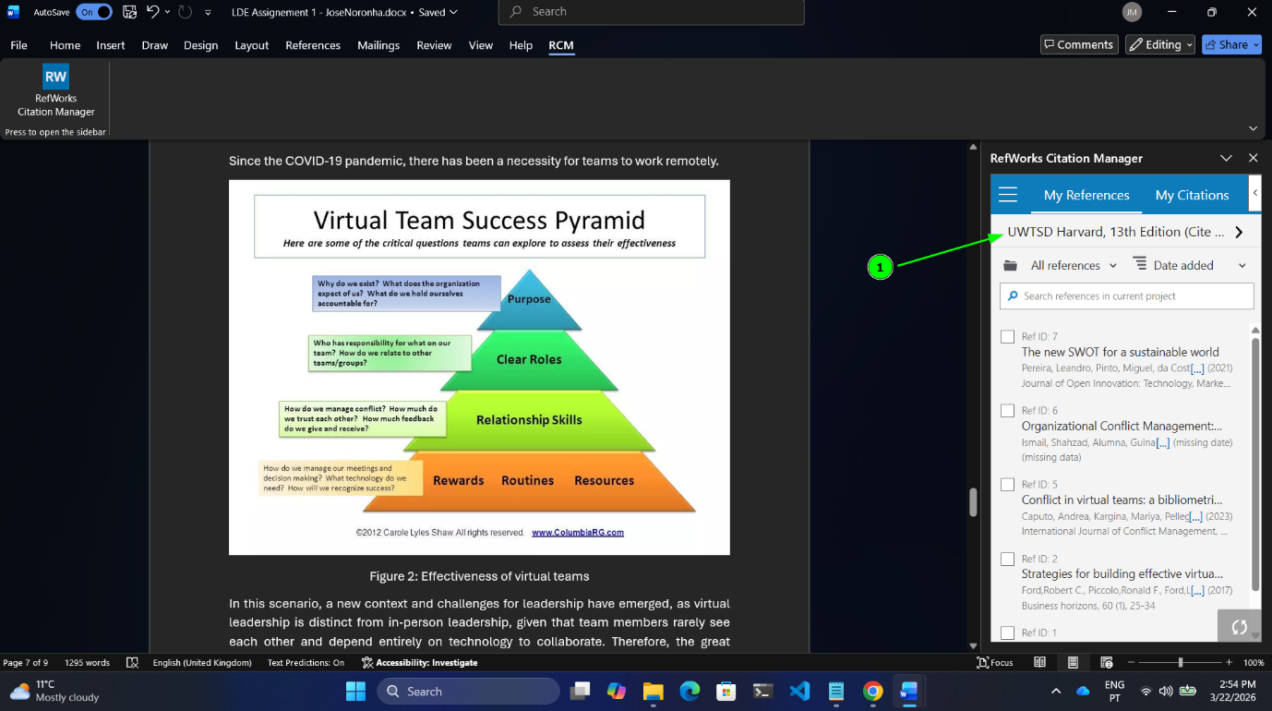
Figure 16: RefWorks Step 10 (Microsoft Word – Citation style)
Before inserting your references, you must change or confirm that the citation style is set to “IEEE UWTSD”. If it is not, click on option (1) as shown in the image above.
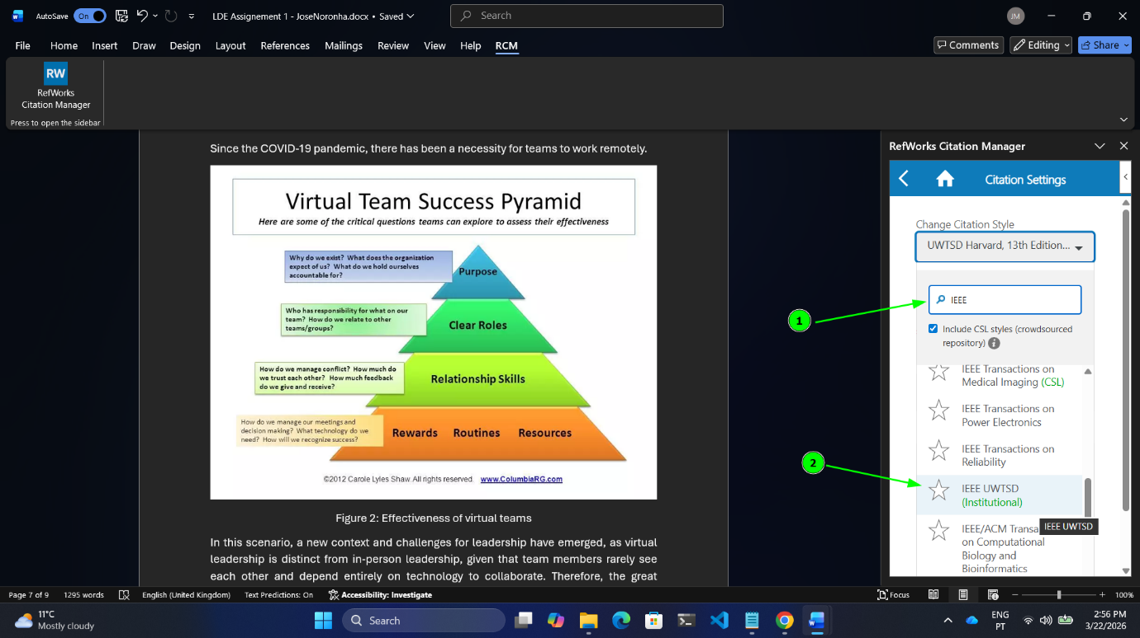
Figure 17: RefWorks Step 11 (Microsoft Word - Citation style Cont.)
- First, search for "IEEE UWTSD".
- Once you have located the style, select it.

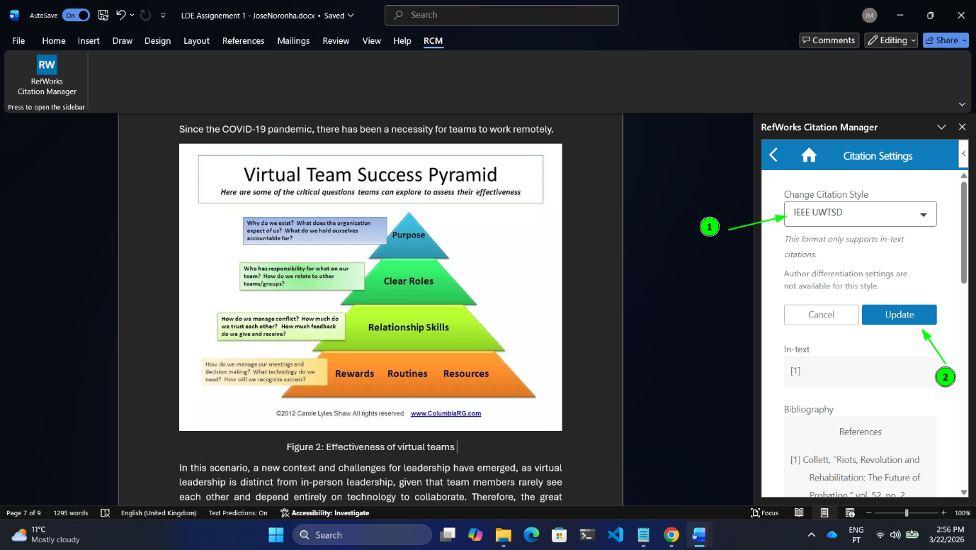
Figure 18: RefWorks Step 12 (Microsoft Word - Citation style Cont.)
- Once selected, confirm that the style is actually applied.
- Click "Update" to finish.
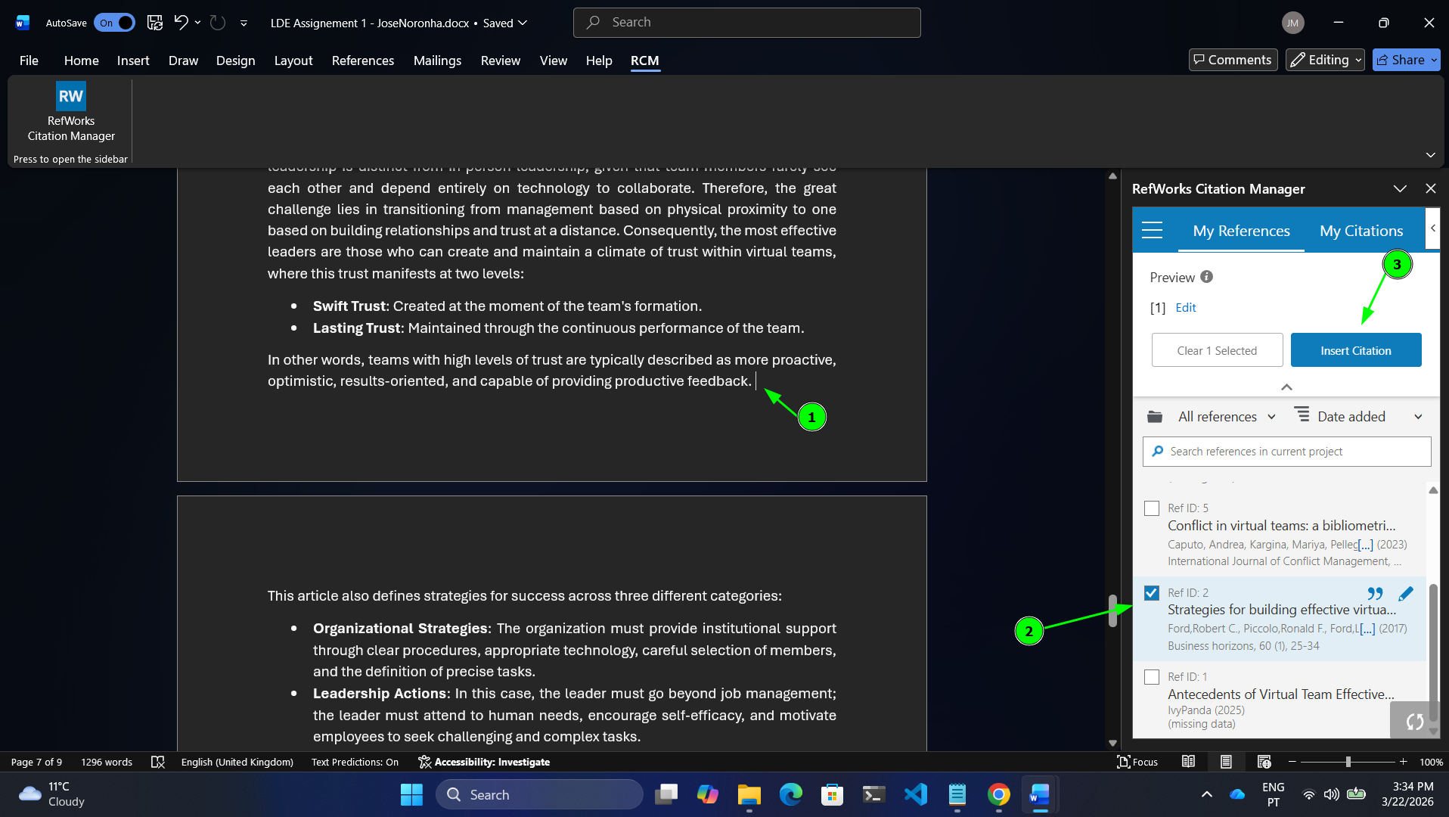
Figure 19: RefWorks Step 13 (Microsoft Word – Insert Citation)
- To insert a reference, first place your cursor at the location in the document where you want it to appear.
- Select the desired reference.
- Click "Insert Citation".
Generating the Bibliography
There are two ways to generate a bibliography using RefWorks:
- The first way is through the RefWorks website. However, using this method, the bibliography may not follow the same order in which the citations appear in your Word document.
- The second way is directly within Microsoft Word using the Add-in (Recommended).

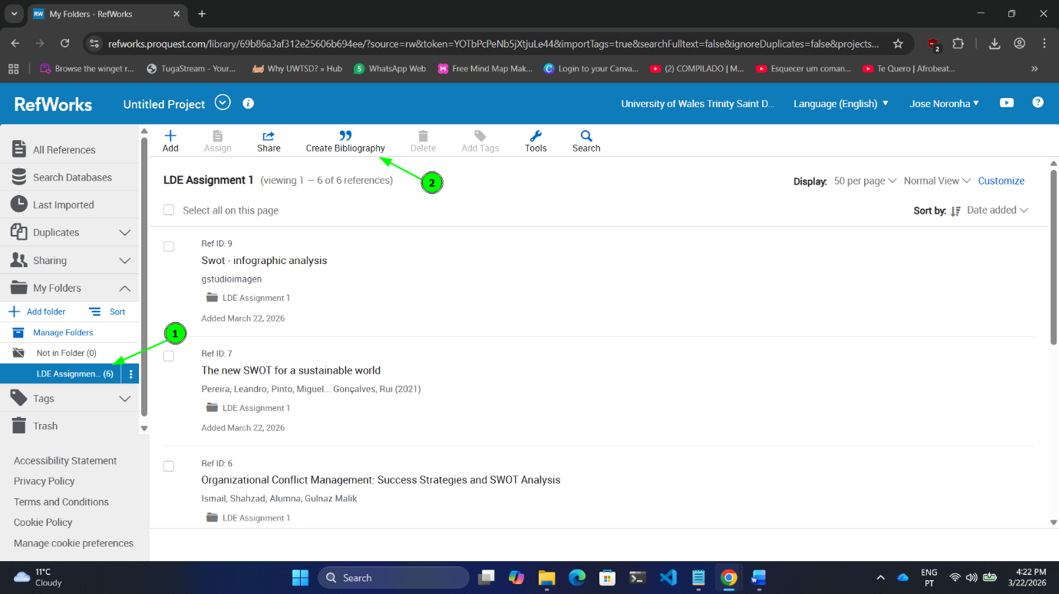
Figure 20: RefWorks Web page version
- Select the folder that contains your references.
- Click on "Create Bibliography".
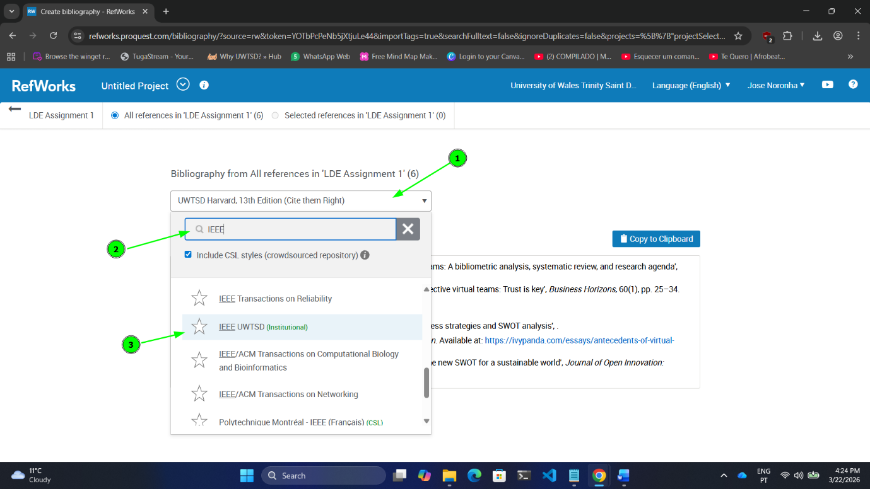
Figure 21: RefWorks Web page version (Cont.)
Here, you must select the “Citation Style”. In this case, choose “IEEE UWTSD”.

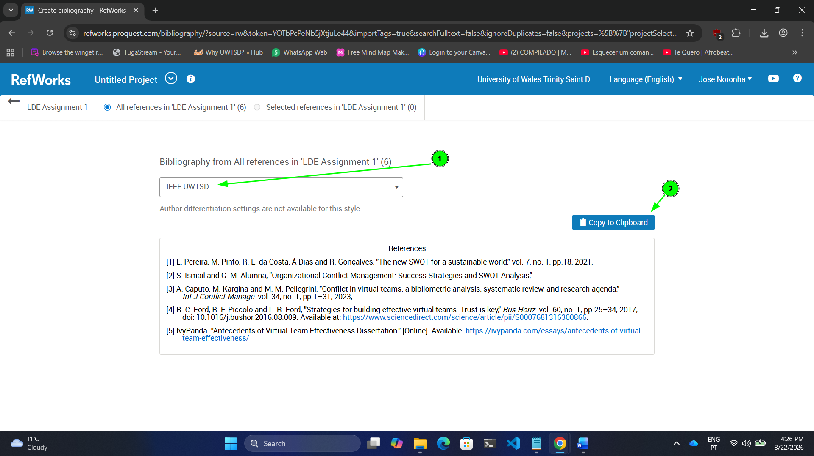
Figure 22: RefWorks Web page version (Cont.)
After selecting the “Citation Style”, click “Copy to Clipboard” to copy the generated bibliography. Then, paste it into your destination document.

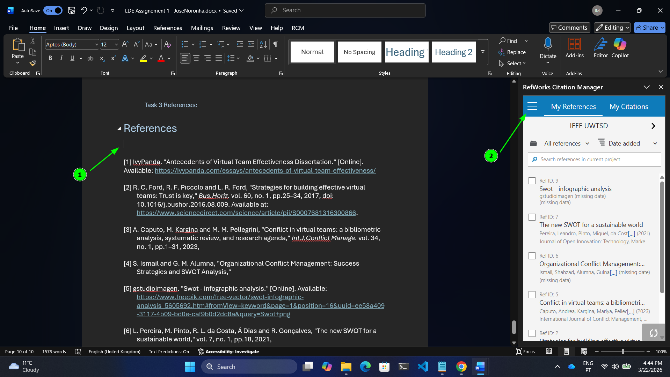
Figure 23: RefWorks Microsoft Word version
- First, place your cursor at the location in the document where you want the bibliography to appear.
- Go to the RefWorks Add-in menu, as shown by number (2) in the image above.
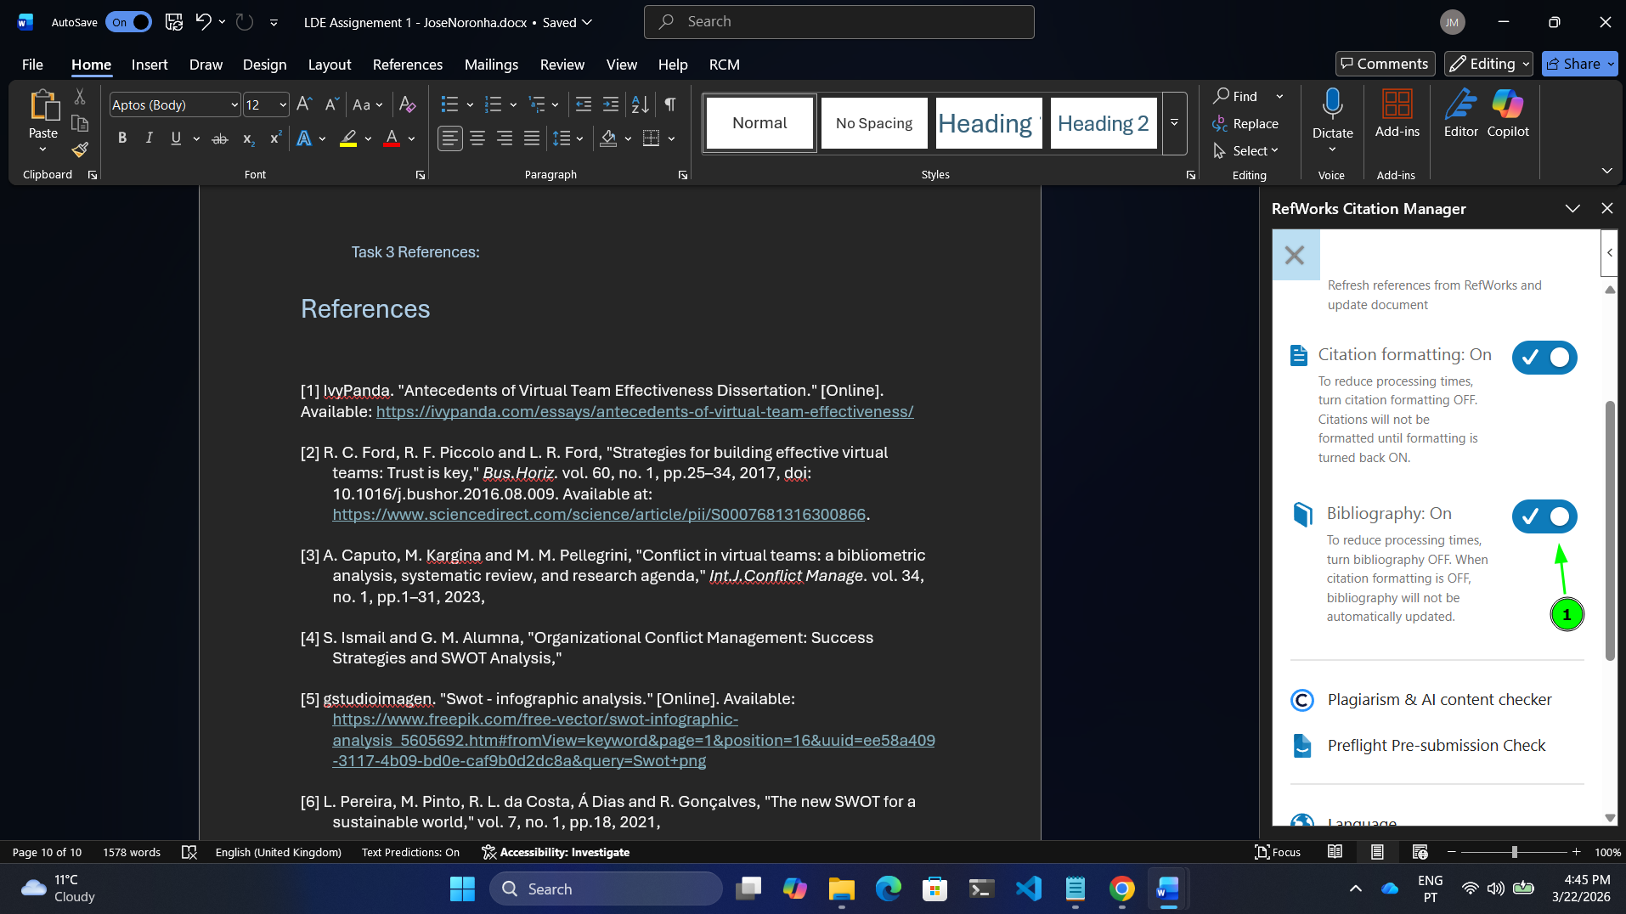
Figure 24: RefWorks Microsoft Word version (Cont.)
After clicking on the menu shown in Figure 23 and following the steps in that same figure, you must enable the “Bibliography: On” option, as shown in Figure 24.

Task 4: E-Portfolio Creation and Evaluation

Task 4 (a): E-Portfolio Creation
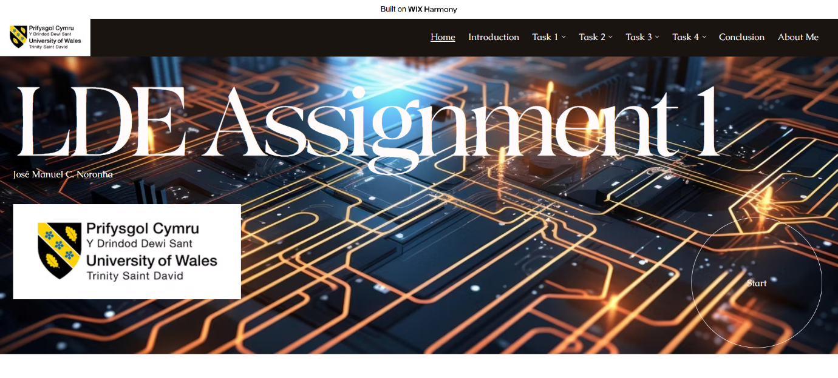
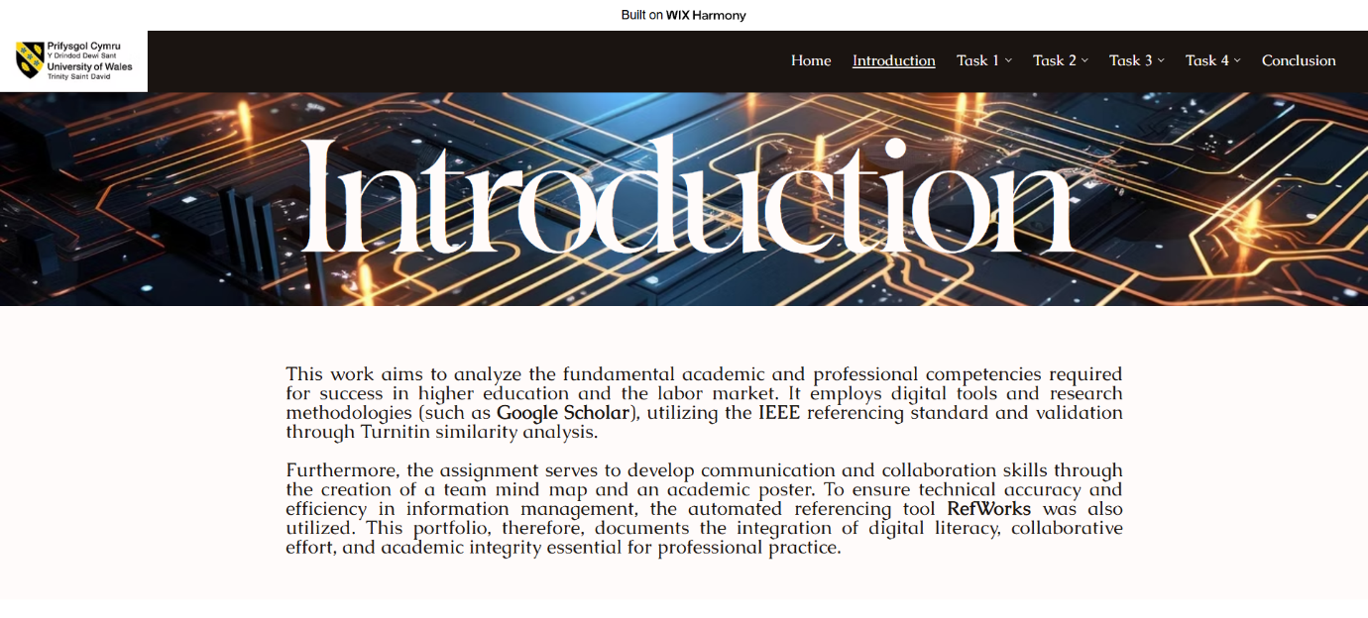
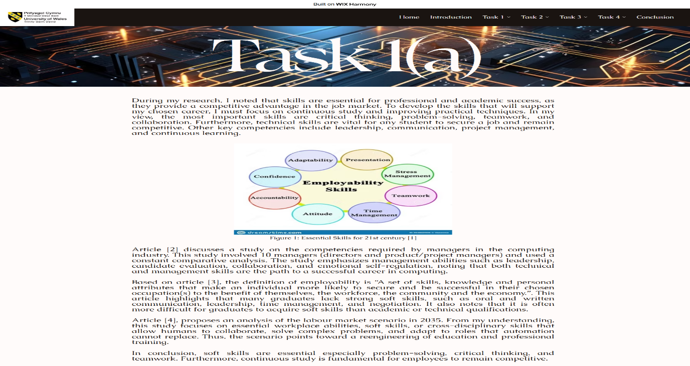
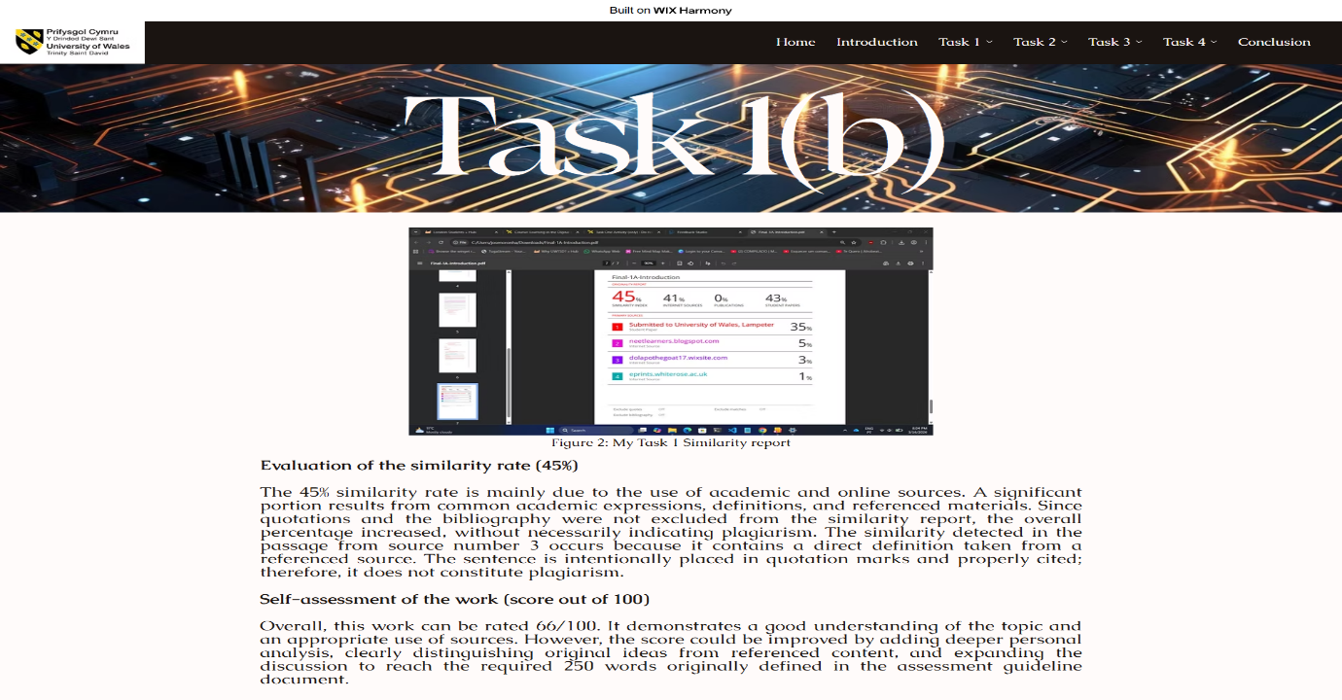
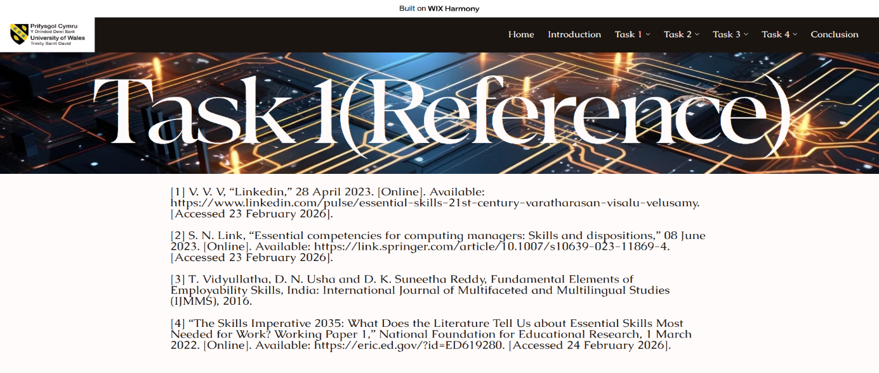
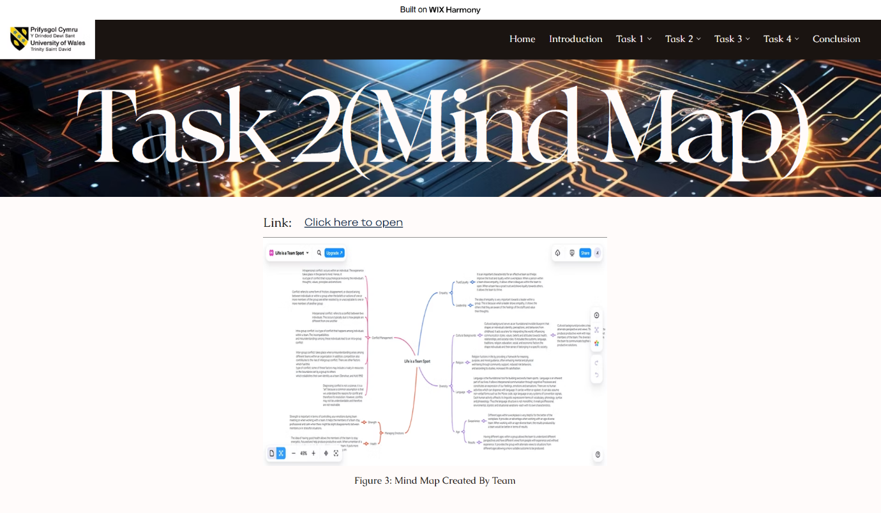
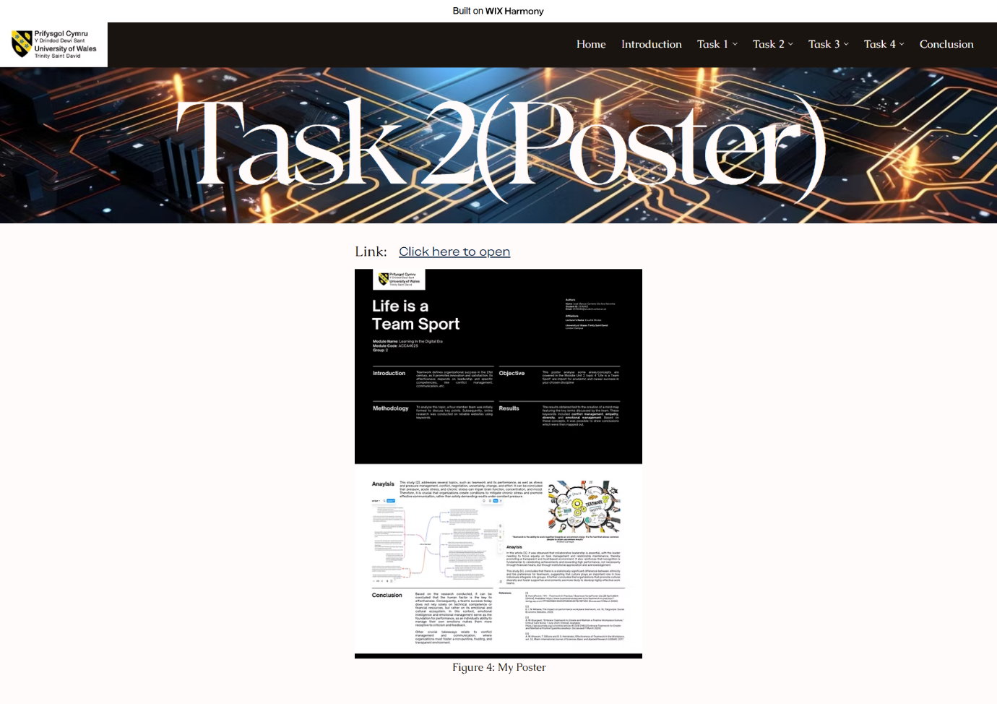
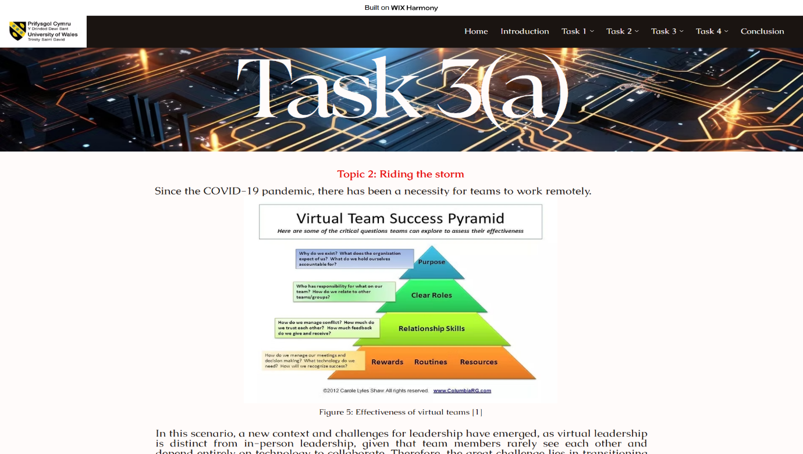
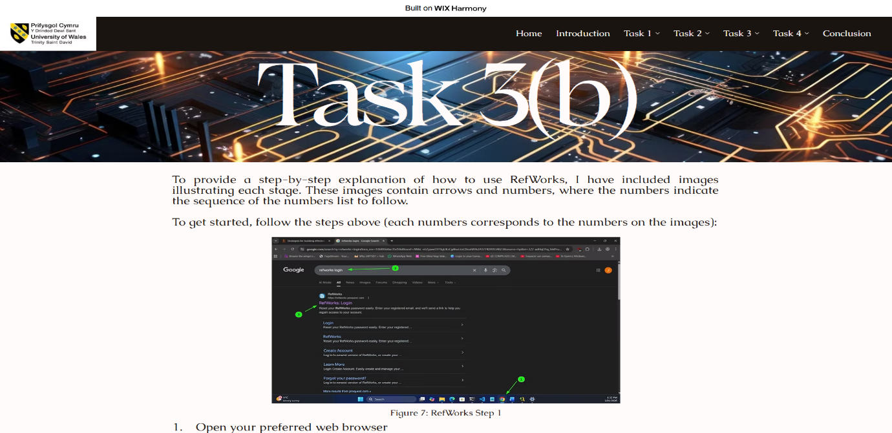
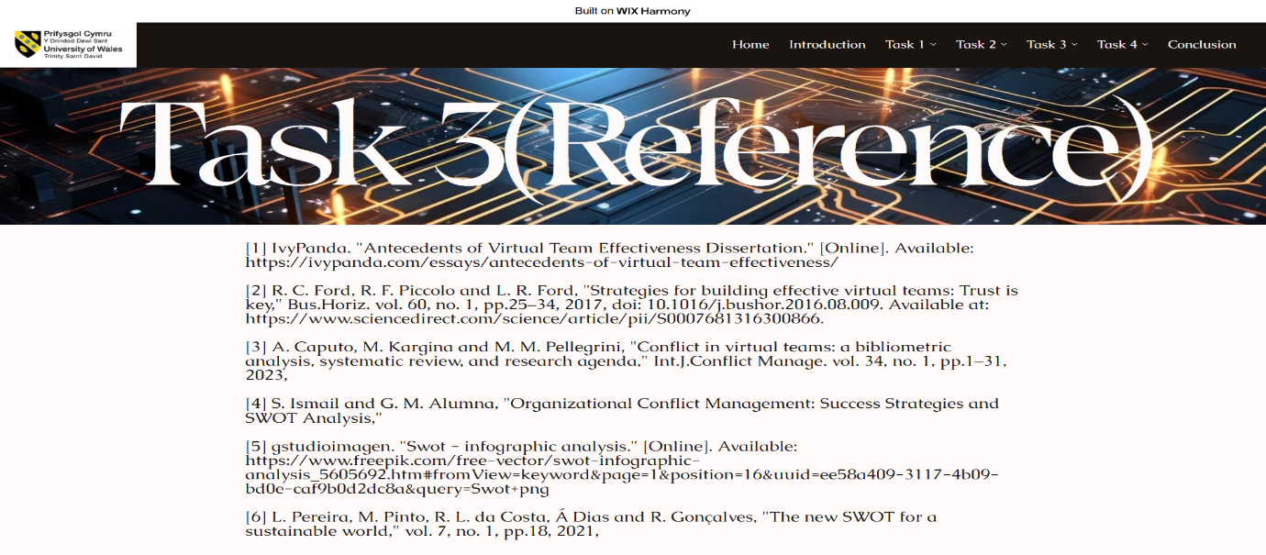
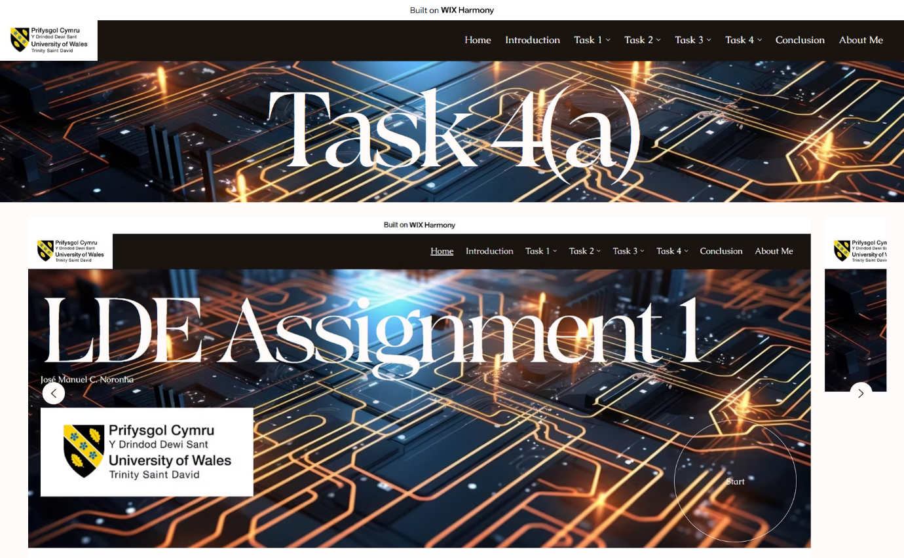
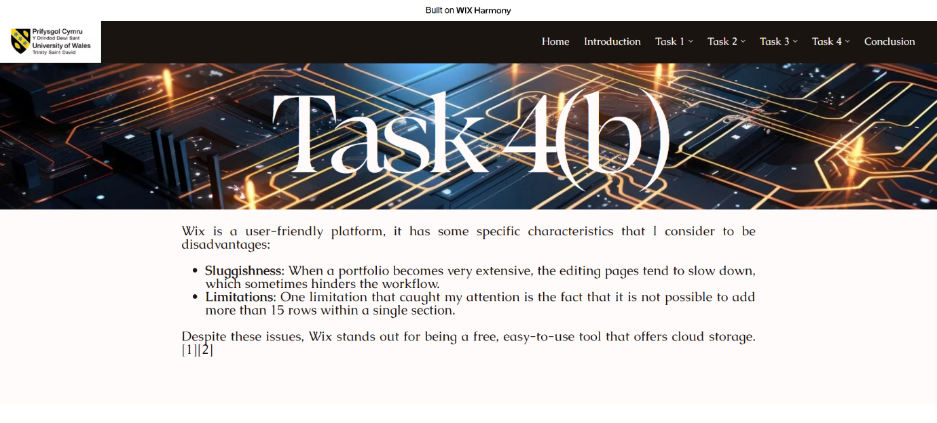
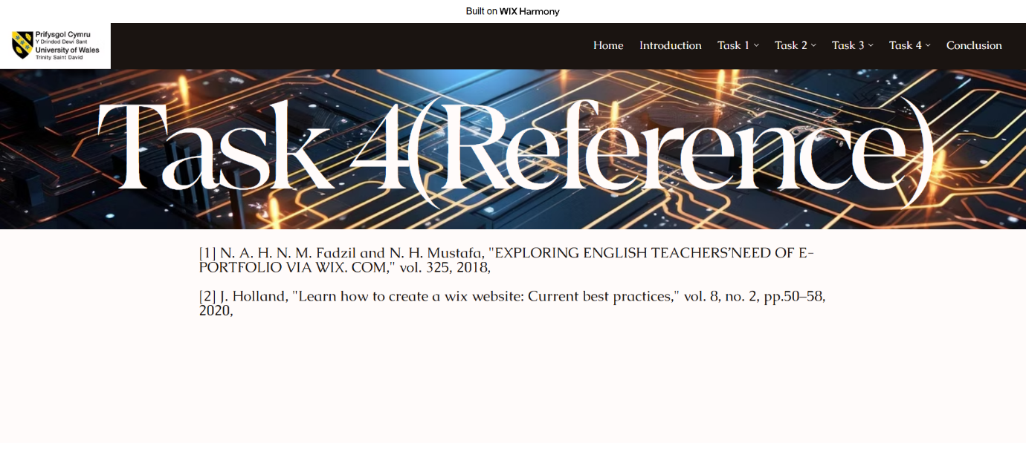
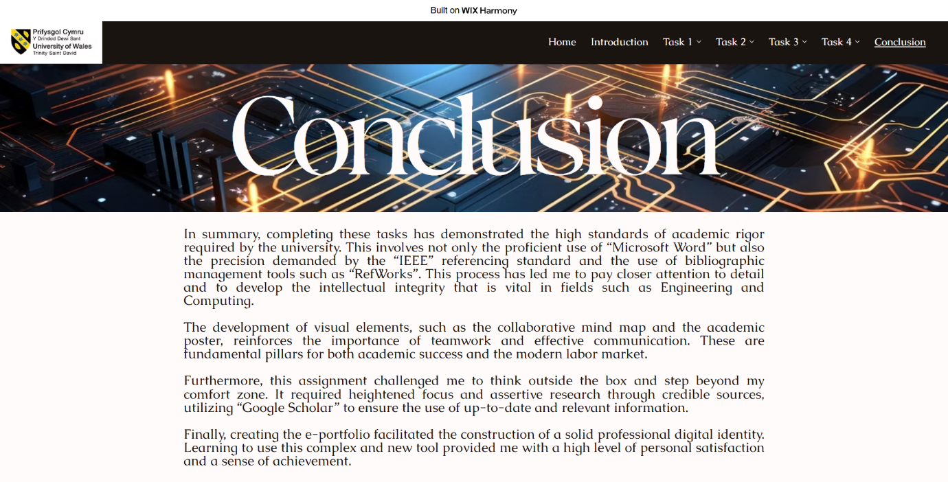

Task 4 (b): Illustrative Review of E-Portfolio tool Selection
Wix is a user-friendly platform, it has some specific characteristics that I consider to be disadvantages:
- Sluggishness: When a portfolio becomes very extensive, the editing pages tend to slow down, which sometimes hinders the workflow.
- Limitations: One limitation that caught my attention is the fact that it is not possible to add more than 15 rows within a single section.
Despite these issues, Wix stands out for being a free, easy-to-use tool that offers cloud storage. [1][2]

Conclusion
In summary, completing these tasks has demonstrated the high standards of academic rigor required by the university. This involves not only the proficient use of “Microsoft Word” but also the precision demanded by the “IEEE” referencing standard and the use of bibliographic management tools such as “RefWorks”. This process has led me to pay closer attention to detail and to develop the intellectual integrity that is vital in fields such as Engineering and Computing.
The development of visual elements, such as the collaborative mind map and the academic poster, reinforces the importance of teamwork and effective communication. These are fundamental pillars for both academic success and the modern labor market.
Furthermore, this assignment challenged me to think outside the box and step beyond my comfort zone. It required heightened focus and assertive research through credible sources, utilizing “Google Scholar” to ensure the use of up-to-date and relevant information.
Finally, creating the e-portfolio facilitated the construction of a solid professional digital identity. Learning to use this complex and new tool provided me with a high level of personal satisfaction and a sense of achievement.

References

Task 1 References:

References

[1] | V. V. V, “Linkedin,” 28 April 2023. [Online]. Available: https://www.linkedin.com/pulse/essential-skills-21st-century-varatharasan-visalu-velusamy. [Accessed 23 February 2026].
[2] | S. N. Link, “Essential competencies for computing managers: Skills and dispositions,” 08 June 2023. [Online]. Available: https://link.springer.com/article/10.1007/s10639-023-11869-4. [Accessed 23 February 2026].
[3] | T. Vidyullatha, D. N. Usha and D. K. Suneetha Reddy, Fundamental Elements of Employability Skills, India: International Journal of Multifaceted and Multilingual Studies (IJMMS), 2016.
[4] | “The Skills Imperative 2035: What Does the Literature Tell Us about Essential Skills Most Needed for Work? Working Paper 1,” National Foundation for Educational Research, 1 March 2022. [Online]. Available: https://eric.ed.gov/?id=ED619280. [Accessed 24 February 2026].

Task 3 References:

References

[1] IvyPanda. "Antecedents of Virtual Team Effectiveness Dissertation." [Online]. Available: https://ivypanda.com/essays/antecedents-of-virtual-team-effectiveness/
[2] R. C. Ford, R. F. Piccolo and L. R. Ford, "Strategies for building effective virtual teams: Trust is key," Bus.Horiz. vol. 60, no. 1, pp.25–34, 2017, doi: 10.1016/j.bushor.2016.08.009. Available at: https://www.sciencedirect.com/science/article/pii/S0007681316300866.
[3] A. Caputo, M. Kargina and M. M. Pellegrini, "Conflict in virtual teams: a bibliometric analysis, systematic review, and research agenda," Int.J.Conflict Manage. vol. 34, no. 1, pp.1–31, 2023,
[4] S. Ismail and G. M. Alumna, "Organizational Conflict Management: Success Strategies and SWOT Analysis,"
[5] gstudioimagen. "Swot - infographic analysis." [Online]. Available: https://www.freepik.com/free-vector/swot-infographic-analysis_5605692.htm#fromView=keyword&page=1&position=16&uuid=ee58a409-3117-4b09-bd0e-caf9b0d2dc8a&query=Swot+png
[6] L. Pereira, M. Pinto, R. L. da Costa, Á Dias and R. Gonçalves, "The new SWOT for a sustainable world," vol. 7, no. 1, pp.18, 2021,

Task 4 References:

References
[1] N. A. H. N. M. Fadzil and N. H. Mustafa, "EXPLORING ENGLISH TEACHERS’NEED OF E-PORTFOLIO VIA WIX. COM," vol. 325, 2018,
[2] J. Holland, "Learn how to create a wix website: Current best practices," vol. 8, no. 2, pp.50–58, 2020,

