THE GLOBAL BUSINESS ENVIRONMENT
Table of Contents
Introduction 4
A. Major forces for business environment shaping 4
Major Forces: 4
Explanation of industrial changes: 6
B. Critical assessment for challenges and opportunities 7
PESTLE: 7
SWOT: 7
PORTERS 5 FORCES: 10
PRODUCTS LIFE CYCLE: 10
Conclusion 11
Reference list 12

Executive Summary
The environmental analysis of business justifies the working environment of the organization. The future scope and the opportunities are to get a focusing point with the help of the business environmental analysis. Various forces are there which positively influence the organization and boost its operational section. The environmental analysis also highlights both the internal and external factors of the organization. Apart from that, it is observed that some of the major forces shape the environment of the global business. Some of the forces such as technological progress, eastern promises, wealthy landscape, and many more.

Introduction
The business environment of an organization plays a crucial role in highlighting the operational process of the organization. From relevant sources, it is observed that there are various forces present which help the global business in taking proper shape. In better words, the forces such as technological, wealthy landscape, and green revolution make sure that the organization's progress continues effectively. This study highlights some of these factors such as the major forces for the progress of the global environmental business. Along with that some other factors such as the PESTEL analysis and the SWOT analysis are also briefly demonstrated in this study. Some of the other factors regarding the challenges and the opportunities are also highlighted by justifying porter’s 5 forces and porter’s chain value and life cycle of products. So these are some of the factors which are critically highlighted to provide a brief description of the industrial changes in the past few years.

Major forces for business environment shaping

Major Forces:
In the present situation, the world is evolving regularly. The infrastructural aspects, the ideas of peoples on business, creative innovations, and other factors are allowing the peoples of the nation to bring positive changes in the operation of a business. From relevant resources, it could be determined that currently, various forces are shaping the organization and its process. As this study is entirely concerned about the automobile industry the changes related to the cars and manufacturing process of the industries will be briefly highlighted. Some of the major forces are technological involvement, the tech invasion, the wealthy landscape, and the green revolution.
The technological changes can be considered as one of the major factors which require special mention. Relating to the previous time the process is considered as vulnerable. As previously, the entire process is being done based on human ability (Sredojević, Cvetanović, and Bošković, 2016). As a result on various occasions, it is observed that occupational hazard has taken place. However, comparing the older situation to the present one it could be determined that the rate of error is comparatively decreased. The only reason for this improvement is the involvement of technological uses. Most of the automobiles companies such as Tesla are seeking the help of the technological factor to manufacture their cars and design. Moreover, it is observed that the involvement of technological factors such as the automation system reduces manpower. As a result, the organization can be concerned about manufacturing more products in less time and money as well. Without the automation system, the human requirement is essential. So as this concern technology takes place the automobile organization can easily and effectively increase their productivity and enable growth.
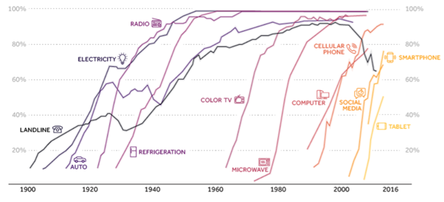
Figure 1: Technological landscape
(Source: Sredojević, Cvetanović, and Bošković, 2016)
The second force which helps in shaping the environment of global business like Tesco is the wealthy landscape. The evaluation of the world not only helps the organization and the county in getting developed but also provides a massive growth in the economic factor (Dudin et al., 2017). The more the organizations gain development the economic flow in the country will also increase. Apart from that, it is also observed that the UK is undoubtedly one of the largest opportunity providers to entrepreneurs to start the business. Also, the country has great technological infrastructure. So from the above statement, it is clear that the country is economically strong. Concerning the factor, the industries of the country will also intend to adapt ethical changes to gain development. The involvement of the tech invasion such as the company Tesla has developed and using their Artificial intelligence for auto-piloting the cars. These tech invasions not only increased the brand image of the organization but also help the organization in gaining a competitive advantage. The wealthy landscape is deliberately encouraging the global business for the adaptation of the technological advantages within their process for better growth and development. Recently another major factor that is observed in the automobile industry is the involvement of the 4.0 technology. This following technology can be defined as the mixture of the human and the artificial intelligence’s mind. In better words, the compilation and data exchange in the technologies of manufacturing. Also include the system of cyber-physical, the internet, and cognitive computing. With the help of this particular technology, an AI system within a car will easily provide the basic information regarding the engine condition, tire pressure, and other informative elements. Also, this specific technology is observed in one of the advanced cars from Tesla known as Cyber Truck (Undurraga, 2017). It is completely environmentally friendly as it runs on electricity.
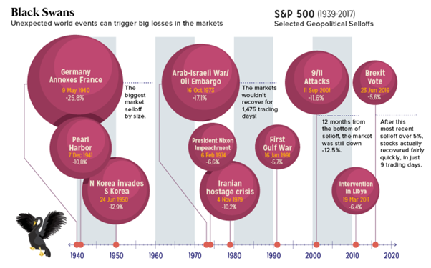
Figure 2: Wealthy Landscape
(Source: Undurraga, 2017)

Explanation of industrial changes:
From relevant information, it could be determined that the automobile industry has drastically changed in the past few years. It is observed that growth and development have increased in the automobile industry after the implementation of technological uses (Mitchell, 2017). The technological factor not only increases the growth of the global business but also changes the economic landscape of the country. However, the major factor which can be considered as another major force for the business environment shaping and industrial change is The Green Revolution. From various sources, it could be determined that the prime factor which helps the industry in getting developed is the adaptation of sustainable practices. It is observed that normal vehicles release harmful gases that affect the environment. This is why organizations like Tesla introduce Electric vehicles that are entirely environmentally friendly and do not affect the ecosystem (Eisenhut, Roell, and Weber, 2019). Also, other automobile organizations are desperately trying to adapt alternate sources of fuel for their vehicles which pose the least threat to the environment.

Critical assessment for challenges and opportunities

PESTLE:
Political factors: The political factors of the UK is very important as the UK is the most leading and powerful country in the world. The country has a parliamentary democracy with modern facilities and ideas. The great strength of this country is its political stability. However, Brexit has taken place and created some sort of uncertainties which is very much controversial. It creates some political debate also.
Economic factors: The economic landscape of the UK is another important element in the PESTLE. Though the recession had put trouble in 2008, the government and policymakers have taken major steps to develop it. Hence, According to the World Bank, in 2018, the UK has the 5th largest and biggest economy of the world which is considered by the nominal GDP.
Social factors: The social factors of the UK are historic which has various influences over the whole world. The population of the country is multicultural. Various companies have introduced and developed various products to meet up the demands of different religions and still, now there are many opportunities for the companies to explore.
Technological factors: The country has advanced technology in the whole world and the hub for both technological and financial institutions is cited in London (Gheibi et al., 2018). That advanced technology offers unlimited opportunities and a great infrastructure to run their business in the UK.
Environmental factors: Environmental factors of the UK is another important element. The UK has created a significant improvement to reduce the negativity to make a friendly business environment. Currently tourism business is booming there which contributes around 127 billion GBP annually.
Legal factors: Legal landscape of the UK is very clear and straightforward. The country had its employment act in 1996 to protect the rights of staff and employees. The act includes minimum wages, maternity leaves, sick pay, paternity leaves, holiday pay, and many more.

SWOT:
Strength: The strength describes a company’s positive aspects. It helps the company to enforce the position to become a dominant company in the world. The strength includes various aspects such as the number of employees, the company’s creativity, production capacity, market shares, goodwill, and many more. Let's have a look through the point of view of Tesla. Tesla employs almost 50000 employees. It has a great workforce which is full of diversity. | Weakness: The weakness includes the weak points of a company which can create damages for the company. It can create a negative impact on the performance of the company in many ways such as manufacturing complications, lack of huge production, unable to meet the demand, and many more (Blockeel et al., 2016). It is found in the organizational structure of Tesla that the company has those shortages which reduce Tesla’s competitiveness and hamper its business growth.
Opportunity: The SWOT analysis includes opportunities that present various scope for the company to expand it's business and other profitable activities. Tesla has significant opportunities to expand its cars and vehicles business in the market of Asia according to its demand. The market is still underrated for automotive renewable energy. Another opportunity for Tesla is the cars of Tesla are less expensive compared to others. Not only that, currently Tesla has introduced its pickup truck which has a great opportunity to flourish its business. | Threat: Another important and negative aspect of a SWOT analysis is the threats which restrict the company to take full advantage and benefits that might come from the strengths. As far as Tesla’s concern the company has some threats such as its complex production. The products Tesla are so complicated to repair due to its complicated engineering and innovation (Niederwieser et al., 2016). Not only that, extensive competition is another threat for the company also.

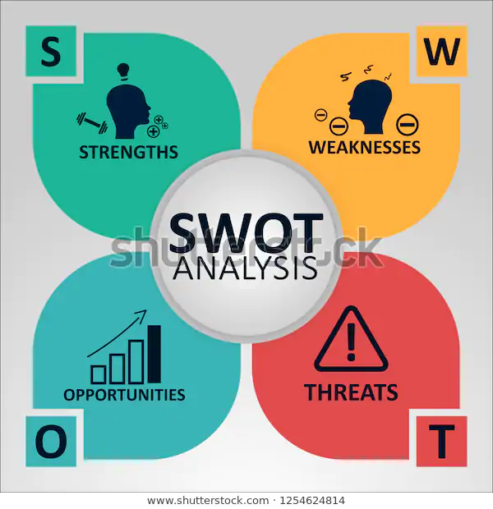
Figure 3: SWOT ANALYSIS
(Source: Niederwieser et al., 2016)

PORTERS 5 FORCES:
- Potential of new entrants into the industry: It is a threat actually for either a company is entering into the market or another company because it can affect the market. For example, Tesla entered the electric car industry in 2003 which is not so old and the company wishes to reduce its production cost to sustain the market.
- Power of suppliers: It is another important factor of five forces which states that the dominant suppliers have the power and capacity to reduce their marginal cost. Tesla needs multiple products to make an electric car so the company can use its power by bargaining efficiently with other multiple suppliers.
- Power of customers: Most of the time the buyers want to purchase electric cars with the lowest price. It creates pressure on the company. To tackle this bargaining power of customers Tesla builds a large number of base customers which help the company to increase its sale.
- The threat of substitute products: It is another threat to the electric car industry which states that the alternative electric car company has arrived in the market as well as similar substitute products. Tesla can switch and increase the costs in other segments for its customers.
- Competition in the industry: Another biggest threat according to Porter's five forces is competition in the electric car industry (Chen and Cheng, 2019). If the rivalry is intense among the players then it can drop the prices and decrease the profitability. Tesla can build innovative designs for their electric cars to beat those rivalries and other competitors.

PRODUCTS LIFE CYCLE:
- Introduction: This is the stage where a company develops a market for a particular product. The company creates awareness about the product and introduces it to the customers. For example, electric cars are very popular nowadays and Tesla is a company that makes electric cars for its customers.
- Growth: According to this stage the product has been accepted by its customers and companies always try to increase its expansion. Tesla does the same also for its electric cars.
- Maturity: In this stage competition increases and the products may require to be enhanced. According to the report of Tesla, as Tesla is not so old a company in the field of electric cars so it does not reach its maturity level (Ruan et al., 2019).
- Decline: In this stage, the life cycle of a product decreases due to high competition, changes in trends, and many more. As still now Tesla has some untapped market so it is not in the declining stage.
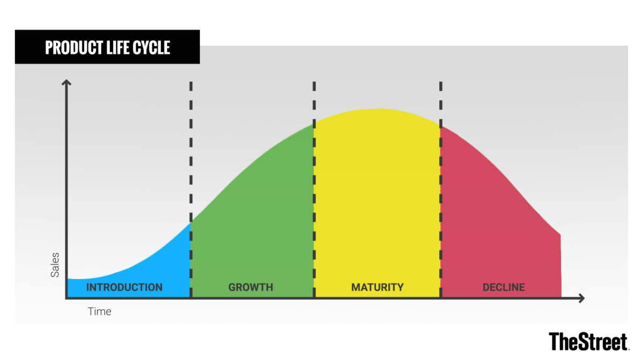
Figure 4: Products life cycle
(Source: Ruan et al., 2019)

Conclusion
Thus, from the above study, it could be concluded that the forces such as the technological innovations, economical landscape, and the factor of sustainability support the organization as well as the country in gaining growth. Some of the very crucial factors are critically highlighted in this study such as the PESTLE analysis along with the SWOT analysis. Apart from that the porter's five forces and value chain are also presented in this study. Lastly, the study put a deep concern on the opportunities and challenges. Also presented a clear analysis of the changes in the industries in the recent past years.

Reference list
Blockeel, C., Drakopoulos, P., Santos-Ribeiro, S., Polyzos, N.P. and Tournaye, H., 2016. A fresh look at the freeze-all protocol: a SWOT analysis. Human reproduction, 31(3), pp.491-497.
Chen, Y.G. and Cheng, J.N., 2019. A STUDY INVESTIGATING TEACHERS'COMPETITIVENESS-MICHAEL PORTER'S FIVE FORCES MODEL AS THEORETICAL BASIS. Academy of Educational Leadership Journal, 23(2), pp.1-18.
Dudin, M.N., Lyasnikov, N.V.E., Sekerin, V.D., Gorokhova, A.E.E., Danko, T.P. and Bank, O.A.E., 2017. Technological changes as the development factor of the global and Russian energy sector. International journal of energy economics and policy, 7(1), pp.209-215.
Eisenhut, M., Roell, M.S. and Weber, A.P., 2019. Mechanistic understanding of photorespiration paves the way to a new green revolution. New Phytologist, 223(4), pp.1762-1769.
Gheibi, M., Karrabi, M., Mohammadi, A. and Dadvar, A., 2018. Controlling air pollution in a city: A perspective from SOAR‐PESTLE analysis. Integrated environmental assessment and management, 14(4), pp.480-488.
Mitchell, D., 2017. A relational approach to landscape and urbanism: the view from an exclusive suburb. Landscape research, 42(3), pp.277-290.
Niederwieser, D., Baldomero, H., Szer, J., Gratwohl, M., Aljurf, M., Atsuta, Y., Bouzas, L.F., Confer, D., Greinix, H., Horowitz, M. and Iida, M., 2016. Hematopoietic stem cell transplantation activity worldwide in 2012 and a SWOT analysis of the Worldwide Network for Blood and Marrow Transplantation Group including the global survey. Bone marrow transplantation, 51(6), pp.778-785.
Ruan, J., Wang, Y., Chan, F.T.S., Hu, X., Zhao, M., Zhu, F., Shi, B., Shi, Y. and Lin, F., 2019. A life cycle framework of green IoT-based agriculture and its finance, operation, and management issues. IEEE communications magazine, 57(3), pp.90-96.
Sredojević, D., Cvetanović, S. and Bošković, G., 2016. Technological changes in economic growth theory: Neoclassical, endogenous, and evolutionary-institutional approach. Economic Themes, 54(2), pp.177-194.
Undurraga, T., 2017. Making news, making the economy: Technological changes and financial pressures in Brazil. Cultural Sociology, 11(1), pp.77-96.

