
Intercultural Competence Report
Foreign Languages & Cultural Awareness – BMIH5003

Megan pallant
2225226
University of Wales Trinity Saint David
Heidi Posser
Word Count: 1030

Executive Summary

The purpose of this report is to evaluate the challenges that affect international management and leadership factors within the hospitality industry, this evaluation will critically analyse the pros and cons of intercultural leadership in the service business. Utilising the research study of the GLOBE project to investigate similarities and differences between the two countries and their cultures generating their GLOBE project scores.
Each country was placed into a cluster depending on culture, relevance and history, the two countries discussed was England, a part of the Anglo cluster, and Germany, a part of the Germanic Europe cluster. Differences were obvious however the more interesting factor was the obvious similarities between the two countries within all nine dimensions.
A successful leadership and management team will be determined by the resources and attitude the company has toward intercultural awareness and differences, international businesses can grow within the hospitality world if careful consideration and effective research is carried out when expanding the company. The research has proven simple misunderstandings and taking elements for granted can negatively impact the growth and success of management.

Table of Contents
Executive Summary 1
Introduction 3
Main Body 3
Conclusion 7
Recommendations 7
Reference List 8

Introduction
Barrows and Powers (2009), examine the dynamic factors continuously changing and advancing the hospitality industry, an inconsistent market relying on individual segmentations and being adapted through developing international cultures. Even though the purpose of the industry will never alter, generating positive customer experiences through a passionate service, the evolution of the world has brought to light new demanding topics to shape the future of the hotel marketplace. The GLOBE project (Global Leadership and Organisational Behaviour Effectiveness) was a study introduced to define nine cultural dimensions (performance orientation, assertiveness, future orientation, human orientation, institutional collectivism, in-group collectivism, gender egalitarianism, power distance and uncertainty avoidance) affecting international management and leadership, the practices and values of individual countries within a business environment were investigated through the use of the GLOBE project (Brewer and Venaik, 2010). Javidan et al (2016), further discusses the positive developments of multinational corporations' intercultural leadership through interrogating the evidence proven by the GLOBE projects nine dimensions.

Main Body
Culture is a vast term with a thousand definitions and stems from hundreds of diverse terminologies, Spencer-Oatey (2012), states alongside all the other definitions culture is simply the shared beliefs, attitudes and values that characterise grouped communities and countries to form different diversities around the world. The hospitality industry embraces global cultures within customer service however, intercultural insensitivity frequently emerges in customer interactions due to the continuous evolution of the human world and the misunderstandings surrounding It (Tabari, Wilson and Ingram , 2016).
To unite and tackle the obstacles of cultural misunderstandings 150 countries collaborated with 500 researchers to generate the GLOBE project, this consists of the nine dimensions which are a fair collective assessment of the potential complications affecting hospitality management and leadership in international businesses in the corporate world (Jenkinson, 2022). Robert House founded the GLOBE project in 1991 with the purpose of connecting intercultural businesses and choosing the nine dimensions which are described below (Sochor, 2020):
- Performance Orientation: The acknowledgment of high work performance in an individual or collective group.
- Assertiveness: Members being hostile and assertive to others in scenarios.
- Future Orientation: People planning and investing in future objectives with positive behaviour.
- Humane Orientation: Acknowledging and rewarding the positive and kind characteristics of a human being.
- Institutional Collectivism: Organisations motivating and rewarding institutional practitioners.
- In-Group Collectivism: Members appreciate the institute for which they work.
- Gender Egalitarianism: An organisation or individual minimising gender inequality.
- Power Distance: Humanity accepting and advocating authority and society's privileges and differences.
- Uncertainty Avoidance: Organisations heavily depend on political procedures to protect them from uncertain future events, heavy dependence requires daily laws and structure dictating people's lives.
The GLOBE project analysed each countries culture and formed a cluster, England are a part of the Anglo culture cluster which dates back to the British Empire, Ashkanasy et al (2002), elaborates on how the Anglo collection is formed of some of the wealthiest countries in the world with unique corporate characteristics such as a high form of male dominance and strong individualistic performance orientation values and practices. England specifically has several cultures within its communities; therefore, the practices and values of an institution need to account for employee lifestyle differences. England’s GLOBE scores from the nine dimensions match what Ashkanasy, Trevor-Roberts and Earnshaw previously discussed, segments that would indicate characteristics of a competitive and power-focused workforce are shown in England intercultural values and practices. The balance between values and practices draws a fine line, having managerial competence on a cultural level requires the close work of aligning the two on all subjects, referring to the source England has aligned practices and values linking to the individual and prevailing progression sections and not the others like: assertiveness, future orientation and institutional collectivism.
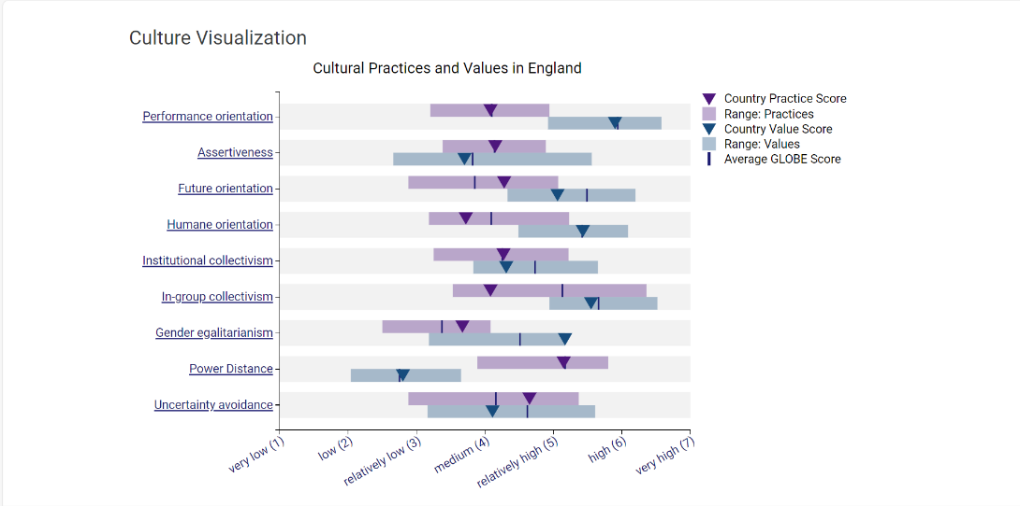
(The GLOBE Project, 2020)
Germany, like England, has a very powerful and influential background, however, the modern era has learned from the past of Germany and aligned all corporate and lifestyle values and practices against its history. Germany’s GLOBE project scores are split between East and West Germany due to the forty one year divide, this divide generated drastic cultural and lifestyle differences which slowly had to turn into the new normal after 1990 (Dalton and Weldon, 2010). Everything between east and west Germanys cultural practices are identical meaning Germany relied on corporate management and institutional intercultural competence to form generalised values and practices for businesses.
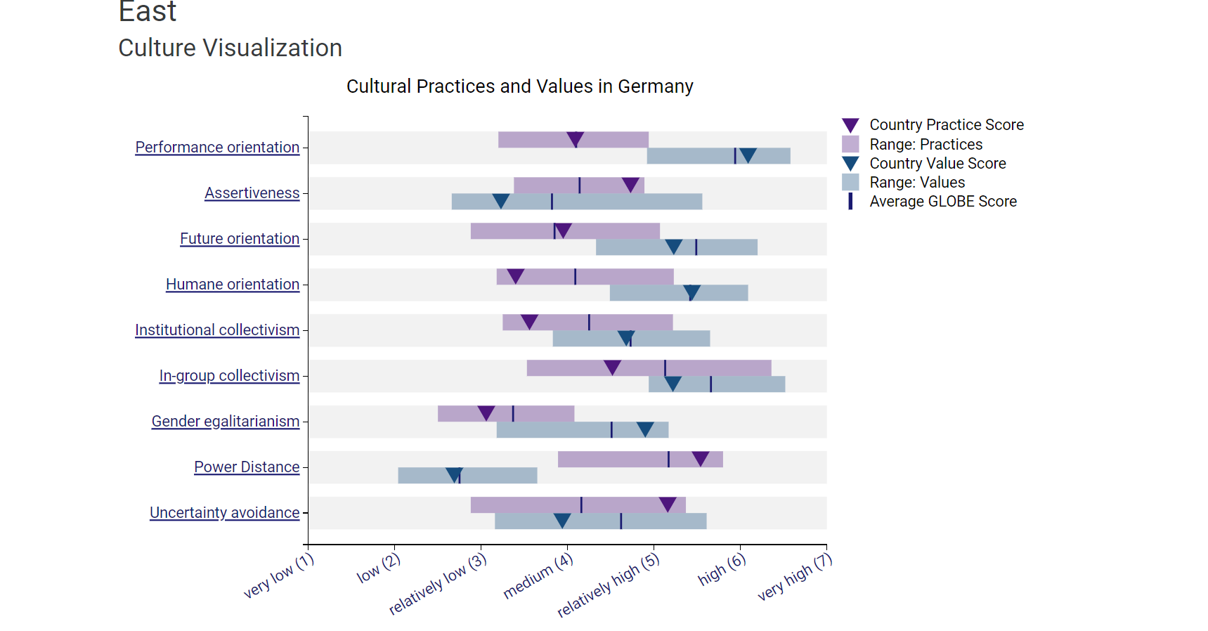
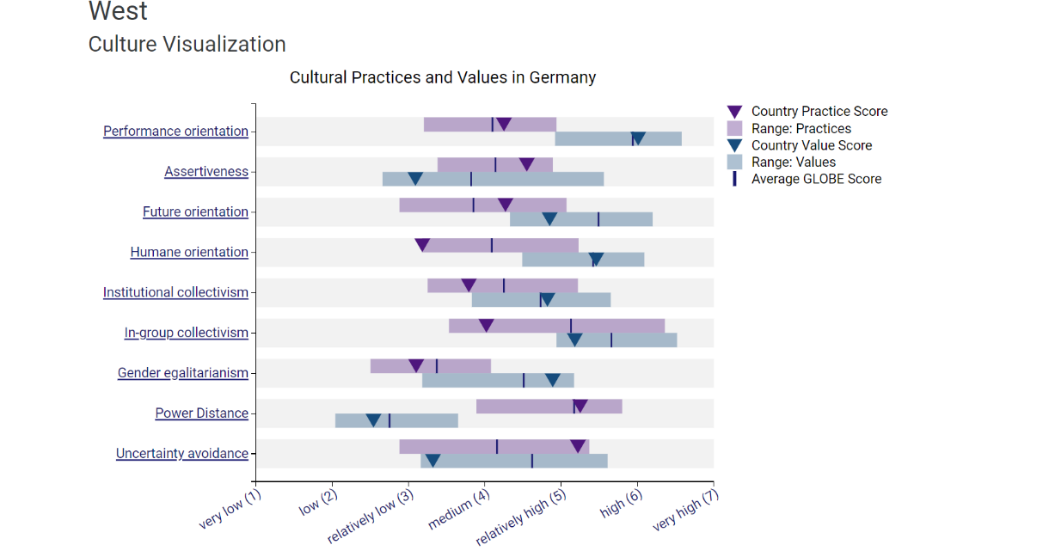
(The GLOBE Project, 2020)
England and Germany have similar GLOBE project scores which is beneficial for businesses from either country expanding into the other, key segments which will affect an establishment going international to the next country will be the institutional orientated and personal elements. Gender egalitarianism is not a culture or a part of a culture it is personal and it is life, history has shaped today's generation and their views on gender equality and this shapes the corporate world. England is more inclusive in businesses when it comes to gender equality compared to Germany, this can affect the hiring intake and success of an organisation if individuals feel practices and values are not put in place to deter the company from favouriting the opposite gender.
Hospitality organisations that venture into international businesses automatically produce more stress and challenges for operating staff and managers, intercultural communications between managers and staff and then staff and customers cause an increase in complaints generating complications. Leaders and management must become versed in all cultures and knowledge to handle misunderstandings and insensitivity (Grobelna, 2015).

Conclusion
International establishments make themselves responsible for being intercultural aware when they progress a company across borders. Each cluster and country have its own cultures, ways of life, gestures and everyday norms which must be understood in depth to competently teach and lead in a group of employees in a successful company abroad. England and Germany are not all different so leadership and management styles will not have to drastically adjust however the importance is in the approach and willingness to adapt slightly to the surrounding communities beliefs and values.

Recommendations
- Constantly take into consideration the evolution of the surrounding world.
- Take time to teach all staff about the surrounding communities' cultures and everyday norms.
- Ensure values and practices support each other to effectively reach employees and customers.

Reference List
Ashkanasy, N.M., Trevor-Roberts, E. and Earnshaw, L. (2002) ‘The Anglo Cluster: legacy of the British empire’, Journal of World Business, 37(1), pp. 28–39. Available at: https://doi.org/10.1016/S1090-9516(01)00072-4. (Accessed: 25 February 2024).
Barrows, C.W. and Powers, T. (2009) Introduction to the Hospitality Industry. Seventh. New Jersey: Wiley, pp. 3–4. Available at: https://viewer.ebscohost.com/EbscoViewerService/ebook?an=225446&callbackUrl=https%3a%2f%2fresearch.ebsco.com&db=nlebk&format=EB&profId=ehost&lpid=&ppid=&lang=en&location=https%3a%2f%2fresearch.ebsco.com%2fc%2f4krktg%2fsearch%2fdetails%2fk27ye6prln%3flimiters%3dNone%26q%3dThe%2bhospitality%2bindustry%26db%3dplh%252Cnlebk%252Chjh%252Cnsm&isPLink=False&requestContext=&profileIdentifier=4krktg&recordId=k27ye6prln (Accessed: 14 February 2024).
Brewer, P. and Venaik, S. (2010) ‘GLOBE practices and values: A case of diminishing marginal utility?’, Journal of International Business Studies, 41(8). Available at: https://doi.org/10.1057/jibs.2010.23. (Accessed: 14 February 2024).
Dalton, R.J. and Weldon, S. (2010) ‘Germans Divided? Political Culture in a United Germany’, German Politics, 19(1). Available at: https://doi.org/10.1080/09644001003588390. (Accessed: 26 February 2024).
Grobelna, A. (2015) ‘Intercultural Challenges Facing the Hospitality Industry. Implications for Education and Hospitality Management’, Journal of Intercultural Management [Preprint], (3). Available at: https://www.ceeol.com/search/article-detail?id=798971 (Accessed: 26 February 2024).
Javidan, M. Dorfman, P.W. Luque, M.S.D. House, R.J. (2016) Readings and Cases in International Human Resource Management. 6th edn. Edited by S. Reiche. New York: Routledge. Available at: https://www.taylorfrancis.com/chapters/edit/10.4324/9781315668703-10/eye-beholder-cross-cultural-lessons-leadership-project-globe-mansour-javidan-peter-dorfman-mary-sully-de-luque-robert-house (Accessed: 15 February 2024).
Jenkinson, P. (2022) ‘GLOBE Project Cultural Dimensions’. Available at: https://www.youtube.com/watch?v=3du_rZ0U90Q (Accessed: 22 February 2024).
Sochor, J. (2020) ‘Comparison of selected attributes in cultural dimensions as defined by Hofstede and the GLOBE Project’, in CENTRAL AND EASTERN EUROPE IN THE CHANGING BUSINESS ENVIRONMENT. 20th International Joint Conference. Available at: https://www.researchgate.net/profile/Malgorzata-Budzanowska-Drzewiecka/publication/351248901_Cross-cultural_Differences_in_Electronic_Word-of-Mouth_A_Literature_Review/links/608d2193458515d315ea4272/Cross-cultural-Differences-in-Electronic-Word-of-Mouth-A-Literature-Review.pdf#page=279 (Accessed: 22 February 2024).
Spencer-Oatey, H. (2012) ‘What is Culture?’, A Compilation of Quotations [Preprint]. Available at: https://d1wqtxts1xzle7.cloudfront.net/40397043/Spencer-Oatey_2012_What_is_Culture-libre.pdf?1448544489=&response-content-disposition=inline%3B+filename%3DSpencer_Oatey_2012_What_is_Culture.pdf&Expires=1708531808&Signature=EW3mdbWJb20buEc6PCPJ8yXEdMcCrVymq17lAkxKfWTIiwS--QGSEPERwi-sPmGk3D8Q1s3jSFAU2zWUs0riSQtK5uqMv5vVD8MHPUn-d4q3XRr5Re6ZdgVmxFzoUCVKVGTPV949Aq-ol1ltqbEz-PFEhkhpq68WMf8YBKFtmt4DjPssdZLVxZO7FVvsWff0OKESagpbG0fIuFrVoM4fnQDS7EXnQ19llePgIaSIaqjmdcWU9~GXJp2TaBL2bdEWXxT5-k8H1WmFycUosEGmRQ1w~dvidUeP1Dc2ebfaJag-YyHJ-iZy55CEMaU84bjM3weUvO52S9lecjvUE-vDgA__&Key-Pair-Id=APKAJLOHF5GGSLRBV4ZA (Accessed: 21 February 2024).
Tabari, S., Wilson, J.A.J. and Ingram , H. (2016) ‘Conceptualising the impact of culture and language upon hospitality service management’, Worldwide Hospitality and Tourism Themes, 8(1). Available at: https://doi.org/10.1108/WHATT-10-2015-0037. (Accessed: 22 February 2024).
The GLOBE Project (2020) Cultural Practices and Values in Germany, GLOBE 2020. Available at: https://globeproject.com/results/countries/DEU%3Fmenu=list.html#list (Accessed: 26 February 2024).
The GLOBE Project (2020) Cultural Practices and Values in England, GLOBE 2020. Available at: https://globeproject.com/results/countries/GBR%3Fmenu=list.html#list (Accessed: 25 February 2024).

