AYSHA KHATUN - 1816670
developing innovation & creativity for business advantage BMSW6102
Urban Electronics
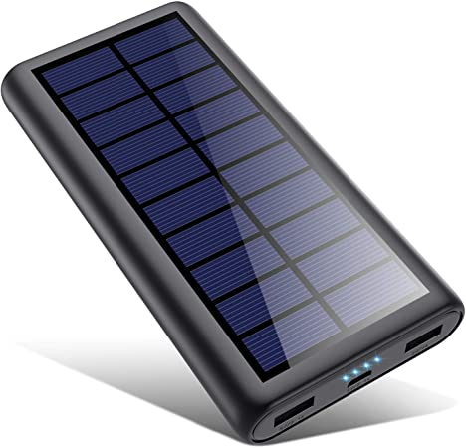

Portable Solar 3 Plugged Charging Device

Table of Contents
1. Introduction 3
2. Task 1 3
2.1 Innovative Service Idea 3
2.1.1 Required Services 3
2.1.2 Catering to the Growing Customer Needs 4
2.1.3 Target Customers 5
2.4 SWOT Analysis 5
2.5 Innovation Matrix Framework 6
2.6 Competitor Analysis 7
2.7 Sustainability of the Product 7
2.2 E-commerce OR Brick-and-Mortar Store 9
2.2.1 Shopify and eBay 9
2.2.2 Developing Content, Written and Pictorial 9
2.2.4 Content Consumption 10
2.2.5 Financing 10
2.2.7 Recruitment 10
2.2.8 Payment Options 10
2.3 Marketing 11
2.3.1 Location and Identification of Client 11
2.3.2 Promotion 11
2.3.3 Email Marketing 12
2.3.4 Social Media Marketing 12
2.3.5 SEO and SEM 12
2.3.6 Market through Influencers 12
References 14

1. Introduction
The role of technology is emerging at the highest rate, and in the current period, people are more forward toward technology than they have ever before. The current report is based on the saleable innovative service that attends to the customers’ emerging needs and wants. In contrast, the purpose of this report is to understand the customer’s wants and propose an innovative service to sell. However, while considering the customer’s wants, the product which is the focus of the study is the solar mobile charging device, and it will be launched with the venture name Urban Electronics. The use of solar energy for charging the phone leads to greater benefits; as per the study by Rahi et al. (2021, p. 37), solar energy chargers are portable, which creates ease for users. In addition, Urban Electronics gives a competitive advantage by promising fast and efficient 24-hour delivery to its customers. The in-depth reasoning is described below.

2. Task 1

2.1 Innovative Service Idea
The use of technology is increasing at a fast pace, and that product who have good technology with reasonable price and convenience is the best choice for all customers (Saona et al., 2021, p. 32). The innovative service of portable solar charger that provides battery charging through solar panels helps contribute to reducing global pollution and caring for the environment. The product offers the public an eco-friendly portable charger with a three-port that allows charging the cell phone and other devices at the same time, making use of its solar panels to trap solar energy in the internal battery, being the main attraction since the customer will not be aware of any charging outlet if they are outside their home or office. In addition, it is friendly to the environment be created with recycled materials

2.1.1 Required Services
The current focus is on the offering of solar energy portable mobile charging devices while considering the need of customers. The idea of using solar energy helps the customers to save electricity, and also, if the customer is out of charging, then it will be easy for them to charge through solar energy. However, the best thing is the efficient, fast delivery service which will resolve the hassle of customers.

2.1.2 Catering to the Growing Customer Needs
According to Montag and Elhai (2020), electronic chargers play an important role in charging the device. However, customers always demand a product that is easy and convenient to use. The current product is easy to charge, which fulfills the customer requirement but apart from easiness, the proposed product brings innovation by giving the options of 3 charging portals. Saona et al. (2021, p. 32). The problem that is identified is that people often do not find a place to charge their cell phones and other devices, especially if they run out of battery. It is so the product 3 charging portals eco-friendly portable charger is realized as part of the solution. The product is an ecological solar charger, and this product is made based on corrugated cardboard, a recycled battery, two solar panels, 3 USB outlets, and a switch that controls the energy output. This charger is powered by solar energy and led light; all this energy is stored in the recycled battery, which allows customers to use this charger at any time when they need it. The output includes 3 USB ports, so any smartphone and other devices can be connected via a USB cable

2.1.2.1 The Unique Selling Point (USP)
There are already a large number of people selling electronic gadget accessories online; therefore, there are less likely chances that the consumer would purchase this device. Apart from that, the USP has been added in two ways; one is the option of using three devices, such as a mobile phone, camera, ear-pods, and smartwatch, at a time with a single device. On the other hand, the fastest delivery option is the second USP of the proposed product. Keeping the inventory up to date with the latest trends and releases is a key strategy for sustaining this business and ensuring its long-term growth and operation (Kiel, Arnold, and Voigt, 2017, p. 15). The Unique Selling Point (USP) is the option of using three devices at a time for charging with a single solar portable charging device. The device would be launched with the venture name Urban Electronics because the name reflects the electronic appliance, and Urban denotes the population in urban areas.

2.1.3 Target Customers
This product targets the market of men and women between the ages of 18 and 39 that require an eco-friendly portable charger. Moreover, to reach the target audience, the 3 port eco-friendly portable charger will be marketed through its own web platform and social networks. (Payne, 2020, p. 245). Users of this service are likely to be people who spend most of their day working with, needing, or simply enjoying electronic devices for personal or professional reasons. It is a common problem for people who spend most of their time in front of a computer or other electronic device to charge their devices on time (Donthu and Gustafsson, 2020, pp. 286).

2.4 SWOT Analysis
Table 1: SWOT Analysis
Strengths | Weaknesses
1. Urban Electronics provides rich solar resources. | 1. In the manufacturing of products, it occurs a high investment cost.
2. Urban Electronics provides three charging portals. | 2. Battery degradation.
3. Strong domestic demand. | 3. It is difficult to repair in case of damage.
4. Efficient, fast delivery service. | 4. No availability of charging storage or backup.
5. Flexible, portable design. | 5. High cost of raw material.
Opportunities | Threats
1. Emerging trend of solar power products. | 1. Less trust in new electronics products.
2. Long-term economic benefit. | 2. Uncertain weather conditions.
3. Increasing gap within energy supply. | 3. Existing competition in the market.
4. Increasing awareness of the use of renewable energy resources. | 4. Increase the use of hybrid technology.
5. Decrease the dependency on the availability of electricity. | 5. Solar technologies require rare materials in their production.

Therefore, form the SWOT table analyzes the key factors to achieve business success. are highlighted strengths and weaknesses when relating it realistically and objectively to the competition and the opportunities and threats of the environment. Therefore, considering the strengths and weakness, the company need to adopt strategies such as taking advantage of our products to enter the market with a new brand, investing in customer recruitment, taking advantage of optimization costs, providing quality of service to our clients, having negotiations and/or contracts exclusively with the providers and generating income through e-commerce. Moreover, considering the opportunities and threats, it should prepare mass publicity before the growth of new bidders takes advantage of the growing economy of the country to carry out investments in improvement areas, Offer customers discounts on the purchase of products, take advantage trade agreements with China and generate quotes with various providers to have a backup, in case the main supplier fails us or alters the contract.

2.5 Innovation Matrix Framework
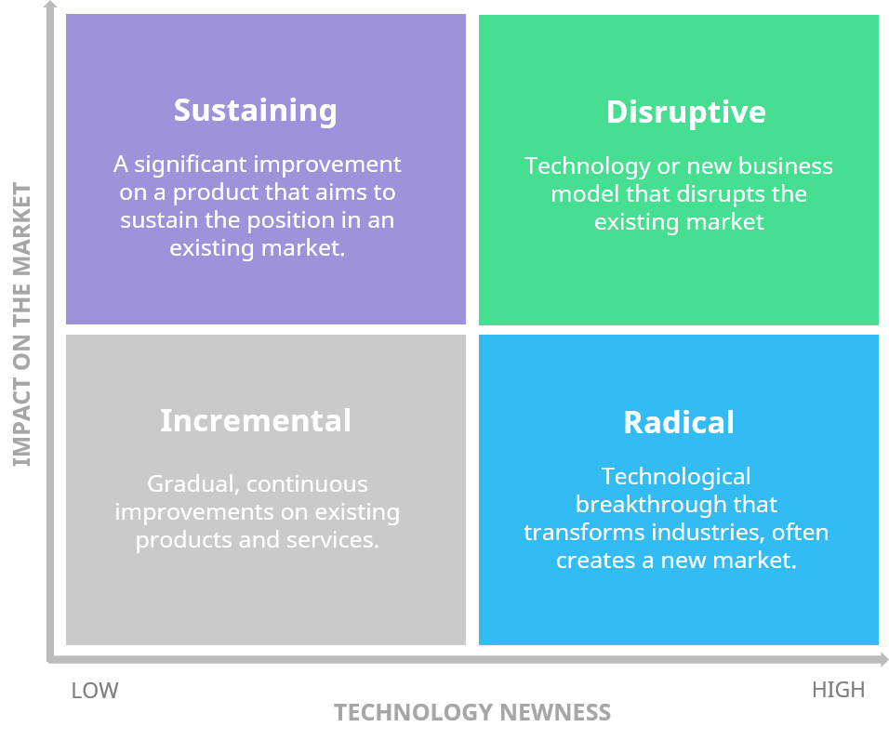
Figure 1: Innovation Matrix Framework
Therefore, considering the innovation matrix for the product, the product lies in disruptive innovation as there is a possibility that the innovation could reduce the market size of the existing electric chargers used and offered by different competitors currently.

2.6 Competitor Analysis
The Samsung brand was chosen as the first competitor since it is one of the most technology sectors in the world; what this pioneer of the technology is the clear and constant communication with its clients in the campaign advertising they carry out, thus positioning themselves as a brand of good quality and high technological development. However, the prices of their products are high and are not eco-friendly; therefore, Samsung positions it in the lowest rank of the matrix of competitors. The second competitor we consider is Suaoki, a trader brand of products technological products from China; among these products its portable solar chargers. They are the ones that stand out the most. This last-mentioned product, although it is the star product of the brand, it is not yet fully positioned in the current market;
Furthermore, the perception the products from China are of low quality. Also, the price of their chargers is higher than average, and it uses solar power for charging (Burnett and Hutton, 2019). Furthermore, the third competitor we chose, Coolbox, a technology brand already positioned in the market and with a good brand recall. Although the prices at which offers its portable chargers are according to the average market price, they are not friendly to the environment. The competitive advantage that Coolbox offers, apart from the quality and prestige, is the guarantee they offer. Thus, in conclusion, our innovative products in the above-mentioned competitors have good attributes with regard to quality and the good positioning of some brands in the market. On the contrary, Urban Electronics offers a new proposal since it has a price that directly competes with market prices and is a product 100% ecological.

2.7 Sustainability of the Product
Product Life Cycle
Our port eco-friendly portable charger is in the Introduction stage in the cycle of life. This is because it is a new product on the market, and the brand does not have recognition by the target audience.

Figure 2: Product Life Cycle
Market Life Cycle
The market where our product is located is the market of laptops charger, which is positioned in the growth stage of the life cycle. This market is growing, thanks to the new competitors that are entering the market, mostly Chinese brands; It is also because the market does not is fully established in the country.

Figure 3: Market Life Cycle

2.2 E-commerce OR Brick-and-Mortar Store
The medium of e-commerce has been chosen because online presence creates more impact on the sale of products. Also, because of the Covid-19 pandemic, consumers are shifting away from the traditional approach to trade, which necessitates an online presence for businesses (Ma and Kwon, 2021, pp. 3078). Because Urban Electronics needs to be in the right place at the right time, the business will be launched on both SaaS and marketplace levels.
The product will be promoted through various promotional programs, but after all the marketing and promotion procedures, the product will be launched and active on eBay and Shopify. There are many e-commerce sites, but eBay and Shopify were chosen because it is the most popular and widely used platform, allowing for a more flourishing business (Saona et al., 2021, p. 32). For one thing, it is better if the business starts in a location that is already frequented by the community. Therefore, deliveries can be made more quickly. Through the help of eBay and Shopify, customers in the UK and across the UK can access the product. In order for a new business to be successful, it must be based on a solid platform that has been thoroughly researched and is ready to go (Allen, 2015. p. 18).

2.2.1 Shopify and eBay
Shopify is the SaaS platform of choice for this service, and eBay is the preferred marketplace, as stated by Burnett and Hutton (2019, p.7). The region for sale is not only the UK, but target customers will also be across from other countries as well. The reason for choosing Shopify and eBay is because they are the most widely used by locals, and they generally ship to all corners of the globe, making them ideal for international customers (Jana, 2017, pp7). These two mentioned platforms will cover different spaces, and being indifferent spaces will help reach various potential customers at the same time (Crespo-Almendros and Del Barrio Gracia, 2016, pp. 23-25).

2.2.2 Developing Content, Written and Pictorial
Urban electronics consider the content because when pictures and content are attractive, then customers can influence by the presentation (Baltes (2017, p.111). However, attractive pictures of products lead to help in abreacting viewers who can become potential customers and ultimately buyers. In order to achieve a flawless online presence and promotion, careful and meticulous steps were taken following a thorough investigation.

2.2.4 Content Consumption
Customers’ content consumption habits were also taken into consideration when designing an e-commerce space. They were primarily people who used smartphones and laptops, preferred to interact with videos rather than written content, and had a short attention span when it came to websites. When it came to designing, it was decided that more images than words would be used on both the website and the SaaS, which made it easier for consumers to access the information.

2.2.5 Financing
The price of the solar charger is £30 in the UK, although as compared to the competitors, it is relatively low because one of the competitors sells it for £50 with having one option. However, deciding a price is always a critical decision. Therefore, Tencati and Pogutz (2015) suggested that it is important to consider the prices of competitors and compare the features for more selling. After choosing eh e-commerce platform, urban electronics ensured that adequate financing was in place to provide a smooth operation. However, in the planning process, many different types of current and trendy accessories were required to fill the customer’s demand.

2.2.7 Recruitment
Urban electronics gather the right person for the right job, however, starting with a manager and some delivery people who could handle multiple orders at once. Besides approving orders, the manager was in charge of overseeing the company’s inventory, and placing reorders when necessary (Prabhu, Rodrigues, and Kumar 2016, p. 10). Team meetings were also conducted every two to three days to discuss any modifications or new tactics. However, a sales manager is also a part of a business who is responsible for promoting the product and increasing the sale.

2.2.8 Payment Options
Cash on Delivery (COD) was the only method of payment offered because customers could inspect their goods before making a purchase, and the firm could avoid PCI-DSS concerns. However, the option of online payment always brings doubt to the mind of customers about the quality of the product.

2.3 Marketing
A proper marketing plan is highly important to bring success, but on the other hand, it is the most complex task as well (Krizanova et al., 2019, p. 25). Despite the complexity, promotion and marketing are not the same things. For example, promoting a brand is simply shouting about it on the street where no one is paying attention, whereas marketing is identifying and selling a product or service to a company’s target audience (Tencati and Pogutz, 2015, p. 38). Marketing and promotion are two very distinct things. The strategies used by Urban Electronics and how the intended demographic was discovered and targeted are mentioned below.

2.3.1 Location and Identification of Client
The approaches used in this component of the study included a variety of methods for promoting services to those who were most in desperate need of support. The first step was to perform an in-depth examination of the clientele and interview them in person. Later, the company conducted extensive market research based on current industry trends, which helped them to have a better knowledge of the expectations placed on them by customers in the new technological field. The firm also kept a close watch on its rivals and updated graphs and numbers on a regular basis to identify which areas they should concentrate on and which areas they should avoid focusing on or ignoring altogether (Grover, 2018, pp. 390). Technology such as Google Analytics was employed to give extra assistance in order to present the information in a more professional manner (Krizanova et al., 2019, p. 25).

2.3.2 promotion
After determining who its target demographic was and why it was vital for the business to engage them, the marketing abilities of the service-providing company were put to use by the company (Hartemo, 2016, p. 9). All that remains are for us to wait and observe how things turned out and what was achieved. According to the preceding paragraph, many marketing methods were used, including social media marketing and multi-channel advertising.

2.3.3 Email Marketing
The initial step was to create and maintain an email distribution list for the company’s employees. Consumer confidence was boosted by sending weekly updates to all prospective customers, which included enticing discounts, with the goal of increasing consumer confidence (Hartemo, 2016, p. 10). Aside from that, the clear majority of consumers in the poll were laptop and smartphone users, as well as those who checked their email on a daily basis (Gupta, Nair and Radhakrishnan, 2021, p.5).

2.3.4 Social Media Marketing
It was also possible to boost the company’s online presence via the usage of social media marketing strategies. Not only should an individual have an online presence, but an individual should also put effort into building a strong brand that people will remember. In order to be successful, Urban Electronics must have a strong social media presence (Krizanova et al., 2019, p.26). While the company’s services were described in-depth via extensive Facebook posts, its merchandise was shown using Instagram images and boomerang videos. As a result, they took the choice to sell the service in a manner that would appeal to young people, who formed the majority of those who utilized social media at the time (Hartemo, 2016, p. 17).

2.3.5 SEO and SEM
Urban Electronics, as an internet retailer, is responsible for ensuring that its brand is adequately sold and marketed to customers (Krizanova et al., 2019, p. 17).

2.3.6 Market through Influencers
According to the results of Johnstone and Lindh (2018, p. 7), children and adolescents are more likely than anybody else to pay attention to influencers, despite the fact that they are younger. It was standard procedure for this firm to give them a certain sum of money in return for a review or other services. The reviews were posted on their Instagram stories and Facebook posts after they got the items and paid the influencers for sponsored marketing. Sales started to flow as a result of the positive feedback. A variety of other tools and tactics were employed in addition to those that were more traditional in nature, such as printing flyers and sticking them up on the walls, lifts and doors of a large corporate building, as this is where the majority of electronic gadgets and the people who use electronic gadgets are concentrated (Hartemo, 2016, p. 8).

References
Books
Allen, K.R. (2017) Launching new ventures: An entrepreneurial approach. Cengage Learning.
Journal
Baltes, L.P. (2017) ‘The content marketing-the fundamental tool of digital marketing. Bulletin of the Transilvania University of Brasov. Economic Sciences. Series V, 8(2), p.111.
Burnett, J. and Hutton, R.B. (2019) ‘New consumers need new brands.’ Journal of Product and Brand Management.
Crespo-Almendros, E. and Del Barrio-García, S. (2017) ‘Online airline ticket purchasing: Influence of online sales promotion type and Internet experience’. Journal of Air Transport Management, 53, pp.23-34.
Donthu, N. and Gustafsson, A. (2020) ‘Effects of COVID-19 on business and research’. Journal of business research, 117, pp.284-289.
Grover, V., Chiang, R.H., Liang, T.P. and Zhang, D. (2018) ‘Creating strategic business value from big data analytics: A research framework’. Journal of Management Information Systems, 35(2), pp.388-423.
Gupta, R., Nair, K. and Radhakrishnan, L. (2021) ‘Impact of COVID-19 crisis on stocking and impulse buying behaviour of consumers. International Journal of Social Economics.
Hartemo, M. (2017) ‘Email marketing in the era of the empowered consumer. Journal of Research in Interactive Marketing.
Jana, S.K. (2017) ‘The measure of e-cash on delivery payment convenience option in the context of demonetization and its effect on customer loyalty. Thus Journal of Business Management, 16(3), pp.1-9.
Kiel, D., Arnold, C. and Voigt, K.I. (2017) ‘The influence of the Industrial Internet of Things on business models of established manufacturing companies–A business-level perspective’. Technovation, 68, pp.4-19.
Krizanova, A., Lăzăroiu, G., Gajanova, L., Kliestikova, J., Nadanyiova, M. and Moravcikova, D. (2019) ‘The effectiveness of marketing communication and the importance of its evaluation in an online environment’. Sustainability, 11(24), p.7016.
Ma, Y. and Kwon, K.H. (2021) ‘Changes in purchasing patterns in the beauty market due to Post–COVID‐19: Literature review’. Journal of cosmetic dermatology, 20(10), pp.3074-3079.
Montag, C. and Elhai, J.D. (2020) ‘Discussing digital technology overuse in children and adolescents during the COVID-19 pandemic and beyond: On the importance of considering Affective Neuroscience Theory’. Addictive behaviours reports, 12, p.100313.
Payne, A., Frow, P., Steinhoff, L. and Eggert, A. (2020) ‘Toward a comprehensive framework of value proposition development: From strategy to implementation. Industrial Marketing Management, 87, pp.244-255.
Prabhu, K.N., Rodrigues, L.L. and Kumar, K.R. (2017) ‘Workplace spirituality and team spirit at work: A team-level contextualization of spirituality’. Prabandhan: Indian Journal of Management, 9(12), pp.7-18.
Rahi, S., Ishtiaq, M., Farooq, W. and Alnaser, F. (2021) ‘Examining factors influence individual behaviour to continue the use of mobile shopping apps with the integration of technology acceptance model and brand awareness’. Economic and Social Development: Book of Proceedings, pp.35-45.
Saona, P., Akther, N., Al Mamun, MA and Azad, M.A.K. (2021) ‘Technologies for Cross-Border E-Commerce’. In Cross-Border E-Commerce Marketing and Management (pp. 30-53). IGI Global.
Tencati, A. and Pogutz, S. (2017) ‘It recognize the limits: Sustainable development, corporate sustainability and the need for innovative business paradigms’. Sinergie Italian Journal of Management, 33(Jan-Apr), pp.37-55.

