Using AI to secure cyber spaces
By Dylan Jones
2106499@student.uwtsd.ac.uk

Project Background
- Mini review - This project was inspired by the cyber world, everything to do with the world wide web, to the many devices we use today that make the world what it is. With the rising attacks to businesses security, it is paramount that more advanced system are set in place to prevent them. AI is one of the only systems that could easily mitigate these attacks. As found AI is able to adapt to situations, being able to detect problems and attacks faster, stopping them from causing harm. [1]
- Project field - Within this project there are two different fields that will be covered, one will be about cybersecurity, pertaining information about securing data, computer systems and network systems using specialist software. Cybersecurity also dwells into the physical side of security as well, much like security cameras, automatic doors, security personnel ETC. of course it entirely depends on the type of organisation, businesses may opt in for both system and physical security as both offer benefits. However, for a personal office/home, a system approach may be more suited, as a home office is easily more manageable physically by the owner. Cybersecurity makes sure that all devices are safely secured, while also mitigating attacks and alerting users of potential malware.
AI is another field that will be found in the project. AI Stands for artificial intelligence and is recently making a huge impact on the world today. The use of AI is changing how we work. Some softwares are able to write whole programs or large essays within seconds with barely any errors. Artificial intelligence is able to take mundane tasks such as scanning a computer for viruses manually and can automatically do them. AI takes tasks and makes them easier, a task that could take a human a few days to finish, could take an AI a matter of seconds if not minutes.
This project will be incorporating these 2 fields, showing how AI can change how we use cybersecurity, either by increasing security due to the AIs algorithm, or by setting up full automation so that all security tasks will not require full human interaction.
- Aim and Objectives - The whole idea of this project is to show how AI can be used to fully secure a cyber space, whether that be a home/personal space, or an organisational space. Considering all factors of this project, The main Aim for this project is to show the effectiveness and effortlessness of using AI to completely secure a cyberspace/network; in other words, to demonstrate that AI has the power to negate all forms of attacks and increases security without the need of human interaction.
While the aim of the project has been recognised, there are many milestones that need to be achieved in order to reach the projects final goal, some objectives have been created in order to mark these areas:
- To extract information on different AI systems to understand how they work
- To Identify using the data gathered, whether or not AI can be used to secure cyberspaces.
- To design, develop and experiment on AI systems to test cybersecurity function
- To test AI controlled system by initiating attacks, stress test
- Expectations and project submission - The expected outcome would be for the AI system to be fully operational, being able to fully detect, scan, and remove all vulnerabilities, while also deflecting/mitigating attacks from outside threats with little human intervention. For at this moment, most common cybersecurity measures have to be done manually using software, however this process should be done automatically, as some users have no awareness that this needs to be done.
The main submission for the project would be a demonstration of an AI system Securing a cyberspace in real-time, this will also be followed by extensive data collection. Recommendations will also be provided exploring the idea that switching to an AI system is beneficial, providing some AI tools that others could try for themselves.

Project Design
- Project outline - AI is complex, it definitely requires a vast amount of prior knowledge and time, due to some constraints this project will consist of experimental systems. Different AI systems will be used to experiment to see how each AI system is able to provide full security.
- Data collection methods - Data collection is vital for projects to succeed, it allows others to understand how the project came to such a place and how the main aim was reached. The data collection for this project will be based of the objectives:
- Information will be gathered on other AI systems to better understand how they work, seeing how different they are, how compatible they are to different systems and comparing them.
- Different AI systems will be used in different environments to see how they react, while comparing their issues and strengths.
- A stress test will be performed that will produce a full table of data. This would show whether or not the AI systems can protect against certain threats.
- Risks, limitations, ethical, legal issues - With any project, a series of issues can arise. Risks - While unlikely, a risk of using AI would be the AI being able to control more than just the security of a device, more so the AI taking over the whole system effectively losing control of the situation.
Depending on how the AI was created, in some cases malicious code can be infused within the AI code, effectively rendering the AI useless, or the AI becoming a vulnerability instead.
Limitations - a limitation would be that it would be quite hard to make any changes to the AI systems if needed, this is due to inexperience in the field, having no prior experience dealing with programming languages. While the AI systems need to have one outcome, if this outcome cannot be reached then the system will be voided or at least logged as a different term.
Ethical - Unjustified actions are a problem with AI, sometimes an AI might make a decision for securing the space that may not show any benefits, or could completely break the system. In which a complete reset would need to be done.
Legal - while most legal issues don't apply to this project, the use of AI that came from someone else that has not allowed use of the system, is in many ways illegal and with that many more factors will be made. To stop this confirmation will be required before any experimentation is done.
- Generalisability, reliability, validity of research -
Generalisability - While Cybersecurity has become a topic which most people will know at this point, as with every device has some sort of system that protects devices, however, AI isn't that well known, and explaining AI would require some prior knowledge to fully understand.
reliability - The research that will be undertaken will mainly consist of academic literatures, books, accredited websites, demonstrations ETC. all forms of research will have been made using sources that are credible.
- Data analysis - The data that will be obtained will be a series of screenshots/photos physically showing the process of how the AI will work. Statistical data will be collected to show how far the systems are able to protect a computer system/network and if that security will be able to hold against attacks.

Resource & Planning
- Resources required - Some resources that will be required will be: Computer systems, AI systems, Access to network servers, Virtual machine applications, these all are needed for the project to be developed, the use of literature is also required, as it could give more opportunity to test other theories. Of course as this project continues, there may be a need for more resources that may not have been planned.
- Timescale chart
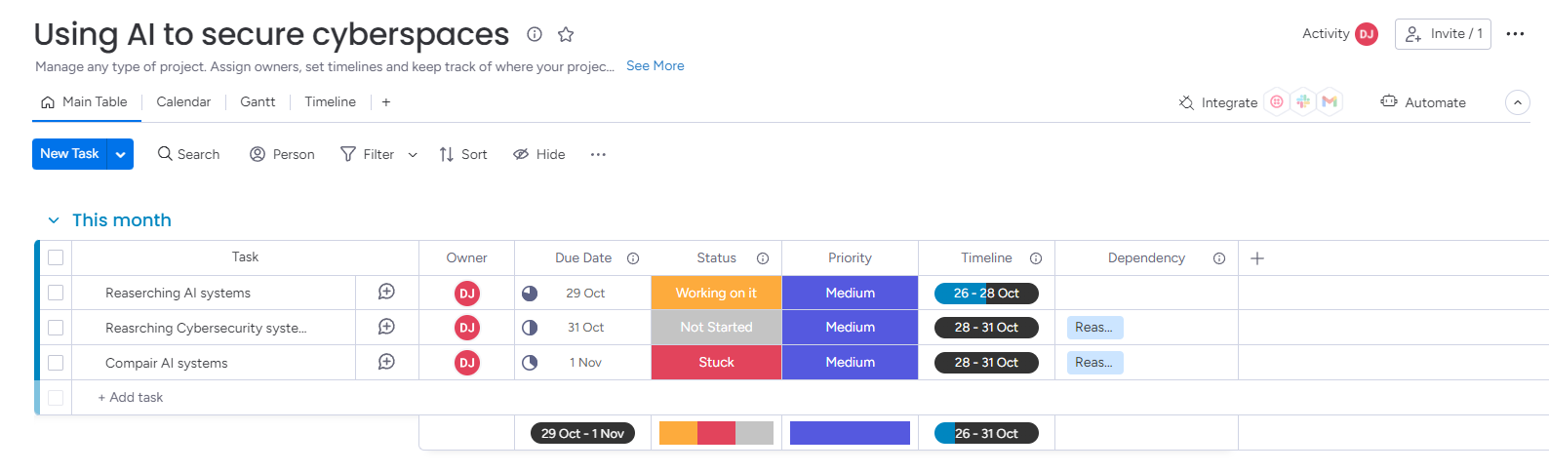
As the project is requiring 2 different types of information, for the first few weeks, research will be undertaken to better understand the 2 fields. As the project progresses, the time scales and the amount of tasks will increase exponentially

Bibliography

[1] | T. security, “AI in Cyber Security: Pros and Cons,” Terranova security, NA 01 2023. [Online]. Available: https://terranovasecurity.com/ai-in-cyber-security/. [Accessed 24 October 2023].

