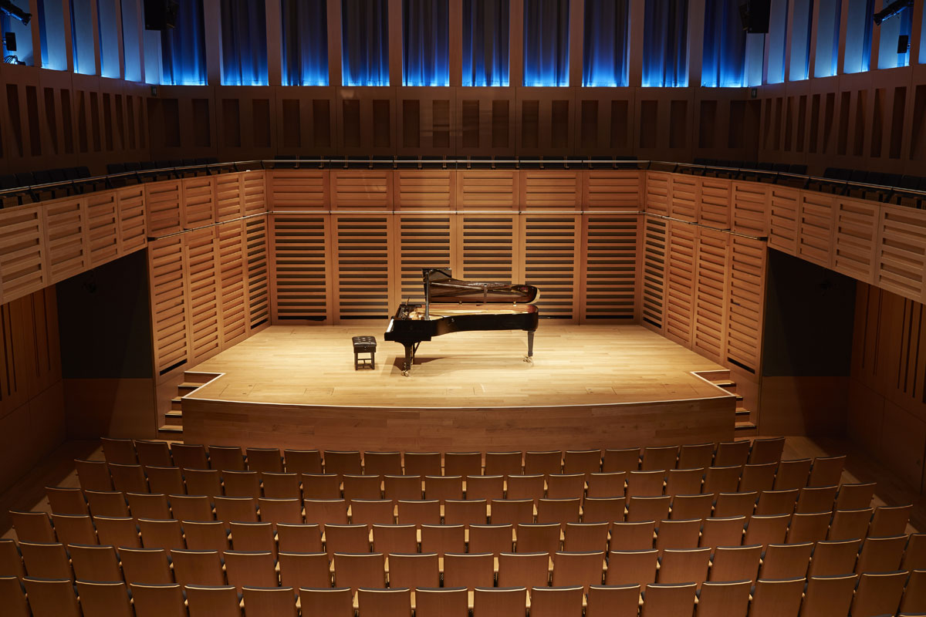

Kings Place Events

Denitsa Kazandzhieva – 1905860

DK Solutions

11/06/2021

Executive Summary
The purpose of this consultancy report is to address how events at King's Place London will be conducted after Covid-19 and how the organization can recover from the huge financial hit from the Covid-19 crisis. King's place Events is a hub providing venues for music, visual arts, and parties. It has maintained to be an exquisite site for holding such events. It is known for its exemplary setting along King's Square. Since the beginning of the Covid-19 crisis, the organization has been forced to shut down its physical events. The company has been forced to implement certain measures to ensure that some events are held online through social media and other online platforms that support video streaming. The company has been able to develop online tickets to sell to its viewers. The revenue generated from these events was less compared to in-house events.
This research incorporates a deep online survey from articles and blogs posted on the website of King's Place Events. The conducted research shows that despite the Covid-19 vaccine rollout, most people are not ready to attend physical events due to the fear of contracting Covid-19 again. Most event organizers are not ready to provide total security to the attendants of their events. Even if the host of the event is ready to offer physical events, the number of attendants will be less due to the World Health Organization directive of practising social distance (Lock, 2020).
The main problems at hand are rolling out a consistent set of rules at the events that every person who attends the event will agree to and ensuring responsibility for the safety and security of the attendants, staff, and stakeholders at the events. So far, only 42.4% of the total population has been fully vaccinated in the United Kingdom (WHO, 2021). This leaves less than half of the population vulnerable to Covid-19. In ratio, for every five people, two people Aare not vaccinated and vulnerable to Covid-19.
It is also evident from the research that most people are comfortable attending events via online streaming services. Most of these people are persons over 50 years of age (Bennett, 2015). Their age is most susceptible to Covid-19. Therefore, they prefer their comfort to watch on the sofa from their house rather than risk contracting Covid-19 at physical events (Bob, 2020). This would greatly affect the number of attendants to the events hence being less cost-effective. Streaming maintenance costs are higher since they need experts to maintain the websites. Findings also show that most people have restricted their movements due to curfew in place.
From the findings, most people have developed a paranoia about crowded places. It is not certain that the Covid-19 virus will be eradicated 100%. With the infection rate in the UK being at 3% and total death being over 130 000, Covid-19 might be a while to be eradicated (Triggle, 2021). With the paranoia of the population and the need to put their safety first before recreational services, it will be hard for events to attain full attendance. The government has directed older people to stay at home, making them involuntary to join physical events. This leaves the youths and the people under 50 years to be the target group to attend the events. This population makes up 36.5% of the total population in the United Kingdom (Clark, 2021). The findings also show that most people have abstained from unnecessary movements due to curfew and World Health Organization directives to the world to avoid these movements. This means that the number of people willing to attend physical events post covid is uncertain. The findings are evidence that post-COVID-19 transitioning for event organizers will be hard for event organizers, and therefore, there is a need to formulate strategies that will entice the attendants and ensure their total safety and the safety of their employees (Splento,2020). Due to the recklessness of attendants, the organization must be prepared to handle the liabilities that the attendants will pose to their organization and their economic recovery.
To ensure the safe transition of the organization post-Covid pandemic, the organization has to adopt a couple of measures to attract more attendance. King's place should expand its halls by remodeling them to accommodate a higher number of attendants and ensure that social distancing is respected (Sarah, 2020). Although social distancing might not be enforced during events, the organization should check temperatures before entering the event to reduce the chances of a Covid positive person mixing with the crowd (Cruwys, Stevens, and Greenaway, 2020). In addition, King's Place should investigate the age bracket of individuals who are likely to attend the events and create massive awareness and proper marketing strategies tools to reach the intended group. Furthermore, they should investigate possible product diversification to expand their product portfolio both in event hosting and hospitality services to attract more customers around the UK.

Table of Contents
Executive Summary 2
Introduction 6
Scope and Analysis 7
PESTEL ANALYSIS 8
Political Factors. 8
Economic factors that Impact Kings Place events. 9
Social Factor in the affecting Kings Place Events 9
Technological factors 10
Environmental Factors 10
Legal Factors that Impact Kings Place Events 10
SWOT ANALYSIS 11
Strengths 11
Weaknesses 11
Opportunities 12
Threats 12
Background Research 12
Findings and Results. 17
Action Plan 22
Recommendations. 22
Conclusion 24
References 26

Introduction
The research group of this study consists of any individual who is interested in joining physical events post Covid-19 at the King's Place, London, UK. The group was picked from internet users by PULSE surveys (Loren, 2021) and Event Marketing Blogs (Bizzabo, 2020). King's Place has been able to host virtual events during the Covid-19 pandemic to maintain its cash flow and ensure little layoff of employees. Most of the company's facilities, like bars and restaurants, were underutilized during the pandemic. The research methodology exclusively utilizes the research articles on the Internet and extensively analyzes the findings.
The main purpose of this report is to address the possible ways in which events at King's Place will be conducted after the COVID-19 pandemic. The organization needs to and adopt the new way of hosting events at their organization. The business has been disrupted a lot during the pandemic, and it has resulted in huge losses.
Mass gatherings have been banned in the UK, and this research would seek to see how the organization will adjust their parameters to accommodate the people in their events and ensure their safety from the virus (Heather,2020). The report also looks forward to addressing the age bracket which will be the most viable audience to attend the events post COVID-19. This study also wishes to study if, after the implementation of the necessary measures to keep the attendants safe during the events, will they come (Allington, 2020)?
This research aims at utilizing the use of PESTLE and SWOT analysis of the company to analyze the problems of King's Place. The PESTLE analysis will look into the picture of the macro-environment of the industry. This will analyze the political, economic, social, Technological, Legal, and environmental factors that affect the Events organizing in the UK. These factors are normally crucial to the survival of the business. This analysis will provide a strategic evaluation and of the possible risks and business entries in the environment. SWOT analysis will provide an insight into the organization's internal structure. This shows the capability of the organization to conduct the activities as expected after COVID-19. These two tools are major keys to decision-making in the organization (Manas,2019).

Scope and Analysis
Kings Place is a popular building in London that provides venues for music and visual arts. It the home of The Guardian newspaper editorial offices. It is located on York Way, right across the King's cross. Its development was due to the proximity to Central St Martins College, which is one of the art colleges in London. It was built by Dixon Jones (Fordham, 2008). It is a commercial development that provides 26000 square meters of office space. It was constructed in 2005, and it took three years for it to be completed. King's Place is the first public venue for music and arts to be built in central London. The facility has facilitated a wide range of musical performances and exhibition in London (King's Place, 2020). The performance arenas are arranged in public places to form a hub in the building. The building has a wide range of commercial art galleries. The Kings Place host Aurora Orchestra and other associations, which include London Sinfonietta. It is also the headquarters of the OperaUpClose company (Tilden, 2014).
The facility has two halls: Hall one, which is a concert hall with a capacity of 415 seats and Hall Two, which is a rehearsal podium with a capacity of 200 seats. Hall one is a great work of art for it is the main concert hall. It is separated from the building by the use of rubber strings. The hall won the 2009 Gold Award in the Woods Awards for the best Concert Hall. It also has an auditorium for 100 people called St Pancreas room. The organization offers catering services that are provided in-house by a contracted company called Green & Fortune. The facility also is provided meals by the Rotunda Restaurant and bar. Kings Place is a seven-story building in which all the space is exclusively commercially preserved. Kings Place is known to promote arts in the surrounding areas by the use of outreach programs. The staff from Kings Place engage in community participation to educate kids and discover talents from society. They engage in visual arts projects with the Local schools and the Visual Learning Foundation. The structure of the building has been greatly referenced as an inspiration to visual arts.
Over the last year, Kings Place has hosted 350 events, both virtual and only exclusive member invite events that were streamed online. From the revenue made public by the company, Kings Place made over five million Euros in 2014 from hosting events. The Kings Place is set to hold several events this year, including the London Unwrapped event, a cultural event that depicts London as a home to refugees and looks back at four Millenia of London's musical appreciation. The event is set to go throughout the year. Kings Place has been very well-reviewed by Google users. The most recent review dates back to over eight months ago since it has restricted its access to the public due to the COVID-19 pandemic (Fancourt, Hei, and Mak, 2020). Internet users have termed it as an excellent venue for arts and music for it provides a wide variety of music, and their staff is very hospitable.

PESTEL Analysis
The PESTEL analysis tool for Kings Place is a strategic tool that analyzes the external environment of the institution. Changes in the external environment may have a direct impact on the performance of the organization and also influence the competitors in the event hosting services. These outside forces can either adversely affect the profitability level of the organization or the organization's competitive advantage over its competitors (Tool, 2021). This analysis will provide a great insight into the external operating that the firm may face in the UK.

Political Factors.
Political factors play an important role in determining the profitability of Kings Place. The following political factors are some of the aspects that Kings Place will look into before organizing events post COVID-19 pandemic (Joe, 2020);
- Trade regulations and tariffs are imposed on hospitality services.
- Tax rates and possible tax holidays that the government may impose.
- Wage legislation that the government may impose to set a new wage minimum.
- The framework for enforcing contracts.
- Events regulation policy includes the maximum number of events and people to attend.

Economic factors that Impact Kings Place events.
The UK is the 6th largest economy in the world in terms of nominal GDP. The global lockdowns due to COID-19 have put a lot of pressure on the national treasury and have destroyed a lot of businesses. The National living wage is at £ 8.91 for persons over the age of 23 as of April 2021, and the corporate tax at 19% (BBC, 2021). The external economic environment is highly unstable. Most of the funds have been directed by the government to cushion people affected by the COVID-19 pandemic. The following are some of the economic aspects that Kings Place should consider before beginning operations (Ahsan, 2020).
- Inflation rate due to COVID-19
- Government intervention in the free market (Swift, 2020).
- Effects of COVID-19 on labor costs after the pandemic.
- Interest rates on loans from banks and other financial institutions.
- Economic recovery rate
- Unemployment rate
Social Factor in the affecting Kings Place Events.
The United Kingdom is known for its consumer market due to its high population. London alone has a population of over 8.9 million people (Worldometer, 2021). Due to the COVID-19 virus, the following are social implications that the coronavirus might have on Kings Place (Inman, 2021):
- Education level and Standards of the employee in Kings Place.
- New leisure interests from the population.
- Skill levels of the population
- Entrepreneurial spirits

Technological factors
The United Kingdom is among the most technologically advanced countries in the world. London is known to host a great deal of technological and financial firms (OEC, 2021). Advanced infrastructure in London gives businesses unlimited entrepreneurial opportunities in the City of London (Ben, 2020). These are the technological factors that may affect the operations of Kings Place.
- Technological impact on service provision.
- Recent technological innovations by the Kings Place Events.
- Rate of technical diffusion

Environmental Factors
The government of the United Kingdom has done a lot to preserve the environment and reduce the negative effects of businesses on the environment through pollution. Well-wishers and local governments in the UK have gone to great lengths to address the negative effects of economic growth on the environment (Joe, 2021). The following are some of the environmental factors that may affect Kings Place Events:
- Adverse weather conditions.
- Waste management for consumer products
- Attitude towards the use of renewable energy
- Environmental pollution regulatory laws.
- Attitude towards the use of ecologically friendly products.

Legal Factors that Impact Kings Place Events
Sometimes in developed countries like the UK, the legal framework is not well structured to protect the intellectual property rights of private property (James, 2020). The Employment Act of 1996 and the Equality Act of 2010 are doctored to protect employees against discrimination in wages, paid holidays, Paternity and Maternity leaves, etc. (House of Commons Library, 2021).
- Health and Safety laws
- Consumer protection laws.
- Intellectual property law
- Market Discrimination law.

SWOT Analysis
SWOT analysis is a strategic planning tool that can be used by Kings Place Events managers to do a complete analysis of the internal structure of the firm. It analyzes the strengths, weaknesses, opportunities, and threats that the organization might face (Chandler, 2010).

Strengths
- High-level consumer satisfaction. Kings Place has been reviewed by internet users as an impeccable place to experience good music. The food provided by the Green Gardens has been loved by many.
- Successful development of the Kings place Music Foundation. This is a foundation that partners with local schools to promote talent and mentor young talents in arts.
- Kings Place has a strong brand Portfolio. Its building has won a lot of awards for being an outstanding theatre hall and for hosting a lot of London's cultural events.
- Kings Place can evaluate new priorities to carry out businesses despite the effects of COVID-19. It has implemented virtual concerts.
- Strong cash flow due to their foundation, the Kings Place Music Foundation.

Weaknesses
- The low budget allocated to research and development as compared to the big players in the industry.
- The product demand has gone low due to the effects of COVID-19. Most people have relocated to free streaming services like Facebook, YouTube, etc.
- The product marketing is not well structured, leaving a lot to be desired by consumers. The product of Kings Place is successful in sales, but a unique selling proposition is not clearly defined, which can lead to exploitation from competitors.

Opportunities
- There has been the development of new trade partners that seek partnership with Kings Place to reduce the effects of COVID-19 in the industry.
- Technological advances in arts and music. Due to Corona Virus, most people have looked into new technological advances to enjoy concerts in virtual realities (Hopkins and Reicher, 2016).

Threats
- Kings Place faces a lot of competition from five-star hotels offering hospitality services.
- Financial crisis. Kings Place will experience a financial crisis due to business closure and competition from huge firms with huge spaces that allow social distancing in halls. Revenue for the company has reduced significantly due to the effects of the Corona Virus.

Background Research
Kings Place Events is an exemplary event host. It is loved by many people who have attended the events in the facility. COVID-19 did disrupt the events of the organization. Lockdowns forced the shutdown of all physical events in the organization. The organization's revenue was slightly affected due to the rollout of online virtual concerts and online theatres (Gossling, 2020). The coronavirus pandemic has changed how events will be conducted. The effect is probably long-lasting. If the rollout procedures for event handling post-COVID-19, the hospitality can benefit from the pandemic in the long run.
There is great uncertainty on how firms in the hospitality and events industry can best set a new landscape on how the events should be organized after the coronavirus pandemic. The time for the recovery of the industry from the effects of the pandemic largely depends on the consumers and the guarantee of safety that the industry provides to its consumers (Margaret, 2020). The new mass vaccination measures might light at the end of the tunnel, but the timeline to which events will fully function better than before or as before is very uncertain. Kings Place is not an exception since its annual revenue has taken a hit from the pandemic. The financial data below, Fig 1, (Kings Place, 2020), shows how the revenue of Kings place has been affected by the COVID-19 pandemic. It has been affected slightly; therefore, it can implement strategies that will help the organization to roll back to the market.
The first approach that Kings Place should implement is while the activities are on pause and people are not travelling a lot, and the organization should keep in touch with their past attendees who will be their future customer through social media and sending the customized, and adding value to maintain a strong brand relationship (Patrick, 2021). By doing this, the customers are prepared psychologically that after everything resumes, Kings Place will be the destination for events and parties. By staying in touch with the previous customers, loyalty and trust are built by the customers are who familiar with Kings Place products and are more likely to choose their brand when they want to attend concerts and art galleries. Through loyalty, the institution should reward its loyal customers with exclusive packages that appeal to their preferences.
The second implementation strategy that Kings Place should implement is the use of recovery realities. This is the application of virtual realities with the help of 3D technology to predict how concerts and art viewing in halls will be implemented (Andrew, 2018). The organization should contract external technological planners to explore the events' venues digitally. By the use of 3D visualization, the managers can easily show planners the unique layout of each event hall and the entire facilities mapping. The technical team will also add 3D tours to the virtual space of the Kings Place residence to replace the onsite tours of the premises. This virtual map and virtual tour can be crucial during remodelling (Sam, 2020). The King's Place can be easily remodelled by making virtual adjustments and virtual designs which be replicated in the building's design. The use of this 3d technology can allow users to experience the concerts at the comfort of their seats hence maintaining the necessary six-feet distance for social distancing.
Adding this virtual experience to the organization will allow more appealing video streaming services that will kick out the competition. Better video experiences will attract many customers to buy tickets hence increasing the revenue.
As the COVID-19 curve flattens, Kings Place should analyze the global flights to London for vacations and businesses. This will allow them to predict the number of people in London on a particular day and plan events that the majority of the foreigners will love to attend. This also is a marketing advantage to reach out to potential new customers to attend their concerts and art gallery shows (Claire, 2020).

Fig. 1 Graph showing King's Place annual income and expenditure over the years (Kings Place Events, 2020)

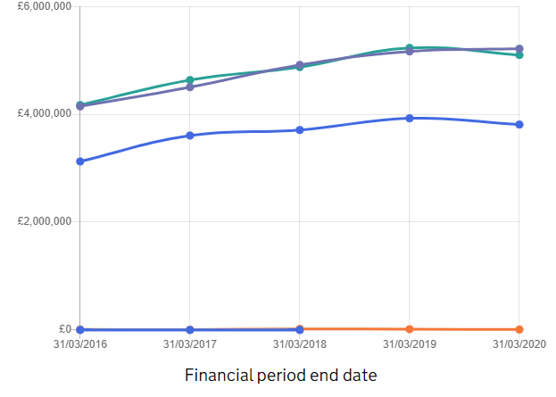
income / Expenditure | 31/03/2016 | 31/03/2017 | 31/03/2018 | 31/03/2019 | 31/03/2020
 |  | Total gross income | £4.15m | £4.50m | £4.91m | £5.17m | £5.21m
 |  | Total expenditure | £4.17m | £4.63m | £4.88m | £5.23m | £5.10m
 |  | Income from government contracts | £0 | £0 | £0 | N/A | N/A

Kings Palace should install audio reminders at halls and around the premises to remind their guests after a certain amount of time to keep social distance at all times. This will create a long-lasting impact on the guests to always remember to keep social distance. This might not apply to the deaf and numb. In their case, they should put posters or visual screens to do the same. This might act as a nuisance, so the reminders should not be too frequent and should only be installed in the hallways and walking paths outside the premises (Drury,2020).
The institution should arrange sittings at the bars at the Green Lounge to accommodate a few people. When people are drunk, they have little consent about their COVID-19 safety. Alcohol service at Kings Place is another way of generating revenue o the catering and drinks services, but it comes with a lot of risks and concerns about the health and safety of the people getting the service. Consumption of alcohol reduces the social distance as people tend to interact and remove their masks. This poses risks to a lot of people in that if one person is infected with the virus, other people are at risk of getting infected too. If possible, the bar should be taken to a free space where space and air circulation are sufficient.
The organization should consider taking the temperatures of their guests and keeping their data for a period of 21 days. In case a COVID patient at the incubation stage attends unnoticed and infects other people, the management can easily track the people who came in contact with the patient and take them to quarantine.
Kings Place should employ an emergency medical team to respond to any reported case of COVID-19 on the premises. This will reduce panic in case a COVID-patient is registered on the premises. The medical team will also quarantine the people who have associated with the patients and have not received the vaccine. By the time the COVID-19 curve is at the decomposition stage, it is not guaranteed that all the people in the UK will have been vaccinated.
Most people over the age of 50 years are reluctant to attend physical functions. Kings Place needs to identify its target audience for certain events. This will give them a clear picture of the demographic population they should reach out to (Amy, 2020). They will know exactly how to communicate to them by presenting their advertising campaigns in a way that appeals to the target audience. In addition, creating market personas acts as an economic control tool to focus efforts on where they should be focused (Charlotte, 2018).
Food and beverages in Kings Place restaurants should be served in a no-contact way. Service staff is required to wear hand gloves and face masks at all times to avoid contact with other people. All alcoholic and non-alcoholic drinks should be served in a grab-and-go manner where the container used is disposed of by the user at the litter bin. All containers for drinks and food should be sterilized first before serving the food and beverages in them. The policy enforces pre-packed meals and pre-packed cutlery that is disposable after use. Buffet should only be served by staff who wears protective gear. By enforcing this policy, the institution ensures that there is minimal contact between individuals and their staff (Deepak,2020).
Kings Place should create confidence in their consumers that their health safety is guaranteed when they show up to their events. Most of the events have been held in Europe, and the turn-up has been low. Kings Place should always update their progress on ensuring the safety of their customers. People want to see to believe. In research conducted by FTHglobal, 61% of the respondents are not willing to travel overseas to attend physical events in 2021 (Eli,2021). Most of the respondents have described the coronavirus sanitation protocols as hygiene theatre. They see these protocols as ways that are designed to create less actual safety than to placate the paranoia of the masses.

Findings and Results.

Fig. 2 Graph showing King's Place annual income and expenditure over the years ( Kings Place Events, 2020)
income / Expenditure | 31/03/2016 | 31/03/2017 | 31/03/2018 | 31/03/2019 | 31/03/2020
 |  | Total gross income | £4.15m | £4.50m | £4.91m | £5.17m | £5.21m
 |  | Total expenditure | £4.17m | £4.63m | £4.88m | £5.23m | £5.10m
 |  | Income from government contracts | £0 | £0 | £0 | N/A | N/A

The graph above represents the annual income for the Kings Place Events. The financial report was obtained from their website (Charity Commission of England, 2021). From the financial report, it is evident that the income was not adversely affected. There was a decrease of 0.2% in the income since, for the beginning of the year, the King's Place was already booked for the year, and 89,462 tickets were already sold. The sold tickets were 3342 more than the tickets sold in the 2018/2019 financial period. In the 2019/2020 period ending on 31st March 2020, there was an increase in donations to Kings place by 30%. This was used to secure employees' jobs and send some amounts to the Kings Place Music Foundation.
In 2020 after the closure of events, Kings Place managed to continue to hold virtual events for the concerts that had already book the venue for the event.
A research was conducted by EventMB to find out the biggest obstacle for resuming physical events. The respondents were given factors safety, Bad return on Investment, and cost. 55% of the respondents cited that safety is the biggest obstacle that hinders the planning of physical events. Travel bans were second at 14.1%, and bad returns on investments were third with 10.4% (EventMB, 2021).
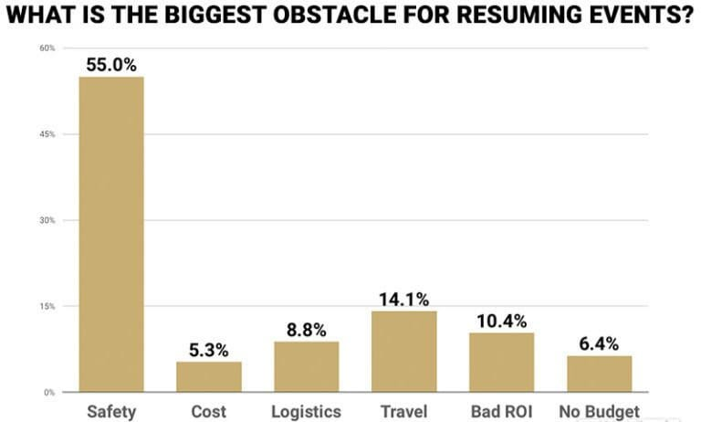

Fig 3. A graph showing obstacles affecting the organization of Physical events (EventMB,2020)

The same company conducted primary research to ask the on the Internet the Factor that would make them feel safe when organizing a physical event. Most of the respondents accumulating to a total of 40.4%, cited that the COVID-19 vaccine would make them feel safe when attending live events at Kings Place Events. 16.1% cited that appropriate COVID-19 would make them feel and safe, and onsite testing was cited by 15% of the respondents.

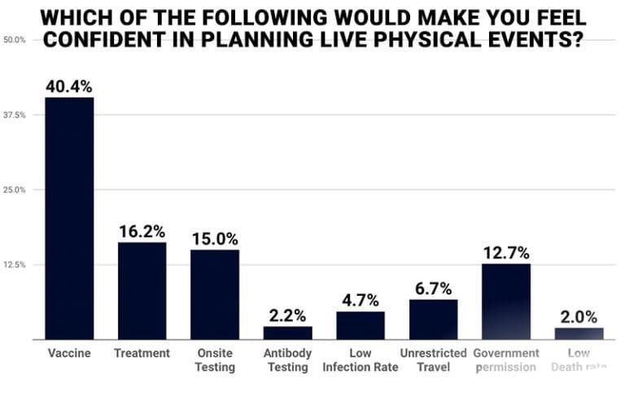

Fig 4. A graph showing factors that will make people feel safe when planning physical events (EventMB,2020)

Primary research was also conducted to find out if the respondents are willing to attend physical meetings in person upon the recovery of the industry. More than a third of the respondents are not willing to attend any physical event. Another third of the respondents are only willing to attend the event if it is a local and small event.
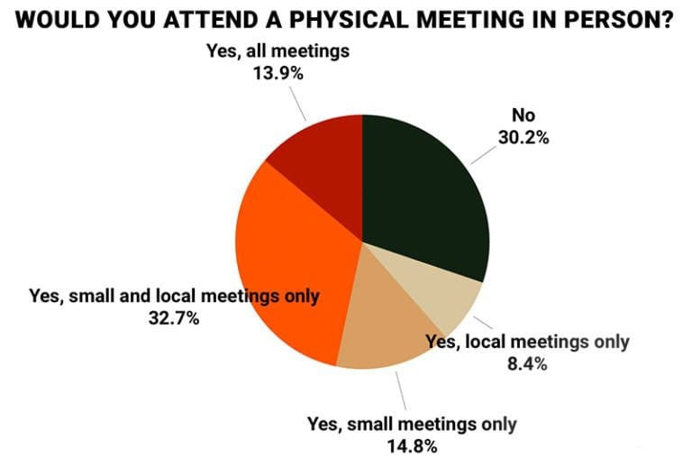

Fig 5. A chart showing the number of respondents willing to attend a physical meeting in person (EventMB, 2020).

The Unknowns
As the world is still adjusting to the impacts of the coronavirus in daily life, some variables are dynamically changing and are yet to be addressed due to uncertainties. These factors can largely affect the future organization of physical meetings by Kings Place Events. These factors are out of the control of the management and attendants, which will make Kings Place Events rely on more than the safety and comfort of their guests (Sergio, 2020).
The first uncertainty is the comfort level of international guests. From the primary results above, respondents are unclear as to when they would be comfortable and feel safe to travel and attend physical events at Kings Place. It is unclear what would make international guests feel comfortable apart from vaccination (John, 2021).
The second uncertainty is will there be post-vaccine travel restrictions? This is a question that cannot be predicted and be certain about. So far, the United Kingdom government has not issued any directive and travel guidance on post-vaccination time (Morowska and Milton, 2020). The UK has banned flights from India to Heathrow airport in London, and borders are still closed to some countries in Europe. The post-COVID restrictions are not clear. There may be travel restrictions to ensure that the disease is eradicated. This uncertainty might affect the business at Kings Place.

Action Plan
Number | Problem | Solution | Desired Outcome | Time | Budget
1.  2.  3. | Social distance is not guaranteed in halls and theatres.  Possibility to lose existing customers and fail to acquire new ones.  Possibility of too much physical contact between employees in the cafeteria and guests | Use of 3D modelling and Virtual reality to model the new sitting arrangement in concert halls and give tours of the premises using virtual reality goggles.  Kings Place should send customized packages that appeal to the personality of their past guests. They should identify their target audience customize adverts that appeal to them.  Employees to wear protective gear and use disposable cutlery (Bonell,2020) | The sitting modelling should be exactly six feet apart from each other. Tours of the premises should be given to guests using virtual reality goggles, which would provide the same experience as touring the premises in person  Past guests should come back to Kings Place, and there should be an increase in the number of new clients  All food and beverages should be preserved in disposable containers that are sterilized before giving to consumers. All employees should wear protective gear | 4 months  8 months  1 week | £ 50000  £ 20000  £ 15,000

Recommendations.
- Kings Place should use 3D modelling and Virtual reality to model the new sitting arrangement in concert halls and give tours of the premises using virtual reality goggles.
- King's place should use 3D virtual reality for online concerts in streaming services.
- Kings Place should reach out to their old clients through emails and presents that appeal to their likes and customize adverts to reach out to new clients.
- Kings Place should install audio reminders in the halls to remind their guests to always keep a social distance of six feet.
- Kings Place should use a pre-packed meal and ordering system for food and beverages.

Conclusion
King's Place Events is an institution with quite a reputation for hosting musical and visual arts. Since the beginning of the Coronavirus pandemic, the institution has continued to keep the candle of music and theatre alive by making sure that at all costs, events are carried out. The institution was briefly closed due to the high rate of infections from the COVID-19 virus (Peter, 2021). The institution took a financial hit on its revenue, but so far, it has opened its operations, and it is continuing to host virtual events.
From the annual financial statement of Kings Place Events, annual income was not hugely affected as there was a decrease of less than 0.2%. The donations that the institution gets increased by a significant percentage. From the primary research carried out, most people are not ready to resume physical events. When they were asked what would make them feel safe to make them attend live events, a higher percentage of respondents cited that vaccination would mostly be appropriate. When the respondents were asked the major hindrance to the opening of live events, most of them were much concerned about their health safety. People are not fully ready to attend live events, which will be a bummer to the events industry and their planners.
To stay at the top of the competition, Kings Place should adopt a couple of measures to ensure that customer health safety and comfort is adequate. The institution should remodel its premises to host its guests and make sure that they are seated six feet apart in their theatre halls. The institutions should adopt the policy of minimum physical contact of employees and guests by ensuring that meals are pre-packed for their customers. This ensures that all the guests and employees enjoy their personal space (Novelli, Drury, and Reicher, 2020). Kings Place should adopt the use of 3D technology and virtual reality to reduce movements in the premises and ensure that the premises are well ventilated. By adopting these recommendations, it is without a doubt that post-COVID-19, Kings Place will open its doors to physical events with no problems and enjoy the fruits of its hard work in a safe environment for its guests and employees. They will also provide a top-notch theatre experience to their audience in the theatre halls and those watching from their homes through online streaming services (Templeton, Drury, and Philippides, 2020).
In conclusion, I would like to pass my heartfelt gratitude to Kings Place Events for this wonderful opportunity to consult on behalf of your company. Working on this project has been endearing and educative even to me as a consultant. I have been able to learn a lot and perfect my skills better working on this project. I hope my work be of great benefit to the strategies of your company. It would be a great honour for me to work with your institution in the future.

References
Ahsan, A. S. 2020. Macro-environment in the UK. Marketing.net. https://graduateway.com/macro-environment-analysis-of-the-uk-economics-essay/
Allington, D., Beaver, K., and Duffy, B. 2020. Becoming "Covid-secure": How the UK is getting used to wearing face masks and other precautionary behaviors. The Policy Institute, King's College London.
Amy, P. 2020. Importance of Knowing Your Target Market. https://www.google.com/amp/www.manobyte.com/growth-strategy/importance-knowing-target-market%3fhs_amp=true
Andrew, S. 2018. Management Information System of Event organizer. https://doi.org/10.24843/ijeet.2018.v03.i02.p19
Ben, G. 2020. Effects of COVID-19 on UK's Future Infrastructure Provision. https://www.ice.org.uk/news-and-insight/the-infrastructure-blog/august-2020/ice-white-paper-on-infrastructure-post-covid
Bennett, R. and Jones, A. 2015. The Digital Evolution of Live Music: Live concerts and fan identity in the age of the Internet. Oxford Chandos Publishing (2015), pp. 3-15
Bob, R. 2021, The Future of Events After Covid-19 Pandemic. https://www.google.com/url?sa=t&source=web&rct=j&url=https://www.marketing-interactive.com/the-future-of-events-in-a-post-covid-era&ved=2ahUKEwjH_IGs6Y3xAhWRhVwKHacZBA4QFjAGegQICRAC&usg=AOvVaw2jSc4aMRDRT2FkVzUUiSA0&cshid=1623354134890
Bizzabo. 2020. Events Marketing Analysis. Bizzabo group. https://www.google.com/url?sa=t&source=web&rct=j&url=https://www.adweek.com/performance-marketing/networking-is-the-biggest-challenge-virtual-event-marketers-face-in-2021/amp/&ved=2ahUKEwj-pqvi6I3xAhVKilwKHR-rDWcQFjAMegQIHRAC&usg=AOvVaw2u6rqAVc4y4NMN9JYamIxo&ampcf=1
Bonell, C. 2020. Harnessing behavioral science in public health campaigns to maintain 'social distancing' in response to the COVID-19 pandemic. Community Health, 74 (8) pp. 617-619, 10.1136/jech-2020-214290
Campiranon, K.; Scott, N. 2014. Critical success factors for crisis recovery management. J. Travel Tour. Mark. 31, 313–326
Chandler, A. 2010. Strategy and Structure. Cambridge Mass: MIT press
Charlotte, F. 2018. Importance of Understanding Target Audience. https://www.speedstartup.org/blog-post/importance-understanding-target-audience/
Charity Commission of England. 2021. https://register-of-charities.charitycommission.gov.uk/charity-search/-/charity-details/4013483/financial-history
Clark, D., 2020. Population of the UK by Age Group. Statista.
https://www.google.com/url?sa=t&source=web&rct=j&url=https://www.statista.com/statistics/281174/uk-population-by-age/&ved=2ahUKEwjbnavs6Y3xAhWHT8AKHQNeDOQQFjAAegQIAxAC&usg=AOvVaw3AZ0lDK73QZR3B-bBeE8tm
Claire, D. 2020. Preparation for Post-COVID-19 by event Industry. https://www.euruni.edu/blog/event-industry-impact-covid-19/
Christie & Co Hotels. 2020. COVID-19 Medidas de Apoyo a la Industria Hotelera Una Comparativa Europea-2020; https://es.christie.com/christieMediaLibraries/christieSpain/PDFs-Publications/COVID-19Medidas-de-Apoyo-Economico.pdf?ext=.pdf
Cruwys, T., Stevens, M., and Greenaway, H. 2020. A social identity perspective on COVID-19: Health risk is affected by shared group membership 10.1111/bjso.12391
Deepak, C. 2020. How event industry is adapting to the covid-19 period. https://www.financialexpress.com/brandwagon/writers-alley/how-event-industry-is-adapting-to-the-covid-19-period/1961184/
Drury, J., 2020. Live events: It's an experience thing. Conference News. https://conference-news.co.uk/features/live-events-its-experience-thing.
Eli, G. 2021. COVID-19 and Physical Meetings. FTHglobal https://www.linkedin.com/posts/eligorin_covid-19-medical-mtgs-intl-participation-activity-6742843140736192512-vkSz
Eventbright, 2016. An Introduction to The UK Event Industry in Numbers. Eventbright blog. https://www.eventbrite.co.uk/blog/academy/uk-event-industry-in-numbers-ds00/.
EventMB. 2021. Research factors hindering Physical events: https://www.google.com/amp/s/www.eventmanagerblog.com/event-trends/amp/
Fancourt, D., Hei, W., and Mak, F. 2020. Covid-19 Social Study Results Release 2 1. http://allcatsrgrey.org.uk/wp/download/public_health/3d9db5_c99f0f8bb89545a6a10040f27949f7f9.pdf.
Fordham, J. 2008. King's Place Opens its Doors to Jazz. The Guardian. https://www.theguardian.com/music/musicblog/2008/sep/26/johnfordham.jazz
Gössling, S.& Scott, D. 2020. Pandemics, tourism and global change: A rapid assessment of COVID-19. J. Sustain. Tour.
Gursoy, D. 2020. Effects of COVID-19 pandemic on hospitality industry: Review of the current situations and a research agenda. J. Hosp. Mark. Manag., 29, 527–529.
Heather, H. 2020. UK ban mass gatherings in Coronavirus U-turn. The Guardian.
Hopkins, N. and Reicher, S. 2016. Adding a psychological dimension to mass gatherings medicine. International Journal of Infectious Diseases, 47, pp.112–116.
https://doi.org/10.1016/j.ijid.2015.12.017
James, S. Using PESTEL analysis Model. https://www.google.com/amp/s/www.smartinsights.com/marketing-planning/marketing-models/pestle-analysis-model/amp/
Joe, D., Effects of Business Activities on Environment. Cambridge University.
Joe, M. 2020. Global Business Issues. https://online.hbs.edu/blog/post/challenges-of-international-business
Joseph, K. 2014. Formulation of a Systemic PEST Analysis for Strategic Analysis // European academic research, Vol. II, Issue 5, pp. 6478-6492.
John, D. and Brooke, R. 2021. Re-opening live events and large venues after Covid-19' lockdown': Behavioral risks and their mitigations. https://www.sciencedirect.com/science/article/pii/S0925753521000886
Kings Place Concert Hall. The Woods Awards. http://www.woodawards.com/kings-place-concert-hall/
Kings Place Events. March 2020. Financial History. https://register-of-charities.charitycommission.gov.uk/charity-search/-/charity-details/4013483/financial-history
Lock, S. 2020. Impact of COVID-19 on hotel and events in London. Statista. https://www.statista.com/statistics/1105288/covid-19-impact-on-london-hotel-performance/
Loren, G. E., 2021, Survey in Uptick Optimism. Pulse Group. https://www.northstarmeetingsgroup.com/News/Industry/Weekly-Survey-Tracking-Coronavirus-Meetings-Response
Manas, K. 2019. SWOT analysis of Event Industry. https://blog.townscript.com/swot-analysis-of-event-industry/amp/
Morawska, L. and Milton, D.K. 2020. It is Time to Address Airborne Transmission of COVID-19. Clinical Infectious Diseases, 71(9). https://doi.org/10.1093/cid/ciaa939
Nicola, M. 2020. The socio-economic implications of the coronavirus pandemic (COVID-19): A review. Int. J. Surg., 78, 185
Novelli, D., Drury, J. and Reicher, S. (2010). Come together: Two studies concerning the impact of group relations on personal space. British Journal of Social Psychology, 49(2), pp.223–236. https://doi.org/10.1348/014466609X449377
Online Events. 2021. Kings Place Events. https://www.kingsplace.co.uk/whats-on/online-events/
Patrick, E. 2021. How Event Industry is tackling the impact of Covid-19. https://www.euruni.edu/blog/event-industry-impact-covid-19/
PESTLE Analysis. https://pestleanalysis.com/what-is-pestle-analysis
Peter, M. 2021. Kings Palace COVID-19 updates. https://www.kingsplace.co.uk/about-us/covid-19-coronavirus-updates/
Rutherford, A. 2017. The Pandemic and its Impacts. https://doi.org/10.5195/hcs.2017.221
Sam, H. 2020. How COVID-19 is Affecting Event Industry. https://www.eventindustrynews.com/news/covid-19-and-how-its-changing-the-industry
Sanjoy, R. 2020. EEMA examines the impact of COVID-19 on event and entertainment industry https://brandequity.economictimes.indiatimes.com/news/media/eema-examines-the-impact-of-covid-19-on-event-and-entertainment-industry/75268619
Sarah, A. 2020. How Hotels Should Adapt Meetings and Events. https://www.hospitalitynet.org/opinion/4099502.html
Sergio, C., Stephan, L. & Emil, V. 2020. Pandemics Depress the Economy, Public Health Interventions https://dx.doi.org/10.2139/ssrn.3561560
Splento, 2020. Events Industry: Rising to the Challenges of COVID-19. https://www.splento.com/blog/marketing/events-industry-rising-to-the-challenges-of-covid-19/
Swift, R., 2020. Stronger political alliances are forming in northern England as local lockdown anger grows. The Conversation. https://theconversation.com/stronger-political-alliances-are-forming-in-northern-england-as-local-lockdown-anger-grows-147965.
Templeton, A., Drury, J. and Philippides, A. 2020. From Mindless Masses to Small Groups: Conceptualizing Collective Behavior in Crowd Modeling. Review of General Psychology, 19(3), pp.215–229. https://assets.publishing.service.gov.uk/government/uploads/system/uploads/attachment_data/file/916546/S0703a_SPI-B_Extended_Paper_Behavioural_evidence_on_reopening_of_large_events_and_venues.pdf
Tilden, I. OperaUpClose to leave King's Head, Islington, for fresh challenges
2014. The Guardian. https://www.theguardian.com/music/2014/sep/25/operaupclose-to-leave-kings-head-islington
Triggle, A. 2021. Covid-19 Infections in the UK. https://www.google.com/url?sa=t&source=web&rct=j&url=https://www.bbc.com/news/uk-51768274&ved=2ahUKEwjz2NfG6o3xAhVtzoUKHfGvC-AQFjADegQIBxAC&usg=AOvVaw10mseOC6LguS10Dvn21sVa
Tool, W., 2021. What is PESTLE Analysis? An Important Business Analysis Tool. https://pestleanalysis.com/what-is-pestle-analysis/
World Health Organization, 2021, Covid-19 Vaccinations. https://www.google.com/url?sa=t&source=web&rct=j&url=https://www.who.int/emergencies/diseases/novel-coronavirus-2019/covid-19-vaccines&ved=2ahUKEwiQ7L7v6o3xAhXGxoUKHe_dAoMQFjALegQIJxAC&usg=AOvVaw0_5Pbz0IHe35CezIwf3i8N
World Health Organization. 2020. Coronavirus disease (COVID-19) advice for the public. https://www.who.int/emergencies/diseases/novel-coronavirus-2019/advice-for-public/videos

