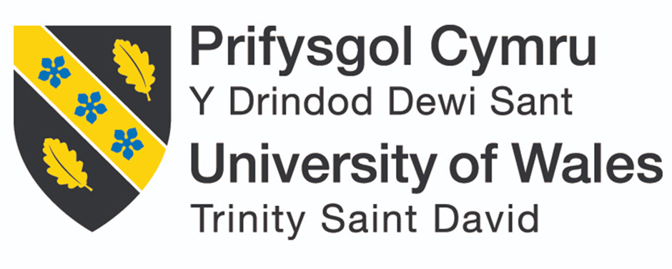

School of Engineering
Engineering technical report
Sophie Reed

2000492
Motorsport Engineering
Workshop and Practice - ACHA4011

Contents
Chapter 1 - Introduction 3
Chapter 2 – Engineering team structure 4
Figure 1 – ‘Team structure for project’ Reed.S (2022) 5
Chapter 3 – Product Development 6
Figure 2 - ‘The new product development process’ Gastaldello (2021) 6
Chapter 4 – Issues, legislation, and standards 8
Chapter 5 – Personal development plan 9
Conclusion 10
Reference list 11

Chapter 1 - Introduction
“Teams have been considered as fundamental units in today’s organizations” (Mathieu et al, 2014). The team will be designing a component for a steering wheel of the highest quality, to make this possible there has got to be a clear goal and a strong team structure. It will be for a standard steering wheel. The team will be there to design a component, this will be a volume control for the exhaust on electric cars. This will be done through the speakers as most electric vehicles do already, for example “the Charger Daytona SRT concept is an electric vehicle that uses fake exhaust to produce engine-like noises” (Chen. J, 2022) however being able to change the volume is the new concept. This is important concerning the transition from petrol/diesel to electric as many people don’t like how “electric vehicles make very little sound” (Jones. P, 2022) in terms of health and safety, and aesthetics. This report will be looking at the best team structure for this engineering project and the different sectors involved. Many different departments will be needed when it comes to this project, “no two projects are the same” (Lock. D, 2020) so a unique group of people will be needed.

Chapter 2 – Engineering team structure
A good quality system should be based on four things; “planning, execution, checking, and action” (Smith. N, 2002). Adjusting this to suit the current operation (Smith. N, 2002). The type of team working on this product will be from different departments working on different aspects of the component, they will need to be organised and communicate well to allow this to run smoothly and have no issues. There are three common structures for an engineering team; Horizontal, vertical, and matrix. These all work well when creating a project but they all have their positives and negatives. “In a horizontal team structure, members have defined roles without any given team member holding a position over another” (Indeed Career Guide, 2022), this type of team structure allows an equal distribution of responsibility and is most “effective for small teams” (Indeed Career Guide, 2022). This structure wouldn’t necessarily work for this team as creating a new product can lead to uncertainty of the end goal. However, vertical teams using a hierarchy with higher levels of management which would be better suited because “this type of team structure often works for teams with product-oriented goals” (Indeed Career Guide, 2022). This allows for one person to guide the rest of the team to the final goal. This leads to the matrix team structures have multiple people in charge, it “allows for flexibility and rapid project development” (Indeed Career Guide, 2022). A benefit to all of these is it allows creativity and organisation, some more than others. This structure wouldn’t work for this project as the team will need more structure for the new product.
The team manager will have to be someone who has full leadership skills with a full understanding of the task ahead and it is in their line of work. This is known as “expertise power” (Hayes. N, 1997). There are 8 main roles needed for a project to succeed, these are; “chairperson, shaper, plant, monitor, company worker, team worker, resource investigator, and completer” (Hayes. N, 1997). These roles all require different activities and characteristics, so will need different people to fit each role criteria. This means that the team can stick to the vertical team structure but can also have important roles so no one is feeling a minority within the group.
The code of conduct document tells employees what is expected of their behaviour when presenting the company (Betterteam, 2020). Employers have their own code of conduct handbook, these normally contain many different principles. However, there is a core five which are normally seen, these include; “integrity, objectivity, competence, confidentiality and professionalism” (Indeed Editorial Team, 2022). The code of conduct is a set of ground rules which ensure the company has no workplace conflict as the employees are aware of what is expected from them. This is even when people from different backgrounds come together, it helps create a sense of belonging. The team will already be working for a company and so will have to go over these rules at the beginning of the project.
There will be a leader of each smaller team within the project who has to report back to the main leader who will oversee the entire project. For this project there will only be five teams, these will be from different sectors. Teams will be split into responsibilities of what they are doing, so finance is a separate team for example. The team plan can be seen below, this includes how many team members each team will have.
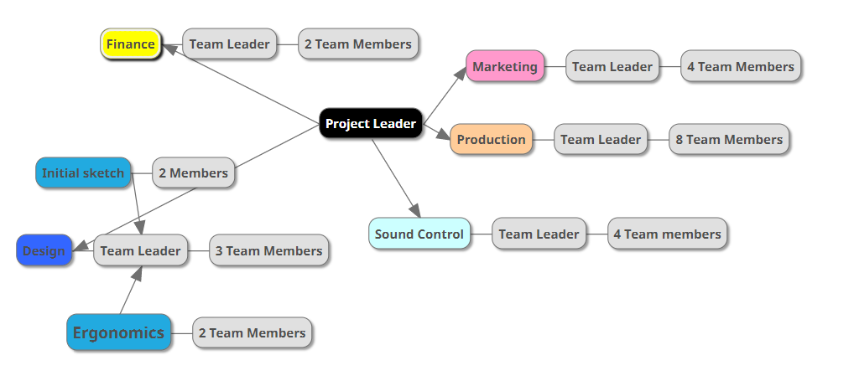

Figure 1 – ‘Team structure for project’ Reed.S (2022)

Chapter 3 – Product Development
There are many different processes when it comes to product development however they all have a generic order. The diagram below shows the best steps to take and allows for market research as well, this is key when it comes to developing a new product as there is no point in creating the product unless there is a market out there for it.
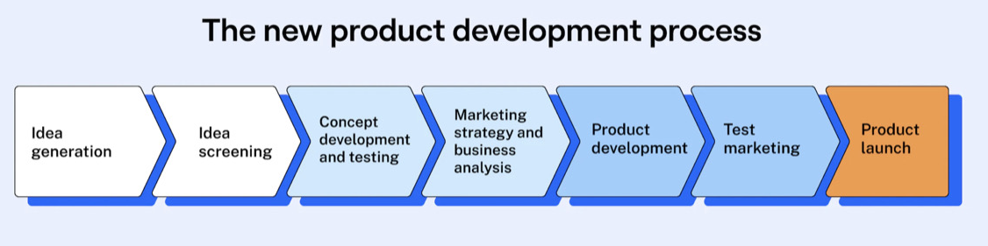

Figure 2 - ‘The new product development process’ Gastaldello (2021)
Figure 1 suggests the first two steps are about generating the idea. However, this idea has already been chosen, so this doesn’t apply to this project. The next step is to look at concept development and testing, this “involves coming up with a detailed description of an idea, explained from the perspective of your customer” (Migrator, 2000). Indicating that the next step would be to look at the best way to portray the product and how a customer would want to see the product and the easiest way for them to use it. Following that marketing is the next biggest thing, it is important to ensure that the product is actually wanted by consumers, there are many different ways to test this. To be able to do this, a marketing group would be created, they would do surveys, focus groups, interviews with potential buyers etc. All of these allow for secondary and primary data collection.
After looking at the marketing data product development can take place, this may change from the original plan due to marketing teams collections. Once the product is developed a prototype will be made which leads to the final steps. The product launch will be the most crucial part to ensure the product the best possibility, marketing will have to work with the engineering and design teams to allow for a full understanding of the product. “Product development is characterised by numerous problems” (Albers. A et el, 2005). However, the majority of the time there are solutions to these issues and/or ways around them. If an issue arises in the development of the product, the team will follow a simple “8 step process; define the problem, clarify the problem, define the goals, identify root cause of the problem, develop action plan, execute action plan, evaluate results, continuously improve” (Iowa University, 2019). The reason for this problem-solving technique is because it can be used with any aspect of the project, from marketing to final design, the technique allows for a well-thought-out end result.

Chapter 4 – Issues, legislation, and standards
The team will have to look for similar products on the market or in development to stop being sued, this is due to patents. ‘A patent is a monopoly right which protects inventions’ (Clarke Willmott LLP, 2022). It stops others from copying, manufacturing, and selling the product without permission, this will be important as it’s a new product and may have a big impact. This allows the team to make the most money as they will be the only people who have access to selling the product. However, the cost of a patent can be expensive, which means the financial side of the team will need to ensure that the revenue forecast is more than the cost otherwise there will be a loss. A patent ‘can be a very time-consuming and lengthy process (typically three to four years)’ (Nibusinessinfo.co.uk, 2022). Due to this there could be a delay in the project process and would have to be a close door project to stop competitors from creating the project quicker and possibly cheaper.
There normally is no restriction for anyone to be an engineer in the UK (Engc.org.uk, 2012). However, some laws need to be followed, this is mostly for health and safety, not only for the staff creating the product but for the consumers and general public. For example ‘The Personal Protective Equipment (enforcement) Regulation 2018’ (Hse.gov.uk, 2021), the team physically making the product will need to wear the correct protective equipment to ensure they are safe when using the machines.
Industry-standard is “a set of criteria within an industry relating to the standard functioning and carrying out operations in their respective fields of production” (Johnson, 2016). It is important to ensure that the product fits within the set of criteria to allow for the product to be used within different vehicles.

Chapter 5 – Personal development plan
My end goal is to be a CAD Engineer within a Formula One team, CAD has always been a passion of mine and I enjoy using CAD Software. I have done research into what CAD Software is used in the industry and have downloaded and been using them. During this degree, I am hoping to do a placement year to boost my employability rate and have extra experience. I have also considered doing a master’s in a form of design engineering to allow for extra qualifications. I understand the likelihood of getting straight into F1 is slim, so I have also looked at WSeries and World Rally Car series, these are slightly smaller industries that would be a great place to gain experience and build my way up. I am also trying to get the highest grades I can by putting extra time and effort into assignments and exams, this again will boost my employability rate.

Conclusion
From being a team leader, learning how to format a team and the best way to do this based on the product is difficult. It has many different aspects that all need to be considered. For example; finance, marketing, production, legal and design all need to be thought about and have strong team members in each to ensure no department is letting another down. This is why the vertical team structure is best suited to this project, it allows for teams to focus on their own departments whilst someone else concentrates on them all working towards the same end goal. It ensures each group has someone in charge and someone in overseeing the entire project. The legal aspect of the project needs to be considered carefully this is due to the amount of laws and patents involved with creating a new product. If legal miss something it could cause a lot of money to be lost/wasted. It is crucial that they thorough. In conclusion, using the vertical team structure, using as many teams as possible, the project will be a huge success.

Reference list
- Albers, A., Burkardt, N., Meboldt, M. and Saak, M., 2005. SPALTEN problem solving methodology in the product development. Available at: https://scholar.google.com/scholar?hl=en&as_sdt=0%2C5&q=splaten+problem+solving+methodology+in+the+product+development&btnG=&oq=splaten+problem+solving+methodology+in+the+product+dev. [Accessed 28 Nov. 2022]
- Betterteam (2020). Professional Code of Conduct. [online] Betterteam. Available at: https://www.betterteam.com/professional-code-of-conduct#:~:text=A%20professional%20code%20of%20conduct,%2C%20disciplinary%20steps%2C%20and%20responsibilities. [Accessed 23 Nov. 2022].
- Chen, J. (2022). Dodge hopes fake engine noises can trick traditionalists into buying an EV. [online] https://www.inverse.com/input/tech/dodge-charger-ev-fake-engine-noises-daytona-srt-concept-electric-cars [Accessed 8 Nov. 2022].
- Clarke Willmott LLP. (2022). Patent law. [online] Available at: https://www.clarkewillmott.com/legal-services/intellectual-property-lawyers/patent-law/#:~:text=A%20patent%20is%20a%20monopoly,cover%20either%20processes%20or%20products. [Accessed 29 Nov. 2022].
- Engc.org.uk. (2012). Engineering Council. [online] Available at: https://www.engc.org.uk/international-activity/access-to-practise-in-the-uk/#:~:text=In%20general%20there%20is%20no,licensed%20or%20otherwise%20approved%20persons. [Accessed 29 Nov. 2022].
- Gastaldello, G. (2021). New Product Development: Process & Stages. [online] Maze. Available at: https://maze.co/collections/product-development/new/.
- Haynes. N (1997). Successful Team Management. Essential business psychology. International Thomason Business.
- Hse.gov.uk. (2021). UK law on product design and supply - Work equipment & machinery. [online] Available at: https://www.hse.gov.uk/work-equipment-machinery/uk-law-design-supply-products.htm#sec6hswa74 [Accessed 29 Nov. 2022].
- Indeed Career Guide. (2022). How To Structure an Engineering Team (Plus Tips). [online] Available at: https://www.indeed.com/career-advice/career-development/structure-engineering-team [Accessed 22 Nov. 2022].
- Iowa University (2019). 8-Step Problem Solving Process | University Human Resources - The University of Iowa. [online] Uiowa.edu. Available at: https://hr.uiowa.edu/development/organizational-development/lean/8-step-problem-solving-process.
- Johnson, D. (2016). Industry Standard — DOE Directives, Guidance, and Delegations. [online] Doe.gov. Available at: https://www.directives.doe.gov/terms_definitions/industry-standard#:~:text=Definition,the%20members%20of%20an%20industry. [Accessed 29 Nov. 2022].
- Jones, P. (2022). Why Are Electric Cars SO Quiet? (Explained). [online] Motorandwheels.com. Available at: https://motorandwheels.com/why-are-electric-cars-so-quiet/#:~:text=The%20reason%20electric%20cars%20are,the%20noise%20from%20the%20wheels. [Accessed 29 Nov. 2022].
- Lock, D. (2020). Project Management. [online] https://www.taylorfrancis.com/books/mono/10.4324/9781315245911/project-management-dennis-lock [Accessed 9 Nov. 2022].
- Mathieu, J. E., Tannenbaum, S. I., Donsbach, J. S., & Alliger, G. M. (2014). A Review and Integration of Team Composition Models: Moving Toward a Dynamic and Temporal Framework. Journal of Management, 40(1), 130–160. https://doi.org/10.1177/0149206313503014
- Migrator (2000). Concept development and testing. [online] nibusinessinfo.co.uk. Available at: https://www.nibusinessinfo.co.uk/content/concept-development-and-testing.
- Nibusinessinfo.co.uk. (2022). Advantages and disadvantages of getting a patent | nibusinessinfo.co.uk. [online] Available at: https://www.nibusinessinfo.co.uk/content/advantages-and-disadvantages-getting-patent [Accessed 29 Nov. 2022].
- Pragmatic Thinking (2020). 4 types of teams you’ll find in organisations [online] Pragmatic Thinking. https://pragmaticthinking.com/blog/types-of-teams/ [Accessed 8 Nov. 2022].
- Smith. N (2002). - VleReader. [online] https://r1.vlereader.com/Reader?ean=9781405172271 [Accessed 8 Nov. 2022].
- University Human Resources - The University of Iowa. (2020). 8-Step Problem Solving Process. [online] Available at: https://hr.uiowa.edu/development/organizational-development/lean/8-step-problem-solving-process [Accessed 29 Nov. 2022].

