International Meetings Management for the Hotel Industry
Feasibility plan for an international meeting
BMIH6007
Possibility & progress in hospitality
Kobirul Islam
2130690
Kathryn Flynn

Slide 1

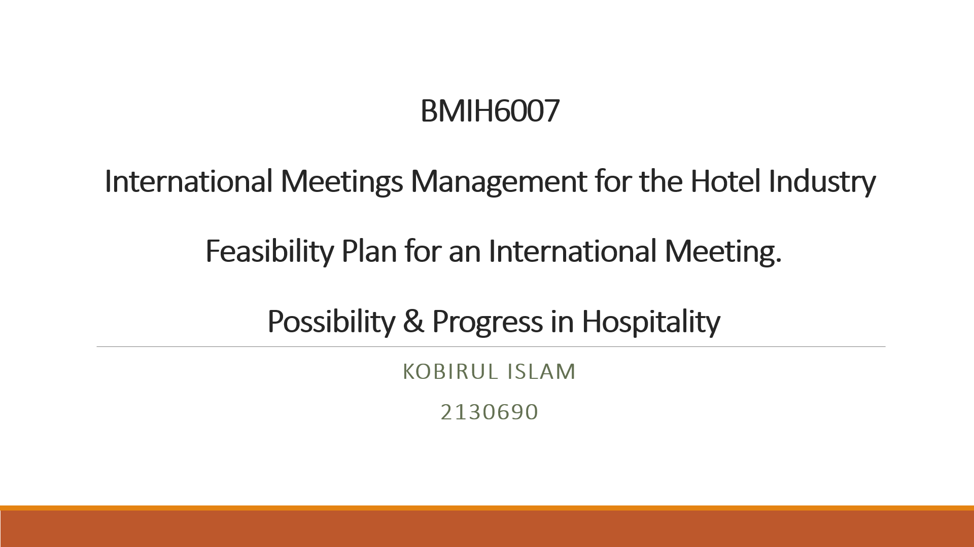

Slide 2

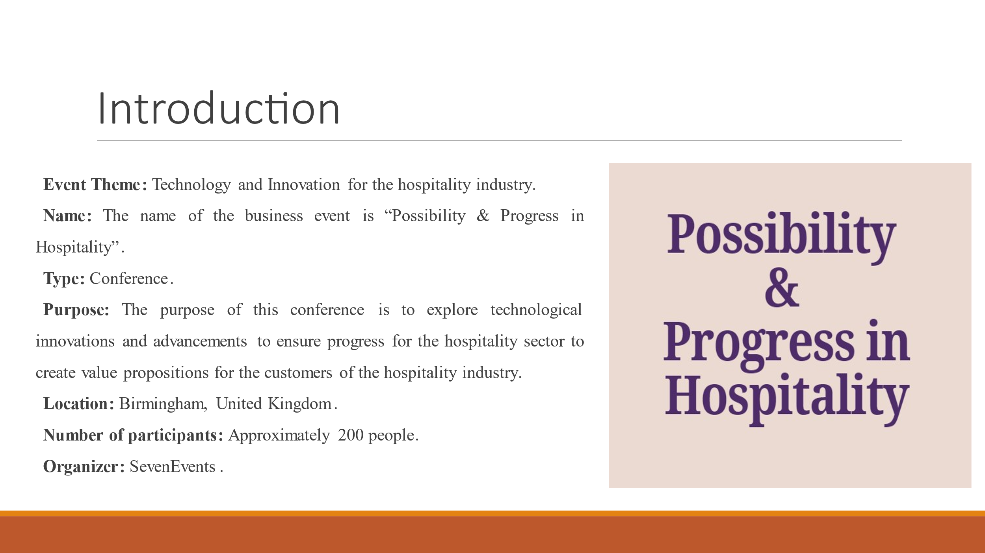

Slide 3

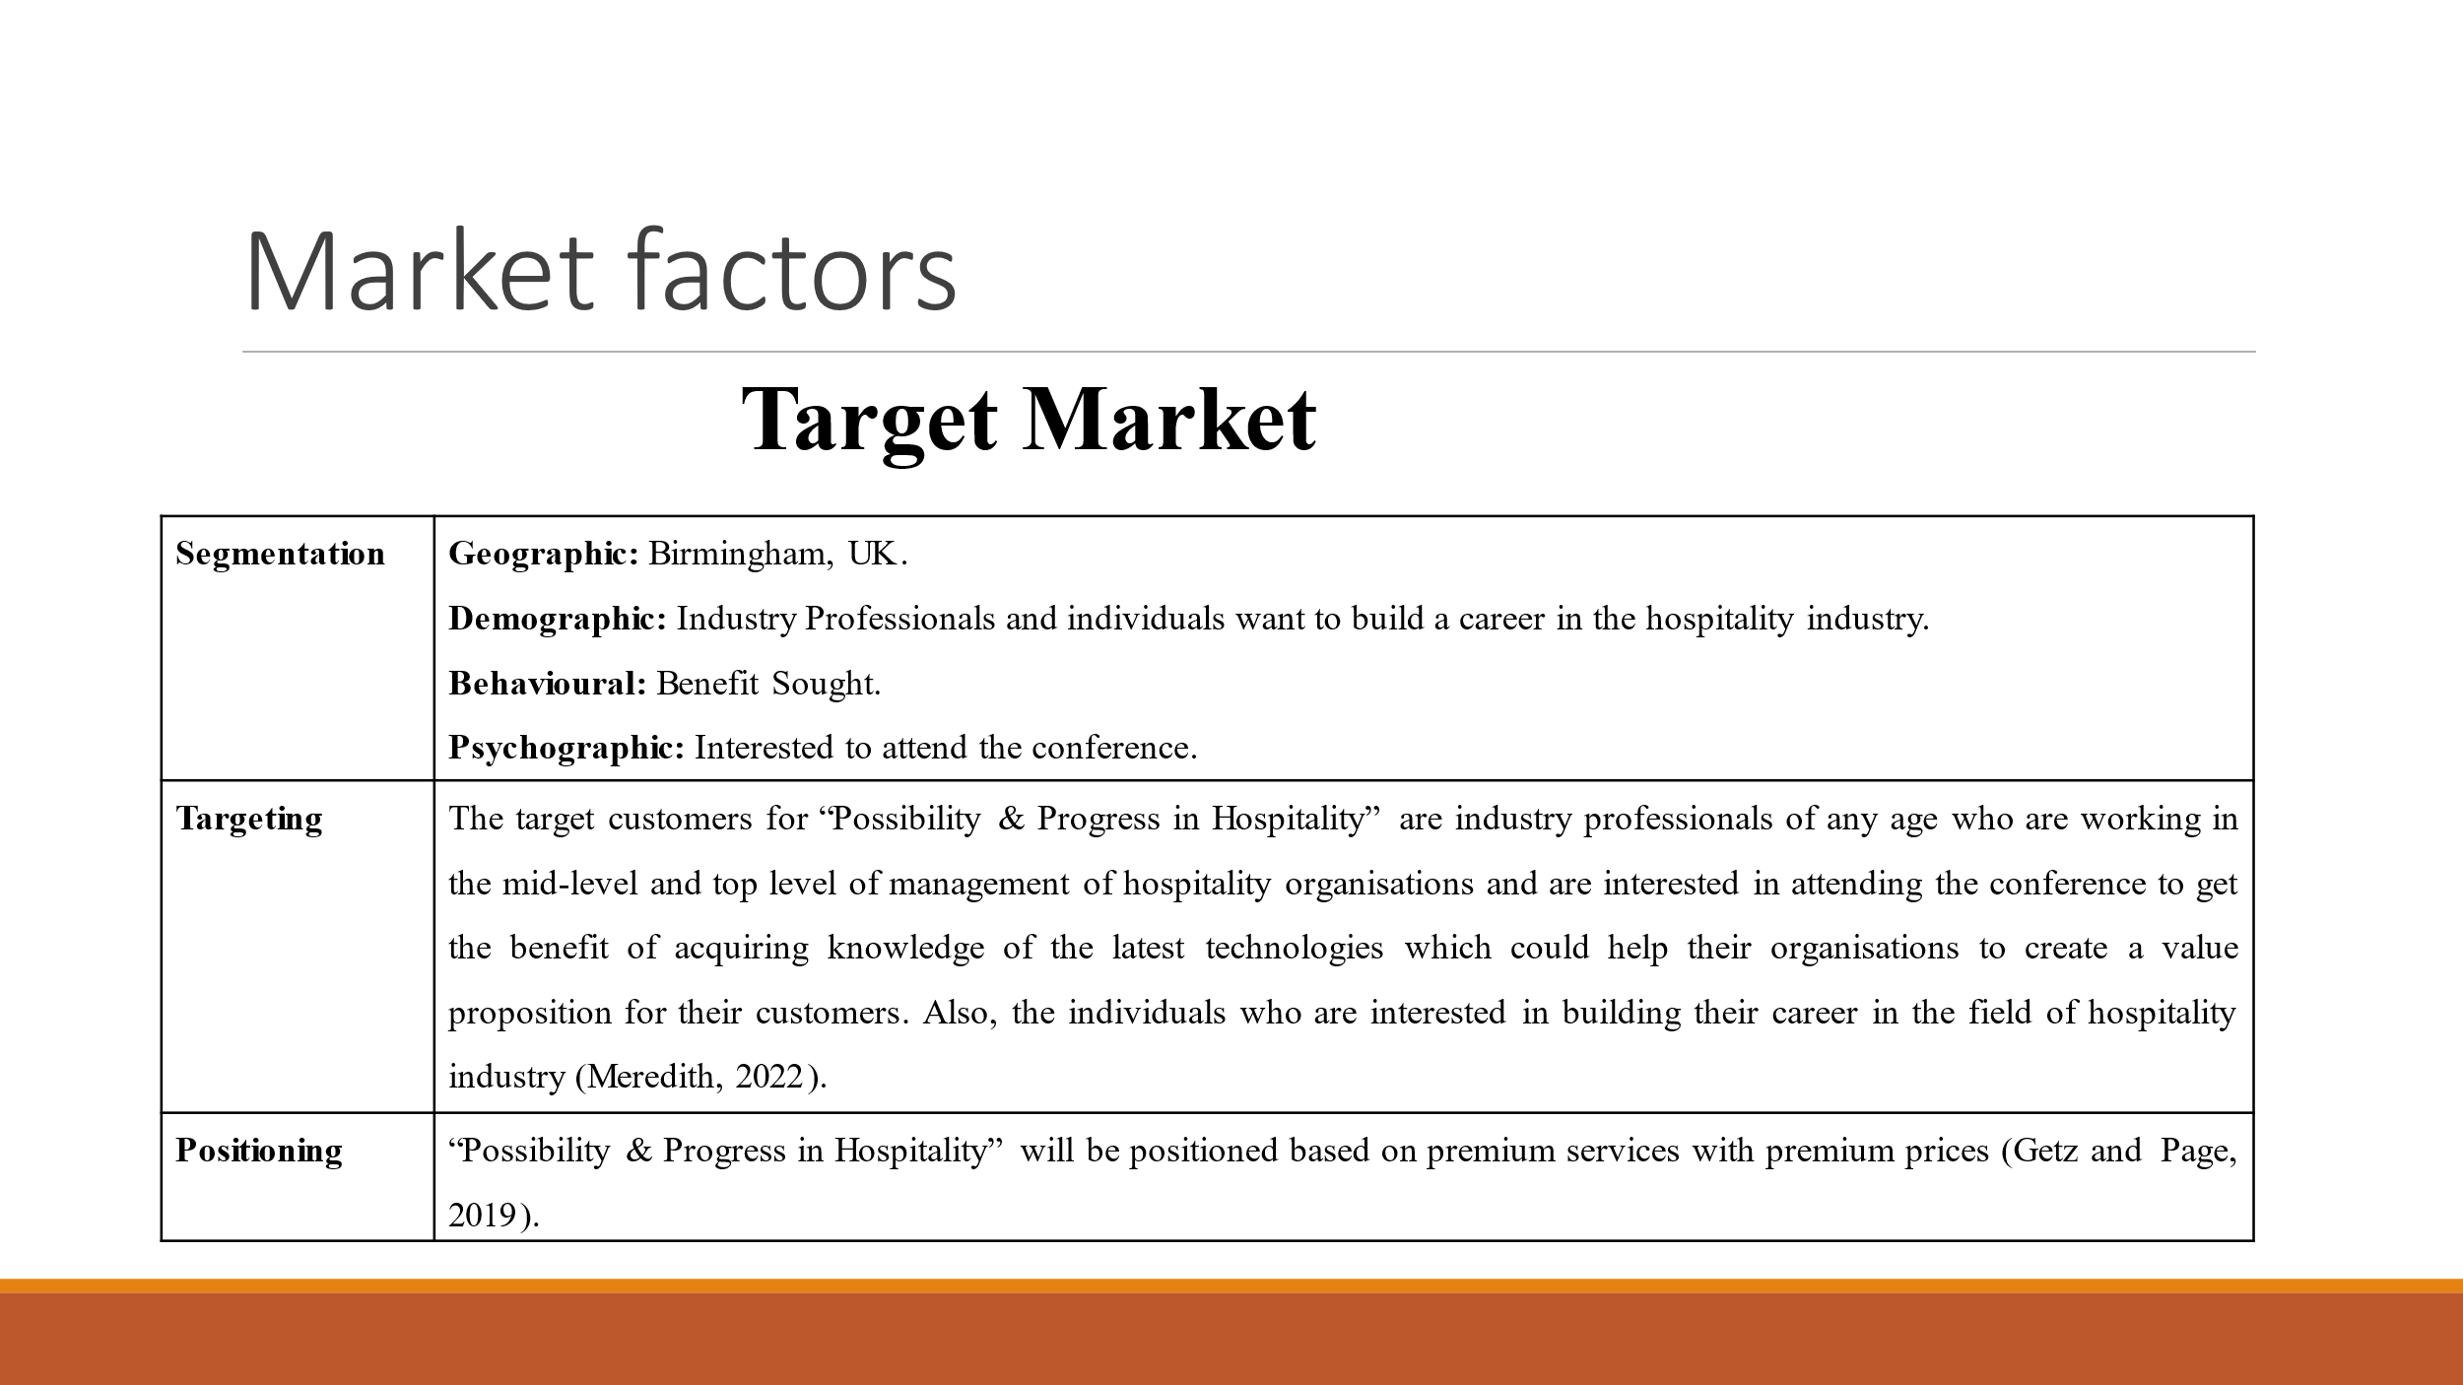

Slide 4

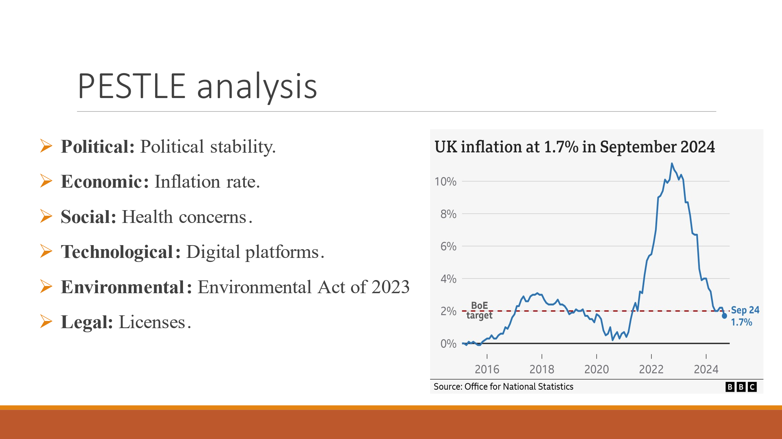

Slide 5
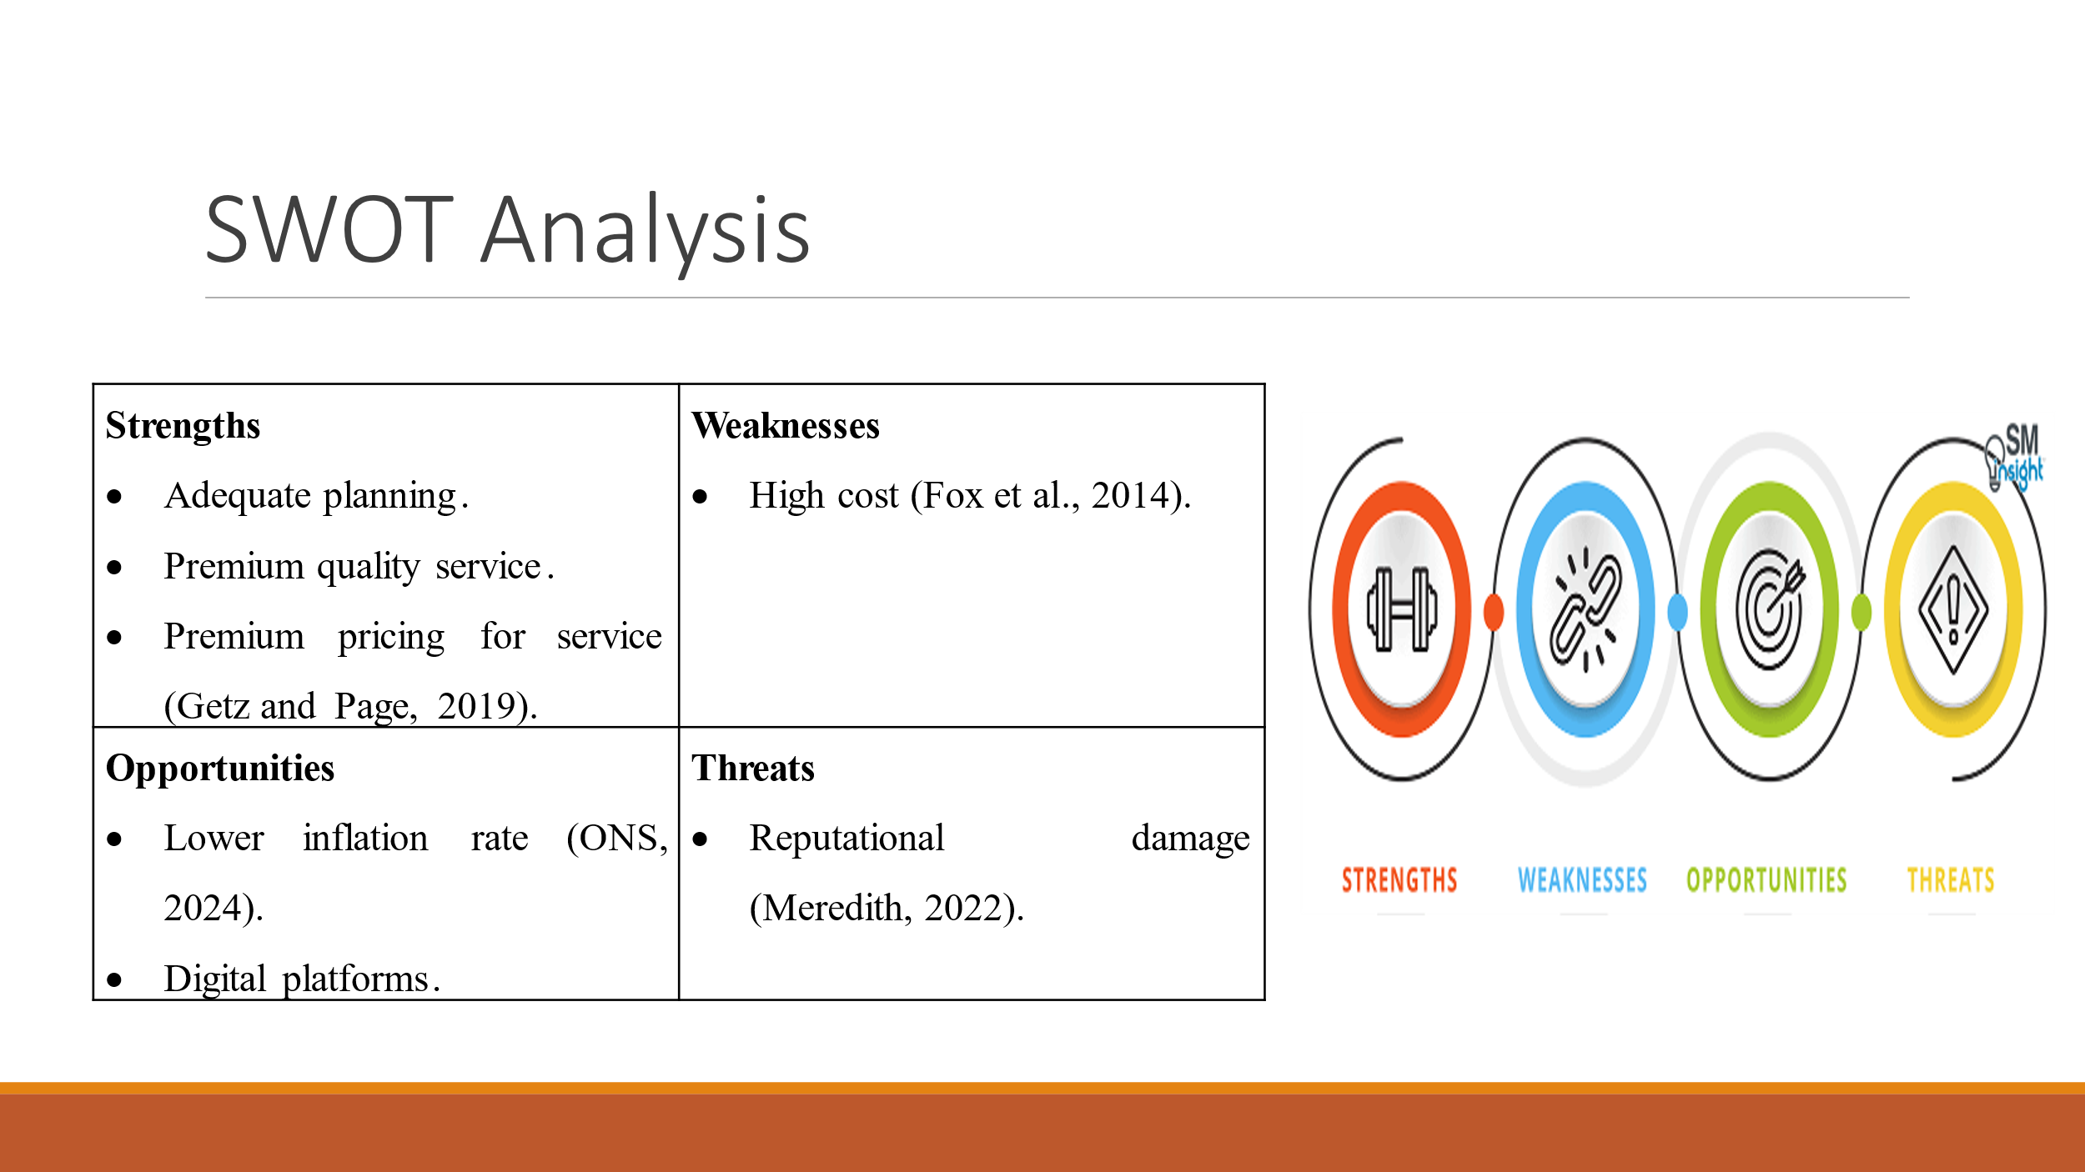

Slide 6

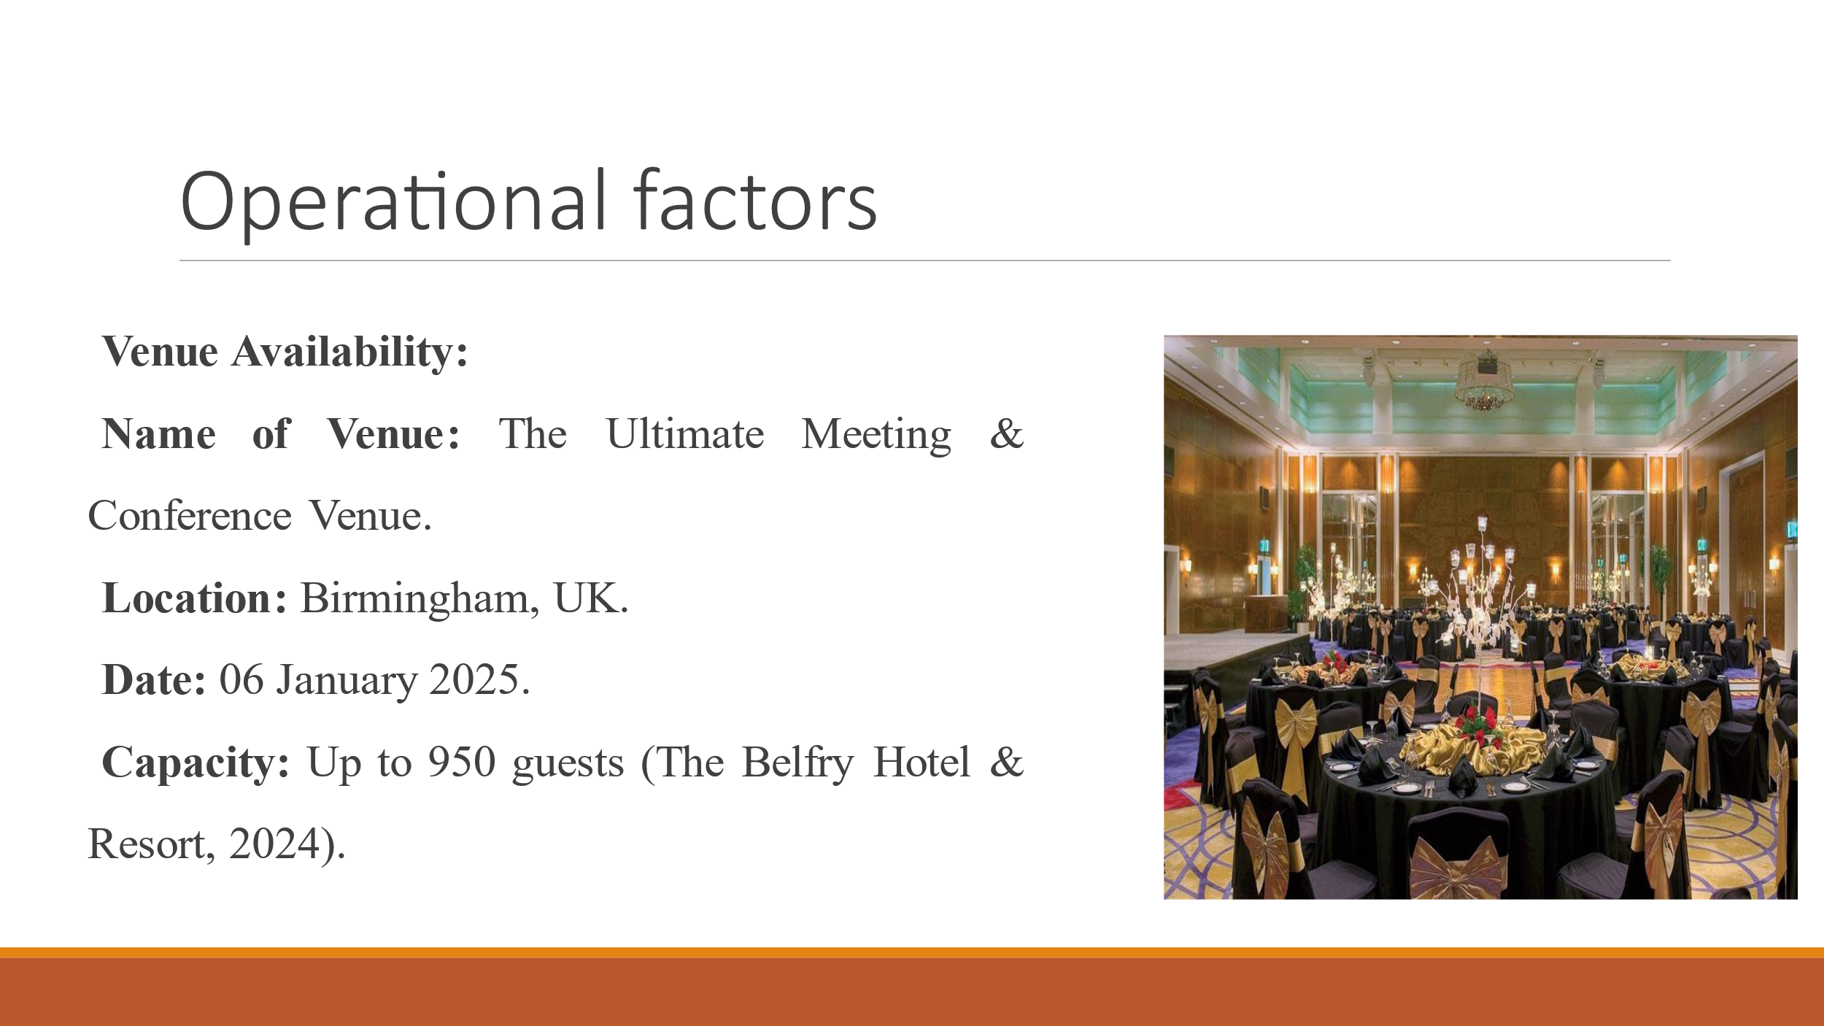

Slide 7

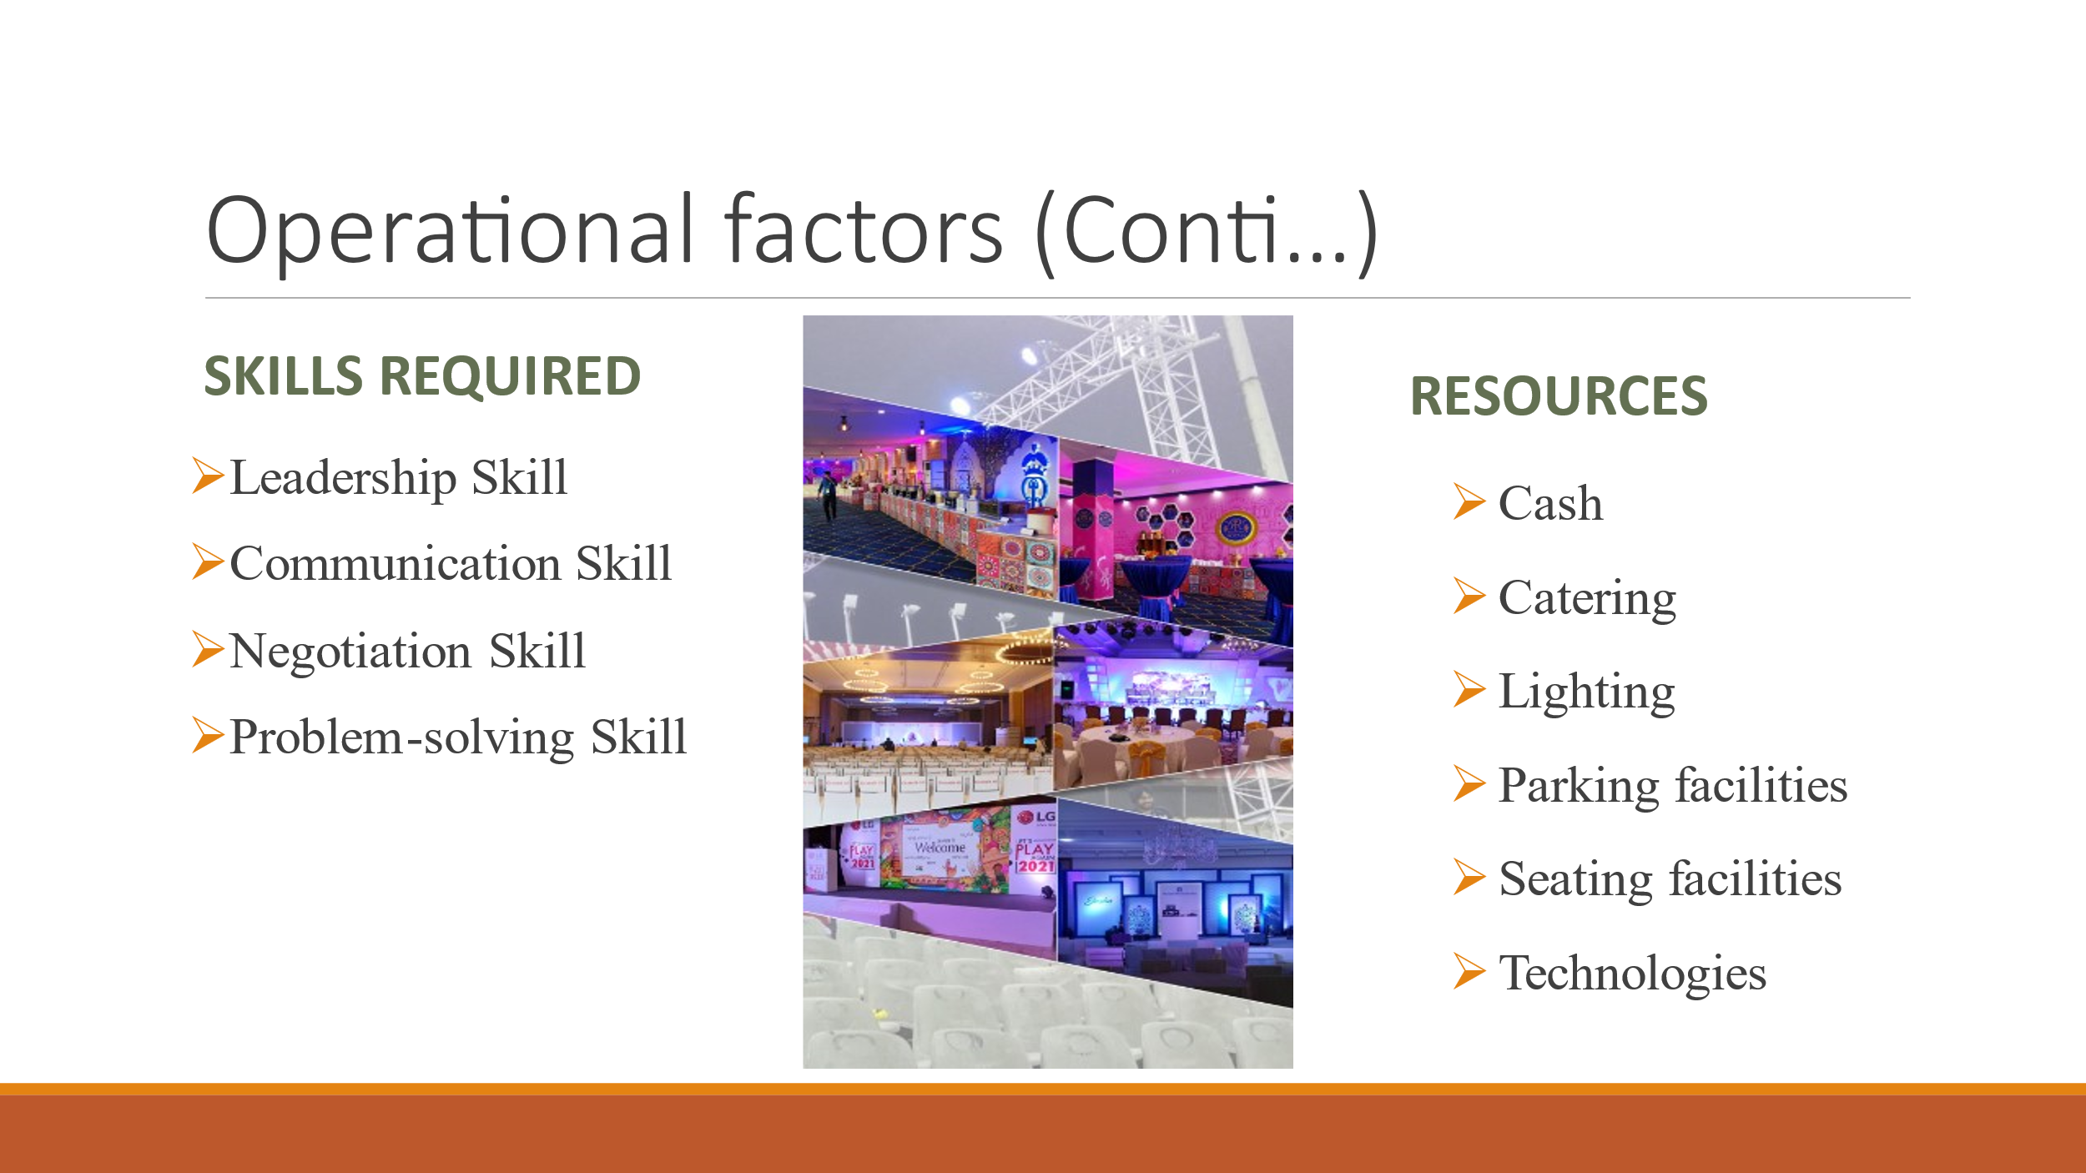

Slide 8

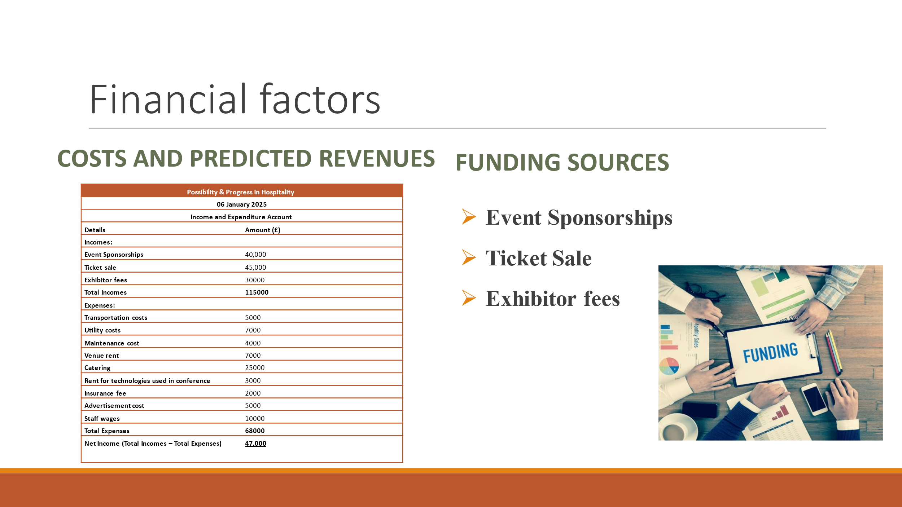

Slide 9

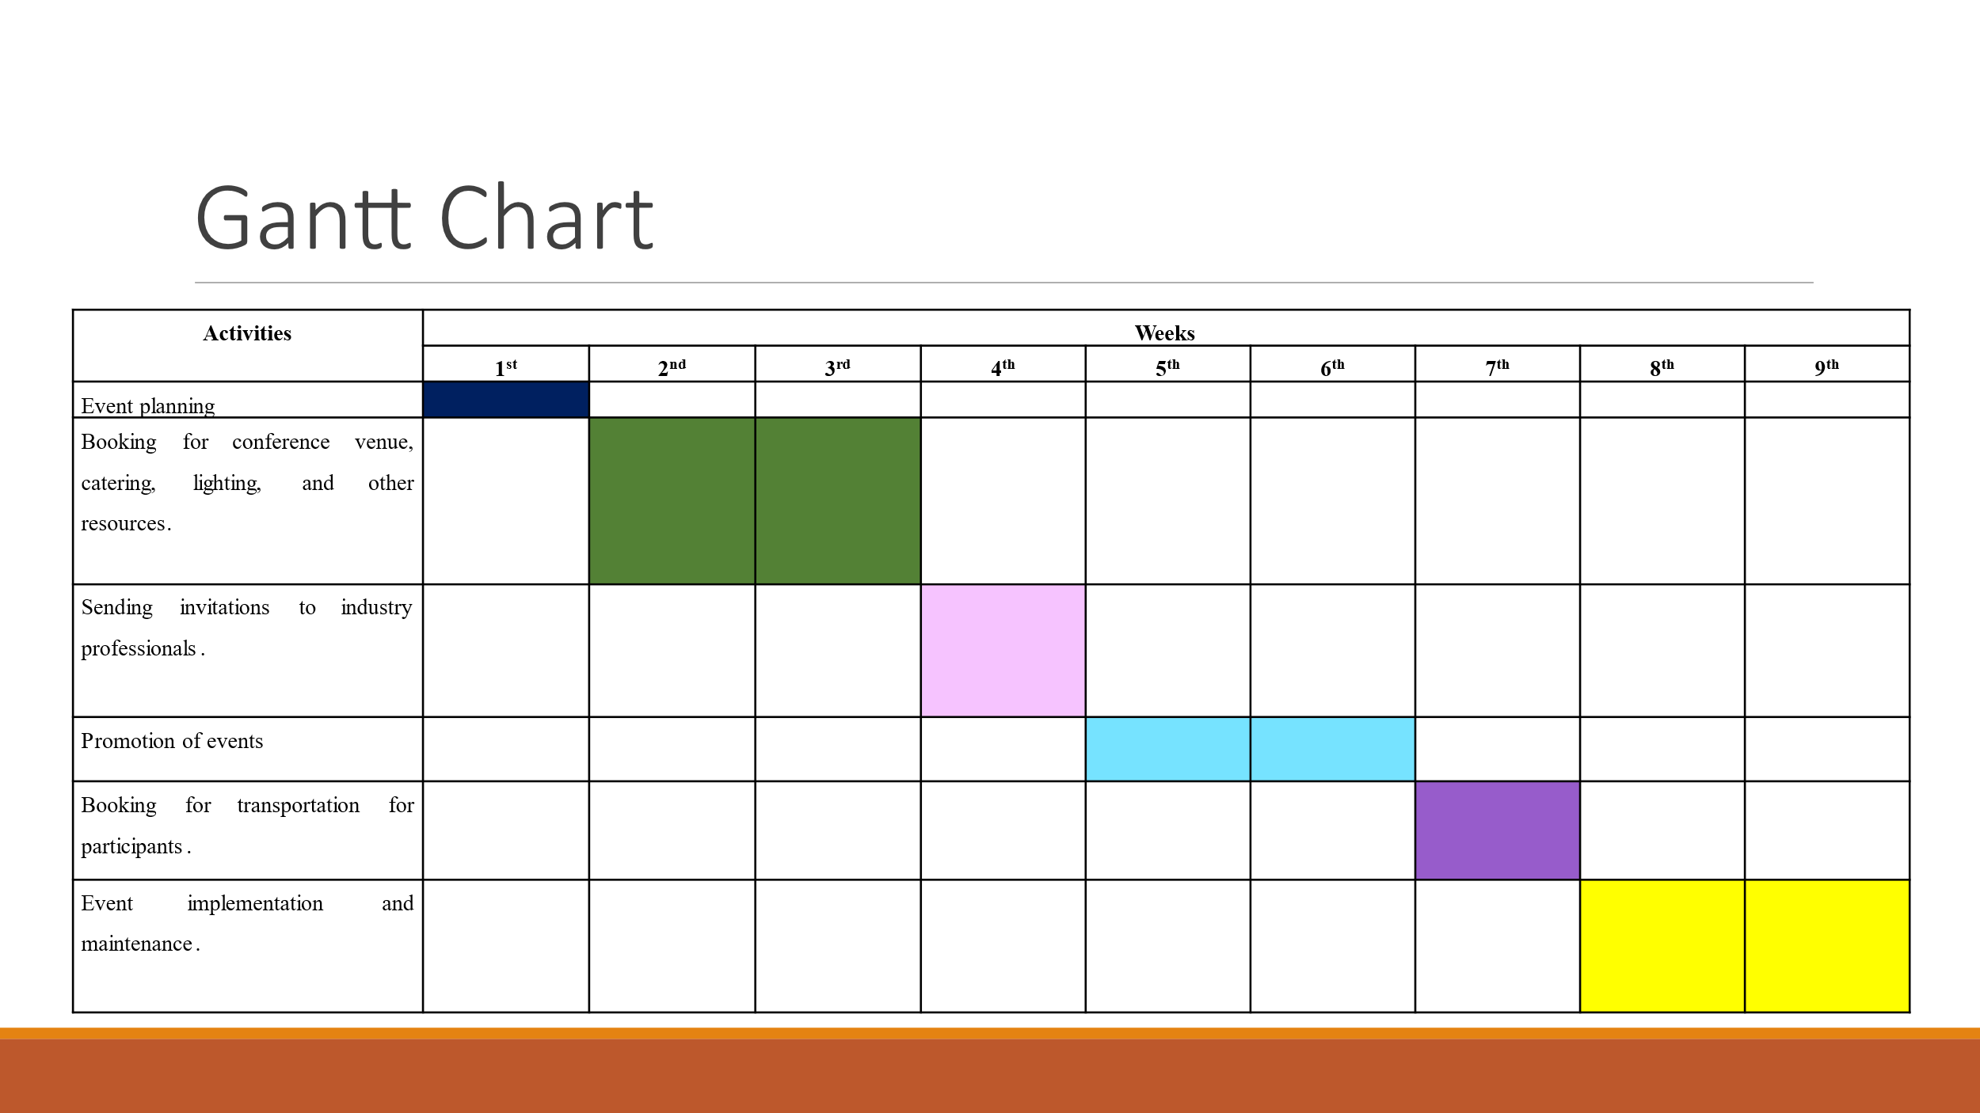

Slide 10

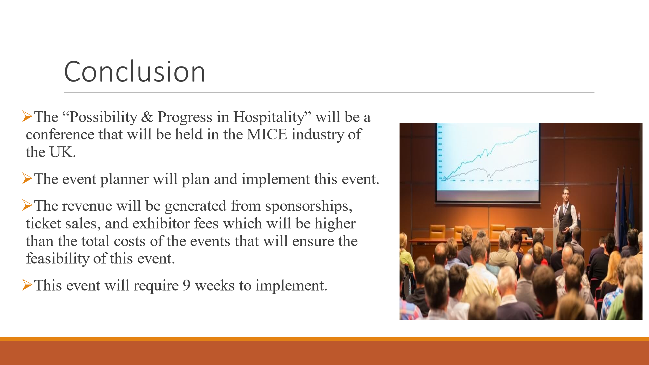

Slide 11

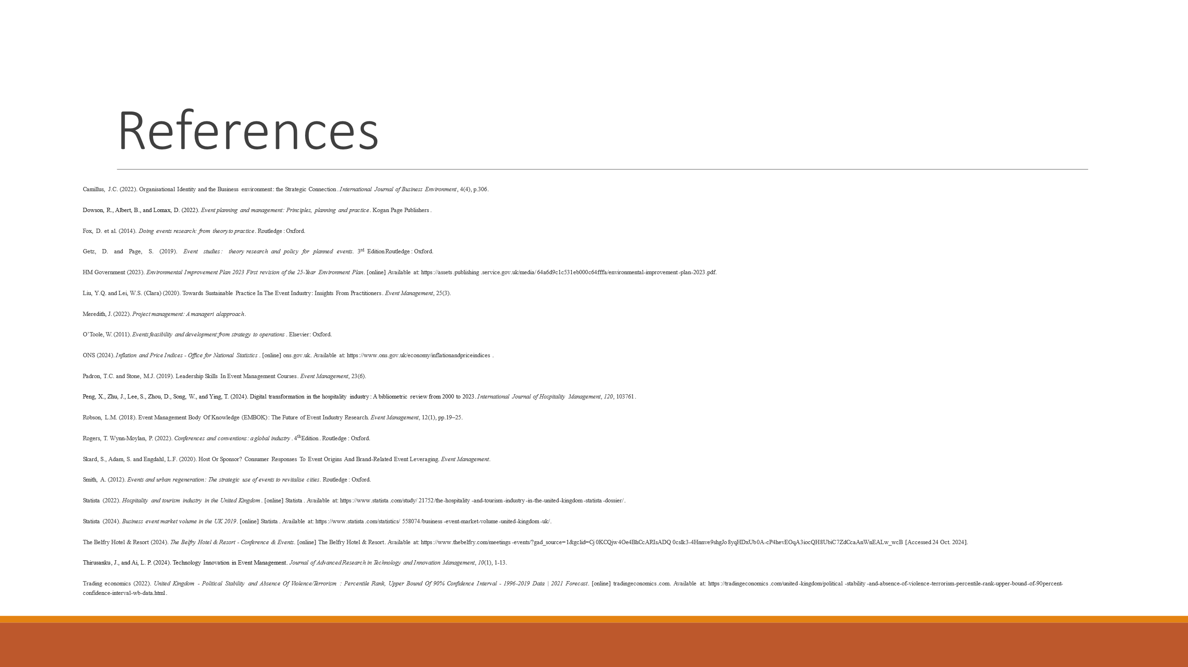

References
Camillus, J.C. (2022). Organisational Identity and the Business environment: the Strategic Connection. International Journal of Business Environment, 4(4), p.306.
Dowson, R., Albert, B., and Lomax, D. (2022). Event planning and management: Principles, planning and practice. Kogan Page Publishers.
Fox, D. et al. (2014). Doing events research: from theory to practice. Routledge: Oxford.
Getz, D. and Page, S. (2019). Event studies: theory research and policy for planned events. 3rd Edition Routledge: Oxford.
HM Government (2023). Environmental Improvement Plan 2023 First revision of the 25-Year Environment Plan. [online] Available at: https://assets.publishing.service.gov.uk/media/64a6d9c1c531eb000c64fffa/environmental-improvement-plan-2023.pdf.
Liu, Y.Q. and Lei, W.S. (Clara) (2020). Towards Sustainable Practice In The Event Industry: Insights From Practitioners. Event Management, 25(3).
Meredith, J. (2022). Project management: A manageri al approach.
O’Toole, W. (2011). Events feasibility and development: from strategy to operations. Elsevier: Oxford.
ONS (2024). Inflation and Price Indices - Office for National Statistics. [online] ons.gov.uk. Available at: https://www.ons.gov.uk/economy/inflationandpriceindices.
Padron, T.C. and Stone, M.J. (2019). Leadership Skills In Event Management Courses. Event Management, 23(6).
Peng, X., Zhu, J., Lee, S., Zhou, D., Song, W., and Ying, T. (2024). Digital transformation in the hospitality industry: A bibliometric review from 2000 to 2023. International Journal of Hospitality Management, 120, 103761.
Robson, L.M. (2018). Event Management Body Of Knowledge (EMBOK): The Future of Event Industry Research. Event Management, 12(1), pp.19–25.
Rogers, T. Wynn-Moylan, P. (2022). Conferences and conventions: a global industry. 4th Edition. Routledge: Oxford.
Skard, S., Adam, S. and Engdahl, L.F. (2020). Host Or Sponsor? Consumer Responses To Event Origins And Brand-Related Event Leveraging. Event Management.
Smith, A. (2012). Events and urban regeneration: The strategic use of events to revitalise cities. Routledge: Oxford.
Statista (2022). Hospitality and tourism industry in the United Kingdom. [online] Statista. Available at: https://www.statista.com/study/21752/the-hospitality-and-tourism-industry-in-the-united-kingdom-statista-dossier/.
Statista (2024). Business event market volume in the UK 2019. [online] Statista. Available at: https://www.statista.com/statistics/558074/business-event-market-volume-united-kingdom-uk/.
The Belfry Hotel & Resort (2024). The Belfry Hotel & Resort - Conference & Events. [online] The Belfry Hotel & Resort. Available at: https://www.thebelfry.com/meetings-events/?gad_source=1&gclid=Cj0KCQjw4Oe4BhCcARIsADQ0cslk3-4Hnnve9shgJo8yqHDxUb0A-cP4hevEOqA3iocQH8UbiC7ZdCcaAnWnEALw_wcB [Accessed 24 Oct. 2024].
Thirusanku, J., and Ai, L. P. (2024). Technology Innovation in Event Management. Journal of Advanced Research in Technology and Innovation Management, 10(1), 1-13.
Trading economics (2022). United Kingdom - Political Stability and Absence Of Violence/Terrorism: Percentile Rank, Upper Bound Of 90% Confidence Interval - 1996-2019 Data | 2021 Forecast. [online] tradingeconomics.com. Available at: https://tradingeconomics.com/united-kingdom/political-stability-and-absence-of-violence-terrorism-percentile-rank-upper-bound-of-90percent-confidence-interval-wb-data.html.

