Tania Vaninna Zalazar Poletti
Student number: 2021161
University of Wales Trinity Saint David
CertHE in Skills for the Workplace.
Effective Teamwork and Communication.
BMSW4002.
Lecturer: Rita Ukachi-Lois.
academic report
ETW Task 1

Table of Contents.
- Introduction.
- Models of communication.
- Shannon and Weaver.
- Schramm.
- Berlo.
- Communication skills.
- Conclusion.
- Reference list.
      - Introduction.
This is an academic report to show my understanding and knowledge about the 3 models of communication that we learned through the module and the necessary communication skills for them. With this objective I will analyse each of the models through academic examples and comparing them with real life cases in my daily life.
      - Models of communication.
Like Narula (2006) said: “Complexity and constant change in communication process makes it imperative that it is presented in simple and generalized way to explain and understand the structure and functions of communication. Communication Models present this simplification.” Here I will analyse each model separately in detail according to my perception, applying published material about the subject, information gained during lessons as well as the case studies.
- Shannon and Weaver model.
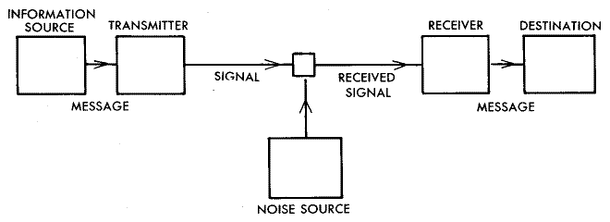
Shannon and Weaver model, graphic representation. (1949)

This particular model is clearly explained in the graphic, and as visible, is a lineal model. It al begins with the “information source”, which elaborates the “message”, which could be represented in many ways, that could be using words, pictures, music, etc. The “transmitter” converts the message to what we know as a “signal”, that will go through the “communication channel”, so it arrives to the “receiver”. A very good example could be a normal conversation between two people. The information comes from the brain, the transmitter will be our voice, and the message will travel through the air and will arrive to the human ear. This theory also talks about the “noise” which will be the term used to refer any disturbance in the channel that can affect the message. (Shannon, 1949)
A good example of this is the one given in class, in which a businessman sends a message to his employee to let him know that a meeting is coming, but because of a phone disruption, the message arrives incomplete, proving that this theory is effective, as the feedback of the employee asking again for the missing details to the businessman, lets him know that the message arrived incomplete.
A similar situation happened to me at work. There was a change on the management and the new people in charge was calling the staff in separate groups to understand how everything was running in the business. For this purpose, a message was sent on the WhatsApp group chat, but because of an app failure, I did not receive the message, therefore I did not assist to the meeting. The manager’s phone was the transmitter, the internet the channel and my phone the decoder, being me the receiver, and the app failure was the noise. Analysing this example, I was able to see clearly reflected this model in my life.
- Schramm.
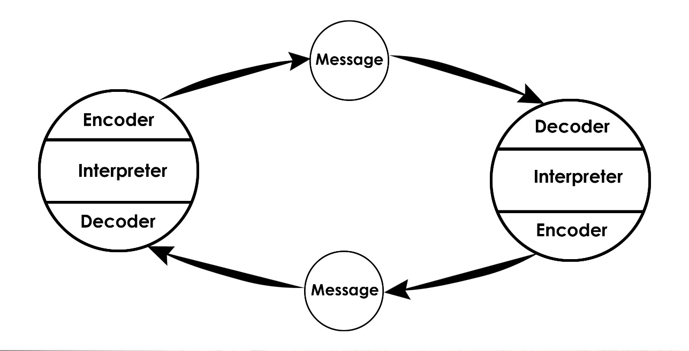
Schramm’s model, graphic representation. (1954)
This model is different because it's a cycle. In this model is necessary that both parties are collaborating for it to be effective. It is very important that encoding is present because it's the beginning of the communication process coma that is what converts the thought into content. The person receiving the message needs to understand an des afraid what the transmitter is saying until that happened the message is useless because the conversation cannot work if both ways are not aware of the full understanding of what is trying to be explained. According to the Schramm’s model (1954), coding and decoding are the two essential processes of an effective communication. Grammes are firms that this model is not effective and it's incomplete until the sender gives an answer to the recipient. Once the information arrives to the recipient it's his responsibility to give an answer and tell him if he received the message as the sender wanted. Once the receiver replies to the transmitter, he decodes the message and after understanding it completely replies again, closing the circle. This is what we know as a conversation. This model also states that an individual’s background, experience, knowledge and everything he already knows it's key for the understanding of the message as his background can make him understand the message on a different way. (Juneja, 2015)
A good example of this is a conversation that we have every day with our friends or our family. The only way for it to be effective if it is if both parties are understanding the messages and replying. There are many times in which different backgrounds have proven for me to be an obstacle during a conversation with other people, for example one time I was talking to an Ecuadorian friend and as I am from Paraguay there are certain words that I use on a certain way, and he understands it on a different way so the sentence that I was telling him had a different meaning to him, so the conversation took a different turn. That made me hard to stop the reservation in explaining him the actual meaning of what I was trying to say for the conversation to go back in trail. Being a foreigner in the UK, this happened to me many times. This proves that Schramm’s model is present in our lives every day.
- Berlo.
This model, just as Shannon and Weaver's, is also linear and it is very similar to the one seen first. It has four parts: the source called the message, the channel and the receiver. There are many factors that can affect this model like the knowledge, the social system, the culture, code, the communication skills, etcetera.
The problem with Berlo's model of communication is that it has a lot of cons, for example, there is no feedback which means that the sender will never know is them if the message has been received correctly, for this model to be effective both parties have to be on the same level, Berlo does not mention the possible obstacles which may affect the message itself, which in Shannon's model would be the noise, it is way more complex than the other models that we've seen before, it is very unrealistic, and lastly, it does not mention the thinking an understanding and analysing of the human nature. (Communication theory, 2014)
I could not actually think of an example of this model because he's not very realistic as it's not very common to find people at same level to maintain a conversation, and it is very usual to find a lot of noise that will affect the conversation. Therefore, I don't have much feedback to give in this model as I don't see the way to apply it on my daily life.

      - Communication skills.
Our communication skills are very important to understand others during a conversation in help them understand us. It is crucial that we develop them to gain a benefit in all the areas of our lives including our workplace or place of study. So, make samples of communication skills are:
- Active listening: This is to listen carefully to the person speaking. This is not as easy as it may sound, because having a good hearing doesn't mean that you will have good listening skills. This might take a lot of time to develop coma as it requires to pay attention not only to what the person is saying, but also to understand their body language and their facial expressions.
- Confidence: this is a great mic to attract people's attention. If you show a clear and confident understanding of what you're talking about people will be interested on listening what you have to say. It is very important to have a good knowledge of the subject you will talk about.
- Empathy: having a good and understanding of other people’s emotions and being able to put yourself on their shoes it's very useful at the moment of sharing information as you can support their ideas if they're happy or acknowledge and help them get rid of negative emotions as well. It is very important to remember that the attitude that the listener is having towards us affects the way that they take the information given
- Respect: it is key that we respect everyone when on a conversation. We need to make sure that we let them speak and we do not interrupt them, always trying to stay on our subject and being concise and precise when asking and answering questions.
- Understanding body language: our number well communication is also crucial at the moment of sharing communication an also listening. Our body language when we are listening someone says a lot of the amount of attention we're giving to them, if they see ask yawning or looking to the sides instead of their face, they will clearly see lack of attention from our side. At the same way our position at the time of talking to someone else says a lot of our confidence with the subject.
- Adapting your communication style to your audience: we should be very mindful of the person we are talking to so the communication can be effective. The same information might be understood on a different way if we use the same methods of communication with people with different backgrounds and attitudes. We need to learn the difference between the kind of people we are trying to give information to.
- Offering and taking feedback: we must be able to accept critiques after sharing information on a positive way, this is very helpful to keep up with our communication methods and have a better performance in the future.
- volume and clarity: we need to be heard in each part of the room when giving a speech. our volume can be seen as a lack of respect in some situations if we are speaking too loudly, and it go also cost us the interest of people if we are speaking to quietly. it can be useful to see how other people communicate in the places we are going to talk.
- Responsiveness: it is known that fast replies are better seen than slow ones, because it shows a clear interest. it is very important to consider the amount of time that it might take us an answer to the terminate the right moment do it. Letting the other person know how long it will take us to reply, gives a very positive impact. (Indeed career guide, n.d.)
These are just some examples of communication skills that we see in our daily life, and it is crucial to pay attention to them. It is important to understand each of these communication skills as they can help you succeed in your professional and personal life.
      - Conclusion.
This report has been very useful for me to fully understand these three models of communication, I learned that Berlo's and Shannon and Weaver’s model are both lineal, and Schramm’s model is a cycle, which I personally think is more realistic as it shows how conversation works, when the first two choose shows how the communication works from one side. this has shown me that the first two models analysed in this report which were Berlo’s and Shannon's are usually seen in our life on a daily basis, I need help me gain a better understanding of human communication itself, as eat explains the main problems that we can usually have when maintaining a conversation.
This also helped me understanding the skills that we need for an optimal communication, as it shows what we need when listening and speaking with other people. The most important thing that I gained during the writing of this report are the skills that I learned to be applied on my daily life. this could be at work, at university, or just having a simple conversation with friends or family. I was able to fully understand the different ways in which communication happens and what is needed for it to be completely effective. Writing this report, I was able to clarify all the doubts that I had left after lessons.
      - Reference list.
- Communication Theory. (2014). BERLO’S SMCR MODEL OF COMMUNICATION. [online]
- Indeed Career Guide. (n.d.). What Are Communication Skills? [online]
- Juneja, P. (2015). Schramm’s Model of Communication. [online] Managementstudyguide.com.
- Narula, U. (2006). Communication Models. India: Atlantic.
- Shannon, C.E. and Weaver, W. (1949). The mathematical theory of communication. Urbana: University of Illinois Press.

