
MODULE NAME: ENTREPRENEURSHIP
MODULE NUMBER: LCBB5001

TOPIC: BUSINESS PLAN

STUDENT NAME: MARTINA CHORLOVA
STUDENT NUMBER: 2028046

LECTURER NAME: RITA UKACHI-LOIS DATE: 13/01/2023

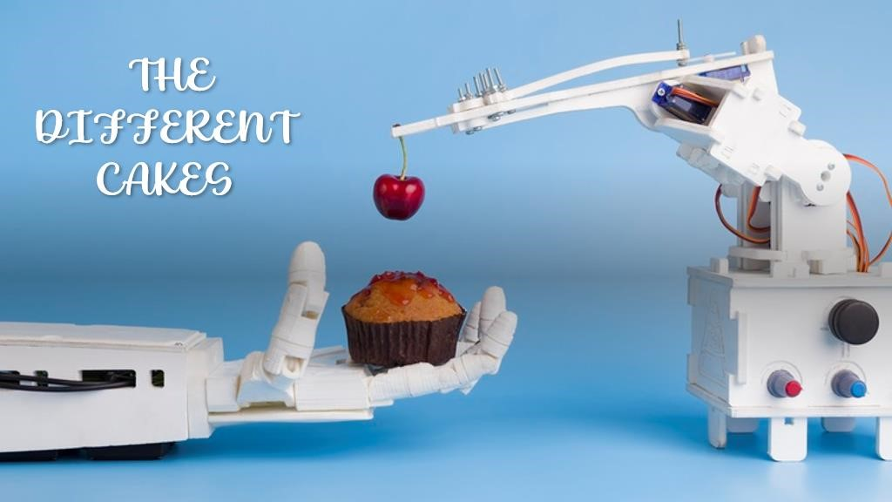

BUSINESS DESCRIPTION/MARKET OPPORTUNITY

The Different Cakes is innovative bakery in Peterborough, Cambridgeshire, with the mission to serve high quality baked goods in a creative and modern way. We will sale freshly baked desserts, made from 100% natural ingredients and we will fill the demand for healthy delicious products. What will make our brand to stand out in baked good industry is our drive to let customers be inspired, through their own design and flavour creations. Covid-19 Pandemic changed the consumers preferences and habits. The demand for healthier eating and personalised products will increase in the future. The consumer now understands the role of healthy eating, that have positive effect on their immunity and mental wellbeing. Today, the consumer is more mindful, with changing priorities and has wider access to information, and want to know from what and how are made the products that they consume. The pandemic changes the way of shopping and now customers have the necessity for artificial intelligence and smart technologies for more personalised experience.
Our focus is on the quality of the baked products and incorporating creativity of our customer to design their dream cake or cupcake. The customers will feel involved and important in making the product. The bakery will be modern and keep up with technologies, this includes – design stations with tablets, website that will provide organized way for orders, production technology for improved baking process with automation and artificial intelligence for customised baking.

MISSION STATEMENT
Our mission is to create inviting environment for our customers. To use technology and connect with our customers in a modern and creative way. To produce the best baked goods in the industry and to be as customer friendly as possible.

PRODUCTS AND SERVICES
High personal products will be available in-store and online for orders. The customer will have the opportunity to create own design or can choose from suggested list. First step is to choose the occasion – Birthday, Wedding, Anniversary, Celebration cakes etc. When the occasion is chosen, the customer can choose the size options. Next step is to select their flavour from the generated list or to create own one. Also, there will be choice for dairy, gluten, sugar or nut free cakes. The next choice to the customer is to select the cake topper, again can be chosen from the list or customised. The last choice is for delivery method – where and when, collection choice will be available as well. All option and choices have different price, at the end of the selection, the end price of the product will be available.
To provide this service, our bakery will use technology in the production. Artificial intelligence will be used in our baking ovens to calculate the time based on the ingredients used for the product. Also, customised orders will be generated with Artificial Intelligence, to be ensure that there are used correct proportions and the baked good is delicious. Automotive machine will be used for decorating, with potential in the future to be bought 3D printer, for new and innovative designs. The using of technologies will make the processes faster and cost effective.

MANAGMENT STRUCTURE
The Different Cakes will be a general partnership between Martina Chorlova and Katrin Ivanova. The ownership of the company will be share equal. Martina Chorlova will act as the CEO (Chief Executive Officer) and will manage and assist in the baking process. Miss Chorlova is confident, organised and persistent. She has experience in customer service, sales and leading more than ten years from her past employment experience. Her very motivated personality and hardworking, will create stable and solid environment for the employees. With her experience and knowledge, she will be able to put The Different Cake in the industry and make it the best brand.
Katrin Ivanova will be Chief Marketing Officer and the primary cake designer and baker. She is experienced pastry chef, with several awards for her artwork. She will be obtaining all certification and licensing needed for the job.
Sam Martin will be hired as Chief Financial Officer. He will handle technological facility and website. He is experienced in financial as well as IT operations.

INDUSRTY ANALYSIS

THREAT OF NEW ENTRY
The Threat of New Entry for The Different Cakes is low, because:
- The entry in this industry requires high capital, especially for our bakery with the strength of product differentiation and unique experience is high
- Distribution channels for 100% natural ingredients is restricted, new entrants will be discouraged
- Achieving brand loyalty from the customer is another benefit
- With the usage of technology, the access to valuable customer data will set strong differentiation basis

THREAT OF SUBSTITUTES
Threat of substitutes for The Different Cakes is low, because:
- It is not available from another industry cheaper substitutes products
- We offer products is with better and higher quality than the available substitutes
- Customers are provided with high quality products and that will prevent the usage of substitutes products from our customers

BARGAINING POWER OF CUSTOMERS
The bargaining power of customers is low, because:
- The competitors do not offer the products that we have
- For the customers is impossible to prepare by themselves the products that we sell
- The trend of using technology for healthy baked goods is new, the customers does not have the market knowledge of the prices
- Marketing strategies will be used for increasing the customer base and manage bargaining power

BARGAINING POWER OF SUPPLIERS
For The Different Cakes, the power of suppliers is low, because:
- The suppliers are not concentrated in one specific region
- The cost of switching from one to another supplier is low
- Our bakery has more than one supplier, from different regions and that give to us independence
- If the product is with high demand, we will have alternative ways to produce it, this redesign will help to reduce the power of suppliers
•

COMPETETIVE RIVARLY
NAME OF COMPETITOR | DIFFERENTATION
Cake Box | They are offering traditional cakes; they do not have the choice of personalised ingredients cake. Without plant-based products.
Cake INN | The cakes that they are offering are not innovative, using old techniques of decorations. Without plant-based products
Peter’s Traditional Bakery | Traditional products, no plant-based products, without online ordering or website.

OPERATIONS AND MANAGEMENT TEAM

OPERATIONS
The operations in our bakery will use technology to create efficient and no waste policy. The best way to fully efficient is to use specialized bakery planning software. Our operations include five steps of processes – raw materials, mixing, baking, decorating and packing. With the use of this software, we will permanently be updated with our inventory, to prevent any shortage of ingredients. If we are missing any baked goods, the customer can choose another brand or substitute. Also, this software will save the time of management team, will be easier to order, to produce, to inventory management and product costing. For our production processes we need to look for locally or trusted international suppliers. The fresh baked goods need easy reachable and with fast delivery supply. International suppliers we can use for our decorating inventory, packaging and some backing ingredients that are hard to find in our area. To be sure that our suppliers offer high quality products, we will ask for samples, to use it in our production process and check the end product. After investigating the product that they offer, we can consider the offer, with focus on the price.
The inventory that we will need to open the bakery is:

BAKING EQUIPMENT
• Commercial mixers, heavy-duty food chopper, turnover machine, slicers, rolling pins, rolling mats, icing spatulas and grates, ventilation, fans, ovens, baking trays, cake décor accessories etc.

STORAGE EQUIPMENT
• Food prep services, shelving, refrigerators. Freezers, fast cooler, storage utensils, food bags, serving trays etc. • Delivery van

SAFETY EQUIPMENT
- Aprons, hairnets, gloves, hats, first aid kit, date labels, cleaning sheets etc.

HOW WE GONNA GENERATE REVENUE FOR OUR BUSINESS?
Opening a bakery have certain risks, but with the correct planning and monitoring the business will be profitable. There are steps that we will take to prevent any loss of revenue:
- Our products cannot be found elsewhere, healthy and free from baked goods are in demand
- Healthy standards – correct storage of all raw materials to prevent any food poisoning or cross contamination, that can be critical to our brand name
- We will create loyal customers base – different promotions and sale for loyal clients
- We will use different price strategies to increase the revenue
- With professional analysing of costs, monitoring and adapting to any changes
- If there are any future health pandemic and lockdowns, we will be prepared to work fully online with contact free delivery

MANAGMENT TEAM
NAME | SKILLS | WHAT DO THEY BRINGS TO THE FIRM
Martina Chorlova | Experienced in sales and customer service, leading | Will be able to stand out the brand in the industry
Katrin Ivanova | Experienced pastry chef, creative, innovative, leading and teaching | Bring the uniqueness and taste to our baked goods
Sam Martin | Problem-solving, time management, knowledge of technology and engineering service | Keep up to date our technological site and online website.
Chris Newton | Team player, team leading, organising, problem solving | Control all employees, give correct instruction and tasks, run processes smooth

MARKETING

PRODUCT/SERVICE STRATEGY
The Different Cakes will sell quality baked goods, we will make our food unique with excellent experience to our customers. With incorporating technology, we will supply even greater experience. The customer will have the opportunity to direct and design own cakes or cupcakes. Keeping the wide variety of products and ingredients to stand out of our competitors.
PRICE Our price will vary depending on the ingredients that are used for the baked good. The strive for high quality products is paired with higher prices. The cost for every product will be different. The prices will be set according to the rises and falls of some raw materials, to prevent the gap between quality and price.

PROMOTIONAL MIX
Nowadays the use of social media is a key of promoting products. We will use Facebook, Instagram and our website to attract new customers and raise the sales. Our website will include detailed description of the products, description of the company and photos of our baked goods. Another social channel is Tik Tok, and we can use it to gain popularity of our products, with short videos of decorating and baking in healthy way. Another never getting old strategy is the recommendation from our customers to their friends, family members and colleagues.

PLACE
Our primary way of distributing our baked goods will be through our bakery (in-store). Customers will have the choice of walk in, buy and order online, order by telephone. Delivery will be available in radius of 20 miles and will be charged added amount. Because of the range of our products, we are expecting between 150-200 customers per day. The location of our bakery is on a main street with high people traffic. The area is surrounded by corporative companies, regional college, two primary schools and train station. All bakery goods that are not sold on the day, will be displayed on the next day with half price. If in the end of the second day they are still not sold, we will work closely with the local community, and all baked goods will be sent to people in need.

FINANCIALS
SOURCES OF FUNDS:
The partners Martina Chorlova and Katrin Ivanova will contribute with £10,000 each. The amount of £20,000 will be used for purchasing used delivery vans. An added amount of £25,000 will be invest from family members and friends. This amount will be used for renovating the place, buying some used machinery and more equipment. A 5-year loan will of £30,000 will be required from local bank in Peterborough. The amount will be used for technological part – machines with artificial intelligence. Also, the amount will be used for two months ahead of employee payments. The loan will be paid in full until 2027 year. The same year The Different Cakes may request additional loan to expand production and replace the equipment.

 | MONTH 1 | MONTH 2 | MONTH 3 | MONTH 4 | MONTH 5 | MONTH 6
REVENUE (from operations and marketing section) | £130,000 | £150,000 | £160,000 | £175,000 | £185,000 | £200,000
Fixed Costs
Rent | £2,000 | £2,000 | £2,000 | £2,000 | £2,000 | £2,000
Advertising | £100 | £100 | £100 | £100 | £100 | £100
Payment of Chief Financial Officer | £4,000 | £4,000 | £4,000 | £4,000 | £4,000 | £4,000
Insurance | £1,200 | £1,200 | £1,200 | £1,200 | £1,200 | £1,200
Van insurances | £250 | £250 | £250 | £250 | £250 | £250
Loan payment | £500 | £500 | £500 | £500 | £500 | £500
Total | £8,050 | £8,050 | £8,050 | £8,050 | £8,050 | £8,050
Variable Costs
Utilities | £500 | £600 | £1,000 | £1,100 | £1,250 | £1,400
Raw materials | £2,500 | £2,600 | £3,000 | £3,200 | £3,100 | £3,500
Packaging materials | £1,000 | £1,200 | £1,750 | £2,000 | £1,800 | £2,000
Delivery cost | £200 | £220 | £180 | £200 | £190 | £300
Payment of employees | £4,000 | £3,800 | £4,100 | £4,500 | £4,300 | £4,800
Total | £8,200 | £8,440 | £10,030 | £11,000 | £10,640 | £10,000
Profit | £113,750 | £133,510 | £141,920 | £155,950 | £166,310 | £181,950

REFERENCES
Argyres, N. and McGahan, N (2002) An interview with Michael Porter, Academy of Management perspectives, Vol. 16, N2, pp.42-53

Blackwell, E. (2011) “How to prepare Business Plan”, Kogan Page, 5th Edition, available at: Full details and actions for How to prepare a business plan (uwtsd.ac.uk) (accessed on 21/12/2022)

Burnts, P. (2016) “Entrepreneurship and Small Business. Start-up, Growth and Maturity”, Macmillian Education, 4th Edition

Evans, V. (2011) “The Financial Times essential guide to writing a business plan: how to win backing to start up or grow your business”, Harlow: Pearson

Food Standards Agency (2021) Emerging Technologies that will impact on the UK Food System, online source, available at: Emerging technologies that will impact on the UK Food System (accessed on 22/12/2022)

Mariotti, S, & Glackin, C 2015, Entrepreneurship: Starting and Operating a Small Business, Global Edition, Pearson Education, Limited, Harlow. Available at: ProQuest Ebook Central - Detail page (accessed on 22/12/2022)

Matthews, C & Bruggemann, R (2015) “Innovation and Entrepreneurship – A competency framework”, Routledge, New York

Mavani, N et al (2021) “Application of Artificial Intelligence in Food Industry” Springer, 135-144pp.

Porter, M. (2008) “The five competitive forces that shape strategy”, Harvard business review, Vol. 16, N1, pp. 78-93

Scott, J (2017) “The Entrepreneur’s Guide to Building a Small Business”, EFMD, Belgium, pp.192-196

Sharma, S et al. (2021) “Sustainable Innovations in the Food Industry through Artificial Intelligence and Big Data Analytics”, online source, available at: Logistics | Free Full-Text | Sustainable Innovations in the Food Industry through Artificial Intelligence and Big Data Analytics
(mdpi.com) (accessed on 20/12/2022)

