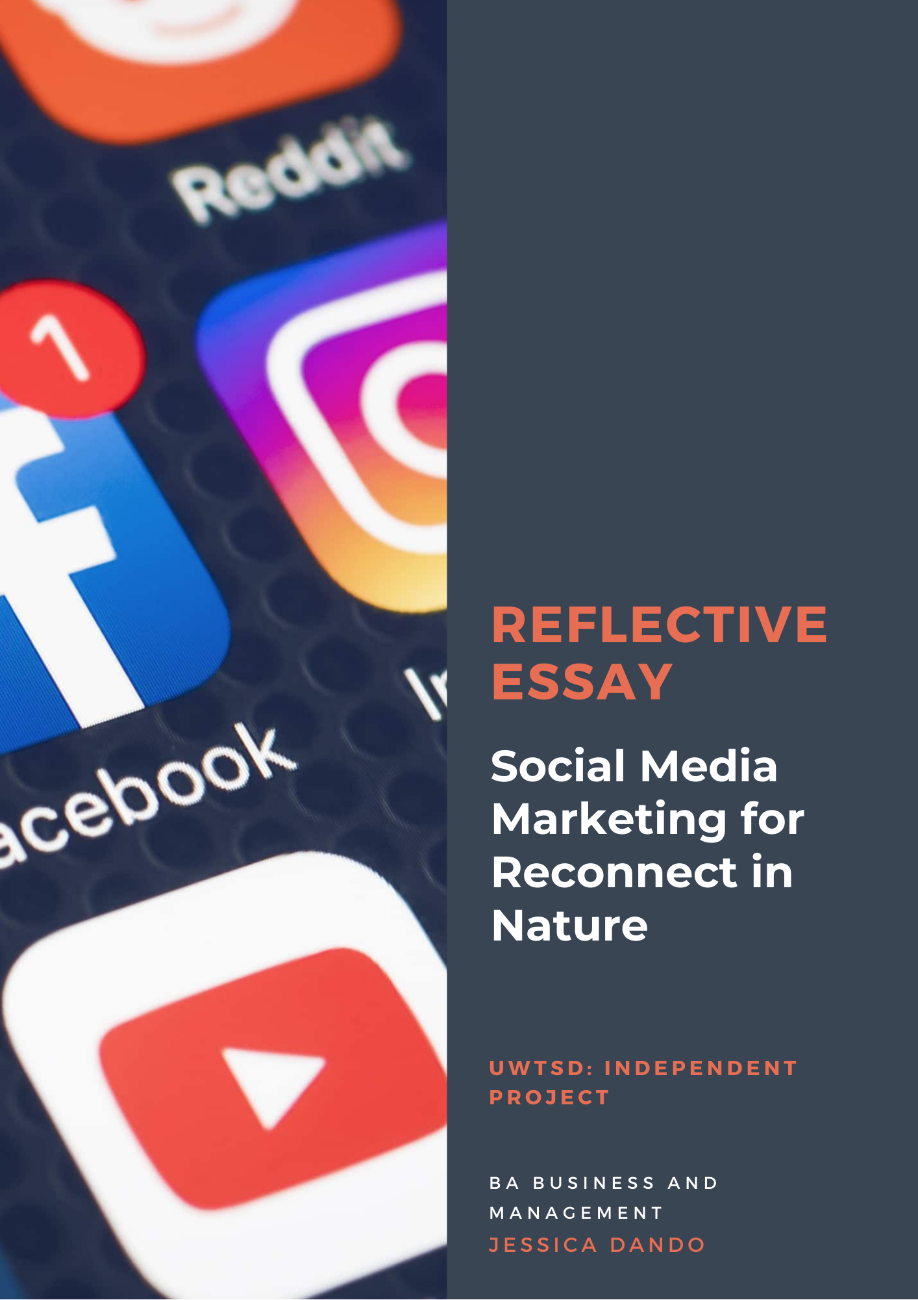
Introduction
Reflective practice is a way of promoting learning by experience and helping to attaining new insights about oneself and future practices (Ghaye, 2010; Finlay, 2008) Throughout research into the most suitable model to use to reflect on the practical portfolio, I was attracted to more than one model, but also wanted to express my journey through the research and implementation uniquely, in my own voice, so I decided to take some key elements from two models.
Firstly, I liked Kolb’s cyclical model of learning and the four-stage learning cycle that involves doing (having an experience) reflective observation (reviewing/reflecting on the experience) abstract (concluding/learning from the experience) and active experimentation (planning/trying out what you have learned) as is described throughout this writing, all aspects have been observed from the cycle, and examples are provided throughout. As a social media marketing campaign develops through learning what works and what doesn’t in terms of demonstrating consistent analysis and evaluation of the metrics, the model incorporates an aspect of trying out what is learned. Lastly, I also found Gibbs (1988) model for reflection useful and despite the writing not necessarily being laid out in the exact order, it was used to guide each aspect of the writing maintaining that I described the event; my feelings about the event and analysed the process. I have also evaluated, concluded and presented an action plan to help me use what I have learned throughout this practice in the future.
The aim of this reflective essay is to develop a deeper understanding of social media marketing through reflection. After some initial research, it was decided that social media marketing and the practical application of an actual campaign would be the most suitable project for me to undertake, and this was considered in the context of future career progression and the usefulness of a practical undertaking to the betterment of my aspirations.
After an initial meeting with the organization, it was determined that they needed assistance with their social media, and help to enhance their online profile, it was agreed that my role would be to assist with the development and implementation of a social media marketing campaign that would enhance their engagement and grow their digital presence.
Initial research and plan
The research then began into social media marketing, and how non-profit organsiations would utilize this to promote their causes. (Macduff, 2012) Immediately within the literature, which consisted of journals; websites; books and existing campaigns and profiles of successful charities and non-profit organizations, what I first noticed was how the research unequivocally ascertained that social media marketing with a necessity and an essential tool for non-profits and businesses alike, and if used effectively could revolutionise the marketing of organizations by promoting their causes and attracting key stakeholders including donors and volunteers (Kanter, 2012)
The focus at first, was to identify what other organizations had done with their social media in order to identify tools and strategies for success yet simultaneously realizing that each organization is different, so one would have to adapt tools and strategies to suit the organization, their needs and values.
Some interested campaigns included that of The Red Cross, and March of Dimes where key themes such as sharing of Facebook stories; blogs; uploads on YouTube, and microblogs on Twitter became apparent. (Milde, 2017) I identified trends familiar in successful social media campaigns and the concurrent use of effective and entertaining content strategies aligned with the organizations mission became apparent (Readings, 2015) the initial research inspired my focus to incorporate the creation of content and inspired me to concentrate on a strategy that would incorporate the creation of content. I then began to research potential platforms from which to share that content.
Kaplan and Haenlein (2010) present six types of social media and I identified the relevant choices from their suggestions, which included blogs and microblogs (WordPress; Twitter) content communities (YouTube; Vimeo) and social networking sites (Facebook and LinkedIn) The first platform that I did not even debate using was Facebook, the world’s largest social networking site (Hootsuite, 2020) focused on the key demographic for Reconnect (predominantly age 30-65) and having had experience of using Facebook both personally, and for marketing purposes this was, and continued to be the most successful platform to use.
I was apprehensive about considering the other platforms and knew that out of the remaining platforms I would have to extensively research how to use them, and the content that would ensure the most success on each individual platform. According to Butow et al (2020) there is no one size fits all for the networks, so it was essential to undertake the work and learn how each platform could be utilized to ensure the best levels of engagement and response from audiences.
Lui et al (2012) stated that microblogging on Twitter allowed organizations to communicate with audiences and establish clear understanding of their needs and values. Aside from Facebook, a networking site that was recommended by a large proportion of the literature was LinkedIn, being the third best platform overall (Lindholm, 2019) it made sense to choose it as one of the platforms, it was also discussed with the organization as a platform that could be utilized in order to sell spaces on a summer wellbeing training course, as it would enable us to target health professionals and grow that network, to identify potential contact in that area who may be attracted to the course. Last, but not least to consider platform wise was one that ended up being the most enjoyable to use, Instagram. Bevins (2014) states that the success of Instagram comes from its visual strategy, and with existing knowledge and research showing that photographs are incredibly popular when engaging audiences, and an awareness of the assets the organization owned that could be repurposed for the platform, it made sense to choose it.
After several meetings with the organization that were conducted throughout every stage of the research process and the production of the methodology; content plan and the schedule, the recurring theme and something they expressed at every opportunity was how important the principles of the organization (five principles) and how information and content shared should fall in line with the principles and mission of the organization. Carey (2019); Camacho (2020) Campbell et al (2014) highlighted the importance of a mix of both curated and content relevant to the principles of Reconnect.
The survey results identify photographs, videos, blogs and infographics as being the most popular created content. The literature identified the need for a strong content strategy that incorporated informative and educational curated content also (Hubspot.com) this translated into the plan as sharing relevant content relating the effect spending time in nature has on mental health; how the crisis relating to mental health has increased during the pandemic (relating to the principle of connecting with nature) studies that talk about loneliness and how the lockdowns have affected our connection with others (relating to the connecting with others principle) and information and articles on things like meditation; mindfulness; walking in nature; and ecotherapy (relating to the connecting with oneself principle) The challenge when it came to content, was generating user-generated content, according to (Carey, 2019) that type of content is one of the most effective in engaging and starting conversations with the audience, efforts to ask users to share videos and pictures of their own was met with very little response and eventually got one result overall, however it is still early days, and through repetition and trying new ways of generating a response this is expected to improve.
Reflecting on the methodology and analysis
Before evaluating the campaign, itself, it is necessary to talk a little about the methodology and evaluate the effectiveness of the methods chosen and talk about negatives and positives. After reading that a mixed-method approach could be tricky, I was apprehensive about choosing it but from the reading I did, I came to understand that the whole point in using both methods is to strengthen the data (Hesse-Biber, 2015) which made perfect sense in practice, with the results of analytics eventually proving whether information from the quantitative data was reliable and made sense. At first, I did consider doing interviews and part of me feels a little disappointed that I did not but I wanted to maintain the focus on the analysis of the before and after social media results, and the actual implementation of the campaign rather than focus too much on interview questions and organizing times and dates for interviews where reasonable results could be collated through surveys.
When considering how to collect, measure and analyse the before and after results for the social platforms I researched several methods before finally accepting my limitations of being unable to adequately interpret the data provided by the networks without a lot more experience, and decided to utilize a free trial of the best social media metrics analysis tools agorapulse. The software offered publishing; reporting; monitoring and team collaboration tools, (Agorapulse.com) everything to make the implementation and measurement of results from campaign run more smoothly.

Implementation of the Campaign
The implementation of the campaign presented challenges and both positive and negative results, and things to reflect on. Survey data in the beginning led the scheduling for the campaign, with most users stating that they used social media in the evening and at night. The first posts were scheduled at that time, but then adapted when results from the analytics were collated, that showed platforms like Twitter and Instagram engaging users earlier on in that day. Due to the literature suggesting more than one Twitter post a day, the schedule incorporated both a morning and night-time tweet to encourage the most engagement. I also utilized software that identified what posts performed particularly well relate to the subject matter to identify the best content to share on the platforms, such as Buzzsumo, where you can type key words related to the subject matter and the platform would suggest links to the best performing content within those key categories.
As well as spending at least two hours searching the internet, Buzzsumo, and the platforms for content and to keep up to date with events and industry news that would be informative I would also spend time posting and scheduling within the publishing section of Agorapulse as well as some random posts that were more spur of the moment. I created infographics for Instagram which would predominantly share infographics based on special events or days such as ‘Autism awareness day’ I also put together inspirational quotes relating to nature and mental health, using existing photographs and design software such as Canva and adding quotes to original photographs in order to create original content that we could add the Reconnect logo to. I also wrote a blog that explained a journey I had taken with the organization, and there was also a video of the journey that went well alongside it, and that generated great engagement on Facebook in particular. The literature expressed how important it was for an organization to tell a story, (emergentdigital.com) and the blog and video aligned with that aspect of storytelling, it was a sense of pride to share quite personal aspects of my story. I put together a slideshow of photographs timed with music and graphics that took me longer than anticipated because I realized after I had purchased the template that it was to be done in After effects, a program I had little experience using. After a few courses and many hours work I managed to put together the slideshow but struggled with time-mapping and utilizing the graphics, allowing me to utilize new software and learn more about an unfamiliar platform. A video blog was planned, with call to actions being shared on all platforms to ask for people to interview about their experiences in nature, the plan was to interview people for the videos and share them as a podcast series, which could be shared across all platforms as part of the content strategy.

Evaluation
There were many aspects, that have been described above, that went well and that I was proud of. There were, of course negatives and as is always the case, I feel I learned more from those than I did from the things that went to plan. One main complication came when the owners expressed dissatisfaction with a few posts that they said did not align with their principles, and were subsequently deleted, the literature indicated that not all posts should be related to the organizations’ values, and that there should be elements of experimentation, but I had not considered the feelings of the organization. I felt annoyed and frustrated with this, it made me feel like my judgement was not trusted. Eventually, after some reassurance from the organization I began to understand that it was not personal and that they were pleased with what I was doing for them but were just focused on posts being in line with their principles and beliefs. Overall, there were much more positives than negatives and this was indicated in the analytical results, with 60 new followers on Facebook, 20 new followers on Twitter, 16 on Instagram and a network of 30 on LinkedIn, a page set up specifically for the campaign as well as enhanced engagement, mentions, visitors to all social sites and brand engagement being 7 times what it was before the campaign.
Conclusion
Social media marketing seems a relatively easy task to approach, until it becomes apparent that it is such a complex and huge undertaking for someone with little experience. The experience of researching, developing and implementing a social media marketing campaign for Reconnect in Nature taught me a great deal about working with organizations, how to use platforms and what works and does not on each; how to measure and analyse results and how software works; and most importantly, how to create entertaining content that works for the organization.
Overall, after also researching the effectiveness of paid advertising on the platforms, it became apparent and was mirrored by the literature that organic use of social media can only take an organization so far, and that it is necessary to utilize that advertising to gain results that will attain the most comprehensive results for any business or organization. (Sehl, 2020) I have gained valuable insights into content creation’ social media marketing; time-management and organizational skills.
Action Plan
Having taken the time out to reflect-on-action, I have compiled a plan of action that will allow me to further develop my skills and to help me address some issues I encountered throughout (Williams et al, 2012)
I arranged a further meeting with the owners of the organization and clarified the content plan, to ensure that I would not drift away from the aims and campaign and not make the mistake of sharing content that did not fit in with the principles and brand.
I researched paid-for advertising and came up with a potential plan, including calculating what budget the organization would need, and what platforms offered the most comprehensive and targeted advertising that would gain the most likes/followers and audience engagement. I established a mix of advertising the page itself and boosting important posts that would enable more engagement and enable the organization to sell more spaces on the training course.
I also committed to a learning schedule where I would undertake more research on creating high quality content, and utilizing the software needed to make professional content for the campaign.

Summary and Conclusion
The process of reflection within this study has allowed me to identify gaps in knowledge and things I need to work on improving, including communication; confidence; listening; planning and time-management skills. If I had listened and taken more comprehensive notes to begin with, I do not think I would have posted the things that were deemed inappropriate by the organization. The importance of respecting the aims and needs of Reconnect rather than to achieve the results I wanted for the campaign has been highlighted, and key lessons from this will be taken from this process into the future of my career as an important lesson, and I am sure that these will enable me to be more effective in any role I undertake in the future.

Bibiliography
A Digital Marketing Guide for Social Enterprise - Emergent Digital. (2020). https://emergentdigital.com/social-enterprise-digital-marketing/
Butow, E., Herman, J., Liu, S., Robinson, A., & Allton, M. (2020). Ultimate Guide to Social Media Marketing. Entrepreneur Press. https://www.perlego.com/book/1600716/
Camacho, J. (2020). Campaign Examples SOCIAL MEDIA AND NONPROFITS: USING SOCIAL MEDIA TO DO THE MOST SOCIAL GOOD. https://www.theshelf.com/the-blog/social-media-and-nonprofits
Campbell, D., Lambright, K., & Wells, C. (2014). Looking for friends, fans, and followers? Social media use in public and nonprofit human services. Public Administration Review, 74, 655-663
Carboni, J. L. & Maxwell, S. P. (2015). Effective social media engagement for nonprofits: What matters? Journal of Public and Nonprofit Affairs, 1(1), 18-28. doi:10.20899/jpna.1.1.18-28
Carey, B. (2019). Succeed with Social Media Like a Creative Genius: A Guide for Artists, Entrepreneurs, and Kindred Spirits. Allworth. https://www.perlego.com/book/1032302/
Ghaye, T. (2010). In what ways can reflective practices enhance human flourishing? Null, 11 (1), 1-7 doi:10.1080/14623940903525132
Hesse-Biber, S. (2010). Qualitative Approaches to Mixed Methods Practice. Qualitative Inquiry, 16(6), 455–468. https://doi.org/10.1177/1077800410364611
Kanter, B., Fine, A., The Networked Nonprofit Connecting with Social Media to Drive Change.-San Fransisco: John Wiley.-2010. -29-30
Kaplan, Andreas M. and Michael Haenlein. 2010. “Users of the World, Unite! The Challenges and Opportunities of Social Media.” Business Horizons 53: 59-68.
Lovejoy, K., Waters, R. D., & Saxton, G. D. (2012). Engaging stakeholders through Twitter: How nonprofit organizations are getting more out of 140 characters or less. Public Relations Review, 38(2), 313-318. doi:10.1016/j.pubrev.2021.03.25
McMahon, D., Seaman, S., & Buckingham, J. (2011). Nonprofit adoption of websites and website types. Journal of Marketing Development and Competitiveness, 5(6), 43-50.
Milde, Katherine & Yawson, Robert. (2017). Strategies for Social Media Use in Nonprofits. Journal of Management Policy and Practice,. 18. 19-27.
Pew Research Center Internet, Science & Tech. (2015). Social Media Usage: 2005-2015. Retrieved March 25th, 2021, from http://www.pewinternet.org/2015/10/08/social-networking-usage-2005-2015/
Reflecting on ‘Reflective practice’ PBPL paper 52 Linda Finlay A discussion paper prepared for PBPL CETL (www.open.ac.uk/pbpl. January 2008)
Sehl, K. (2021). Social Media for Nonprofits: 11 Essential Tips for Success. Retrieved 26 April 2021, from https://blog.hootsuite.com/social-media-for-nonprofits/
Social Media Marketing: The Ultimate Guide. (2020). https://blog.hubspot.com/marketing/social-media-marketing
Thomas, R. M. (2003). Blending qualitative & quantitative research methods in theses and dissertations. Thousand Oaks, CA: Corwin Press.
Why Nonprofits Are Easier to Endorse on Social Media: The Roles of Warmth and Brand Symbolism,Journal of Interactive Marketing, Volume 33,2016,Pages 27-42,ISSN 1094-9968,
Williams, M., & Buttle, F. (2013). Managing word-of-mouth: A nonprofit case study. Journal of Nonprofit & Public Sector Marketing, 25, 284-308. doi:10.1080/10495142.2013.816191

