Academic Employability Skills

Student Name: Forhad Ali

ID: 1707076

Lecturer: Sylvia Hoffmann

Module Code: BMSK4001

Contents
Introduction 3
Part 1 -Report 4
Conclusion 11
References 12

Introduction
Employability skills refer to set of skills University students must acquire before their graduation to be able to impart their capability and capacity right after their graduation. Students can learn various skills necessary in professional life as they take part in various class lectures, assignments, thesis works, viva, extracurricular activities and research project during their academic life. The idea is to extract necessary skills from these events that a student can carry on with his professional life. University is full of resources and academics that can assist a student to utilize his/her own capacity and all a student needs is to be proactive and participate in these events to widen his/her skill-set. (Hind and Moss, 2011)

Part 1 -Report
Skill refers to a person’s ability to appropriately perform a task. University students need various skills to do well in their academic life and to make them prepared for the professional life ahead. Employability skills refer to the set of skills a university student must acquire over the course of the student’s university life that enable the student to better understand the job responsibilities and make the person a suitable candidate for the kind of career he/she desires to pursue. Skills are of two types, Hard Skills and Soft Skills. Soft Skills are common skills that are required to perform almost all types of jobs. Some people possess these skills from birth and University students are required to acquire basic soft-skills to do well in their academic and professional career. Three categories of Soft skills are -
- Adaptive skills are the kind of skills that one must acquire to be able to properly govern interpersonal interactions with other people and learn to behave and manage oneself under a given circumstance. It involves communication etiquette, dressing etiquette, behavioral etiquette etc.
- Academic Skills are set of skills that a student must learn in order to do well in their academic career, it involves learning skill, time management skills, presentation skills, group work, creative thinking, critical analysis skills etc. (Kent.ac.uk, 2017)
- Transferable skills refer to the skills that can be carry forward from an existing situation to a whole new situation and are commonly applicable in all types of academic and professional settings. Leadership, Teamwork, Problem Solving and Critical thinking are some of the most common transferable skills
Hard Skills refer to certain skills that are measurable and specific towards a certain job. Hard skills vary of profession to profession and are to be acquired systematically.
- Job Related skills are hard skills and for a marketing executive, it might involve Market analytics skills, Selling skills, Researching skills, Digital skills and so on.

However, Marketing Employers these days look for students who are adept enough to apply their theoretical knowledge in their professional arena and have tremendous enterprising skills. Students must read plenty of cases and develop a critical sense of practical life implication of common theoretical marketing topics like BCG Matrix, Market Entry Strategies, and Porter’s Five Forces and so on. Students should also cultivate the habit of solving various business related problems using the theoretical knowledge and by participating in various business competitions, project works and courses, they can practice them. It is recommended that Student’s get a good hold of the world as an international marketplace and possess sufficient knowledge regarding international culture, economics, politics, environment and legal setting prevailing in various markets across the globe. Employers look for candidates who have a clear idea about the products, market and industry where the company operates and how to get a job done in group basis. Students must also cultivate organization and negotiation skill to work with various groups of people in day to day corporate job. These skills are achieved by hosting various events and seminars and taking part in interpersonal duties. The ability to work under pressure and decision making can greatly increase a person’s employment opportunity. Various project works and group/individual assignments can help a student harnessing these skills. Employers also look for candidates who have strong ethical sense and integrity. Integrity can be practiced from personal life and during academic period. (Kent.ac.uk, 2017)
I am currently enrolled into the Marketing department of my university and want to pursue my career in Branding and Marketing division of a reputed UK based company. I am a very keen observer of marketing trends and various marketing activities undertaken by UK companies and like to read about branding and customer psychology. I am also interested in learning graphic design and digital technology. However, a complete personal SWOT analysis will exhibit my in-depth abilities and shortcomings. (Tran, 2016)

Personal SWOT Analysis
Strengths | Weakness
- Leadership capability  - Good hold over Human Psychology  - Creativity  - Strong Ethical sense  - Technology driven  - Ability to work under pressure | - Time management skill  - Negotiation Skill  - Organization Skills  - Presentation skills  - Copywriting skills
Opportunities | Threats
- Increasing Globalization  - Increased Internet usage  - Increased Demand of transferable skills | - Less predictive Consumer market  - Saturated industry  - Competitive Job market  - Customer’s getting more control

The SWOT analysis shown above clearly demonstrates that I have a well grasp over Leadership, Human Psychology, Technological understanding etc. but it also shows my weakness in certain characteristics that are very common and necessary to perform regular marketing executive tasks in any reputed UK company. However, certain employment opportunities like Globalization, Increased demand for versatile workers is likely to go in my favor for my professional life. Possible challenges I might face during my professional life is the competitive job market and more options for today’s customers. However, to be able to perform the regular duties of a Marketing and Branding executive of a reputed UK company, I have to develop my Time management, Negotiation and Organization skills. These three skills are not only job specific but also are required to perform a wide array of professional tasks. A personal development plan can assist me in drawing up my future endeavors as I intend to develop these three skills over my four years’ undergraduate academic life. (Hind and Moss, 2011)

Time management skill
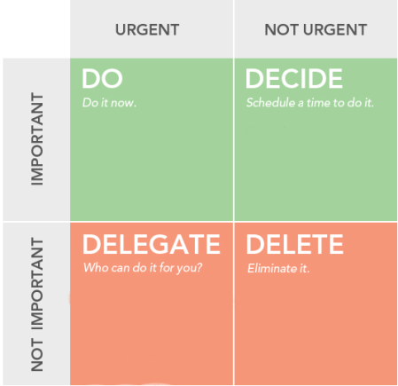
Among the mentioned Skills, Time management skill is probably the most important skills employers look for in candidates and university life is undoubtedly the best period to harness the skill. Time management knows all about how to allocate right amount of time to perform a task based on the task’s intensity and importance. Eisenhower method is a very useful technique to time management

Figure – Eisenhower Model (Dunne, 2017)
As a student, I must give the maximum priority to my tasks at hand that are crucial like taking preparation for an ensuing examination. Submitting a report based on the topics covered is also important but since I have given a deadline, I should schedule it accordingly. An urgent call might come up where I am asked to volunteer for a blood donation, I should ask one of my friends or junior to help me deal with the urgency. Tasks that are not important and not require immediate concern should be given the least priority like attending a seminar on marketing ethics. Preparing a To-do list or managing To-Do List software for the purpose can provide great assistance to the learner. (Kent.ac.uk, 2017)
Negotiation Skill
Negotiation skill is one of the most important skills a student must develop during his/her academic period as It is widely used from the initial days of professional career as a marketing executive needs to work closely with various stakeholders like shareholders, other divisions, suppliers, regulatory bodies and so on. As a student, I can learn Negotiation skill by participating in various Debating programs where I will be able to make logical explanations to various issues which will widen my contextual knowledge as well.
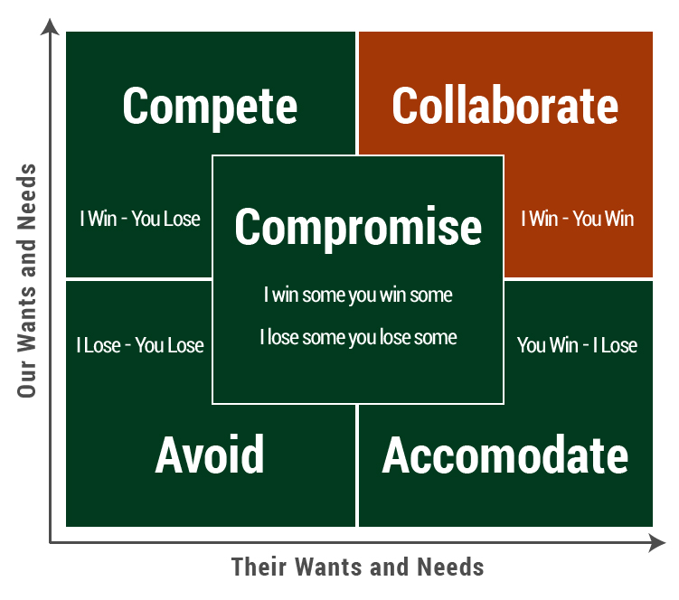

Negotiation Model (Knight and Yorke, 2007)
Negotiation styles vary from situation to situation as each situation requires different approaches to create a win-win situation for all parties involved in a negotiation. Given various scenarios and negotiation techniques, Collaborative approach is the most ideal one to proceed with any negotiation as It yields to maximum number of Win-Win results. (Dunne, 2017)
Organization Skill
Organization skill involves drawing a guideline to perform any activity. As a student, I should learn organizing various events and programs by working with diverse groups of students in my University. Organizing is learnt the best by taking part in events and programs and seeing others organizing from close distance. Organizing allows students to properly identify team member’s strengths and weaknesses and assign responsibilities properly. It enables a student to learn Teamwork. (Kent.ac.uk, 2017)

The idea of Personal Development plan is to address the skills that I want to develop and drawing means and tools to develop them. I have state a time-frame within which I am intending to learn these skills. However, the success of a personal development plan depends largely on my ability to implement those skills in practical life and getting positive results as I take part in various activities. The exact time frame required to learn a skill varies from person to person and I should take a note of my progress on a monthly basis and keep a note of when I feel I have learnt the skill. To be able to develop the skills properly before graduation, the best practice is to practice the skills from the day one of university like along with the academic curriculum and check progress after each semester. (Tran, 2016)

Personal Development Plan
Skill Name | My Overall Goal | Skills and Knowledge Associated | Resources and Activities | Targeted Time Frame
Time Management Skill | My goal is to effectively prioritize my tasks according to given timeframe and achieve superior productivity | I need to gain enough knowledge regarding prioritizing task, Realize when I can work the most and discover ways in which can increase my daily productivity | I will need to read books, learn time management theories and develop my understanding of importance to a given task.  Being able to attend classes timely, submit assignments and get done with exam preparation timely can lead to positive results | 6 months to 1 year
Negotiation Skill | My goal is to learning Negotiation skill with logical explanation to theories and excellent understanding of the context | To be a good negotiator, I would have to learn how to deal with various parties and exchange mutual benefits as effectively as possible. The idea of good negotiation skill refers to achieving a win-win situation for various parties | I will need to see others making a deal, learn negotiation theories and develop my understanding of various contexts and interests of various parties.  Participating in debating programs can greatly increase my logical explanation and negotiation skill | 1 year – 1.5 years

Organization Skill | My goal is to effectively organize, get people to work and get my voices heard as I host a program. Being a good time manager and negotiator is prerequisite to be a good organizer | I need to gain enough knowledge regarding organization theories, Understand how to forms groups like Logistics, PR, Technical support and how their contribution add up to successfully undertaking a project work | I will need to take part in events, closely observe other organizers and learn organizations theories.  Being able to host events like picnics, class programs can increase the skill. Clubbing can be another mean of developing organizing skill | 6 months to 1 year

Skill Name | My Overall Goal | Skills and Knowledge Associated | Resources and Activities | Targeted Time Frame
A self reflective journal can help me identify whether I have truly gained a skill or not by analyzing my performance before and after developing the personal development plan. The PDP shown above was developed a year ago and I can already see changes in my abilities to manage time better than before. Previously, I couldn’t allocate my time properly for my exam preparation and ended up rejecting every other chore during exam as I used to save my studies during exam time. Later on I learnt how to complete the course before exam season and take less stress during exam. (Dunne, 2017)

Conclusion

Employability Skills are required skills sought by employers in a fresh candidate that consists of various soft-skills like time management, leadership, communication, teamwork and a set of hard skills that are specific to the job. Students must figure out their goals and identify required skills to land on to their dream job. It is ideal to go through the job description letters from university life and learn skills that are asked in those letters from earlier days of Academic period. A student should develop him/herself in a way that he or she lands onto his/her dream job right after the graduation. (Tran, 2016)

References
Baukens, M. (2017). Employability. Taylor and Francis.
Dunne, J. (2017). Work placement reflective assessments and employability enhanced through highlighting graduate attributes. Journal of Teaching and Learning for Graduate Employability, 8(1), p.40.
Gravells, A. (2010). Delivering Employability Skills in the Lifelong Learning Sector. Exeter: Learning Matters Ltd.
Hind, D. and Moss, S. (2011). Employability skills. Sunderland: Business Education.
Kent.ac.uk. (2017). Top ten employability skills. [online] Available at: https://www.kent.ac.uk/careers/sk/top-ten-skills.htm [Accessed 28 Dec. 2017].
Knight, P. and Yorke, M. (2017). Assessment, Learning And Employability. Maidenhead: McGraw-Hill International (UK) Ltd.
Ober, S. (2009). Contemporary business communication. Boston: Houghton Mifflin.
Overton, R. (2008). Business communication. Boat Harbour, N.S.W.: Martin Books.
TARGETjobs. (2007). The top 10 skills that'll get you a job when you graduate. [online] Available at: https://targetjobs.co.uk/careers-advice/career-planning/273051-the-top-10-skills-thatll-get-you-a-job-when-you-graduate [Accessed 28 Dec. 2017].
Tran, T. (2016). Enhancing graduate employability and the need for university-enterprise collaboration. Journal of Teaching and Learning for Graduate Employability, 7(1), p.58.

