Project proposal for a travel and carbon reduction campaign
1 Introduction 2
2 Motivation as to why this project is good for the environment 2
3 Project idea 3
3.1 Simple sketch of the board game idea 4
4 Project aim 4
5 Success criteria 4
6 Proposed delivery 5
6.1 Case studies of success elsewhere 5
7 Stakeholder and communication plan 7
8 Costs 8
9 Delivery team 8
10 Role table 8
11 Summary table 9
12 Time plan 9
13 Risk assessment 10
14 Closing statement 10
15 Appendix 11
16 Reference list 11

Course: Environment, sustainability and climate change

Module: Changemakers, building your personal brand for employment

Name: Eva Timms

Student number: 2405050

Word count: 2,148 excluding titles and references

1 Introduction
This project is to promote sustainable travel for staff and students through an educational board game. The board game will be created for Daniel Priddy, who is the head of sustainability and environment at UWTSD and will be used by students and staff. To figure out exactly what the customer wanted, a range of questions was asked through an online meeting. Here is a summary of the questions with answers: What was the motive for this plan, and why was the plan created? The customer explained that the plan is for students and staff, and there is a lot of commuting happening from the wider area and not many people are in proximity to the university, and there are a lot of people who drive cars. Daniel explained that he wants to cut down on people commuting in cars and encourage car shares, encourage people to use different travel methods and educate people about the effects of driving to university and how they can reduce their carbon footprint. Another question that was asked was do you want a campaign to happen? The customer replied that they want a short and sharp campaign that can be repeated for students during freshers. Also, they wanted it to be accessible for students and staff. A question was asked if the customer would like any promotional elements for the project, and they replied that maybe some posters could be created or banners if there is any extra money. The customer would like more online elements, as that seems to be engaging for students. The maximum budget was asked for, and the customer gave us a budget of £5,000, but it could be stretched to £10,000 if needed. They were asked when they needed it done by, and they explained it should be done before the freshers, which is in September. The final question that was asked was who the stakeholders are, and the reply was that staff and students will be using it, and Daniel and Koi will be presenting it.

From these answers, we came up with the idea of creating an interactive board game that is easy to carry around, so it can be used during lectures too.

2 Motivation as to why this project is good for the environment
This idea is good for the environment because it will reduce carbon emissions from students and staff driving cars to the university. Travel accounts for around one-fifth of global carbon dioxide emissions. If we look at just road travel, which accounts for three-quarters of travel emissions, cars and buses contributed 45.1% of those travel emissions in 2018 (Ritchie, 2020). That is a very broad statistic as it is talking about world carbon emissions; however, it has been shown that students and staff driving to university is having a big impact on the university's carbon footprint. A range of universities have created action plans to try to change the travel behaviours of students; however, plans must consider the students' and staff's motives for using their mode of transport, and they must be included with solutions, otherwise no change will happen (Aleyeh Roknaldin et al., 2024). This project will focus on trying to educate staff and students about their carbon emissions and give them alternative ways of commuting. A simple and easy way to reduce carbon emissions is by carpooling. Carpooling is when people travel in the same car to either similar locations or the same location (Driversnote, 2024). This is good for students in the same course, as they will all be travelling to lectures on the same day, so it would be a lot easier to take one car. This method is good as it reduces the amount of cars on the road, therefore reducing congestion, exhaust emissions and increasing road safety. This then increases the incentive for a sharing economy, which refers to sharing something rather than buying new goods or services. Also, sharing a car can save time, reduce the costs of other travel methods and reduce environmental impacts (Boichuk, 2025).

3 Project idea
A board game that is centred around travel and carbon reduction, the game will be played in teams. The board will be a satellite picture of Swansea, including the Swansea UWTSD campus. There will be a path through Swansea that ends on the IQ campus. Each space along the path will have a colour. This colour will correspond to a card which, if a team lands on a colour, they must then pick up the card with the same colour.

There will be 3 different colours, red, green and blue.
Here is what they mean:
Red card- Carbon/travel fact (for example: driving produces around 10g C02/km)
Green card- A travel scenario (for example: A bus route now stops outside the IQ campus, how would you ensure that people on the campus know about this?)
Blue card- Travel question (for example: if you could walk to campus, would you instead of driving a car?)

As the teams move along the path using a dice, they will be learning about how they can change the way they travel and how to reduce their carbon footprint. The first team to get to the IQ campus wins. Hopefully, this board game might change the way people think about the way they travel and allow them to discuss this issue with their peers.
The game is easy to change, so it can be adapted to different UWTSD campuses with different boards and different cards which relate to the area.

The board game will also have a rule book inside, so people can play whenever they like, as well as a QR code linked to the UWTSD sustainability page. Also, it can be used when presentations are being done in lectures by you and Koi. It will be done before freshers start.

3.1 Simple sketch of the board game idea
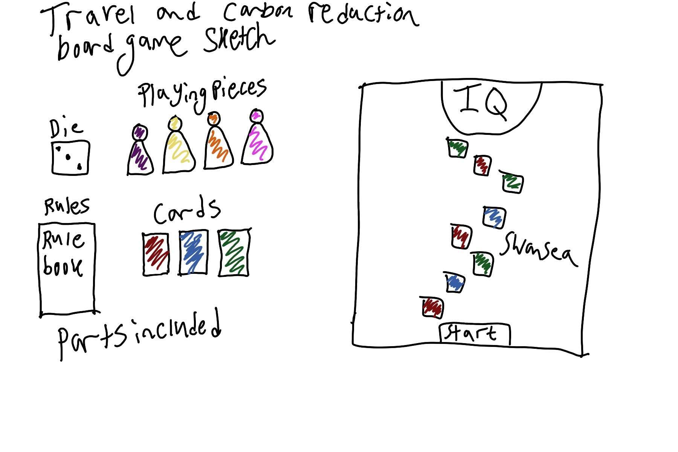

4 Project aim
The project aims to change the behaviours of staff and students regarding how they commute to university. The project should show the positives of different travel options that may reduce their carbon emissions and how they can get access to free bus passes or bikes for getting back and forth from the University. The desired outcome of this project is to educate students during Freshers' Week to allow students to see their travel options before starting university full-time, so they can figure out how they want to travel to university. The aim is to change the mindsets of students and staff and show them what impact they are having on the environment and how they can reduce their impact by simply walking to university instead of driving.

5 Success criteria
The target is that students and staff will travel to the university using different options, and the number of cars in the car park will be greatly reduced. The way that this can be measured is by emailing out a survey to everyone on campus, asking them how they travel to university. This data can then be compared to the last survey that was conducted in 2024. Hopefully, it will clearly show that the number of people driving to university has decreased and more people are walking, cycling or taking public transport.

Deliverables: The deliverable for this project is the complete board game with all pieces needed to play the board game, e.g. around 15 cards, one die, 4 playing pieces, and a rule sheet.

Outcomes: Outcomes are that people are enjoying the game and using it often during fresher’s and lectures. Also, that they are understanding the different facts, scenarios and questions that appear on the cards during the game.

6 Proposed delivery
In order to ensure that we achieve success, which is a key part of this project, we must create a success criteria to ensure that the idea is good and it will be effective. Also, if we define the scope, it will ensure that the project is successful and the quality is up to the standards of the customer. To achieve success, good project management has to take place. Project management is when a project manager must ensure that they meet the scope, schedule, cost, resource, risk and quality requirements of projects (Schwalbe, 2017).

6.1 Case studies of success elsewhere
A case study was found by Charleen (2023) where they looked at an environmental board game called “Paved Paradise: A tiny house ecovillage board game”, which helps teach people how to live on the planet with minimal impact while they design a tiny house ecovillage. It can be used in many settings, such as educational and for families. It is said that games provide opportunities particularly well adapted to sustainability education. This is due to students being immersed in the game, where they are in complex situations and have to have active roles that demonstrate decision-making and collaboration in uncertain conditions. Educational board games are great for simulating real-world issues involving the environment, as during the playing of the game, players are usually forced to discuss these issues, which is a more appropriate way of discussing them. They have proved that the game is encouraging people to think about the way they live, as shown in Figure 3. This could prove that any environmental game may change the mindset of the people playing, as it makes them see the world in a different context.

Another study was conducted by Eisenack (2012), which looked at another environmental board game, “KEEP COOL”, as shown in Figure 1, which focuses on climate change. The game covers central biophysical, economic and political aspects of the issue. The board game has been used by students and scientists. This board game is the first game on climate change that is available from a commercial publisher, and it has been successfully used in many settings. The motivation for the game is to have communication between the general public, students and scientists on the climate change issue. It has been proven that it can be used for anything, such as raising awareness, public relations, science communication and many more. They have noted that games are known to be effective in enhancing motivation and increasing student interest. The game's potential has been explored using different settings already. They looked at using “KEEP COOL” with conventional teaching methods in an experiment with 10 to 12-year-old students. The results were that teaching is slightly more effective when using the game; however, in particular, it is particularly more effective with girls. A board game can be effective when it comes to teaching students about environmental issues; however, it can all depend on factors such as age, interest, gender and overall simple understanding of the topic in the first place.

Overall, it is clear that board games have been proven to help with education and learning, both through creating and playing the board game. It is not just students who can use the board games; it is the public, families, staff, etc. It is important to understand that not everyone would find an educational board game entertaining or interesting; however, it can have its uses when it comes to events where they may be forced to play it by friends or family who are interested.

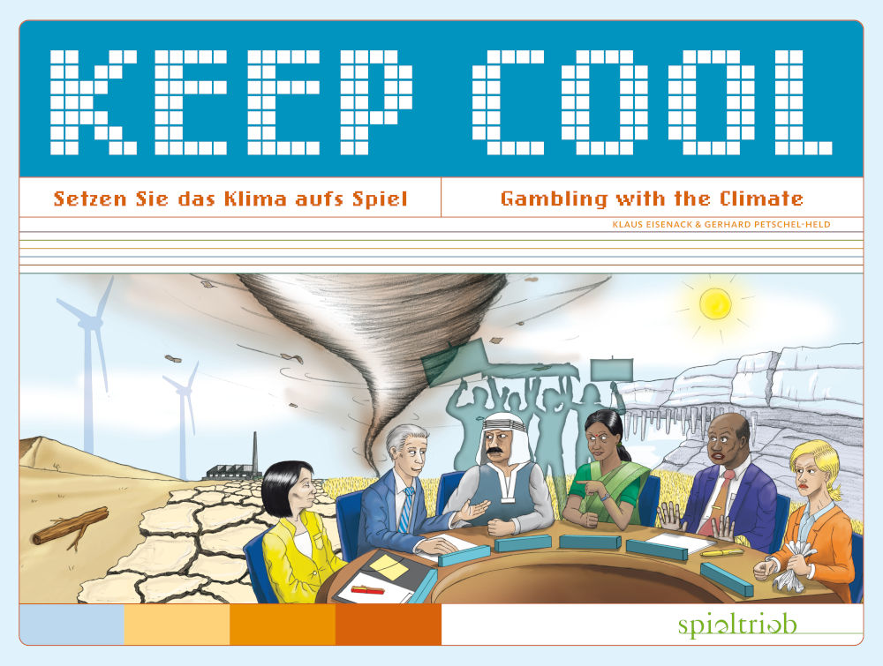
Figure 1: “KEEP COOL” board game (From KEEP COOL, no date)

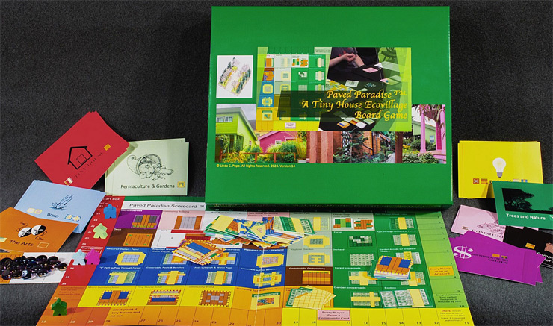
Figure 2: Paved Paradise: A tiny house ecovillage board game (From Pope, 2025)
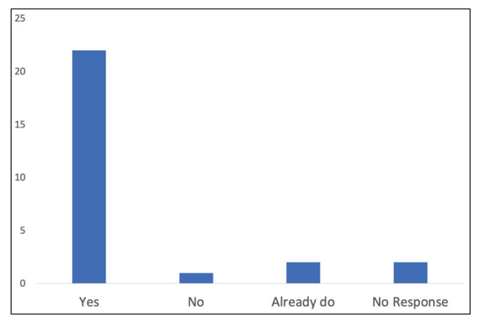
Figure 3: Postgame survey: Is the game encouraging you to think about the way you live? (Adapted from Charleen, 2023, p.287)

7 Stakeholder and communication plan
The client will get updates weekly via email to tell them about the progress that is happening. The customer can ask for any updates or meetings, and those can be scheduled; however, 3 face-to-face meetings will happen at the beginning, middle and one week before completion. The client will get sent monthly progress reports so they can assess the progress and communicate any changes or flaws with the project.

8 Costs

Item | Units | Unit cost | Total cost | Notes
Dice | 1 | £1 | £1
Cards | 15 | £3.50 | £53.96
Playing pieces | 4 | £0.18 | £0.72
Board game mat | 1 | £20.72 | £20.72
Board game box | 1 | £35.40 | £35.40
Rule book | 1 | £7.60 | £7.60

9 Delivery team
The delivery team for this project will be the project manager, the sustainability team and a game designer. The game designer is one person, as the board game is relatively simple. The stakeholders for this project are the student union, as they set up freshers, and will want to know about the board game, so they can advertise it. Another stakeholder is the university itself, as they will have the game on campus and allow students and staff to use it.

10 Role table

Role | Hourly rate | Project hours | Total cost | Notes/responsibilities
Game designer | £20 | 50 | £1,000 | To design and then create the game with all pieces included.
Sustainability team | £12 | 7 | £84 | To help the game designer with the cards, so they will know what to write down.
Project manager | £15 | 30 | £450 | To oversee the team and ensure the project is going smoothly, and it will be finished on time
Stakeholders |  |  |  | To support the project and have a say in what is included in the project

11 Summary table
Total item costs | Total delivery team costs | Final costs
£119.40 | £1,534 | £1,653.40

12 Time plan
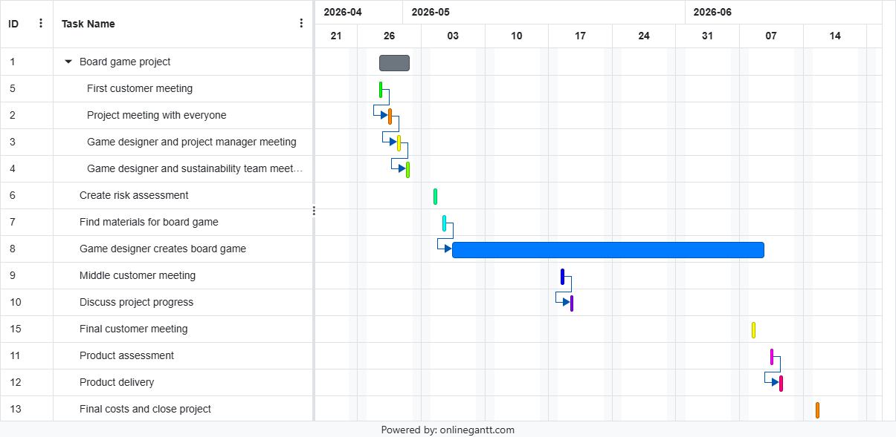

13 Risk assessment
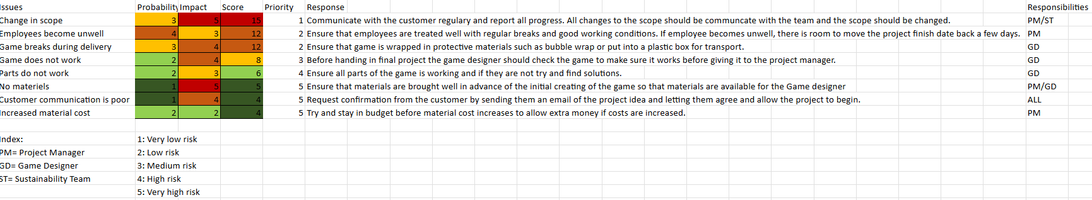

14 Closing statement
Overall, we hope that this project proposal is exactly what you envisioned for your project and that we have met your brief perfectly. The product is set to be done in around 3 months, which is ahead of your schedule, and this allows us 2 extra months to fix errors, or if you change the scope, we might be able to get it done in time for September. The cost of the project is around £1,653.40, which is within your budget of £3,000. Our team is ready to get started on your project. However, if you have any further questions or concerns, please do not hesitate to email or call me, and I will respond as quickly as possible.

15 Appendix
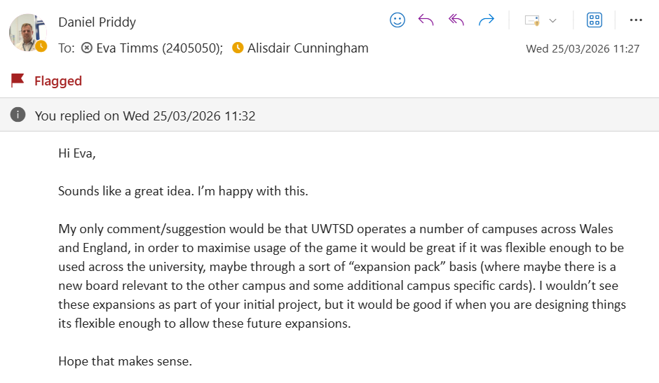

16 Reference list
- Aleyeh Roknaldin et al. (2024) ‘Reducing carbon emissions from student commuting in higher education’, Environment Systems & Decisions, 45(1). Available at: https://doi.org/10.1007/s10669-024-09996-5. (Accessed: 1 May 2026)
- Boichuk, N. (2025) ‘Sustainability: Carpooling as a Component of Smart Mobility’, Education Excellence and Innovation Management: a 2025 Vision to Sustain Economic Development during Global Challenges, pp. 15786–15794. Available at: https://www.researchgate.net/profile/Nataliia-Boichuk/publication/344402442_Sustainability_Carpooling_as_A_Component_of_Smart_Mobility/links/5fbd29fa458515b7976935a9/Sustainability-Carpooling-as-A-Component-of-Smart-Mobility.pdf (Accessed: 1 May 2026).
- Charleen, L. (2023) ‘Board Games as a Teaching Tool for Sustainability - ProQuest’, www.proquest.com [Preprint]. Available at: https://www.proquest.com/openview/5806b627df230de2ad1ce5415e854293/1?pq-origsite=gscholar&cbl=18750&diss=y (Accessed: 22 January 2024).
- Driversnote (2024) Carpooling, Driversnote.co.uk. Available at: https://www.driversnote.co.uk/dictionary/carpooling (Accessed: 1 May 2026).
- Eisenack, K. (2012) ‘A Climate Change Board Game for Interdisciplinary Communication and Education’, Simulation & Gaming, 44(2-3), pp. 328–348. Available at: https://doi.org/10.1177/1046878112452639. (Accessed: 1 May 2026)
- KEEP COOL (no date) The Board Game – KEEP COOL [Online Image], Keep Cool. Available at: https://www.climate-game.net/en/the-board-game/ (Accessed: 1 May 2026).
- Pope, L. (2025). Paved Paradise – a Tiny House Ecovillage Board Game [Online Image], Lindapopeinsightsystems.com. Available at: https://www.lindapopeinsightsystems.com/paved-paradise.php (Accessed: 1 May 2026).
- Ritchie, H. (2020) Cars, planes, trains: where do CO₂ emissions from transport come from? Our World In Data. Available at: https://ourworldindata.org/co2-emissions-from-transport?&sznclid=51c9417b024946eb947fac4c7314e12f (Accessed: 1 May 2026).
- Schwalbe, K. (2017). An Introduction to Project Management, Sixth Edition with a Brief Guide to Microsoft Project Professional 2016, pp. 1–8. Available at: https://intropm2.com/wp-content/uploads/2017/09/6e-ch-1-sep-6-2017.pdf (Accessed: 1 May 2026).

