Student Learning Log

Module Code: BMIH6002
Student name: Anamaria Bursuc
Student number:2122375
Lecture name: Lisa Bassler

Table of Contents
Introduction 3
Section 1: Reflection on Experience and Personal Development 3
Section 2: Critical Analysis of Work-Based Skills and Technical Knowledge 5
Section 3: Reflection on Organisational Issues 5
Section 4: Future Action Plan 6
Areas for Improvement 6
Strategies for Enhancement 7
Conclusion 7
References 9

Introduction
Food and beverage (F&B) is a critical aspect of hotel operations since it deals with the principal service of bringing quality food to clients who are visitors to the hotel (Kurnia et al., 2021). This line of work includes the preparation of meals, cooks, waiters, waitresses, restaurant managers, and supervisors, among others, who synchronise their functions in delivering meals. As a result, my chosen working environment is fast-paced, and my placement was to offer exposure in the F&B sector concerning operational, managerial, and guest interaction parts. The learning objectives incorporated the requirements for a demonstration of growing attentiveness to the utility of work-based skills, furthering technical content knowledge, and comprehending guest service standards at its core.

Figure 1: Food and beverage (F&B)
Source: (Kurnia et al., 2021)

Section 1: Reflection on Experience and Personal Development
The Gibbs' Reflection Model is a type of guide that is useful in reflecting on experience, usually in occupational or learning activities (Adeani et al., 2020). This cyclical model assists individuals in going through a step-by-step approach of trying to understand their experiences, make meaning out of them as well and make other gains for future betterment. I will use this model to evaluate my experience.
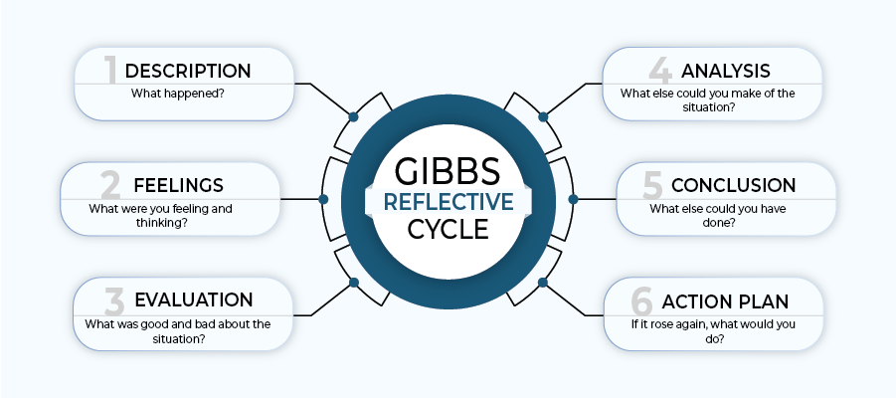
Figure 2: Gibbs Reflective Cycle
Source: (Adeani et al., 2020)

Description: While on my placement, I was able to observe another line of supervision in the F&B section within the hotel. This entails having first-hand experience in its day-to-day activities, dealing with people, and delivering service to customers, among others (Perez and Apritado, 2022).
Feelings: At first, when I heard about the intended change, I was thrilled but also nervously anxious about the change. Lack of time and the expected strict line of activities possible to deliver when offering a certain service took a lot of work (Sulastri, 2023). It became more interesting because as the days and weeks passed, I gained confidence in the kind of tasks I was expected to accomplish.
Evaluation: The activity stressed the need for communication, collaboration, and organisation of work among individuals who are part of a team. As for the positive changes, it was possible to list the aspects, such as the ability to offer direct communication with guests and the opportunity to learn from seniors who are supervisors (Davis et al., 2018).
Analysis: Experiencing the supervisory role highlighted the significance of work-based competencies and knowledge in work-related corresponding fields (Tayco et al., 2020). This strengthened an understanding that while lessons learned at university provide strong theoretical foundations, proper guest service is enacted only when, in practice, I implement them to meet the required standards.
Conclusion: As a result of this experience, the reality of the need for constant personal and vocational growth to stay relevant and valuable within any working environment emerges. By applying for this placement in front of my previous industry experience, I got a better idea of the proper coordination of technical skills and interpersonal interactions in a hospitality.
Action Plan: I intend to work towards making significant improvements in possessive areas like conflict-solving and proactive task accomplishment in the future. This will be important in the development process in this context to undergo further training and seek feedback.

Section 2: Critical Analysis of Work-Based Skills and Technical Knowledge
Work-based skills like communication, teamwork skills, and problem-solving skills that are acquired from the workplace and other professional courses are crucial in enhancing guest service delivery. These skills ensure that operations at the facility run smoothly, contribute to having a good staff ethos. Technical skills in the F&B industry include comprehension of the food hygiene laws, adeptness in the operational computer aid, particularly point-of-sale systems, and familiarity with the offered menus and wines (Perez and Apritado, 2022). The understanding of how the role, power, and authority work in society can be exemplified during the encounters during my shadowing experience and how this knowledge impacts the effectiveness and improvement of service delivery.
For instance, in the case of a busy formation of servers during a dinner service, the features that enabled fast entry of orders into the POS system and relay of special instructions to the kitchen were quite important. Moreover, knowledge about food allergies and special diets was also useful in guiding all the guests and providing what they needed to have a healthy and enjoyable stay (Sulastri, 2023). These skills and knowledge are not merely practical requirements for the operations but are an essential component of the service process that adds value to the guest. They make sure this is delivered on time, correctly, and in a manner that suits the various guests in order to meet the standards of the industry.

Section 3: Reflection on Organisational Issues
The main problem I identified in my experience is the inefficient communication between the kitchen and other sectors of the restaurant, such as frontline employees, which at times caused delays in the delivery of dishes as well as minor mistakes. This issue created dissatisfaction within the department a lack of satisfaction among the guests, and frustration within the department (Yulianti et al., 2023). It also identified the necessity of managing communications with clients with a focus on optimising anticipated service performance.
Towards this, the organisation should enhance its communication technology as a way to improve its communication framework, which a digital ordering system could strengthen. It is also beneficial to have a daily or weekly update meeting where team members have the chance to inform others about issues relating to service delivery and discuss strategies for overcoming current difficulties. According to Herzberg's Two Factor Theory, increasing effective communication and making sure that the service staff are equipped adequately and have a proper working environment will be linked to higher levels of job satisfaction as well as productivity (Safitri et al., 2023).

Figure 3: Importance of communication in Food and beverage (F&B)
Source: (Safitri et al., 2023)

Section 4: Future Action Plan

Areas for Improvement
Some of the general areas of development include professional competencies concerning information technology, especially computerised ordering systems, interpersonal competencies, and minority discharge and management expertise. These intricate work environments demand adept use of contemporary information and communication technologies to optimise food and beverage department operations and services (Dopson and Hayes, 2019). Also, interpersonal conflict-solving skills are crucial when it comes to promoting cooperation in the workplace, and leadership skills are considered vital when dealing with subordinates and employees.

Strategies for Enhancement
- Learners must receive constant feedback from supervisors and fellow learners so as to discover what they are undertaking nicely and the issues that necessitate improvement. Constructive, positive criticism will ensure that errors observed are well defined to enable the individuals to improve through personal and professional skills enhancement (Mahardika, 2018). Giving and receiving feedback is likely to enhance a positive work culture that is practised among colleagues, including me.
- While it is effective to subject the learners to lectures and textbook readings, it is equally important to use scenario-based exercises to practice what they learn. Training methodology should be incorporated into practical activities to improve retention of learnt techniques and self-confidence.
- It is often helpful to work on communication tactics, like the use of frequent meetings and debriefs, to better understand the overall state of play and maintain effective working for all parties. The use of a structured means of communication will assist in avoiding situations where there is a conflict of expectations due to misunderstanding of various issues (Dopson and Hayes, 2019).

Conclusion
In conclusion, the experience of shadowing the occupation within the hotel's Food and Beverage department was highly beneficial in terms of understanding the practical and organisational aspects of running a business in the hospitality industry. It swayed the concept of integrating the theory derived from the institute with experience gathered from the workplace in ascertaining and surpassing guest service expectations. This really opened my eyes to how important it is to be working on professional development along with personal and vocational skills enhancement because skills applied in the classroom need to be practised and enhanced in the hospitality industry. The insights identified later in this reflection will prepare me for my future career and assist me in being competent in any hospitality setting.

References
Adeani, I.S., Febriani, R.B. and Syafryadin, S., 2020. Using GIBBS’reflective cycle in making reflections of literary analysis. Indonesian EFL Journal, 6(2), pp.139-148.
Davis, B., Lockwood, A., Pantelidis, I.S. and Alcott, P., 2018. Food and beverage management. Routledge.
Dopson, L.R. and Hayes, D.K., 2019. Food and beverage cost control. John Wiley & Sons.
Kurnia, H., Sriyogani, I.A. and Nuryati, N., 2021. Implementasi Nilai-Nilai Pancasila dalam Food And Beverage Departemen di Restoran Hotel New Saphir Yogyakarta. Jurnal Basicedu, 5(5), pp.4127-4137.
Mahardika, A.N.Y.M., 2018. ANALYSING TARGET COMMUNICATIVE NEEDS FOR ENGLISH FOR FOOD AND BEVERAGE SERVICE COURSE. Jurnal Bahasa Lingua Scientia, 10(2), pp.341-356.
Perez, M.D. and Apritado, J.M.M., 2022. Towards framework development: Exploring the role of skills competencies and service quality to guest experience in food and beverage department of hotels in NCR. International Journal of Research, 10(5), pp.31-46.
Safitri, R.H.R., Fadilah, O.A. and Halim, V., 2023. Service skills in solving hotel guest problems in the food and beverage service department in the post-COVID-19 pandemic in the hospitality world. Journal of Gastro Tourism, 1(1), pp.21-27.
Sulastri, I.A.P., 2023. The Effects of Training and Communication: Study on Performance of the Food and Beverage (F&B) Service Employee. Jurnal Manajemen Pelayanan Hotel, 7(1), pp.98-114.
Tayco, R.O., Rizada, M.L.P. and Antique, C.T., 2020. Competency Requirements of the Food and Beverage Service Establishments in Dumaguete City, Philippines. Journal of Philippine Tourism and Hospitality Studies.
Yulianti, Y., Artant, G.D. and Kandriasari, A., 2023. The Use of Digital Literacy through E-Learning and Project Assignments in the Food and Beverage Service Course. In Proceedings of Vocational Engineering International Conference (Vol. 5, pp. 632-638).

