Peter Down

Risk Assessment & ALARP Justification
Safety and Hazard Assessment Assignment

Contents
Acronyms 2
Introduction 2
Operation 2
Assumptions 3
Risk Matrix 4
Part 1 5
Part 2 11
The Hazard 11
Controls 12
References 13

Acronyms
ALARP | As low as reasonably practicable
IM | Insensitive munitions
CofD | Certificate of design
DDT | Deflagration to detonation transition
HE | High explosive
FOD | Foreign object debris/damage

Introduction
This risk assessment and ALARP justification will look at the L118 105 mm large calibre gun system. This is a light artillery piece used primarily by the UK armed forces, but is also exported around the world. It has a crew of six [1]:
- Commander who has responsibility for the vehicle
- Opens and closes breach, rams shell and propellant
- Interface and aiming
- Loading the shell and propellant
- Transport of ammunition
- Second in command, responsible for ammunition and setting the fuzes.
Operators 1, 2, 3, and 4 are positioned next to the gun at all times. Operator 5 moves between the stored ammunition and the gun. Finally, operator 6 is positioned next to the stored ammunition at all times. These considerations will be taken into account when assessing the impact of an event at each process.
The scope of this risk assessment and ALARP justification consists of the field operation of the L118 gun system. This includes field storage, transporting the munitions to the gun, loading, firing, and post firing effects. System manufacture, system design, system transportation, nor system set-up will be considered to be in-scope for this report. Mitigation actions may relate to the design of the system as well as the operation of the system. The shell type considered for this risk assessment is the L31 high explosive shell, weighing 16.1 kg [2].

Operation
Fuzes are fitted by operator 6 upon arriving in the field. This allows the munitions to be ready to be used as soon as there is demand. Munitions are transported in transport boxes. In the field, they are either stacked on pallets (Figure 1) or are stacked in their inner packaging (Figure 2).
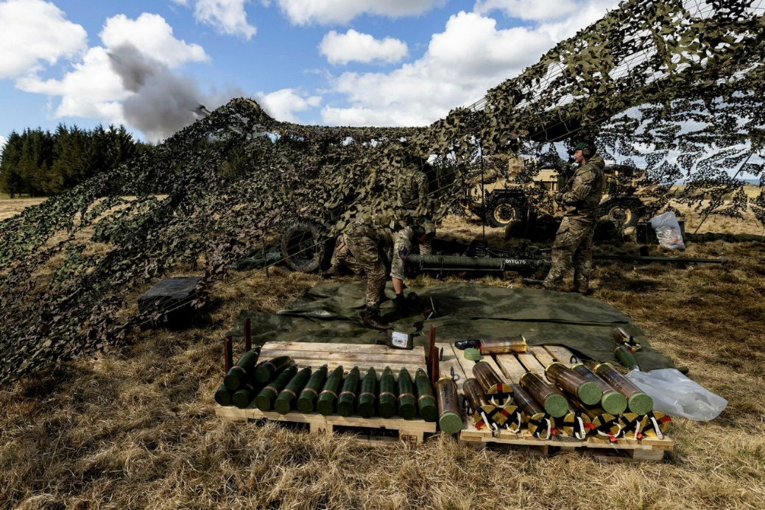
Figure 1: Shells and propellant charges stored on pallets [3].
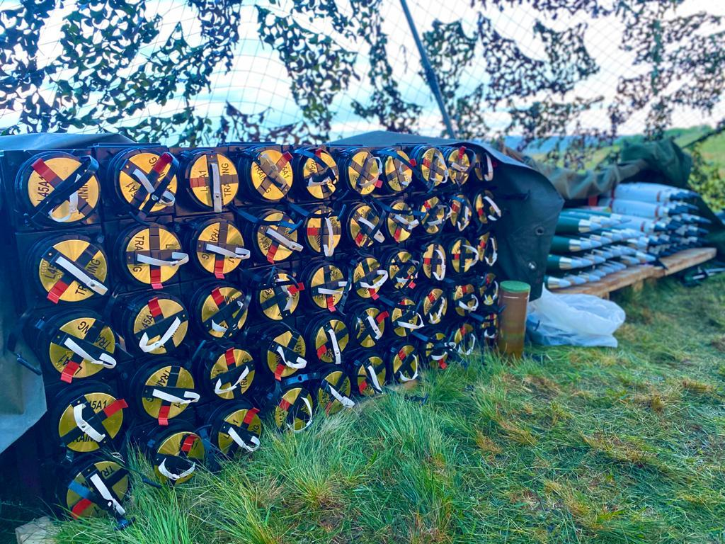
Figure 2: Shells being stored on pallets. Propellant charges being stored by stacking them in their inner packaging [3]..
Before leaving the stores, operator 6 sets the fuze. From here, munitions are carried a short distance to the gun by operator 5. The shell is loaded first, followed by the propellant charge. These are then rammed and the breach closed. The gun is then fired. Post firing, the breach is opened and the spent cartridge is ejected.

Assumptions
- The light gun is being used in a static manner, as opposed to ‘shoot and scoot’ tactics.
- If a munition becomes damaged, the operators will avoid using it.

Risk Matrix
The risk assessment will use the below matrix to determine the risk associated with an event.
Likelihood |  | Severity
 |  | 1 | 2 | 3 | 4 | 5
 |  | Trivial | Serious | Major | Fatal | Mass Event
1 | Negligible | 1 | 2 | 3 | 4 | 5
2 | Unlikely | 2 | 4 | 6 | 8 | 10
3 | Likely | 3 | 6 | 9 | 12 | 15
4 | Most Likely | 4 | 8 | 12 | 16 | 20
5 | Certain | 5 | 10 | 15 | 20 | 25
Table 1 – Risk Matrix
Likelihood | Explanation | Severity | Explanation
Negligible | Impossible or remote under normal conditions (Trivial) | Trivial | Scratch/cut
Unlikely | Unlikely under normal conditions (Tolerable) | Serious | Fracture/injury resulting in more than three days away from work
Likely | 50/50 chance (Moderate) | Major | Amputation/serious burns/permanent damage
Most Likely | Greater than 50% chance (Substantial) | Fatal | Single death
Certain | Very likely (Intolerable) | Mass Event | More than one death
Table 2 – Definition of likelihood and severity.
Scores | Risk Classification | Management Activities
1 - 5 | Low Risk | Monitor identified control measures for effectiveness. Work may start or continue with every effort to ensure that the risks are maintained As Low as Reasonably Practicable (ALARP).
6 – 12 | Medium Risk – Acceptable Region | Improve or increase the control measures. Work may start if the risk has been reduced to As Low as Reasonably Practicable (ALARP). Where work is already underway, then every effort must be expended within a defined time period to make further improvements
15 - 25 | High Risk – Unacceptable Region | Stop the work. Improve or increase controls to reduce the risk as this situation is not acceptable.
Table 3 – Guidance on risk acceptability

Part 1
Task/ System | Hazard | Who/What is at Risk? | Explanation | Risk Classification |  |  | Additional Control Measures to Reduce Risk | New Risk Classification
 |  |  |  | Likelihood | Severity | Risk Score | Additional Control Measures to Reduce Risk | Likelihood | Severity | Risk Score
Storage | Shrapnel impact on stowed munitions | Operators, other munitions | Munitions are vulnerable should the system come under counter-battery fire. Such an event would produce large quantities of shrapnel which are a source of ignition. As munitions are stored together, there is a high probability of sympathetic reaction leading to event propagation. | 3 | 5 | 15 | - Minimum quantity of munitions in stores.  - Move munitions as far away from gun as is reasonably practicable.  - Move shells as far away from propellant charges as is reasonably practicable.  - Munitions should be IM compliant.  - Locate stores in a naturally occurring safe locations wherever possible.  - When practical, store munitions without the fuzes/initiators fitted.  - Use ‘shoot and scoot’ tactics. | 2 | 3 | 6
Storage | Munition stack stored in internal packaging collapsing. | Operators, other munitions | Cartridges are sometimes stacked prior to use. A variety of incidents could lead to them falling up to two meters to the ground. Munitions can be stored in their internal packaging, see Figure 2. Such an event could lead to crushing injuries as well as damage to the munition. | 2 | 1 | 2 | - Wherever possible, store munitions as close to the ground as is reasonably practicable.  - Wear correct PPE (suitable footwear). | 2 | 1 | 2
Storage | Munition stack stored on a pallet collapsing | Operators, other munitions | Propellant charges and shells may be stacked on pallets. These stacks might collapse leading to munitions tumbling for a short distance. No additional packaging is used when munitions are stored in this manner. | 2 | 1 | 2 | - Whenever possible, store munitions as close to the ground as is reasonably practicable.  - Wear correct PPE (suitable footwear). | 2 | 1 | 2
Storage | Detonation or deflagration due to degradation of energetics in hot climates | Operators, other munitions | Munitions typically age/degrade faster due to increased temperature as might be experienced in hot climates. This increases the chance of an auto-catalytic reaction occurring due to reduced stabiliser levels leading to detonation or deflagration. | 2 | 5 | 10 | - Munitions are only used if they are within their CofD life or within an extended life period following a life extension programme.  - Where possible, regular inspections of munitions should take place. | 1 | 5 | 5
Fitting the Fuze | Detonation or deflagration due to eutectics | Operators, other munitions | TNT based munitions may have eutectics that have separated from the charge which are highly sensitive. These could become entrapped during the fuze fitting operation leading to a detonation or deflagration. | 2 | 4 | 8 | - Regular inspection to ensure there are no eutectics that have separated. | 1 | 4 | 4
Fitting the Fuze | Static discharge | Operators, other munitions | Static electricity can build up on the operator’s clothing leading to a discharge while fitting the fuze. The fuze has low energy, high sensitivity primary explosives in it which may be sensitive to such a discharge. | 2 | 3 | 6 | - Use PPE to ground operators (conductive footwear). | 1 | 3 | 3
Fitting the Fuze | Contamination of energetics | Operators | While fitting the fuze, foreign objects/debris (FOD) may be introduced into the shell. When a contaminated shell is fired, there is an increased chance of detonation/deflagration on launch. | 2 | 4 | 8 | - Fuze thread should be inspected to ensure no FOD is introduced.  - Prior to fuze fitting, the fuze hole should be covered. | 1 | 4 | 4
Manual Handling | Dropping munitions | Operators, munition | A munition could be dropped from around elbow height while being carried from storage to the gun. It would likely be carried at this height due to manual handling regulations specifying the correct height at which to move a load [4]. This could lead to crushing injuries or damage to the munition. | 2 | 1 | 2 | - Correctly follow manual handling procedures.  - Wear appropriate footwear.  - Operators trained to a suitable level. | 1 | 1 | 1
Manual Handling | Slips, trips, and falls (general) | Operators | While moving around, operators may slip, trip, or fall. | 2 | 1 | 2 | - Wear appropriate footwear.  - Place matting with improved grip on the ground.  - Minimise clutter. | 2 | 1 | 2
Manual Handling | Slips, trips, and falls (while carrying munitions) | Operators, munition | While moving around, operators may slip, trip, or fall. If a munition is also being carried at the time, there is an increased potential for the operator to be injured by falling, or for the munition to be damaged. | 2 | 1 | 2 | - Wear appropriate footwear.  - Place matting with improved grip on the ground.  - Minimise clutter.  - Minimise time spent carrying munitions where appropriate. | 2 | 1 | 2
Manual Handling | Incorrect handling | Operators | The munitions are heavy. If handled incorrectly that could cause musculoskeletal damage over a period of time. | 3 | 3 | 9 | - Correctly follow manual handling procedures.  - Operators trained to a suitable level. | 2 | 3 | 6
Loading | Hot barrel after previous round has been fired | Operators, munitions, equipment | Following previous firings, there will be significant residual heat in the barrel. Loading a new munition into a hot barrel might lead to an operator being burned. | 2 | 1 | 2 | - Wear PPE (gloves).  - Avoid contact with hot gun components.  - Reduce heat in system through increasing heat dissipation rate. | 2 | 1 | 2
Loading | Inhalation of combustion products | Operators | Combustion products can be harmful to breath in. This hazard is present for anyone near the muzzle, anyone near the breach after firing, and everyone around the gun if the wind is blowing. Single base propellants produce several metal based ash compounds when they are burned [5]. | 3 | 1 | 3 | - Crew should be as far away as is reasonably practicable from the muzzle post-firing.  - Crew should be as far away as is reasonably practicable when the breach is opened post-firing. | 3 | 1 | 3
Loading | Entrapment in breach mechanism | Operators | The breach mechanism includes heavy moving parts which an operator could become trapped in. | 1 | 3 | 3 | - Ensure operator isn’t wearing loose clothing that could get trapped in mechanism.  - Only operate breach when operator is clear of mechanism.  - Operators trained to a suitable level to reduce the likelihood that operator 2 will close the breach before operator 4 is clear. | 1 | 3 | 3
Loading | Munition getting trapped in the breach | Operators, munition, equipment | While loading a munition, it is possible that the breach might be closed too early as a result of operator error. If this happens, the munition may be damaged. | 1 | 1 | 1 | - Operators trained to a suitable level:  - Operator 4 – Ram the munitions sufficiently far that they are not impeding the breach mechanism.  - Operator 2 – Ensures the munitions are correctly in place before closing the breach. | 1 | 1 | 1
Loading | Incorrect loading | Operators | Musculoskeletal injury due to incorrect loading method. | 3 | 3 | 9 | - Operators trained to a suitable level to reduce the likelihood of incorrect loading technique being used.  - Consider automatic loading system. | 1 | 3 | 3
Loading | Repetitive action | Operators | Musculoskeletal injury due to incorrect loading method. | 2 | 3 | 6 | - Operators trained to a suitable level to ensure correct loading technique is used.  - Multiskilled operators allowing roles to be temporarily switched to alleviate repetitive strain. | 1 | 3 | 3
Firing | Flame from muzzle | Operators | Muzzle break redirects hot gases backwards in order to help control recoil. Any operator standing near the muzzle may receive burns as a result. | 1 | 4 | 4 | - Operators trained to a suitable level in order to reduce the likelihood that they will stand somewhere that the flame from the muzzle might injure them.  - Design system so that ideal crew positions are as far away as reasonably practicable from the muzzle. | 1 | 4 | 4
Firing | Dust produced through combustion | Operators | Combustion produces dust and other solid products. This may be inhaled by an operator leading to respiratory issues. | 3 | 1 | 3 | - Crew should be as far away as is reasonably practicable from the muzzle post-firing.  - Crew should be as far away as is reasonably practicable when the breach is opened post-firing.  - If gun stays in one position for an extended duration, then good housekeeping procedures should be followed to clear dust, such as cleaning down the gun. | 2 | 1 | 2
Firing | Muzzle flash | Operators | The flash produced during firing is very bright. If an operator were to repeatedly look at it, there is a chance for damage to eyesight. | 1 | 2 | 2 | - Flash suppressants can be used in propellants.  - Eye protection such as tinted safety glasses to reduce the effect of gun flash.  - Train operators to look away from the gun flash | 1 | 1 | 1
Firing | Loud noise | Operators | The sound produced during firing can be up to 171 dB [6]. Prolonged exposure to sounds louder than 85 dB can lead to hearing loss [7]. High decibel exposure can also lead to hearing loss. | 5 | 3 | 15 | - Use the minimum graduation of propellant possible to service a target in order to reduce noise levels.  - Crew should be as far away from the muzzle during firing as is reasonably practicable.  - Hearing protection, such as ear defenders, to be worn. | 2 | 3 | 6
Firing | Recoil | Operators | Components of the gun travel as a result of recoil during firing. If an operator were to be in the wrong place then they would be injured by this. | 1 | 2 | 2 | - Increase damping of system in order to reduce the travel distance.  - Design system so that the crew are not adjacent to components that move with recoil.  - Train crew to be aware of components that may suddenly move due to recoil. | 1 | 2 | 2
Firing | Unintentional detonation of munitions during firing | Operators, equipment | Munitions may detonate during initiation due to explosive degradation or munition damage. | 2 | 5 | 10 | - Frequent physical inspection of shells and propellant charges to ensure they are undamaged.  - Frequent surveillance programmes on lowest condition assets to determine suitability for use.  - Frequent inspection of the barrel to ensure it has not worn to the point of being unsafe.  - Only use munitions that are within their CofD life, or have had their life extended by a suitable life extension programme.  - Design the breach mechanism to withstand a barrel detonation in order to protect the crew.  - Design system so that the crew does not stand near or beside the barrel during firing.  - Train operators to reduce the likelihood that they are near or beside the barrel during firing.  - Use the minimum graduation of propellant suitable to service a target in order to keep energetic quantities at a minimum. | 1 | 4 | 4
Firing | Burns from expended cartridge ejection | Operators | Expended cartridges are ejected following firing. Ejection is straight out from the back of the breach and towards the floor. The cartridge is very hot. | 1 | 1 | 1 | - Give cartridge time to cool down before attempting to move.  - Operators to use suitable PPE (gloves) to handle spent cartridges. | 1 | 1 | 1

Part 2
As low as reasonably practicable (ALARP) involves considering the benefit provided by a control against the cost, time, and trouble of implementing it [8].

The Hazard
The hazard this ALARP exercise will address the detonation hazard of ammunition within the barrel at firing. The risk of detonation can come from either the shell (high explosive filling and explosive train) or from the propelling charge (single base propellant with an igniter). When these munitions are in good condition and are being used in an ideal environment, the possibility of accidental detonation is extremely low. Two broad changes can significantly impact this: field conditions and explosive condition.
When in the field, a gun crew might be operating in extreme temperatures, munitions might become damaged, and munitions may be exposed to extraneous variables such as FOD. Explosive charges also might not be suitable for use due to aging.
- Extreme temperature effects:
  - High temperatures – In high temperature environments, explosives typically degrade at an increased rate. For nitrocellulose (NC) based explosives such as the propelling charge, the rate at which the chemical bonds break down increase leading to a decrease in the remaining stabilisers. Furthermore, as stabiliser quantities reduce, NC decomposition products starts to catalyse the degradation of NC throughout the charge. This itself presents a hazard of potential auto-ignition as the decomposition reactions are exothermic, but as pertains to this context, a reduction in stabiliser content leads to an increase in explosive sensitivity and burning rate. When a severely degraded charge is fired, there is an increased chance of DDT occurring due to an increased burning rate. High temperatures also generally lead to an increased burning rate which increases the probability of DDT occurring.
  - Low temperatures – Due to differing rates of thermal expansion, there is inevitably more movement in an explosive charge than in a cartridge case or a shell casing. As a result, explosive fillings will shrink in cold environments which will introduce mechanical stresses. The hazard this presents for the propelling charge is that it could lead to the bond between propellant and cartridge to break. This most likely would be partial. The issue this presents is that an increased surface area available for burning will lead to an increased burning rate, which leads to an increased pressure. This relationship is reciprocal and the munition is not designed for it meaning the burning rate could ‘runaway’ which could lead to DDT. Regarding the shell, de-bonds between the explosive filling and the case would be expanded greatly by the acceleration force the shell undergoes. If this force is sufficient to completely break the bond, the charge will spin differently to the casing. This difference in spin speed will produce friction which might lead to detonation.
  - Thermal shocks – In field environments where the temperature changes frequently from two extremes (for example, hot at day, cold at night), munitions may experience both of the above issues. Mechanical stresses are more extreme due to the constant expansion and contraction of the explosive charges. Any damage caused by these stresses could lead to detonation upon launch of the munition.
- Munitions could become damaged. The above risk assessment details a number of ways munitions can be damaged such as by being dropped. Such damage could cause:
  - Propellant cracking leading to an increased burn rate and therefore an increased chance of DDT.
  - HE cracking which will be exacerbated by the high acceleration at launch causing the charge to split. Any loose sections of HE might experience friction that could lead to detonation.
- Foreign object debris, if contaminating explosive charges, could lead to accidental detonation. For example, a shell could be contaminated by small rocks or grit prior to the fuze being fitted. If this were to happen, the rocks or grit would be accelerated into the HE by the extreme acceleration at launch. This event would produce a large amount of friction and therefore heat, which might be sufficient to cause the charge to detonate.
- Explosive charges all have a shelf life, although the reason behind this differs depending on the type of munition. Most often, munitions first reach a shelf life which is based on ballistic properties. The munition is still safe to use, but will no longer be able to suitably perform. Sometimes however, munitions can be approved for use beyond this point. Explosives typically have stabilisers in them that are consumed over time. Eventually a chemical life is reached where stabiliser levels are so low that the munition is unsafe. This could lead to auto-ignition, but could also lead to detonation should the munition be fired.
- Charges can also be made unsafe if they were made incorrectly, stored incorrectly, or handled incorrectly. One such example is the crystal structure of explosive fillings. If the munition is made incorrectly, the crystal structure could be large and brittle leading to an increased likelihood of unexpected detonation.

Controls
Control can be implemented in order to reduce either the severity or the likelihood of a risk.
- Shells and propellant charges can be inspected frequently to ensure they are in good condition and are undamaged. Such inspections can be more thorough in non-field conditions, but even in the field some inspection would allow obvious damage to be spotted. The inspection should look at the general condition of the cartridge and case as well as looking (wherever possible) for anything wrong with the explosive charges themselves. If this activity was carried out, damaged or unsuitable munitions would not be used and therefore would not present a risk of accidental detonation on firing. This mitigation reduces the likelihood of an event.
- Surveillance and life extension programmes can be carried out. The purpose of surveillance programmes is to carry out testing to ensure that aged munitions are performing as expected based off qualification data. The purpose of life extension programmes is to carry out testing (including artificial aging of assets) to assure the end user that the munitions will perform safely and suitably for a period of time longer than the original CofD specified life. By carrying out this type of testing, general observations about the safety of batches of munitions can be made. If issues are found, then affected munitions can be withdrawn from service before they lead to an incident. This mitigation reduces the likelihood of an accidental detonation.
- The barrel can be a potential cause of accidental explosion. As the barrel is used over a long period of time, it wears. This can result in the barrel explosively failing if it is too damaged. This can be mitigated by close monitoring of the quantity of shells fired with that barrel and by inspecting it frequently to ensure there has been no damage. This control method reduces the likelihood of an event.
- As explosives degrade, operators should be trained to not use munitions that are beyond their life end. The life end can be dictated by either the CofD or by a suitable life extension programme. By only using munitions that are within life, the likelihood of accidental detonation decreases.
- Breach mechanisms should be designed to withstand a detonation. Several operators are stationed near the breach of the gun meaning that if a detonation were to cause the breach mechanism to fail, they would all be at greater risk. Such a design would need the breach to be substantial enough that it doesn’t break apart in the event of detonation, and that it is securely held closed so that it cannot be opened by the detonation. This measure would reduce the severity of an event.
- The system is designed to be operated in a specific manner with each crew member roughly in a given position. That design of the system should ensure that not operator is forward of the breach as this would put them next to or near the barrel. If a detonation did occur then the majority of the energy would be directed forwards and sideways relative to the gun due to the structure of the gun being most substantial behind the barrel. By taking operators out of the area of greatest danger, the severity of an event would be decreased.
- Operators require training to understand the detonative hazard. By possessing this training, they are less likely to be in an area significantly affected by an accidental detonation and they are more likely to identify potential sources of accidental detonation such as damaged munitions. Training therefore reduces both likelihood and severity.
- Depending on the distance to the target being serviced, different quantities of propellant might be used. As there is overlap between ranges available with each propellant graduation, the commander must choose which propellant graduation is the most suitable. Wherever possible, the minimum quantity of propellant should be used as this will reduce the quantity of explosives involved with any events which will reduce the severity.
All the suggested control measures can be described as ALARP. Mitigations such as field inspections and recording the quantity of shells already fired carry a minimal cost that is far outweighed by the benefits they bring. Surveillance and life extension programmes are substantial, but provide much needed confidence in the safety and ability of munitions while they are in-service. These programmes are also desirable from a cost perspective because they provide a basis for allowing old munitions to have a longer life meaning new munitions are not needed as often. Training elements are always necessary to reduce risk as it reduces human error. Additionally, training is cheap when compared with design changes for example, which makes them a desirable control method. Design factors such as the breach have a high cost, but have the potential of reducing fatalities from potentially five people down to none as they are all behind the breach.

References

[1] | Forces News, “A British gunner's step-by-step guide to firing a howitzer,” 01 12 2022. [Online]. Available: https://www.youtube.com/watch?v=7h0D7w0FQbw.
[2] | Army Guide, “L118,” [Online]. Available: http://www.army-guide.com/eng/product1941.html.
[3] | Think Defence, “The L118 105mm Light Gun Replacement,” 11 02 2022. [Online]. Available: https://www.thinkdefence.co.uk/2022/02/the-l118-105mm-light-gun-replacement/.
[4] | Health and Safety Exective, “Manual Handling Operations Regulations,” no. L23 (Fourth edition), p. 54, 1992.
[5] | S. S. Park, I. S. Hwang, M. S. Kang, H. J. Jeong and J. Hwang, “Thermal decomposition characteristics of expired single-based propellant using a lab-scale tube furnace and a thermo-gravimetric analysis reactor,” Journal of Thermal Analysis & Calorimetry, p. 664, 2016.
[6] | C. Turnage, “Guard says cannon fire will sound in NLR area,” Arkansas Democrat Gazette, 09 08 2019. [Online]. Available: https://www.arkansasonline.com/news/2019/aug/09/guard-says-cannon-fire-will-sound-in-nl/. [Accessed 20 07 2023].
[7] | Hearing Centre of Excellence, “High Decibel Levels,” [Online]. Available: https://hearing.health.mil/Prevention/Causes-of-Injury/High-Decibel-Levels.
[8] | Health and Safety Executive, “ALARP - As low as reasonably practicable,” [Online]. Available: https://www.hse.gov.uk/comah/alarp.htm.

