Nicola Carr
Module code: ECGE4001
Student number: 2415256
Infographic poster: Word count: 1100
The concept of holistic child development essay: Word count: 1033
Human Development: Word count: 1100
References.

Use of AI
I can confirm I have not used any AI tools in the research and creation of my assignment.
I can confirm I have not presented any AI generated materials as my own work.

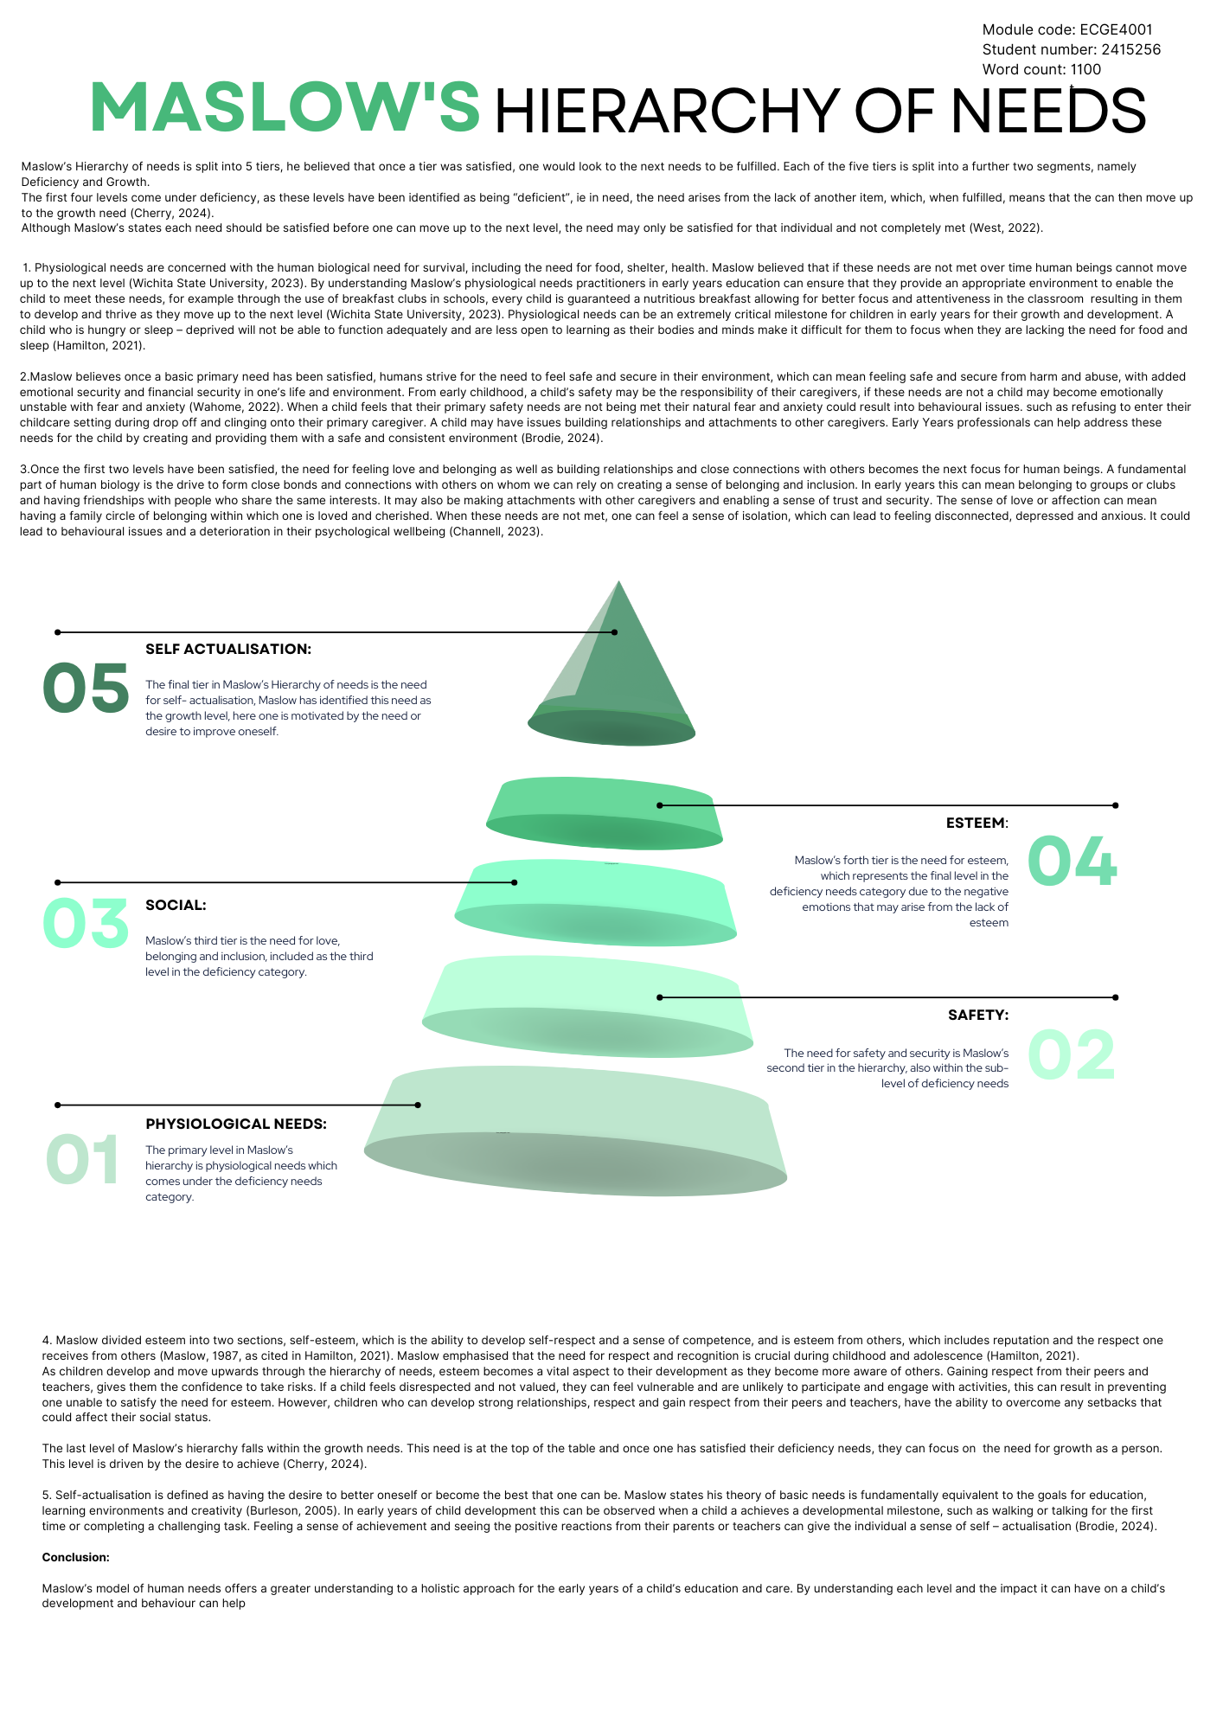

The Concept of Holistic Child development

Over the centuries, child education has evolved from a strict, academically focused approach to a more holistic approach that considers the child as a whole person.
Holistic development means looking at someone as a whole, although this can be spilt into many areas. Holistic child development is a model that recognises all areas of a child’s growth, development and learning are interlinked with each other (Brodie, 2018, p.g. 2).
Holistic child development recognises for a child to learn, develop and grow, there are multiple factors that need to be considered. Therefore, focusing on the many aspects to a child’s development which are essential to help them grow and develop. These areas of child development are:
Cognitive development, referring to a child’s intellectual growth, ability to solve problems and critically think.
Emotional development, understanding how a child manages their feelings and learns how to become resilient.
Social development teaching the child the skills and abilities they need to learn to communicate, interact and build relationships with others.
Physical development looking at a child’s health and overall well-being, as well as fine tuning their motor skills.
Linguistic development focusing on a child’s speech, language and literacy.
Spiritual development as the child gains a sense of wonder and curiosity about the world around them, promoting values and ethics and connection to something bigger than themselves.
The Holistic method allows practitioners to observe, reflect and think about the child as an individual and not become too focused on just one or two areas but to look at all the development areas of the child (Brodie, 2018).
This concept to holistic child development has been supported by many educational and psychological theorists including, Abraham Maslow’s Hierarchy of needs, Jean Piaget cognitive development theory, Eric Erikson’s Psychosocial development theory, Lev Vygotsky sociocultural theory and Friedrich Froebel’s educational philosophy, which will be discussed in brief in this essay.
Abraham Maslow’s Hierarchy of needs
Abraham Maslow’s Hierarchy of needs model is a practical way to understand the foundation of Holistic child development. Maslow studied the complexity and structure of human needs and came up with five tiers which he believed humans need to complete or satisfy before moving onwards and up into the next level.
These levels are:
- Physical needs: Essential needs to survive, such as food, air, water, shelter and health.

- Safety and security: Protection from harm and a stable environment.

- Love and acceptance: Building emotional connections and relationships with others

- Self-esteem: Confidence, sense of achievement and respect to and from others.

- Self-Actualisation: The need for development, creativity and growth, reaching one’s full potential.

Maslow’s motivational theory is often depicted as a pyramid of hierarchical levels, therefore introducing the ability for a human to move upwards from one level to the next. Maslow believes one must satisfy the level of each need before moving up to the next level with the basic level being the need to survive and the highest level the need to thrive. This model can be applied to child development to help Holistic practitioners to understand the fundamental needs of the child: whereby where lower-level needs are not met, the child may struggle to move up in “development” to the next levels, therefore affecting their emotional and cognitive development and growth (Pichère & Cadiat, 2015). An example of fulfilling a child’s basic need in early years education is the introduction of free school meals in primary schools in Wales. ‘Ensuring no child goes hungry policy’, provides access to nutritious meals during school hours for all primary aged children regardless of their family income. This not only helps satisfy the child’s basic need for food but can also help support child’s physical development, cognitive function, and overall well-being (Welsh Government, 2022).
Jean Piaget
Jean Piaget’s theory of cognitive development focused on how children think and learn, as he understood how a child’s thinking differed from that of an adult. Paiget understood how children were fascinated with their environment and through exploring, experimenting and playing in their environment, could begin to learn new skills and abilities. Piaget’s theory was influenced by the work of Maria Montessori, (Aubrey and Riley, 2019, p45), as both psychologist and educator understood the importance of play and how this supported a child’s cognitive development. Montessori’s method of learning kept the child at the centre, believing that through self-directed learning and independent play the child could identify and learn to solve problems and gain a better understanding of the world around them.
Friedrich Froebel
Friedrich Froebel was a 19th century German educator who invented the first ever kindergarten in the 21st century, everyone is familiar with the “child’s garden” or Kindergarten usage as the concept has influenced many practices in early years education and the introduction of forest schools and outdoor play. Froebel believed that for children to grow and develop at their own pace, they needed to have the space and freedom to be allowed to play, giving them the opportunity to express their creativity and engage with their environment. Froebel also believed that education should be taught through the means of play, exploring and questioning, rather than the traditional teacher – led education, therefore bringing forth, a more holistic development approach to child education which focused on their social, emotional and cognitive needs and development (Tovey, 2020).

Conclusion
Piaget, Froebel, Maslow and other educational theorist have all had a significant impact on the holistic child care approach in today’s curriculum, this has been evidenced by government policies through introduction of the foundation phase in 2010 by the Welsh Government. The change has created a more child-centred and holistic approach to early years education as appose to the traditional teacher led curriculum for young children that was previously based on the National Curriculum for England, which focused mainly of formal, subject-based learning with an emphasis on literacy and numeracy. Today’s curriculum focuses more around the child’s development as a whole where emphasis is placed on play - based learning and a focus on social, emotional, physical and cognitive development (Welsh Government, 2015). By nurturing all aspects of a child’s development practitioners in early years education can help the child reach their full potential.

Maslow’s significance in understanding child development
This essay will explore the significance of Maslow’s hierarchy of needs and its relevance to early years education and care. It examines how Maslow’s theory can help understand child development and how it can support a child’s transition into a childcare environment holistically. Focusing on the importance of meeting a child’s basic needs, creating a safe and stable environment and building confidence and independence enabling them a smooth transition into their first childcare environment.
- Understanding the importance of basic needs
In Maslow’s Theory of the hierarchy of needs. The author emphasises the importance of meeting the basic need for food, water, sleep and health. As an early year practitioner, it is important to ensure the physical health needs of the child are met to promote development (Care Learning, 2024). For example, a practitioner in a nursery can help ensure these needs are met by providing the child with regular nutritious meals at set times. Not only can the practitioner satisfy the need for food, but they can also encourage children to try eat a range of healthy foods whilst ensuring the child’s meals, snacks and drinks meet the dietary and nutritious need for their age and development. This approach can also help children who may be part of a family that maybe unable access or afford healthy food or understand nutritious values in food impacting the child’s long-term health (Welsh Government, 2024). Practitioners can also source menus for nutritious recipes from local and national government and healthcare providers.
- Creating a safe and stable environment is Maslow’s second tier in his hierarchy of needs
There are many aspects to understand how a practitioner and the way they operate can help make a child feel safe and secure. For example, the environment which the child is entering can have a huge impact on their emotional well-being. Ensuring the environment is organised, tidy, has space to move around freely, provision of materials and equipment for the child and create curiosity and independence while providing them with a routine, can give the child a sense of security and stability. This can be especially important to a child coming from a disorganised or chaotic home environment. Establishing regular routines can also help the child settle into the environment. By providing the child with a sense of security you are meeting their human needs allowing them to gain a feeling of love and belonging whilst building attachments with their primary care givers and peers (NSPCC, 2021). It is also vital for practitioners to build relationships with the child’s family to build trust as well as promote a feeling of safety and security and the child can build an attachment to their primary caregiver in nursery. Bowlby recognised that a child may experience anxiety and stress when they separate from their primary caregiver, for example, when a parent drops of the child at nursery (Cherry, 2023). By regularly considering the well-being of the child, the practitioner is giving an opportunity for the child to form a bond of trust and attachment.

- Building confidence and independence
In a child’s formative years, helping a child to build confidence and independence is crucial for their emotional development enabling them to believe in themselves giving them the confidence and independence to carry out everyday tasks. From birth to early childhood, a child is entirely dependent on their caregivers, leading children to form strong attachments. Overtime, as the child grows and develops, these attachments extend to other caregivers who also provide help and support. As the child reaches new developmental milestones, it is crucial to help the child gradually become less dependent on their caregivers by encouraging the child to take on daily tasks independently, fostering independence building a sense of self-confidence (Kidz Village, 2019).
When a child transitions from home to an early year’s setting for the first time, such as nursery, childminder or school they are reaching a significant milestone in life, this can be an exciting yet challenging experience, it can also have an emotional impact on the child and family. This transition needs to be managed in a sensitive and effective way, to ensure it has a positive impact on the child’s emotional development. It is therefore vital that early year’s settings create a smooth transition for the child to attend, helping them build confidence and independence during this crucial time (Walker and Croner-i, 2019). To make the transition as smooth as possible it is important that professional practitioners develop policies and procedures to follow to enable them to create an easy transition for the child and family. A few examples of this could be:
- Plan a meeting with the parent before their first day, providing them with all the expectations and information they may need. This can also give the practitioner and parent an opportunity to complete any paperwork and contracts before the child’s settling in days.

- Invite the child to come and visit the setting with their parent and meet their key worker, using this opportunity to talk with the child and find out their interests. Allowing the child to start building a bond with their primary key worker and know what to expect when they start and give the practitioner ideas of activities the child could do on their settling in days.

- Offer the family shorter settling-in days. Shorter visits allow the child to arrive after the other children have settled leave before pick–up time, reducing chaos, confusion and anxiety for the child. Settling-in sessions can help provide a calm, welcoming environment for the child to ease into the new setting. Planning engaging activities for the child when they visit can also work as an effective distraction, helping them feel more comfortable and at ease and give them an opportunity to play with or alongside other children.

- Provide parents with updates on how their child is feeling, along with pictures of their activities throughout the session. This approach helps ease the parent’s emotions and anxieties reassuring them about their child’s well-being. Additionally, sharing these updates gives the child an opportunity to discuss their experiences with their parents by explaining the pictures and fostering positive conversations and preparing them for their next visit.

Conclusion:
Maslow’s hierarchy of needs emphasises that a child’s basic deficiency needs must be met before they can fully engage in learning and development. When caregivers ensure that these fundamental needs are fulfilled, a child can focus on their growth, self-confidence and independence becoming more aware of the world around them and their ethical approach to life, helping them become well–rounded individuals.

Reference List
Baniqued, J. (2014) Maslow’s Hierarchy of Needs. Available at: https://www.canva.com/design/DAGEj18VEIM/EBuIiPkNq1DtSOLADSUsKw/view?mode=preview&utm_source=slidescarnival&referrer=slidescarnival&utm_medium=referral (Accessed 26 November 2024)
Brodie, K. (2018) The Holistic Care and Development of Children from Birth to Three. London: Routledge.
Brodie, K. (2024). Maslow’s Hierarchy of Needs. [online] Early Years TV. Available at: https://www.earlyyears.tv/maslows-hierarchy-of-needs/ (Accessed 22.11.2024)
Burleson, W. (2005) ‘Developing creativity, motivation, and self-actualization with learning systems’, International Journal of Human-Computer Studies, 63(4-5), pp.436–451. doi: https://doi.org/10.1016/j.ijhcs.2005.04.007 (Accessed 22.11.2024)
Care Learning (2024) Examples Of Maslow’s Hierarchy Of Needs In Early Years. Available at: https://carelearning.org.uk/early-years/models-theory/examples-of-maslows-hierarchy-of-needs-in-early-years/ (Accessed 21.11. 2024)
Channell, M. (2023). Maslow’s Hierarchy of Needs: An In-Depth Guide for Leaders and Managers. Available at: https://www.tsw.co.uk/blog/leadership-and-management/maslows-hierarchy-of-needs/ (Accessed 21.11. 2024)
Cherry, K. (2023). What Is Attachment Theory? [online] Verywell Mind. Available at: https://www.verywellmind.com/what-is-attachment-theory-2795337 (Accessed 22.11. 2024)
Cherry, K. (2024) Maslow’s Hierarchy of Needs. Available at: https://www.verywellmind.com/what-is-maslows-hierarchy-of-needs-4136760 (Accessed 22.11. 2024)
Croner-i (2019). Managing Transitions in Early Years Provisions | Croner-i. [online] Croneri.co.uk. Available at: https://app.croneri.co.uk/feature-articles/managing-transitions-early-years-provisions (Accessed 21.11. 2024)
Government, W. (2024). Best practice guidance Section 1 Why healthy eating matters for children 1 FOOD & NUTRITION for Childcare settings Best Practice Guidance Best practice guidance Food and Nutrition for Childcare settings Contents. [online] Available at: https://www.gov.wales/sites/default/files/publications/2024-09/section-1-why-healthy-eating-matters-for-children.pdf (Accessed 26.11. 2024)

Hamilton, C. (2021) The Importance of Maslow’s Fourth Tier. Available at: https://www.cultofpedagogy.com/maslow-esteem/ (Accessed 21.11. 2024)
Johnston, J., Nahmad-Williams, L., Oates, R. and Wood, V. (2018) Early Childhood Studies. 2nd edn. London: Routledge.
Kidz Village. (2019). Promoting Independence and Self-Confidence – attachment perspective. [online] Available at: https://kidz-village.ac.th/promoting-independence-and-self-confidence-attachment-perspective/ (Accessed 29.11. 2024)
King. L. (2024) What is Maslow’s hierarchy of needs. Available at: https://www.webmd.com/mental-health/what-is-maslow-hierarchy-of-needs (Accessed 19.11. 2024)
Leatherbarrow, K. (2024) Overview of theorist that underpin Early Years Education. Available at: https://eden-ts.com/hot-topics/overview-of-theorist-that-underpin-early-years-education/ (Accessed 21.11. 2024)
National Society for the Prevention of Cruelty to Children [NSPCC] (2021) Attachment and child development. Available at: https://learning.nspcc.org.uk/child-health-development/attachment-early-years (Accessed 26.11. 2024)
NSPCC (2021). Attachment and child development. [online] NSPCC Learning. Available at: https://learning.nspcc.org.uk/child-health-development/attachment-early-years (Accessed 26.11. 2024)
Solutions, E.T. (2024). Overview of theorist that underpin Early Years Education. [online] eden-ts.com. Available at: https://eden-ts.com/hot-topics/overview-of-theorist-that-underpin-early-years-education/ (Accessed 26.11. 2024)
Stoyanov, S. (2017) A Theory of Human Motivation. Michigan, USA: The Macat Library
Tovey, H. (2013) Bringing the Froebel approach to your early years practice. London: Routledge/Taylor & Francis Group.
Wahome, C. (2022). What is Maslow’s hierarchy of needs. [online] WebMD. Available at: https://www.webmd.com/mental-health/what-is-maslow-hierarchy-of-needs (Accessed 26.11. 2024)
Welsh Government (2015). Foundation Phase Framework Curriculum for Wales. [online] p.2. Available at: https://hwb.gov.wales/storage/d5d8e39c-b534-40cb-a3f5-7e2e126d8077/foundation-phase-framework.pdf (Accessed 27.11.2024)
Welsh Government (2024) ‘Why healthy eating matters for children’, Best Practice Guidance: FOOD & NUTRITION for Childcare settings. Available at: https://www.gov.wales/sites/default/files/publications/2024-09/section-1-why-healthy-eating-matters-for-children.pdf (Accessed 26.11. 2024)
West, M. (2022) Maslow’s hierarchy of needs pyramid: Uses and criticism. Available at: https://www.medicalnewstoday.com/articles/maslows-hierarchy-of-needs#unmet-needs (Accessed 21.11. 2024)
Wichita State University (2023). Hierarchy of Needs. Available at: https://www.wichita.edu/services/mrc/OIR/Pedagogy/Theories/maslow.php (Accessed 26.11. 2024)

