Electronics I

Designing an Automatic Traffic Light Controller for a T-Junction Road

BEng Embedded Electronics systems

Module Code: ACDB5002

Name: Bailey Freeman Date: 01/04/2025
Contents
Introduction 3

Research 4

Software design 6

Testing & Results 10

Conclusion 13

Table of Figures
Figure 1: Circuit Design layout 5
Figure 2: Main software loop 6
Figure 3: Print Count Function 7
Figure 4: Display Lights Function 8
Figure 6: Pedestrian crossing on 11
Figure 5: Traffic Light 3 in amber state 11
Figure 7: Traffic Light 1 in green state 12

Introduction
I have been tasked with creating a set of traffic lights to control traffic at a T-junction that meets the following requirements:
TL01: Include 3 sets of traffic lights (one for each side)
TL02: Include 3 pairs of seven segment displays (one for each side)
TL03: Seven segment displays count from 0 to 40 at one second intervals
TL04: Traffic lights should cycle every 10 seconds
TL05: The last 10 seconds of the cycle should be for pedestrian crossing
TL06: Use a PIC series microcontroller
In this report I will go through the process of researching and planning what is required for the brief, the design of the circuit and the software for the traffic light system, as well as the testing and final results.

Research
The main component in this circuit is the PIC16F877A. The whole circuit is designed around this microcontroller because it is used to control all the other components in the circuit. I chose this microcontroller because it had enough pins to connect to all the components I needed as well as being able to be programmed using C programming language which I am familiar with. It was also selected to meet requirement TL06. The PIC needs a clock signal input to operate because it needs know what speed to run at, this can be achieved by using a crystal oscillator which resonates at a desired frequency (in this case 8MHz) it is connected to 2 capacitors to create a resonant circuit because the capacitors apply the necessary load capacitance to make the crystal oscillator oscillate.
The brief asks for a set of traffic lights (TL01), so I selected a traffic light component which has 3 pins each correlating to a colour of the traffic light set (Red, Amber and Green). If a pin is set high the correlating light will turn on and when it is low it will turn off, the traffic light is a digital component. This traffic light can be operated by a PIC’s digital output pins, but a resistor should be added between the PIC and traffic light to limit current to the light to make sure it is not overloaded with current.
The brief also asks for a seven segment displays (TL02), so I selected a seven-segment display component that has 7 input pins each correlating to a segment on the display. If a pin is set high, the corresponding segment will light up and when it’s low, it will turn off. This is a digital component and can be controlled by a PIC by connecting a whole register to the pins of the display and then passing hex values through this register that correlate to a letter or number on the seven-segment display. This component should also make use of resistors to limit current to the LEDs (light-emitting diode).
The brief requires a pedestrian crossing cycle (TL05), but it does not specify the need for a pedestrian crossing light although I thought it would make more sense to include this. I selected a blue LED to differentiate from the colours of the traffic lights which would help to signify that it’s safe to cross. This can be controlled by a digital output from the PIC. This LED should also make use of a current limiting resistor.

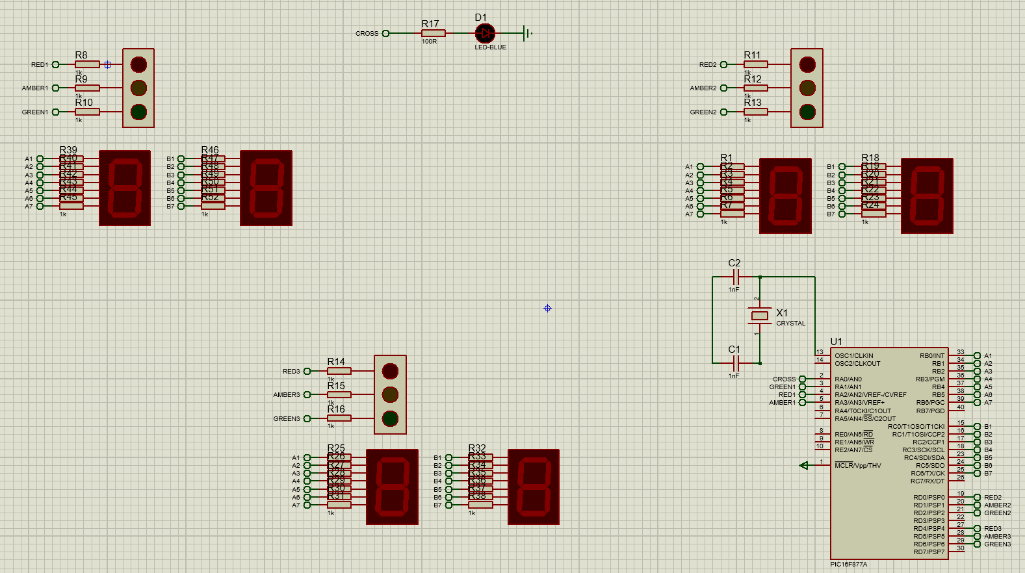
Circuit design
Figure 1: Circuit Design layout
In Figure 1 the layout of the design is displayed. The B and C register of the PIC microcontroller are connected to the 2 seven segment displays and each controls a digit of the count that the displays show. These registers are used as a whole to output a hex value to the display at once. The traffic lights and cross light are connected to individual digital output pins that can work independently of each other to allow many different light variations.

Software design
Based on the requirements for the traffic lights of being on a repeating 40 second cycle I decided to write a closed loop program in C language. This loop would work by establishing a variable called ‘count’ starting at 0 then calling a function that checks the count value and displays that value on the two 7 segment displays, then call a second function which checks the count value and displays the correct corresponding lights at that time then wait for 1 second and then the count will increment and the program will go back to the top of the loop. This loop will also check if the count is greater than 40 and if it is then it resets it to 0. This main loop is shown in Figure 2 shows how this idea was implemented. I decided to go with this approach because keeping everything contained in a loop and just calling two functions made things as simple as possible and easy to manage.
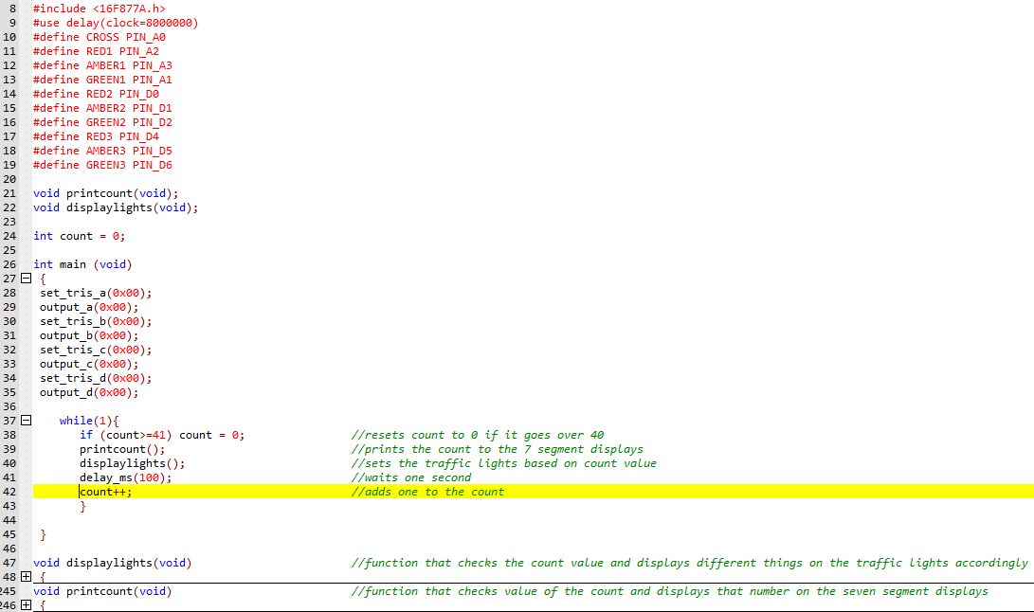
Figure 2: Main software loop
The function that displays the count value on the 7 segment displays (printcount) works by checking the count value from 0 to 40 through a series of if statements and then outputting the hex values for the two digits of the count. Figure 3 shows how this idea was implemented.
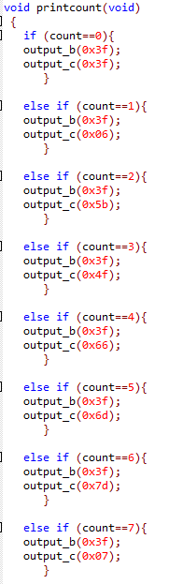
Figure 3: Print Count Function
The function that controls the lights works by checking the count value through a series of if statements and turns the lights on and off through the digital output pins depending on what lights need to be on in that part of the cycle for example if the count is at 0 all lights will be red but when the count gets to 5 light 1 would be green and the rest be red. Figure 4 shows how this was implemented.
Before writing any of this program I made a plan with pseudo code which I have made a copy of on page 9 to show my ideas of how I could meet the requirments with this program.
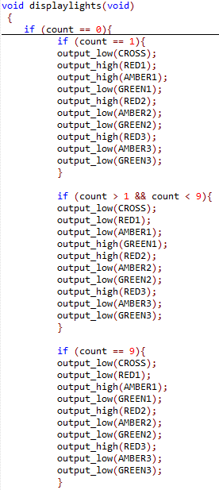
Figure 4: Display Lights Function

Pseudo code
Count = 0
Void loop
Printcount()
If (Count= 0) Lightsred()
If (count >0 && count <2) Light1amber()
If (count>=2 && count<10) Light1green()
If (Count= 10) Lightsred()
If (count >10 && count <12) Light2amber()
If (count>=12 && count<20) Light2green()
If (Count= 20) Lightsred()
If (count >20 && count <22) Light3amber()
If (count>=22 && count<30) Light3green()
If(count>30 && count<40) pedestrianlight()
If(count=40)lightsred()
Count++
If(count>=41)
Count = 0
Delay(1000ms)
End of loop

Void printcount
If(count=1)
Output_b(hex for 7 seg display 0)
Output_c(hex for 7 seg display 1)
If(count=2)
Output_b(hex for 7 seg display 0)
Output_c(hex for 7 seg display 2)
Etc.

Testing & Results
Requirement | Test | Result
TL01: Include 3 sets of traffic lights | Check that 3 traffic light components are included in the circuit and are operational when the program is running. | There are 3 sets of traffic light and they are operational as shown in Figure 5, Figure 6, and Figure 7.
TL02: Include 3 pairs of seven segment displays | Check that 3 pairs of seven segment displays are included in the circuit and are operational when the program is running. | There are 3 pairs of seven segment displays and they are operational as shown in Figure 5, Figure 6, and Figure 7.
TL03: Seven segment displays count from 0 to 40 at one second intervals | Run the program at the same time as a stopwatch and make sure that the displays count from 0 to 40 and stay in time with the stopwatch. | The displays counted through from 0 up to 40 which took 40 seconds according to a stopwatch then looped back to 0.
TL04: Traffic lights should cycle every 10 seconds | Run the program at the same time and make sure the traffic lights cycle through their colours in 10 second cycles. | The traffic lights cycled through from red to green each taking turns on a 10 second cycle shown in Figure 5 and Figure 7.
TL05: The last 10 seconds of the cycle should be for pedestrian crossing | Run the program and make sure that in the last 10 seconds of the cycle all traffic lights are red, and the cross light is lit. | The last 10 seconds of the cycle all traffic lights were red and pedestrian light was on, shown in Figure 6.
TL06: Use a PIC series microcontroller | Make sure a OIC series microcontroller is included in the circuit. | The circuit includes a PIC16F877A.
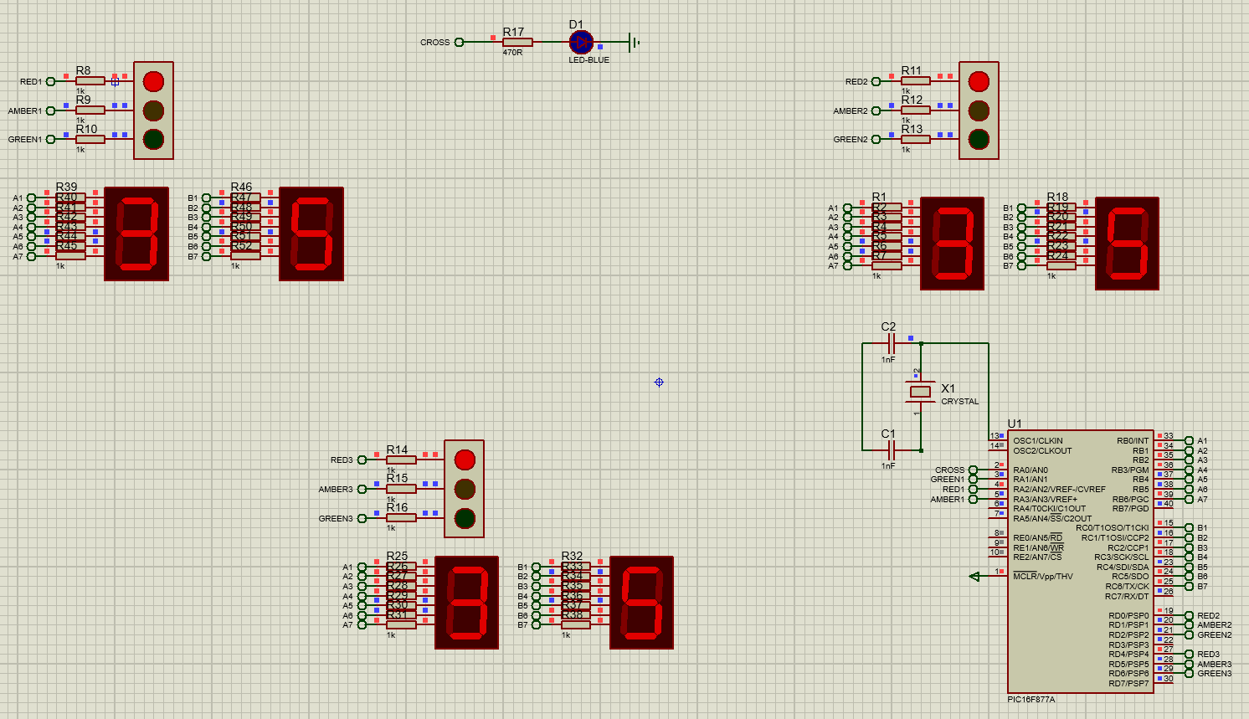
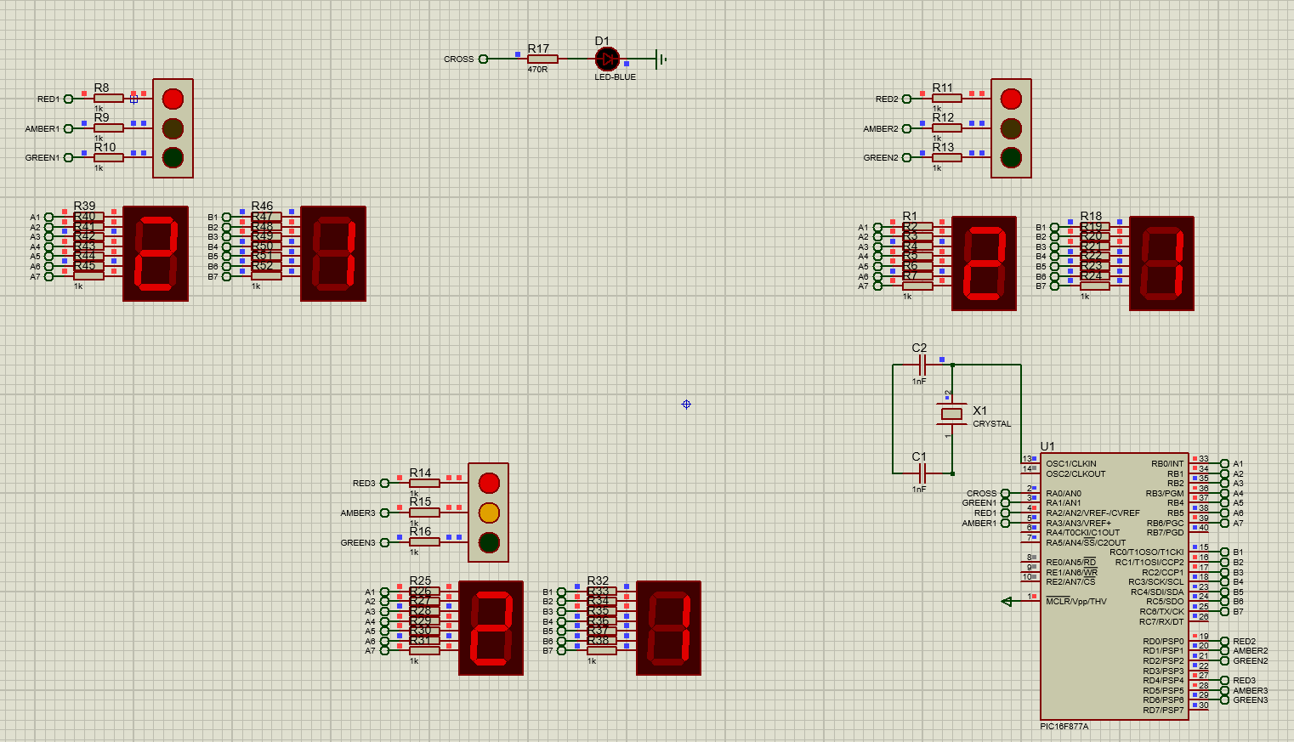
Figure 6: Pedestrian crossing on
Figure 5: Traffic Light 3 in amber state

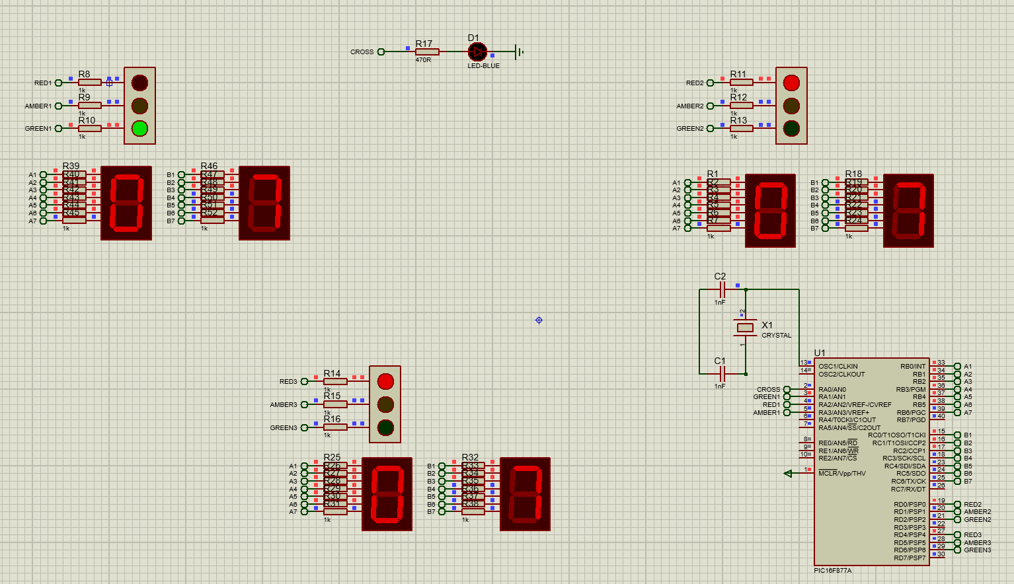
Figure 7: Traffic Light 1 in green state

Conclusion
This report has outlined the design, implementation, and testing of an automatic traffic light controller for a T-junction. The project successfully met all the requirements set in the brief, including the integration of three sets of traffic lights, seven segment displays for count timing, and a pedestrian crossing phase within a 40 second cycle. The PIC16F877A microcontroller served as the main component, managing the system’s operations through digital outputs and a structured software loop written in C.
Throughout the design process, consideration was given to component selection, circuit layout, and software logic to ensure requirements were met. Testing confirmed that the system operates as intended, with all traffic lights cycling correctly, countdown timers functioning accurately, and pedestrian signals aligning with the expected timing.
While the system met its functional requirements, there are areas for potential improvement. Future iterations could incorporate additional safety features, such as a push button pedestrian crossing system, real traffic sensing to adjust signal timing, or an LCD interface to display additional information. Further refinement of the software code could also enhance efficiency, potentially optimising memory usage and processing speed.
Overall, this project provided valuable experience in embedded electronic systems design and microcontroller programming. The final product demonstrates a practical solution for automated traffic management at T-junctions.

