


Effective Team Working and Communication
Task 2

Student name: Alexandra Florica Student number: 2029869 Module number: BMSW4002 Lecturer name: Ejiro Esohwode

The Benefits of Team Working

Teamwork is the collaborative effort of a group to achieve a common goal or to complete a task in the most effective and efficient way.
Before the 1960s, organizational research had focused mainly in individual productivity.
In the 1970s and 1980s there was an increased focus team development and team building in an effort to improve productivity in the workplace.

- Improves Idea Generation -> A more positive, free-flowing atmosphere will encourage everyone to take part in the discussion by bringing forward more ideas.
- Fosters Creativity -> Through teamwork, your employees can start building on an idea or work towards an effective solution for a problem.
- Shared Workload -> Through the proper delegation of duties, a shared workload can do wonders for overall productivity and efficiency.
- Boosts Productivity -> A diversified workplace that focuses on individual strengths, creativity, and efficiency will inevitably set itself up for productivity. To increase loyalty and morale, you need to keep your employees motivated.
- Expands Perspectives -> Teamwork helps expand your horizons through work-appropriate interactions. When you work in a team, you are placed into different situations that offer a new perspective.

Tuckman`s Stages of Team Development

Psychologist Bruce Tuckman came up with the memorable phrase "forming, storming, norming, and performing" in his 1965 paper, "Developmental Sequence in Small Groups." [1] It describes the path that teams follow on
their way to high performance. Later, he added a fifth stage, "adjourning“ to
mark the end of a team's journey.
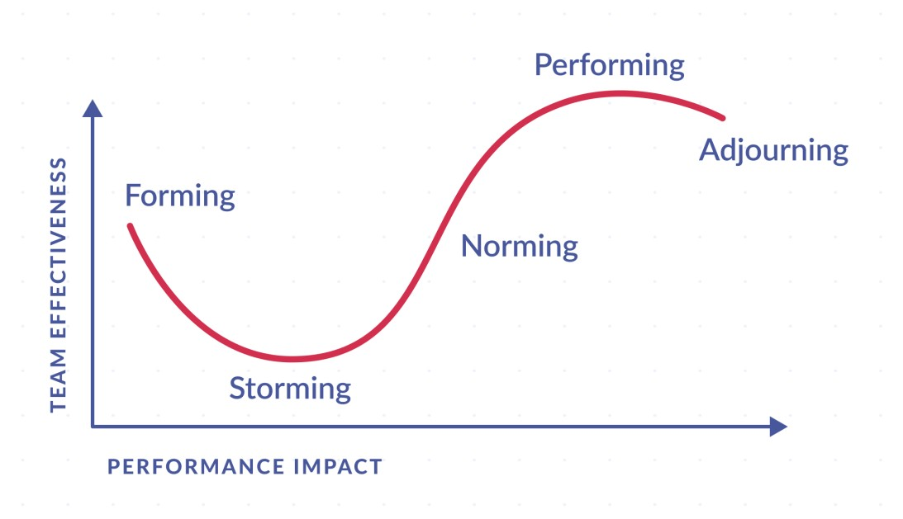

- Forming: help team members to set personal goals.
- Storming: try asking for help on tasks to build team trust, don`t leave team conflict, ask for and hear, everyone`s point of view.
- Norming: get your team to bond further with face-to-face or virtual team-building exercises.
- Performing: team has settled into the performing stage, discuss with your team what opportunities and resources are available to them.
- Adjourning: celebrate the team`s achievements, personal relationship formed.

Conclusion

While Tuckman's Model can provide some guidance towards making a successful team, it's also important to observe individual members to find out what they need to help them thrive as individuals.

References

- https://www.apollotechnical.com/
- https://www.google.com photo
- subject taught in class

