Methods and Search Strategy Academic Poster

Student name: Tariq Mehmood Warraich
Student ID: 2244964
Module name: Independent Project
Module code: BMHP6020
Lecturer Name: Chloe Harries

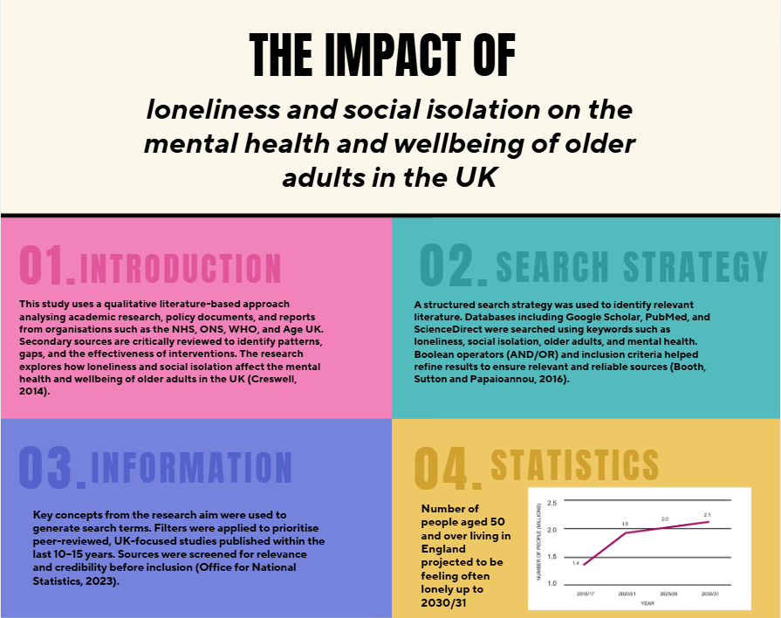
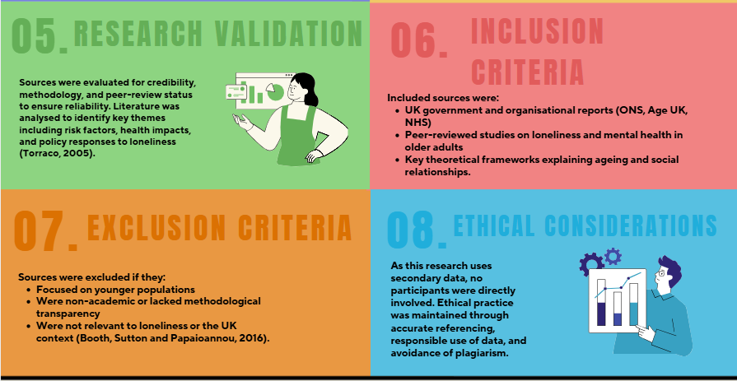

References
Age UK (2022) Loneliness in later life. London: Age UK. Available at: https://www.ageuk.org.uk (Accessed: 22 February 2026).
Antonucci, T.C., Ajrouch, K.J. and Birditt, K.S. (2014) ‘The convoy model: Explaining social relations from a multidisciplinary perspective’, The Gerontologist, 54(1), pp. 82–92.
Booth, A., Sutton, A. and Papaioannou, D. (2016) Systematic approaches to a successful literature review. 2nd edn. London: Sage.
Braun, V. and Clarke, V. (2006) ‘Using thematic analysis in psychology’, Qualitative Research in Psychology, 3(2), pp. 77–101.
Office for National Statistics (2023) Loneliness – What characteristics and circumstances are associated with feeling lonely? London: ONS. Available at: https://www.ons.gov.uk (Accessed: 22 February 2026).
Perlman, D. and Peplau, L.A. (1981) ‘Toward a social psychology of loneliness’, in Gilmour, R. and Duck, S. (eds.) Personal relationships in disorder. London: Academic Press, pp. 31–56.
UK Government (2018) A connected society: A strategy for tackling loneliness. London: HM Government. Available at: https://www.gov.uk (Accessed: 28 February 2026).
World Health Organization (2021) Social isolation and loneliness among older people: Advocacy brief. Geneva: WHO. Available at: https://www.who.int (Accessed: 22 February 2026).

