

Professionalising Police Education: The challenges faced by South Wales Police and student officers in the Policing Education Qualification Framework Programme

Student Name: Sarah Jones
Student Number: 2015345
Degree Title: MA Criminal Justice and Policing
Module: BMCJ7004
Acknowledgements

Firstly, I would likely to express my deepest gratitude to University of Wales Trinity Saint David for allowing me the opportunity to further my policing knowledge and study for my Masters of Art. I have thoroughly enjoyed my journey into a new world of academia.
I would like to extend my thanks to my supervisor Rhiannon Lloyd for her enduring support and much appreciated advice. Her invaluable guidance and wealth of experience inspired me and helped me succeed in my studies.
I have to mention my family, with their constant love and support, I would not have achieved what I have today.
And finally, I wish to thank my husband for his endless support and encouragement during my studies. It would not have been possible to finish my Masters without his unwavering support over the past few years.

Declaration

This work has not previously been accepted in substance for any degree and is not being concurrently submitted in candidature for any degree.
Signed: S Jones
Date: 10/10/2022
This dissertation is being submitted in partial fulfilment of the requirements for the degree of Masters.
Signed: S Jones
Date: 10/10/2022
This dissertation is the result of my own independent work/investigation, except where otherwise stated.
Other sources are acknowledged by footnotes giving explicit references. A bibliography is appended.
Signed: S Jones
Date: 10/10/2022
I hereby give consent for my dissertation, if accepted, to be available for photocopying and for interlibrary loan, and for the title and summary to be made available to outside organisations.
Signed: S Jones
Date: 10/10/2022
I hereby give consent for my dissertation, if accepted, to be available on the university’s IT system to those who have consent to use the system.
Signed: S Jones
Date: 10/10/2022

Abstract

The aim of this dissertations to explore

Table of Contents
Chapter One: Introduction
  - Introduction
  - Background
  - Research Focus
  - Research Aims and Objectives
  - Research Rationale
  - Methodology
Chapter Two: Literature Review
  - Introduction
  - Rationale

Chapter Three: Methodology
3.1 Introduction
3.2
3.3

Chapter Four: Findings and Analysis
4.1 Introduction
4.2 Participants Views
4.3

Chapter Five: Conclusion
5.1 Introduction
Bibliography
Appendices
Appendix 1. South Wales Police Data
Appendix 2. Questionnaire
Appendix 3. Justin Evans Interview
Appendix 4. Questionnaire Findings
Appendix 5. Ethics Form

List of Figures and Appendix

Figures:
Figure 1. UK Police Service National Headcount
Figure 2. UK Police Service National Data of Resignations
Figure 3. UK Police Service National Data of Reasons for Resignation
Figure 4. The Research Onion
Figure 5. Graph to Reflect the Perceptions of the PEQF by Student Officers in South Wales Police
Figure 6. Graph to reflect South Wales Police Students views of resigning from the Police
Figure 7. Graph to reflect the reasons why South Wales Police Students have considered resigning from the police service
Figure 8. Graph to reflect South Wales Police Students views of challenges faced by their employer following the introduction of the PEQF

Appendices:
Appendix 1. South Wales Police Data
Appendix 2. Questionnaire
Appendix 3. Interview with Justin Evans
Appendix 4. Questionnaire Findings
Chapter One - Introduction
1.1 Introduction
Despite long-standing worries regarding the educational standards of police recruits, it is well acknowledged that for many years there has never been a nationally determined minimum level of education for the selection of police recruits in England and Wales (Neyroud, 2011).
Peter Neyroud's 2010 investigation into police leadership and training resulted in suggestions for the police in England and Wales to review their standards of professionalisation. The Conservative Government at the time were also considering radical reforms to police training, including the forming of a professional association (Neyroud, 2011). Neyroud believed that confusion over the entity in charge of establishing policing standards presented the most pressing issue that both the police and the government needed to address right away. For a long time, the suggestions made by Chief Constables for establishing policing standards had not been heard (Neyroud, 2011).
To identify and communicate essential information about "what works in policing," (Bayley, 1997), national policing standards, professional practise, and local best practise, a new professional body for policing was established and given the name The College of Policing (Neyroud, 2011). One of their main objectives, included ‘setting standards of professional practice’ (College of Policing, 2014). Additionally, the College wanted the public to believe that police personnel follow a national code of professional policing practises and receive career-long professional development (College of Policing, 2015b).
Given how the complexity of policing investigations has changed over the years, which includes cybercrime and terrorism, along with complex and diverse criminal investigations, many argued that the lack of academic qualifications as being inadequate for the role of constable (Shohel et al, 2020).
This view was supported by suggestions made by Neyroud (2011) and as a result the Police Educational Qualification Framework (PEFQ) was established. The introduction of the PEQF allowed police education to undergo some radical changes in England and Wales. Since 2019, new routes into the police service were established which includes a self-funded undergraduate (pre-join) professional degree in policing; a Police Constable Degree Apprenticeship (PCDA), and a two-year conversion programme for those whose first degree is not the professional policing degree (College of Policing, 2020).
The new framework works under the concept of ‘work as you learn’ (Strong, 2019). One author argues these approaches neglect people's actual abilities and traits, which also make them qualified candidates for police recruitment and effective officers. Instead, they place a greater focus on academic achievement (Levers, 2021) It is said that the PEQF is a representation of ‘a massive reconfiguration or decomposition of cherished principles of traditional policing, and pushes out boundaries…’ (McDowell and Brown, 2019),
In addition, UK Parliament (2019) state that the Police Federation claimed that having a degree does not necessarily make a successful police officer, and that requiring it of all new recruits will make policing less appealing to the public. This view was shared by the Chief Constable of Northamptonshire Police, who expressed that graduate-only recruits represent a generation that is immature and lacking in exposure to be able to handle the challenges of modern policing (Vincent, 2021).
Along with the College of Policing's designation as the police professional body and the implementation of a new Code of Ethics, the PEQF is seen as an extra key component in the police becoming a professional body. It is argued that making new police recruits graduate candidates will link the police with other UK public sector careers such as nursing, teaching, and social work (Christopher, 2015).
This view is echoed by Green and Gates (2014, p. 79) who state, ‘practitioner led research is necessary to drive the establishment of the complex body of knowledge that is distinct from existing disciplinary knowledge and constitutes the knowledge base of the profession’ (2014, p.79). Further, the uniformed Police Constable role is a public facing role and there are concerns over the suitability the recruitment process will have by focusing only on degree-level academic accomplishment (McDowell and Brown, 2019). The police force has historically been unsuccessful in supporting an individual officer's growth, and in preparing them to handle the pressure of demands from an ever-more complicated society (Institute for Government, 2022) .
However, despite all the concerns raised by senior police officers, the College of Policing continue to aim to produce a workforce for the future that is more qualified and skilled, and introduced the Policing Education Qualification Framework in 2019 (College of Policing, 2020). The Policing Vision 2025 and 2030 aims to strengthen public service by including this aim as part of its goals (College of Policing, 2020b).
South Wales Police was one of the first police forces in the UK to embrace the changes and began to develop close partnership workings with their Higher Education Institute, University of Wales Trinity Saint David (UWTSD). Their goal was to establish standardised procedures for the implementation, evaluation, and accreditation of the introductory police training (University of Wales Trinity Saint David, 2020).
Chief Constable Matt Dukes recognised,
“This experience will enable us to be a profession with a more representative workforce that will align the right skills, powers, and experience to meet challenging requirements that officers face on a daily basis” (University of Wales Trinity Saint David, 2019)
Numerous scholars have contested the idea that the police is a profession. According to Holdaway back in 1977, the police prioritised senior officers' administrative skills and educational backgrounds more than they did fast-track, direct entry candidates for officer rank (Holdaway, 1977). Neyroud (2011) disputes this, describing the police as a profession comparable to nursing and other occupations because they apportion similar and traditional characteristics.
The College of Policing have produced a comprehensive curriculum for police student officers. The theory of education is supported by the contemporary curriculum of modern operational training. It forms part of the Policing Vision 2025 and was approved by the Association of Police and Crime Commissioners (College of Policing, 2020)
The primary goals of the PEQF are to solve the long-standing issue of failing to recognise the level at which police employees operate and to standardise learning across all forces, particularly the training for newly hired officers (College of Policing, 2022) Even though the college of policing's primary goal is to give student officers a positive experience by fostering a deeper knowledge and understanding, critical thinking, and superior writing abilities, they have acknowledged that they do not want the PEQF to be a barrier for working officers (College of Policing, 2022).
The College of Policing (2022) reveals that the retention rate of student officers remains a priority. The new learning initiatives have sparked concerns among many police forces that more student officers may decide to leave the police before completing their initial training. Attrition is a pressing concern for police forces, however the College of Policing highlights that retention of officers on the PEQF is over 95%, which is higher than originally estimated (College of Policing, 2022).
Cambridge Dictionary (2022) defines attrition as a reduction in the number of employees in a company made by not replacing those who leave, rather than forcing people to leave their jobs. However, the College of Policing defines attrition of Police Student Officers as the percentage of people who do not finish the entire learning programme or their probation (College of Policing, 2022).
The professionalisation of the police force is fraught with difficulties, and one of the key hurdles the police force must overcome is identifying what constitutes an acceptable retention rate and why student officers leave the force. These difficulties have been identified by South Wales Police as potential areas that require further monitoring (see appendix 1.)
As a result, the aim of this research is:
To identify the main challenges faced by South Wales Police and their student officers who are enrolled onto the Police Education Qualification Framework.
This research has not been conducted before, and it will provide the author the opportunity to make a comparison between their findings and those of other police forces across England and Wales. This will allow opportunities to share findings with South Wales Police, who may be influenced upon the outcome. According to Biggam (2021) the overall aim of the research will be realised when the individual research objectives are achieved.
Therefore, the following objectives will be achieved;
- To explore the perceptions of the student officers who are currently completing the Police Constable Degree Apprenticeship (PCDA) and Degree Holder Entry Programme (DHEP).
- To analyse the retention data of South Wales Police students since the introduction of the PEQF to date. This shall help identify the period during the probationary period when student officers resign from the service and the reasons why they leave.
- To evaluate the correlation between South Wales Police challenges surrounding retention of officers and those of other forces nationally.
Methodology
Resources for this dissertation’s data will come from both primary and secondary sources. To obtain a thorough understanding of the research, it will be essential to consult textbooks and journal articles. This study would also benefit from a multi-method approach that includes both qualitative and quantitative data analysis. In contrast to a quantitative approach, which involves a formal analysis of data, qualitative research permits the study of attitudes, views, and behaviour (Kothari, 2004).
The research for this dissertation will be based on previously collected data and statistics from work collated through the partnership working between South Wales Police and UWTSD, as well as new primary data gathered as part of this new piece of research.
The primary data will be produced through the use of an online questionnaire and this will allow the data to be collated efficiently. According to Kara (2017), questionnaires have a greater response rate since respondents can complete them whenever it is convenient and give truthful responses. For this reason, as outlined in more detail in chapter three, a questionnaire was a method adopted to carry out the primary research. This view is echoed by Oliver (2010) who describes quantitative research as “Research that uses numerical data or statistical research”. He further states that quantitative research methods have characteristics which provide clear and precise results, which are objective and measured. This type of research will quickly and efficiently gather a wide range of data from a huge number of sources.
As explained by Gingham (2008), depending on the type of question, surveys and questionnaires can also elicit qualitative data. Open questions will provide qualitative information whilst closed questions will provide quantitative data. According to Gingham (2008) quantitative methods bring disadvantages to the author. Lack of control over the sequence and context of answering questions may make it difficult to motivate respondents to finish questionnaires. There may also be issues when checking the seriousness or honesty of people.
A further method of research analysis will be via a structured interview. Using this qualitative research technique, the author will be able to compare the opinions of South Wales Police and those from the online survey.
Qualitative research is concerned with opinions, feelings, and experiences of people. The data provides depth and detail of people’s responses and encourages people to expand on their responses. However, it can be more time consuming and therefore fewer people are studied. It may be difficult to make comparisons of the data as people’s responses may be subjective as further explained in chapter three (Boile and Hox, 2005)
To gather the most accurate information, the author will marry both qualitative and quantitative methods. Both research techniques are hoped to offer thorough and reliable data which will highlight the challenges South Wales Police and what its student officers face in Year Two of their academic programme.
It is important to recognise the limitations when collating the data for this research which will be outlined in chapter three. The author has access to a wide variety of online university resources, as well access to data held between the university and Police Force through an information sharing agreement. However, due to the sensitivity of the data, this information cannot be openly shared with external agencies, but only with the university and South Wales Police.

Chapter Two - Literature Review
2.1 Introduction
Over the years UK police forces have moved away from the conventional training methods they historically used and steered more towards higher education programmes (Shohel et al, 2020).
When Sir Robert Peel was appointed Home Secretary in 1822, he was the first to introduce the idea of professionalising law enforcement. The Peels Metropolitan Police Act 1829 established the Metropolitan Police as a full-time, professional, and centrally managed police force for the greater London area (National Archives, 2022). However, Cordner (2011) recognised that the intricacy of police work today and the evolving nature of policing have become central themes in the discussions surrounding police studies.
The necessity of higher education inside the police service has been questioned in several studies. The distinctive responsibilities of a police officer including making decisions independently and exerting their authority whilst employing their discretionary powers, may be directly impacted by an officers’ education and training (MacVean & Cox, 2012). However, one author suggests that there has been little comparative research into the introduction and impact of police educational practices and questions whether police officers are shaped by their police education when entering their profession, however it may be dependent on the sort of person who is recruited into the service (Bjorgo & Damen, 2020).
UK police education has developed into an accredited academic programme to bring about a positive impact on the UK police service (Del Barrio, 2009). Paterson (2011) suggests that higher education is thought to be essential for the professional growth of all professions since it promotes critical thinking and reflective practice. Similarly, Clapton et al (2008) also suggests the prerequisites for every profession to function in a professional capacity and include specialised knowledge, adherence to associated ethical norms, opportunity for continual professional development (CPD), and specific educational qualifications.
It is recognised that police departments in other European nations, including Denmark, Norway, and Sweden, have similarly looked for a link between education and professional training, and supports this point of view (Kyvik, 2009). Moreover, these nations have the longest initial police training programmes compared to other nations and view police education as higher education (Kyvik, 2009).
Many police professionals recognise the need for theoretical reflection during police training and this is due to the ever-changing police role (Bjorgo & Damen, 2020). However, Wood (2018) raises questions about whether higher education creates competent, reflective police officers given the absence of evidence to support this claim. However, it can be argued that having a higher education degree has a more significant impact on police officers' understanding of, and respect for, individuals from various cultures, particularly members of underrepresented groups (Brown, 2018). As a result, it has been suggested that the professional academic education programme is an essential tool for the development of the British police forces.
In 2009, Wood & Tong (2009) argued that there was serious concern surrounding professionalising police initial training, which raised tensions amongst police officers. Furthermore, Telep (2010) suggests that the timing of a policing degree during the officers probationary period has brought about a negative attitude of newly appointed officers. Others specialising in this field explores that police recruits may be impacted by the delivery of higher educational training, when the lecturers themselves were not professionally placed to deliver the curriculum (White & Heslop, 2012).
Many continue to question whether a degree aids the performance and behaviour of a police officer. According to research, officers with a higher education demonstrate greater oral and written communication skills, are more intelligent, and have a professional mindset (Carlan and Byxbe, 2000). This view is also expressed by American research, who identify that college-educated police officers experience less disciplinary problems than their non-educated counterparts (Aamodt, 2004).
Kleinig (1996) suggests that effective policing is based on sound decision-making whilst working under pressure, and it is the ability of officers to think critically and make wise decisions. The College of Policing (2021) supports this view and acknowledges the significance of developing a professional workforce by supplying the skills, knowledge, and behaviours to effectively police a constantly changing society.
Through incorporated learning and assessment, the Police Education Qualification Framework (PEQF) offers an opportunity to enhance policing through reflective practice (College of Policing, 2021). One author reveals that a reflective practitioner is someone engaged in professional practice (Simmons,1979). However, this brings into question whether the police service can be identified as a profession.
Ashenhurst (1959) stated that persons who work in a profession must be educated, trained, and able to use their knowledge in a professional capacity. However, police work has not been traditionally recognised as a profession, despite the views of those such as Huber in 1977, who acknowledged that a modern profession must have formal training of knowledge, codes of ethics, and a professional culture, with a strong service orientation (Huber, 1977).
This point of view would imply that the police service is a profession, yet it has recently been questioned as to whether the UK police service has a professional culture. Police Foundation (2017) state ‘Policing cultures are almost universally condemned as being sites of, among other things, masculine hegemony, prejudice, discrimination and exclusion’ (Police Foundation, 2017, pg3) However, Kleinig (2003) argues that police officers are members of a governing body and are subject to self-regulation and professionalism. Yet, according to Lumsden (2017), police professionalisation is linked to government changes, education, recruitment, and policing principles.
Neyroud (2011) advocated for the need for a professional police force to be overseen by a professional authority. These suggestions were accepted, and the Police Education Qualification Framework was developed with the help of the College of Policing. The PEQF is ‘a professional training framework for police officers and staff and is based on a modern curriculum of dynamic operational training, underpinned by sound theoretical education’ (College of Policing, 2020c).
The close collaboration between police and academia mirrors other professions within the UK for example nursing, manufacturing, and banking (Home Office, 2015). It has been identified that many students in the health care profession who are undertaking academia as part of their job role question the advantages that it brings, as suggested by Sanchez & Brutus (2022). It is well known that new police recruits typically disagree with academic lessons and see life skills acquired on the job as being far more valuable than those obtained in university (Constable, 2017). This view is also debated by the Police Federation (2021) who raises concerns that police students are falling behind in their studies, even though they are a competent police officer (Police Federation, 2021).
In previous years, becoming a police officer required a certain level of education (Neyroud, 2011). However, all police recruits must now possess or obtain a degree-based certification to become police officers. The College of Policing (2020) has designed and regulated three entry points into policing, as outlined in chapter one; an advanced apprenticeship programme, where upon the recruit will graduate with a bachelor’s degree (PCDA), a degree holder entry programme (DHEP), and a pre-join undergraduate degree in Professional Policing. The level of theory, operational, and practical skills will be the same for all pathways.
The Policing Vision 2025 and 2030 has set the objectives of the PEQF, which hopes to provide an improved service to the public. The vision emphasised the necessity of consistency, certification in clearly defined jobs, and that roles call for specialised expertise supported by credentials (College of Policing, 2020b). By enabling policing to become a graduate profession, which some have said would be a dramatic reform of the police service, the PEQF has been created to promote the policing vision (Watkinson-Miley, 2022)
The PCDA programme is crucial since it is predicted to become the most preferred way to join the police service, as many applicants do not hold a degree level qualification (Wood, 2018). However, it is important to note that four in ten police recruits entering the police service already have a undergraduate qualification (Dodd, 2016), and many officers believe that a higher education will benefit their career (Rydberg et al, 2012).
Historically, the curriculum for police training had been dictatorial and provided limited learning for a probationer officer and did not develop the skills and knowledge needed for policing (Wood & Tong, 2009). However, the new curriculum is modern, dynamic and more fitting for operational policing today (College of Policing, 2020b).
According to Rogers and Smith (2018), the College of Policing has become a crucial player in the growth of ties between the police and academic institutions. As Lumsden and Goode (2017) expresses, the police force has evolved into a learning organisation that is more receptive to outside study. As a result of the PEQF's implementation, it is now possible for the police to evaluate their professional practise and knowledge, which has helped the police officer integrate themselves into the core of the curriculum.
A substantial advancement in police education and training is provided through the PEQF, and it prioritises postsecondary education over all other forms of education within the police organisation (Wood, 2020). The police service must embrace, support, and empower their officers as reflective practitioners for the PEQF to achieve its full potential.
The development of the policing education programme has advanced significantly, but there has been, and continues to be, numerous implementation obstacles and challenges. Morgan et al (2004, p360) contends that foundation degrees ‘…are another in a long list of government schemes aimed at combining or bridging the academic vocational divide or at least providing an HE-based curriculum with a vocational content’.
It is not a simple task to redefine the 100-year-old traditional police-training to university education programmes, and police forces are having difficulty addressing various practical and academic concerns while implementing the new programmes (Mahruf et al, 2020). Furthermore, the creation of police education programmes has advanced significantly, yet there are still major obstacles to overcome (Shohel et al, 2020). Many opponents of the police services’ professionalisation are concerned that new recruits may become weary of the erratic hours, investigational pressures, and low pay (Varricchio, 1988). One author acknowledges that the implementation of higher education inside the police service may result in a higher rate of resignations and a larger turnover of recruits (Whetstone, 2000).
The UK Government (Home Office 2022b) has made it a key priority to minimise crime as part of the countrys levelling up effort. However, they acknowledge the need for a trained and driven police force to develop aptitude and capacity to deal with contemporary crime. Research by the Home Office (2022b) suggests that there are several factors that obstruct the government’s goals, even though police funding has increased to £16.9 billion in 2022/23. This includes funding for national priorities, such as recruitment and retention of police officers (Home Office, 2022b).
There has been a steady increase in the number of officers recruited to meet the UK Government's target of hiring an additional 20,000 police officers by March 2023. However, the number of officers hired varies from month to month, which may reflect the distinct hiring cycles of the forces.
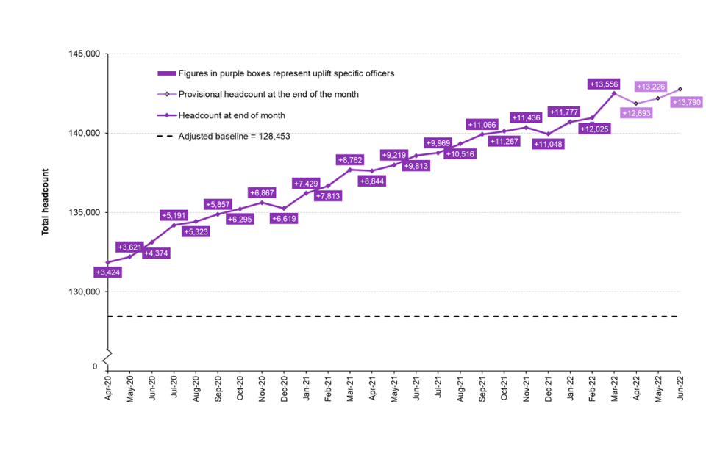
Figure 1: UK Police Service National Headcount
As shown in the above graph (Home Office, 2022c) there has been a steady rise of police officers employed across England and Wales. However, there was a significant decline in the number of officers leaving the service between November 2021 and December 2021, and between March 2022 and April 2022. This decline falls within the period that the Police Education Qualification Framework was introduced in March 2019, which may be significant or coincidental (Home Office, 2022).
In January 2021, the Office of National Statistics (2022) confirmed that there were 97,300 full-time officers in 43 territorial police forces in England and Wales, but according to the Home Office (2022c) by March 2022 that number had risen to 140,228. There appears to be inconsistences between the data, as the Home Office (2022c) identified that only 12,789 new police officers joined the 43 territorial police forces in England and Wales in the year ending March 2022. This is an increase of 662 (or 5.5%) on the previous year (Home Office, 2022c). Compared to previous years, this year has seen the second-highest number of new police recruits.
The increase in recruitment is reflected in the UK Governments pledge to employ 20,000 more police officers in England and Wales by the end of March 2023, and 12,000 extra police officers could be employed by the end of March 2022 under the first two phases of this pledge.
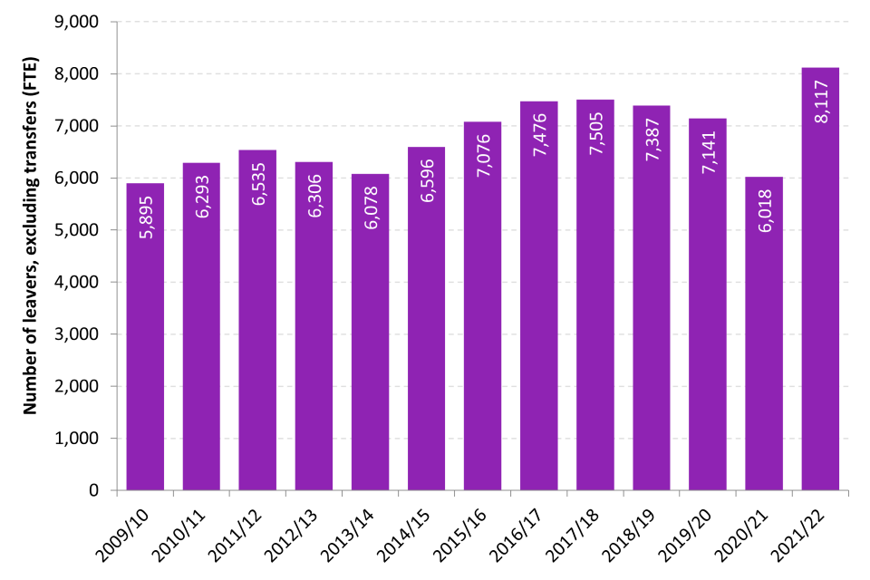
Figure 2: UK Police Service National data of resignations
The above table obtained from the Home Office (2022c), shows that the same year 8,117 police officers leaving the 43 territorial police forces in England and Wales. This is the most annual leavers since comparable data first started in March 2003. This data excluded transferees. It is interesting that the same author acknowledges that the rate of police officers leaving was 6.0%, which was comparable to levels between the fiscal years ending in 2016 and 2019 (Home Office, 2022c).
There may be many reasons for the significant 35% decrease in national police force establishment figures. An expanding workforce may cause a rise in departures, however, according to the Home Office (2022c), the reasons for resignations vary.
Year ending 31 March: | 2017 | 2018 | 2019 | 2020 | 2021 | 2022
Normal retirement | 4,507 | 4,747 | 4,492 | 4,169 | 3,429 | 4,134
Voluntary resignation | 2,035 | 1,995 | 2,175 | 2,363 | 1,996 | 3,433
Transfer | 1,093 | 1,068 | 1,339 | 1,405 | 1,024 | 1,186
Medical retirement | 587 | 500 | 514 | 377 | 357 | 303
Contract termination and dismissal | 289 | 269 | 161 | 163 | 169 | 180
Death | 57 | 51 | 46 | 69 | 67 | 67

Figure 3: UK Police Service National Data of reasons for resignation
In the years prior to March 2022, many officers leaving the service (excluding transferees) did so via normal retirement, which has historically accounted for 60% to 70% of departing officers. Interestingly, the number of voluntary resignations has risen compared to previous years and although there is no national data surrounding the reasons for the resignations, the Home Office (2022c) has identified that the makeup of police officers in the year ending March 2022 showed that 33% of the police force have less than 5 years’ service, with 9% of them having less than 1 year service. This not only reflects a young in-service workforce, but it could be suggested that the significant size of the young workforce would play a prominent place in the figures relating to voluntary resignations.
According to the Police Federation (2022), many police officers have resigned from their jobs before their probationary periods ends. Research suggests there were 2,567 resignations from 28,173 probationary officers within this financial year. This resulted in an average attrition rate of 9.1% (Police Federation, 2022). This data is echoed by Northamptonshire Police who reported that 19.3% of their new recruits left the police service within their probationary period since the launch of the new national uplift of police officers (National Police Chiefs' Council, 2022).
There are smaller forces that have seen a lower rate of resignations, including Cumbria and North Wales, who both had rates of 3.9%, in addition to Merseyside and the West Midlands, who both had rates of 5.4%. Furthermore, data shows notable variations in attrition rates across forces, however within some forces, attrition rates have reached double digits.
Police Federation (2022) recognises that to retain new officers, fairer compensation and working conditions are essential. They highlighted that many officers begin with a salary of £19,164 in the first year of a police constable degree apprenticeship, which is just slightly more than the nation's national living wage, which was implemented in April of this year. Additionally, Police Federation (2022) identified that more than one in ten police officers are unable to afford their monthly bills, and they recognise that the low income has made student officers more likely to leave the force. They also contend that the quantity of academic work that officers are required to complete in their own time, lowers their hourly pay, which puts further strain on families. It could therefore be argued that for policing to continue to offer the finest service to the public, police leaders must make sure they do not just focus on getting people through the door, but also take the necessary steps to keep them (Smith & Smith, 2022).
Police Federation (2022) has emphasised how national attrition rates are impacted by low pay, poor management, the lack of promotion opportunities, and heavy workloads.
Jeff Harris, Surrey Police's Deputy Police & Crime Commissioner (2022), shares this opinion and claims that recruitment practices are becoming problematic, and that a poisonous combination of lack of confidence, incident trauma, and academic pressures exists (Policing Insight, 2022).
The government has pledged to support the police by providing them with the tools they need to safeguard the public and has promised to employ 20,000 more police officers, despite the fact that it acknowledges the resolve and dedication displayed by police officers all around the nation (Home Office, 2022b). In order to carry out this pledge, the government has promised to provide a professional and motivated police force, however it is recognised that the UK Government has fallen short of its desired uplift figures, with only 13,790 recruited up until July 2022 (Home Office, 2022b).
Despite the remarkable success of developing the police education programme, there remains several challenges faced by the police forces, higher educational providers, and the police students when putting the certification framework into practice.
Organisational Challenge
A new organisational framework is required to give the UK police service the skills it needs to deal with the growing issues it is currently facing. These issues feature a shift in social divisions causing rising demands to deal with violence, abuse, and exploitation. As expressed by The Police Foundation (2022), who contends that difficult hurdles are causing troubling signals and a decline in police performance. These are due to the technical advancements inherent in modern society, where a new criminal realm has emerged. The police have also seen an increase in public order and violence during national protests, an increase in organised crime that preys on the young and vulnerable, and a growing threat of terrorism to public safety. (National Crime Agency, 2020)
The new educational platform aims to supply police officers with the cognitive and problem-solving abilities to manage these growing issues, whilst applying their own professional judgement in a more challenging working environment (The Police Foundation, 2022). Chappell and Lanza-Kaduce (2010) recognise that historically, recruit learning was hindered by the militaristic characteristics of police training, which included hierarchy, submission to authority, isolation, and discipline. This implies that for police training reform to take root, a necessary precondition is a suitable shift in police culture. Moreover, Hellenberg and Cockcroft (2021) contends that a vital aspect of changing the culture of policing, is a change in how police officers learn and think. According to Christopher (2015), adopting a new learning paradigm into police training would necessitate a considerable organisational transformation because modern policing, like many other professions, should embrace the idea of becoming a critically reflective practice. However, according to Lumb & Breazeale (2002) inadequate implementation or a lack of organisational support may lead to a lack of relevant resources for recruits. To ensure that police services have the infrastructure necessary to accommodate postsecondary levels of learning and assessment, both investment and a significant adjustment to the curriculum are required, which will be an advocate for a change in the culture of policing (Wood, 2018)

Student morale and wellbeing
There have been some debates and complaints over the PEQF's implementation. Lincolnshire Constabulary Chief Constable Bill Skelly (2021) asserts that the implementation of the PEQF would lead to a reduction in the number of police officers engaged in front-line work. His views are that they are working many hours to achieve their degree-related courses and this would have an adverse effect on his current staff, causing increased pressures (Kadry & Lambert, 2021). Furthermore, according to Reiner & Newburn, (2007), it is evident that when developing learning materials for police studies, consideration must be made to operational commitments. However, in practice, police students may find it difficult to spend a significant portion of their working hours and free time to purse an academic degree, compared to traditional students on university programmes who are required to study and learn throughout the week (Mahruf et al, 2020). Duran et al, (2019) suggests that due to exposure to some extremely stressful incidents, policing is perceived as a very demanding profession, and as a result, physical and mental ill health is more prevalent among police officers. A paralleled opinion can be drawn from Buda & Lenaghan (2005) who reveals that working and studying can produce substantial stress and have a negative effect on a student’s wellbeing.
Ellison (2004) recognises that inadequate staffing levels, heavy workloads, extended hours of work under pressure, refusal of holiday leave, and deadlines for academic submissions, are experienced by student police officers and are all linked to poor mental wellbeing. Furthermore, Baskinska et al, (2014) suggests long study sessions, shift work, and the demands of the employer may lead to fatigue, which can be a psychological risk in an already hard profession. The author also recognises that the negative perception of police study heightens emotions and could further add to increased stress within their family life.
According to Syed et al, (2020), police officers experience twice as much stress as the average population and are more likely to experience mental health issues like PTSD, depression, and anxiety. This view is supported by Elliot-Davies (2018) who suggests that a police officer’s job role is the main cause of stress, depression, anxiety, or mental health issues.
The UK Government continues to support the wellbeing of officers despite acknowledging the challenging and demanding work that student officers do. The government has committed £7.5 million to creating a national police wellbeing programme that would offer officers guidance, resources, and tools. These include tools for officers who are struggling with their mental health (Home Office, 2022d). The onerous workloads and worries concerning health and wellbeing were highlighted by police personnel all around the UK. In 2019, the Home Secretary listened to the officers and outlined a proposal for a new police covenant. The covenant would recognise the courage and commitment of the police while emphasising the officers' physical safety, their well-being, and aid for their families (Home Office, 2022d).
Personal wellbeing is influenced by both the individual and the organisation, with a focus on the organisation and managements ability to assist its employees. While there are several national programmes and campaigns in place, it is unclear how the individual and organisational perspectives of wellbeing can be aligned (Phythian et al, 2021).

Collaboration
Making sure that higher education institutions (HEI) and police forces collaborate consistently and deliver the degree programme to students is a challenge. Jones & Since 1994, it has been suggested that the HEI and the force will experience many obstacles Newburn (1994), with the partnership facing difficulties of bringing the workplace into the classroom and the classroom into the workplace (Payne et al, 2003). It has been recognised across several universities that there is a reduction of teaching staff with policing skills and experience, which is needed to deliver the police education programme and this has brought about tensions within the partnership (Stanislas, 2014). However, this view is refuted as it has been recognised that many police departments enjoy a productive working relationship with the higher education institution that collaborates on other programmes, such as promotional qualifications (Stanislas, 2014).
Although some programmes are force-led, in which the force designs and delivers the course materials while the HEI approves and evaluates the learning, many forces and HEIs pursue a co-delivery model. This raises the question of who should oversee the running of the programme. One author questions that within the collaborative arrangement who ‘owns’ the student officers? (Wood & Tong, 2009).
The collaboration between the police and the HEI has produced successes, and many forces have fruitful conversations with their HEIs about the curriculum and assessment (Wood & Tong, 2009). However, Wood (2020) contends that whilst initial police training includes a very specific curriculum that outlines what must be studied, it focuses too much on what must be taught from the perspective of liability issues, and not enough on what must be learned to improve the officers skill and comprehension. Kadry et al, (2022) reveals that in contrast to their operational responsibilities, some student police officers have withdrawn from their studies, which has led to a strained relationship between them and their higher education institution.
Perception of Higher Education in Policing
Cockcroft & Hallenberg, (2021) suggested that education has the power to influence how police officers engage with the public and their co-workers. However, there is currently limited knowledge surrounding the ways that higher education can alter the dynamics of the collaboration between police officers and police institutions. Furthermore, Paoline III et al, (2014) notes that education has a substantial impact on police officer behaviour, and that educated police officers are more effective in combating crime. However, Lee and Punch (2004) contend that additional study is necessary to strengthen the case for why education is the most effective way to produce accomplished police officers.
In terms of the advantages of higher education, Punch (2007) suggests that officers benefit from a rise in personal and intellectual self-confidence, which in turn encourages effective working both internally and externally. However, the author also noted that officers share a more negative perception of higher education and highlight that the organisation values higher education credentials more when they were held by senior-ranking officers. The link between policing and higher education institutions is further complicated by the fact that Rowe (2006) suggests that many officers view practical experience as the gold standard of police knowledge and competency.
Additionally, Ramshaw & Soppitt (2018) noted that one criticism of the programme was that students frequently found it difficult to recognise the link of the academic content that was presented to them to their role. According to Cockcroft & Hallenberg (2021), the police forces show little appreciation for either student achievement or its potential value to the police, which highlights the cultural resistance faced in integrating education into policing.
Learning Experience
The delivery of police education is predominantly via a virtual learning environment, and the learning materials require interaction by the student officer. Some students may not interact with online lectures and thus lose critical instruction on the laws that are relevant to their professional duties, despite online learning being as effective as traditional classroom delivery models (Hammer and Smith, 2021). One author notes that many students would still prefer a more conventional classroom setting as online delivery does not cater for all learning needs of students (Smart & Cappel, 2006). However, research suggests students learn by doing in real-life contexts, and retain ‘10% of what they read and 90% of what they say and do’ (Reif, 1993). Furthermore, it could be argued that officers need to be trusted and urged to put their knowledge to use in a manner that fosters their individual sense of professionalism (Williams et al, 2019)
Recruitment
During the recession of 2007, a problematic period for policing was indicated by a decline in the number of police officers, a more complicated pattern of developing crime, and the ripple impact of budgetary cuts to public services (McMahon, 2017). Both the police forces and universities were unprepared when Prime Minister Boris Johnson declared in 2019 that he would recruit 20,000 new officers for the country's police forces to alleviate the lack of personnel (Brown, 2019).
In order to ensure that policing maintains resilience in areas that are crucial to the success of the service, the boost of 20,000 officers has brought extra recruitment and retention issues. To address these issues, the UK Government is closely collaborating with the National Police Chief Council (NPCC) whose objective is to improve learning and development, especially for those who supervise student officers (Home Office, 2022d)
According to Pollard et al, (2014) organisations must steer clear of the quantity over quality policy, which limits staff student ratios and strains already-limited resources by over-recruiting students. This view is echoed by Sir Mark Rowley (2022), who is the commissioner of the Metropolitan Police, who raises concerns whether it is prudent to swiftly hire thousands of officers. He also emphasises that the sheer magnitude of recruitment entailed considerable risks of hiring the incorrect people (BBC News, 2022).
Retention
In England and Wales, there has been a substantial increase in the number of police officers who have voluntarily left the force in recent years (Charman & Bennett, 2021). Concerns over the nation's police forces' increased rates of voluntary resignations, coupled with the challenging and expensive aim of hiring 20,000 additional officers over a three-year period, appear to have prompted a fresh focus on retention (Home Office, 2019). Furthermore, the Chief Constable of Northamptonshire, Nick Adderley, (2022) voiced his criticism of the police educational framework, claiming it was affecting force retention rates (Kadry and Lambert, 2022).
The number of police officers resigning prematurely from their employment has been rising quickly, despite statements from the Home Office that retention rates are consistent (Home Office, 2020). In contrast, UK police forces are receiving fewer applications than there are vacancies (NPCC, 2018). The stability of employment and the superior final wage pensions meant that retirement was always the primary cause of police resignations (Institute for Fiscal Studies, 2016). However, following dramatic changes to police pensions and wages, one author suggests that these negative long-term impacts may hinder an organisations ability to function, thus increasing absenteeism and increasing the propensity of individuals to quit their jobs (Noblet et al, 2009).
According to Matz et al, (2014), workplace attitudes and work environments are more closely correlated with intentions to leave the police force than individual characteristics. Several elements, such as the working environment, autonomy, managements support, and opportunities for growth, have an impact on officers' perceptions of their professions. However, according to Boag-Munroe et al, (2017), police officers are more likely to leave the organisation on their own, or publicly declare their wish to do so if they demonstrate weak organisational commitment, low levels of job satisfaction, high levels of stress, and low morale. This view was supported by Allen and Meyer (1990) who suggests that officers displaying a lack of organisational commitment is directly linked to staff attrition.
Contrary to what many organisations believe, research suggests that employees have a strong organisational loyalty which declines as length of service grows, and this presents a dilemma for policing organisations (Beck and Wilson, 2000). The decision to voluntarily leave the police service is complex, and it is more likely that a run of negative events will influence an officers decision making rather than a single, defining one.
Police Funding
Even in 1995, Hom and Griffeth (1995) expressed that high levels of voluntary turnover can negatively impact an organisation's efficiency and expertise as well as its performance. Additionally, the hiring and training of new workers can be expensive, with the cost of training a police constable to be £80,000 over two years (Boyd et al, 2011).
The demands imposed on the police are changing and becoming more complicated, but the UK government is devoted to supporting the police and giving them the additional funds, they need to safeguard the public. The UK government vows to increase the number of police officers by 20,000 over the following three years which has raised concerns about the retention of existing experienced police officers.
The previous Police Pension Scheme from 1987 encouraged officers to serve for 30 years and then retire to maximise their pension benefits. However, the reforms to police pensions in 2006 is no longer an incentive to retire at 30 years’ service and much experience is lost following its introduction (Home Office, 2022d). Retirement rates have remained constant over the past number of years, and many officers continue to leave the organisation soon after 30 years service. However, the police uplift initiative makes it difficult to preserve the workforces important expertise and abilities. De Mesquita-Ferreira and de Acquino-Almeida (2015) suggests that employee turnover poses a serious threat to organisations. The authors contend that when individuals leave an organisation, new employees are brought in who don't possess the same level of competence and as a result, while the new employee is adjusting to the organisational culture, productivity within the organisation declines.
The government has acknowledged the need to strike a compromise between measures to increase recruitment and retention through an affordable pay award, as they recognise that retention is crucial to delivering on the police uplift commitment of additional officers. The now starting salary for police officers is approximately £20,880, although Chief Constables have the flexibility to appoint those joining on the Police Constable Degree Apprenticeship Scheme on a starting salary of £18,000. Police Federation (2022) argue that the recent pay award for all police officers was not enough and is not aligned to the increase in cost of living. They have disclosed how the epidemic, growing inflation, and the terrible financial impacts of the wage freeze have made it impossible for officers to pay their bills (Police Federation, 2022b). Dissatisfaction within the service has grown with many voicing that they intend to resign within the next year.

Chapter Three - Methodology

3.1 Introduction
An outline of the research techniques used for this dissertation will be provided in this chapter. Prior to describing the data gathering techniques and doing an analysis of them, it will first discuss the ethical commitment of the dissertation. The many research methodologies that will be used will be examined throughout, along with the rationale behind the methods' selection. Additionally, this chapter will examine any potential restrictions that these techniques may present.

It's important to understand what research is before beginning any piece of work. Research methodology is a thorough and deliberate search for pertinent information or facts on a certain topic (Saunders et al, 2019). However, Ghauri and Gronhaugs (2010) suggest that research is more than merely a collection of ideas and they describe it as the techniques used to collect data, and how the findings are interpreted. Research can be defined as ‘a system of ways of doing, teaching or studying something’ (Cambridge English Dictionary, 2022).
According to Cohen et al (2007), the principle of ‘fitness for purpose’ governs a research design, therefore the methodology and research design of a study are determined by the research strategy. However, according to Kumer (2019), research is divided into three primary divisions based on the studys application, goals for doing the research, and methods used to get the data.
Saunders et al (2019) developed a research framework called the research onion. It serves as an illustration of the steps that must be taken when creating a research strategy. When viewed from the outside, each layer of the onion represents a more detailed step in the research process.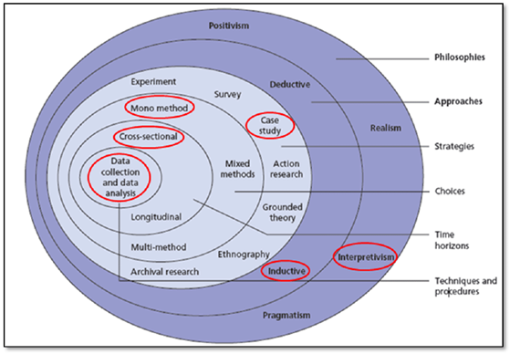
Figure 4. The Research Onion
(Adapted from Saunders et al, 2019)

The layers of the onion describe the different decisions made when developing the research methodology. There are several decisions that must be made when moving inside from the exterior of the onion, from theoretical and analytical, to strategic and practical. The onion model is a useful tool for developing a holistic approach and comprehending the choices that must be made when planning the research for the dissertation. This has been adopted through the structure of this chapter in order to ensure that the primary research collection is both effective and efficient. The researcher shall also concentrate specifically on secondary research of the national implementation of the PEQF. The researcher shall utilise the results from the questionnaires to analyse the primary data and make comparisons to existing research.
According to the literature research, the notion to professionalise the police through graduate entry recruitment started with a national review and evaluation. However, to supplement the existing body of knowledge about this topic, further data collection is required to produce core information which shall meet the research objectives. This method of data collection will confirm the accuracy of the data that has already been gathered.
Ethical Practice
It is a prerequisite that any research conducted for a study is completed in accordance with current ethical standards. According to Farrimond (2012), ethics is essential to sound research and design, and failing to operate ethically can have serious repercussions.
To undertake ethical research, a researcher must adhere to the moral and ethical norms that are expected of them. This guarantees that any research is conducted with the utmost morality, fairness, and integrity (Corea & Molligoda, 2017). This aligns with the national police Codes of Ethics, which the researcher recognises as an important aspect of this study and of which they wish to adhere to (College of Policing, 2022b).
According to Gelling (2016), all studies involving human subjects must acquire ethical approval before they can begin, and this is required prior to approaching research subjects and starting data collecting.
An ethics application form was utilised to obtain ethical approval from the ethics committee to confirm that the methods employed in this study complied with ethical norms. The form contained details about potential risks that the researcher had thought about and, if appropriate, how those risks could be reduced. The ethical consent form also specified the study’s methodology, such as whether it would use interviews or surveys, and how or where data would be kept. Additionally, it would describe how the researcher would uphold their obligation to always conduct research with the utmost honesty and openness, as well as how participant privacy would be respected (Sin, 2005).
Research Methods
The secondary research conducted for this dissertation was based on previously gathered information and research statistics surrounding the PEQF. In addition, primary research will also be collated, where both qualitative and quantitative approaches for the research were important aspects to be considered in this study, aiding a response to the researcher’s aim and objectives.
The desire to professionalise the police service by requiring a university degree has generated substantial secondary data and theory and has resulted in varied viewpoints from numerous authors as outlined in chapter two. Therefore, this study comprises of qualitative data collection, and an analysis strategy.
Data can be collated from a variety of sources and is available in many forms. As advised by Cowell (2014), data should be gathered from credible, peer-reviewed sources in order to ensure that research and data are coming from non-biased sources. Peer review establishes the validity and reliability of the source (Cowell, 2014). The literature review's entire body of research and data was compiled from a variety of academic and non-academic but credible sources. The qualitative secondary research for this study was accessed via the university online library and other web directories, as well as data shared from South Wales Police.
Experts have attempted to define this phrase to help people understand how qualitative research works. According to Largan & Morris (2019), qualitative secondary research is a rigorous method of exploration that uses existing data in a systematic, analytical manner, and the data for the study is readily available from a plethora of sources. This view was complimented by Stewart & Kamins (1993) who highlight that secondary data is information that was not generated by the researcher and was not used in their research.
In their 2015 article, Merriam and Tisdell (2015) discussed the value of sound design research. They suggest that the fundamental manual for comprehending, planning, carrying out, and presenting research is qualitative analysis. The authors emphasise that qualitative research concentrates on the why, how, and variables influencing human behaviour (Merriam & Tisdell, 2015). The usage of qualitative research methodologies is highly advantageous given the type of the research being conducted within the study. However, Yilmaz (2013) reveals that there are strengths and weaknesses to use of qualitative research
Yauch & Steudel (2003) suggest that the main problem with qualitative analysis is that it takes a long time to complete, and as a result, important content could be overlooked by the researcher. Research can also be interpreted in different ways, and personal knowledge and experience may affect the overall conclusions.
To avoid imprinting personal thoughts and opinions on the data when performing qualitative research, the researcher must ensure that they are acting impartially. In the event that this does happen, the research may suffer, and the conclusion may be false and misleading (Avis, 1995). Norris (1997) suggests that when collating qualitative research some degree of detachment is necessary to keep an open mind and be vigilant and aware of sources of error. Research necessitates the ability to accept and apply criticism as well as to be constructively critical.
The advantages of qualitative research methodologies enable researchers to examine the opinions of a wide range of people who present various viewpoints. The ability to delve into others' underlying beliefs and presumptions gives the qualitative approach to research its main advantage, and it enables the researcher to fully understand the problem at hand. The researcher will endeavour to achieve this through the use of a questionnaire to explore students perceptions of the PCDA and DHEP programmes.
In the context of the research being conducted within this dissertation, secondary qualitative methods have been used in this study such as the review of police leadership and training by Neyroud (2011), who advocated for the need for a professional police force to be overseen by a professional authority. In contrast quantitative data may also be used to conduct research. Quantitative research as described by Oliver (2010) is ‘[r]esearch that uses numerical data or statistical research’ (2010, p.13). Quantitative research methods have characteristics which provide clear and precise results, which are objective and measured.
According to one author, in quantitative data research, the emphasis is on drawing exact, objective, and general conclusions. Quantitative techniques are built on a variety of statistical and probability theories, supported by both simulated and actual data (Guo, 2013). Quantitative data can be used to explore relationships, interpretations, and characteristics of data. A common method for quantitative research is through the use of a questionnaire. Depending on the type of question, questionnaires can also elicit qualitative data. Open questions will provide qualitative information, whilst closed questions will provide quantitative data (Swanson & Holton, 2009) Thus, the researcher will ensure that there is an appropriate balance of open and closed questions within the questionnaire which will aid to answer the main objectives of the research, relating to perception and retention.
The quantitative research approach offers two key benefits. There is no need to spend significant time at the location of the study, and the study can be administered, reviewed, and tabulated immediately (Yauch & Steudel, 2003). According to Gillham (2007), quantitative methods provide respondent anonymity, however, the author identifies disadvantages to this research method which includes the possible lack of motivation of the participants, and the lack of control over order and context of answering questions.
Furthermore, quantitative research advantages can also be its disadvantages. Large sample sizes are typically necessary for effective quantitative research. Nevertheless, a shortage of resources can occasionally prevent this type of large-scale research, and researchers might not have the knowledge and resources necessary to carry out an exhaustive quantitative analysis (Dudwick et al, 2006).
Reliability and Validity
A research project’s data collection is of utmost importance. If research findings are to be used in practice, the evaluation of the research's quality is crucial.
Long & Johnson (2000) suggest that to establish the validity of study findings, researchers must assess the "soundness" of the research regarding the applicability and suitability of the methodology utilised, and the integrity of the final conclusions.
Due to prejudice, lack of transparency in the analytical procedures, and lack of scientific rigour, the conclusions of qualitative research are sometimes criticised as being little more than a compilation of the researcher's subjective opinions. It might be challenging for a novice researcher to demonstrate rigour when performing qualitative research because there is no widely accepted consensus regarding the standards by which such research should be evaluated (Rolfe, 2006).
There is ongoing discussion regarding whether terminology like validity and reliability are acceptable to evaluate qualitative research, even though the tests and procedures used to prove the validity and reliability of quantitative research are not tested (Long & Johnson, 2000). In contrast to quantitative researchers, who use statistical techniques to check the validity and reliability of study findings, qualitative researchers work to develop and include methodological methods to ensure the ‘trustworthiness’ of the findings. Admitting bias is one of these tactics (Sandelowski, 1993). Therefore, it is essential that every qualitative research, both in the planning and execution stages, incorporate measures to increase the credibility of a study, which will be discussed later on this chapter.
Secondary sources make up much of the research contained within the literature review chapter, and it is crucial to ensure that the sources are trustworthy and relevant for the topic. Government websites were a major internet source from which a lot of data was produced. This gave accurate and official statistics about the national retention rates for the English and Welsh police services. The College of Policing website and the Police Federation of England and Wales website were two other trustworthy online resources. Online news organisation sources were used with caution since they might have been biased in their reporting due to their political philosophies and personal agendas.

Limitations and Reflection
Biggams (2021) suggests that all studies have limitations, and it is important to identify and counteract them, which shall allow the research to become more reliable. Research can then become trusted and remain transparent. While every attempt has been taken to present an impartial study, it important to note that it was carried out by a single individual and was not subjected to peer review. It would also be unrealistic to imply that the researcher's own personal bias was avoided.
The researcher highlights the restricted time frame for the data to be collected, with only a small window of 4 weeks to allow the data to be retrieved. To reduce the limitation, the researcher informed the force who in turn made their student officer participants aware and promoted participation. The questionnaire was easily accessed via Moodle that all students had access to, the structure of the questionnaire was easy to read and could be completed within a few minutes for the officers convenience.
Asking people to give a negative or positive opinion about the discipline organisation that they employed with, which could provide a bias opinion, this be managed by reassuring participants that their contributions will remain anonymous (Data sharing with external partners)

Research tools
Combining both qualitative and quantitative methods of design was adopted for the purpose of this research. In this research design, it is considered appropriate to adopt a questionnaire in conjunction with a semi structured interview.
The author designed a questionnaire to gather data on students’ perceptions and multiple-choice questions were employed. This is supported by Thomas (1998, P.169) who stated, ‘[q]uestionnaires can be given to the entire group simultaneously, allowing the researcher to collect a quantity of data in a brief period of time’.
There are several advantages to adopting online questionnaires for research, including its usability, convenience, and adaptability for both researcher and participants. Further benefits of questionnaires are a reasonably inexpensive way to acquire data, interviewers are often free from prejudice, and the sheer number of people who can be asked to reply are all benefits (Judd, Smith & Kidder, 1991).
Online surveys and questionnaires have the potential to reach a larger audience and produce vast amounts of data quickly. The questionnaire was sent to all probationary police students who serve in South Wales Police. There were approx. 1000 students who could participate in the questionnaire.
Students completed the questionnaire using an online learning platform. Administration expenses remained low because most online survey/questionnaire generators are free to access and disseminate, which is especially useful when time or money are constraints (Bartram, 2019).
Although the author was not present during the completion of the questionnaire, the author provided the purpose of the research, written guidance, and reassurance that confidentiality was be respected, in order to alleviate the limitation previous discussed in the chapter. It could be suggested that some participants in the research could be hesitant to share their true feelings or ideas on the subject, however due to the level of anonymity, it could be suggested, that a questionnaire was less intimidating or intrusive than face-to-face interactions (Bartram, 2019).
Completion of a questionnaire allowed the responses to be immediate and gave the author the opportunity to collate the information without any delays. Care was needed to be taken to design the questionnaire, using clear language which could not be open to misinterpretation and a variety of open and closed question styles were used (Bartram, 2019).
Due to the researcher's limited ability to follow up on or investigate responses, using an online questionnaire as a research tool may be viewed as restricting; however, to resolve this, participants were invited to add additional personal opinions and views on the subject that they believed had not been addressed, in turn allowing the collection of qualitative data. This formed the basis of a conclusion and the quantitative data was converted into graphs to present a visual representation of the data as outlined in the next chapter.
Sampling Technique
The author carried out a controlled sample which allowed the author to make amendments before conducting the actual questionnaire. Giddens (2001) stated, ‘[m]ost surveys are preceded by pilot studies in order to pick up problems not anticipated by the investigator. It is a trial run and any difficulties can be ironed out before the main survey is done’ Giddens (2001, p.88).
Since it would have been impractical to evaluate the views of every student police officer in South Wales Police, sampling was used by the author. Despite being a sample, it served as a good representative of the participants and was convenient, affordable, and efficient for research. However, it must be acknowledged that testing every person is the greatest possible outcome for acquiring reliable, accurate, and trustworthy data (Sanap, 2017).
When choosing participants for the study, a researcher might use a purposive sampling strategy to make a considered decision to elicit pertinent information. The author posted the questionnaire onto an online learning platform Moodle, as stated above, that all South Wales Police student officers could access in order to reach the target audience. This platform was chosen since it was available to all students, allowing the questionnaire to be distributed to all potential respondents. In turn this elicited the limitation discussed earlier on this chapter.
Between December 2022 and January 2023, the questionnaire was accessible for one month, giving as many individuals as possible the opportunity to participate.

Participant confidentiality
As expressed previously, a significant aspect of conducting ethical research entails making sure that participants' opinions are correctly and carefully conveyed. To achieve this, every effort had been made to keep the participants viewpoints from being biased to maintain objectivity, however, unconscious biases do have the ability to have an inadvertent but significant impact on us all (Van Ryn, 2016). The researcher had considered this as a possible limitation earlier on in this chapter, and will endeavoured to overcome this limitation, by ensuring that the students felt comfortable in answering the questions.

Interviews
To gain the views of South Wales Police, the author will carried out a semi structured interview that was conducted at the convenience of a senior South Wales Police Officer, who manages police officer training. The interview remained informal, allowing discussion amongst all parties but still followed a predetermined structure. Bell (2014) describes an interview as ‘a conversation between interviewer and respondent with a purpose of eliciting certain information from the respondent’ Bell (2014, p.178).
A semi-structured interview is a popular technique for gathering data for studies and improves the objectivity and credibility of research while also strengthening the plausibility of the findings (Kallio et al, 2016). Therefore, conducting an interview with a senior police officer, allowed the researcher to collate potential comparisons or inconstancies to draw upon between the perspective of the organisation and its employees.
There are strengths and weaknesses to this form of data management. Although the collection of this form of data can become very time consuming for all parties, it provides freedom for creative responses. Another weakness as expressed previously is the potential for unconscious bias of the participant (Diefenbach, 2009). Contrarily, according to one scholar, interviews are essentially social interactions that depend on the specific interactional circumstances of the participants, in which they draw upon and jointly build more general social norms (Rapley, 2001).
Care and consideration was be made during the preparation of the interview. Prior to starting the interview, the author explained what to expect, a time frame of the interview, and the confidentiality of the information provided. A structure was followed, where the author remained impartial throughout. The author asked open ended questions based on the topic areas they wanted to discuss, which allowed the author to probe deeper when answers were given. One author suggests that this style of questioning encourages the participant to use their own language and be more open in their answers whilst not influenced by the interviewer (Flick, 2004). This allows the author to ask questions in detail and prompt the participant to elaborate on what they are saying.
By using the student questionnaire and the semi structured interview it allowed the author to triangulate the data and formulate their findings which could be transposed into recommendations for action for future periods of training.
By integrating both forms of research methods, there is a likelihood the findings would complement each other and provide an overall informative and in-depth result, as suggested by Baker (2014) this triangulation will ‘…[give] a more detailed and balanced picture of the situation’.

Chapter Four - Presentation of the Findings, Discussion, and Analysis

4.1 Introduction
The main focus of this chapter will be the analysis of the results of the primary research which was conducted using a survey and centred on the perceptions of South Wales Police students. The aim of this research is to identify the main challenges faced by South Wales Police and their student officers who are enrolled onto the PEQF programme. All the questions embedded into the questionnaire meet the objectives of the research:
- To explore the perceptions of the student officers who are currently completing the Police Constable Degree Apprenticeship (PCDA) and Degree Holder Entry Programme (DHEP).
- To analyse the retention data of South Wales Police students since the introduction of the PEQF to date. This shall help identify the period during the probationary period when student officers resign from the service and the reasons why they leave.
- To evaluate the correlation between South Wales Police challenges surrounding retention of officers and those of other forces nationally.
The chapter will present the findings in a methodical manner while also offering an analysis and discussion of the findings. This chapter shall be following a thematic analysis, studying the themes found within the data which links to the research objectives (GradCoach, 2021). This will be further analysed through implementing the model advised by Bigham (2021), which follows a process of descriptive, analysis and synthesis which will lead to evaluation.

Responses were collated between the 1st of December 2022 and 1st of January 2023. The survey was completed by 83 participants who are enrolled onto both the Police Constable Degree Apprenticeship programme (PCDA) and the Degree Holder Entry Programme (DHEP), which are embedded into the Police Education and Qualification Framework (PEQF). A total of 51 PCDA students participated and 32 DHEP students took part in the survey. This included 52 male officers, 27 female officers, and 4 participants who preferred not to disclose their gender.
There was a broad age range who participated in the survey. The highest participants (61%) were young in age and included 25 students aged 18-25 years, and 26 students aged between 26-30 years old. Middle aged students contributed to 30% of the survey. 15 students aged 31-35 years old, and 10 students aged 36-40 years old. The smallest number of participants (8%) were older in age and included 6 students aged between 41-45 years old, and 1 student aged over 46 years old.
All the participants in the survey identified themselves as having different levels of police service. There was a balanced number of participants across all three years of service. Twenty two percent of the participants had recently joined the police service and were enrolled into police training school, which is a department where students remain for the first six months of their three-year probationary period. Twenty eight percent of participants were enrolled into year one of their training, thirty percent were enrolled into year two, and twenty percent were enrolled into year three.
References shall also be made within this chapter from an interview (see appendix 3) with Superintendent Justin Evans, who is the head of Learning and Development in South Wales Police. He provides a strategic view on the challenges faced by South Wales Police following the introduction of the PEQF in South Wales.
Perception
The survey consisted of 12 questions and within the survey question six explored the students perception of the PEQF programme.
The results provided both positive and negative views of the PEQF programme. Responses 1-5 related to positive views of the programme and responses 6-11 related to negative views of the programme. Response 12 allowed for students to provide a more open response to the question, enabling the findings to collate a good range of qualitative and quantitative data.
As shown below, responses 1-5 recognise a positive view of the PEQF programme. A small number of respondents (5) recognised that the programme aided them to reach their full potential as a police constable, as well as a small proportion (9) also recognised that the programme provided the knowledge, theory, skills, and qualities such as investigation and decision-making in their role. This supports the view of the College of Policing who state, ‘the PEQF aims to create a consistent high standard of training for all police officers’ (College of Police, 2020c).
Furthermore, an additional question linking to the perceptions of student constables asked officers their views on whether the PEQF assisted with their continuing professional development. A higher proportion (56%) suggested it would not, compared to 12% who said it would, and 31% had no opinion on this subject. This is a consistent view of both PCDA and DHEP students. Moreover, the College of Policing (2020d) also recognise that the fundamental requirements of the policing profession is the continuing professional development and high standards of education.
Furthermore, as shown in appendix 4, the findings suggest that those who have joined the service through the PCDA route, and fit within the lower age ranges of 18-25 to 31-35, share the opinion that the PEQF has had a positive impact and aided them to reach their full potential as serving police constables. This is comparable to the students of the same age range on the DHEP programme as also shown in appendix 4.
There could be many reasons for these findings, however it could be suggested that younger serving constables may not be affected by the external issues surrounding a career in the police service, such as financial constraints, compared to those who are older, as many may be still living at home, and not have the responsibilities of the cost of living, as much as a mature student. This supports the view of Shohel et al (2020), who believes that many obstacles are still faced by newly appointed officers including poor pay and pressures of work.
It could also suggest that they have more recently left education and therefore have a better understanding of working in an academic environment, compared to someone returning to higher education after several years away from study (Police Foundation, 2017).
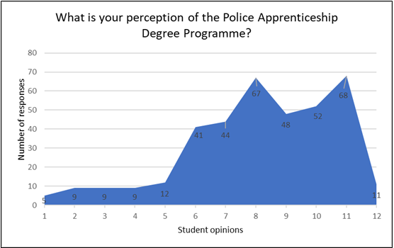
Figure 5: Graph to reflect the perceptions of the PEQF by student officers in South Wales Police
On the contrary, responses 6-11 provided a negative view of the PEQF programme. These questions covered areas involving the barriers to academia, and the relevance of the programme to the policing role. It also provided perceptions surrounding work-life balance and job satisfaction. The views of these students are supported by Telep (2010) who suggests that a policing degree has brought about a negative attitude of newly appointed officers as explored in the literature review.
The highest number of respondents (68) expressed that the PEQF programme has affected their work-life balance, corelating to how they felt that the programme was too time consuming (67), which in turn prevented them from enjoying the job role (52).
Furthermore, as shown in appendix 4, the findings suggest that the older age range of students on the PCDA programme view the route into policing negatively, and share the opinion that academia has no place in policing and is a barrier to the operational role. This opinion is also expressed by DHEP students. This view is also reflected in the national survey conducted by the College of Policing (2022b), who recognised that mature student officers also had an adverse view of the Policing Apprenticeship (College of Policing 2022b)
This could suggest that mature students are affected more when completing their academic work, as they recognise the constraints placed on their homelife which in turn places strain on their wellbeing. Moreover, Ellison (2004) highlights that the introduction of academic work to the policing role is linked to poor mental wellbeing. Previous research by Buda & Lenaghan (2005) produced a similar opinion that working and studying can produce substantial stress and have a negative effect on a student’s wellbeing.
The reduction in wage and the increased cost of living is also placing pressure on their ability to commit to the role as much they would like to, and therefore are more likely to consider resigning. This view is supported by the Police Federation (2022b) who identified that more than one in ten police officers are unable to afford their monthly bills.
Response 12 allowed for the participants to further express their views of the PEQF in an open manner by answering question 6. The overall consensus over years 1-3 were very similar in addressing the following reoccurring themes in relation to work pressures versus work-life balance, and the impact the PEQF has on officer’s mental wellbeing. It could also be said that the respondents showed a lack of understanding of the role of academia within an officers’ probationary period, with many viewing the programme as “a waste of time” and “no relevance”. This view was identified within both PCDA and DHEP routes and is also recognised within the National Policing Survey (2022). These findings correlate with the views of Ramshaw & Soppitt (2018), who noted that students frequently found it difficult to recognise the link of the academic content that was presented to them to their role.
As referred to in the literature review, it is important to note that the recent research conducted by the College of Policing (2022b) suggests that many students surveyed (41.6%) were DHEP respondents, and who stated they were very satisfied with their education and training overall. However, the PCDA respondents were less satisfied, (34.9%) and many were dissatisfied (34.4%). This contradicts the views of the responses received from South Wales Police.

Retention

Question 9 from the survey provides the participants an opportunity to state if they have considered resigning from the police service.
Figure 6 below reflects the results of this question. Interestingly, a higher proportion (61%) of participants have considered resigning within their probationary period compared to 39% who have not. As shown in appendix 4, the findings suggest that a higher proportion who have considered resigning from the police service are older in age, with 34 of the participants aged between 31 years and above. In comparison to the lower age range of 18-30 years, only 17 participants have considered resigning. This data is supported by the Police Federation (2022b) who identifies that many new mature officers are unable to balance the cost of living with the poor wages of a police constable, with averaging £1200 per month, and therefore are considering resigning from the police service.
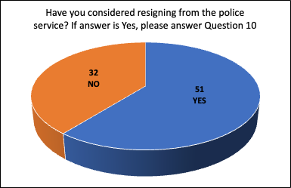
Figure 6: Graph to reflect if participants have considered resigning from the police service

In contrast, other research conducted does not correlate to those statistics which have been produced by the force. Since March 2019, South Wales Police have received a significant number of sixty-two resignations from their student officers, as seen in appendix 1. This is reflective of both PCDA and DHEP programmes and the statistics reflect a balanced number of resignations on each programme. The figures show that the majority of those resigning are younger in age with over 50% resigning aged between 18 years and 30 years. The mature student officers within South Wales Police are less declined to resign despite the data held by the participants conducted for this survey.
Furthermore, Question 10 asked the 51 participants who considered resigning from the police service the reasons why they would resign.
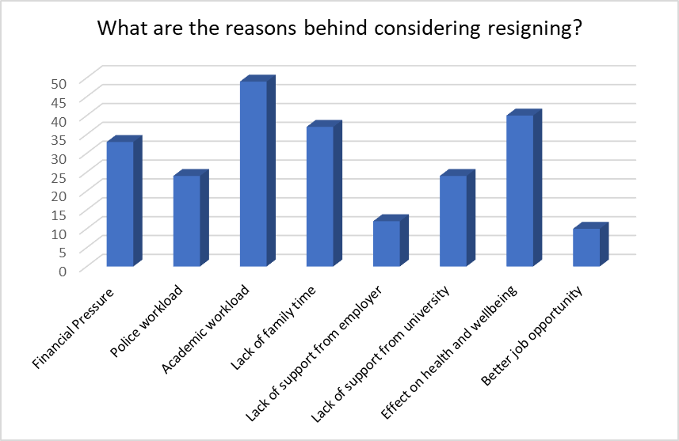

Figure 7: Graph to reflect the reasons why participants have considered resigning from the police service

As shown above, the responses recognise that the main reason for considering resigning is the academic workload, with the effect of health and wellbeing playing a prominent second reason. This supports the assertion made by Buda & Lenaghan (2005) that balancing employment and study can be extremely stressful and detrimental to a student's wellbeing. Police students may also find it difficult to devote a significant percentage of their working hours and spare time to achieving an academic degree, in contrast to regular university students who are required to study and learn throughout the week as previously discussed (Mahruf et al, 2020).
The College of Policing (2022b) have recognised the tensions growing within the workforce and acknowledge that work has to be done regarding the national attrition rates of police officers. Interestingly, they have identified from their survey that over 50% of officers within their first year of service are feeling the adverse effects of stress and tension through their policing role.
Financial pressure plays another significant role in an officers decision to resign. This response is common amongst many officers who are currently disputing their national pay scales with UK Government (Police Remuneration Review Body, 2022). Police Federation (2022b) supports this view, as they have identified from a recent survey that 9 in 10 officers feel financially worse off than they were five years ago, with 1 in 5 considering resigning and seeking alternative employment due to this fact. Officers have outlined that the stress and workload placed upon them is not consistent with the level of pay they receive.
In contrast, the College of Policing (2022b) survey contradicts the views of surveyed participants, highlighting that only 1% of those surveyed suggested financial concerns were connected to their decision to resign. Possible reasons for this difference maybe due to the time students were surveyed by the College of Policing as it was prior to the financial and economic crisis the country now faces.
Many of the participants suggested that the policing role and academic requirement is placing considerable pressure on their family life. The Police Federation (2022) also expresses worries that police students are lagging in their education despite being capable police officers, which is causing a negative effect of their personal home life. They suggest that this is pertinent to female officers, which may be due to managing workload, study, and young children (Police Federation, 2022)
Job satisfaction and new job opportunities also play a significant role within the reasons for resignation. This view is also reflected by the College of Policing (2022b) who highlighted in their survey that officers within their first year of service were dissatisfied with policing and the role was not meeting their expectations, and therefore chose to leave to pursue alternative employment. This may be due to the recruitment strategies employed by the individual forces and the management of the uplift of 20,000 extra police officers.
It could be suggested that applicants for the police role did not fully understand the job role and not enough information was sought by them or provided to them by the employer at the time of recruitment. As shown in Appendix 3, Superintendent Justin Evans from South Wales Police recognises this concern and that South Wales Police also needed to improve their recruitment strategy and refine its processes that are linked to advertising and recruitment, in order to combat these issues. He highlights that additional investment is needed to improve the resources and infrastructure surrounding recruitment within South Wales Police, following the intensified recruitment of officers in the past year. He identifies that the university plays a significant role within this area of concern and joint delivery may combat the concerns that students have raised. This was highlighted in the College of Policing Survey (2022b), who identified that the higher education provider and the police force need to work in closer partnership to provide the best delivery of the programme (College of Policing, 2022b).
Furthermore, Question 11 asks the participants to expand on the reasons for resignation. The most common views of the participants relate to the operational requirements expected of a police officer. They acknowledge that they were not fully prepared for the unmanageable police workload, the cancellation of rest days, and the lack of resources which in turn is compromises their safety and wellbeing. Moreover, they highlighted that they were not aware how physically and mentally demanding the role would be. The response was echoed by Superintendent Justin Evans, who acknowledges that improved communication and further support is required for student officers, but also concedes that policing is a difficult and challenging role and more could be done to make prospective applicants aware of this.
Correlation of Retention Locally and Nationally

Question 12 from the survey provided the participants an opportunity to highlight what challenges they think their employer faces following the introduction of the PEQF.
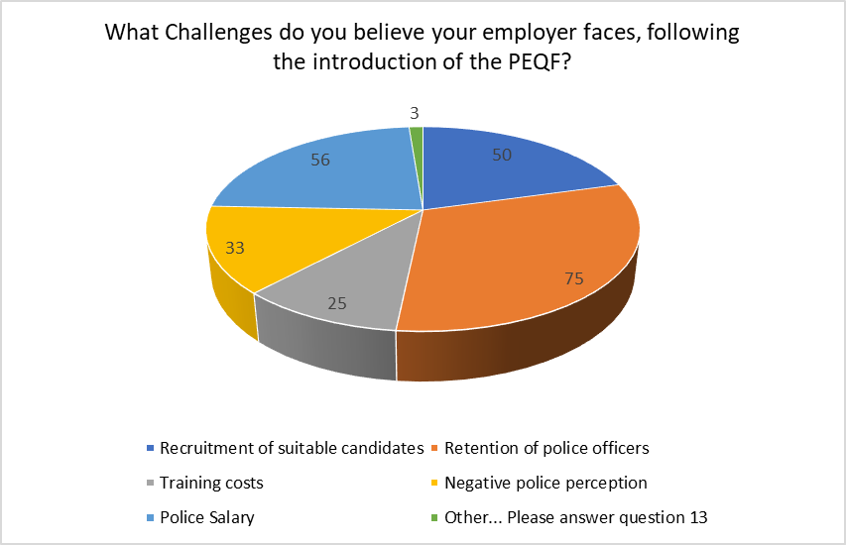
Figure 8: Graph to reflect participants view of the challenges faced by their employer following the introduction of the PEQF
Figure 8 above reflects the results of this question. More compelling, a higher proportion (75) of participants believe that the retention of officers plays a significant challenge for South Wales Police.
This view is echoed nationally, and the College of Policing (2022b) also reveals that retention rates are a priority. In spite of these views, Supt Justin Evans contradicts the participants opinions, as well as the College of Policing’s, and confirms that South Wales Police attrition remains steady at 6% which places them in the top ten forces nationally for retention. He confirms that the data for South Wales Police does not bare resemblance to the national statistics.
Interestingly, the Home Office (2022c) highlights that the rate of police officers resigning from the police service was 6.0%, which was comparable to levels between the fiscal years ending in 2016 and 2019 and to those of South Wales Police (Home Office, 2022c). Consequently, this demonstrates that this perception participants have of South Wales Police attrition is inaccurate and an issue that the force is trying to resolve.
Although there is no national data recorded for the reasons why officers leave the service, the Home Office (2022c) highlights that those leaving the service voluntarily are young in service and in age. This would reflect the views of a recent survey by the College of Policing (2022b) who highlighted 33% of officers resigning had less than 5 years’ service, and were aged approx. 25 years. Moreover, according to the Police Federation (2022b), many police officers have resigned from their jobs before their probationary periods ends. This may suggest that a growing younger workforce may impact on attrition rates in the future.
It could be suggested that increased social media forums have influenced this negative view of poor retention rates. This can be reflected in recent online comments by the South Wales Police Federation representative, who provided a negative view of the PEQF and shares this with new and influential student officers within the force (Steven Treharne, 2023) However, it could also imply that the participants of the survey may not have a comprehensive understanding of the attrition and establishment requirements for their force. Superintendent Justin Evans also echos the views surrounding the negative views of modern-day policing, which he suggests is also fuelled by social media, combined with the low pay and the buoyant employment market. Superintendent Justin Evans also highlights that additional challenges are faced surrounding the culture amongst student officers, however, this is seen as a minority, and many students are engaging with their studies and applying themselves to the operational role.
Question 13 from the survey asked the participants to expand on their answers to the previous question relating to challenges faced by their employer. A common view was that the PEQF created a lack of police resources on shift due to the time student officers needed to complete their studies. This was causing increased stress on other officers who were required to cover those not working on frontline duties. Many participants shared the view that the force sickness rates had increased due to the pressure upon student officers, which they believed would be a serious concern for their employer. Superintendent Justin Evans acknowledges that it is currently a challenging time for the service and for student officers joining the police service, however he is optimistic that with significant investment the PEQF can strengthen, and be improved to become a well-respected apprenticeship in the future.

Chapter Five - Conclusion

This chapter shall summarise the research findings, which will include revisiting the objectives of the study which were outlined in the introduction chapter. The chapter shall explore whether the research supports or refutes the main aim of this study and its objectives, and the chapter will then close with its conclusions and recommendations.

5.1 Summary of Primary Findings
The primary focus of this dissertation was to provide the reader with an understanding of the challenges faced by South Wales Police following the introduction of the Police Education Qualification Framework (PEQF). The information for the research was collated from many different origins including academic sources and documents produced by the College of Policing. Information was also collected from a survey, which was completed by 83 participants, and an interview of a senior ranked police officer who works within the Learning and Development Department of South Wales Police.
The PEQF was originally implemented to raise the standards of policing education and training, and as a result, enhancing the quality of the police service in the United Kingdom (College of Policing, 2022). On balance, the research supports this view and the views of Paterson (2011), that higher education is essential for the professional growth of policing, but the findings also reinforced the views of Shohel et al, (2020) who had reservations of introducing higher education into a police service, that is currently experiencing major obstacles such as heavy financial constraints, and limited resources.
5.2 Objectives
The research objectives were set out within the introductory chapter of the dissertation and the research aided the objectives to be achieved.

Objective One: To explore the perceptions of the student officers who are currently completing the Police Constable Degree Apprenticeship, (PCDA) and Degree Holder Entry Programme (DHEP).

The first objective was to explore the perceptions of student police officers who were undertaking the Policing Apprenticeship within South Wales Police. As the research showed very few student officers saw the PCDA and DHEP programmes as a great opportunity to gain valuable on the job experience whilst earning a degree. Few saw it as a way to fast track their careers in policing and gain a strong foundation of knowledge and skills for the future. Moreover, a higher number of students viewed the programme in a negative light, with some implying it to be very demanding and stressful, and one with a heavy workload and long working hours. Many found it challenging to balance the demands of the programme with their personal and family responsibilities. Furthermore, there was a mixed response of views, which was dependent on the students’ personal experiences and circumstances. The students perceptions supported the view of Telep (2010), who suggested that the introduction of the PEQF has brought about a negative view of policing by new officers.
Although the perceptions of student officers have brought about many negative responses, it is worth noting that the framework has also brought some positive changes such as increased level of professionalism, knowledge, and skills for all officers. This aligns with the Police Vision 2025 (NPCC, 2023)
Objective Two: To analyse the retention data of South Wales Police students since the introduction of the PEQF to date. This shall help identify the period during the probationary period when student officers resign from the service and the reasons why they leave.

Objective two provided the reader with an analysis of the retention data of South Wales Police students. The data showed that South Wales Police manages a 6% retention rate which falls within the top ten police forces in England and Wales. However, retention of officers nationally continues to remain a common challenge to the police service. South Wales Police have highlighted that they need to develop a specific retention strategy to aid career development opportunities and develop incentives to encourage officers to remain in the police service. (See appendix 3)
Those that have resigned from South Wales Police have done so for a variety of reasons which includes career progression, as they do not recognise the same career opportunities within the police service compared to the private sector. Financial incentives play a significant role, as the police service offers low paid salaries for new officers compared to other employers who offer a higher rate of pay, especially for graduates. Many of those resigning from South Wales Police highlighted that the police service is not the right career path for them and were unaware what the job role involved when applying for the position. One of the main reasons for resignation was students were seeking alternative employment which offered better work-life balance and flexible working arrangements. These views were supported by a survey conducted by the College of Policing (2022b), who concluded that the Police Apprenticeship programme was not flexible enough to accommodate the diverse needs of different officers and those of different police forces. Additionally, some officers suggested too much emphasis is placed on formal education and qualifications, rather than on practical experience and skills, and therefore they had resigned as they found academia an unmanageable obstacle.

Objective Three: To evaluate the correlation between South Wales Police challenges surrounding retention of officers and those of other forces nationally.

Following the introduction of the Police Education Qualifications Framework (PEQF) in the UK, police forces across England and Wales are facing several challenges, including South Wales Police. The implementation of the programme requires a significant investment in training and education, which has put a strain on police forces’ budgets. Budget constraints may limit resources available for recruitment and training and this may make it difficult to recruit and retain the best candidates.
Attracting new recruits with the necessary qualifications and experience to meet the PEQF requirements can be a further obstacle. Retaining officers who are in their probationary period can be an arduous task for many forces, as many student officers are seeking alternative career opportunities, which in turn makes it difficult to attract and retain an experienced and motivational workforce. This then places further demand on the police service.
Police forces must show flexibility in their working practices whilst student officers undertake a degree programme and working full time, which means forces are having to find new ways to adapt to these changes of working in line with new policies and procedures.
In recent years there has been a change to the public perception of policing due to the negative press and events which has led to a decline in the number of applicants from specific communities.
South Wales Police have highlighted some positive changes that the PEQF has brought following its introduction. They suggest that the degree qualification has brought an increase of professionalism and increased knowledge, and it has brought new skills to its officers which enhances the ability of its student officers to perform their duties. It is embedding a new career pathway for officers and aids talent management for its successful officers. The PEQF has encouraged South Wales Police student officers to engage more with their communities and become involved in evidenced-based research within the police service, both locally and nationally. This has allowed them to be more innovative in their approach to policing which may lead to more effective and efficient policing.

The below are five key recommendations for South Wales Police as a result of this research:

- Change/adapt the current structure of delivery of the PEQF. For example, to provide a classroom setting for lesson deliver as opposed to asynchronous content.
- Change/adapt the current modes of assessment of the PEQF. For example, acknowledging officers practical competencies in line with the PEQF learning outcomes and academic modules.
- Improve the officers understanding of the curriculum and how it links to the role of constable. For example, more work is required to build a stronger connection between HEI’s and police forces.
- Develop officer awareness surrounding student perceptions of the PEQF programme and its issues surrounding retention.
- Pursue a flexible and more diverse working pathway such as part time working from initial application stage.

