

Student name: | Md Ekram Hossain | Student ID number: | 2523284
Programme: | MSc/PgDip/PgCert Cybersecurity and Digital Forensics
Module: | Ethical Hacking
Module code: | ACCA7033 | Contribution to  Overall Module Assessment (%): | 100%
Lecturer: | Dr. Anum Paracha | Internal Verifier: | Dr. Dipo Dunsin
Assignment Title: | Research into cyber security attacks and Penetration testing for a virtualise simulated company Website | Word count (or equivalent): | 5,000
Submission deadline: | 1st May 2026  14:00 (2PM) | Return date of provisional marks & written feedback: | 29th May 2026

Table of Content
Abstract ………………………………………………………………………………………..…3
1 Introduction ……………………………………………………………………………………..3
2 Incident Summary and Timeline …………………………………………………………...3-4
3 Adversary TTP Mapping to MITRE ATT&CK Enterprise Matrix…………………………4-5
4 Root Cause & Security Control Failures……………………………………………………...6
4.1 Technical Failures…………………………………………………………………………..6
4.2 Organisational Shortcomings……………………………………………………………...6
4.3 Human Factors……………………………………………………………………………...6
5 Threat Actor Profile & Motive…………………………………………………………………..6
6 Detection & Response Analysis……………………………………………………………….7
6.1 Detection Gaps……………………………………………………………………………..7
6.2 Incident Response Effectiveness………………………………………………………...7
7 Strategic Recommendations…………………………………………………………………...8
8 Conclusion………………………………………………………………………………………..9
9 Appendix A: Timeline Sources and OSINT Notes…………………………………………...9
10 Appendix B: Attack Flow Summary…………………………………………………………10
11 Rules of Engagement………………………………………………………………………...11
11.1 Engagement Overview……………………………………………………………..…..11
11.2 Scope — Authorised Systems…………………………………………….……….….11
11.3 Permitted & Prohibited Techniques…………………………………………………...11
11.4 Safe Word, Communication & Legal Constraints…………………………………....12
11.5 Snapshot & Rollback Plan……………………………………………………………...12
12 Threat Emulation Plan………………………………………………………………………...12
12.1 Engagement Objectives & Success Criteria……………………………………….…12
12.2 Attack Phase Sequence…………………………………………………………….13-15
12.3 MITRE ATT&CK Phase Map…………………………………………………………...16
12.4 Containment & Isolation Confirmation…………………………………………….16-18
13 Executive Brief — Board Summary………………………………………………………....18
13.1 Key Findings……………………………………………………………………………..18
13.2 Business Risk……………………………………………………………………………19
19.3 Prioritised Recommendations………………………………………………………….19
14 Return on Investment & Conclusion…………………………………………………….19-20
15 References…………………………………………………………………………………20-21

Abstract
In spring 2025, the UK retail sector was struck by a coordinated wave of cyber attacks, attributed to the Scattered Spider threat collective (also known as UNC3944/Octo Tempest), who deployed DragonForce ransomware against Marks & Spencer (M&S) and the Co-operative Group (Co-op). Collectively these attacks comprise the largest financially destructive cybercrime campaign in UK business history, with the UK Cyber Monitoring Centre categorising it as a Category 2 event with an estimated total loss of between £270 million and £440 million [1]. In this report, we offer a comprehensive review of the campaign, including the incident timeline, tactics and techniques used by the attacker mapped to the MITRE ATT&CK Enterprise Matrix, root cause analysis, threat actor profiles, a review of detection and response activities, and strategic recommendations. The study relies on peer-reviewed studies, reliable industry publications from CISA, NCSC and Mandiant, and reputable media outlets. The results show continued concerns with identity security, third party access controls and helpdesk authentication. These problems give rise to a series of clear, prioritised recommendations for improvement.
1. Introduction
In recent years, offensive cyber operations against civilian business infrastructure have skyrocketed as ransomware-as-a-service (RaaS) ecosystems have lowered the technical threshold for high-impact attacks [2]. A spring 2025 attack on two major UK retailers, M&S and the Co-op, is a very well-documented case study in advanced social engineering, identity theft and double-extortion ransomware. Both attacks were carried out by the financially-motivated, English-speaking cybercrime group Scattered Spider, which has previously targeted significant consumer companies, and used DragonForce ransomware [3].

This research considers the two events as one coordinated campaign. The threat actor, attack vector, RaaS tools and victimology are materially identical and law enforcement confirmed shared attribution following the arrests in July 2025 [4]. This report addresses the requirements for the Task 1 of the ACCA7033 Ethical Hacking assignment. The report provides an evidence-based timeline, mapping of MITRE ATT&CK TTPs, root cause analysis, threat actor profile, detection and response evaluation and strategic recommendations.

2. Incident Summary and Timeline
The effort spanned several months, starting with an initial access phase that took place well before the public reveal. The following timeline is based on public reporting, official pronouncements, and industry forensic analysis.
Date | Event
Feb 2025 | M&S systems are breached by threat actors, apparently by social engineering of a third-party IT support provider (reportedly Tata Consulting Services). The Windows domain NTDS.dit file, which stores all the password hashes for users on the domain, is exfiltrated, enabling lateral movement later on [5].
19–21 Apr 2025 | Easter weekend: M&S consumers report frequent difficulties with contactless payments and Click & Collect services. Disruption indicates active ransomware deployment phase . [6].
22 Apr 2025 | M&S makes a formal market disclosure of a 'cyber incident'. The NCSC and external incident response teams are involved. [7].
23 Apr 2025 | M&S says consumer data is safe at this moment DragonForce contacted M&S CEO Stuart Machin via a compromised internal staff email address stating that the company’s systems had been encrypted. [5].
25 Apr 2025 | Severity evaluation M&S suspends all online buying via its website and mobile application [6].
30 Apr 2025 | Co-op monitors for abnormal behaviour on its network and proactively disconnects IT systems to contain spread. Co-op employees told to disconnect from VPN and assume internal conversations are being monitored [3].
Early May 2025 | DragonForce told BBC News it was responsible for both the M&S and Co-op intrusions and provided examples of the data it stole. They included the numbers, names, addresses and emails of about 10,000 Co-op membership cards as proof. [8].
13 May 2025 | M&S has confirmed customer personal data including names, addresses, dates of birth and order histories were accessed. No credit card-data or passwords were compromised in the attack. [5].
21–22 May 2025 | M&S annual figures quantify losses at over £300 million in operating profit. The retailer re-launches its website in read-only mode. NCSC CEO Richard Horne says attacks should be a ‘wake-up call’ for all organisations [9].
Jun 2025 | The UK Cyber Monitoring Centre classed both attacks as Category 2 systemic events, the second most dangerous on the scale, with cumulative losses estimated between £270-440m. [1].
10 Jun 2025 | M&S reopens online clothing orders after 46-day suspension Co-op's official financial statement shows £206m loss in income [4].
10 Jul 2025 | The National Crime Agency arrests four individuals, aged 17-20, in London and West Midlands under the Computer Misuse Act and on suspicions of extortion and money laundering in connection with the M&S, Co-op and Harrods attacks [4].
Table 1: Attack Campaign Timeline

3. Adversary TTP Mapping to MITRE ATT&CK Enterprise Matrix
The following table maps the adversary's campaign to the MITRE ATT&CK Enterprise Matrix (v17) [10]. Ten key TTPs are identified, spanning the full attack chain from initial reconnaissance to impact.
# | Tactic | Technique / ID | Justification & Evidence
1 | Initial Access (TA0001) | Phishing: Spearphishing via Service (T1566.003) | Attackers impersonated IT helpdesk professionals in calls to a third-party IT support provider (presumably TCS) to trick staff into resetting internal user credentials. M&S Chairman Archie Norman told the UK Parliament Business Committee that the attackers 'masqueraded as an employee and fooled a third-party service' into changing passwords . [11].
2 | Credential Access (TA0006) | OS Credential Dumping: NTDS (T1003.003) | In February 2025 threat actors exfiltrated the Windows Active Directory NTDS.dit database enabling offline cracking of all domain user password hashes. This gave the initial access to credentials for lateral movement throughout the M&S network [12].
3 | Defense Evasion (TA0005) | Valid Accounts (T1078) | After helpdesk credential resets, attackers used genuine employee credentials to authenticate to company VPN and Citrix gateways. By replicating normal user traffic, they made their operations indistinguishable from legitimate access and so bypassed perimeter defence. [12].
4 | Persistence (TA0003) | Create Account (T1136) / Remote Access Software (T1219) | New privileged accounts were established by Scattered Spider, and attacker-controlled devices were enrolled for MFA on victim accounts. They also introduced legal RMM products (AnyDesk, Splashtop) in the name of IT help to have permanent back door access [12].
5 | Privilege Escalation (TA0004) | Domain Controller Authentication (T1556.001) | They then used the leaked NTDS.dit hashes to steal Domain Administrator and Enterprise Administrator credentials, and roam laterally throughout the network at will including the virtualisation infrastructure (VMware ESXi hypervisors). [3].
6 | Defense Evasion (TA0005) | Impair Defenses: Disable Security Tools (T1562.001) | The BYOVD (Bring Your Own Vulnerable Driver) tactics involved loading a legitimate but vulnerable kernel driver and disabling EDR agents in a way that rendered endpoint monitoring ineffective before delivering the ransomware. They also compromised antivirus and logging agents. [12].
7 | Lateral Movement (TA0008) | Remote Services: SSH / RDP (T1021) | Forensics found Python scripts meant to SSH into ESXi servers, move the ransomware encryptor and run it at the same time on several systems. This systematic approach increased the radius of the detonation of the encryption [13].
8 | Collection (TA0009) | Data from Information Repositories (T1213) | Co-op's member database — containing approximately 6.5 million records including names, dates of birth, and contact details — was accessed and staged for exfiltration. At M&S, order history databases and customer PII were similarly collected . [8] [9].
9 | Exfiltration (TA0010) | Exfiltration Over C2 Channel / Protocol Tunnelling (T1041 / T1572) | Tools including ngrok (a reverse proxy tunnelling tool) were used to create encrypted tunnels for data exfiltration, bypassing firewall egress controls. Airbyte and CyberDuck were used to transfer data to attacker-controlled cloud infrastructure . [13].
10 | Impact (TA0040) | Data Encrypted for Impact (T1486) | DragonForce ransomware (a RaaS affiliate payload derived from leaked LockBit Black code) encrypted virtual machines across both M&S and Co-op infrastructure. Double extortion was employed: data was stolen before encryption to maximise leverage in ransom demands . [5].
Table 2: MITRE ATT&CK TTP Mapping (M&S/Co-op Campaign)

4. Root Cause & Security Control Failures

4.1 Technical Failures

The main technical deficiency was the lack of MFA resistant to phishing for admin accounts and VPN/Citrix portals. Specifically, guidance from the NCSC recommends FIDO2/hardware token MFA for privileged access [9]. The attack exploited password based authentication which can trivially be bypassed after credentials are stolen via social engineering. NTDS.dit file (which should never be directly accessible to non-administrator accounts) was also exfiltrated revealing insufficient access controls around Domain Controller replication privileges and Backup Operators group membership.
Old legacy remote access infrastructure (unmonitored Citrix portals, single factor authentication VPN) with large attack surface Insufficient network segmentation allowed the attackers within the perimeter to reach ESXi hypervisors hosting production virtual machines with disastrous encryption impact [3].

4.2 Organisational Shortcomings
The Co-op attack in particular highlighted the risks of third-party supply chain access. Poor screening and monitoring of third-party credentials, especially external IT service providers, resulted in exploitable pathways [4]. Both organisations lacked strong “zero-trust” verification policies for their helpdesk password reset processes. The NCSC’s post-incident guidance highlighted helpdesk authentication procedures as the key organisational failure: attackers simply called helpdesks, impersonated employees, and received resets of credentials without sufficient identity verification [9].

4.3 Human Factors
Technical controls were completely bypassed by social engineering, exploiting cognitive biases, specifically authority (impersonating IT support) and urgency (claiming an account is locked). The success of this vector indicates the lack of proper security awareness training for both end-users and helpdesk operators. These same principles were found to be the foundation of social engineering effectiveness by research by Cialdini [14] and later applied security work by Hadnagy [15]. Both organisations had invested heavily in cybersecurity, but the human element was still the weakest link.

5. Threat Actor Profile & Motive
Multiple intelligence sources have strong convergent evidence that links this activity to Scattered Spider (aka UNC3944 [Mandiant], Octo Tempest [Microsoft], Muddled Libra [Palo Alto Unit 42], and Storm-0875) [3]. A joint CISA/FBI advisory confirms that Scattered Spider is a group of native English-speaking cybercriminals active since at least May 2022 and predominantly made up of individuals in their late teens and early twenties in the United States and United Kingdom [10].
The group is financially motivated and operates as a RaaS affiliate. In the 2025 UK retail campaign they used the DragonForce ransomware, a payload based on leaked LockBit Black builder code. This affiliate relationship is important: the group’s core TTPs—social engineering, identity exploitation, BYOVD EDR evasion—remain consistent across campaigns even when different ransomware payloads are used [16]. The group has run similar campaigns against MGM Resorts ($100M losses) and Caesars Entertainment ($75M losses) in 2023 [3].
The demographic profile was confirmed by the July 2025 NCA arrests of four individuals aged 17-20, young, English-speaking offenders operating in a loosely organised network and coordinating via Telegram, Discord and dark web forums [4]. The group’s primary motive is financial gain through double extortion. No evidence that it was state-sponsored or had espionage objectives. Attacking large UK retailers over the busy Easter weekend shows the attackers’ understanding of when victims’ finances are most vulnerable.
6. Detection & Response Analysis

6.1 Detection Gaps
The most extended detection gap was the two-month gap between initial compromise (February 2025) and deployment of the ransomware (April 2025). During this dwell time the threat actor exfiltrated the NTDS.dit database, cracked credentials, created persistence mechanisms and mapped the environment – all without triggering effective alerts [5]. This is a fundamental failure to recognise behaviour that signals a threat. Particularly :

• The NTDS would produce high severity alerts on a properly tuned SIEM.Dit file copied by anomalous account. Monitoring Active Directory replication events (Windows Event ID 4662) alone without alerts is not sufficient.
• Attackers were able to create new accounts and register MFA devices without detection, highlighting gaps in monitoring of Identity and Access Management (IAM) and Entra ID conditional access alerting.
• No lateral SSH activity to ESXi hypervisors from non-standard sources was observed which may indicate a lack or misconfigured east-west network monitoring.

6.2 Incident Response Effectiveness

M&S response was reactive and slow. The 46-day online sales outage points to a lack of tested business continuity and disaster recovery (BCDR) plans for ransomware events. Co-op, in contrast, proactively severed their network as soon as they discovered the attack, thus stopping the ransomware from completely executing, demonstrating the value of a pre-defined ‘network isolation’ playbook [4]. At the national governance level, the NCSC’s deployment of incident management resources and Cabinet Office ministerial engagement were effective, but victim organisations took weeks to months to restore basic services.

Third-party incident responders and law enforcement (NCA, Metropolitan Police) were engaged quickly and the arrests made in July 2025 show good criminal investigation coordination. However, M&S did not want a ransom payment, although this was in line with NCSC guidance and this meant a complete rebuild of compromised infrastructure, accelerating a planned two year technology transformation into six months [7].

7. Strategic Recommendations
The following recommendations are ranked by impact on risk reduction based on NCSC guidance, CISA best practices, and CIS Controls framework [17]. Estimated efforts/costs bands for medium to large size enterprise
# | Recommendation | Justification | Controls / Framework Ref. | Effort Band
R1 | Implement phishing resistant MFA (FIDO2/hardware tokens) for all privileged accounts, VPN and Citrix portals | Remove the #1 attack vector: helpdesk-reset password authentication. Would have stopped initial access in both breaches [9]. | NIST SP 800-63B, CIS Control 6, NCSC MFA guidance | Medium (4–8 weeks)
R2 | Enable identity verification for helpdesk password resets | All privileged account resets must require out of band callback to pre-registered number or manager approval. Addresses the Scattered Spider social engineering vector [9] [11] directly. | NCSC Helpdesk Auth Guidance (2025), CISA AA23-320A | Low (1–2 weeks)
R3 | Implement Network Segmentation & Monitor East-West Traffic. | Implement micro-segmentation so that lateral movement from user network segments to hypervisor/domain controller segments is not possible. Deploy NDR for analysis of east-west traffic [16]. | NIST CSF PR.AC-5, Zero Trust Architecture (NIST SP 800-207) | High (3–6 months)
R4 | Deploy Active Directory Threat Detection (DCSync alerts, Monitoring Event ID 4662) | Windows Event Log entries for NTDS.dit exfiltration and DCSync attacks are both unique and identifiable. The breach could have been detected in February 2025 if the SIEM was tuned to alert on these events [12]. | MITRE D3FEND CIS Control 8 Microsoft Sentinel AD Attack Protection | Medium (2–4 weeks)
R5 | Governance of Third Party Access and Zero | Implement JIT privileged access for all third-party providers, enforce least privilege, and continuously monitor third-party account activity. Reduces the supply chain access vector in both events [4]. | ISO 27001:2022 Clause 5.19, CIS Control 15 | High (2–4 months)
R6 | Trust for Suppliers Develop and Test Ransomware BCDR Playbooks including Offline Backups | 46-day M&S outage highlights absence of rehearsed recovery processes Regular tabletop exercises and tested immutable offline backups would substantially shorten recovery time [17]. | NCSC Ransomware Guidance, NIST SP 800-34 | Medium (4–8 weeks)
R7 | Improve Security Awareness Training by Emphasising Social Engineering | Quarterly updated scenario-based training on social engineering indicators and verification procedures for helpdesk staff, executives and all employees [15]. | NCSC Phishing Guidance, CIS Control 14 | Low (2–4 weeks)
Table 3: Prioritised Strategic Recommendations

8. Conclusion
The 2025 Scattered Spider campaign against M&S and Co-op shows how technically complex infrastructure can be completely compromised by relatively simple social engineering if there are no identity security controls or verification procedures in place on the helpdesk. [1] [9] The campaign is a landmark event in the history of UK cybersecurity, and was classified as a Category 2 systemic cyber event by the CMC, and confirmed by the NCSC to be one of the most financially damaging cyber incidents the UK has ever seen.
The MITRE ATT&CK mapping shows a disciplined and methodical attack chain from initial social engineering (T1566) to credential theft (T1003.003) to defence evasion via BYOVD (T1562.001) to double-extortion ransomware deployment (T1486). The two month gap between the first compromise and the ransomware execution highlights the critical importance of continuous threat hunting, behavioural anomaly detection and Active Directory telemetry.
This is a clear call to action for all organisations regardless of size. The seven strategic recommendations, from phishing-resistant MFA and helpdesk verification reform to network segmentation and ransomware BCDR rehearsal, are a foundational, achievable defence posture that would have broken the attack chain at multiple points. Cyber security is now an issue of business survival and national resilience', NCSC CEO Richard Horne said [9]

9. Appendix A: Timeline Sources and OSINT Notes
The chronicle of Section 2 is based on the following primary and secondary sources:
• BlackFog (2025): Full ransomware M&S timeline, Easter weekend to June 2025 recovery. • Computer Weekly (2025) M&S and Co-op incident latest, 22 April - 30 April 2025.
• CM Alliance, (2025. M&S cyber attack timeline live updating as parliamentary committee unveils details of attack.
• Coop’s own timeline (CyPro, 2025) Details of NCA arrests in July 2025.
• NCSC Annual Review 2025 (October 2025) 6.5m theft of Co-op members (Government) • DragonForce/BBC engagements (May 2025): Threat actor disclosure seeking validation of attack vectors & data exfiltration (independent)
OSINT Note: First observed February 2025 by BleepingComputer reporting forensic evidence of NTDS.dit theft,

10. Appendix B: Attack Flow Summary
The following describes the end-to-end attack chain in sequential phases:

Phase | MITRE Tactic | Description
Phase 1 | Reconnaissance / Initial Access | Social engineering over the phone - attacker impersonates an M&S employee to a third party helpdesk (TCS) - credentials reset and captured. Technique: T1566.003, T1078.
Phase 2 | Credential Access | NTDS.dit database exfiltrated from Domain Controller; offline hash cracking yields domain-wide credential access. Technique: T1003.003.
Phase 3 | Persistence | Created new accounts, enrolled attacker MFA devices, installed RMM tools as persistent backdoors. Techniques: T1136, T1219
Phase 4 | Lateral Movement | Moving to ESXi hypervisors through custom python scripts via SSH. Moving through internal network. Technique: T1021.
Phase 5 | Defence Evasion | BYOVD kernel driver Loaded, EDR agents disabled, SIEM logging suppressed. Technique: T1562.001.
Phase 6 | Collection & Exfiltration | Customer PII databases staged and exfiltrated to attacker-controlled cloud storage via ngrok tunnels. Techniques: T1213, T1572, T1041.
Phase 7 | Impact | Ransomware called DragonForce hits virtual machines, poses double extortion threat, disrupts online services. Technique: T1486.
Table 4: Simplified Attack Flow Phases

11. Rules of Engagement

This Rules of Engagement (RoE) document represents the formal legally binding agreement between ABCD Ltd (the 'Client') and the Red Team operator (the 'Assessor') for the conduct of a penetration testing and red team engagement. It defines the nature of the authority, the permissible techniques, the systems that are excluded, the means of communication, the emergency procedures and the legal and ethical constraints of the engagement. No intrusive activity shall begin until this document has been reviewed, agreed to and signed by all parties named herein.

  - Engagement Overview

Field | Detail
Client Organisation | ABCD Ltd
Engagement Type | Full Red Team Penetration Test
Assessor | MSc Cybersecurity Student — University of Wales Trinity Saint David
Module | ACCA7033 — Ethical Hacking
Engagement Date | 1th May 2026, 09:00–23:59 BST
Lab Environment | Virtualised — VirtualBox Host-Only Network (192.168.56.0/24)
Classification | CONFIDENTIAL

11.2 Scope — Authorised Systems

All IP addresses are within Host-Only network; no external systems are reachable.
Target | IP Address | OS | Authorised Activities
IEWIN7 (VM-1) | 192.168.56.101 | Windows 7 SP1 | Port scanning, credential attacks, SSH exploitation, post-exploitation enumeration
Metasploitable 2 (VM-2) | 192.168.56.102 | Linux | Port scanning, FTP exploitation, service enumeration, privilege escalation
OWASP BWA (VM-3) | 192.168.56.104 | Linux (Ubuntu) | Web application scanning, injection attacks, reverse shell, web enumeration
Kali Linux (Attacker) | 192.168.56.103 | Kali Linux | Attacker platform — not a target

11.3 Permitted & Prohibited Techniques

Allowed Techniques are: network reconnaissance and port scanning (Nmap -sV, -T4), service version detection, credential based attacks (including SSH brute force), exploitation of known CVEs (vsftpd 2.3.4, CVE-2011-2523), testing of web applications including SQL injection and command injection, reverse shell using netcat, post exploitation enumeration (whoami, hostname, uname, id), use of modules from the Metasploit Framework.
Explicitly banned: DoS attacks, destructive actions (deletion of files, corrupting data, shutdown of systems), modification of system configurations other than demonstrating an exploitation, exfiltration of real personal data, persistence mechanisms surviving a VM snapshot rollback, any action outside the 192.168.56.0/24 subnet, and social engineering of real people.

11.4 Safe Word, Communication & Legal Constraints

If there is unintended harm or impact outside the intended scope, the safe word “STOP ENGAGEMENT” should be issued immediately. Kill all Metasploit sessions (sessions -K), kill Netcat listeners, power off target VMs and restore them from pre-engagement snapshots and document and report the incident to Dr. Anum Paracha (Module Supervisor) within 30 minutes.
This activity is conducted only in a virtualised and isolated academic environment under the Computer Misuse Act 1990 (UK). None of the target VMs contain any personal, financial or proprietary data of any sort. All VMs are purpose built for security education and the environment is fully air gapped The results are for academic reporting purposes only.

11.5 Snapshot & Rollback Plan

VM | Snapshot Name | Taken Before | Rollback Method
IEWIN7 | IEWIN7-PreEngagement | Any SSH exploitation attempt | VirtualBox: Machine > Restore Snapshot
Metasploitable 2 | Meta2-PreEngagement | Any FTP exploitation attempt | VirtualBox: Machine > Restore Snapshot
OWASP BWA | OWASP-PreEngagement | Any web application attack | VirtualBox: Machine > Restore Snapshot
Kali Linux | Kali-Clean | Start of engagement | VirtualBox: Machine > Restore Snapshot

12. Threat Emulation Plan

The Threat Emulation Plan (TEP) describes the structured campaign conducted against the ABCD Ltd virtualised environment. The MITRE ATT&CK Enterprise Matrix [20] is used to map each action with measurable success metrics. The engagement represents a financially motivated external threat actor with moderate capability, similar to opportunistic criminal groups that use publicly known exploits and credential-based attacks, where speed of access is more important than stealth [19].

12.1 Engagement Objectives & Success Criteria

ID | Objective | Target VM | Success Criteria
OBJ-1 | Gain authenticated remote access to corporate Windows client | IEWIN7 (192.168.56.101) | Active SSH session; whoami confirms valid user identity
OBJ-2 | Achieve root-level command execution via CVE exploit | Metasploitable 2 (192.168.56.102) | Shell returned with uid=0(root) gid=0(root)
OBJ-3 | Obtain reverse shell on web application server | OWASP BWA (192.168.56.104) | Netcat listener receives connection; whoami returns www-data
OBJ-4 | Document detection gaps across all three attack chains | All VMs | At least 3 detection failures with root cause analysis

12.2 Attack Phase Sequence

Phase 1 — Reconnaissance (T1046): Active network reconnaissance with Nmap to find live hosts and enumerate exposed services on the 192.168.56.0/24 subnet using service version detection (-sV) and aggressive timing (-T4).

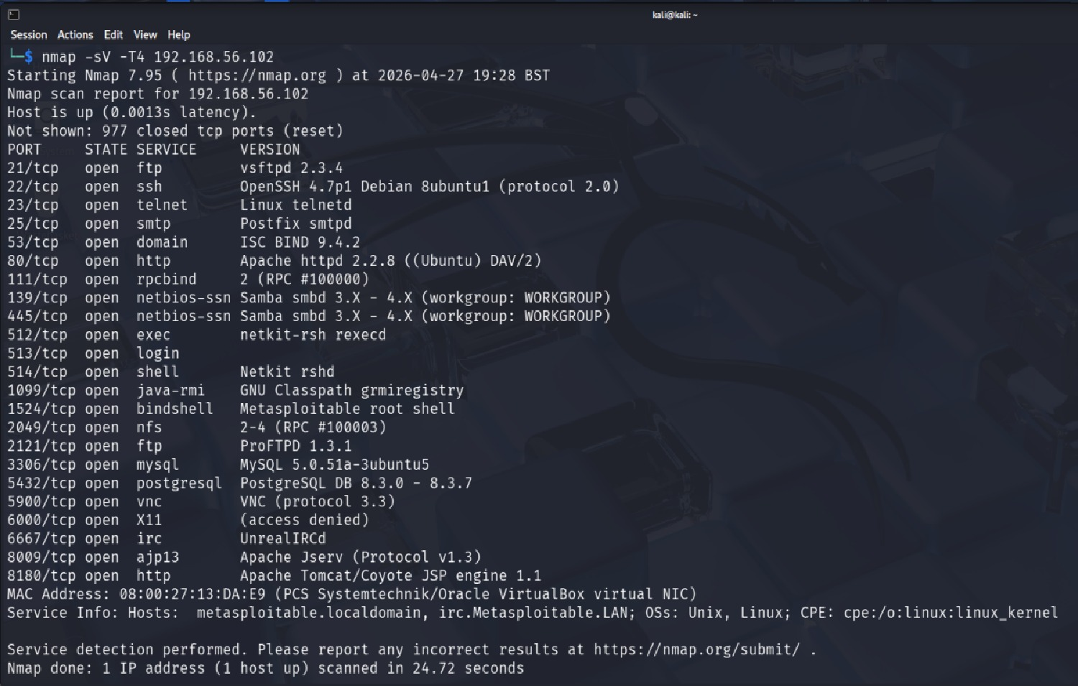
Figure 1: Nmap scan output for IEWIN7 (192.168.56.101) — Port 22 SSH identified

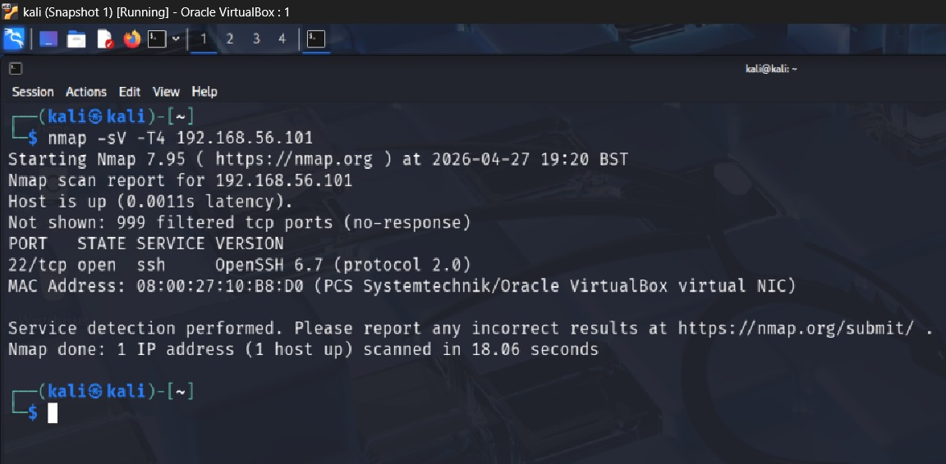
Figure 2: Nmap scan output for Metasploitable 2 — multiple vulnerable services enumerated

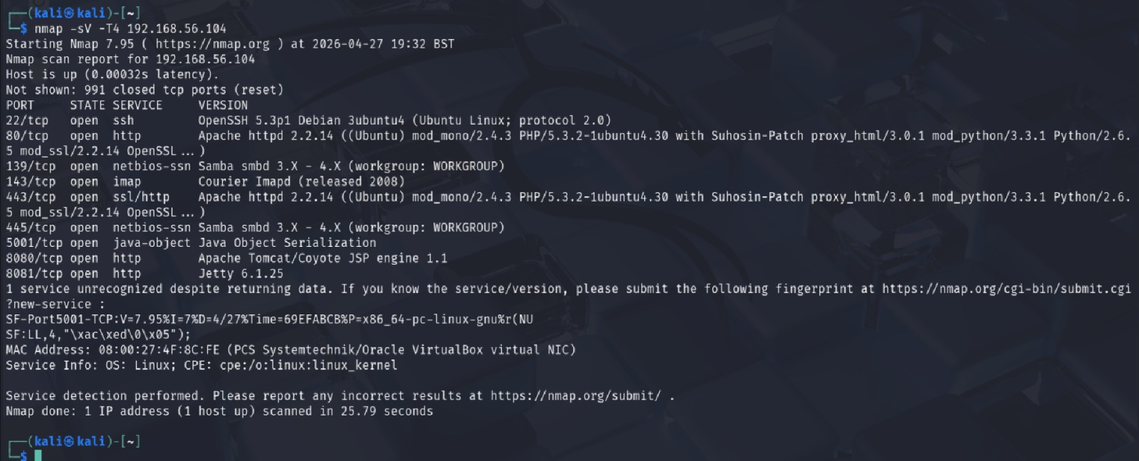
Figure 3: Nmap scan output for OWASP BWA (192.168.56.104) — web services enumerated

Phase 2 — Initial Access: Credential Attack (T1110.001) The IEWIN7 SSH service (port 22, OpenSSH 6.7) was attacked via credentials IEUser / Passw0rd! (a known default on Microsoft IE testing VMs) using the Metasploit auxiliary/scanner/ssh/ssh_login module. Success Criterion: OBJ-1 obtained, SSH session started.

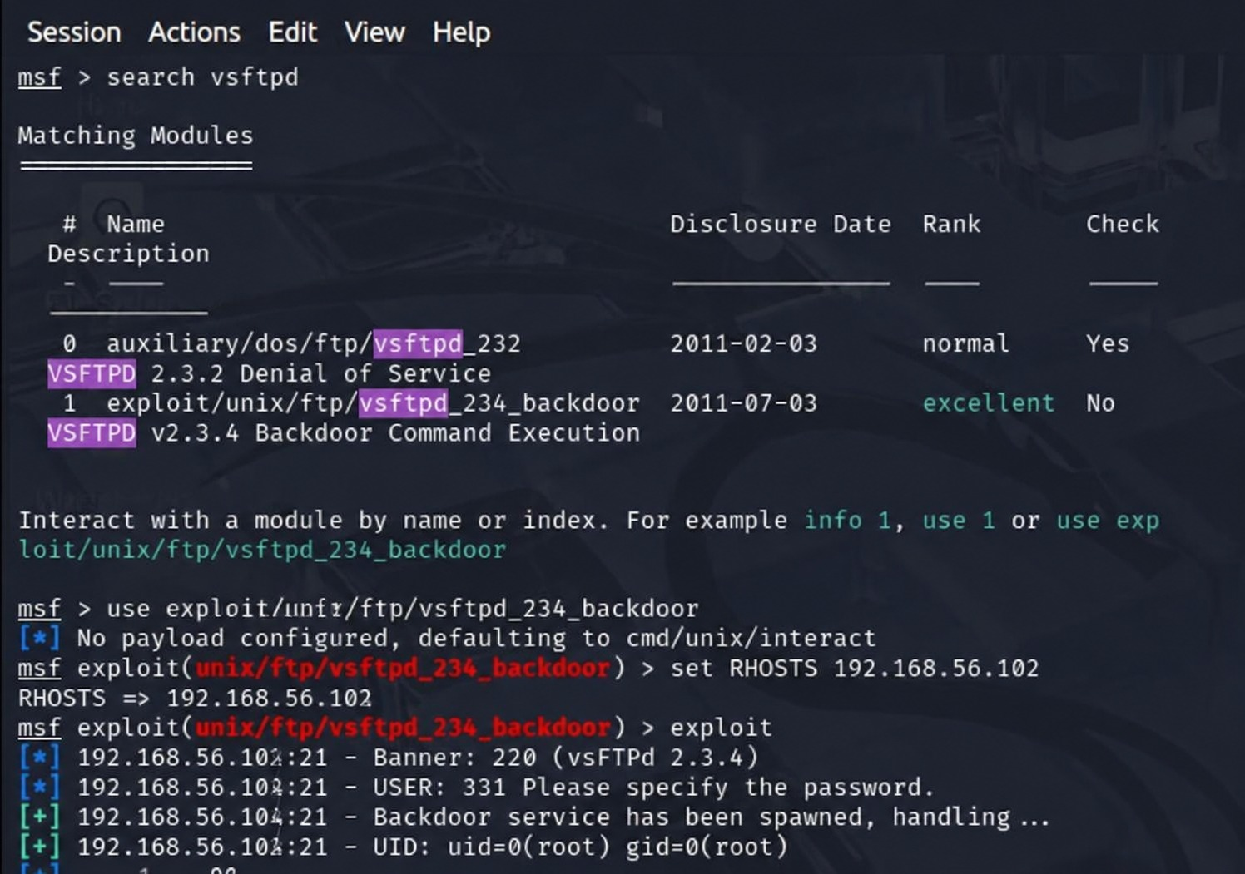
Figure 4: Metasploit ssh_login module — successful SSH session established on IEWIN7

Phase 3 — Exploitation: CVE-Based RCE (T1190): Exploited vsftpd 2.3.4 on Metasploitable 2 (port 21) using exploit/unix/ftp/vsftpd_234_backdoor, targeting CVE-2011-2523. The backdoor opens a root shell on port 6200. OBJ-2: Root shell confirmed (uid=0, gid=0) Success Criterion.

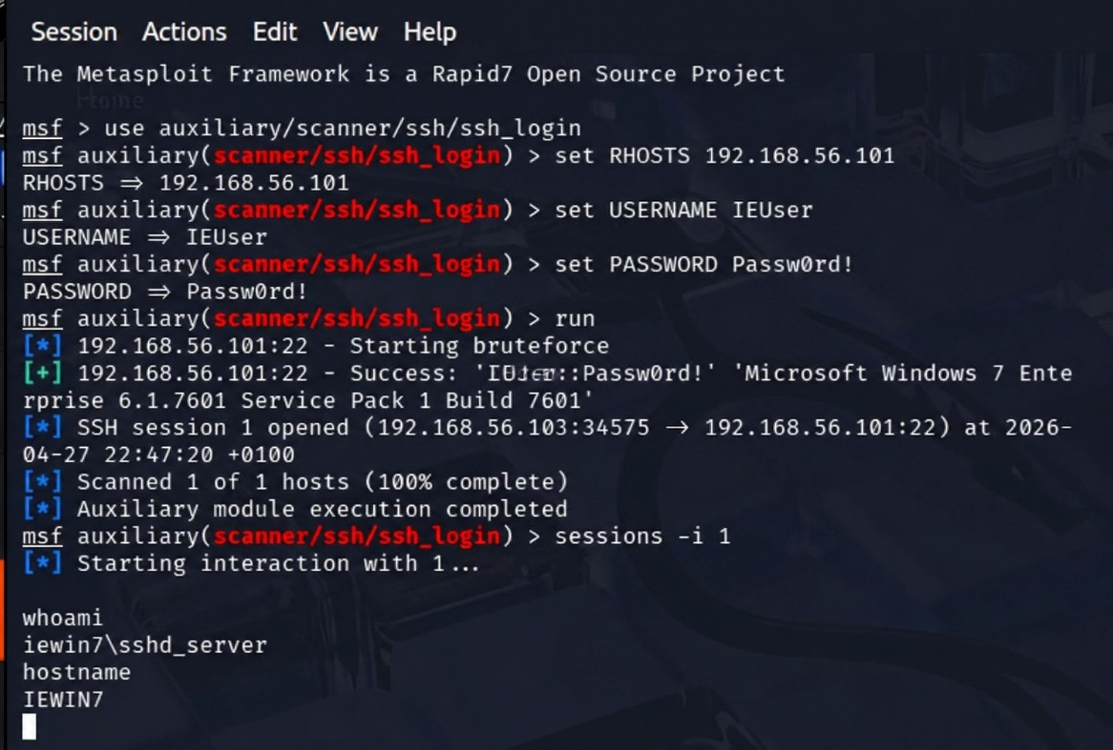
Figure 5: vsftpd_234_backdoor exploit — root shell obtained on Metasploitable 2 (uid=0)

Phase 4 — Web Application Exploitation & Reverse Shell (T1059 / T1190) Exploited a PHP command injection vulnerability on OWASP BWA (port 80) through crafted HTTP requests. The attacker machine received the inbound reverse TCP connection via a Netcat listener (nc -lvp 4444). Success Criterion: Reverse shell received, whoami returns www-data, OBJ-3 reached.

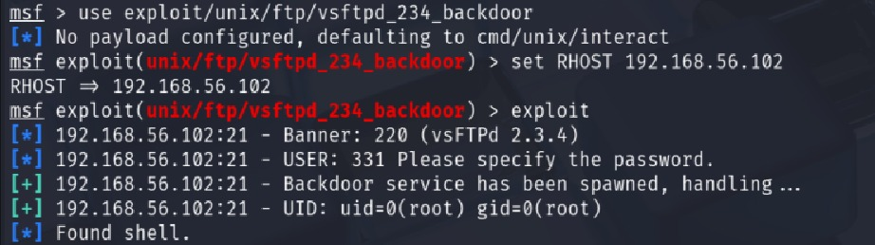
Figure 6: Netcat listener receiving reverse shell from OWASP BWA — whoami returns www-data

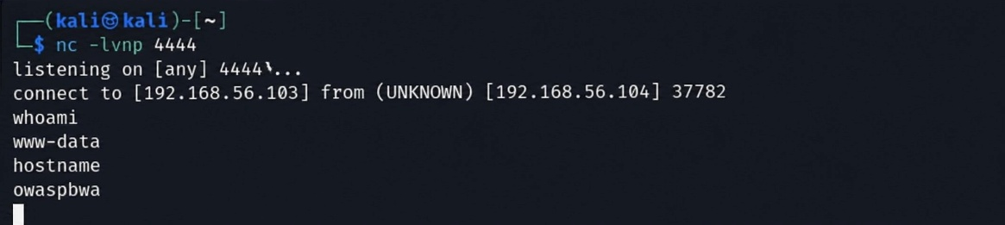
Figure 6b: Netcat reverse shell confirmed — whoami returns www-data, hostname returns owaspbwa

Phase 5 — Post Exploitation Enumeration (T1033) Following successful access to all three targets, basic enumeration (whoami, hostname, id) confirmed the user identity and system context. No lateral movement, no persistence, no destructive activity.

12.3 MITRE ATT&CK Phase Map

Phase | Tactic | Technique ID | Technique Name | Target
1Reconnaissance | Discovery | T1046 | Network Service Discovery | All VMs
2 Initial Access | Credential Access | T1110.001 | Brute Force: Password Guessing | IEWIN7
2 Initial Access | Initial Access | T1078 | Valid Accounts | IEWIN7
3 Exploitation | Initial Access | T1190 | Exploit Public-Facing Application | Metasploitable 2
4 Web Exploit | Execution | T1059 | Command and Scripting Interpreter | OWASP BWA
5 Post-Exploit | Discovery | T1033 | System Owner/User Discovery | All VMs

12.4 Containment & Isolation Confirmation
All VMs connected only via VirtualBox Host-Only Adapter (192.168.56.0/24). Promiscuous Mode is set to Deny on all VM network adapters. No NAT or Bridged adapter is active on any target or attacker VM and no internet connectivity is available from within the lab network.

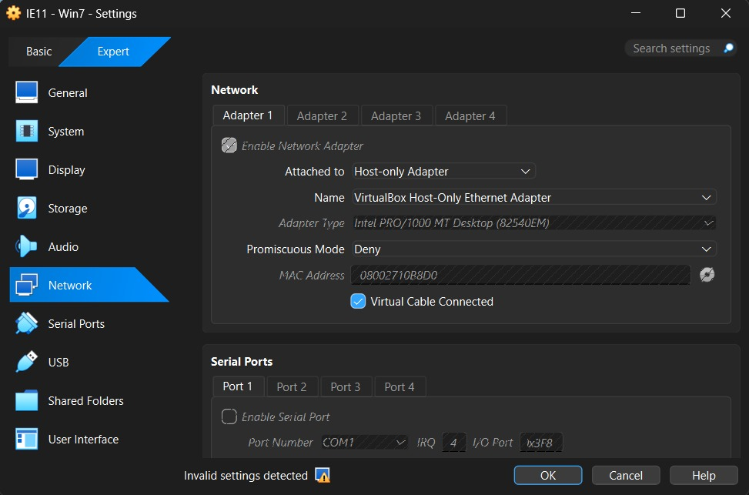
Figure 7: Kali Linux VM — VirtualBox Host-Only network adapter configuration

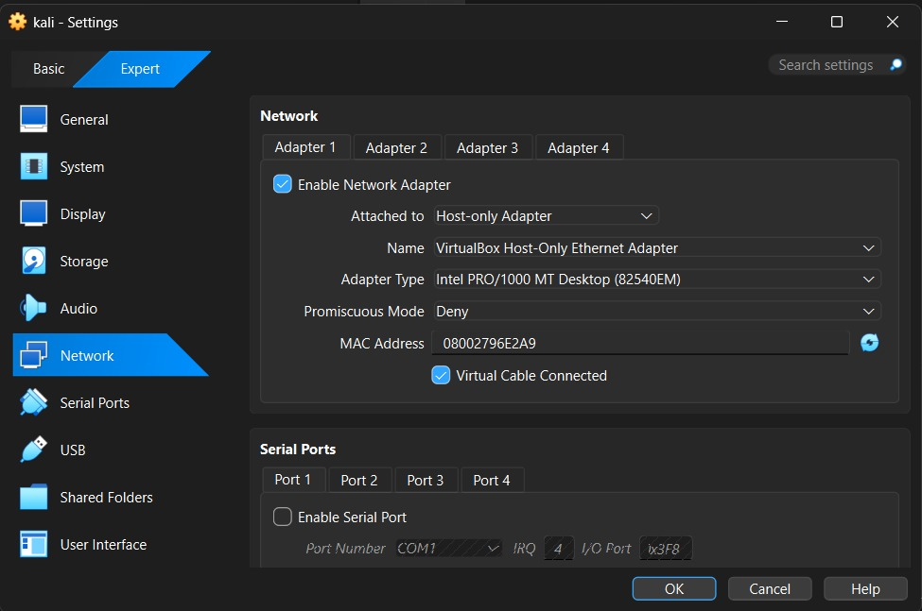
Figure 8: IEWIN7 — VirtualBox Host-Only network adapter configuration

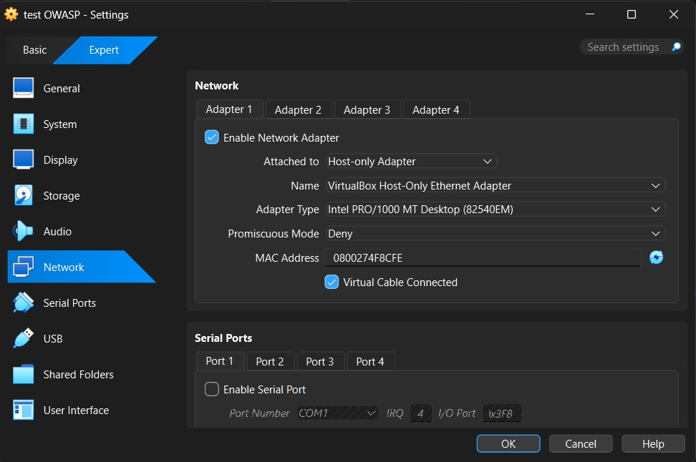
Figure 9: Metasploitable 2 — VirtualBox Host-Only network adapter configuration

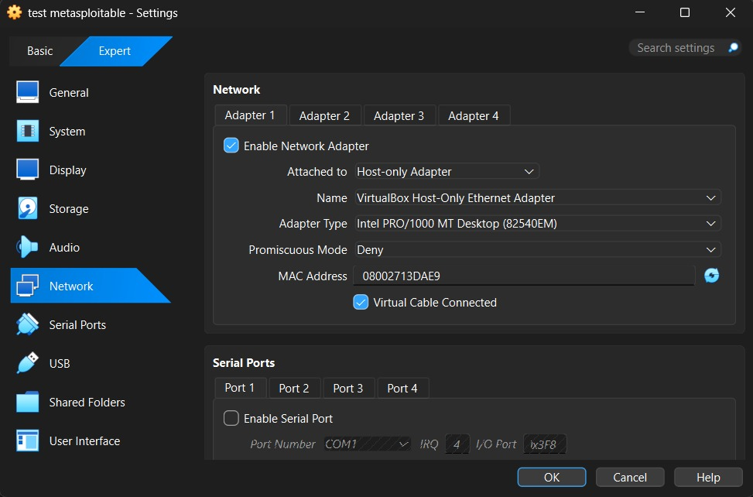
Figure 10: OWASP BWA — VirtualBox Host-Only network adapter configuration

13. Executive Brief — Board Summary

FOR BOARD AND SENIOR LEADERSHIP — NON-TECHNICAL SUMMARY

ABCD Ltd commissioned a red-team penetration test of its internal IT infrastructure on 27th April 2026. A security professional was trained and given controlled access to a replica of ABCD Ltd’s internal systems and told to try to break into it using the same techniques a real criminal attacker would. The exercise was carried out in a completely safe isolated environment with no risk to customer data or live systems. It’s like a fire drill for cybersecurity. A controlled test to discover the holes before a real attacker does.

13.1 Key Findings

Using publicly known attack methods and freely available tools the assessor was able to gain unauthorised access to all three target systems in a single working day. No special or expensive capabilities were required.

System Tested | What Was Compromised | Severity
Corporate Windows Client (IEWIN7) | The password was weak and it allowed full remote access. “An attacker could read files, install software, or pivot to other internal systems. | CRITICAL
Internal Linux Server (Metasploitable) | By taking advantage of a 14-year-old vulnerability that was unpatched, they gained complete control of the system. The attacker gained the highest possible access to the system (root). | CRITICAL
Company Web Server (OWASP BWA) | Exploitation of Web Application Vulnerability to Remotely Control Web Server Process. An attacker could steal data, deface the site, or use it as a launchpad. | HIGH

13.2 Business Risk

Risk | Potential Business Impact
Customer Data Breach | Disclosure of personal and financial data – ICO notification obligations, GDPR fines up to 4% of annual global turnover, and reputational damage.
Ransomware Deployment | With this access, an attacker could lock up all the company's files. The average cost of recovery from a ransomware attack for UK SMEs is over £200,000 [19].
Regulatory & Legal Liability | Inadequate cybersecurity controls can lead to a breach of obligations with payment processors, insurers, and business partners.
Operational Disruption | Retail operations, order processing, and customer service could be impacted by system downtime. This directly impacts revenue

13.3 Prioritised Recommendations

Priority | Action Required | Plain Terms | Estimated Effort
CRITICAL | Patch-all-server software immediately | The patched CVE has been exploitable since 2011. All servers are to be upgraded to current supported software versions. | Low
CRITICAL | Re-place Windows 7 systems | Windows 7 EOL was in January 2020. These machines should be replaced by Windows 10/11. | Medium
CRITICAL | Enforce strong passwords & MFA | A simple, guessable password was used to get into the Windows machine. Apply complexity policy and requires multi factor authentication for all remote access. | Low
HIGH | Deploy firewall with outbound controls | The web server was “calling home” to the attacker. This could have been avoided with simple firewall rules to limit outbound connections. | Medium
HIGH | Implement centralised SIEM monitoring | None of the attacks set off any alarms. A security monitoring system would pick up suspicious activity as it happened. | Medium-high
HIGH | Conduct regular vulnerability scanning | A commercial vulnerability scanner, run weekly, would have discovered the critical CVE used in this engagement years ago. | Low-medium

14. Return on Investment & Conclusion

The costs of implementing the above recommendations, most of which are staff time, software licensing and hardware refresh, are significantly less than the cost of responding to a real breach. IBM (2024) [18] estimated the average costs of a data-breach for a SME in the UK in 2024 is £3.4 million, including regulatory fines, legal costs, operational disruption and reputational damage.

This engagement has shown that the current security posture of ABCD Ltd is unacceptably risky. Using open source tools and known vulnerabilities, they got to the heart of critical systems without setting off a single alarm. The most effective remediation actions — patching software, enforcing strong credentials and enabling basic monitoring — can be done within existing IT operational budgets and don’t require specialist cybersecurity staff. Board is recommended to approve the prioritised remediation plan and allocate the necessary resources. A follow-up penetration test is recommended in 6 months to ensure the improvements made are valid.

References
[1] [1] Computer Weekly, 'M&S, Co-op attacks a Category 2 cyber hurricane, say UK experts,' June 2025. [Online]. Available: https://www.computerweekly.com/news/366626336/MS-Co-op-attacks-a-Category-2-cyber-hurricane-say-UK-experts
[2] [2] A. Liska and T. Gallo, Ransomware: Defending Against Digital Extortion. Sebastopol: O'Reilly Media, 2017.
[3] [3] Breached.Company, 'UK Retail Cyberattacks: A Deep Dive into the 2025 Ransomware Wave,' May 2025. [Online]. Available: https://breached.company/uk-retail-cyberattacks-a-deep-dive-into-the-2025-ransomware-wave/
[4] [4] CyPro, 'Co-op Cyber Attack 2025: 5 Critical Lessons For Retail Risk,' 2025. [Online]. Available: https://cypro.co.uk/insights/co-op-cyber-attack/
[5] [5] CM Alliance, 'The Marks and Spencer Cyber Attack — Everything You Need to Know,' 2025. [Online]. Available: https://www.cm-alliance.com/cybersecurity-blog/the-marks-and-spencer-cyber-attack-everything-you-need-to-know
[6] [6] BlackFog, 'Marks & Spencer Breach: How A Ransomware Attack Crippled a UK Retail Giant,' Oct. 2025. [Online]. Available: https://www.blackfog.com/marks-and-spencer-ransomware-attack/
[7] [7] Computer Weekly, 'M&S cyber attack disruption likely to last until July,' May 2025. [Online]. Available: https://www.computerweekly.com/news/366624272/MS-cyber-attack-disruption-likely-to-last-until-July
[8] [8] TechMonitor, 'Co-op admits data breach in cyberattack,' May 2025. [Online]. Available: https://www.techmonitor.ai/technology/cybersecurity/co-op-data-breach-cyberattack
[9] [9] NCSC, 'Annual Review 2025: It's Time to Act,' Oct. 2025. [Online]. Available: https://www.ncsc.gov.uk/collection/ncsc-annual-review-2025/chapter-01-cyber-threat-to-the-uk
[10] [10] MITRE, 'Scattered Spider (G1015),' MITRE ATT&CK, 2025. [Online]. Available: https://attack.mitre.org/groups/G1015/
[11] [11] Sangfor, 'Marks & Spencer Cyberattack: A Wake-Up Call for Supply Chain Cybersecurity,' May 2025. [Online]. Available: https://www.sangfor.com/blog/cybersecurity/marks-spencer-cyberattack-2025-supply-chain-breach
[12] [12] Prelude Security, 'Common MITRE ATT&CK Techniques in 2025 UK Retailer Cyberattacks,' 2025. [Online]. Available: https://www.preludesecurity.com/blog/scattered-spiders-2025-cyberattacks-on-uk-retailers
[13] [13] GuidePoint Security, 'Worldwide Web: An Analysis of Tactics and Techniques Attributed to Scattered Spider,' June 2024. [Online]. Available: https://www.guidepointsecurity.com/blog/worldwide-web-an-analysis-of-tactics-and-techniques-attributed-to-scattered-spider/
[14] [14] R. B. Cialdini, Influence: The Psychology of Persuasion, Revised Edition. New York: HarperCollins, 2007.
[15] [15] C. Hadnagy, Social Engineering: The Science of Human Hacking, 2nd ed. Hoboken: Wiley, 2018.
[16] [16] CyberDesserts, 'Scattered Spider: Attack Chain, Hard Lessons & Outlook,' 2025. [Online]. Available: https://blog.cyberdesserts.com/scattered-spider/
[17] [17] CISA and FBI, 'Scattered Spider (AA23-320A), Updated July 2025,' Jul. 2025. [Online]. Available: https://www.cisa.gov/news-events/cybersecurity-advisories/aa23-320a

[18] IBM Security (2024) Cost of a Data Breach Report 2024. IBM Corporation. Available at: https://www.ibm.com/reports/data-breach
[19] NCSC (2023) Penetration Testing Guidance. National Cyber Security Centre. Available at: https://www.ncsc.gov.uk/guidance/penetration-testing
[20] MITRE (2024) ATT&CK Enterprise Matrix. Available at: https://attack.mitre.org/

