Running Head: ENTREPRENEURSHIP

Assessment 2– Importance of Entrepreneurship in Start-Ups
Andrey Nikolovski
University of Wales Trinity Saint David

Table of Contents

Introduction 3
Part 1 3
Concept of Entrepreneurship for Start-ups 3
Motivational Factors 6
Opportunity Recognition 6
Part 2 7
Start-Up Growth 7
Determinants and Growth Difficulties 8
Conclusion 10
References 11

Assessment 2– Importance of Entrepreneurship in Start-Ups

Introduction
Business growth is a topic that can be studied from different perspectives. In general, research tends to emphasise it as synonymous with change in quantity and consider it as a dependent variable, with a focus on results (Fritsch and Wyrwich, 2018). These surveys show how much companies have grown, but they neglect other aspects aimed at explaining how and why companies grew. To understand these two aspects, it is important to consider that growth does not necessarily have a linear and homogeneous trajectory (Halberstadt, et al., 2021). Growth can vary by company size. The start-up companies tend to grow more than large scale businesses (Brown, et al., 2019). Growth for start-ups is complex and requires overcoming uncertainties, as well as facing commercial and technological risks considering that they are more vulnerable to uncertainties, rates and variations in the macroeconomic environment. Furthermore, the growth dynamics can vary according to the type of company. In the case of start-ups, understood as “independent companies whose business base is to develop, commercialise or provide quality products or services”, growth is associated with specificities of these companies, such as the establishment of cooperation with entrepreneurs and the appreciation of knowledge.

Part 1

Concept of Entrepreneurship for Start-ups
Entrepreneurship is the ability to generate value for some product/service that may or may not be new and unique in the market, in addition to being the dynamic process of creating wealth through changing business behaviour, where the entrepreneur assumes all responsibilities in terms commitment to goals and objectives (Vaznyte and Andries, 2019). The Initial Entrepreneurship Rate (TEA), composed of nascent and new entrepreneurs, reached the value of 19.6%, also lower than 2015 (21.0%). Therefore, for every 100 people in the UK, approximately 20 were involved in early stage entrepreneurial activities in 2016 (Brown, et al., 2019). Due to a crisis scenario and major economic, political and ethical changes that the country is experiencing, such as the increase in unemployment and other uncertainties, it has raised the market to a more competitive and challenging level, worrying the population in general (Conway and Hemphill, 2019).
The evidence reported in the literature about the complex nature and motives of entrepreneurship transcends the binomial “opportunity” or “need”. Entrepreneurship has been gaining strength, where the number of people who have some idea or desire to turn it into opportunities is increasing, thus becoming an entrepreneur with a new business vision and taking calculated risks, breaking old paradigms and renewing some economic concepts to generate wealth for society (Belitski, et al., 2020). According to Lukeš, et al., (2019) entrepreneurship in the UK emerged in the 1990s with the creation of entities such as the Support Service for Micro and Small Businesses which aim to add support for who want to start a company, as well as consultancy to solve specific business problems and management training.
According to Fritsch and Wyrwich, (2018), entrepreneurship is the ability to generate value for some product or service that may or may not be new or unique in the market, in addition to being the dynamic process of creating wealth through changing business behaviour, where the entrepreneur assumes all responsibilities in terms of commitment to goals and objectives. Figure 01 shows the historical evolution of rates of nascent and new entrepreneurs in the UK, which are included in the classification of early entrepreneurs. Throughout the period of analysis, a constant variation in the rate of new entrepreneurs is noticed, ranging between 3% and 7%. For the year 2016, this rate had a value of 6.2%, lower than that found in 2015 (6.7%) (Wright and Mustar, 2019).
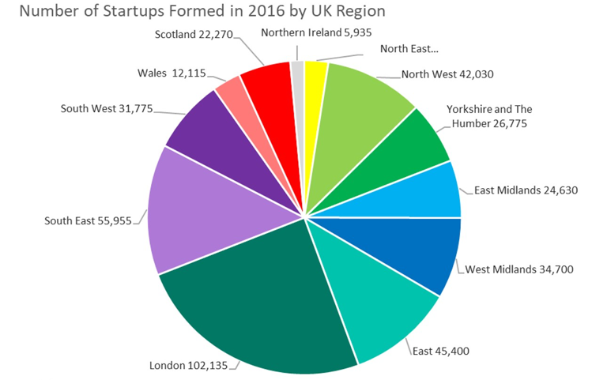
Figure 1: Start-ups in the UK
Source: Wright and Mustar, 2019

Primarily due to the absence of initial entrepreneurs who reach the established entrepreneur stage. It is also observed that, in the case of nascent entrepreneurs, there is greater sensitivity in relation to the country's economic activity than for new entrepreneurs (Symeonidou and Nicolaou, 2018). In short, despite the unfavourable economic situation in recent years, the entrepreneurial mind-set is linked to several factors that contribute to the emergence of an entrepreneurial culture and the creation of new businesses, involving broader items such as economics, legislation, socio-demographic issues to family factors and personal. Amongst this entrepreneurial context are the characteristics and the new socioeconomic profile of the UK entrepreneur.
Data from Marzocchi, et al., (2019) shows that this profile includes age, income, education, marital status and colour of individuals. The survey showed a female supremacy amongst the initial entrepreneurs, with 51.5%, whilst the male was 48.5% (Fritsch and Wyrwich, 2018). Equality between men and women at the front of new businesses is not maintained when the participation by gender in enterprises established for more than 3.5 years is analysed, 57.3% are men, whilst 42.7% are women represented a difference of 14.6% between genders.

Motivational Factors
The motivational factors that drive entrepreneurship are need, being the reasons that motivate for lack of space in the formal market or dismissal, and opportunity, having the desire for autonomy, financial achievement, planned decision or life mission (Halberstadt, et al., 2021). According to Brown, et al., (2019) some of the motivating factors in entrepreneurs, especially the UK, are the objective of setting up their own business, financial freedom, work flexibility, opportunities for new business models and personal independence. Vaznyte and Andries, (2019) mention that motivation is the process responsible for giving intensity, persistence and direction to people's efforts to reach a goal or objective. The same author also argues that there are factors that motivate the entrepreneur distributed in three spheres, personal, environmental and sociological.
The personal factor is related to the desire for self-fulfilment, dissatisfaction at work, desire to earn money and improve financial condition, ardent initiative to change their life or acquire a new job opportunity, through an unemployment situation (Brown, et al., 2019). In the environmental factor, motivation perpetuates the study of the environment where a business is intended to be inserted, studying the existing opportunities and uncertainties, including the possibility of investing in an entrepreneurial project; with the sociological factor, it is understood the initiative of a group of competent people, sharing common characteristics, influencing other groups, which may be formed by family, friends or colleagues, since it motivates the opening of a certain business for the simple fact of understanding that the possibilities for development are favorable (Conway and Hemphill, 2019).

Opportunity Recognition
In the universe of entrepreneurship, a business opportunity can represent a possibility for the entrepreneur to meet an unsatisfied need, or desires of a society or customers, which results in sales and profits. The recognition of an opportunity in general is a consequence of the knowledge and experience of the individual entrepreneur and, where relevant, of the entrepreneurial company (Belitski, et al., 2020). Lukeš, et al., (2019) demonstrate the process of recognition of attention and entrepreneurial networks. The recognition of entrepreneurial opportunity arises not only in the creation of a new product, but through a network that involves vision, reflection, culture, technology and experiences.
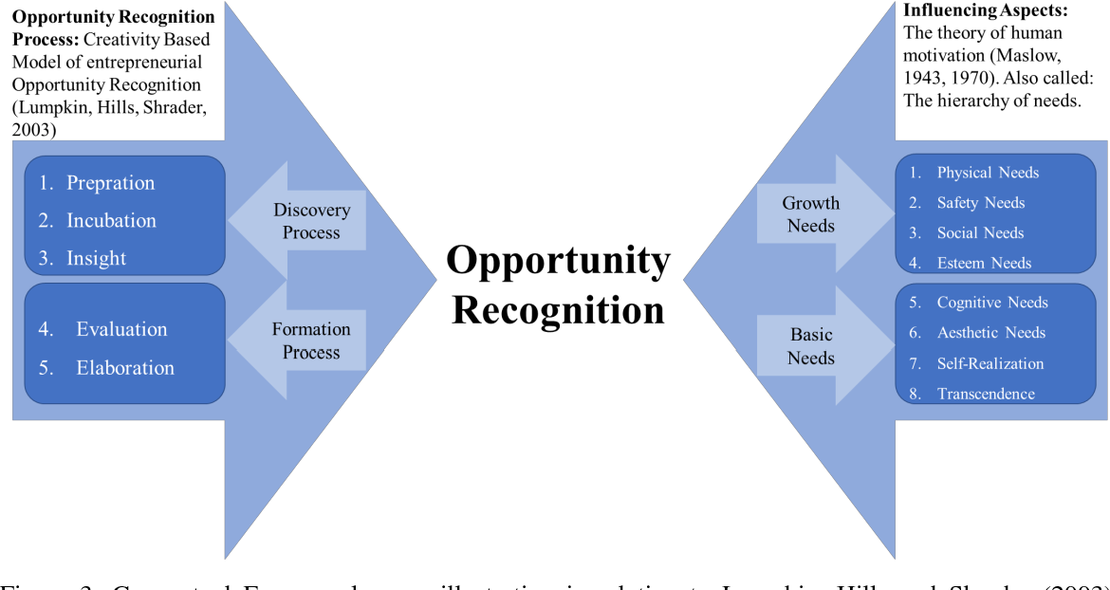
Figure 2: Opportunity Recognition
Source: Fritsch and Wyrwich, 2018
The recurring theme of this story is that entrepreneurial opportunities represent something new. According to Fritsch and Wyrwich, (2018) to identify and create their own opportunities, the entrepreneur must be in constant attention to the movements and changes that are taking place around, always keeping up to date, adding value to their processes and services in an innovative way and achieving success through the enterprise.

Part 2

Start-Up Growth
Firm growth can be understood as “a change in size over a given period of time” (Wright and Mustar, 2019). For Symeonidou and Nicolaou, (2018), growth reflects the company's internal development. It is derived from the entrepreneur's assessment of the company and the market, which is constantly being built and rebuilt. Firm growth is represented by the positive variation between (at least) two points in time (Marzocchi, et al., 2019). This variation may be associated with an increase in sales, number of employees, number of customers, number of products or services (Fritsch and Wyrwich, 2018). According to Halberstadt, et al., (2021) what reflects the company's growth is the increase in demand for the products or services offered by the company, which will consequently result in increased sales, which, in turn, may be accompanied by investments in additional factors of production.
Other concepts of growth, presented by Brown, et al., (2019), consider that growth can also be observed by increasing profitability, increasing company value, growing assets and developing internal skills. The measurement of growth can take place in different ways. The increase in sales, in the number of employees or in profitability are the forms most discussed in the literature (Vaznyte and Andries, 2019). Brown, et al., (2019) consider other forms of measurement, such as asset growth, company value growth and internal development. The latter, for the authors, is reflected in the development of competences, in the establishment of organisational practices of efficiency and professionalisation. Growth can also be interpreted as an increase in the number of branches, an increase in markets, an increase in the number of customers or an increase in the number of products or services (Conway and Hemphill, 2019). Different approaches were used by researchers to explain the growth of small businesses.
The life cycle approach consists in describing growth as a gradual process, through cycles that are characterised by changes in the company's products, market and management, and that occur in a certain sequence. Another focus is centered on the form of management, with the growth of small businesses being related to the competence of planning and management. Another explanation of company growth is as a result of psychological aspects, such as growth intentions (Belitski, et al., 2020). Furthermore, for this approach, growth may result from other reasons, such as the need to feel respected by the community (Lukeš, et al., 2019).
Finally, the focus of integrative studies considers that to understand growth an approach to a multidisciplinary process is necessary, covering characteristics of entrepreneurs, business management and the environment Growth, as a process, is the result of several actions and the performance of actors, as it is not only the result of the entrepreneur's effort, but also encompasses the support of other people, such as customers, family members, suppliers (Fritsch and Wyrwich, 2018). In addition to representing the result of a collective effort, growth results from conditions that determine it and from difficulties that have been overcome (Wright and Mustar, 2019).

Determinants and Growth Difficulties
Variables at the level of the individual, the company and the environment can influence the growth of companies (Symeonidou and Nicolaou, 2018). At the individual level, there is evidence that the educational level and experience of entrepreneurs have a favorable effect on growth. The experience of entrepreneurs in the sector is also relevant, which gives them greater knowledge of the market, implying greater chances of growth (Halberstadt, et al., 2021). Furthermore, the experience of entrepreneurs in creating and managing other ventures gives them advantages to promote the growth of their businesses (Brown, et al., 2019). Additionally, psychological factors such as motivation and aspirations for growth, as well as the internal locus of control, intentions or expectations of growth on the part of entrepreneurs had positive effects on company growth.
There is evidence that growth expectations are associated with the stage of the enterprise, and in the initial stage, the tendency is for growth expectations to be higher (Vaznyte and Andries, 2019). Another aspect that determines the growth of companies, especially small companies, is the engagement of entrepreneurs in company networks or social networks (Brown, et al., 2019). Networks are “ways of sharing information, selecting and accumulating information coming from the external environment. They are disseminators and amplifiers of information for companies” (Conway and Hemphill, 2019) and, in this sense, inclusion in networks can contribute to the empowerment of small entrepreneurs, enabling them to compete with large companies. To generate innovation in technology-based companies, the complementary dynamics between large and small companies is interesting (Belitski, et al., 2020). However, it is necessary that the network is a source of new, varied and quality information and that it connects with the external environment (Lukeš, et al., 2019).
At the firm level, growth strategies proved to be important in determining growth. Amongst these, production strategies aimed at product improvement, development and innovation stand out (Fritsch and Wyrwich, 2018), highlighting the importance of patents, which represent strategic factors for technology-based companies (Wright and Mustar, 2019). Market strategies also stand out, such as taking advantage of market niches and market segmentation and diversification. In addition to these, strategies aimed at product distribution and positioning in the market, as well as the increase in marketing activities contribute to growth. Furthermore, stimulating knowledge, learning and technology analysis are important for the growth of technology-based companies.
In this sense, resorting to specialists and consultants and using skills arising from the learning process contribute to growth (Symeonidou and Nicolaou, 2018). Furthermore, growth for small businesses can be achieved through the strategy of partnerships with suppliers and internationalisation strategies (Marzocchi, et al., 2019). Furthermore, growth is associated with the adoption of a human resources policy, including training and monetary incentives (Fritsch and Wyrwich, 2018). In addition to these strategies, company culture can have a positive effect on growth, as a culture that values ​​growth and the development of internal capabilities favours company growth.
Regarding the influence of environmental variables on company growth, the positive effect of industrial agglomeration and of market supply and demand conditions stand out. on growth (Halberstadt, et al., 2021). Industry dynamism and entry barriers can also positively or negatively influence growth (Brown, et al., 2019). Also in the environment, the presence of investors and venture capital, as well as the presence of universities and technology transfer mechanisms proved to be favorable to growth, especially for technology-based companies (Vaznyte and Andries, 2019). The availability of human resources and raw materials is also important.

Conclusion
This report investigated how entrepreneurs understand the growth process of software companies focusing on difficulties and determinants of growth, which is important because entrepreneurs play a central role in the growth of companies. According to the results of this report, entrepreneurs perceive the growth of their ventures as a process that includes their actions, company management and the environment. As for their actions, they mentioned the importance of participating in Fairs, intense dedication to work and engagement in networks as determinants of growth. At the start-ups management level, they mentioned as determinants of growth, mainly innovation and human resources strategies and policies, but also the adoption of a financial reinvestment policy and the search for certifications and consultancy. In terms of the environment, the support of other institutions was decisive for growth, with emphasis on start-ups. The perception of growth difficulties was limited to the level of the company and the environment. At the company level, the difficulties mentioned were: delay in product development, difficulty in preparing the team, difficulties in negotiating and competing with large companies. At the environmental level, the difficulty was the lack of a results-oriented culture.

References

Belitski, M., Caiazza, R. and Rodionova, Y., 2020. Investment in training and skills for innovation in entrepreneurial start-ups and incumbents: Evidence from the United Kingdom. International Entrepreneurship and Management Journal, 16(2), pp.617-640.
Brown, R., Mawson, S. and Rowe, A., 2019. Start-ups, entrepreneurial networks and equity crowdfunding: A processual perspective. Industrial Marketing Management, 80, pp.115-125.
Brown, R., Mawson, S. and Rowe, A., 2019. Start-ups, entrepreneurial networks and equity crowdfunding: A processual perspective. Industrial Marketing Management, 80, pp.115-125.
Conway, T. and Hemphill, T., 2019. Growth hacking as an approach to producing growth amongst UK technology start-ups: An evaluation. Journal of Research in Marketing and Entrepreneurship.
Fritsch, M. and Wyrwich, M., 2018. Regional knowledge, entrepreneurial culture, and innovative start-ups over time and space―an empirical investigation. Small Business Economics, 51(2), pp.337-353.
Fritsch, M. and Wyrwich, M., 2018. Regional knowledge, entrepreneurial culture, and innovative start-ups over time and space―an empirical investigation. Small Business Economics, 51(2), pp.337-353.
Halberstadt, J., Niemand, T., Kraus, S., Rexhepi, G., Jones, P. and Kailer, N., 2021. Social entrepreneurship orientation: drivers of success for start-ups and established industrial firms. Industrial Marketing Management, 94, pp.137-149.
Lukeš, M., Longo, M.C. and Zouhar, J., 2019. Do business incubators really enhance entrepreneurial growth? Evidence from a large sample of innovative Italian start-ups. Technovation, 82, pp.25-34.
Marzocchi, C., Kitagawa, F. and Sánchez-Barrioluengo, M., 2019. Evolving missions and university entrepreneurship: academic spin-offs and graduate start-ups in the entrepreneurial society. The Journal of Technology Transfer, 44(1), pp.167-188.
Symeonidou, N. and Nicolaou, N., 2018. Resource orchestration in start‐ups: Synchronizing human capital investment, leveraging strategy, and founder start‐up experience. Strategic Entrepreneurship Journal, 12(2), pp.194-218.
Vaznyte, E. and Andries, P., 2019. Entrepreneurial orientation and start-ups' external financing. Journal of business venturing, 34(3), pp.439-458.
Wright, M. and Mustar, P., 2019. Student Start-Ups: The New Landscape of Academic Entrepreneurship (Vol. 1). World Scientific.

