Presentation Notes on “Training and Development needs for an HR Officer”

Prepared By Yawar Abrar Hossain (1916654)

Module: Developing Relationship and Workplace Achievements (BMSW5102)

Prepared for: Modak Koushik
Submission Date: 4th of May 2021



Contents:

Page

- Slide 1 – Introduction .......................................................... 3
- Slide 2 – Background .......................................................... 4
- Slide 3 – Employment History ............................................. 5
- Slide 4 – Human Resource Management ........................... 6
- Slide 5 - Human Resource Management cont..................... 7
- Slide 6 – Knowledge, skills and behaviour (KSB) ............... 8
- Slide 7 – Expectations of HR officer role ............................ 10
- Slide 8 – Personal Skills Audit ............................................ 11
- Slide 9 – Developing HR officer .......................................... 12
- Slide 10 – Advantages of Effective Training ...................... 13
- Slide 11 – Conclusion ........................................................ 14
- Slide 12 – References ....................................................... 15
- Slide 13 – References ....................................................... 15
- References ........................................................................ 16
- Appendices ......................................................................... 19

Slide 1:

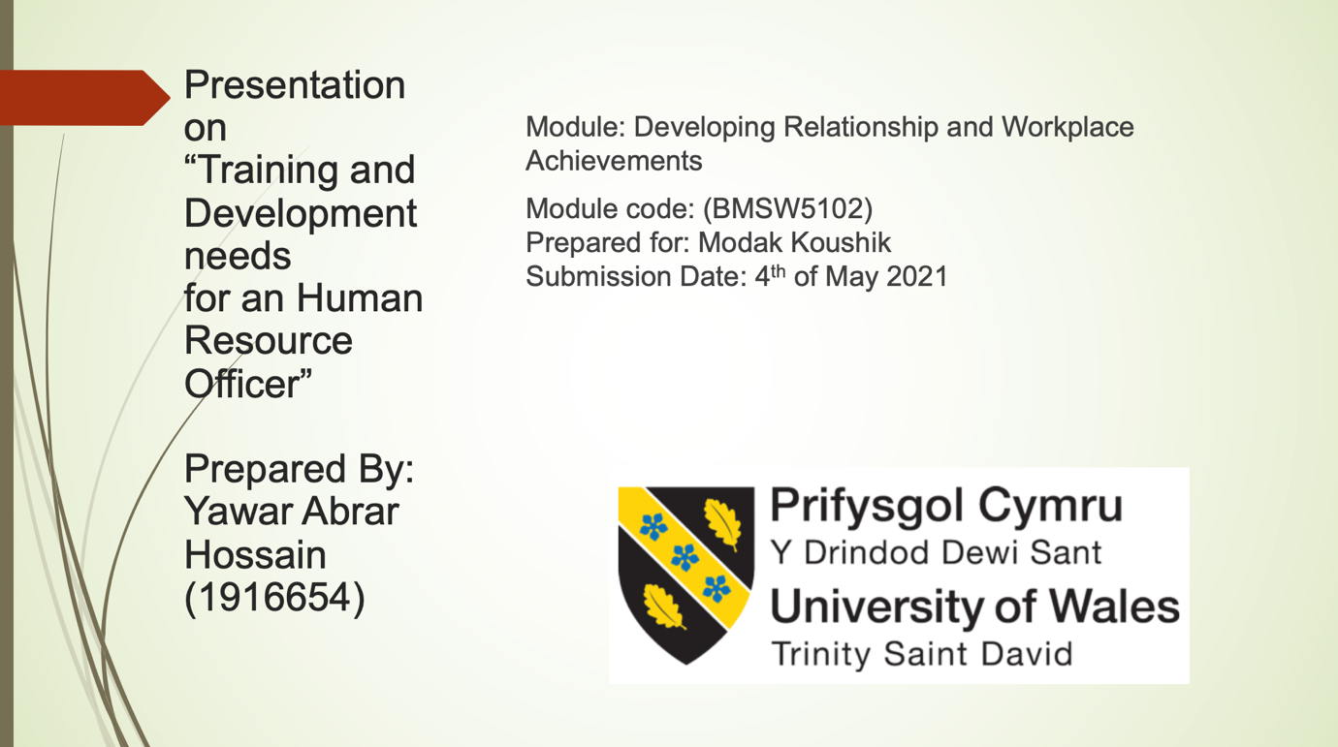

Hello everyone, today I will be speaking about presentation on “Training and Development needs for an Human Resource Officer.” Before I start, I would like to introduce myself, I am Yawar Hossain, currently studying at Level 5 in the University.

Slide 2:

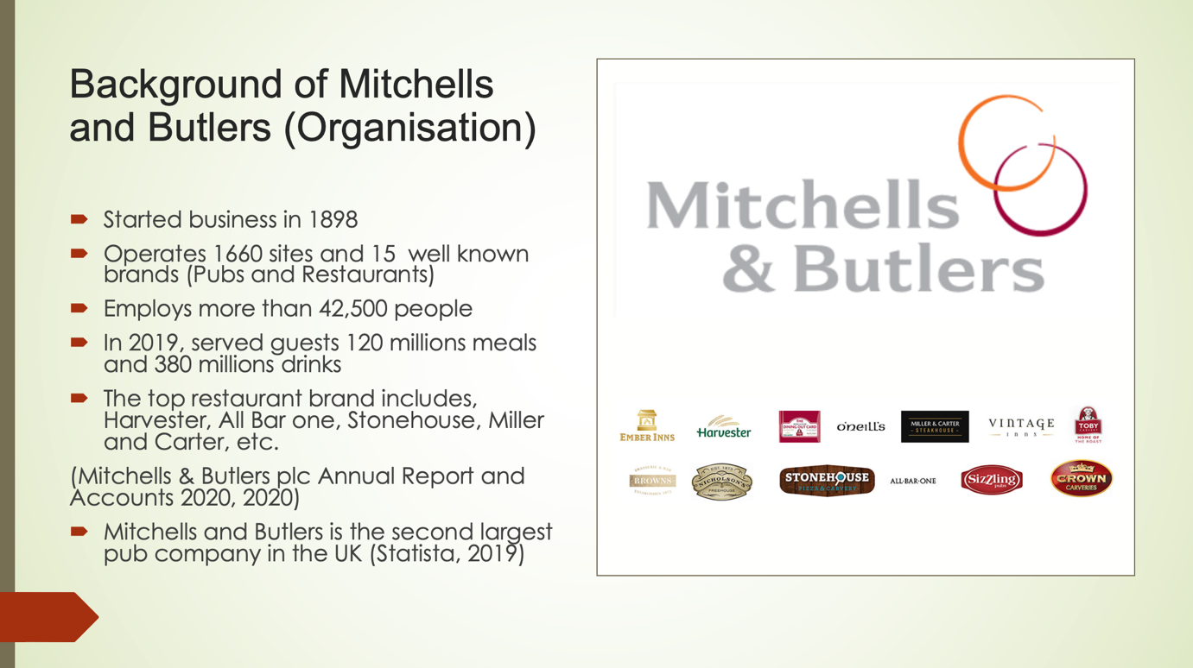

In this slide, will provide a brief introduction about the company, Mitchells and Butlers Plc. (M&B). The reason for choosing this business because I work as a General Manager for them since 2018. M&B started trading in 1898, currently owns 1660 pubs and restaurants, operates 15 well-known brands. The company employs 42,500 people throughout the country; in 2019, the company served over 120 million meals and 380 million drinks. Some of the biggest brand pub and restaurant includes, All Bar One, Miller & Carter, Harvester, Stonehouse, Toby Carvery, etc. (Mitchells & Butlers plc Annual Report and Accounts, 2020). Currently M&B plc is the second largest pub company in the UK (Statista, 2019).

Slide 3:

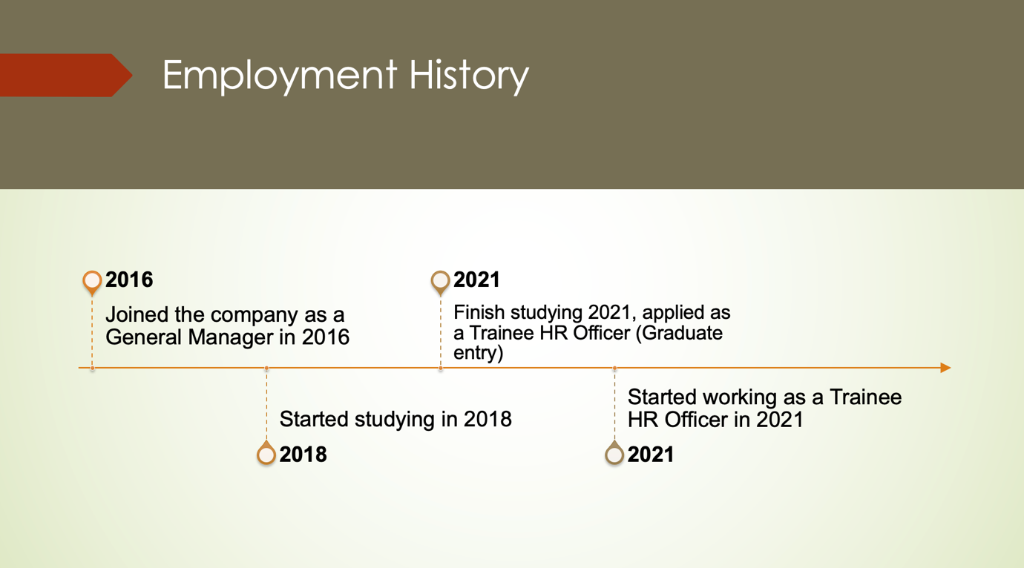

This slide shows about the timeline in M&B, started in 2016 as a General Manager, in the meantime I wanted to improve some of my skills, so I enrolled to the University. In 2021, I have applied for Trainee HR Officer role and I was internally recruited within the company for a different role.

Slide 4:

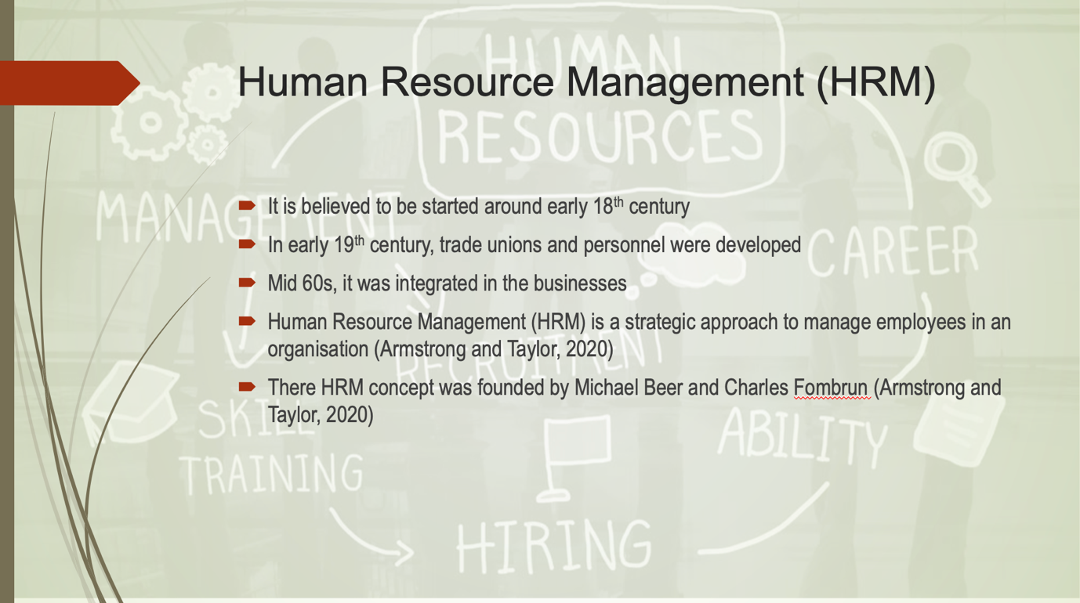

The definition of HR is “the resources that are intrinsic to human beings, which they can apply to the various tasks of life, both in workplaces and in activities such as relationship building, child raising, recreational leisure and community service.” (Boxall 2013, p.4).
In late 19th century, the term HRM arrived from USA and were used in UK as well. (Pinto-Chilcott, 2015)
“Human resource management (HRM) is concerned with all aspects of how people are employed and managed in organisations.” (Armstrong and Taylor, 2020). The concept of HRM was founded by Michael Beer and leading experts created ‘Harvard framework’ and Charles Fombrun and leading experts created ‘Michigan framework’. (Armstrong and Taylor, 2020).

Slide 5:

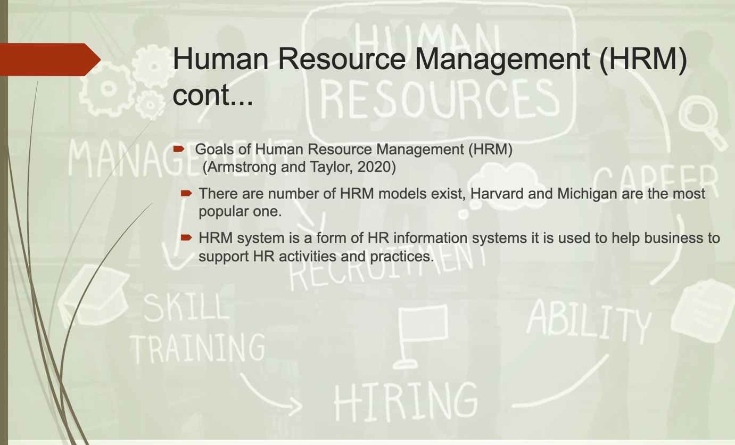

Objectives are:
- Support association to accomplish its targets
- Develop elite culture and prosperity for the specialistsEnsures the organisation provides talented, motivated and skilled employees
- Creates a positive working environment between the manager and employees
- Engage the use of ethical method to people management (Armstrong and Taylor, 2020).
There are many HRM exist, amongst all Harvard and Michigan are the most popular one. HRM system is a form of HR information systems it is used to help business to support HR activities and practices.

Slide 6:

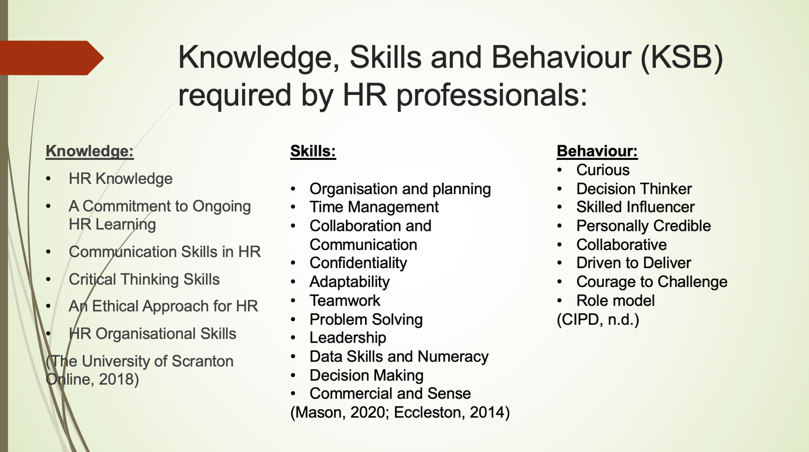

According slide 6, knowledge, skills and behaviour are certain trait required by HR professional. These unique skills and competencies make a successful career in HR (Alison, 2013). An individual should have HR knowledge and committed to regular learning, which includes employment law keeps on updating regularly due to the ongoing demand, for example, immigration, covid 19, etc. (CIPD, 2021). Communication and critical thinking skills are a must and followed by ethical approach and organisational skills. These skills are important as they are hard skills mixed with soft skills which could be applied to real life situations (The University of Scranton Online, 2018).
These soft skills are learnt either in educational institution or workplaces. They are important as it helps to carry out function and responsibility as a HR officer. There is a massive skills gap in the market and employers are consistently looking for someone with the relevant skills (Levy and Rodkins, n.d.). This means the HR officer requires organise and plan task, able to follow within timely manner, communicate with the business partner and peers and take the lead to lay down strategies and work together, commercially aware by following the correct data trend take the right decision and also able to find solution to the problem (Mason, 2020; Eccleston, 2014)
There are eight behaviours have been identified. The behaviour shows different individual have different characteristics, some are good with numbers and some are born leaders who drive results (CIPD, n.d.).

Slide 7:

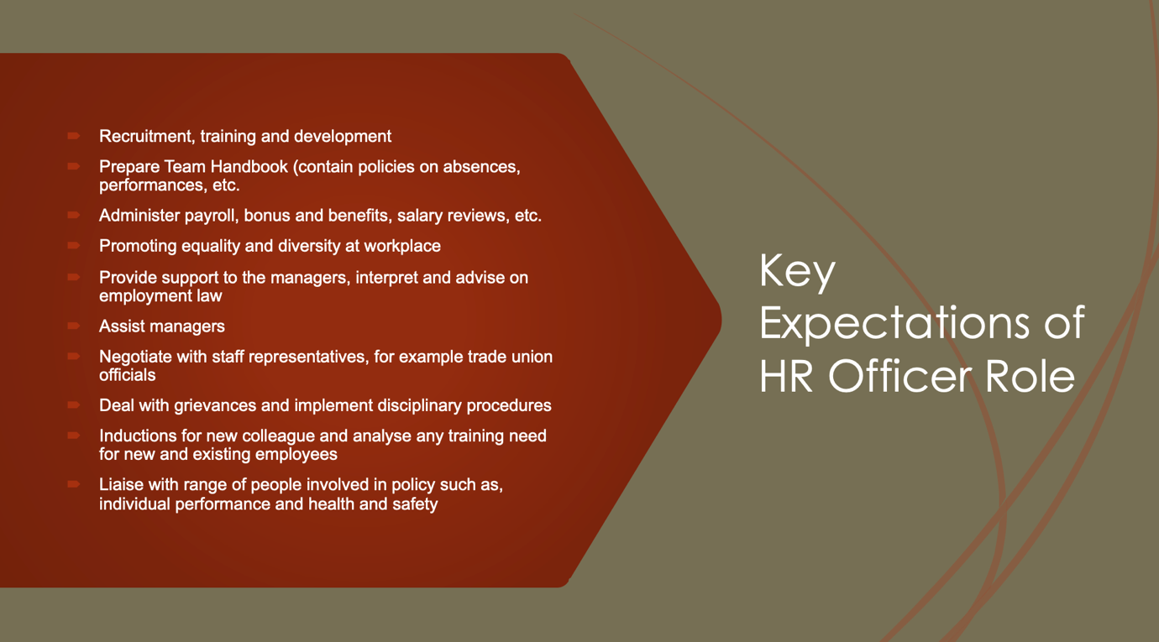

In accordance with Appendix A, the key expectations of HR Officer role have been identified. Slide 6 shows the relevant KSB required to be able to do the job and slide 7 states the job role and what is expected from HR Officer to carry out the responsibility. In this competitive market, the recruiters are looking for competent person who will be able to perform their job and able to drive the business forward. These are few expectations, recruitment, training and development, prepare team handbook, able to write policies in adhere to laws and regulations, administer payroll, salary reviews, bonuses, promote equality and diversity, assist managers, negotiate with trade unions, deal with grievances and disciplinary procedures, etc. (AGCAS, 2020).

Slide 8:

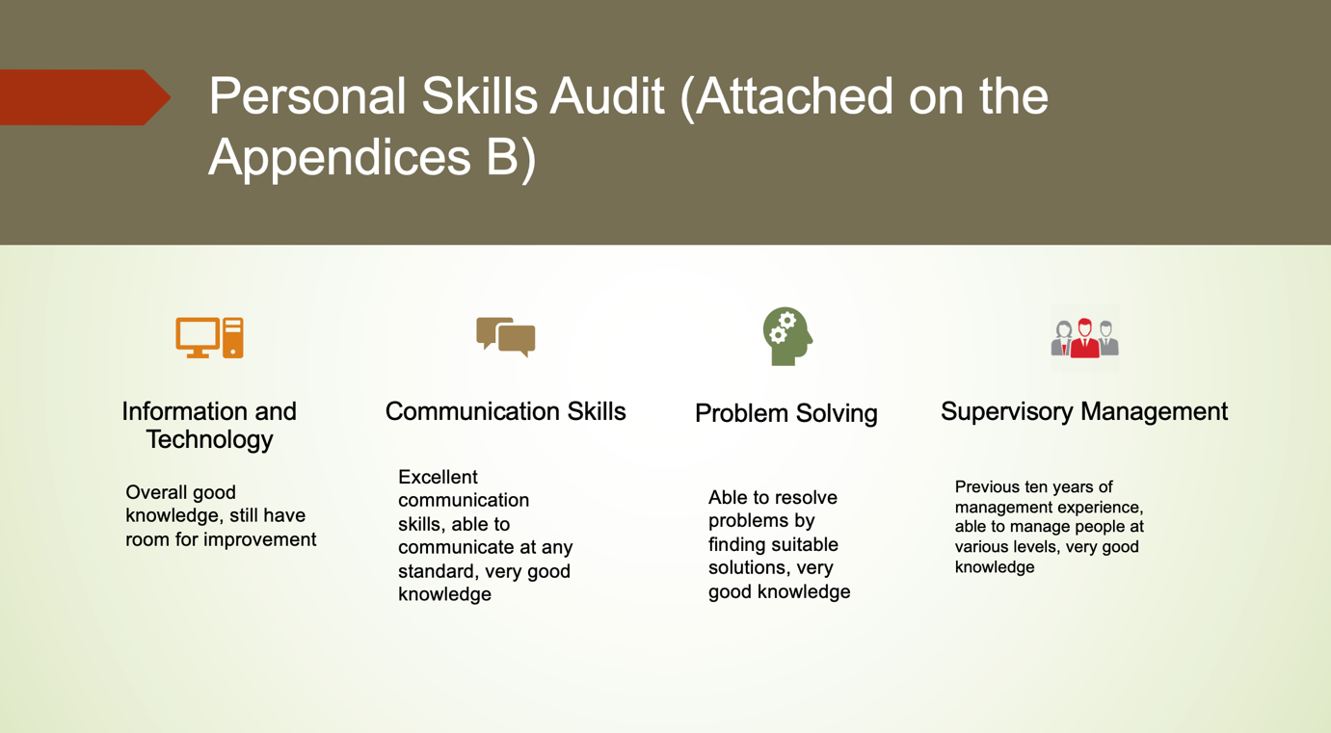

In accordance with appendix B, I have carried out personal skills audit on myself. It enabled me to see what skills I have and what skills I have to work on. This helps an individual to work on the opportunity. It is important to carry out this audit every time an individual changes job or look for improving skills and it is very important that a person should be honest while answering the questionnaires (jobwise.co.uk, 2017 and jobcoconut.com, n.d.).

IT – I have overall good knowledge; I have few opportunities which I need to work on.

Communication Skills – I have previously showed excellent communication at management level, and those skills are transferrable to the new job.

Problem Solving – Working long years in the management helped me to gain this skill, as a manager able to resolve problems by finding possible solutions. I have marked myself on the upper tier.

Supervisory Management – I have over ten years of management experience and managed various restaurants and pubs. Maximum number of employees who I was directly managing were 70 and on average I have managed a team size of 30.

Slide 9:

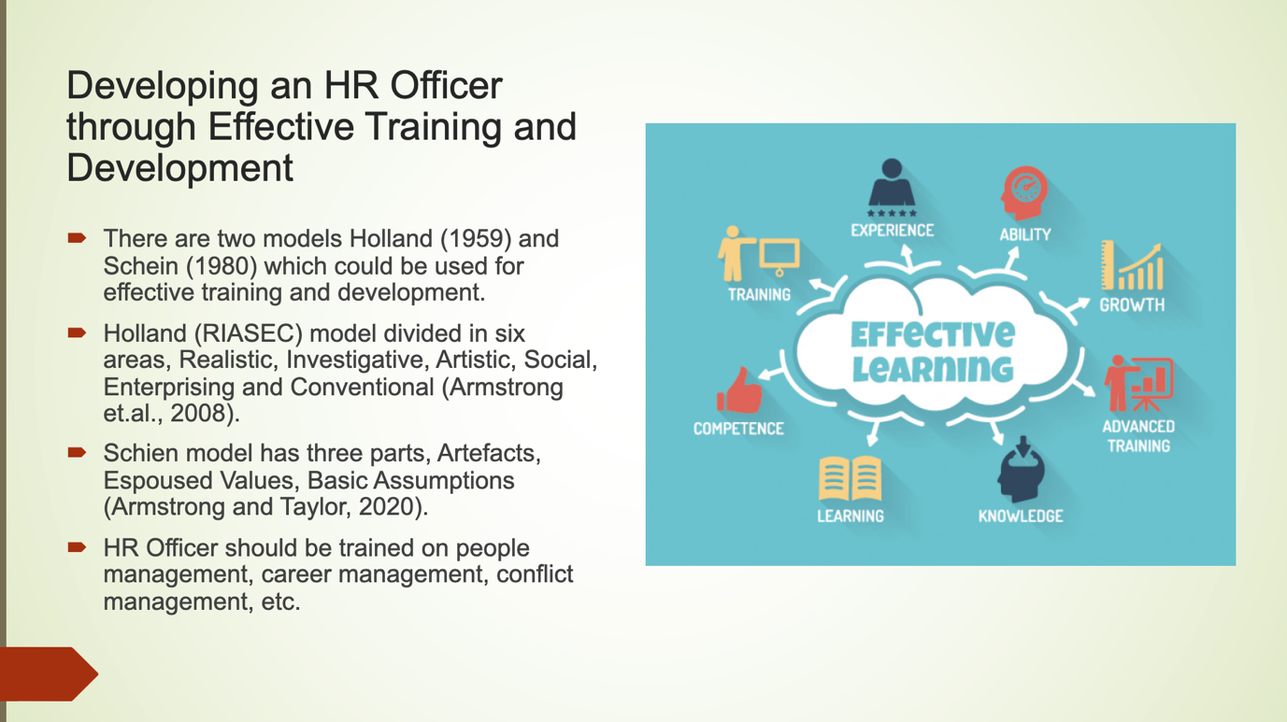

The two major models are Holland (1959) and Schein (1980). Holland model have six parts and Schien have three parts. According to Holland model, all careers can be classified into six broad areas, these areas are used to describe an individual their personality and interest. While choosing a career an individual would prefer jobs who have similar characteristics. Individuals search for circumstances permit to use their capacities and limits and express their attitudes and capacities, while taking on overwhelming issues and occupations (Armstrong and Taylor, 2020; Govt.nz, 2019).

Schein’s theory management theory focuses on culture within an organisation. He explains three level of culture which are necessary to understand for effective leadership; surface societies, like dress, which are effortlessly seen yet hard to translate, cognizant objectives, techniques and ways of thinking, and fundamental suppositions, oblivious convictions and qualities that structure the centre of culture and influence all that we do. (Armstrong and Taylor 2020; Dininni, 2011).

Holland model could be used to develop an individual with people management, career development, etc. Scheins model strategy which targets explaining society and the way in which it impacts affiliations. It is an exceptional model of learning and assembling components. However, none of the principles covers the wellbeing of an employee, the current pandemic has led mental health in critical condition. The HR officer should be trained effectively to ensure the wellbeing of the employees are not compromised. These steps can be followed:
1. Focus on emotional wellness in the work environment by creating and conveying a deliberate program of movement
2. Proactively guarantee work plan and authoritative culture drive positive psychological wellness results
3. Advance an open culture around psychological well-being
4. Increment authoritative certainty and ability
5. Give psychological well-being instruments and backing
6. Increment straightforwardness and responsibility through inward and outer announcing (CIPD, n.d.)

Slide 10:

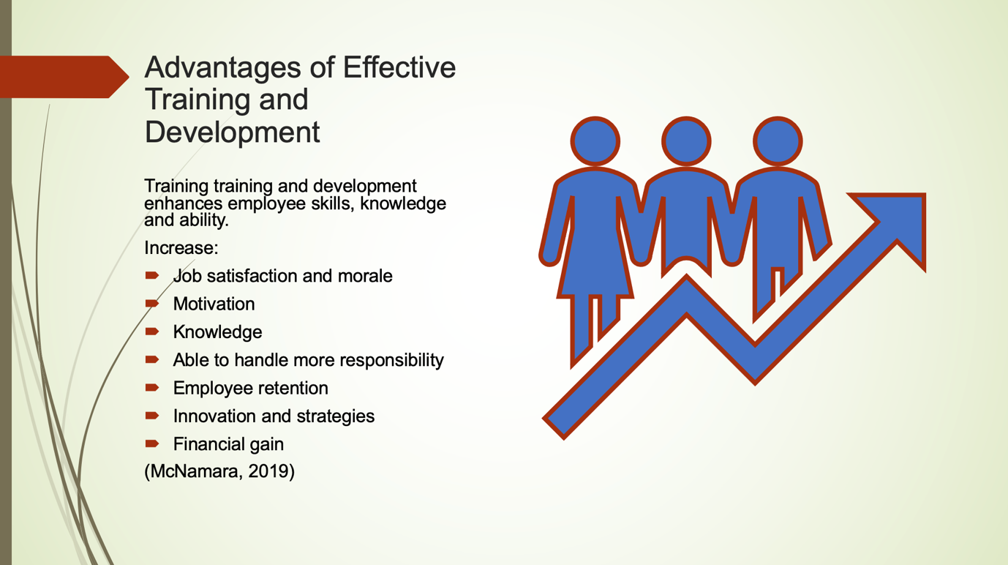

The training and development not only help the individual, but it also helps the company. It increases the efficiency, productivity, knowledge, skills, etc to perform the job better. It increases the individual motivation, boosts morale, increases job satisfaction, able to handle more responsibility and innovate new strategies; this reduces the employee turnover and profits the company (McNamara, 2019).

Slide 11:

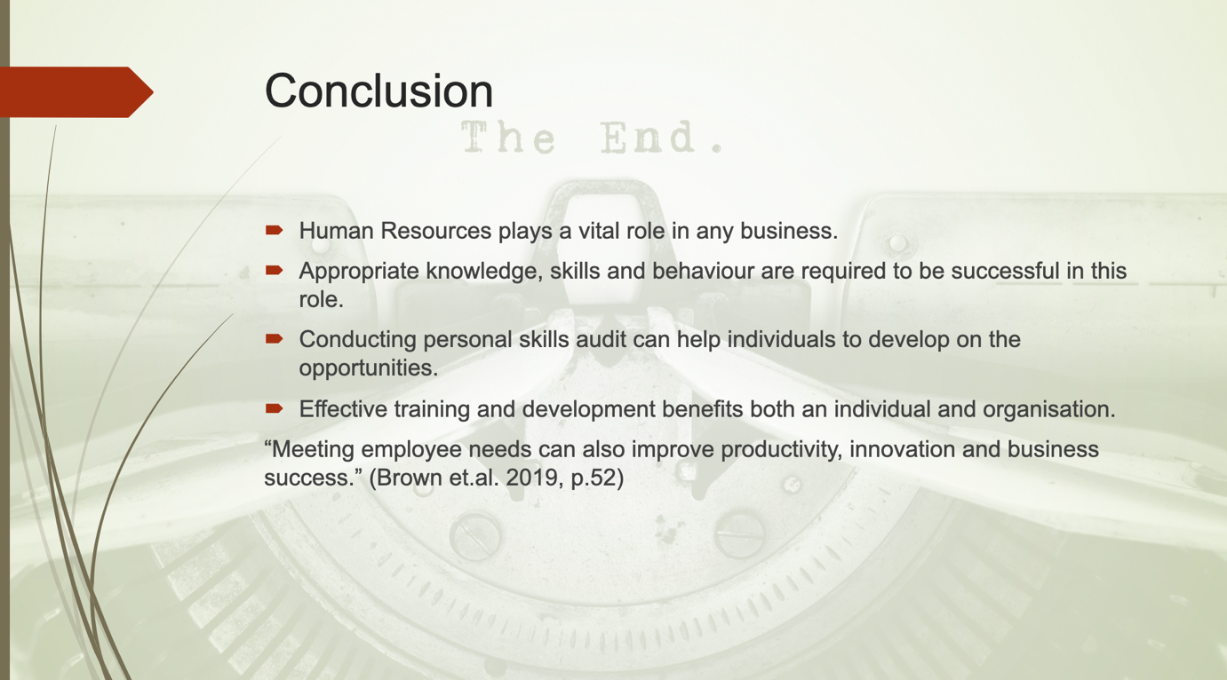

HR plays an important role in the business, knowledge, skills and behaviours are required to be successful in this role, conducting personal skill audit help individual to work on the opportunities, effective training not only benefits employee but also the organisations. According to Brown et.al. (2019), looking after employee wellbeing and increasing motivation helps to improve productivity, innovation and business success.

I would like to thank everyone, my fellow colleagues and lecturer for listening, I wish you all the best and have a good day.

Slide 12:

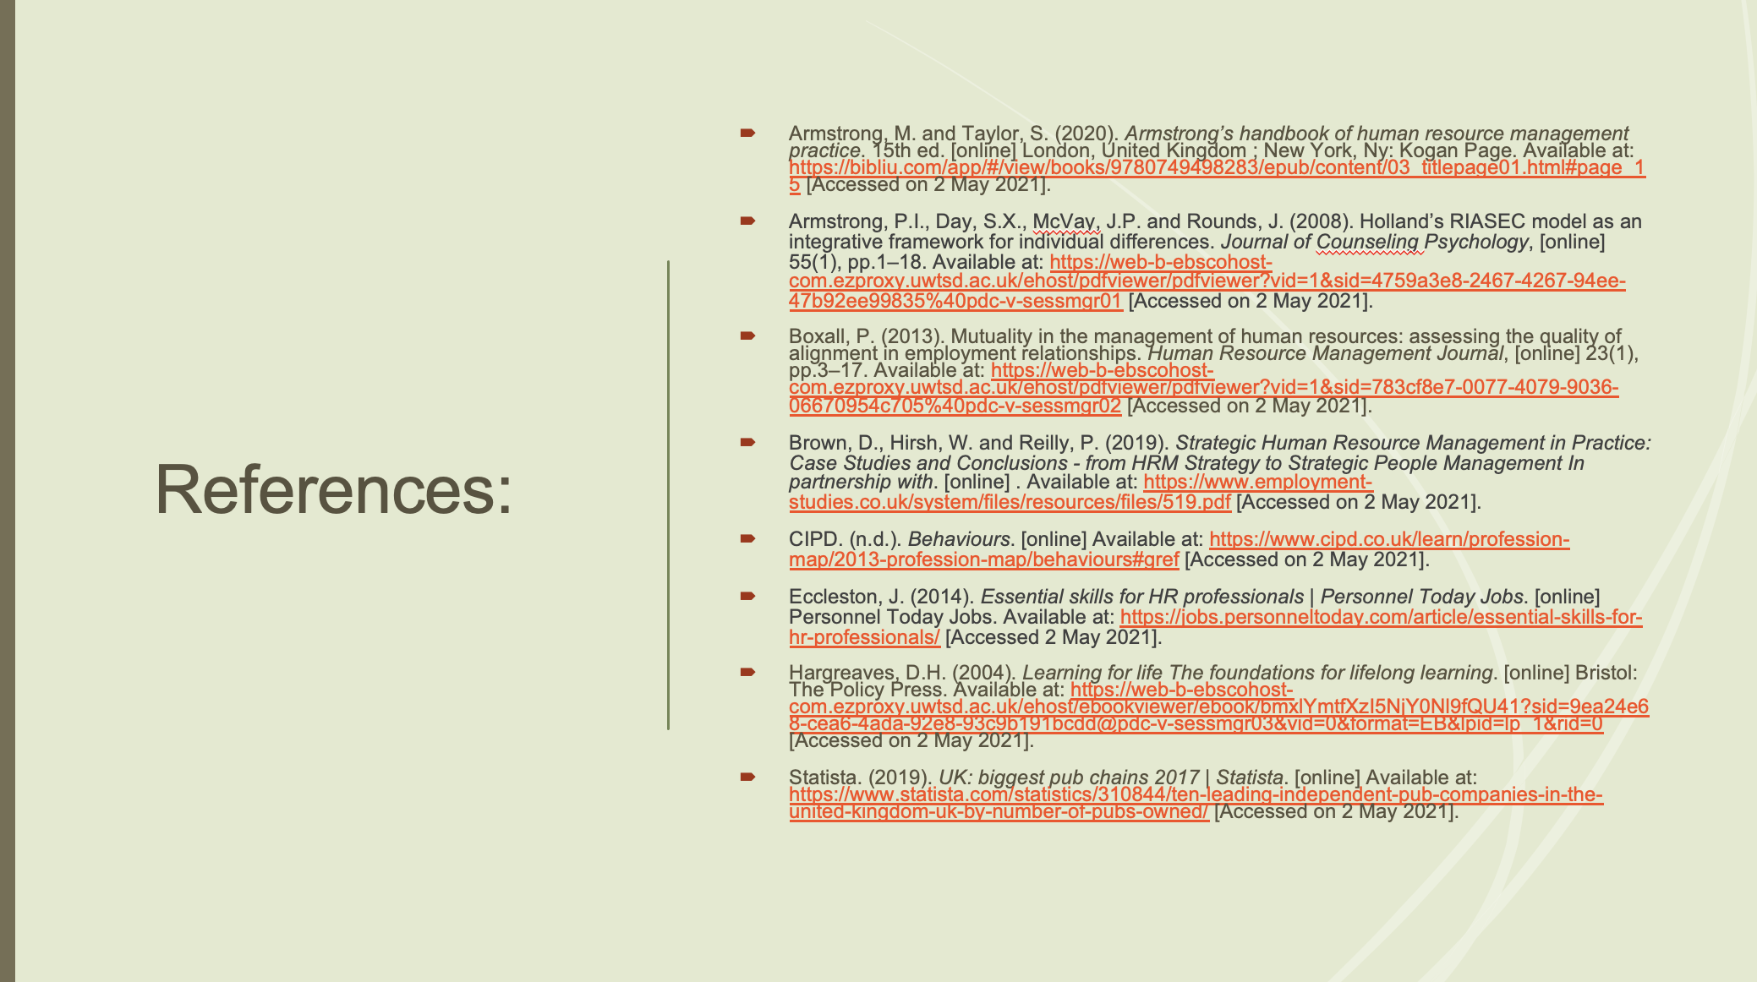

Slide 13:

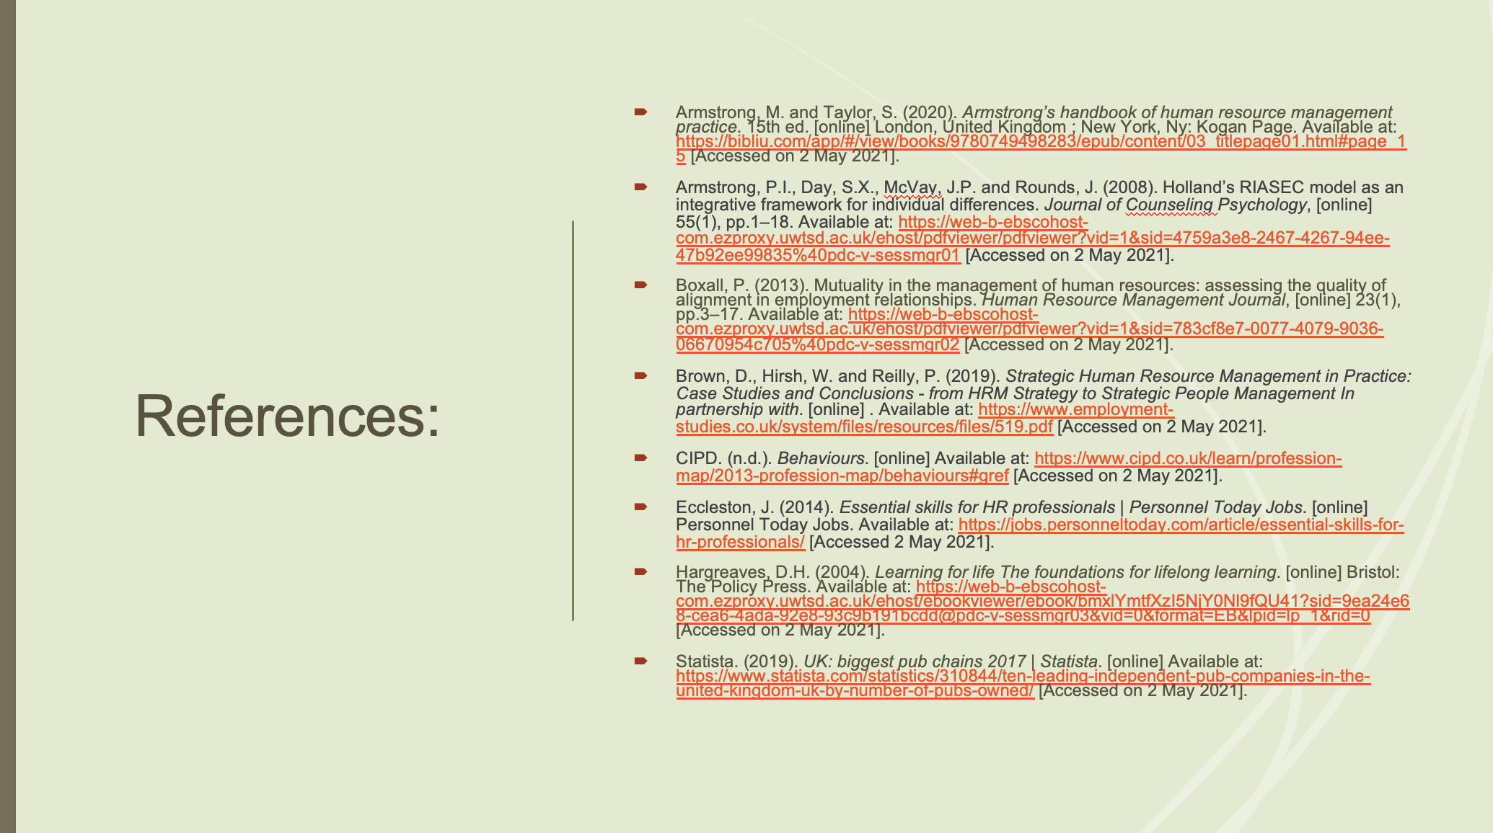

References:

Alison (2013). What skills and competencies do you need for a career in HR? [online] TARGETjobs. Available at: https://targetjobs.co.uk/career-sectors/hr-and-recruitment/324027-what-skills-and-competencies-do-you-need-for-a-career-in-hr [Accessed on 2 May 2021].
Armstrong, M. and Taylor, S. (2020). Armstrong’s handbook of human resource management practice. 15th ed. [online] London, United Kingdom ; New York, Ny: Kogan Page. Available at: https://bibliu.com/app/#/view/books/9780749498283/epub/content/03_titlepage01.html#page_15 [Accessed on 2 May 2021].

Beer, M, Spector, B, Lawrence, P, Quinn Mills, D and Walton, R (1984) Managing Human Assets, New York, The Free Press

CIPD. (2021). Employment Law Updates UK. [online] Available at: https://www.cipd.co.uk/knowledge/fundamentals/emp-law/about/legislation-updates#gref [Accessed on 2 May 2021].
CIPD. (n.d.). Behaviours. [online] Available at: https://www.cipd.co.uk/learn/profession-map/2013-profession-map/behaviours#gref [Accessed on 2 May 2021].
CIPD. (n.d.). Mental health at work commitment. [online] Available at: https://www.cipd.co.uk/knowledge/culture/well-being/mental-health-at-work-commitment [Accessed on 2 May 2021].
Dininni, J. (2011). Management Theory of Edgar Schein. [online] business.com. Available at: https://www.business.com/articles/management-theory-of-edgar-schein/ [Accessed on 2 May 2021].
Eccleston, J. (2014). Essential skills for HR professionals | Personnel Today Jobs. [online] Personnel Today Jobs. Available at: https://jobs.personneltoday.com/article/essential-skills-for-hr-professionals/ [Accessed on 2 May 2021].
Fombrun, C J, Tichy, N M and Devanna, M A (1984) Strategic Human Resource Management, New York, Wiley

Govt.nz. (2019). Holland’s theory. [online] Available at: https://www.careers.govt.nz/resources/career-practice/career-theory-models/hollands-theory/ [Accessed on 2 May 2021].
Jobwise. (2017). Personal Skills Audit – Discover the skills you didn’t know you had! [online] Available at: https://www.jobwise.co.uk/personal-skills-audit/ [Accessed on 2 May 2021].
‌
Levy, F. and Rodkin, J. (n.d.). These Are the Job Skills Employers Want but Can’t Find. Bloomberg.com. [online] Available at: https://www.bloomberg.com/graphics/2015-job-skills-report/ [Accessed on 2 May 2021].
Mitchells & Butlers plc Annual Report and Accounts. (2020). Mitchells & Butlers plc Annual Report and Accounts 2020. [online]. Available at: https://www.mbplc.com/pdf/2020/reports/MAB_Annual_Report_2020.pdf [Accessed on 2 May 2021].

Mason, H. (2020). What soft skills are required to work in HR? [online] People Management Jobs. Available at: https://pmjobs.cipd.co.uk/article/what-soft-skills-are-required-to-work-in-hr-/ [Accessed on 2 May 2021].

Pinto-Chilcott, M. (2015). The History of Human Resource Management (HRM). [online] Consensus HR. Available at: https://consensushr.com/the-history-of-human-resource-management-hrm/ [Accessed on 2 May 2021].
AGCAS (2020). Human resources officer job profile | Prospects.ac.uk. [online] www.prospects.ac.uk. Available at: https://www.prospects.ac.uk/job-profiles/human-resources-officer [Accessed 2 May 2021].
Statista. (2019). UK: biggest pub chains 2017 | Statista. [online] Available at: https://www.statista.com/statistics/310844/ten-leading-independent-pub-companies-in-the-united-kingdom-uk-by-number-of-pubs-owned/ [Accessed on 2 May 2021].‌

The University of Scranton Online. (2018). Essential HR Manager Skills and Competencies. [online] Available at: https://elearning.scranton.edu/resource/business-leadership/essential-hr-manager-skills-competencies [Accessed on 2 May 2021].
www.jobcoconut.com. (n.d.). How to write and conduct a skills audit in order to set yourself up for that dream job! [online] Available at: https://www.jobcoconut.com/blog/2015/08/how-to-write-and-conduct-a-skills-audit-in-order-to-set-yourself-up-for-that-dream-job [Accessed on 2 May 2021].
‌

‌

Appendices:



