The impact of transformational and transactional leadership styles on employee organisational commitment in small and medium-sized enterprises (SMEs) in the UK construction industry

Author Name: Ionel Golovatii
Course/Department: BA Business Management
Supervisor’s Name: Dr Piyumika K. Gamage
Date of Submission: 22 December 2025.

Declaration

I, Ionel Golovatii, a student at the University of Wales Trinity Saint David, London Campus, hereby declare that the research titled "The impact of transformational and transactional leadership styles on employee organisational commitment in small and medium-sized enterprises (SMEs) in the UK construction industry" is an original work conducted by me. The study aims to investigate how transformational and transactional leadership styles influence employee organisational commitment within small and medium-sized enterprises in the UK construction sector.
The research follows ethical guidelines, ensuring confidentiality and voluntary participation of all subjects. The methodology used includes a positivist, deductive, mono-method quantitative survey conducted through an online Likert-scale questionnaire, with data analysed statistically. Any funding received for this study has been disclosed, and there is no conflict of interest.
I affirm that this research adheres to the ethical standards set by the University of Wales Trinity Saint David and has not been submitted elsewhere for publication or evaluation.

Ionel Golovatii
University of Wales Trinity Saint David
22 December 2025

Abstract
The research investigates how transformational and transactional leadership styles influence employee organisational commitment in small and medium-sized enterprises (SMEs) in the UK construction industry. Its primary aim is to examine the differential impact of these two leadership styles on organisational commitment and on its affective, continuance and normative components, and to generate practice-oriented recommendations for SME leaders in this sector. The study is significant because leadership-commitment relationships have been widely examined in large organisations, but remain underexplored in construction SMEs, and because it combines both leadership styles with a multidimensional view of organisational commitment in a single empirical framework.
A positivist, deductive, mono-method quantitative design was adopted, using a cross-sectional online survey administered via Google Forms to 108 employees working in UK construction SMEs. Standardised Likert-type scales were used to measure transformational leadership, transactional leadership and organisational commitment (overall, affective, continuance and normative). Data were analysed using descriptive statistics, reliability analysis, Pearson correlations, multiple linear regression and one-way ANOVA.
The results show that both transformational and transactional leadership are positively associated with overall organisational commitment and with all three components. However, transformational leadership demonstrates stronger relationships with overall and affective commitment and remains a significant predictor in multiple regression models, whereas the apparent effects of transactional leadership become non-significant once transformational leadership is controlled for. Organisational commitment is significantly higher among employees with longer organisational tenure, but does not differ by company size.
The study concludes that, in UK construction SMEs, transformational leadership is the primary driver of employee organisational commitment, particularly affective commitment, while transactional leadership plays a supportive but secondary role. It recommends that SME leaders prioritise transformational behaviours such as articulating a clear vision, recognising individual contributions and supporting development while using transactional practices to provide structure and clarity. Future research should employ longitudinal or mixed-method designs, larger and more diverse samples, more comprehensive measures of commitment, and additional leadership and contextual variables to build richer models of organisational commitment in construction SMEs.
Keywords: transformational leadership; transactional leadership; organisational commitment; affective commitment; continuance commitment; normative commitment; SMEs; UK construction industry.
Table of Contents
Chapter 1: Introduction 8
1.1 Introduction 8
1.2 Background of the Study 8
1.3 Problem Statement 9
1.4 Aims and Objectives 9
1.5 Research Questions 10
1.6 Significance of the Research 10
1.7 Scope of the Study 10
1.8 Rationale of the Study 11
1.9 Report Structure 11
Chapter 2: Literature Review 12
2.1 Introduction 12
2.2 Exploring Transactional and Transformational Leadership Styles 12
2.3 Organisational commitment and its categories 12
2.4 Impact of Transformational Leadership Style on Employee Commitment 13
2.4.1 Positive Impacts 13
2.4.2 Negative Impacts 13
2.5 Impact of Transactional Leadership Style on Employee Commitment 14
2.5.1 Positive Impacts 14
2.5.2 Negative Impacts 14
2.6 Summary 15
Chapter 3: Research Methods and Methodology 16
3.1 Introduction 16
3.2 Research Philosophy 17
3.3 Approach to Theory Development 17
3.4 Methodological Choice 18
3.5 Research Strategies 18
3.6 Time Horizon 18
3.7 Data Collection and Data Analysis 18
3.8 Ethical consideration of the research 19
3.9 Summary 19
Chapter 4: Data Analysis and Discussions 20
4.1 Introduction 20
4.2 Analysis of Demographics 20
4.3 Main Analysis 22
4.3.1 Data preparation and scale construction 22
4.3.2 Reliability analysis (Cronbach’s alpha) 23
4.3.3 Descriptive statistics 24
4.3.4 Correlation analysis (Pearson) 25
4.3.5 Regression analysis 26
4.3.6 Group differences (ANOVA) 30
4.4 Discussion of Findings 32
4.4.1 Objective 1: To review the literature towards transformational and transactional leadership and their impact on employee commitment 32
4.4.2 Objective 2: To investigate how transformational leadership style influences employee commitment in UK construction SMEs 33
4.4.3 Objective 3: To investigate how transactional leadership style influences employee commitment in UK construction SMEs 34
4.4.4 Objective 4: To offer effective recommendations for leaders in construction SMEs 35
4.5 Implications of the Findings 35
4.5.1 Theoretical implications 36
4.5.2 Practical implications 37
4.6 Summary 37
Chapter 5: Conclusions, Limitations and Recommendations 39
5.1. Introduction 39
5.2. Conclusions on Each Research Objective 39
5.2.1 Objective 1: To review the literature towards transformational and transactional leadership and their impact on employee commitment 39
5.2.2 Objective 2: To investigate how transformational leadership style influences employee commitment in UK construction SMEs 40
5.2.3 Objective 3: To investigate how transactional leadership style influences employee commitment in UK construction SMEs 40
5.2.4 Objective 4: To offer effective recommendations for leaders in construction SMEs 41
5.3 Conclusions on the Research Problem 41
5.4 Summary of Research Findings and Outcomes 42
5.5 Original Contribution of the Research 42
5.6 Limitations of the Research 43
5.7 Recommendations for Future Research 44
5.7.1 Practical recommendations for leaders in construction SMEs 44
5.7.2 Directions for future research 44
5.8 Summary 44
Appendices 48
Appendix A 48
Appendix B 55
Appendix C 78
Appendix D 80

Chapter 1: Introduction

1.1 Introduction
Leadership plays a significant role in determining how well individuals perform at work, how motivated they feel, and their level of commitment to their organisation (Koomson, Tetteh, and Bosamtwi, 2022). Some leaders have a unique way of inspiring the people around them, as described by Steinmann, Klug and Maier (2018). They do not simply manage tasks but instead create a sense of purpose by encouraging growth and helping their team feel connected to something more meaningful than day-to-day work. These individuals are often referred to as transformational leaders, as they care deeply about where the team is going and how each person fits into that broader vision (Steinmann, Klug and Maier, 2018). On the other hand, some leaders prioritise structure and consistency, as described by Selvarajah (2024). They emphasise clear instructions, closely monitor progress, and ensure that individuals are recognised when they meet expectations. This approach, known as transactional leadership, is practical and results-oriented. Moreover, it is particularly effective in situations where deadlines are tight and expectations must be clearly defined (Selvarajah, 2024).
This study examines the impact of transformational and transactional leadership styles on employee organisational commitment within small and medium-sized enterprises (SMEs) in the UK construction industry. The study reviews relevant literature on both leadership styles and organisational commitment, investigates their effects within the specific context of UK construction SMEs, and offers practical recommendations for leadership practice in this sector.

1.2 Background of the Study
The UK construction industry is characterised by persistent pressures, including tight deadlines, increasing costs, and skill shortages, which create demanding working conditions for SMEs (Pagabo, 2023). Given that most work in this sector is project-based and heavily reliant on people, effective leadership is not merely beneficial; rather, it is essential. Among the various leadership styles explored in the literature, transformational and transactional leadership are frequently discussed. Although they adopt different approaches, both styles significantly influence how teams are managed and how employees respond (Wicker, 2025).
Both leadership styles have their place, and their effectiveness largely depends on the context in which they are applied, as noted by Song (2025). For small and medium-sized enterprises, understanding the impact of each leadership style on employee attitudes is particularly important, as this insight enables leaders to adjust their approach accordingly, ensuring that tasks are completed efficiently, teams are motivated, and committed to the organisation (Song, 2025).
The topic was selected because transformational and transactional leadership represent two well-established approaches for understanding how leaders shape employee attitudes in organisations, yet they may operate differently in high-pressure SME contexts. Since leadership effectiveness is contextual, examining these styles in UK construction SMEs is necessary to understand how commitment may be shaped in this distinctive environment.

1.3 Problem Statement
Although extensive research links leadership to employee performance and attitudes, relatively few studies focus specifically on small and medium-sized enterprises (SMEs) within the construction sector. Boateng and Ackon (2018), in their study of construction SMEs in Ghana, highlight that effective leadership can be critical to the success or failure of a project, especially in resource-constrained environments. SMEs often differ from larger firms in that they are more fragmented, operate under tighter budgets and deadlines, and have limited resources. As a result, leadership strategies that are effective in large organisations may not transfer directly to smaller firms. While transformational and transactional leadership styles have been widely examined in larger organisations, Boateng and Ackon (2018) note that their impact on motivation, commitment, and performance in smaller construction companies remains underexplored. Their findings emphasise the importance of investigating how these leadership styles influence employee behaviour in the unique, high-pressure environment of SMEs in the construction industry. Building on this gap, the present study examines how transformational and transactional leadership styles influence employee organisational commitment within small and medium-sized enterprises in the UK construction industry.

1.4 Aims and Objectives
Aim:
This research aims to investigate the impact of transformational and transactional leadership styles on employee commitment in small and medium-sized construction companies in the UK.
Objectives:
- To review the literature towards transformational and transactional leadership and their impact on employee commitment.
- To investigate how transformational leadership style influences employee commitment with a special reference to small and medium-sized construction companies in the UK.
- To investigate how transactional leadership style influences employee commitment with a special reference to small and medium-sized construction companies in the UK.
- To offer effective recommendations for leaders in construction SMEs, to utilise transformational and transactional leadership styles towards improving employee commitment.

1.5 Research Questions
- What is the impact of transformational leadership style on employee commitment with a special reference to small and medium-sized construction companies in the UK?
- What is the impact of transactional leadership style on employee commitment with a special reference to small and medium-sized construction companies in the UK?

1.6 Significance of the Research
In the UK construction sector, small and medium-sized enterprises (SMEs) face considerable pressures, including skill shortages, limited resources, and high staff turnover. These conditions require strong leadership to maintain organisational stability and retain the workforce. However, SMEs often lack formal leadership structures and training, which hampers their ability to apply consistent management practices (Department for Business Innovation and Skills, 2015).
Wicker (2025) emphasises that in the construction industry, leadership dynamics directly influence employee commitment, especially through the lens of leader-member exchange (LMX). Leadership that promotes mutual respect and trust can boost team engagement and reduce turnover intentions, which is particularly important in SMEs where operations are usually lean and personal relationships play a crucial role in performance. In this context, transformational and transactional leadership styles provide structured frameworks for understanding how leaders influence behaviour and organisational commitment.
Moreover, the Department for Business Innovation and Skills (2015) notes that effective leadership and management practices are strongly linked to better employee outcomes in SMEs. Given the competitive nature of the construction sector, exploring how transformational and transactional leadership styles affect organisational commitment in SMEs is both timely and essential.

1.7 Scope of the Study
This research explores how transformational and transactional leadership styles influence employee organisational commitment within small and medium-sized enterprises in the UK construction sector. By concentrating on this specific context, the study focuses on examining how these two leadership approaches relate to levels of employee commitment, offering a deeper understanding of their effects within this organisational setting. Furthermore, the research contributes to the broader field of leadership theory by examining how well-established leadership models function and adapt within the distinctive conditions of construction SMEs, where limited resources and sustained operational pressure are common.

1.8 Rationale of the Study
The rationale for this study is grounded in the need for context-relevant leadership evidence for construction SMEs, where operational constraints and limited formal management structures can intensify the influence of leadership behaviours on employee commitment (Department for Business Innovation and Skills, 2015). In the UK construction sector, ongoing pressure from deadlines, costs, and labour shortages heightens the importance of understanding how leaders can sustain employee commitment (Pagabo, 2023). Moreover, leadership effectiveness is not universal but depends on organisational conditions and sector realities (Song, 2025). Transformational and transactional leadership provide complementary lenses for examining commitment through inspiration and development on one hand, and through structure and contingent reinforcement on the other. Therefore, investigating both styles within UK construction SMEs is justified to produce practical insight aligned with current sector challenges and to support leadership approaches that strengthen organisational commitment.

1.9 Report Structure
The document is organised as follows. Chapter 2 presents the literature review, clarifying the concepts of transformational and transactional leadership, outlining the three components of organisational commitment, and examining prior empirical findings on their interrelationships in organisational settings. Chapter 3 explains the research methodology, including the philosophical stance, deductive approach, quantitative survey design, sampling procedures, data collection, analysis techniques and ethical considerations. Chapter 4 reports and analyses the empirical results, covering the sample demographics, data preparation and scale construction, reliability checks, descriptive statistics, correlation and regression analyses, and group comparisons using ANOVA, followed by a discussion of the findings and their implications. Chapter 5 draws together the main conclusions in relation to the research objectives and research problem, summarises the key findings and outcomes, sets out the original contribution of the study, acknowledges its limitations, and offers recommendations for practice and future research. The questionnaire and ethical approval form are included in the appendices.

Chapter 2: Literature Review

2.1 Introduction
This literature review outlines the theoretical and practical foundations for examining how transformational and transactional leadership styles influence employee organisational commitment, with relevance to UK construction SMEs. It clarifies the key concepts, summarises findings from prior studies, and highlights gaps that justify the present research. The chapter, therefore, covers leadership concepts, the dimensions of organisational commitment, and evidence on both leadership styles’ positive and negative effects on commitment.

2.2 Exploring Transactional and Transformational Leadership Styles
Leadership represents the process of guiding individuals towards achieving desired results through persuasion, vision development, motivation, and engagement (Armstrong, 2016, p. 21). Transformational leadership seeks to inspire followers to pursue higher-level goals, fostering trust, admiration, loyalty, and respect, while institutionalising change through a shared vision and incremental progress (Armstrong, 2016, pp. 27-28). In contrast, transactional leadership emphasises structured exchanges, rewarding compliance with tangible benefits such as job security, monetary incentives, and clearly defined roles (Armstrong, 2016, p. 28). While transformational leaders aim to elevate values and long-term objectives, transactional leaders focus on short-term organisational stability and problem-solving within established frameworks. Notably, leaders may exhibit both styles to varying degrees depending on situational demands (Armstrong, 2016, pp. 27-28).

2.3 Organisational commitment and its categories
Organisational commitment represents the psychological connection employees have with their organisation, shaping their motivation and behaviour. Keskes (2014) identifies three main categories of organisational commitment:
- Affective commitment - reflects an employee’s emotional attachment, identification, and involvement in the organisation, where they remain because they want to.
- Continuance commitment - driven by the perceived costs associated with leaving, such as loss of benefits, career stability, or accumulated investments, leading employees to stay because they need to.
- Normative commitment - rooted in a moral or ethical sense of duty, where individuals remain because they feel obligated to do so.

2.4 Impact of Transformational Leadership Style on Employee Commitment

2.4.1 Positive Impacts
Transformational leaders articulate a compelling vision and provide individualised consideration, strengthening employees’ emotional attachment (affective commitment) through the mediating role of trust in leadership. When employees perceive leaders as credible and fair, trust rises and, in turn, commitment strengthens. This pathway is particularly salient in disrupted or remote work arrangements, where trust reduces uncertainty and sustains identification with the organisation (Yuan et al., 2022).
Evidence also indicates that transformational leadership enhances affective organisational commitment indirectly by raising employee engagement (cognitive, emotional and behavioural involvement). Engagement functions as a mediator where leaders’ inspirational motivation and intellectual stimulation energise employees, and that heightened engagement predicts stronger commitment (Park et al., 2022). Analytically, this means the commitment effect is not purely leader-driven but depends on whether engagement can be activated and maintained in daily work (Park et al., 2022).
Transformational leadership additionally raises job satisfaction alongside organisational commitment, offering a complementary attitudinal route that consolidates employees’ willingness to remain and support the organisation (Eliyana, Ma’arif & Muzakki, 2019). Practically, this suggests that transformational behaviours work best when paired with HR practices that stabilise satisfaction (role clarity, recognition), thereby reinforcing commitment (Eliyana, Ma’arif & Muzakki, 2019; Park et al., 2022).
Commitment gains from transformational leadership can be amplified when combined with transactional elements such as clear goals and contingent rewards. Evidence of an interaction between transformational and transactional leadership shows that, in some contexts, the blend delivers stronger commitment than transformational leadership alone (Puni, Hilton & Quao, 2021). Analytically, structure can anchor the vision, translating inspiration into consistent, commitment-supporting routines (Puni, Hilton & Quao, 2021).
However, these effects are contingent: without a trustful leader-employee relationship or sufficient resources to sustain engagement, commitment gains may be limited (Yuan et al., 2022; Park et al., 2022).

2.4.2 Negative Impacts
The transformational-commitment link is conditional, and without a credible, trust-based relationship, transformational cues may not translate into stronger affective commitment (Yuan et al., 2022). This limits effectiveness where leadership credibility is contested or inconsistent.
Although transformational leadership elevates job satisfaction and organisational commitment (Eliyana, Ma’arif & Muzakki, 2019), its contribution to affective commitment operates indirectly via employee engagement; therefore, where engagement is not activated or sustained, the commitment effect may be limited (Park et al., 2022).
Findings on the interaction with transactional leadership imply that transformational behaviours may be insufficient in isolation. Where tasks demand tight coordination or where expectations and rewards are ambiguous, the absence of a transactional framework can blunt the impact on commitment (Puni, Hilton & Quao, 2021). The analytical implication is the mixed approach, inspiration plus structure.

2.5 Impact of Transactional Leadership Style on Employee Commitment

2.5.1 Positive Impacts
Transactional leaders clarify roles and performance standards and link rewards explicitly to results, which provides structure for daily execution and strengthens employees’ attachment to the organisation. Within the full-range framework, contingent reward is the transactional component most consistently associated with favourable attitudes (extra effort, satisfaction with leader), offering a clear mechanism through which transactional leadership can underpin organisational commitment by aligning expectations and reinforcement (Yahaya & Ebrahim, 2016). In a construction context, evidence shows a direct, positive effect of transactional leadership on employee commitment, consistent with the idea that clarifying goals, monitoring progress and recognising performance consolidate employees’ intention to remain and comply with organisational aims (Mahfouz, 2019).
Complementary evidence from an industrial setting indicates that transactional leadership is positively associated with organisational commitment, and that commitment mediates its downstream influence on employee performance. This pattern suggests that transactional exchanges consolidate retention-oriented forms of attachment most closely aligned with continuance and normative commitment by making role-reward linkages reliable (Andriansyah, Sudiro & Juwita, 2023). Taken together, these findings imply that in project-based, deadline-driven environments such as construction SMEs, transactional leadership helps stabilise commitment by turning expectations into predictable contingencies and by reinforcing compliance through recognition of delivered results.

2.5.2 Negative Impacts
Transactional leadership’s reliance on surveillance and corrective action management-by-exception anchors the leader-follower relationship in monitoring and sanctions rather than identification. In practice, this means deviations are sought out and addressed with negative feedback, or only tackled after problems surface, patterns that are unlikely to build durable, value-based attachment (Mahfouz, 2019; Yahaya & Ebrahim, 2016). This exchange logic narrows the commitment route to compliance, and it may secure short-term alignment but weakens the conditions under which affective commitment is cultivated, especially when attention centres on error-spotting and rule enforcement rather than meaning and voice (Yahaya & Ebrahim, 2016).
Evidence also indicates that, where transactional leadership does not deepen commitment, its downstream benefits falter. In the factory study, transactional leadership failed to show a direct effect on performance; results flowed indirectly through organisational commitment instead. This reinforces the idea that transactional leadership produces commitment that is contingent and instrumentally maintained; if commitment does not rise, performance gains do not materialise (Andriansyah, Sudiro & Juwita, 2023). Moreover, the profile of commitment associated with transactional practices skews toward continuance commitment, signalling a more calculative attachment that may be fragile when incentives change and less potent in sustaining identification with organisational values (Andriansyah, Sudiro & Juwita, 2023).
Finally, in construction contexts where transactional leadership can raise commitment overall, the same mechanisms that deliver clarity, tight monitoring, and sanctioning can depress intrinsic motivation if used as the dominant form. Reviews consistently show that management-by-exception is associated with weaker attitudinal outcomes than contingent reward and transformational behaviours, making deep loyalty harder to achieve when corrective control overshadows recognition (Yahaya & Ebrahim, 2016; Mahfouz, 2019). Together, these patterns suggest that transactional leadership, used alone, risks producing narrow, compliance-based commitment that is less resilient under uncertainty or shifting project conditions typical of construction SMEs.

2.6 Summary
The literature highlights distinct but complementary roles of transactional and transformational leadership in shaping employee commitment. Transactional leadership operates within structured frameworks, offering tangible rewards and job security to ensure compliance and task completion (Keskes, 2014). This style primarily strengthens continuance and normative commitment by increasing the perceived costs of leaving and reinforcing a sense of obligation, while its influence on affective commitment remains limited.
Conversely, transformational leadership inspires employees through a compelling vision, recognition of individual contributions, and intellectual stimulation (Keskes, 2014). It strongly enhances affective commitment by fostering trust, loyalty, and emotional attachment to the organisation’s mission, while also reinforcing normative commitment through leaders’ moral support and focus on employee development. Although its effect on continuance commitment is less direct, transformational practices create a supportive environment that can indirectly increase retention.
However, prior research also indicates that leadership-commitment effects are conditional, as transformational cues may not translate into stronger affective commitment when leader credibility and trust are weak (Yuan et al., 2022). In addition, evidence suggests that transformational leadership often strengthens affective commitment indirectly via engagement, implying that commitment gains may be limited where engagement is not activated or sustained (Park et al., 2022). Findings further imply that transformational behaviours may be insufficient in isolation in settings requiring tight coordination, highlighting a need to examine transformational and transactional elements together rather than separately (Puni, Hilton & Quao, 2021). For transactional leadership, the literature differentiates between contingent reward and management-by-exception, yet these components are associated with different attitudinal outcomes, which complicates conclusions when transactional leadership is treated as a single approach (Yahaya & Ebrahim, 2016). Moreover, transactional practices may skew commitment towards continuance commitment, suggesting a more calculative attachment that can be fragile when incentives change (Andriansyah, Sudiro & Juwita, 2023).
Therefore, the present study aims to contribute by examining transformational and transactional leadership in relation to employee organisational commitment using a clear conceptual distinction between the two styles. It also contributes by interpreting organisational commitment as a multidimensional construct, enabling a more precise understanding of how leadership may shape different forms of employee attachment. Finally, by applying this evidence base to a project-focused, high-pressure context, the study provides context-specific evidence on how leadership behaviours may sustain employee organisational commitment in SME construction settings.

Chapter 3: Research Methods and Methodology

3.1 Introduction
This study’s research methodology is based on Research Methods for Business Students by Saunders, Lewis and Thornhill (2019). The authors emphasise that methodology refers to the theoretical framework guiding how research should be conducted, whereas methods are the specific techniques used to collect and analyse data. This distinction ensures clarity when selecting and justifying research procedures.
Business and management research, as defined by Saunders, Lewis and Thornhill (2019), is a systematic process with a clear purpose to “find out things” through logical, structured, and reflective practice. It requires the careful integration of theoretical rigour and practical relevance, ensuring that findings contribute to academic knowledge while addressing real-world organisational issues.
In line with the “research process” model presented by Saunders, Lewis and Thornhill (2019), this dissertation follows a sequence of interrelated stages: formulating and clarifying the research topic, reviewing relevant literature, designing the research, collecting and analysing data, and presenting the results. The process is iterative rather than strictly linear, involving continuous reflection and revision to refine objectives and methods.
Given the study’s focus on transformational and transactional leadership styles and their impact on employee organisational commitment in SMEs within the UK construction industry, a quantitative approach has been selected. This aligns with the methodological emphasis on systematic data collection and analysis to produce valid, reliable, and actionable results. By following the structured guidance in Saunders, Lewis and Thornhill (2019), this research ensures methodological rigour, ethical integrity, and relevance to both theory and practice.

3.2 Research Philosophy
This study adopts a positivist research philosophy, which reflects the stance of the natural scientist and emphasises working with an observable social reality to produce law-like generalisations. Positivism focuses on collecting measurable and quantifiable data to minimise the influence of personal values or bias to generate credible findings. In line with this approach, the research employs a highly structured methodology using Likert-scale surveys. This facilitates the transformation of participants’ perceptions into numerical data that can be compared, analysed, and replicated (Saunders, Lewis and Thornhill, 2019, pp 144-147). Furthermore, by identifying measurable patterns and relationships, the study develops evidence-based insights into how transformational and transactional leadership styles influence employee organisational commitment.

3.3 Approach to Theory Development
This research adopts a deductive approach, starting from established theories on transformational and transactional leadership and their influence on employee organisational commitment. From these theoretical foundations, testable hypotheses are developed. A structured questionnaire is designed to collect quantifiable data, enabling the evaluation of these hypotheses. This approach reflects the deductive process described by Saunders, Lewis and Thornhill (2019, pp 152-154), where research begins with theory, formulates propositions, and tests them through systematic data collection and analysis.

3.4 Methodological Choice
This study employs a mono-method quantitative design, using a structured questionnaire distributed online via Google Forms to the selected sample. This approach provides an efficient and cost-effective means to reach participants across various small and medium-sized construction companies in the UK. Quantitative data collection enables the use of statistical techniques to examine correlations, identify trends, and explore potential causal relationships between leadership styles and employee outcomes, following the principles of standardised measurement and generalisability outlined by Saunders, Lewis and Thornhill (2019, pp. 175–178).

3.5 Research Strategies
This study employs a survey strategy as the primary method for data collection. This approach is effective for gathering standardised information on opinions, attitudes, and behaviours, making it particularly suitable for examining employees’ perceptions of leadership and their organisational commitment (Saunders, Lewis and Thornhill, 2019). The survey uses fixed-response questions, based on a simple 5-point scale ranging from "strongly disagree" to "strongly agree." This makes it easy for participants to quickly share where they stand on each statement, without needing to write lengthy responses. The questions are designed to explore the impact of the transformational and transactional leadership styles on three dimensions of organisational commitment, including Affective commitment, Continuance commitment and Normative commitment (Meyer, J.P. and Allen, N.J.,1990, pp 1-18).

3.6 Time Horizon
The research uses a cross-sectional time horizon, with data collected at a single point in time. This approach is suitable for analysing the current levels of employee organisational commitment and their relationship with leadership style (Saunders, Lewis and Thornhill, 2019, p. 212).

3.7 Data Collection and Data Analysis
The primary data is obtained through a structured questionnaire created using Google Forms and distributed to employees of various small and medium-sized construction firms across the UK. Participants are selected using simple random sampling, focusing on those currently employed in SMEs and working under a team leader or manager. Recruitment is carried out via social media platforms and forums, including WhatsApp, LinkedIn, and Facebook. This also includes the researcher’s workplace WhatsApp group, as the researcher is currently employed in a medium-sized construction company specialising in electrical installations. While there is no universally agreed-upon rule for an adequate sample size and recommendations vary, a target of at least 100 responses has been set for this study to ensure sufficient data for meaningful statistical analysis (O’Gorman and MacIntosh, 2015, p. 163). The questionnaire is anonymous, with no personally identifiable information collected (Miller, Moore and Eden, 2024). Responses are exported to Microsoft Excel for analysis, where descriptive statistics, correlations, and regression analyses are applied to examine relationships between leadership styles and employee outcomes.
A copy of the questionnaire is provided in Appendix A.

3.8 Ethical consideration of the research
This study adheres strictly to established ethical standards. Before participation, respondents receive a Participant Information Sheet (Appendix C) and a brief introduction at the beginning of the Google Form, outlining the research purpose and their rights. Informed consent is obtained before survey commencement using a Participation Consent Form (Appendix D). To ensure privacy, no personal or sensitive data is collected, and all responses remain anonymous. Participants may withdraw at any stage by closing the form without submission. The research complies fully with the university’s ethics policy, and an Ethical Approval Form (Appendix B) has been completed and submitted as an integral component of the overall research proposal (Miller, Moore and Eden, 2024).

3.9 Summary
The Research Methods and Methodology chapter has outlined the methodological design adopted for the study, following the research process model proposed by Saunders, Lewis and Thornhill (2019). A positivist philosophy and deductive approach underpin the research, supporting the development and testing of hypotheses through measurable data. The study applies a mono-method quantitative strategy using a cross-sectional survey distributed via Google Forms, with a Likert-scale questionnaire designed to measure transformational and transactional leadership and the three dimensions of organisational commitment. Data will be collected through simple random sampling, analysed using descriptive and inferential techniques in Microsoft Excel, and conducted in line with ethical principles, including informed consent, anonymity, and the right to withdraw.

Chapter 4: Data Analysis and Discussions

4.1 Introduction
This chapter presents the empirical findings of the study on the impact of transformational and transactional leadership styles on employee organisational commitment in small and medium-sized enterprises (SMEs) in the UK construction industry. In line with the research objectives, the analysis examines how transformational leadership and transactional leadership relate to overall organisational commitment and to its affective, continuance and normative components, and explores differences in commitment across tenure and company size.
The chapter is structured as follows. Section 4.2 describes the demographic characteristics of the sample. Section 4.3 outlines the main analysis, including data preparation and scale construction, reliability analysis, descriptive statistics, correlation analysis, regression models for overall and affective commitment, and group comparisons using one-way ANOVA. Section 4.4 discusses the findings in relation to the research objectives and the literature reviewed in Chapter 2. Section 4.5 considers the theoretical and practical implications of the results, and Section 4.6 provides a brief summary that leads into the final chapter.

4.2 Analysis of Demographics
The empirical sample comprised 108 employees currently employed in small and medium-sized enterprises (SMEs) operating within the UK construction industry. These respondents represent a cross-section of organisational roles and company sizes, thereby providing a reasonably diverse basis for examining the relationships between leadership styles and employee organisational commitment in this sector.
With regard to organisational position (Figure 4.1), the largest proportion of respondents were site workers (n = 36, 33.3%), followed by administrative staff (n = 28, 25.9%) and team leaders/supervisors (n = 21, 19.4%). A further 22 participants (20.4%) selected the “other” category, while only one respondent (0.9%) identified as a project manager. These figures indicate that the survey predominantly reflects the perceptions of operational and support personnel rather than those of senior managerial staff.
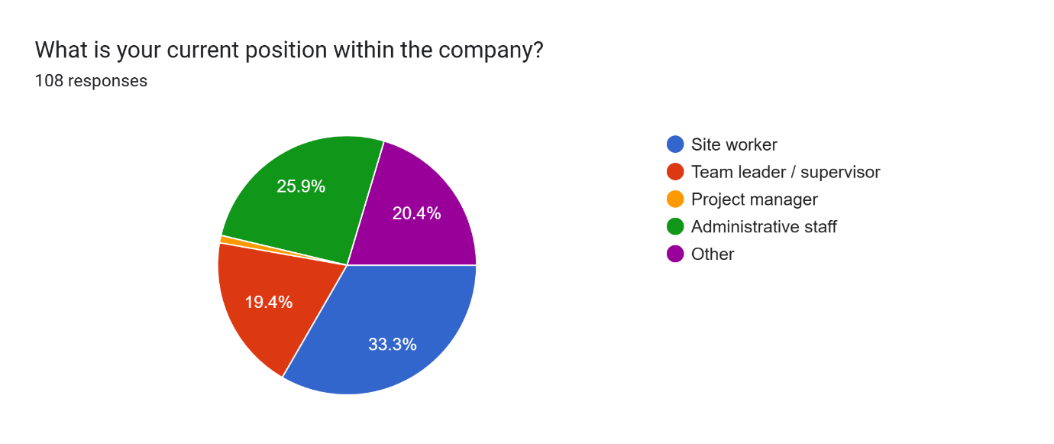
Figure 4.1: Distribution of respondents by current position

In terms of organisational tenure (Figure 4.2), 21 employees (19.4%) had been employed in their current company for less than one year, 34 (31.5%) for 1–3 years, and 27 (25.0%) for 4–6 years. Longer service was less common, with 10 respondents (9.3%) reporting 7–10 years of tenure and 16 (14.8%) indicating more than 10 years.
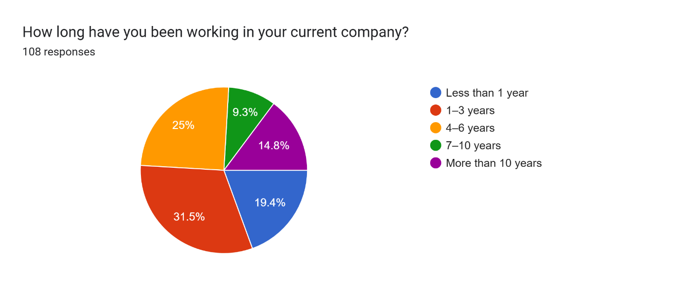
Figure 4.2: Distribution of respondents by organisational tenure

With respect to company size (Figure 4.3), most respondents were employed in medium-sized organisations (50–249 employees) (n = 51, 47.2%), followed by small firms (10–49 employees) (n = 37, 34.3%) and micro-enterprises (fewer than 10 employees) (n = 20, 18.5%).
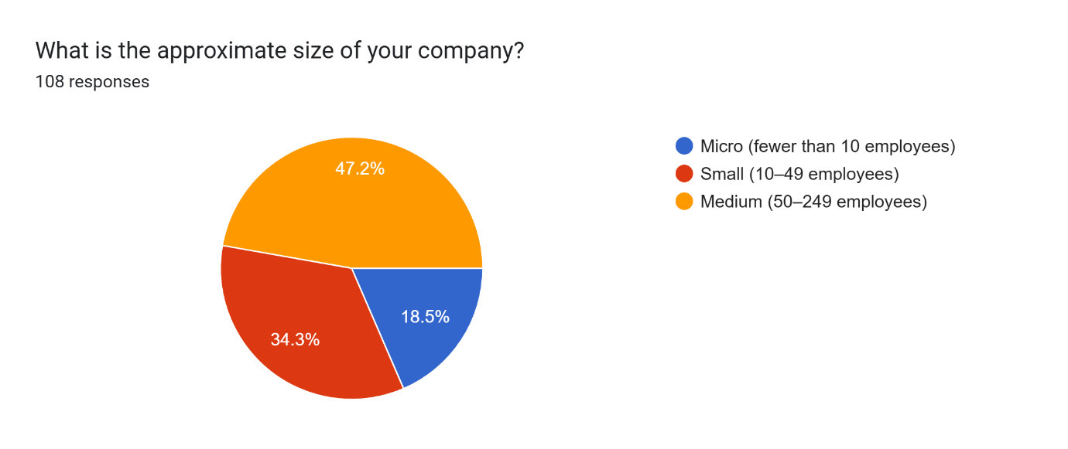
Figure 4.3: Distribution of respondents by company size

Overall, the demographic profile suggests that the dataset provides insights primarily into the experiences of non-managerial employees working in small and medium-sized construction organisations in the UK.

4.3 Main Analysis

4.3.1 Data preparation and scale construction
All items assessing leadership styles and organisational commitment were measured on a five-point Likert scale and were coded so that 1 corresponded to “strongly disagree” and 5 to “strongly agree”, ensuring that higher scores consistently reflected higher levels of the underlying construct. None of the statements required reverse coding, as all items were worded in a positive and conceptually aligned direction.
Composite scale scores were then computed by averaging the relevant items for each respondent. Transformational leadership (TL) was operationalised through five items (TL1–TL5), and transactional leadership (TrL) through a further five items (TrL1–TrL5), each set combined to form a single scale score. Overall employee organisational commitment was measured using five items (EOCa1–EOC5), from which an aggregate commitment score was derived. In line with the three-component model of organisational commitment, three sub-dimensions were also specified: affective commitment (mean of EOCa1 and EOCa2), continuance commitment (EOCc), and normative commitment (EOCn). These derived variables provided the basis for the subsequent reliability, descriptive, correlation, and regression analyses presented in this chapter.

4.3.2 Reliability analysis (Cronbach’s alpha)
The internal consistency of the multi-item scales was assessed using Cronbach’s alpha. The five-item transformational leadership scale (TL1–TL5) demonstrated good reliability (Table 4.1), with a Cronbach’s alpha of 0.89 (α = 0.885).
Table 4.1: Calculation of Cronbach’s alpha for the transformational leadership scale (Alpha_TL)
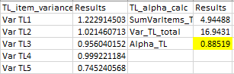

Similarly, the five-item transactional leadership scale (TrL1–TrL5) showed good internal consistency (Table 4.2), yielding an alpha of 0.89 (α = 0.891). These coefficients indicate that, in both cases, the items are strongly interrelated and can be treated as coherent composite measures of the underlying leadership constructs.
Table 4.2: Calculation of Cronbach’s alpha for the transactional leadership scale (Alpha_TrL)
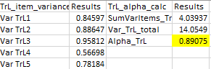

The overall organisational commitment scale, comprising five items (EOCa1–EOC5), also exhibited good reliability (Table 4.3), with a Cronbach’s alpha of 0.87 (α = 0.869). This supports the use of an overall commitment score in subsequent analyses.
Table 4.3: Calculation of Cronbach’s alpha for the organisational commitment scale (Alpha_EOC)
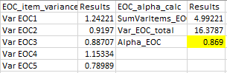

In addition, the affective commitment subscale (Table 4.4), based on two items (EOCa1–EOCa2), achieved an alpha of 0.82 (α = 0.821), which is acceptable for a short scale and suggests a satisfactory level of inter-item correlation.
Table 4.4: Calculation of Cronbach’s alpha for the affective organisational commitment scale (Alpha_EOCaff)
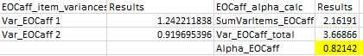

By contrast, the continuance and normative commitment components were each measured using a single item (EOCc and EOCn respectively). For single-item measures, internal consistency coefficients such as Cronbach’s alpha cannot be calculated, as they require variance shared across multiple items. These two indicators were therefore retained as single-item measures and interpreted with appropriate caution in the subsequent analysis.

4.3.3 Descriptive statistics
Descriptive statistics for the main study variables are presented in Table 4.5. On average, respondents reported moderate to moderately high levels of transformational leadership (TL) (mean = 3.41, SD = 0.82) and slightly higher levels of transactional leadership (TrL) (mean = 3.68, SD = 0.75). For both leadership styles, observed scores covered the full possible range from 1 to 5, indicating substantial variability in how employees perceived their leaders’ behaviours.
With regard to employee organisational commitment, the overall commitment (EOC_overal) score was also in the moderate range (mean = 3.34, SD = 0.81), with minimum and maximum values of 1.40 and 5.00 respectively. Examining the three components separately, affective commitment (EOC_affective) showed a mean of 3.47 (SD = 0.96), suggesting that many employees felt at least somewhat emotionally attached and proud to belong to their organisation. Continuance commitment (EOC_continuance) was slightly lower (mean = 3.14, SD = 0.94), indicating a moderate perception of costs associated with leaving the organisation. Normative commitment (EOC_normative) recorded the lowest mean (mean = 2.93, SD = 1.07), implying that employees, on average, felt comparatively less obligated to remain with their current employer. The relatively large standard deviation for normative commitment also suggests considerable dispersion in respondents’ sense of moral obligation towards their organisation.
Table 4.5: Descriptive statistics for transformational leadership, transactional leadership and organisational commitment variables
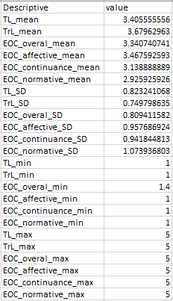

4.3.4 Correlation analysis (Pearson)
Pearson correlation coefficients were computed to examine the bivariate relationships between leadership style variables and employee organisational commitment. The results are summarised in Table 4.6.
Table 4.6: Pearson correlation coefficients between transformational leadership (TL), transactional leadership (TrL) and organisational commitment variables (EOC_overal, EOC_affective, EOCc, EOCn)
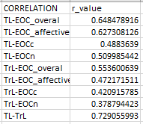
Transformational leadership (TL) showed strong positive associations with overall organisational commitment (EOC_overal, r = 0.65) and affective commitment (EOC_affective, r = 0.63), indicating that employees who perceived higher levels of transformational behaviour from their leaders also tended to report higher overall attachment to the organisation and stronger emotional identification with it. The correlations with continuance commitment (EOCc, r = 0.49) and normative commitment (EOCn, r = 0.51) were slightly weaker but still positive and of moderate magnitude, suggesting that transformational leadership is also linked to perceived costs of leaving and to feelings of obligation to remain.
Transactional leadership (TrL) was likewise positively related to all forms of commitment. It showed moderate positive correlations with overall organisational commitment (EOC_overal, r = 0.55) and affective commitment (EOC_affective, r = 0.47), and smaller but still meaningful associations with continuance (EOCc, r = 0.42) and normative commitment (EOCn, r = 0.38). These patterns indicate that both leadership styles are positively associated with how committed employees feel towards their organisation, with transformational leadership (TL) displaying consistently stronger correlations, particularly in relation to overall and affective commitment.
Finally, transformational and transactional leadership were themselves strongly and positively correlated (TL–TrL, r = 0.73), indicating that employees who rated their leaders highly on transformational behaviours also tended to perceive higher levels of transactional behaviours. This overlap is taken into account in the subsequent regression analyses, which assess the unique contribution of each leadership style to organisational commitment when both predictors are entered simultaneously in the same model.

4.3.5 Regression analysis
Linear regression models were estimated to examine the extent to which transformational leadership (TL) and transactional leadership (TrL) predict employee organisational commitment. Separate models were run for overall organisational commitment (EOC_overal) and affective commitment (EOC_affective), first with each leadership style entered individually and then with both entered simultaneously.
For overall organisational commitment (EOC_overal), transformational leadership emerged as a strong predictor. The simple regression model with TL alone was significant, R Square = 0.421, F = 76.92, p < .001, with a positive unstandardised coefficient (b = 0.64, p < .001), indicating that higher perceptions of TL were associated with higher overall commitment (Table 4.7).
Table 4.7: Simple linear regression of overall organisational commitment (EOC_overal) on transformational leadership (TL)
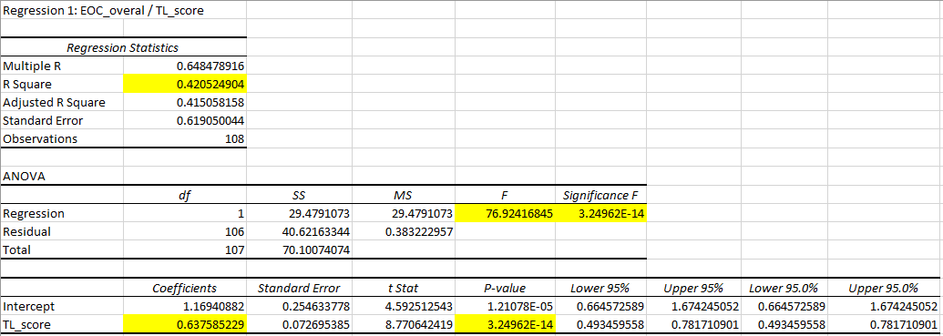

Transactional leadership also significantly predicted EOC_overal when entered on its own, R Square = 0.306, F = 46.84, p < .001, with a positive coefficient (b = 0.60, p < .001), (Table 4.8).
Table 4.8: Simple linear regression of overall organisational commitment (EOC_overal) on transactional leadership (TrL)
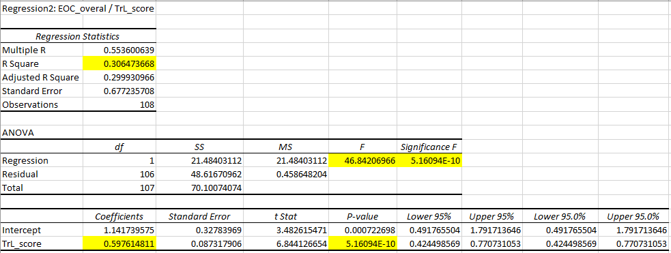

However, in the multiple regression model including both leadership styles, although the overall model remained significant, R Square = 0.434, F = 40.33, p < .001, only transformational leadership retained a significant unique effect on EOC_overal (b = 0.51, p < .001), whereas the coefficient for transactional leadership was no longer significant (b = 0.19, p = .111), (Table 4.9). This suggests that the apparent effect of TrL on overall commitment largely overlaps with, and is subsumed by, the influence of TL.
Table 4.9: Multiple linear regression of overall organisational commitment (EOC_overal) on transformational and transactional leadership (TL and TrL)
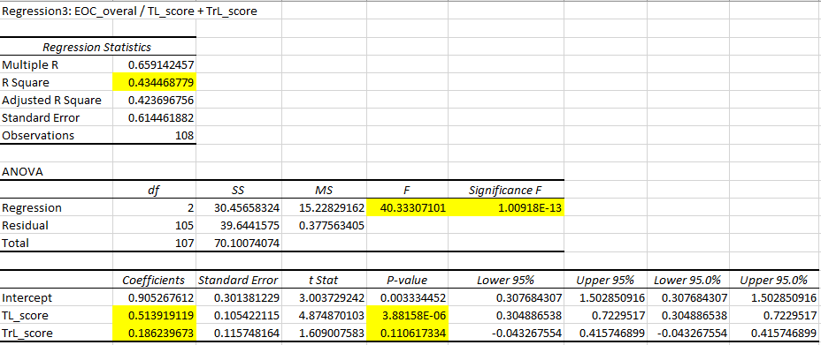

A similar pattern was observed for affective organisational commitment (EOC_affective). Transformational leadership significantly predicted affective commitment in the simple regression model, R Square = 0.394, F = 68.78, p < .001, with a positive coefficient (b = 0.73, p < .001), (Table 4.10).
Table 4.10: Simple linear regression of affective organisational commitment (EOC_affective) on transformational leadership (TL)
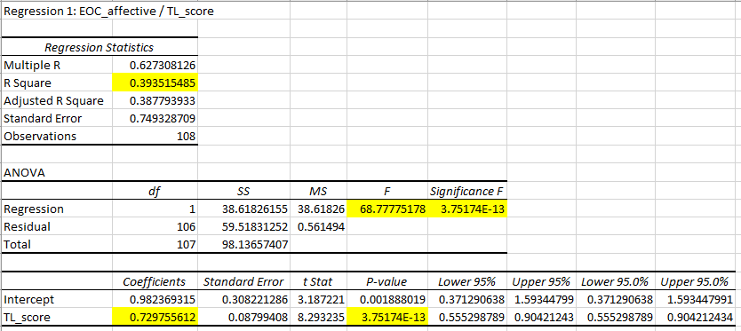

Transactional leadership also showed a significant positive effect when entered alone, R Square = 0.223, F = 30.41, p < .001, with b = 0.60 (p < .001), (Table 4.11).
Table 4.11: Simple linear regression of affective organisational commitment (EOC_affective) on transactional leadership (TrL)
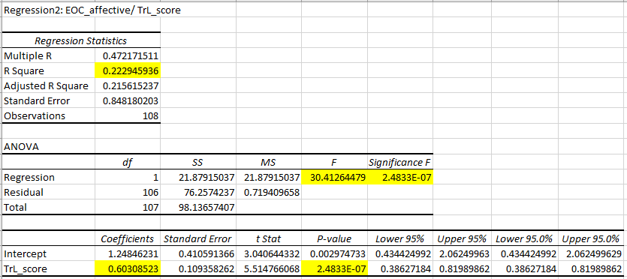

In the combined model including both TL and TrL, the regression remained significant, R Square = 0.394, F = 34.13, p < .001, but only transformational leadership retained a significant unique association with affective commitment (b = 0.70, p < .001), while the effect of transactional leadership became non-significant (b = 0.04, p = .776), (Table 4.12).
Table 4.12: Multiple linear regression of affective organisational commitment (EOC_affective) on transformational and transactional leadership (TL and TrL)
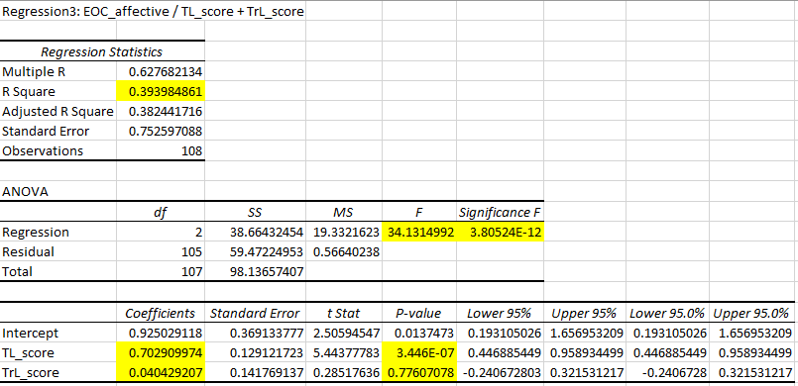

Taken together, these results indicate that both leadership styles are positively related to employees’ overall and affective commitment at the bivariate level, but when considered simultaneously, transformational leadership exerts the stronger and uniquely significant impact, whereas the contribution of transactional leadership is largely shared and does not remain significant after controlling for TL.

4.3.6 Group differences (ANOVA)
One-way ANOVA tests were used to examine whether organisational commitment differed across tenure categories and company size groups. For overall organisational commitment (EOC_overal), the analysis by tenure indicated a statistically significant effect, F = 4.32, p = 0.003. Employees with longer service (especially those with 4–6 years and more than 10 years in the current company) reported higher levels of overall commitment than those with shorter tenure (Table 4.13).
Table 4.13: One-way ANOVA of overall organisational commitment (EOC_overal) by tenure category
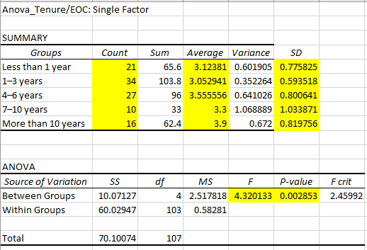

In contrast, the ANOVA for company size showed no significant differences in overall commitment between employees working in micro, small and medium-sized firms, F = 1.39, p = 0.253 (Table 4.14).
Table 4.14: One-way ANOVA of overall organisational commitment (EOC_overal) by company size
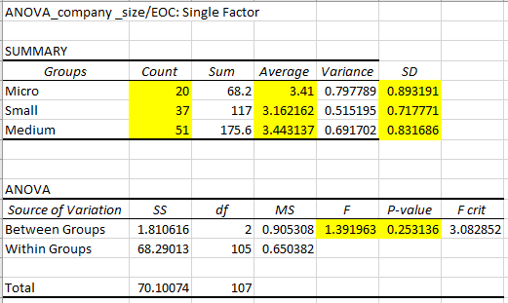

A similar pattern emerged for affective organisational commitment (EOC_affective). Tenure had a significant effect, F = 3.49, p = 0.010, with mean affective commitment increasing with length of service, and the highest scores observed among employees with more than 10 years in their current organisation (Table 4.15).
Table 4.15: One-way ANOVA of affective organisational commitment (EOC_affective) by tenure category
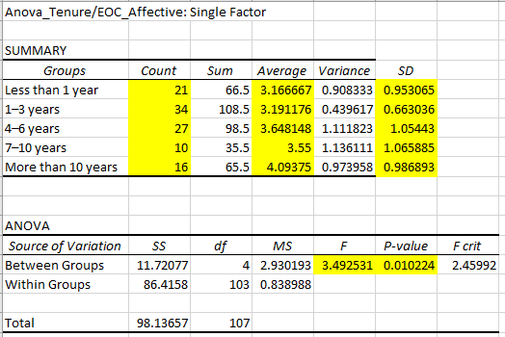

However, affective commitment did not differ significantly by company size, F = 1.37, p = 0.258, suggesting that, in this sample, employees’ emotional attachment to the organisation is more strongly related to how long they have worked there than to whether the firm is micro, small or medium-sized (Table 4.16).
Table 4.16: One-way ANOVA of affective organisational commitment (EOC_affective) by company size
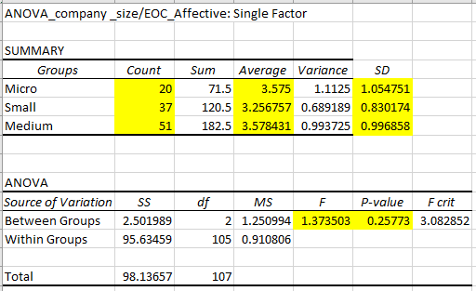

4.4 Discussion of Findings
This section discusses the empirical findings in relation to the research objectives, the literature reviewed in Chapter 2 and the conceptual distinction between transformational and transactional leadership and the three categories of organisational commitment (affective, continuance and normative) outlined by Keskes (2014). The discussion is structured by research objectives and highlights key patterns, consistencies and tensions with prior studies, as well as the study’s contribution in the context of UK construction SMEs.

4.4.1 Objective 1: To review the literature towards transformational and transactional leadership and their impact on employee commitment
The literature review distinguished clearly between transformational and transactional leadership as two complementary but conceptually distinct approaches. Transformational leadership focuses on vision, inspiration and individualised support, seeking to elevate values and long-term objectives (Armstrong, 2016; Steinmann, Klug and Maier, 2018). By contrast, transactional leadership emphasises structured exchanges, monitoring and contingent rewards to secure compliance and short-term stability (Armstrong, 2016; Selvarajah, 2024). Organisational commitment was framed as a multidimensional construct comprising affective, continuance and normative components (Keskes, 2014).
The empirical results align with this conceptual framing. Both transformational leadership (TL) and transactional leadership (TrL) showed positive correlations with overall organisational commitment and with all three components, indicating that higher perceptions of either style are associated with stronger employee attachment. However, the consistently stronger relationships between TL and both overall and affective commitment are in line with the argument that transformational leadership is particularly effective in fostering deeper, emotionally grounded forms of commitment, whereas transactional leadership is more strongly associated with calculative and obligation-based attachment (Keskes, 2014; Yahaya & Ebrahim, 2016; Andriansyah, Sudiro & Juwita, 2023). In this sense, the findings empirically support the theoretical distinction developed in Chapter 2 and confirm that both styles contribute to commitment, but not in identical ways.

4.4.2 Objective 2: To investigate how transformational leadership style influences employee commitment in UK construction SMEs
The findings provide robust evidence that transformational leadership has a strong positive influence on employee commitment in the sampled UK construction SMEs. Transformational leadership was strongly correlated with overall organisational commitment and affective commitment, and moderately associated with continuance and normative commitment. This pattern is consistent with the literature suggesting that transformational leaders strengthen affective commitment by building trust, promoting engagement and enhancing job satisfaction (Yuan et al., 2022; Eliyana, Ma’arif & Muzakki, 2019; Park et al., 2022).
Regression analyses reinforce this conclusion. In the simple regression models, TL significantly predicted both overall and affective commitment, explaining a substantial proportion of variance in each outcome. When TL and TrL were entered together in multiple regression models, transformational leadership remained a significant predictor of both overall and affective commitment, whereas the effect of transactional leadership became non-significant. This indicates that, in this context, transformational leadership is the primary driver of employee commitment, with transactional behaviours adding relatively little explanatory power once transformational elements are accounted for.
These results extend prior findings by demonstrating that the positive effects of transformational leadership on commitment, observed in other sectors and contexts (Yuan et al., 2022; Park et al., 2022), also apply to employees in small and medium-sized construction firms operating under project-based, high-pressure conditions (Boateng and Ackon, 2018; Pagabo, 2023). The evidence therefore supports the view that transformational leadership is particularly valuable in environments where motivation, stability and retention are critical despite resource constraints and operational uncertainty.

4.4.3 Objective 3: To investigate how transactional leadership style influences employee commitment in UK construction SMEs
The study also examined the influence of transactional leadership on commitment. Correlation analysis showed that transactional leadership was moderately and positively associated with overall organisational commitment and with affective, continuance and normative commitment. This supports the argument that transactional mechanisms such as clarifying roles, monitoring performance and providing contingent rewards can help stabilise employee attachment, particularly through continuance and normative components that reflect perceived costs of leaving and a sense of obligation (Yahaya & Ebrahim, 2016; Andriansyah, Sudiro & Juwita2023). Simple regression models confirmed that TrL significantly predicted both overall and affective commitment when considered alone, suggesting that transactional behaviours are not irrelevant for commitment in this context.
However, the multiple regression results nuance this picture. Once transformational leadership was entered into the models alongside transactional leadership, the coefficients for TrL were no longer statistically significant, while TL retained a strong and significant association with both overall and affective commitment. This indicates that the apparent impact of transactional leadership on commitment overlaps substantially with the influence of transformational leadership and does not represent an independent effect in the presence of strong transformational behaviours.
This finding partly contrasts with the suggestion that combining transformational and transactional leadership necessarily produces stronger commitment than transformational leadership alone (Puni, Hilton & Quao, 2021). In the present study, transactional leadership appears to act more as a supplementary mechanism that reinforces structure and clarity, rather than as a distinct source of commitment. At the same time, the positive correlations with continuance and normative commitment are consistent with the view that transactional practices tend to sustain more compliance-based and calculative forms of attachment that may be effective for short-term alignment but less powerful in generating enduring affective commitment (Yahaya & Ebrahim, 2016; Mahfouz, 2019; Andriansyah, Sudiro & Juwita, 2023). This pattern is particularly relevant for construction SMEs, where tight deadlines and procedural control are common but may not be sufficient to build deeper loyalty and identification.

4.4.4 Objective 4: To offer effective recommendations for leaders in construction SMEs
While detailed recommendations are presented in Chapter 5, the findings already suggest several themes with practical relevance for leaders in construction SMEs. First, the stronger and uniquely significant impact of transformational leadership on both overall and affective commitment indicates that leadership development efforts should prioritise behaviours linked to vision, inspiration and individual support (Armstrong, 2016; Steinmann, Klug and Maier, 2018; Yuan et al., 2022; Park et al., 2022). In line with the literature, these behaviours appear particularly important for building affective commitment, which, as emphasised by Keskes (2014), reflects employees’ desire to remain with the organisation because they want to, rather than because they need or feel obliged to do so.
Second, the positive but weaker relationships between transactional leadership and commitment suggest that transactional practices can play a useful, complementary role by providing structure and reinforcing expectations, especially in the project-based and resource-constrained environment typical of construction SMEs (Boateng and Ackon, 2018; Mahfouz, 2019; Department for Business Innovation and Skills, 2015). However, the regression results indicate that transactional leadership alone is unlikely to generate strong affective commitment if not embedded within a broader transformational style, and over-reliance on monitoring and corrective control risks producing narrow, compliance-based attachment (Yahaya & Ebrahim, 2016; Andriansyah, Sudiro & Juwita, 2023).
Finally, the ANOVA findings showed that both overall and affective commitment tended to be higher among employees with longer tenure, while no significant differences were found by company size. This suggests that, within construction SMEs, organisational commitment is shaped more by the quality and continuity of the employment relationship over time than by structural characteristics such as being a micro, small or medium-sized enterprise (Department for Business Innovation and Skills, 2015; Wicker, 2025). Taken together, these patterns indicate that leaders in construction SMEs should focus on sustaining transformational behaviours over time, complemented by well-calibrated transactional practices, in order to build strong and durable forms of employee commitment under demanding operating conditions.

4.5 Implications of the Findings
This section outlines the implications of the study’s results for theory and practice, with particular reference to the distinction between transformational and transactional leadership and the three categories of organisational commitment identified by Keskes (2014).

4.5.1 Theoretical implications
The findings reinforce the conceptual distinction between transformational and transactional leadership by showing that, although both styles are positively associated with organisational commitment, transformational leadership is more strongly and consistently related to overall and affective commitment. This supports the view that transformational behaviours such as articulating a compelling vision, demonstrating individualised consideration and fostering trust are especially important for strengthening employees’ emotional attachment to the organisation, which corresponds to affective commitment as described by Keskes (2014).
The study adds nuance to existing work on transactional leadership by showing that its positive associations with continuance and normative commitment do not translate into a strong independent predictive effect once transformational leadership is controlled for. This aligns with prior evidence that transactional practices are more closely linked to retention-oriented and obligation-based forms of attachment, reflecting employees’ perception that they stay because they need to or feel they ought to, rather than because they want to (Keskes, 2014). The results therefore suggest that transactional leadership contributes to commitment in a more instrumental and dependent way, reinforcing but not replacing the deeper relational mechanisms associated with transformational leadership.
The finding that transformational leadership remains a significant predictor of commitment when entered alongside transactional leadership speaks to debates about the value of combining the two styles. While previous research has suggested that a mixed approach can in some cases strengthen commitment compared to transformational leadership alone, the present study indicates that, in UK construction SMEs, the transformational component exerts the dominant influence, with transactional elements adding limited additional explanatory power (Puni, Hilton & Quao, 2021). This contributes context-specific evidence to the literature and suggests that the benefits of a blended style may be contingent on sectoral conditions and on how leadership is enacted in practice.
Finally, the observed association between longer organisational tenure and higher levels of both overall and affective commitment provides empirical support for the idea that commitment develops over time through repeated interactions between employees, leaders and organisational systems. This is consistent with prior work emphasising the importance of effective leadership and people management for building commitment in resource-constrained SMEs, particularly in the construction sector where projects are complex and work conditions demanding (Boateng and Ackon, 2018). The results thus highlight the relevance of examining leadership-commitment relationships within specific organisational and sectoral contexts rather than assuming that findings from large organisations generalise automatically to SMEs.

4.5.2 Practical implications
From a practical perspective, the findings underline the importance of prioritising transformational leadership behaviours in construction SMEs that seek to strengthen employee commitment. Given the strong and unique impact of transformational leadership on overall and affective commitment, leaders and managers should focus on communicating a clear and meaningful vision, recognising individual contributions, and providing ongoing support for employees’ development and well-being (Armstrong, 2016). In the high-pressure, project-driven environment of construction, such behaviours can help employees feel valued and emotionally connected to the organisation, increasing the likelihood that they remain because they genuinely want to.
At the same time, the positive associations between transactional leadership and commitment suggest that transactional mechanisms should not be discarded but rather integrated carefully as part of a broader leadership approach. Clear goals, structured monitoring and contingent rewards can provide much-needed stability and predictability in SMEs that operate under tight deadlines and limited resources, supporting employees’ perception that expectations are fair and performance is recognised (Mahfouz, 2019). However, the regression results indicate that relying predominantly on transactional control is unlikely to create strong affective commitment and may instead keep commitment at a more calculative level, where employees remain mainly because of perceived costs or obligations.
The absence of significant differences in commitment by company size also has practical relevance. It suggests that even micro and small firms, which may lack formal HR structures, can still foster strong organisational commitment if leadership practices are aligned with transformational principles and embedded consistently in daily interactions (Department for Business Innovation and Skills, 2015). For owners and managers in construction SMEs, this implies that investing in leadership development rather than solely in structural or procedural changes may be a particularly effective route to enhancing employee stability and motivation under the sector’s challenging operating conditions (Pagabo, 2023).
Overall, the findings indicate that construction SME leaders should view transformational leadership as the foundation for building robust organisational commitment, with transactional practices used selectively to provide structure and reinforcement, rather than as the primary basis of the leader-follower relationship.

4.6 Summary
This chapter has presented and analysed the empirical findings of the study in line with the stated research objectives. The demographic analysis showed that the sample comprised 108 employees working in UK construction SMEs, predominantly in non-managerial roles such as site workers and administrative staff, with a broad spread of organisational tenure and representation across micro, small and medium-sized firms. The data preparation procedures and scale construction were outlined, including the coding of Likert responses and the creation of composite scores for transformational leadership (TL), transactional leadership (TrL) and organisational commitment (EOC_overal and its affective, continuance and normative components). Reliability analysis indicated good internal consistency for all multi-item scales (TL, TrL, EOC_overal and EOC_affective), supporting their use in subsequent statistical analyses, while continuance and normative commitment were retained as single-item indicators and interpreted with appropriate caution.
Descriptive statistics revealed that respondents perceived both transformational and transactional leadership at moderate to moderately high levels, with slightly higher mean scores for transactional leadership. Overall organisational commitment (EOC_overal) was also moderate, with affective commitment showing the highest mean, continuance commitment at a slightly lower level, and normative commitment the lowest, suggesting that employees were more emotionally attached to and constrained by their organisation than morally obligated to remain. Correlation analysis showed that both TL and TrL were positively associated with overall and component forms of commitment, but with consistently stronger relationships for TL, particularly in relation to EOC_overal and EOC_affective.
Regression analyses further clarified these relationships by demonstrating that, although both leadership styles significantly predicted overall and affective commitment when considered separately, only transformational leadership retained a significant unique effect when both TL and TrL were included in the same model. This indicates that transformational leadership exerts the stronger and more distinctive influence on employee organisational commitment in this sample, while the apparent impact of transactional leadership overlaps substantially with transformational behaviours. Group comparisons using one-way ANOVA showed that both overall and affective commitment differed significantly by tenure, with higher levels among employees with longer service, but did not vary significantly by company size, suggesting that the length of the employment relationship is more important for commitment than organisational scale.
Taken together, the findings show that transformational leadership is the primary leadership style associated with stronger employee organisational commitment in UK construction SMEs, with transactional leadership playing a more limited, complementary role. These empirical results provide the basis for the conclusions and practical recommendations that are developed in the final chapter.

Chapter 5: Conclusions, Limitations and Recommendations

5.1. Introduction
This chapter brings together the main conclusions of the study on the impact of transformational and transactional leadership styles on employee organisational commitment in small and medium-sized enterprises in the UK construction industry. It first presents conclusions for each research objective, then addresses the overall research problem, followed by a summary of the key empirical findings and outcomes. The chapter also outlines the original contribution of the research, acknowledges its main limitations, and offers recommendations for both practice and future research.

5.2. Conclusions on Each Research Objective

5.2.1 Objective 1: To review the literature towards transformational and transactional leadership and their impact on employee commitment
The first objective has been addressed through the conceptual clarification provided in Chapter 2 and tested indirectly through the empirical results in Chapter 4. The literature review established that transformational and transactional leadership are related but conceptually distinct styles: transformational leadership is centred on vision, inspiration and individualised support, whereas transactional leadership relies on structure, monitoring and contingent rewards (Armstrong, 2016; Steinmann, Klug and Maier, 2018; Selvarajah, 2024). Organisational commitment was framed as a multidimensional construct comprising affective, continuance and normative components, each capturing a different form of attachment to the organisation (Keskes, 2014).
The empirical findings confirm that both leadership styles are positively related to overall organisational commitment and to each of its components, but also support the view that they operate differently. Transformational leadership is more strongly associated with overall and affective commitment, while transactional leadership shows relatively stronger links with more instrumental and obligation-based aspects of commitment, in line with prior work (Keskes, 2014; Yahaya & Ebrahim, 2016; Andriansyah, Sudiro & Juwita, 2023). Overall, the study concludes that the literature-based distinction between transformational and transactional leadership, and between the three commitment components, is empirically meaningful and relevant for understanding employee attitudes in UK construction SMEs.

5.2.2 Objective 2: To investigate how transformational leadership style influences employee commitment in UK construction SMEs
The second objective is clearly supported by the findings. Transformational leadership showed strong positive correlations with overall organisational commitment (EOC_overal) and affective commitment, and moderate positive correlations with continuance and normative commitment. This indicates that higher perceptions of transformational behaviour are associated with stronger overall attachment, greater emotional identification with the organisation and, to a lesser extent, with perceptions of cost and obligation related to staying.
Regression analyses confirm that transformational leadership is a key predictor of commitment in this context. In the simple regression models, TL significantly predicted both overall and affective commitment, explaining a substantial proportion of their variance. In the multiple regression models that included both TL and TrL, transformational leadership remained a significant predictor of overall and affective commitment, while transactional leadership no longer exerted a significant independent effect. The study therefore concludes that transformational leadership is the primary driver of employee organisational commitment in UK construction SMEs, particularly in terms of affective commitment, echoing evidence that such leadership strengthens commitment through trust, engagement and job satisfaction (Yuan et al., 2022; Eliyana, Ma’arif & Muzakki, 2019; Park et al., 2022).

5.2.3 Objective 3: To investigate how transactional leadership style influences employee commitment in UK construction SMEs
With regard to the third objective, the findings indicate that transactional leadership does have a positive association with employee organisational commitment, but its influence is more limited than that of transformational leadership. At the correlational level, transactional leadership was positively related to overall, affective, continuance and normative commitment, suggesting that clearer expectations, monitoring and contingent rewards are linked to stronger employee attachment, particularly in terms of perceived costs of leaving and sense of obligation (Yahaya & Ebrahim, 2016; Andriansyah, Sudiro & Juwita, 2023). Simple regression models confirmed that TrL significantly predicts both overall and affective commitment when examined in isolation.
However, once transformational leadership is included alongside transactional leadership in multiple regression models, the unique effect of TrL on both overall and affective commitment becomes non-significant, while TL remains a strong and significant predictor. The study therefore concludes that, in UK construction SMEs, transactional leadership contributes to organisational commitment primarily in conjunction with transformational leadership rather than as an independent driver. This partially qualifies arguments that a blended approach automatically enhances commitment beyond transformational leadership alone (Puni, Hilton & Quao, 2021) and supports the view that transactional leadership, used on its own, tends to generate more compliance-based and calculative forms of attachment (Mahfouz, 2019; Yahaya & Ebrahim, 2016).

5.2.4 Objective 4: To offer effective recommendations for leaders in construction SMEs
The fourth objective is addressed by translating the empirical findings into practice-oriented conclusions. The results show that transformational leadership exerts the strongest and most consistent influence on both overall and affective organisational commitment, while transactional leadership plays a complementary but secondary role. On this basis, the study concludes that leaders in construction SMEs who seek to strengthen employee commitment should prioritise transformational behaviours such as articulating a clear vision, recognising individual contributions and supporting employee development while using transactional practices to provide structure, clarity and fair reinforcement of performance (Armstrong, 2016; Steinmann, Klug and Maier, 2018; Yuan et al., 2022; Park et al., 2022).
The ANOVA results further indicate that commitment is higher among employees with longer organisational tenure, whereas no significant differences are observed by company size. This leads to the conclusion that, within UK construction SMEs, sustained, high-quality leader-follower relationships over time are more important for building commitment than formal organisational scale, in line with prior work on the importance of leadership and people management in resource-constrained SMEs (Boateng and Ackon, 2018; Department for Business Innovation and Skills, 2015; Pagabo, 2023).

5.3 Conclusions on the Research Problem
The research set out to address the lack of evidence on how transformational and transactional leadership styles influence employee organisational commitment in small and medium-sized construction enterprises in the UK, a context marked by tight deadlines, cost pressures and resource constraints (Boateng and Ackon, 2018; Department for Business Innovation and Skills, 2015; Pagabo, 2023).
Overall, the findings show that both transformational and transactional leadership are positively associated with employee organisational commitment, but that transformational leadership is the main driver of commitment in this context. Transformational leadership demonstrated stronger correlations with overall and affective commitment and remained a significant predictor in all multiple regression models, whereas the effect of transactional leadership became non-significant once TL was controlled for. This indicates that inspiration, vision and individual support are more influential than monitoring and contingent rewards in fostering strong, especially affective, attachment to the organisation (Armstrong, 2016; Keskes, 2014; Yuan et al., 2022; Park et al., 2022).
The results also show that organisational commitment varies by tenure but not by company size, suggesting that commitment develops over time through ongoing relationships and leadership practices rather than being determined by whether the firm is micro, small or medium-sized (Boateng and Ackon, 2018; Department for Business Innovation and Skills, 2015; Wicker, 2025). In summary, the research problem can be answered by concluding that, in UK construction SMEs, transformational leadership provides the primary basis for sustaining employee organisational commitment, with transactional leadership playing a supportive but secondary role.

5.4 Summary of Research Findings and Outcomes
The study found that employees in UK construction SMEs reported moderate levels of both transformational and transactional leadership, as well as moderate overall organisational commitment, with affective commitment higher than continuance and normative components. Both leadership styles were positively related to overall commitment and to all three commitment dimensions, but transformational leadership showed consistently stronger associations, especially with overall and affective commitment.
Regression analyses demonstrated that while each leadership style significantly predicted overall and affective commitment when considered separately, only transformational leadership retained a significant unique effect when both were included in the same model. Transactional leadership’s apparent influence was largely shared with, and subsumed by, transformational leadership. ANOVA results showed that commitment (overall and affective) was significantly higher among employees with longer tenure, but did not differ by company size.
Overall, the main outcomes indicate that transformational leadership is the primary driver of employee organisational commitment in UK construction SMEs, with transactional leadership playing a supportive, complementary role.

5.5 Original Contribution of the Research
This research offers an original contribution by providing context-specific empirical evidence on the impact of transformational and transactional leadership on employee organisational commitment in UK construction SMEs, a setting that has been comparatively underexplored compared with larger organisations and other national contexts (Boateng and Ackon, 2018; Department for Business Innovation and Skills, 2015; Pagabo, 2023).
Conceptually, the study combines the distinction between transformational and transactional leadership (Armstrong, 2016; Steinmann, Klug and Maier, 2018; Selvarajah, 2024) with the three-component model of organisational commitment (affective, continuance, normative) (Keskes, 2014), and tests these relationships empirically within a single, coherent quantitative framework.
Empirically, the study shows that transformational leadership has a stronger and unique impact on overall and affective organisational commitment than transactional leadership when both are considered simultaneously, and that commitment varies by tenure but not by company size. These findings refine existing theory by clarifying the relative weight of TL and TrL in a high-pressure SME construction context and by highlighting the importance of sustained employment relationships for developing stronger forms of employee organisational commitment.

5.6 Limitations of the Research
Several limitations should be acknowledged when interpreting the findings of this study. First, the research is based on a cross-sectional design using self-report questionnaire data, which means that relationships between leadership styles and organisational commitment are correlational and cannot be interpreted as strictly causal. Self-report measures also raise the possibility of common method bias and social desirability effects, as respondents reported both perceptions of leadership and their own commitment at the same time.
Second, the sample was obtained through online, non-probability sampling (Google Forms distributed via social media and the researcher’s professional network) and is limited to 108 employees working in UK construction SMEs. The sample is predominantly composed of non-managerial staff, which restricts the generalisability of the findings to other occupational groups or to different organisational or sectoral contexts.
Third, although the main scales for transformational leadership, transactional leadership and overall organisational commitment showed good internal consistency, the continuance and normative commitment components were each measured using a single item, and the affective commitment subscale comprised only two items. This constrains the reliability and depth with which the three commitment components can be assessed and may limit the precision of conclusions drawn about differences between them.
Finally, the study focuses exclusively on transformational and transactional leadership, without including other leadership styles or contextual variables (such as organisational climate or HR practices) that might also influence organisational commitment. As a result, the models provide only a partial view of the wider set of factors that may shape commitment in UK construction SMEs.

5.7 Recommendations for Future Research

5.7.1 Practical recommendations for leaders in construction SMEs
Leaders in UK construction SMEs should prioritise transformational behaviours, such as clarifying a clear vision, recognising individual contributions and building trust and engagement, as these showed the strongest and most distinctive effects on overall and affective organisational commitment. Transactional practices should be used as a complementary support rather than as the primary leadership approach and combined with efforts to retain employees over time, since organisational commitment was higher among those with longer tenure.

5.7.2 Directions for future research
Future research could employ longitudinal or mixed-method designs, supported by larger and more diverse samples, to examine how relationships between leadership styles and organisational commitment develop over time and across different organisational roles and firms. Further studies should also use more comprehensive multi-item measures of continuance and normative commitment and incorporate additional leadership and contextual variables, such as the quality of leader-follower relationships, organisational climate and human resource practices, in order to develop more complete models of organisational commitment in construction SMEs.

5.8 Summary
This chapter has summarised the study’s main conclusions regarding the impact of transformational and transactional leadership on employee organisational commitment in UK construction SMEs, showing that transformational leadership is the primary driver of overall and affective commitment, while transactional leadership plays a complementary, more limited role. It has drawn together conclusions for each research objective and for the overall research problem, outlined the key empirical findings and their theoretical and practical implications, and clarified how the study contributes to understanding leadership-commitment relationships in a project-based, resource-constrained context. The chapter has also acknowledged important limitations related to research design, sampling and measurement, and has proposed practical recommendations for SME leaders alongside directions for future research. Together, these points provide a coherent reflection on how leadership can support stronger organisational commitment in the UK construction SME sector.

References and Bibliography
Adams, J., Raeside, R., Khan, H. (2014) Research Methods for Business and Social Science Students. SAGE Publications.
Andriansyah, M.A., Sudiro, A. & Juwita, H.A.J. (2023) ‘Employee performance as mediated by organisational commitment between transactional leadership and role ambiguity’, International Journal of Research in Business and Social Science, 12(5), pp. 139–150. doi:10.20525/ijrbs.v12i5.2669.
Armstrong, M. (2016) Armstrong’s handbook of management and leadership for HR: Developing effective people skills for better leadership and management. 4th ed. London: Kogan Page.
Blaxter, L., Hughes, C., Tight, M. (2010) How to research. FOURTH EDITION. McGraw-Hill/Open University Press.
Boateng, C. & Ackon, F. (2018) ‘The Influence of Transformational and Transactional Leadership Styles of Site Managers on Job Performance of Crafts in Cape Coast Metropolis’, International Journal of Vocational and Technical Education, 8(11), pp. 32-43. Available at: https://core.ac.uk/download/234683394.pdf (Accessed: 22 July 2025).
Collis, J., Hussey, R. (2021) Business research: a practical guide for students. Red Globe Press.
Curwin, J., Slater, R., Eadson, D. (2013) Quantitative methods for business decisions. Seventh edition. Cengage Learning.
Department for Business Innovation and Skills (2015). Leadership and management skills in SMEs: Measuring associations with management practices and performance. London: BIS. (BIS Research Paper Number 211). Available at: https://assets.publishing.service.gov.uk/media/5a7f7f53e5274a2e87db6356/BIS-15-95_Leadership_and_Management_Skills_in_SMEs.pdf (Accessed: 7 August 2025).
Denscombe, M. (2012) Research proposals: a practical guide. McGraw Hill Open University Press.
Duignan, J. (2016) A dictionary of business research methods. Oxford University Press.
Eliyana, A., Ma’arif, S. & Muzakki (2019) ‘Job satisfaction and organizational commitment effect in the transformational leadership towards employee performance’, European Research on Management and Business Economics, 25(3), pp. 144–150. doi:10.1016/j.iedeen.2019.05.001.
Keskes, I. (2014) ‘Relationship between leadership styles and dimensions of employee organizational commitment: A critical review and discussion of future directions’, Intangible Capital, 10(1), pp. 26–51. Available at: https://research-ebsco-com.ezproxy.uwtsd.ac.uk/c/onvpsy/viewer/pdf/htq2zav3un (Accessed: 10 August 2025).
Koomson, G.A., Tetteh, E.S. and Bosamtwi, E.B. (2022) ‘The Impact of Transformational Leadership on Motivation and Performance in Selected Public Sector Organizations’, Advances in Social Sciences Research Journal, 9(6), pp. 68–89. Available at: https://doi.org/10.14738/assrj.96.12298 (Accessed: 15 July 2025).
Mahfouz, S.A. (2019) ‘The Impact of Transactional Leadership on Employee Commitment’, International Journal of Innovation, Creativity and Change, 8(8). Available at: https://ijicc.net/images/vol8iss8/8801_Mahfouz_2019_E_R.pdf (Accessed: 19 August 2025).
McNeill, P., Chapman, S. (2005) Research methods. 3rd ed. Routledge.
Meyer, J.P. and Allen, N.J. (1990) 'The measurement and antecedents of affective, continuance and normative commitment to the organization', Journal of Occupational Psycholoy, 63, pp 1-18.
Miller, S.R., Moore, F. and Eden, L. (2024) ‘Ethics and international business research: Considerations and best practices’, International Business Review, 33(1), 102207. Available at: https://www-sciencedirect-com.ezproxy.uwtsd.ac.uk/science/article/pii/S0969593123001075
Murray, N., Hughes, G. (2008) Writing up your university assignments and research projects: a practical handbook. Open University Press.
O’Gorman, K. and MacIntosh, R. (2015) Research methods for business & management: a guide to writing your dissertation. 2nd ed. Oxford: Goodfellow Publishers Ltd.
Pagabo (2023) ‘Survey explores challenges facing the construction industry’, Pagabo, 13 April. Available at: https://pagabo.co.uk/news/55-construction-industry-leaders-reveal-what-challenges-mean-for-the-future (Accessed: 19 July 2025).
Park, J., Han, S.J., Kim, J. & Kim, W. (2022) ‘Structural relationships among transformational leadership, affective organizational commitment, and job performance: the mediating role of employee engagement’, European Journal of Training and Development, 46(9), pp. 920–936. doi:10.1108/EJTD-10-2020-0149.
Paul, P. (2012) Succeeding with your literature review: a handbook for students. Open University Press; McGraw-Hill.
Puni, A., Hilton, S.K. & Quao, B. (2021) ‘The interaction effect of transactional-transformational leadership on employee commitment in a developing country’, Management Research Review, 44(3), pp. 399–417. doi:10.1108/MRR-03-2020-0153.
Saunders, M., Lewis, P. and Thornhill, A. (2019) Research methods for business students. 8th ed. Harlow: Pearson Education Limited.
Selvarajah, T. (2024) 'A Study of the Effects of Transactional Leadership on Employee Motivation and Performance', Malaysian Journal of Business, Economics and Management, 3(1), pp. 101–115. Available at: https://mjbem.com.my/index.php/mjbem/article/download/43/34 (Accessed: 19 July 2025).
Song, L. (2025) ‘Transformational Versus Transactional Leadership: Implications for SME Management’, Frontiers in Business, Economics and Management, 18(1), pp. 133–150. Available at: https://drpress.org/ojs/index.php/fbem/article/download/29260/28713/42445 (Accessed: 18 July 2025).
Steinmann, B., Klug, H.J., and Maier, G.W. (2018) “The Path Is the Goal: How Transformational Leaders Enhance Followers’ Job Attitudes and Proactive Behavior,” Frontiers in Psychology. Available at: https://pmc.ncbi.nlm.nih.gov/articles/PMC6281759/ (Accessed: 19 July 2025).
Wicker, J. (2025) Leadership in the construction industry: An LMX analysis. Bridgewater College. Available at: https://digitalcommons.bridgewater.edu/cgi/viewcontent.cgi?article=1924&context=honors_projects (Accessed: 18 July 2025).
Yahaya, R. & Ebrahim, F. (2016) ‘Leadership styles and organizational commitment: literature review’, Journal of Management Development, 35(2), pp. 190–216. doi:10.1108/JMD-01-2015-0004.
Yuan, Y., Kong, H., Baum, T., Liu, Y., Liu, C., Bu, N., Wang, K. & Yin, Z. (2022) ‘Transformational leadership and trust in leadership impacts on employee commitment’, Tourism Review, 77(5), pp. 1385–1399. doi:10.1108/TR-10-2020-0477.

Appendices

Appendix A
The Impact of Transformational and
Transactional Leadership Styles on Employee Organisational Commitment in Small and Medium-Sized Enterprises (SMEs) in the UK Construction Industry
Researcher: Ionel Golovatii
Institution: University of Wales Trinity Saint David – London Campus
Module: LCBB6000 – Dissertation
* Indicates required question
Introduction and Purpose
You are invited to take part in a research study exploring how different leadership styles, transformational and transactional, influence employee organisational commitment within small and medium-sized enterprises (SMEs) in the UK construction industry.
This research aims to investigate the impact of transformational and transactional leadership styles on employee commitment in UK construction SMEs. The study seeks to understand how these two leadership styles affect employees’ level of commitment to their organisation and to determine which leadership practices are most effective in strengthening this commitment.
Confidentiality and Anonymity
Your participation is completely voluntary and anonymous. No personal or identifiable data (such as your name, email, or company name) will be collected.
All information provided will be treated with strict confidentiality and used only for academic purposes as part of the dissertation project.
You may withdraw at any time by closing the form before submitting your answers. Once submitted, your responses cannot be identified or removed because no personal information is stored.
Consent to Participate
By proceeding with this questionnaire, you confirm that:

You are currently or have recently been employed in a small or medium-sized construction company in the UK.

You have read the information above and agree to participate voluntarily.

You understand that your answers will be used anonymously for academic research purposes only.

The questionnaire contains 18 short questions and should take about 5–7 minutes to complete.
Please click “Next” to begin the questionnaire.
Demographic Information
- What is your current position within the company? *
Mark only one oval.
Site worker
Team leader/supervisor
Project manager
Administrative staff
Other
- How long have you been working in your current company? *
Mark only one oval.
Less than 1 year
1–3 years
4–6 years
7–10 years
More than 10 years
- What is the approximate size of your company? *
Mark only one oval.
Micro (fewer than 10 employees)
Small (10–49 employees)
Medium (50–249 employees)
Transformational Leadership Style
- My supervisor inspires me to see the importance of my work in achieving the * company’s goals.
Mark only one oval per row.
Strongly
Disagree
Disagree
Neutral
Agree
Strongly
Agree
Answer
- My supervisor encourages me to think about problems in new and creative * ways.
Mark only one oval per row.
Strongly
Disagree
Disagree
Neutral
Agree
Strongly
Agree
Answer
- My supervisor shows genuine concern for my personal development and * growth.
Mark only one oval per row.
Strongly
Disagree
Disagree
Neutral
Agree
Strongly
Agree
Answer
- My supervisor communicates a clear and motivating vision for the future. *
Mark only one oval per row.
Strongly
Disagree
Disagree
Neutral
Agree
Strongly
Agree
Answer
- My supervisor earns my trust through fairness, honesty, and consistency. *
Mark only one oval per row.
Strongly
Disagree
Disagree
Neutral
Agree
Strongly
Agree
Answer
Transactional Leadership Style
- My supervisor sets clear goals and performance expectations. *
Mark only one oval per row.
Strongly
Disagree
Disagree
Neutral
Agree
Strongly
Agree
Answer
- My supervisor recognises and rewards me when I meet agreed targets. *
Mark only one oval per row.
Strongly
Disagree
Disagree
Neutral
Agree
Strongly
Agree
Answer
- My supervisor closely monitors my performance to ensure tasks are done * correctly.
Mark only one oval per row.
Strongly
Disagree
Disagree
Neutral
Agree
Strongly
Agree
Answer
- My supervisor provides feedback or corrective action when mistakes occur. *
Mark only one oval per row.
Strongly
Disagree
Disagree
Neutral
Agree
Strongly
Agree
Answer
- My supervisor focuses on maintaining clear rules and procedures to ensure * results.
Mark only one oval per row.
Strongly
Disagree
Disagree
Neutral
Agree
Strongly
Agree
Answer
Employee Organisational Commitment
- I feel emotionally attached to my organisation. *
Mark only one oval per row.
Strongly
Disagree
Disagree
Neutral
Agree
Strongly
Agree
Answer
- I am proud to tell others that I work for this company. *
Mark only one oval per row.
Strongly
Disagree
Disagree
Neutral
Agree
Strongly
Agree
Answer
- It would be difficult for me to leave this company because of what I would lose. *
Mark only one oval per row.
Strongly
Disagree
Disagree
Neutral
Agree
Strongly
Agree
Answer
- I feel a sense of obligation to remain with this organisation. *
Mark only one oval per row.
Strongly
Disagree
Disagree
Neutral
Agree
Strongly
Agree
Answer
- I am willing to put in extra effort to help my organisation succeed. *
Mark only one oval per row.
Strongly
Disagree
Disagree
Neutral
Agree
Strongly
Agree
Answer

This content is neither created nor endorsed by Google.
Forms

Appendix B
APPLICATION FOR ETHICAL APPROVAL

RESEARCH STUDENTS
This form is to be completed by the student within SIX months for full-time students and TWELVE months for part time students, after the commencement of the research degree or following progression to Part Two of your course.

Once complete, submit this form via the MyTSD Doctoral College Portal at (https://mytsd.uwtsd.ac.uk).

This document is also available in Welsh.

RESEARCH STAFF ONLY
All communications relating to this application during its processing must be in writing and emailed to pgresearch@uwtsd.ac.uk , with the title ‘Ethical Approval’ followed by your name.

STUDENTS ON UNDERGRADUATE OR TAUGHT MASTERS PROGRAMMES should submit this form (and receive the outcome) via systems explained to you by the supervisor/module leader.

In order for research to result in benefit and minimise risk of harm, it must be conducted ethically. A researcher may not be covered by the University’s insurance if ethical approval has not been obtained prior to commencement.

The University follows the OECD Frascati manual definition of research activity: “creative work undertaken on a systematic basis in order to increase the stock of knowledge, including knowledge of man, culture and society, and the use of this stock of knowledge to devise new applications”. As such this covers activities undertaken by members of staff, postgraduate research students, and both taught postgraduate and undergraduate students working on dissertations/projects.

The individual undertaking the research activity is known as the “principal researcher”.

Ethical approval is not required for routine audits, performance reviews, quality assurance studies, testing within normal educational requirements, and literary or artistic criticism.

Please read the notes for guidance before completing ALL sections of the form.

This form must be completed and approved prior to undertaking any research activity. Please see Checklist for details of process for different categories of application.

SECTION A: About You (Principal Researcher)
1 | Full Name: |  | Ionel Golovatii
2 | Tick all boxes that apply: |  | Member of staff: | ☐ | Honorary research fellow: | ☐
 | Undergraduate Student | ☒ | Taught Postgraduate Student | ☐ | Postgraduate Research Student | ☐

3 | Institute/Academic Discipline/Centre: | University of Wales Trinity Saint David
4 | Campus: | London
5 | E-mail address: | 2228604@student.uwtsd.ac.uk
6 | Contact Telephone Number: | 07475788188
 | For students:
7 | Student Number: | 2228604
8 | Programme of Study: | Bachelor of Arts:Business Management
9 | Director of Studies/Supervisor: | Dr Piyumika K. Gamage

SECTION B: Approval for Research Activity
1 | Has the research activity received approval in principle?  (please check the Guidance Notes as to the appropriate approval process for different levels of research by different categories of individual) |  | YES | ☒ | NO | ☐
 |  |  |  |  | Date
2 | If Yes, please indicate source of approval (and date where known): Approval in principle must be obtained from the relevant source prior to seeking ethical approval | Research Degrees Committee |  | ☐
2 |  | Institute Research Committee |  | ☒
2 |  | Other (write in) |  | ☐

SECTION C: Internal and External Ethical Guidance Materials
 | Please list the core ethical guidance documents that have been referred to during the completion of this form (including any discipline-specific codes of research ethics, location-specific codes of research ethics, and also any specific ethical guidance relating to the proposed methodology). Please tick to confirm that your research proposal adheres to these codes and guidelines. You may add rows to this table if needed.
1 | UWTSD Research Ethics & Integrity Code of Practice | ☒
2 | UWTSD Research Data Management Policy | ☒
3 | [List any other relevant documents here] | ☐

SECTION D: External Collaborative Research Activity
If there are external collaborators then you should gain consent from the contact persons to share their personal data with the university. If there are no external collaborators then leave this section blank and continue to section E.
1 | Institution
2 | Contact person name
3 | Contact person e-mail address
4 | Is your research externally funded? |  | YES | ☐ | NO |  | ☐
5 | Are you in receipt of a KESS scholarship? |  | YES | ☐ | NO |  | ☐
6 | Are you specifically employed to undertake this research in either a paid or voluntary capacity? | Voluntary | YES | ☐ | NO | ☐
7 |  | Employed | YES | ☐ | NO | ☐
8 | Is the research being undertaken within an existing UWTSD Athrofa Professional Learning Partnership (APLP)? | If YES then the permission question below does not need to be answered. | YES | ☐ | NO |  | ☐
9 | Has permission to undertake the research has been provided by the partner organisation? | (If YES attach copy)  If NO the application cannot continue | YES | ☐ | NO |  | ☐

Where research activity is carried out in collaboration with an external organisation
10 | Does this organisation have its own ethics approval system? | YES | ☐ | NO | ☐
 | If Yes, please attach a copy of any final approval (or interim approval) from the organisation (this may be a copy of an email if appropriate).

SECTION E: Details of Research Activity
1 | Indicative title: | The impact of transformational and transactional leadership styles on employee organisational commitment in small and medium-sized enterprises (SMEs) in the UK construction industry
2 | Proposed start date: | 06/10/2025 | Proposed end date: | 14/12/2025
Introduction to the Research (maximum 300 words per section)
Ensure that you write for a Non-Specialist Audience when outlining your response to the points below:
- Purpose of Research Activity
- Proposed Research Question
- Aims of Research Activity
- Objectives of Research Activity
Demonstrate, briefly, how Existing Research has informed the proposed activity and explain
- What the research activity will add to the body of knowledge
- How it addresses an area of importance.
3 | Purpose of Research Activity  This research is set to explore how transformational and transactional leadership styles influence employee organisational commitment within small and medium-sized enterprises in the UK construction sector. By concentrating on this specific context, the study focuses on examining how these two leadership approaches relate to levels of employee commitment, offering a deeper understanding of their effects within this organisational setting. Furthermore, the research intends to contribute to the broader field of leadership theory by examining how well-established leadership models function and adapt within the distinctive conditions of construction SMEs, where limited resources and sustained operational pressure are common.  (this box should expand as you type)
4 | Research Question  • What is the impact of transformational leadership style on employee commitment with a special reference to small and medium-sized construction companies in the UK?  • What is the impact of transactional leadership style on employee commitment with a special reference to small and medium-sized construction companies in the UK?  (this box should expand as you type)
5 | Aims of Research Activity  This research aims to investigate the impact of transformational and transactional leadership styles on employee commitment in small and medium-sized construction companies in the UK.  (this box should expand as you type)
6 | Objectives of Research Activity  - To review the literature towards transformational and transactional leadership and their impact on employee commitment.  - To investigate how transformational leadership style influences employee commitment with a special reference to small and medium-sized construction companies in the UK.  - To investigate how transactional leadership style influences employee commitment with a special reference to small and medium-sized construction companies in the UK.  - To offer effective recommendations for leaders in construction SMEs, to utilise transformational and transactional leadership styles towards improving employee commitment.  (this box should expand as you type)
Proposed methods (maximum 600 words)
Provide a brief summary of all the methods that may be used in the research activity, making it clear what specific techniques may be used. If methods other than those listed in this section are deemed appropriate later, additional ethical approval for those methods will be needed. You do not need to justify the methods here, but should instead describe how you intend to collect the data necessary for you to complete your project.
7 | Proposed Methods  This study will use a quantitative, cross-sectional survey to investigate the relationship between transformational and transactional leadership styles and employee organisational commitment in small and medium-sized enterprises (SMEs) in the UK construction industry.  Data Collection  The primary data will be collected through an anonymous, structured questionnaire created using Google Forms. The survey will contain closed-ended questions on a 5-point Likert scale (from “strongly disagree” to “strongly agree”) to measure participants’ perceptions of leadership styles and organisational commitment.  Sampling and Recruitment  Participants will be employees currently working in SMEs in the UK construction sector under a leader, manager, or team leader. Recruitment will be done through professional and social networks such as LinkedIn, Facebook, and WhatsApp groups, including the researcher’s workplace group. The target sample size is at least 100 completed responses to ensure adequate data for statistical analysis.  Informed Consent and Participation  Before starting the questionnaire, participants will receive an information sheet explaining the study’s purpose, voluntary nature, confidentiality measures, and their right to withdraw at any time before submitting. Consent will be confirmed by selecting an “I agree to participate” option. If a participant closes the form without submitting, no data will be stored.  Anonymity and Confidentiality  The questionnaire will not collect any personal identifiers such as names, contact details, or sensitive personal information. All responses will remain anonymous. Data will be stored securely on password-protected devices and accessible only to the researcher and academic supervisor. Data will be deleted after the completion and marking of the dissertation.  Data Analysis  Collected responses will be exported from Google Forms to SPSS for analysis. The statistical analysis will include descriptive statistics, correlation analysis, and regression analysis to examine the relationships between leadership styles and organisational commitment.  Ethical Compliance  The study will comply with the University’s ethics policy and General Data Protection Regulation requirements. The research poses minimal risk to participants, as it only involves their professional perceptions and does not address sensitive or distressing topics.  (this box should expand as you type)
Location of research activity
Identify all locations where research activity will take place.
8 | United Kingdom.  (this box should expand as you type)
Research activity outside of the UK
If research activity will take place overseas, you are responsible for ensuring that local ethical considerations are complied with and that the relevant permissions are sought. Specify any local guidelines (e.g. from local professional associations/learned societies/universities) that exist and whether these involve any ethical stipulations beyond those usual in the UK (provide details of any licenses or permissions required). Also specify whether there are any specific ethical issues raised by the local context in which the research activity is taking place, for example, particular cultural and/or legal sensitivities or vulnerabilities of participants. If you live in the country where you will do the research then please state this.
9 | (this box should expand as you type)

10 | Use of documentation not in the public domain: Are any documents NOT publicly available? | NO | ☒
10 |  | YES | ☐
11 | If Yes, please provide details here of how you will gain access to specific documentation that is not in the public domain and that this is in accordance with the current data protection law of the country in question and that of England and Wales.  (this box should expand as you type)

 | Does your research relate to one or more of the seven aims of the Well-being of Future Generations (Wales) Act 2015? | YES | NO
12 | A prosperous Wales | ☐ | ☒
13 | A resilient Wales | ☐ | ☒
14 | A healthier Wales | ☐ | ☒
15 | A more equal Wales | ☐ | ☒
16 | A Wales of cohesive communities | ☐ | ☒
17 | A Wales of vibrant culture and thriving Welsh language | ☐ | ☒
18 | A globally responsible Wales | ☐ | ☒
19 | If YES to any of the above, please give details:
 | (this box should expand as you type)

SECTION F: Scope of Research Activity
 | Will the research activity include: | YES | NO
1 | Use of a questionnaire or similar research instrument? | ☒ | ☐
2 | Use of interviews? | ☐ | ☒
3 | Use of focus groups? | ☐ | ☒
4 | Use of participant diaries? | ☐ | ☒
5 | Use of video or audio recording? | ☐ | ☒
6 | Use of computer-generated log files? | ☐ | ☒
7 | Participant observation with their knowledge? | ☐ | ☒
8 | Participant observation without their knowledge? | ☐ | ☒
9 | Access to personal or confidential information without the participants’ specific consent? | ☐ | ☒
10 | Administration of any questions, test stimuli, presentation that may be experienced as physically, mentally or emotionally harmful / offensive? | ☐ | ☒
11 | Performance of any acts which may cause embarrassment or affect self-esteem? | ☐ | ☒
12 | Investigation of participants involved in illegal activities? | ☐ | ☒
13 | Use of procedures that involve deception? | ☐ | ☒
14 | Administration of any substance, agent or placebo? | ☐ | ☒
15 | Working with live vertebrate animals? | ☐ | ☒
16 | Procedures that may have a negative impact on the environment? | ☐ | ☒
17 | Other primary data collection methods. Please indicate the type of data collection method(s) below. | ☐ | ☒
 | Details of any other primary data collection method:  (this box should expand as you type) | ☐ | ☒
If NO to every question, then the research activity is (ethically) low risk and may be exempt from some of the following sections (please refer to Guidance Notes).

If YES to any question, then no research activity should be undertaken until full ethical approval has been obtained.

SECTION G: Intended Participants
If there are no participants then do not complete this section, but go directly to section H.

 | Who are the intended participants: | YES | NO
1 | Students or staff at the University? | ☐ | ☒
2 | Adults (over the age of 18 and competent to give consent)? | ☒ | ☐
3 | Vulnerable adults? | ☐ | ☒
4 | Children and Young People under the age of 18? (Consent from Parent, Carer or Guardian will be required) | ☐ | ☒
5 | Prisoners? | ☐ | ☒
6 | Young offenders? | ☐ | ☒
7 | Those who could be considered to have a particularly dependent relationship with the investigator or a gatekeeper? | ☐ | ☒
8 | People engaged in illegal activities? | ☐ | ☒
9 | Others. Please indicate the participants below, and specifically any group who may be unable to give consent. | ☐ | ☒
 | Details of any other participant groups:  (this box should expand as you type) | ☐ | ☒

Participant numbers and source
Provide an estimate of the expected number of participants. How will you identify participants and how will they be recruited?
10 | How many participants are expected? | A minimum of 100 participants are expected to complete the questionnaire to ensure sufficient data for statistical analysis.  (this box should expand as you type)
11 | Who will the participants be? | Participants will be employees of small and medium-sized enterprises (SMEs) in the UK construction industry who work under the supervision of a manager, team leader, or supervisor.  (this box should expand as you type)
12 | How will you identify the participants? | Participants will be identified through professional and social networks such as LinkedIn, Facebook, and WhatsApp groups, including the researcher’s workplace group.  (this box should expand as you type)

 | Information for participants: | YES | NO | N/A
13 | Will you describe the main research procedures to participants in advance, so that they are informed about what to expect? | ☒ | ☐ | ☐
14 | Will you tell participants that their participation is voluntary? | ☒ | ☐ | ☐
15 | Will you obtain written consent for participation? | ☒ | ☐ | ☐
16 | Will you explain to participants that refusal to participate in the research will not affect their treatment or education (if relevant)? | ☒ | ☐ | ☐
17 | If the research is observational, will you ask participants for their consent to being observed? | ☐ | ☐ | ☒
18 | Will you tell participants that they may withdraw from the research at any time and for any reason? | ☒ | ☐ | ☐
19 | With questionnaires, will you give participants the option of omitting questions they do not want to answer? | ☒ | ☐ | ☐
20 | Will you tell participants that their data will be treated with full confidentiality and that, if published, it will not be identifiable as theirs? | ☒ | ☐ | ☐
21 | Will you debrief participants at the end of their participation, in a way appropriate to the type of research undertaken? | ☒ | ☐ | ☐
22 | If NO to any of above questions, please give an explanation
Participants will be required to answer all questions in the questionnaire because each item is essential for measuring the variables under study and ensuring data completeness for statistical analysis. However, participation in the study is entirely voluntary, and participants may withdraw at any time before submitting their responses by closing the questionnaire without saving their data.

(this box should expand as you type)

 | Information for participants: | YES | NO | N/A
24 | Will participants be paid? | ☐ | ☒ | ☐
25 | Is specialist electrical or other equipment to be used with participants? | ☐ | ☒ | ☐
26 | Are there any financial or other interests to the investigator or University arising from this study? | ☐ | ☒ | ☐
27 | Will the research activity involve deliberately misleading participants in any way, or the partial or full concealment of the specific study aims? | ☐ | ☒ | ☐
28 | If YES to any question, please provide full details
 | (this box should expand as you type)

SECTION H: Anticipated Risks

Outline any anticipated risks that may adversely affect any of the participants, the researchers and/or the University, and the steps that will be taken to address them.

If you have completed a full risk assessment (for example as required by a laboratory, or external research collaborator) you may append that to this form.
1 | Full risk assessment completed and appended? |  | Yes | ☐
1 |  |  | No | ☒
2 | Risks to participants  For example: sector-specific health & safety, emotional distress, financial disclosure, physical harm, transfer of personal data, sensitive organisational information
 | Risk to participants: No  The researcher will use an anonymous questionnaire, and no sensitive data collected from the participants. The questionnaire will be sent to the supervisor for approval prior to the data collection.  (this box should expand as you type) | How you will mitigate the risk to participants: N/A  (this box should expand as you type)
3 | If research activity may include sensitive, embarrassing or upsetting topics (e.g. sexual activity, drug use) or issues likely to disclose information requiring further action (e.g. criminal activity), give details of the procedures to deal with these issues, including any support/advice (e.g. helpline numbers) to be offered to participants. Note that where applicable, consent procedures should make it clear that if something potentially or actually illegal is discovered in the course of a project, it may need to be disclosed to the proper authorities
N/A

(this box should expand as you type)
4 | Risks to the investigator  For example: personal health & safety, physical harm, emotional distress, risk of accusation of harm/impropriety, conflict of interest
 | Risk to the investigator:  None  The researcher will use an anonymous questionnaire, and no sensitive data collected from the participants  (this box should expand as you type) | How you will mitigate the risk to the investigator:N/A  (this box should expand as you type)
5 | University/institutional risks  For example: adverse publicity, financial loss, data protection
 | Risk to the University:  None  The researcher will follow the UWTSD ethical code of conduct  (this box should expand as you type) | How you will mitigate the risk to the University: N/A  (this box should expand as you type)
6 | Environmental risks  For example: accidental spillage of pollutants, damage to local ecosystems
 | Risk to the environment:  None  (this box should expand as you type) | How you will mitigate the risk to environment:N/A  (this box should expand as you type)

 | Disclosure and Barring Service
 | If the research activity involves children or vulnerable adults, a Disclosure and Barring Service (DBS) certificate must be obtained before any contact with such participants. | YES | NO | N/A
7 | Does your research require you to hold a current DBS Certificate? | ☐ | ☐ | ☒
8 | If YES, please give the certificate number. If the certificate number is not available please write “Pending”; in this case any ethical approval will be subject to providing the appropriate certificate number.

SECTION I: Feedback, Consent and Confidentiality

1 | Feedback  What de-briefing and feedback will be provided to participants, how will this be done and when?
At the end of the questionnaire, participants will receive a brief debrief message thanking them for their time and participation. This message will summarise the purpose of the study, explain how their data will be used, and confirm that all responses are anonymous and confidential. Contact details for the researcher will be provided in case participants have questions or wish to withdraw their data before analysis. The debrief will appear immediately after survey completion.

(this box should expand as you type)
2 | Informed consent  Describe the arrangements to inform potential participants, before providing consent, of what is involved in participating. Describe the arrangements for participants to provide full consent before data collection begins. If gaining consent in this way is inappropriate, explain how consent will be obtained and recorded in accordance with prevailing data protection legislation.
Before starting the questionnaire, participants will be presented with a Participant Information Sheet on the first page of the online survey. This will explain the purpose of the study, what participation involves, the voluntary nature of involvement, the expected time commitment, data confidentiality and storage procedures, and the right to withdraw before submission without providing a reason. Consent will be obtained electronically by asking participants to select an “I agree to participate” option before they can proceed to the survey questions. This process ensures that consent is fully informed and documented in accordance with data protection legislation, including General Data Protection Regulation. No data will be collected until participants have provided this explicit consent.

(this box should expand as you type)
3 | Confidentiality / Anonymity  Set out how anonymity of participants and confidentiality will be ensured in any outputs. If anonymity is not being offered, explain why this is the case.
Anonymity will be maintained by not collecting any personally identifiable information such as names, addresses, contact details, or other identifying characteristics. The online questionnaire will be completed anonymously, and no IP addresses or system log data will be stored. Confidentiality will be ensured by storing all responses on password-protected devices, with access restricted to the researcher. Data will be reported in aggregate form only, with no individual responses linked to any specific participant. All data will be deleted after the completion and marking of the dissertation.

(this box should expand as you type)

SECTION J: Data Protection and Storage

 | Does the research activity involve personal data (as defined by the General Data Protection Regulation 2016 “GDPR” and the Data Protection Act 2018 “DPA”)? | YES | NO
1 | “Personal data” means any information relating to an identified or identifiable natural person (‘data subject’). An identifiable natural person is one who can be identified, directly or indirectly, in particular by reference to an identifier such as a name, an identification number, location data, an online identifier or to one or more factors specific to the physical, physiological, genetic, mental, economic, cultural or social identity of that natural person. Any video or audio recordings of participants is considered to be personal data. | ☐ | ☐x
 | If YES, provide a description of the data and explain why this data needs to be collected:
2 | (this box should expand as you type)
 | Does it involve special category data (as defined by the GDPR)? | YES | NO
3 | “Special category data” means sensitive personal data consisting of information as to the data subjects’ –  (a) racial or ethnic origin,  (b) political opinions,  (c ) religious beliefs or other beliefs of a similar nature,  (d) membership of a trade union (within the meaning of the Trade Union and Labour Relations (Consolidation) Act 1992),  (e) physical or mental health or condition,  (f) sexual life,  (g) genetics,  (h) biometric data (as used for ID purposes), | ☐ | ☐x
 | If YES, provide a description of the special category data and explain why this data needs to be collected:
4 | (this box should expand as you type)

 | Will data from the research activity (collected data, drafts of the thesis, or materials for publication) be stored in any of the following ways? | YES | NO
5 | Manual files (i.e. in paper form)? | ☐ | ☒
6 | University computers? | ☐ | ☒
7 | Private company computers? | ☐ | ☒
8 | Home or other personal computers? | ☐ | ☒
9 | Laptop computers/ CDs/ Portable disk-drives/ memory sticks? | ☒ | ☐
10 | “Cloud” storage or websites? | ☐ | ☒
11 | Other – specify: | ☐ | ☒
12 | For all stored data, explain the measures in place to ensure the security of the data collected, data confidentiality, including details of backup procedures, password protection, encryption, anonymisation and pseudonymisation:
All data will be stored on the researcher’s laptop, which is password-protected and accessible only to the researcher. The laptop’s hard drive is encrypted to prevent unauthorised access. A backup copy of the dataset will be stored on a password-protected external portable drive kept in a secure location. All data will be anonymised, and responses will be stored in aggregate form. No pseudonymisation is required, as there will be no link between responses and individual participants. Data will be permanently deleted from all storage devices once the dissertation has been completed, marked, and examined.

(this box should expand as you type)

 | Data Protection
 | Will the research activity involve any of the following activities: | YES | NO
13 | Electronic transfer of data in any form? | ☒ | ☐
14 | Sharing of data with others at the University outside of the immediate research team? | ☐ | ☒
15 | Sharing of data with other organisations? | ☐ | ☒
16 | Export of data outside the UK or importing of data from outside the UK? | ☐ | ☒
17 | Use of personal addresses, postcodes, faxes, emails or telephone numbers? | ☐ | ☒
18 | Publication of data that might allow identification of individuals? | ☐ | ☒
19 | Use of data management system? | ☐ | ☒
20 | Data archiving? | ☐ | ☒
21 | If YES to any question, please provide full details, explaining how this will be conducted in accordance with the GDPR and Data Protection Act (2018) (and any international equivalents, where appropriate):
The research data will be collected through Google Forms and transferred electronically to the researcher’s laptop for storage and analysis. All transfers will be conducted over secure, encrypted connections (HTTPS). No personally identifiable information will be collected, ensuring that all transferred data is anonymous. In accordance with GDPR and the Data Protection Act 2018, the dataset will be stored on a password-protected, encrypted laptop accessible only to the researcher. A backup copy will be stored on a password-protected external drive in a secure location. Data will be deleted from both storage locations once the dissertation has been completed, marked, and examined.

(this box should expand as you type)
22 | List all who will have access to the data generated by the research activity:
The data will be accessible only to the researcher and the academic supervisor. No other individuals or third parties will have access to the raw dataset.

(this box should expand as you type)
23 | List who will have control of, and act as custodian(s) for, data generated by the research activity:
The researcher will have full control of, and act as the sole custodian for, all data generated by the research activity. The academic supervisor will have access for oversight purposes only.

(this box should expand as you type)
24 | Give details of data storage arrangements, including security measures in place to protect the data, where data will be stored, how long for, and in what form. Will data be archived – if so how and if not why not.
All data will be stored electronically on the researcher’s personal password-protected and encrypted laptop. A backup copy will be saved on a password-protected external drive kept in a secure location. Access to the data will be restricted to the researcher and the academic supervisor. The data will be stored in anonymised form, with no personal identifiers collected. It will be kept until the dissertation has been completed, marked, and examined, after which all copies will be permanently deleted from all storage devices. The data will not be archived because it is collected solely for the purpose of completing the dissertation and has no long-term value once the research project is concluded.

(this box should expand as you type)
25 | Please indicate if your data will be stored in the UWTSD Research Data Repository (see https://researchdata.uwtsd.ac.uk/ ). If so please explain. (Most relevant to academic staff)
The data will not be stored in the UWTSD Research Data Repository, as it is being collected solely for the purpose of completing the dissertation. Once the dissertation has been completed, marked, and examined, all data will be permanently deleted.

(this box should expand as you type)
26 | Confirm that you have read the UWTSD guidance on data management (see https://www.uwtsd.ac.uk/library/research-data-management/) | YES | ☒
27 | Confirm that you are aware that you need to keep all data until after your research has completed or the end of your funding | YES | ☒

SECTION K: Declaration
The information which I have provided is correct and complete to the best of my knowledge. I have attempted to identify any risks and issues related to the research activity and acknowledge my obligations and the rights of the participants.

In submitting this application I hereby confirm that I undertake to ensure that the above named research activity will meet the University’s Research Ethics and Integrity Code of Practice which is published on the website: https://www.uwtsd.ac.uk/research/research-ethics/
1 | Signature of applicant: | Ionel Golovatii | Date:12/08/2025

For STUDENT Submissions:
2 | Director of Studies/Supervisor: | Dr Piyumika K. Gamage | Date:  16/08/2025
3 | Signature: |  | Date:  16/08/2025

For STAFF Submissions:
4 | Academic Director/ Assistant Dean: |  | Date:
5 | Signature: |  | Date:

Checklist: Please complete the checklist below to ensure that you have completed the form according to the guidelines and attached any required documentation:
☒ | I have read the guidance notes supplied before completing the form.
☒ | I have completed ALL RELEVANT sections of the form in full.
☒ | I confirm that the research activity has received approval in principle
☐ | I have attached a copy of final/interim approval from external organisation (where appropriate)
☐ | I have attached a full risk assessment (where appropriate) ONLY TICK IF YOU HAVE ATTACHED A FULL RISK ASSESSMENT
☒ | I understand that it is my responsibility to ensure that the above named research activity will meet the University’s Research Ethics and Integrity Code of Practice.
☒ | I understand that before commencing data collection all documents aimed at respondents (including information sheets, consent forms, questionnaires, interview schedules etc.) must be confirmed by the DoS/Supervisor, module tutor or Academic Director.

RESEARCH STUDENTS ONLY
Once complete, submit this form via the MyTSD Doctoral College Portal at (https://mytsd.uwtsd.ac.uk).

RESEARCH STAFF ONLY
All communications relating to this application during its processing must be in writing and emailed to pgresearch@uwtsd.ac.uk , with the title ‘Ethical Approval’ followed by your name.

STUDENTS ON UNDERGRADUATE OR TAUGHT MASTERS PROGRAMMES should submit this form (and receive the outcome) via systems explained to you by the supervisor/module leader.

Appendix C
Participant Information Sheet
University of Wales Trinity Saint David (London Campus)
Winchester House
11 Cranmer Road
London – SW9 6EJ
Tel: +442075667600
Email: info.london@tsd.ac.uk
londonstudentservice@tsd.ac.uk


Rhif Adnabod Cyfranogwr:
Participant Identification Number:
FFURFLEN GANIATÂD CYFRANOGIAD | SAMPLE PARTICIPANT INFORMATION SHEET
Teitl Y Prosiect: / Project Title: The impact of transformational and transactional leadership styles on employee organisational commitment in small and medium-sized enterprises (SMEs) in the UK construction industry

Dear Sir/Madam,

My name is Ionel Golovatii and I am an undergraduate student in the School of Business, Finance and Management (London Campus), Faculty of Business and Management in University of Wales Trinity Saint David, United Kingdom. At present, I am conducting a research on The impact of transformational and transactional leadership styles on employee organisational commitment in small and medium-sized enterprises (SMEs) in the UK construction industry. The purpose of this research is to explore how transformational and transactional leadership styles influence employee organisational commitment within small and medium-sized enterprises in the UK construction sector.

I would like to invite you to participate in my research project by answering the attached short questions developed by the researchers. Those questions will assess your opinions, experiences, knowledge, suggestions and views. Through your participation in the interviews, I hope to ascertain my research purpose to get the best opinion from you. I believe your opinion will be extremely helpful to me to carry out this research.

All questions will be kept strictly confidential to the researchers involved and at NO time will individual questions will be released to the general public. This gives you a chance to express your views on your programme a confidential and anonymous forum and still be able to make a difference. Your participation in this study is completely voluntary so you can withdraw from the questionnaire at any stage.

Please note, questionnaire should take no more than 30 minutes to complete but however, there is no time constraint. There are also no right or wrong answers. Attached to this letter along with the questionnaire there is a consent form where you will better understand researchers intension As this is a new project, your feedback is also important to me and I would be much obliged if you could also complete the feedback sheet along with the questionnaire. I understand that your time is at a premium, but your opinions are very valuable to me.
After careful and precise analysis of the data obtained from this questionnaire, I will be happy to provide you with a copy of the findings at your request. The results of this questionnaire will hopefully enhance my understanding of current level of knowledge and future findings. The results of the research will be feedback to Director of Studies, Supervisor, University and British Library.

I thank you in advance for your time and participation. If any questions do arise, feel free to contact me at your convenience.

Ionel Golovatii, 7 Howe Dell, Hatfield, Hertfordshire, AL108BW.
University of Wales Trinity Saint David (London Campus)
Winchester House
11 Cranmer Road
London – SW9 6EJ
Tel: +442075667600
Email: info.london@tsd.ac.uk
londonstudentservice@tsd.ac.uk
Appendix D

Participation Consent Form
University of Wales Trinity Saint David (London Campus)
Winchester House
11 Cranmer Road
London – SW9 6EJ
Tel: +442075667600
Email: info.london@uwtsd.ac.uk
londonstudentservice@uwtsd.ac.uk



Rhif Adnabod Cyfranogwr:
Participant Identification Number:
FFURFLEN GANIATÂD CYFRANOGIAD | PARTICIPATION CONSENT FORM
Teitl Y Prosiect: / Project Title: The impact of transformational and transactional leadership styles on employee organisational commitment in small and medium-sized enterprises (SMEs) in the UK construction industry
Enw'r Ymchwilydd / Name of Researcher: Ionel Golovatii

1 | I confirm that I have read and understand the information sheet dated 11/10/2025 for the above study. I have had the opportunity to consider the information, ask questions and have had these answered satisfactorily.
2 | I understand that my participation is voluntary and that I am free to withdraw at any time, without giving any reason.
3 | I understand that any information given by me may be used in future reports, articles or presentations by the research team.
4 | I understand that my name will not appear in any reports, articles or presentations.
5 | I agree to take part in the above study.
Name of Participant |  |  | Signature
Researcher |  | Ionel Golovatii | Ionel Golovatii

You may decline to participate in this study. You may end your participation in this study at any time. If you decide to remain anonymous, maintaining your anonymity will be a priority and every practical precaution will be taken to disguise your identity. If you prefer anonymity, there will not be any identifying information on audiotapes or transcripts of this or any interview. No one will hear any audiotapes or see any transcripts without your prior consent. All materials generated from this or any interview will remain confidential.
When completed please return in the envelope provided. One copy will be given to you and the original to be kept on the file of the research team at:

Ionel Golovatii, 7 Howe Dell, Hatfield, Hertfordshire, AL108BW.

University of Wales Trinity Saint David (London Campus)
Winchester House
11 Cranmer Road
London – SW9 6EJ
Tel: +442075667600
Email: info.london@uwtsd.ac.uk
: londonstudentservice@uwtsd.ac.uk

