Research Proposal

An Investigation into the Socio-cultural Impacts of Small-scale, Independent Trade Events.

Millie George – 1703011
University of Wales Trinity Saint David
BA Events Management



Contents

- Introduction ……………………………………………………………. Page 3.
- Background & Rationale ……………………………………………… Pages 3-4.
- Literature Review ……………………………………………………… Page 4.
- Aims & Objectives: ……………………………………………………. Page 5.
4.1 – Aim ……………………………………………………………….. Page 5.
4.2 – Objectives ……………………………………………………….. Page 5.
- Hypotheses ……………………………………………………………. Page 5.
- Research Design & Methodology …………………………………… Pages 5-7.
Figure 1 – Research Onion (Saunders et al, 2007) ………. Page 6.
6.1 – Paradigm & Philosophy ……………………………………….. Page 6-7.
6.2 – Research Approach & Purpose ……………………………… Pages 7-8.
- Strategies ……………………………………………………………… Pages 8-9.
7.1 – Data Collection Methods and Analysis ……………………… Page 8.
7.2 – Sampling Framework …………………………………………. Pages 8-9.
Figure 2 – Sampling Framework (Saunders et al, 2016, pg.276).. Page 9.
- Resources & Planning ………………………………………………. Pages 9-10.
- Limitations & Ethical Risks …………………………………………. Page 10.
9.1 – Resource Limitations ………………………………………… Page 10.
  - – Ethical Considerations ……………………………………….. Page 10.
  - – Reliability & Validity ………………………………………….. Page 11.
- Conclusion …………………………………………………………. Page 11.
- References …………………………………………………………. Pages 12-13.
- Appendices ………………………………………………………… Page 14.
  - Appendix 1 – Gantt Chart ………………………………… Page 14.
Figure 3 – Gantt Chart ……………………………………. Page 14.

- Introduction

This proposal aims to analyse the socio-cultural impacts of small-scale, independent events in Swansea. Previous studies conducted to investigate the socio-cultural impacts that events have on the community, suggest that one of the biggest research areas in events is the atmosphere and how a consumer felt during and after their ‘experience’, (Getz, 2007). Berridge (2008) states that ‘experiences result from engaging people in a personal way’.
Socio-cultural impacts are formed through the emotional connection an event has with its attendees, this has therefore increased participation levels for events, as there is a need for experience and being a part of the atmosphere. The demand for new technology and entertainment has also increased as a result, (Getz, 2007). The cultural aspects of events refer to participants gaining a new knowledge into community tradition; this emotionally engages them with the event and allows them to make new connections outside their local area, (Getz, 2007). Furthermore, social experiences are generated from planned events, resulting in leisure. Therefore, it could be said that events are the catalyst to shaping the authenticity of events in our minds to explain experiences, resulting in a socio-cultural impact, (Getz, 2007).

- Background & Rationale

Community events portray an area’s identity and image, (Derett, 2000). These small-scale events, such as local food and craft markets, have the power to motivate participation and bring a community together, resulting in a community feel-good factor and a further need for the community to celebrate their identity, (Douglas et al., 2000). Getz further defines these small-scale events as not only having a direct socio-cultural effect on the community in which it is held, but also to a wider host community, (Getz, 1997). Furthermore, ‘Cultural tourism is the movement of people towards cultural attractions, somewhere other than their habitual place of residence, in order to obtain information and knowledge to fulfil their own cultural demands’, (Jovicic, 2016). This statement is also conveyed by Small (2005) who states that the exclusive interaction between the visitors of an event and its locals is the founding for socio-cultural impacts, (Small et al, 2005). These interactions continue to encourage the positives of tourism to the resident, however, they can also demonstrate negatives, due to disruption and overcrowding, (Small, 2005).
There is a growing need to measure social and cultural impacts, both by event theorists and planners. If a community event generates frustration, it can be detrimental to future success, therefore, no legacy of the event is left behind and it is deemed unsustainable, (Bowdin et al., 2006).
Getz defines cultural experiences as understanding and wanting to learn something new to share with friends and family in a community, that creates a sense of belonging and involvement, (Getz, 2007). Bowdin supports Getz’s definition through his theory that communities that share their culture gain an increased sense of passion and pride for where they live, therefore, increasing the sense of identity, (Bowdin et al, 2011). However, Getz also states that there is a lack of research to support how events socially impact a community and more must be done, (Getz, 2007).

- Literature Review

Bladen 2012 believes that humans are the most evolved species socially, and events can be triggers when social interactions between people are developed, (Bladen, C. Kennel, J. Abson, E and Wilde, N. 2012). Furthermore, human needs such as self-actualisation, esteem, love, belonging, safety and physiological, contribute to the need for social interaction, (Maslow, 1943).
The need for small-scale community events has increased and therefore, theories on socio-cultural impacts that events deliver has increased (Small, 2005). Additionally, events have the ability to positively impact a person’s life, meaning that more literature is needed on the subject, as previous research has focussed heavily on the economic impacts that events bring to an area (Grosbois, 2009).
However, it could be said that economic studies tie in with socio-cultural impacts, as events help the economy of a community grow, therefore, their reputation and image is stronger (Derrett, 2004). This creates community pride and satisfaction. Researchers such as Getz 2007, Ritchie 1984 and Dwyer et al 2000, have explored and analysed the factors of events creating socio-cultural experiences, but more could be done to enhance these experiences and spread to a wider demographic.

- Aims & Objectives
  - Aim

The aim of this study is to critically analyse the socio-cultural factors of small scale, independent events, with particular interest to pop up markets in Swansea, to determine whether the events can contribute to the well-being of a community.

  - Objectives

- To investigate whether small-scale event can contribute to the well-being of a community.
- To examine whether the event is capable of building community networks and providing new skills for the participants.
- To analyse how a community event can leave a legacy behind, and ensure the event is sustainable.

- Hypotheses

Positive:
The hosting of small scale, independent trade events in Swansea results in an increase in community participation and feel-good factor on the day the events take place, in comparison to the days the events do not take place.

Null:
The hosting of small scale, independent trade events in Swansea has no socio-cultural effect on the community in which it is held.

- Research Design & Methodology

Saunders defines research as ‘something that people undertake in order to find out things in a systematic way, thereby increasing their knowledge’, (Saunders et al, 2009, pg.5), this suggests that academic research should be done so in a strategic manor. The researcher of this study will refer to the Research Onion to create a research design in order to ensure no strategies are absent, (Saunders et al, 2007). Research is carried out to solve a problem, by objectively using facts and data in an orderly manner to provide evidence to resolve the researcher’s original enquiry, (Ariola, 2006).

Figure 1 – Research Onion (Saunders et al, 2007)

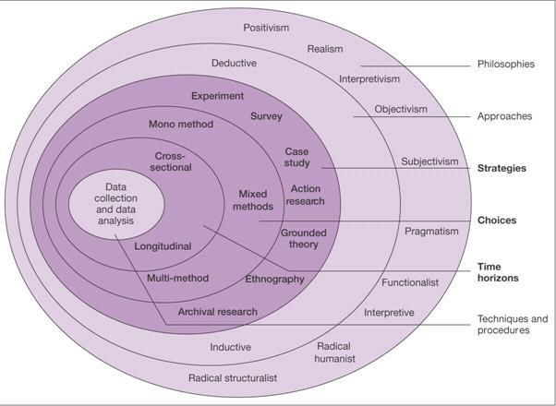

Figure 1 shows the Research Onion, created by Saunders. This theory contains layers relating to different stages of research, suggesting that if the researcher follows the layers of the onion, an effective research strategy will be created, (Saunders et al, 2007).

  - Paradigm & Philosophy

Positivism philosophy is researched by Johnson and Clark (2006), who convey the importance of philosophy and the way it is chosen for the research strategy, it is of significant importance to the understanding and application of what is being investigated, (Johnson and Clark, 2006). This is mainly concerned with methods that are highly structured with large quantitative samples, which then makes the study open to duplication, (Saunders and Philip, 2012). This paradigm should be used in this study, as the researcher will carry out a large number of questionnaires to generate numerical results on participation levels at the events. However, the researcher will also need to adopt an interpretivist approach. An interpretivist approach requires methods of qualitative data from interviews, (Saunders et al, 2016). This study will also require qualitative data in order to analyse overall satisfaction at the markets, resulting in an interpretivist approach being the most appropriate paradigm.

  - Research Approach & Purpose

The deductive research approach focusses on logical theory to produce a research hypothesis, whereas, an inductive approach would detect similarities and differences to previous theories through patterns and relations, (Ritchie et al, 2013). Loseke supports this theory by stating that a deductive approach involves ‘using what is already known to determine what data to collect’, (Loseke, 2017).
This dissertation will utilise a deductive approach, as a wealth of knowledge already exists on socio-cultural theories and event analysis. The researcher will follow the process of deduction created by Bryman and Bell, as shown below in figure 2, (Bryman and Bell, 2015). The purpose of this study will be exploratory as the outcome will not provide concluding categorical explanations to the issue in question, however, the intention of this investigation will be to explore the research question and deliver a foundation to future study on the topic, (Dudovskiy, 2018).

Figure 2 – The Process of Deduction, (Bryman and Bell, 2015)
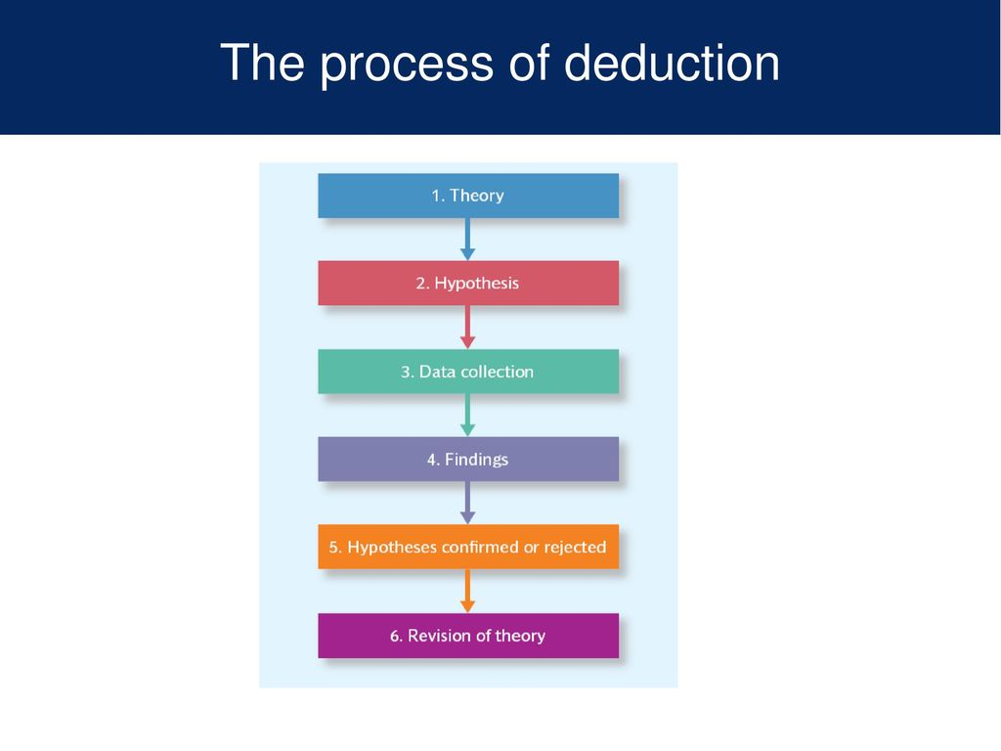

- Strategies
  - Data Collection Methods & Analysis

The researcher will use mixed methods triangulation, as questionnaires and interviews will be carried out to generate both quantitative and qualitative data, to determine the socio-cultural standard for small-scale events in Swansea. Triangulation will allow previous socio-cultural event studies to be examined and compared with the information collected. This will be done through multiple techniques in order to detect similarities and differences between studies, resulting in an insightful analysis, (Olsen, 2004). This study best lends itself to a combination of interviews and surveys to make a detailed case study.

  - Sampling Framework

Figure 2 shows the varied methods of sampling frameworks. Saunders states that an in-depth study must prove an ‘information rich case study’, (Saunders et al, 2008, pgs.276-297), therefore, non-probability sampling would need to be used in this investigation as it will focus on both interviews and secondary data. Furthermore, a volunteer sampling method will be tested, as the researcher will ask stallholders at the market events to participate in surveys to generate qualitative and quantitative data and post in the markets’ Facebook groups, asking spectators of the events to participate in an online questionnaire.

Figure 3 – Sampling Framework (Saunders et al, 2016, pg.276)

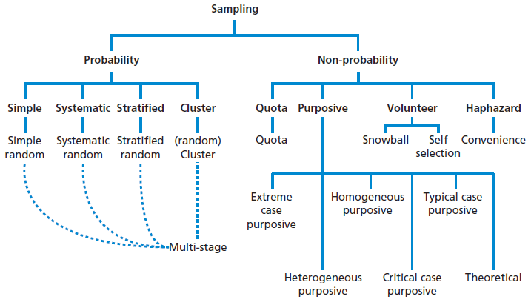

- Resources & Planning

Bryman and Bell state that all research is constrained by time and resources, (Bryman & Bell, 2007). In order to fully understand and achieve the aims and objectives set for the study, various resources must be used. Also, in order to be successful, planning is key.
The use of primary and secondary data will help to develop the understanding of the socio-cultural impacts of events and the researcher will include these aspects in the literature review. Secondary data will be accessed through books in the university library, the online resources the library offers, academic journals and articles and reliable websites. Appropriate resources will be selected on the basis of their relevance to local independent trade events. Primary data will be gathered through the university computers and an online questionnaire, which will be distributed to Facebook groups who follow the markets around Swansea. Furthermore, the researcher will obtain primary data through attending the independent trade events around Swansea and conducting surveys and interviews on stallholders and shoppers.

- Limitations & Ethical Risks
  - Resource Limitations

Due to the limited time-frame for this study, resources and primary data may face a limitation. Additionally, the sample used for questionnaires, surveys and interviews may not be a true reflection of the wider population, but it is the most appropriate sample for the research in this time-frame. However, the researcher will attempt to overcome these limitations by creating a Gantt Chart (see Appendix 1), in order to stick to a structured time frame and avoid as many restrictions as possible.

  - Ethical Considerations

Generally, the study is low risk and is unlikely to cause any offence to participants or the public, or pose any risk to the university or researcher. However, ethical considerations have become of significant importance to achieving a meaningful and successful study and the protection of participant must be considered, clear communication and consent will be provided prior to anyone taking part in the study, (Sage Publications, 2007). This is backed up by Saunders who states that everyone has the ‘right to privacy’ and should not feel ‘coerced into participating’, (Saunders et al, 2016, pg.249). All research conducted in this investigation will strictly follow the ethical guidelines, supported by an ethics document.
Prior to the research, all participants will be given full information of the details, their role, the aims and objectives and the purpose for carrying out the study. All participant information will be kept confidential and will also be kept within the strict anonymity regulations as stated in the ethics form.

  - – Reliability & Validity

Reliability and validity are concerned with the credibility of research and how successful the researcher has been in reaching the objectives set, (Kirk & Miller, 1986). Reliability is how repeatable the results of the tests are, whereby validity refers to the findings accuracy.
For this research, it is of particular importance to understand the threats that reliability and validity may face. This can be overcome through ensuring that the correct methodology and research design is used to meet the objectives, but also, testing the findings for bias.

- Conclusion

The researcher will analyse the socio-cultural impacts that arise from a small community event. Analysing data from community perceptions, both event participants and resident, in order to assess how the events benefits the well-being of locals. The main goal of this research is to meet the aims and objectives set.

- References

Ariola, M. (2006), Principals and Methods of Research, Manila: Rex Book Store.
Bladen, C. Kennel, J. Abson, E and Wilde, N. (2012), ‘Managing the event human resource’, Events Management; An Introduction, Abington: Routledge.
Bowdin, G. Allen, J. O’Toole, W. Harris, R. and McDonnell, I. (2006), Events Management, (Third Edition), Great Britain: John Wiley & Sons.
Bryman, A and Bell, E. (2015), Business Research Methods, (Fourth Edition), Oxford: Oxford University Press.
Bryman, A. and Bell, E. (2007), Business Research Methods, (Second Edition), Oxford: Oxford University Press.
Derrett, R. (2004), Festivals, events and the destination, Oxford: Butterworth.
Dudovskiy, J. (2018), ‘Exploratory Research’, [Online], Research Methodology, Available: https://research-methodology.net/research-methodology/research-design/exploratory-research/, Accessed Date: 20th November 2019.
Dwyer, L. Mellor, R, M, N. Mistillis and Mules, T. (2000), ‘A framework for assessing ‘tangible’ and ‘intangible’ impacts of events and conventions’, Events Management, Vol. 6, No. 3.
Getz, D. (2007), Event Studies: Theory, research and policy for planned events, Oxford: Elsevier.
Grosbois, D, D. (2009), ‘Assessing the Socio-Cultural Impact of Special Events: Frameworks, Methods, And Challenges’, Journal of Tourism Challenges and Trends, Vol. 11, No. 2.
Johnson, P. and Clark, M. (2006), Business and Management Research, London: Sage.
Jovicic, D. (2016), ‘Cultural tourism in the context of relations between mass and alternative tourism’, Current Issues in Tourism, Vol. 19, No.6, pgs. 605-612.
Kirk, J and Miller, M, L. (1986), Reliability and Validity in Qualitative Research, London: Sage.
Loseke, D, R. (2017), ‘Methodological Thinking basic principles of social research design’, (Second Edition), London: Sage.
Maslow, A, H. (1943), ‘A Theory of Human Motivation, Psychological Review’, Journal Psychological Review, Vol. 50, No. 4.
Olsen, W. (2004), ‘Developments in Sociology’, Triangulation in Social Research: Qualitative and Quantitative Methods Can Really Be Mixed, [Online], Available: https://www.federica.eu/users/9/docs/amaturo-39571-01-Triangulation.pdf, Accessed Date – 20th November 2019.
Ritchie, J. (1984), ‘Assessing the impact of hallmark events: Conceptual and research issues’, Journal of Travel Research, Vol. 22, No. 1.
Ritchie, J. Lewis, J. Nicholls, C. M. and Ormston, R. (2013), A GUIDE FOR SOCIAL SCIENCE STUDENTS AND RESEARCHERS, London: Sage.
Sage Publications, (2007), ETHICAL ISSUES IN CONDUCTING RESEARCH, London: Sage.
Saunders, M and Philip, L. (2012), Doing Research in Business & Management, Harlow: Pearson Education Limited.
Saunders, M., Lewis, P and Thornhill, A. (2016), Research Methods for Business Students, (Seventh Edition), Harlow: Pearson Education Limited.
Saunders, M., Lewis, P. and Thornhill, A. (2009) Research Methods for Business Students. Pearson, New York.
Saunders, M., Lewis, P., and Thornhill, A. (2007). Research Methods for Business Students, (Sixth Edition), London: Pearson.
Saunders, M., Lewis, P., and Thornhill, A. (2008). Research Methods for Business Students, (Fifth Edition), Italy: Rotolito Lombarda.
Small, K. Edwards, D. and Sheridan, L. (2005), A Flexible Framework for Evaluating the Socio-Cultural Impacts of a (Small) Festival, International Journal of Event Management Research, Vol. 1, No.1, pgs.66-77.

- Appendices
  - – Appendix 1 – Gantt Chart

A planning technique that will be used throughout this study is a Gantt Chart in order to meet deadlines and keep all work up to date. The Gantt Chart shown below is a timescale against the activity that needs to be completed, (see Figure 3 below).
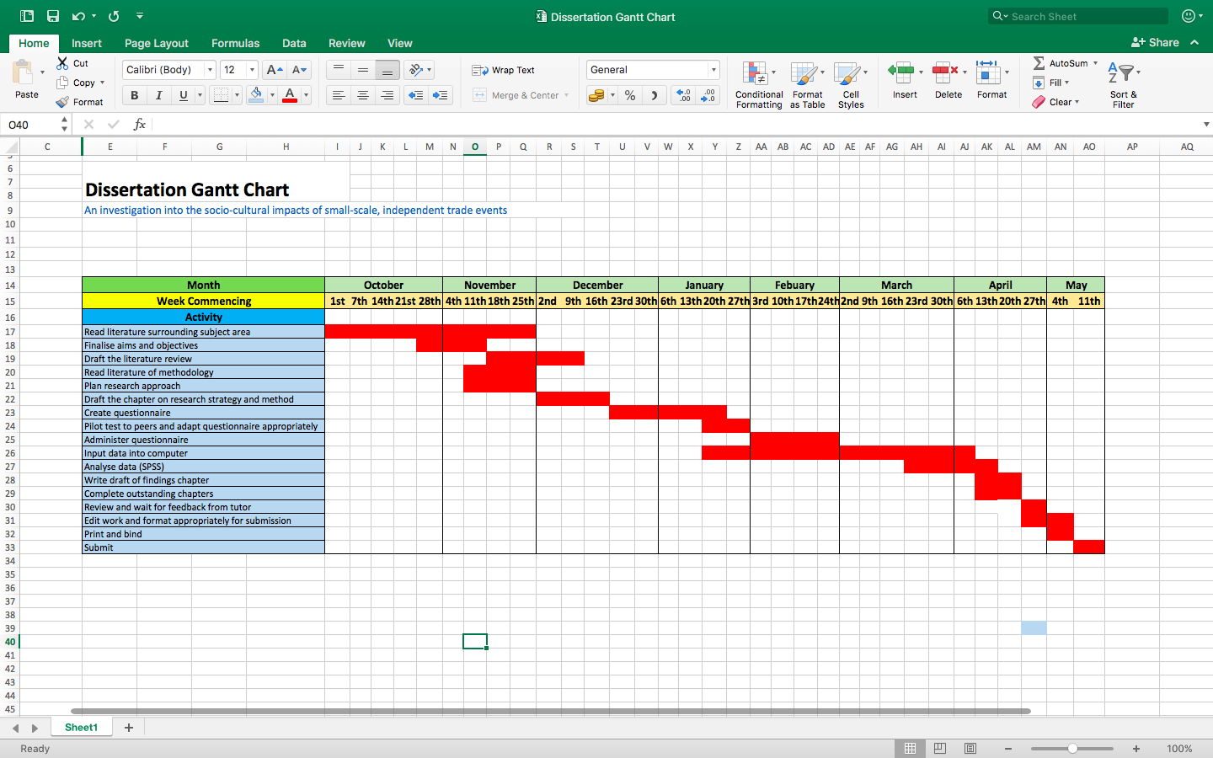

Figure 3 – Gantt Chart.

