

County Lines and vulnerability: A critical examination of policing strategies used in fighting the so called “War on Drugs”

Alex Gregory (1910666)
School: UWTSD Swansea
Degree: BSc Professional Policing Practice
Due Date: 27th June 2022
Word Count: 8525

Declaration
This work has not previously been accepted in substance for any degree and is not being concurrently submitted in candidature for any degree.
Signed Date: 23rd June 2022
STATEMENT 1
This dissertation is being submitted in partial fulfilment of the requirements for the degree of BSc
Signed Date: 23rd June 2022
STATEMENT 2
This dissertation is the result of my own independent work/investigation, except where otherwise stated.
Other sources are acknowledged in the Reference Section.
Signed Date: 23rd June 2022
STATEMENT 3
I hereby give consent for my dissertation, if accepted, to be available for photocopying and for interlibrary loan, and for the title and summary to be made available to outside organisations.
Signed Date: 23rd June 2022
STATEMENT 4
I hereby give consent for my dissertation, if accepted, to be available on the university’s IT system to those who have consent to use the system.
Signed Date: 23rd June 2022

Table of Contents
1.0 Introduction: 5
1.1 Rationale 5
1.2 Objectives 6
1.3 Conclusion 6
2.0 Literature Review 7
2.1 County Lines: Understanding the scope of the problem 7
2.2 Studies and literature involving the examination of current Policing strategy in tackling County Lines drugs gangs 9
2.21 NRM (National Reporting Mechanism) 9
2.22 Police intelligence, prioritisation and response 10
2.23 Symbolic policing crackdowns 11
2.24 Cuckooing 11
2.3 Studies and literature involving the harm caused to young and vulnerable people involved in the distribution of drugs 12
2.3.1 Exploitation 13
2.3.2 Adverse Childhood Experiences 14
2.3.4 Recruitment 14
2.3.5 Covid 19 impact 15
2.4 Conclusion 15
3.0 Research Strategy 16
3.1 Data Collection 16
3.11 Benefits and Limitations 17
3.12 Qualitative Research: Pros and Cons 17
3.13 Quantitative Research: Pros and Cons 17
3.2 Survey distribution and completion 17
3.3 Survey Questions 18
3.4 Data Analysis 18
3.5 Limitations and Potential Problems 19
3.6 Conclusion 20
4.0 Results introduction 20
4.1 Results obtained 21
4.2 Reviewing the Research Objectives 30
4.3 Conclusion 30
5.0 Conclusions and recommendations 32
5.1 Overall findings in relation to the research aims 32
5.2 Contribution to the area of research 32
5.3 Reflecting on the limitations of the study 32
5.4 Recommendations for future research 33
5.5 Closing summary 34
References 35
Appendix 38
Survey front page 38
Survey results 39
Ethics form 46

1.0 Introduction:

UK government research highlights that the UK has a significant and growing issue of drug distribution (justiceinspectorates.gov.uk), via the exploitation of young people and vulnerable adults by Organized Crime Gangs, operating a so-called County Lines drugs model. This activity proliferates from larger metropolitan areas, acting as central distribution hubs, feeding into smaller towns and villages all around the country. This activity has become commonly known as “County Lines” and predominantly involves the distribution of Class A drugs. It is coordinated using dedicated telephone supply lines and are run as highly complex and lucrative criminal operations. (National Crime Agency, 2022)
Traditional drug supply used to involve a user, travelling to a city or larger town to collect the drugs before returning to their locality for consumption or onward distribution on a far smaller scale to their known acquaintances or fellow users. This new method of distribution is particularly concerning to lawmakers and law enforcement, given the involvement of young people and the corresponding risk and harm that can come to these vulnerable groups as a result. (National Crime Agency, 2022)
Policing strategy in dealing with drugs in England and Wales as a whole, is formed around the basis of existing legislation determined by the Misuse of drugs act 1971 (Legislation.gov.uk). The main purpose of the Act is designed to prevent the misuse of controlled drugs by imposing a complete ban on the possession, supply, manufacture, import and export of controlled drugs, with the only exceptions allowed by further legislation allowing for some regulated use by licence, authorised by the Secretary of State (gov.uk).
At ground level, Police have some discretion in relation to the disposal methods used in dealing with drugs offences (gov.uk, 2022) and what this research project will explore, are the strategies used to target the lower levels of these operations, primarily focussed on the vulnerable adults and youths, who are the bottom rung of this criminal ladder, and whether these strategies have been effective in tackling the issue.

1.1 Rationale

This research project will critically examine the policing strategies currently used in dealing with County Lines and the wider issue of policing drugs in England and Wales. It will also look at the individuals who get caught up in this trade, recognizing their vulnerability, while at the core of this project will be to ascertain and examine the views of serving police officers to establish what their views are in relation to the effectiveness of the current strategies being employed and what changes if any, they would like to see, put in place. effectiveness of the approach of the diversionary disposals used. It will also look at the wider issue of youth reoffending and will draw conclusions as to the impact that Legislation has on policy and whether this is effective in reducing the prevalence of drug use and harm being caused across society.
There is a significant body of existing literature and research in relation to the wider topics of drugs, county lines and drug harm but there were no studies found, where police officers are asked if what they are doing is effective in tackling the problem. This project aims to help and address that shortfall, then go some way to help inform and influence operational change going forward.

1.2 Objectives

For this research project, the following four objectives have been identified:
- To determine the effectiveness of current law enforcement strategy in tackling County Lines drugs gangs
- To assess the harm caused to young and vulnerable people by these groups
- To examine the effectiveness of the current disposal methods and diversionary services available to offenders
- To determine the effectiveness of current legislation and critically assess it is fit for purpose in reducing the prevalence of harm caused by drugs, also including the current classification of drugs and the criminalisation of drug dealers and users.
Primarily, this research is being undertaken, to ascertain the opinions of serving police officers, in relation to county lines and drugs, aiming to address the objectives above.

1.3 Conclusion

This opening chapter has covered the purpose of the research project, providing background as to the significance of the issue of drugs and drug use in the United Kingdom. It has highlighted my area of focus, that being to ascertain the views of serving police officers with regards to the effectiveness of current policing strategy and has set out the specific objectives which will look to be addressed. As no similar existing research could be found, it would seem reasonable to conclude that further research in this area could be beneficial.
The next chapter will look at the existing literature available covering the scope of the County Lines issue, the current Policing strategy in dealing with County Lines gangs as well as studies and literature, involving harm caused to young and vulnerable people involved in the distribution of drugs

2.0 Literature Review

A literature review is typically understood to be a systematic and critical review of the most important literature and academic research on any particular subject matter (Snyder, 2019)
Oliver (2012) suggests that a review and analysis of existing literature will help formulate appropriate research questions to identify what is known (and not known) about a given subject, with the purpose of that review being, to develop as much knowledge around that subject as is practicable.
For this literature review, research will be organised under the following categories:
- Understanding the scope of the County Lines problem
- Studies and literature involving the examination of current Policing strategy in tackling County Lines drugs gangs
- Studies and literature involving the harm caused to young and vulnerable people involved in the distribution of drugs

2.1 County Lines: Understanding the scope of the problem

As noted earlier, County Lines activity proliferates from larger metropolitan areas, acting as central distribution hubs, feeding into smaller towns and villages all around the country. According to the NCA (National Crime Agency, 2018), Crack Cocaine and Heroin are the drugs most supplied through County Line activity. Other substances such as powdered cocaine and cannabis are also supplied in lower quantities. The higher profit margins for Heroin and Crack mean that these other drugs act as a supplementary side-line to their main activities (See Fig.1 below from the National County Lines Coordination Centre).
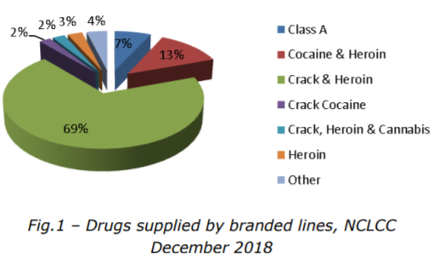
Current NCA research suggests that the largest number of County lines, originate from the Metropolitan Police area, followed then by the West Midlands and Merseyside, with a total of 26 Policing areas currently noted as “Exporting” locations with an estimated 1000 active lines nationwide.
Traditional drug supply used to involve a user, travelling to a city or larger town to collect the drugs before returning to their locality for consumption or onward distribution on a far smaller scale to their known acquaintances or fellow users. This new method of distribution is particularly concerning to lawmakers and law enforcement, given the involvement of young people and the corresponding risk and harm that can come to these vulnerable groups as a result. The flowchart below, outline the typical operation of a single County Line:
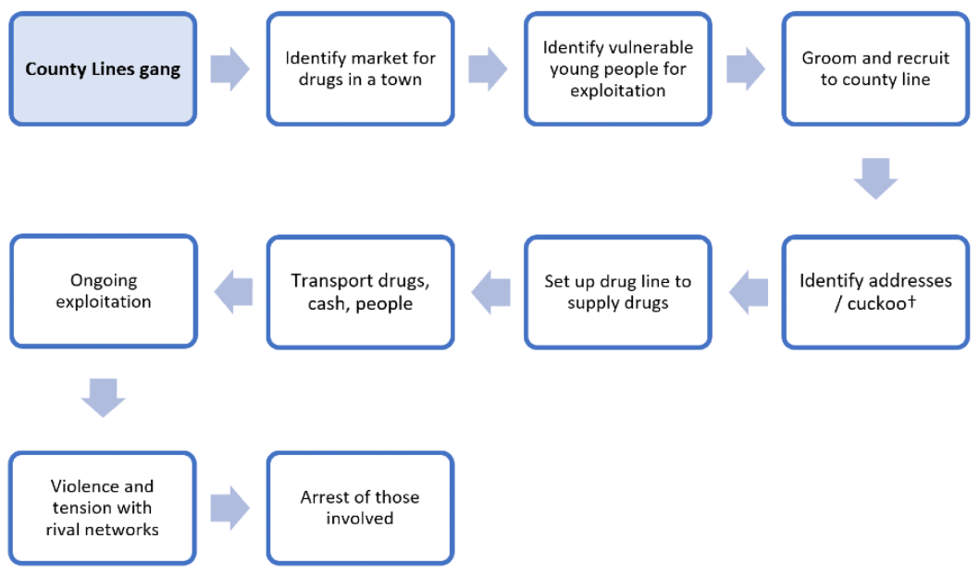
Fig 1.1 – County Lines Operation (Gov.uk, 2022)

Policing strategy in dealing with drugs in England and Wales as a whole, is based around legislation determined by the Misuse of drugs act 1971 (Legislation.gov.uk). The main purpose of the Act is to prevent the misuse of controlled drugs by criminalising the possession, supply, manufacture, import and export of controlled drugs, with exceptions only permitted by further legislation allowing for some regulated use by licence, authorised by the Secretary of State (gov.uk).
Looking within the South Wales policing area, the Neighbourhood Policing teams, along with Response officers, primarily deal with local drugs offences often involving these young or vulnerable people with county lines activity. These individuals can be seen to be the bottom rung of this larger criminal ladder. This research project will examine the strategies used to target these individuals.
The project will also examine the links between the exploitation of vulnerable people and the effectiveness of the approaches used in combatting this activity. It will also look at the wider issue of youth reoffending and will draw conclusions as to the impact that Legislation has on policy and whether they are effective in reducing the prevalence of drug use and harm being caused across society and with approximately 100 "county lines" currently supplying drugs into Welsh towns, according to the director general of the National Crime Agency (NCA), the scale of this issue is readily apparent.
As will be set out below, there are several studies, articles and research projects which look at the County Lines problem, including research on Policing strategy in tackling the problem as well as those which examine and discuss the risk and harm being suffered by the young and vulnerable people who become involved and trapped in county line activity. What is not readily available are studies which look at policing opinion and perception of these areas of concern and what front line police propose can be done in helping to tackle the issues and what they see as the day-to-day harm caused on the coal face. By focussing on these areas, this would look to inform policing policy and provide an informed alternate perspective for policy makers and senior management, to the end of improving best practice and future process and policy in dealing with offenders (or perceived victims depending on circumstance).

2.2 Studies and literature involving the examination of current Policing strategy in tackling County Lines drugs gangs

2.21 NRM (National Reporting Mechanism)

Police forces report any exploitation and human trafficking concerns associated with county lines via a National Referral Mechanism (NRM) and through this mechanism, a steady rise in quarterly referrals from 2014, through to Q1 2020 van be observed. The sudden drop observed at that time, can be attributed to Covid 19 and a significant reduction in the wider movement of people due to the enforced lockdown of society. What this does indicate is the scale of the increasing problem. See Graph (Fig 1.2) below:
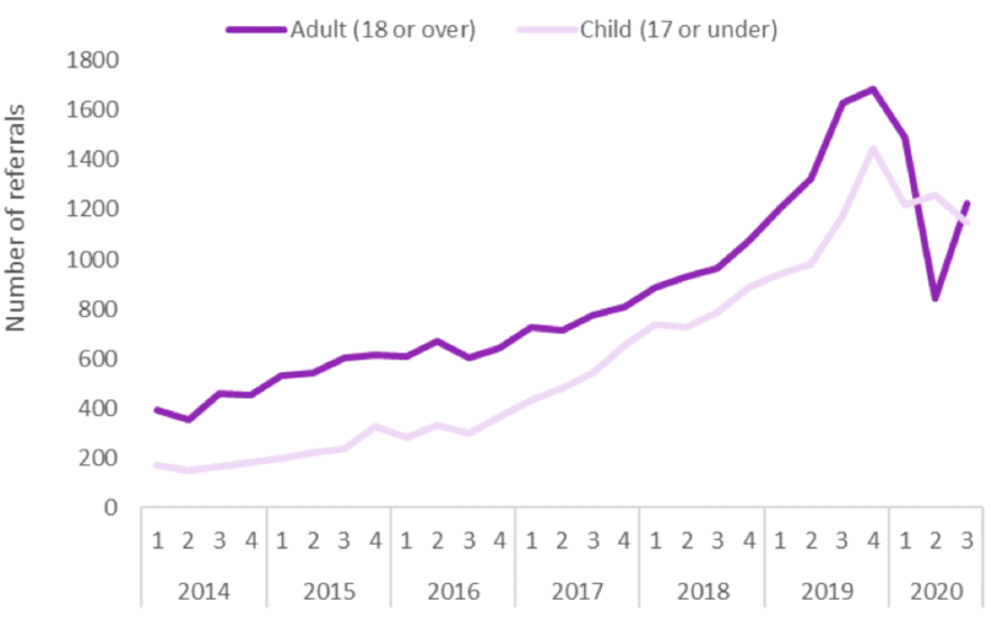
Fig 1.2 – National Referral Mechanism (NRM) Number of quarterly referrals by age group of exploitation, 2014 to 2020 (Gov.uk, 2022)

2.22 Police intelligence, prioritisation and response

According to the HMICFRS (Her Majesty's Inspectorate of Constabulary and Fire & Rescue Services) and their “Both Sides of the Coin” report, the intelligence picture around County Lines activity in the UK is improving, via police forces and the National Crime Agency’s collaboratively working together in supporting the national county lines co-ordination centre.
According to the Justice Inspectorates, most forces can be seen to have significantly improved their understanding of the scale of offending in their area with current intelligence analysis showing that there are more than 2,000 individuals ‘deal line’ numbers (mobile phone numbers circulated to users to purchase controlled drugs), linked to approximately 1,000 county lines. As previously noted, in can be seen that London, the Midlands (Birmingham) and the Northwest of England (Liverpool) are the main exporting areas but there are shortcomings in the intelligence processes. Forces don’t understand enough about county lines criminality to tackle it as effectively as possible. (justiceinspectorates.gov.uk, 2022)
HMICFRS also suggests that much of the guidance on how to submit intelligence needs revising, as Police Forces have been inconsistent in their approach. They have noted that Police have failed to prioritise attention on County Lines activity compared to other serious offences and that in fact, most regional drug investigations taking place are not actually looking into county lines at all. HMICFRS concluded that regional tasking and co-ordination arrangements aren’t always effective, believing that a more active regional co-ordination of the police response, involving a recently established team of regional co-ordinators is a more effective approach. (HMICFRS, 2020)
Blakeburn and Smith (2021) conclude that the traditional road-centric policing tactics that have been previously used to disrupt drug supply may now be redundant, where the transportation method of choice is by train. They also acknowledge the issues of policing boundaries being problematic in the sharing of information between different forces, with gangs exploiting the fact that the UK does not have one centralised policing database. Information sharing (or lack of) is critical in this regard.
Spicer (2021) notes that there are two prominent new tactics introduced and represented as being specifically bespoke to the issue of County Lines. These being the use of a “Drug Dealing Telecommunication Restriction Order”, alongside the pursuit of modern slavery convictions for those found to be illegally exploiting vulnerable people.

2.23 Symbolic policing crackdowns

Coomber, Moyle and Mahoney (2016) suggest that policing of local drug activity across England can sometimes take the form of specific and high-profile, crackdown operations which form a symbolic, generic, or periodic response to localised drug activity. They go on to note that this type of symbolic policing, can be perceived as the police only ‘appearing to be doing something’ and may in fact have counterproductive enforcement outcome. They conclude that generic local ‘crackdown’ operations fail to target the wider national model and in certain circumstances, they can be detrimental to more considered enforcement and public health aims, again suggesting a wider national collaborative approach is needed.

2.24 Cuckooing

Spicer (2021) notes that dealing with so-called 'cuckooing' activity, where drug dealers take over vulnerable people's homes, requires a significant policing response in the UK and because of its nature of the activity, it aligns with the need to respond to vulnerability and prevent exploitation of these vulnerable people, who are being targeted by County Lines gangs. Spicer also observes that the inclusion of other organisations in responding to cuckooing, ties into the promotion of multi-agency working, which is something that has been particularly promoted over recent years due to reductions in police funding and desires for a so-called 'public health approach'. His research goes on to conclude that cuckooing is central to the enablement of county lines activity. Moyle (2019) supports the notion that vulnerable populations including drug users and those with mental health issues are specifically targeted to undertake cuckooing activity.
Olver and Cockbain (2021) suggest that law enforcement agencies are not effective, equipped, or appropriate to identify, target or support vulnerable populations alone and that effective collaboration and information sharing is required to facilitate successful safeguarding measures through a multiagency approach, including education, NHS, police and local authorities.

2.3 Studies and literature involving the harm caused to young and vulnerable people involved in the distribution of drugs

As indicated by Olver (2021), the exploitation of vulnerable persons (VP’s) in the pursuit of distributing drugs is not a new issue but it is one of growing concern. Research by Moyle (2019) and Robinson et al (2018) indicate that although many of the VP’s are controlled by violence and intimidation and are often brought in by “debt bondage”; that many of these street level workers enter these roles under their own volition, seeing the role as a preferential form of earning money and or gaining status to other jobs. To tackle this growing concern; further research must be carried out in order to determine how to prevent the VP’s from entering these roles from policing strategies to multiagency approaches (Stelfox, 2002; Coliandris, 2015; Middleton, 2018 & Wroe, 2019).

According to Marc Radley (The Strategic Director, CACI Child and Young Persons Division), early intervention alongside a divisionary approach is broadly considered to be the panacea for tackling County Lines within the vulnerable groups who find themselves targeted and caught up in this activity, but it is also noted that this is easier said than done. Schools, local authorities, youth services, youth justice teams and the police align all need to coordinate via a multi-agency approach, to address the issues which these exploited children are being exposed to.

Radley (2020) also notes that awareness of the issue plays a significant role, with County Lines activities, taking place right under the noses of the wider population, occurring down the lanes and back alleys of our streets and in the homes of vulnerable drug users and addicts. Multi-agency services such as Multi-Agency Safeguarding Hubs as well as Youth Offending Services, have shown how to build and sustain effective responses to the issues.
According to UK government research, as it stands the precise number of children involved with County Lines is not known as there is no systematic data collection (Maxwell et al, 2019) but there are an estimated 27,000 children in England, currently identified as being a gang member (Children’s Commissioner, 2019) which can go some way to highlighting the scale of the issue. The NCA states that 91% of children currently involved in County Lines are male but within these figures, both sexes can become subject to sexual exploitation, with children between the ages 15 to 17 most likely to be at risk. However younger children and young or vulnerable adults are also at risk of exploitation (NCA, 2019).
The NCA also examined the impacts and harm caused by County Lines gangs and have broken this down into 8 main areas of concern (See Fig. 2). As can be seen, the most common areas of harm are the exploitation of vulnerable adults and Cuckooing of their addresses.
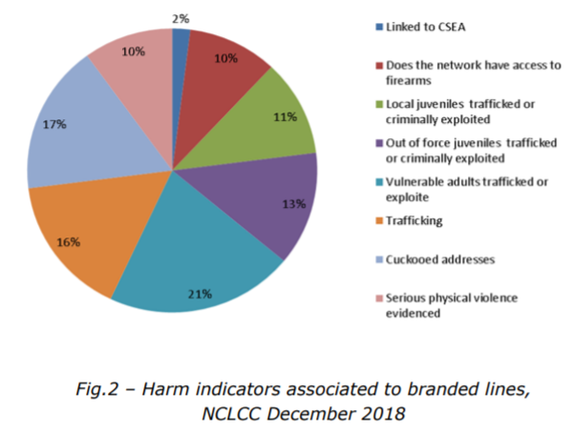
When it comes to the method of transportation of the people involved with county lines, it can be clearly seen (Fig. 3 below) that Rail Travel is the preferred method of used by these operations. Given the young age of those generally recruited to move these drugs from the central hubs into a local area their inability to legally drive can be seen as the most Likely reason.
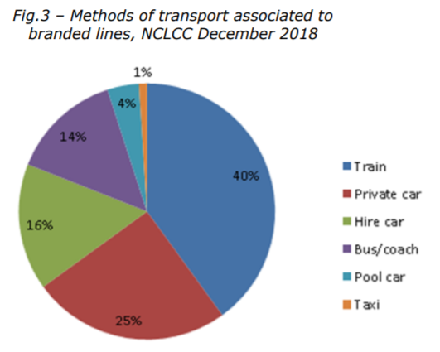

2.3.1 Exploitation

According to HMICFRS, when a vulnerable person is arrested in relation to County Lines drug dealing, the use of a statutory defence in their involvement has been seen to increase the risk of exploitation. It has been observed that victims of Modern slavery and exploitation who commit offences on behalf of their abusers, such as county lines drug dealing, are being coached by their recruiters to say they have been trafficked, when they are caught and arrested. This also poses a challenge in court whereby police and prosecutors are reporting practical difficulties disproving the defence, even when it is false. (HMICFRS, 2020)
Glover and Finlay (2019) support the observation that gangs target the most vulnerable young people including the homeless, neglected, living in chaotic circumstances, or are looked after children. These individuals are then coerced, threatened, groomed, manipulated, and exploited physically, emotionally, and sexually to satisfy the requirements of their recruiters and that tackling county line gang activity, requires a multi-agency approach.
Windle, Moyle and Coomber (2020) assert that Children and young people are being exploited because they represent a cheap, easy to recruit workforce who can absorb many of the risks associated with transport of drugs and the street-level sales of these products. They are also then considered to be a disposable or expendable resource if caught. They go on to conclude that although only 14 per cent of those recorded as linked to county lines were girls, the overall level of girls’ involvement in county lines is currently unknown and requires more research into this demographic. Currently, just 9 per cent of county lines offences recorded as involving females and they suggest that there may be an associated with gender bias where women and girls are less likely to be viewed as offenders, thereby reducing police suspicion.

2.3.2 Adverse Childhood Experiences

Windle, Moyle and Coomber (2020) go on to discuss the significant impact of Adverse Childhood Experiences on the outcomes of you people recruited into County Lines activity, observing that people with more than five ACEs were ‘7- to 10-fold more likely to report illicit drug use problems, addiction to illicit drugs, and parenteral drug use and that a culmination of ACEs can lead to an increased risk of that individual becoming a victim of human trafficking for sexual exploitation. Some of those recruited in county lines activity, may have already suffered from significant ACEs at home or whilst in a care environment but their involvement after recruitment into a county line, can then accentuate the harm already caused. This can then be summarised as a ‘Spectrum of harm’

2.3.4 Recruitment

Spicer (2021) suggests that Austerity Policy in the UK and the reduction of social diversionary activity alongside socio-economic depravation for young people, may be contributing to them turning to county lines activity. He considers that some young people can view drug supply as an attractive option amongst a limited number of poorly remunerated, legitimate employment opportunities. United Kingdom Government research (2020) indicates that vulnerable people who are targeted for county lines dealings are exploited using an imbalance of power such as age, mental capacity, gender, or economic vulnerability and are recruited by means of exchange and reward. The exchanges and rewards can include tangible assets such as money and drugs or intangible ideas of friendship and protection.

2.3.5 Covid 19 impact

Due to insufficient research, it is unclear what effect the global pandemic has had upon county lines operations. During the initial lock down phases at the start of the pandemic, there was a drop in reported crime throughout the UK with the significant exception of drug offences as well as domestic violence offences. Throughout this period, young people involved in county line activity, continued to be found by on rail networks, away from their own homes, and carrying significant sums of money and/or drugs, with the British Transport Police (BTP) commenting that a 94% reduction in rail travel had not resulted in a perceived reduction of juvenile drug runners on trains. The increased visibility of juveniles moving drugs on public transport, may also have resulted in a change in tactics towards deliveries being made in cars rather than young males travelling empty trains and buses, where they would be more likely to be spotted by authorities. This suggests that county line runners might have been travelling less often but carrying larger quantities of drugs and/or money. Again, research in this area is limited.
Their research also suggests that reports of juveniles missing from home or care reports dropped during lockdown, with a study by the University of Liverpool, reporting a 35% decrease in reports of missing children. While not unexpected due to the reduced mobility of the wider society, children under the care of the local authority, who comprise a significant proportion of all missing cases, are of increasing concern due to the vulnerability, again relating to their likelihood of having had multiple ACE’s. Lockdown restrictions also reduced the opportunities for professionals to identify potential risks, gather information, and the provision of space for disclosures, which could exacerbate the perceived ‘postcode lottery’ of service provision, which already leaves many young people at risk.

2.4 Conclusion

This concludes the Literature Review chapter. As can be seen throughout, there is significant existing research into the law enforcement tactics used to tackle county line activity and research into the vulnerable people involved in county line activity. What has been found not to be in abundance, are the opinions, perceptions, and suggestions from acting front line police officers into what can be done to improve or influence policing policy and response in tackling this activity. The chosen area of research for this project is designed to address this. The limitations of this study, mean that only a very small subsection of the literature has been discussed and there is further opportunity to expand upon this greatly, but it has not been possible for the purposes of this project and would warrant further study. The next chapter will cover the research strategy, the rationale for the chosen methodology, the data collection and the questions which will be put to police officers in a survey. It will discuss how the data obtained will be analysed, as well as discussing the limitations and the issues encountered with the study.

3.0 Research Strategy

There are many differing Research Strategies, which can include case studies, experimental, interviews, surveys, and archival analysis (Yin 2003). For this study, it was decided that electronic surveys would be used, to gather the data necessary.
Surveys are a common and popular research strategy, as it is an efficient data collection method, given that a large amount of data can be collected in a relatively short time and with a relatively small commitment from the respondent.
Given the time pressures currently being experienced by police officers, a qualitive research approach was discounted as this would have involved interviewing participants and would have resulted in a very limited subset of participants due to time constraints.

3.1 Data Collection

Research data can be divided into two categories: Quantitative and Qualitative.
- Quantitative, refers to data which is in numerical and measurable and again includes questionnaires and experiments etc.
- Qualitative data includes views, opinions, and observations. This can be more labour intensive to obtain and is often achieved by interviewing the participant.

3.11 Benefits and Limitations

Both forms of research have their benefits and limitations. Consideration was given as to which was best used for this research project, while recognising these factors. Qualitative data ultimately could have been more beneficial as it would have allowed the topic to be explored more thoroughly with each participant, but it was not practical due to the time constraints.

3.12 Qualitative Research: Pros and Cons

A qualitative study can provide more creativity and flexibility, which could have enabled the scope of the research project to change as more information as gathered.
Research also observes however that these studies can be more subjective in the results and interpretation than in a quantitative approach. The research skillset, perspective, and personal bias towards the outcome or subject matter, may also allow the results to be influenced more than in a quantities approach which is more binary

3.13 Quantitative Research: Pros and Cons

Quantitative research produces objective data, which is free from the researchers influence, which was noted above, in a qualitative study. Results tend to be displayed through statistics and numbers and can be quickly produced, using the survey and analytical tools highlighted earlier.
For the purposes of this study, it is noted that quantitative research is a more restrictive as the studies participants cannot tailor their responses to the questions or add context and additional explanation as to the reasoning behind their answer, this in turn does not allow for further exploration and understanding. Statistical data analysis can also require a larger data sample from more participants, than a qualitative approach. (gcu.edu, 2022)
In this research project and utilising a survey, only Quantitative data will be collected and analysed.

3.2 Survey distribution and completion

To facilitate this survey, various out of the box, online survey tools such as “SurveyMonkey” “Qualtrics” or “SurveyGizmo” were considered, as all these offer similar services offer a free and secure means of constructing a survey to be distributed quickly and simply to a target group. Having evaluated these tools, it was decided that google forms provided the best solution, with it being easy to setup and providing useful analytics for the results.
This Primary Research survey will be opened to Neighbourhood Policing, Response Policing and Priority Policing teams across the Western Division of South Wales Police. It will be extended to other areas if the participant volumes prove to be insufficient.
The exact number of surveys will be determined by the number of replies received from the targeted departments and will depend on the willingness of participants to engage in the process, but it is expected to generate somewhere in the region of 30 responses which will provide a suitably broad data set. Results will be quantitatively analysed with results displayed using graphs and charts.
This survey was designed to be ethical, completely anonymous and will omit personal details or specifics relating to any current or previous case files or real-world case scenarios. No names of participants, suspects, victims, or witnesses will be used, nor would any identifying addresses. If captured in a freeform entry field used, these will be omitted from the results, with all data erased and not retained on any physical or computerised system. This will ensure compliance with all obligations of the Data Protection Act and GDPR in the UK. The final dataset would then be adjusted accordingly.

3.3 Survey Questions

- How do you identify yourself?
- Please select your age bracket
- Please state which department you work in
- Length of service
- I think that drugs are an increasing problem in the UK
- I believe that current UK legislation is fit for purpose to combat drug use and supply
- I believe that current policing strategy is effective in reducing drug dealing and supply
- I believe that current policing strategy is effective in reducing drug use
- On average, how many times in a set would you encounter a call where drugs were a factor?
- I think that police have sufficient resources to combat County Lines gangs
- I think that police are focussing their resources effectively to combat County Lines gangs
- I believe that County Lines activity is being reduced because of policing strategy
- I believe that changes are needed to tackle County Lines drugs gangs
- I believe that changes are needed to tackle drug use
- I believe in a zero-tolerance approach to drugs
- I believe that drug use should be decriminalised
- I think that education and diversionary approaches are more effective than criminalising drug users
- I believe there should be tougher sentences for drug dealers
- I believe there should be tougher sentences for drug possession
- I am concerned by the harm I encounter, which is caused by drugs

3.4 Data Analysis

The data analysis will be completed using primary research data collected from the survey, cross referenced to the secondary research from the literature review. As the survey comprises of questions with only 5 closed responses to each, these can be presented as results in the form of percentages and in graphs or charts.
It is hoped that following the analysis of the data, that conclusions and recommendations for the future improvement in the research question can be achieved.

3.5 Limitations and Potential Problems

As can be observed with any research project, limitations are often to be expected, and the primary limitation in doing quantitative research for this area of focus, is that the participants will be deliberately restricted in their replies, only being able to select how they feel on a graduated scale with regards to each individual question, posed by the researcher. To allow the respondent full autonomy, this would require freeform text entry boxes on the survey or for an interview to be conducted. This would in turn require a switch to a Qualitative analysis, all of which takes time, which as noted earlier, is a limiting factor in this project for both the researcher and the participants. For this to be an effective project, it must also be considered as to whether the right questions are asked, or indeed if further questions are needed to form an effective conclusion.
This research is being conducted, only in South Wales Police (Western Division only) and as such the participants will only be from that one force area. There may be differing opinions from forces across England and Wales, where the issues with drugs and the local strategies may differ regionally. Police support and police administrative staff are not being included in the study.
The area of study is significant and as such the scope has been deliberately limited in size. County Lines, Drug Harm, Drug Legislation and Police Process are all significant individual topics of research, and this study only aims to establish a Birdseye view of police opinion, in relation to the stated objectives. This may result in limited data collection process at best and inadequate data at worst.
There was a further risk that the numbers of respondents may be too low, given the target area. This could be because of apathy towards the project or due to time restraints. Should the number of respondents be insufficient, consideration was to be given to extend the survey from the Western Division, across other South Wales Police Divisions.
For the purposes of this study, there is an awareness of participants potential bias with the target group being police officers and will there is a further area of research highlighted by looking to extend the survey to participants, outside of the police, to see if opinion differs in this regard. This will provide a further opportunity for data analysis and should present an interesting comparison between public and police opinion with regards to the drugs issues faced in the UK.
Despite the anticipated issues likely to be experienced in obtaining and analysing the data, it was decided that the survey could be effectively conducted and concluded in line with the dissertation submission schedule.

3.6 Conclusion

This concludes the Research Methods chapter. This has covered the types of research considered for the study, as well as the pros and cons of the available approaches that could be taken. The decision to use a survey for the primary research was taken as it was seen as the most workable solution for this study, given the constraints of the project. The next chapter will discuss the results obtained from the survey. There will be an analysis of the answers obtained for each question, with each outcome displayed in the form of pie charts and tables. There will then be a review of the research objectives, to analyse how these have aligned to the results obtained.

4.0 Results introduction

As discussed in the methodology section for this study, quantitative surveys were chosen to obtain results for this project. It was seen as an efficient data collection method, given that a large amount of data can be collected in a relatively short time and requiring a relatively small commitment from the respondent. Primary Research comprised of the Survey containing 20 questions with answers on a graduating scale for the respondent to give replies ranging from strongly agreeing to strongly disagreeing with each individual statement.
The mobile friendly weblink for the survey was sent to approximately 150 frontline offers across the Western division of South Wales Police, covering both Neighbourhood Policing and Response Teams. With initial estimates, it was expected to receive between 30-50 responses and the low estimate of 30 was reached before the survey was closed. This provided a response rate of 20% which was slightly disappointing. With 90 researchers in the current dissertation cohort, there have been several requests for similar survey responses which could have impacted upon this return rate due to fatigue, but this can only be speculated upon as hearsay without further research.

4.1 Results obtained
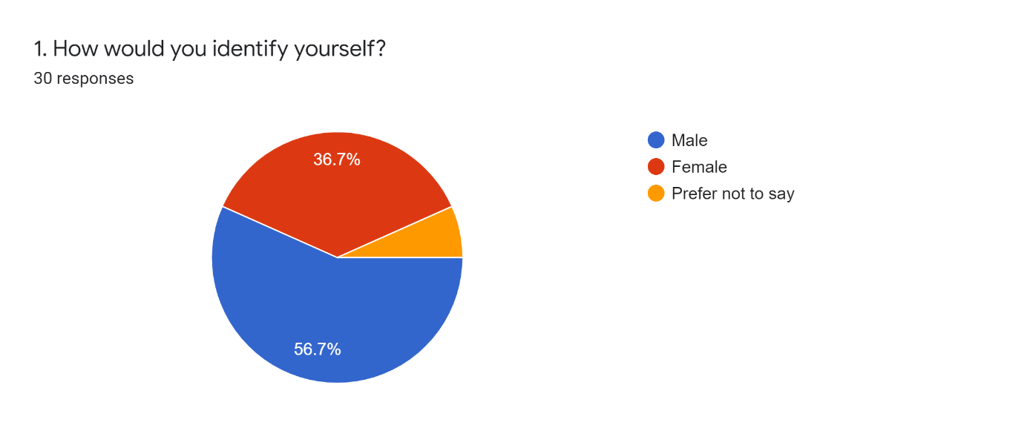As per figure 1, results were weighted towards mostly male respondents with 56.7% identifying as male, 36.7% female with the remainder preferring not top say. According to government statistics, compiled in March 2019, 68.3% of officers serving in South Wales Police are male and 31.7% are female, so this uneven split between gender response was to be expected. (Police.UK, 2019). Research suggests that there are several differing opinions between men and women in use patterns and risk factors for substance abuse which could affect opinion in this survey. (Kauffman et al, 1997). Given the limitations and constraints of this research project, this will not be examined for the purposes of the results analysis but could be considered as having an impact.
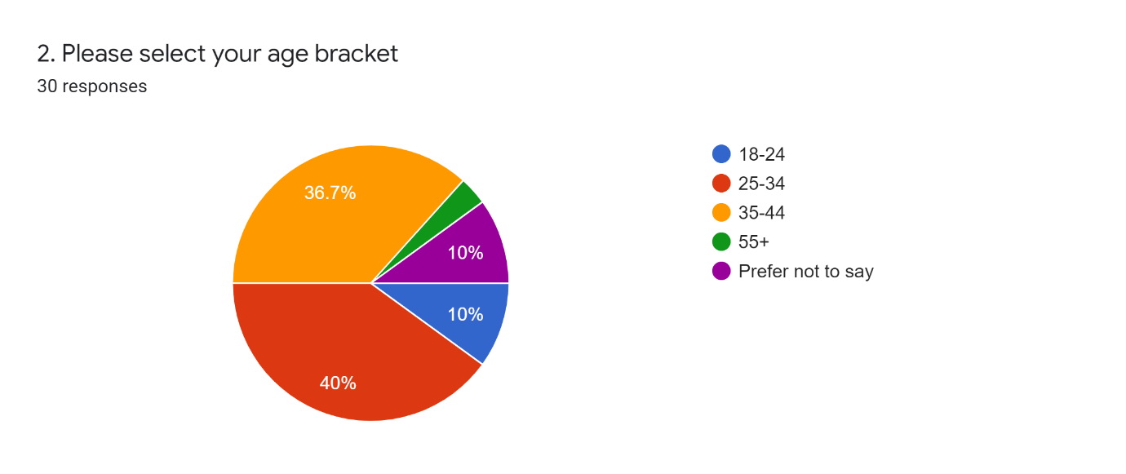
As per figure 2, staying with demographic for the survey responses, as far as age was concerned, most of the respondents were from the 25-44 age brackets, with only 23% of respondents, falling outside of this age range. As with gender, Research indicates that there are differing attitudes towards drugs across this demographic, with adults in both the youngest (16–29 years) and older age groups (60+ years) having more negative attitudes towards those with drug problems than those in other age groups (www.ukdpc.org.uk, 2010). Again, this could impact the results obtained but is not being considered due to the constraints in this research project.
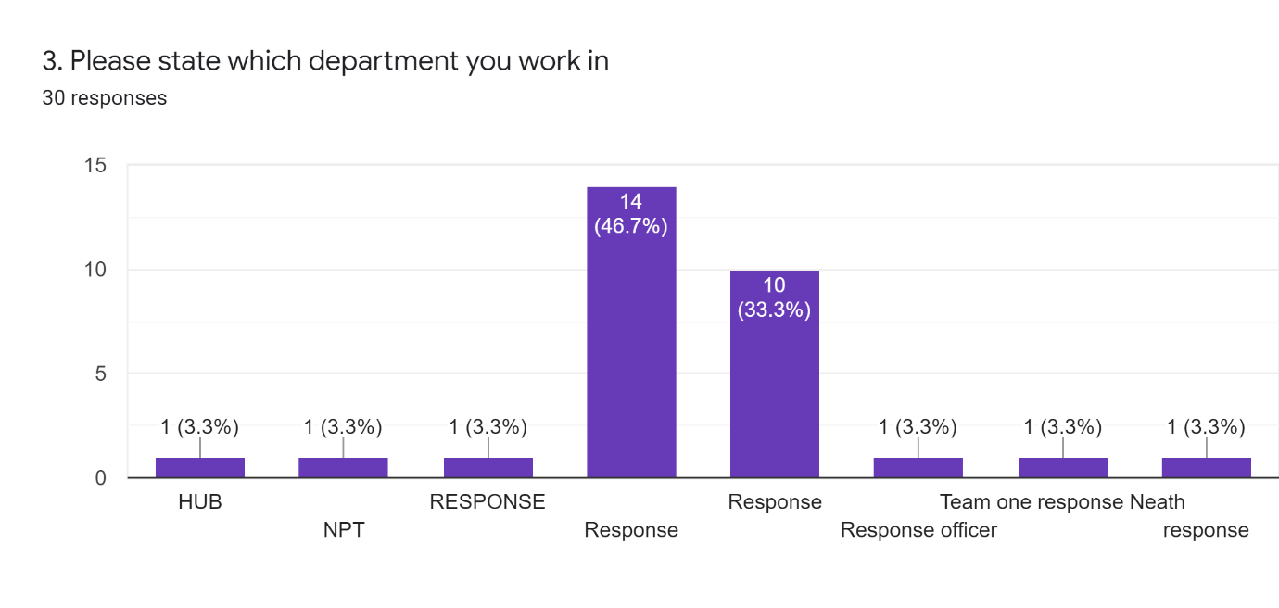Figure 3 shows the department in which the respondent works. Learning can be taken from this question as it was decided to allow for a freeform text entry field, where as a dropdown list should have been provided. The results of this question will be ignored for the purposes of this research project. It had been anticipated that a breakdown of opinion from differing departments could have been analysed as part of the results but as can be seen there was only one response from a hub officer and one from Neighbourhood policing, which does not provide for a useable subset of data in which to compare results.
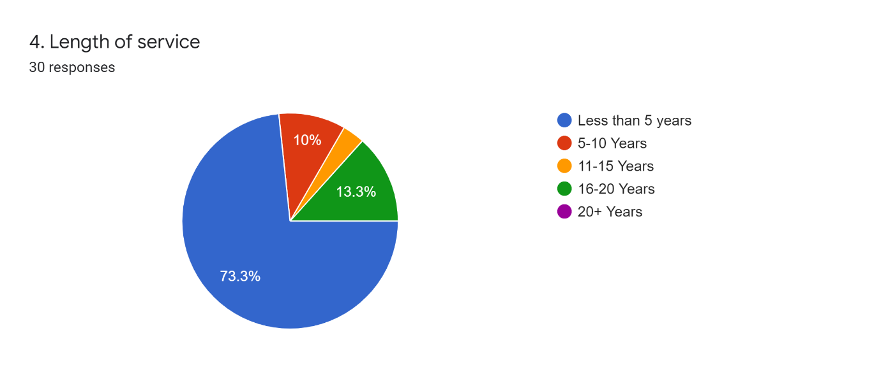Figure 4 shows the length of service of the respondent. As shown, most respondents (73.3%) have less than 5 years of service. This was to be expected as Response policing is the entry route for a new police officer, with many moving into specialist departments or away from front line as their tenure increases. This observation can only be seen as anecdotal as no figures for tenure per department within South Wales Police currently exist and this question was not within scope for this research project. Long tenured officers within other roles, may have impacted upon the results if they had been surveyed and could have been considered as part of a larger project.
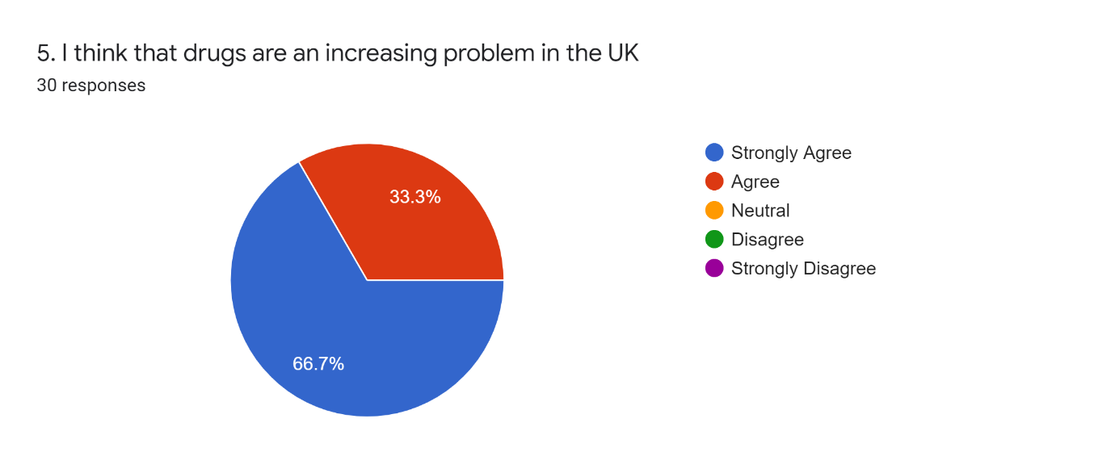
Figure 5 represents one of the most conclusive results from the survey, in that all 30 respondents agreed or strongly agreed that the drug problem is increasing in the UK. Government figures indicate that the overall prevalence of drug use reported has remained stable, but the most recent surveys report the highest prevalence of drug use in the past 10 years with the prevalence of any drug use in the last year standing at 9.4% for England and Wales, 12% for Scotland, and 5.9% for Northern Ireland. (Gov.uk, 2021), this would support that officer’s opinions on this question are a broadly accurate reflection.
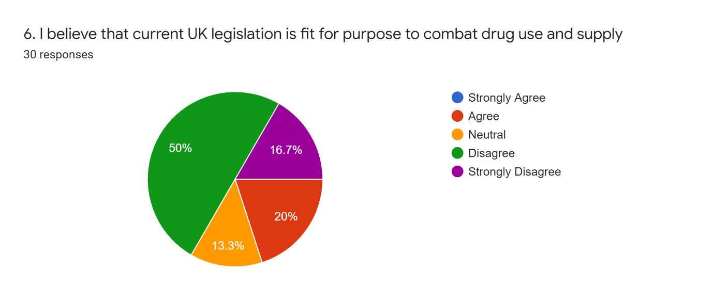
Figure 6 clearly indicates that officers believe that UK legislation is not fit for purpose in tackling the issue of drugs in the UK with 66.7% disagreeing or strongly disagreeing with its effectiveness and only 20% agreeing, with a further 13.3% remaining neutral. This would suggest a belief that wider and possibly systemic change is needed to tackle the issue.
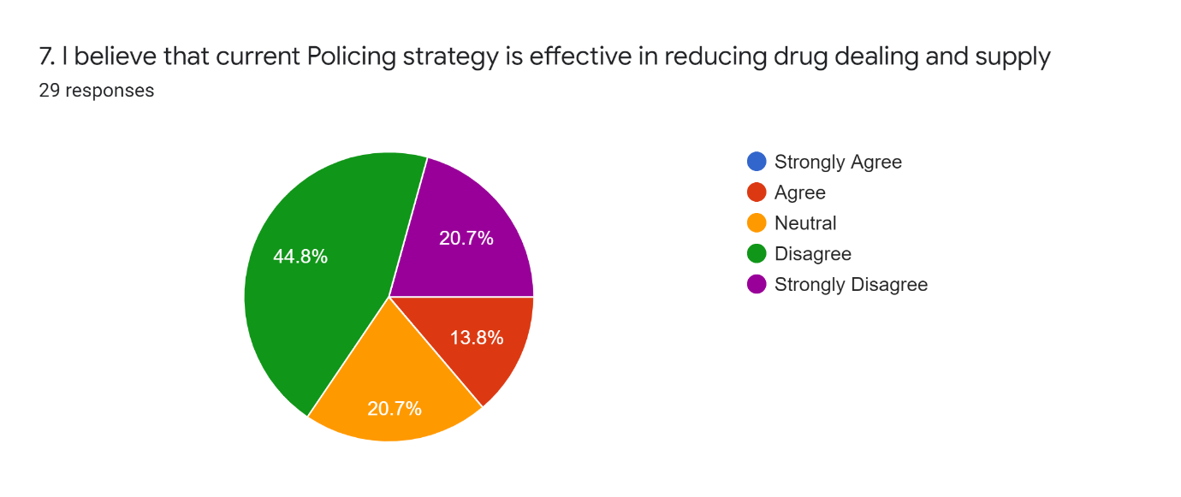
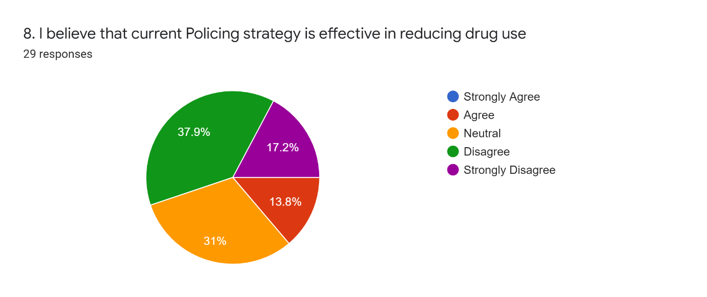
Figures 7 and 8, represent similar results, with over 60% of respondents suggesting that Policing strategy in dealing with the issues of drug use and dealing is ineffective, with only 13.8% believing that it is effective in its current state.
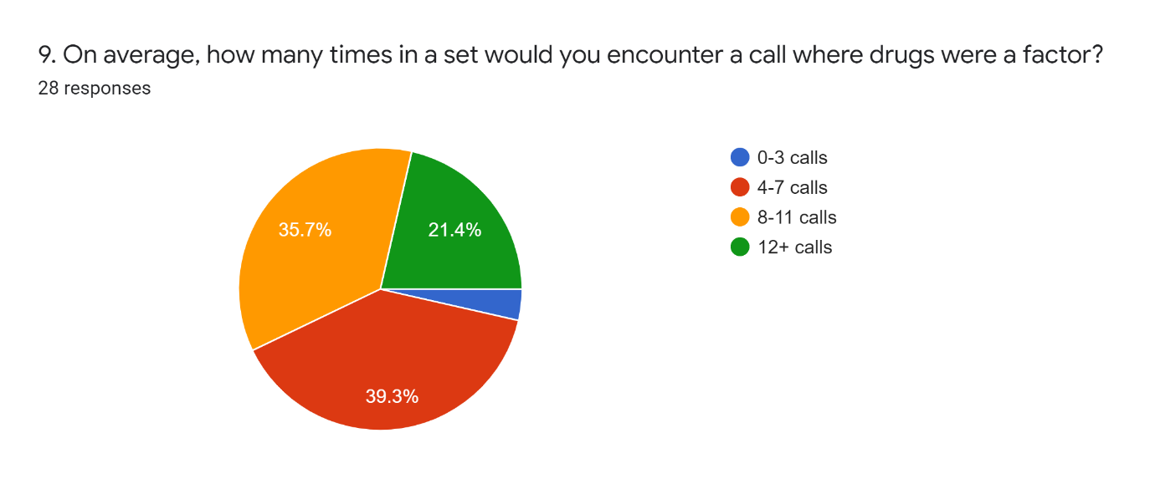
Figure 9 shows the scale of the issue, where officers indicate that they believe drugs have played a notable factor in the reason for police involvement. This result could warrant further examination to ascertain the number of total calls attended by officers and how they have identified drugs as a factor. Again, this is beyond the scope of the current project and is being considered anecdotal for the purposes of these results.
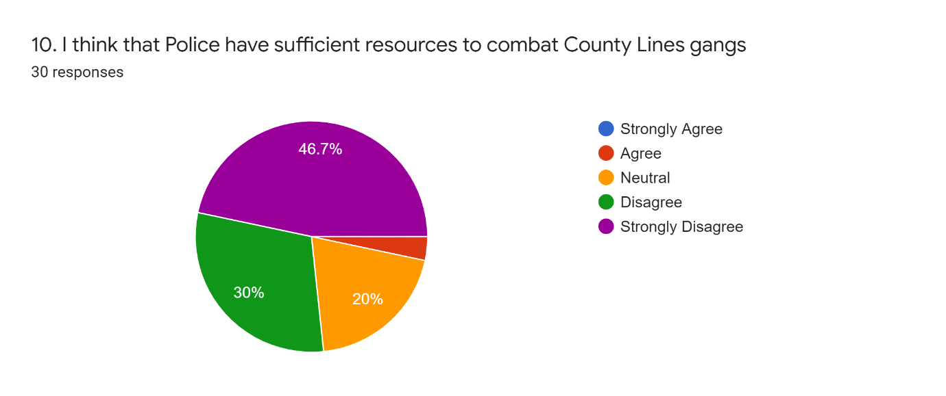
Fig 10.1 – Change in day-to-day spending on Police services in England and Wales
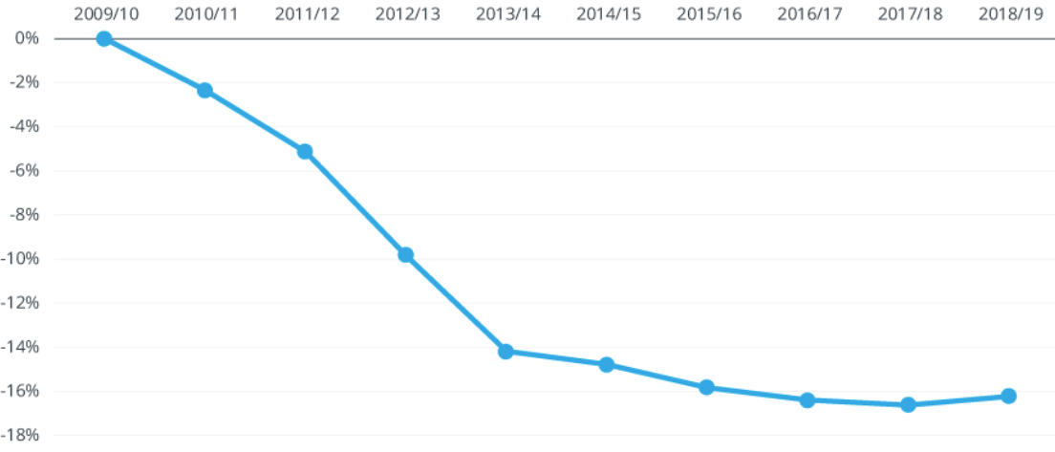
Figure 10 highlights the perceived concern amongst officers that police do not have the resources needed to tackle the growing issue of county lines drugs gangs, with 76.7% of officers indicating that resources are insufficient, with Figure 10.1 showing the real time change in government investment in policing between 2009 and 2019 (instituteforgovernment.org.uk, 2019).
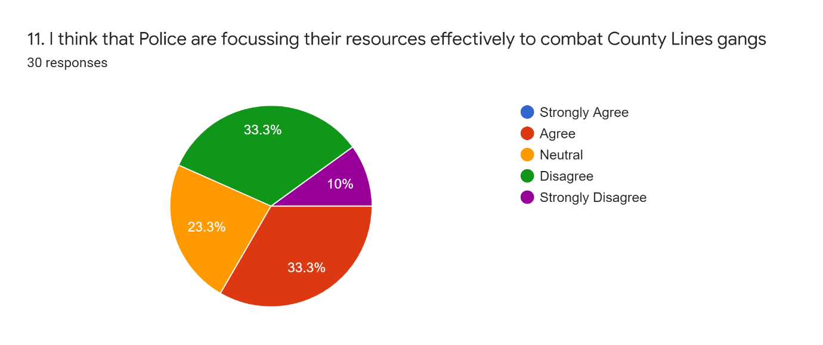
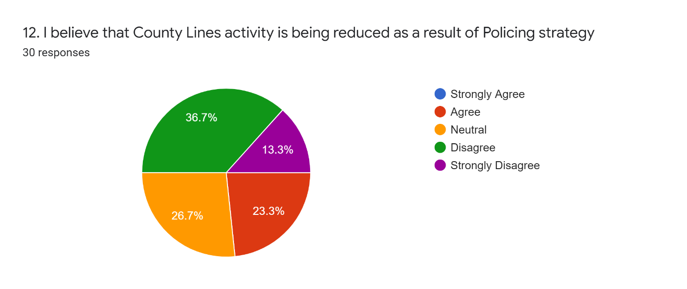
Figures 11 and 12 yield similar results and indicate that most officers feel that policing resources are not being used effectively and overall county lines activity is not being reduced because of policing strategy.
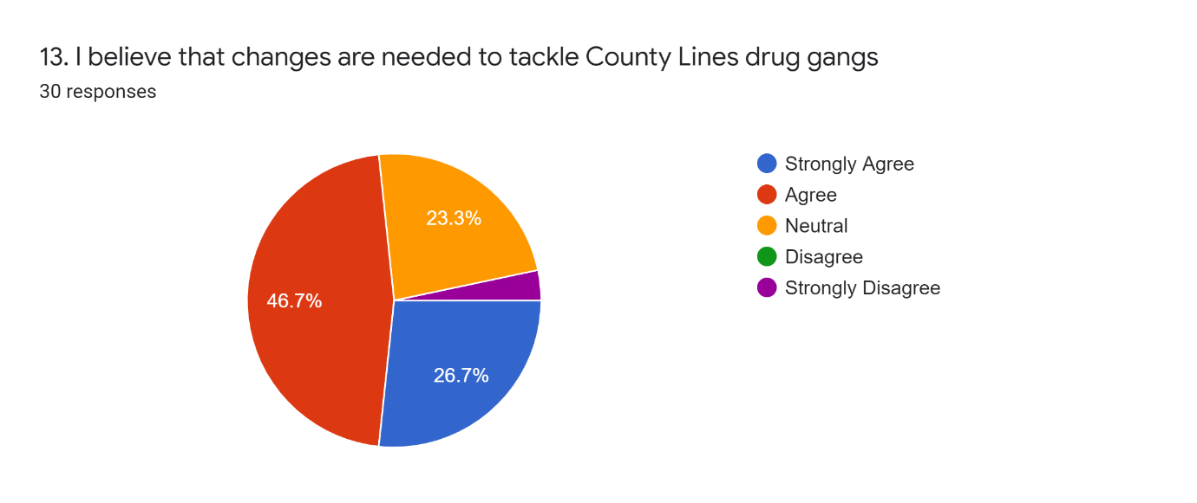
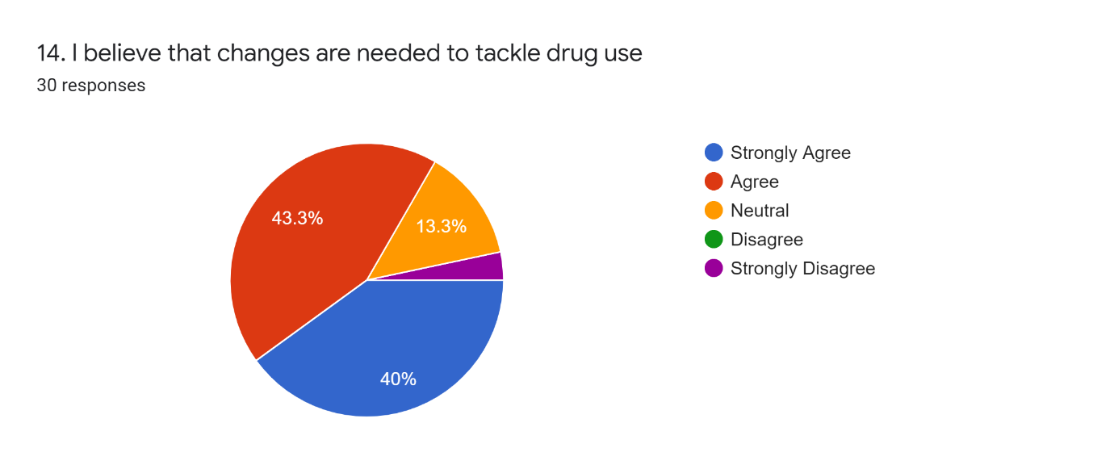
As can be seen in Figures 13 and 14, strongly supporting earlier results, officers believe that changes are needed to tackle both county lines drugs gangs and more widely drugs in society.
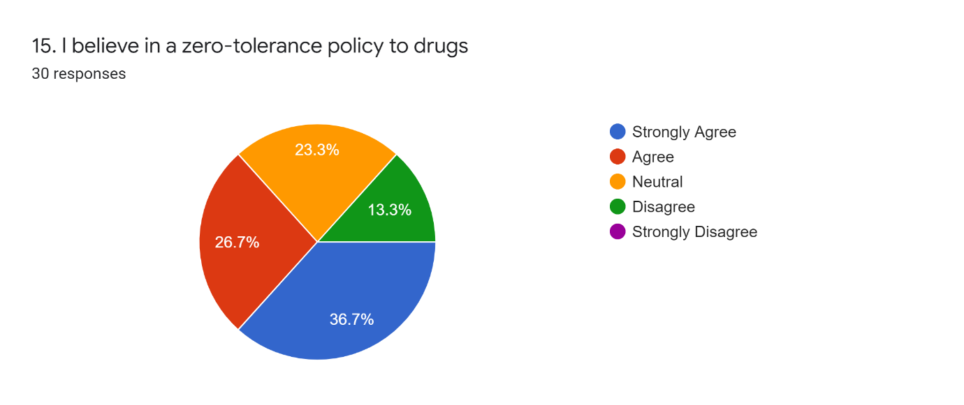
Figure 15 shows that 63.4% of officer respondents agree with a zero tolerance towards drugs. This could be further expanded to examine what zero tolerance would look like for officers and how it should be managed, again out of scope for this study.
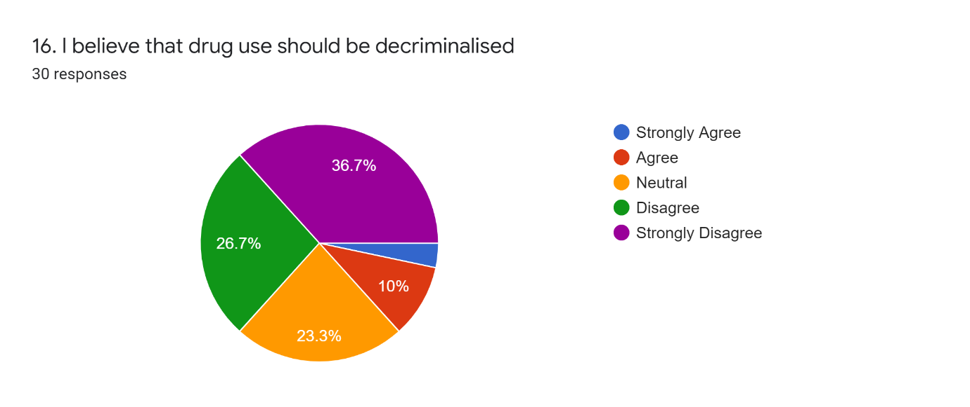 Figure 16 indicates that 63.4% of officers surveyed believe that drug use should remain criminalized, possibly more surprisingly is that 36.6% are either neutral or support decriminalisation of drugs. According to a recent YouGov survey of adults in the UK, six in ten people now believe that making drugs illegal, is an ineffective way to prevent people from using them (independent.co.uk, 2021). This survey does not differentiate between so called “harder” and “softer” drugs and could be expanded to examine the opinions of officers if given the distinction between the two. This remains out of scope for the current project.
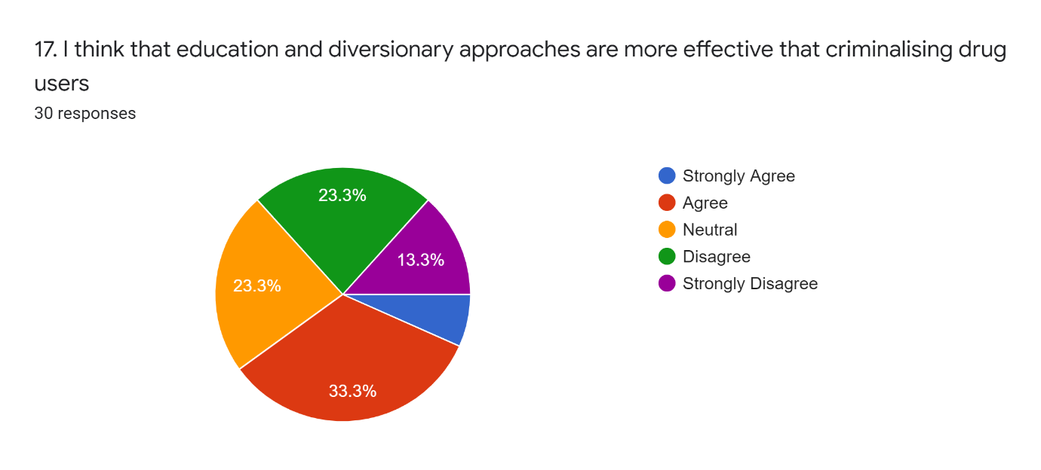Figure 17 interestingly is very split amongst officers with just 36.6% of respondents favouring criminalising drug users and 40.1% favouring a diversionary approach, with the remainder seemingly undecided on the issue.
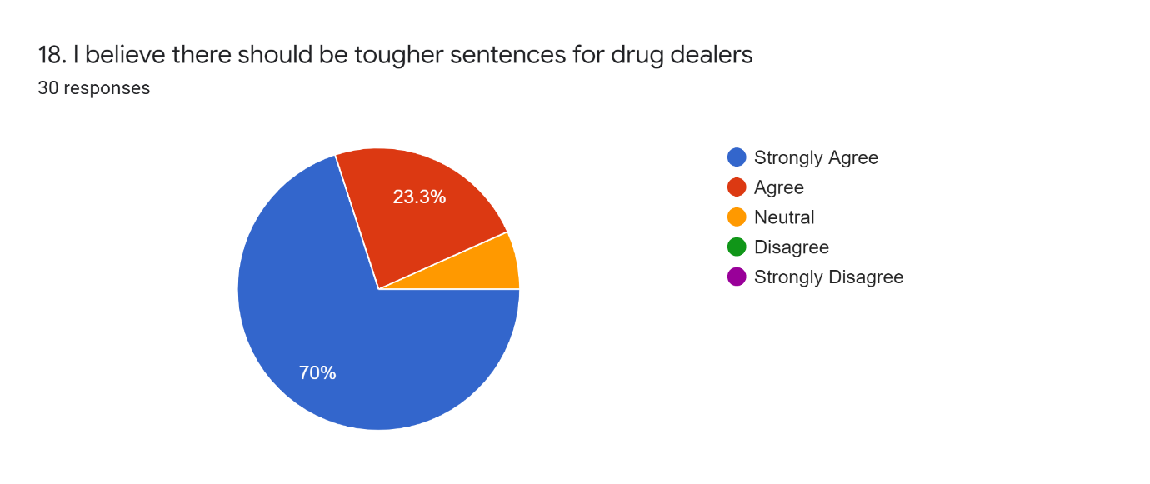
Perhaps unsurprisingly, there is broadly unequivocal support amongst officers for tougher sentences for drug dealers, with Figure 18 showing 93.3% of officers believing there should be tougher sentences.
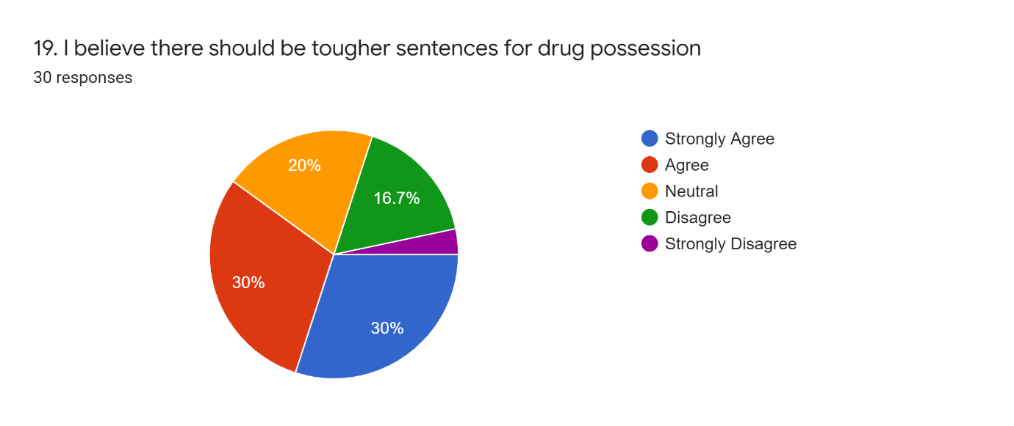 Figure 19 shows 60% support amongst officers for tougher sentencing for drug possession but given the split for the earlier diversionary approach, this result should perhaps be taken with more caution, with consideration for wider questioning around disposal methods such as fixed penalty notices, street warnings, referral to support services etc. This could warrant further research, beyond this study.
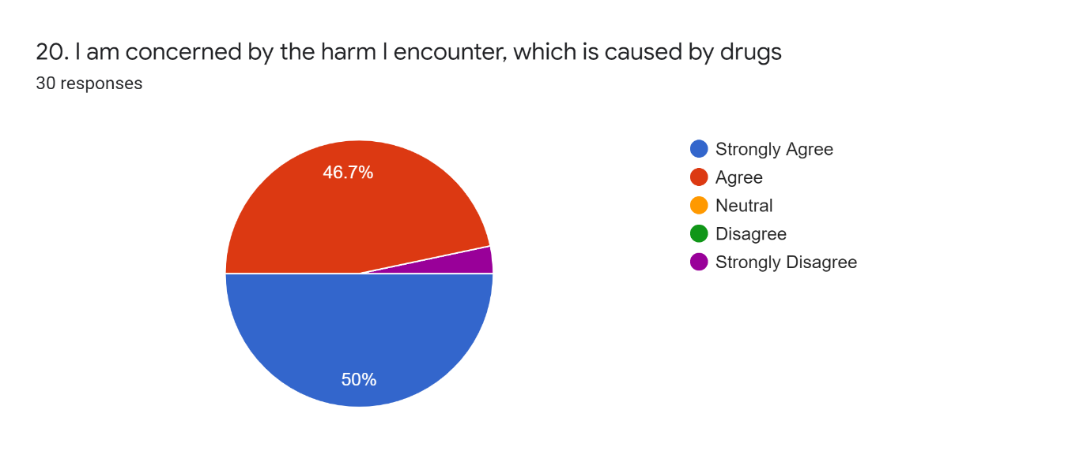
Finally Figure 20 shows near unequivocal (96.7%) concern amongst officers for the level of harm encountered, which is seen to be caused by drugs.

4.2 Reviewing the Research Objectives

In reviewing the research objectives, the survey questions can be categorised into the following headings:
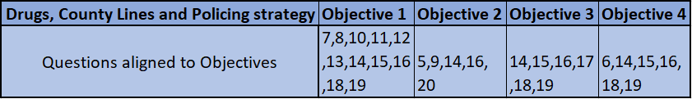
Objective 1) To determine the effectiveness of current law enforcement strategy in tackling County Lines drugs gangs
Objective 2) To assess the harm caused to young and vulnerable people by these groups
Objective 3) To examine the effectiveness of the current disposal methods and diversionary services available to offenders
Objective 4) To determine the effectiveness of current legislation and critically assess it is fit for purpose in reducing the prevalence of harm caused by drugs, also including the current classification of drugs and the criminalisation of drug dealers and users.

4.3 Conclusion

This concludes the results chapter. During this chapter, each question from the survey was presented and the findings were subjectively analysed by the researcher. This interpretation needs to be highlighted as a potential limitation of the study as the researcher’s opinion and personal bias will have had an impact on the conclusions drawn. During the final chapter, as well as drawing conclusions from the results analysis above, what has gone well throughout the project will be discussed, as well as identifying the limitations that have been observed as well as areas highlighted for further research.

5.0 Conclusions and recommendations
This chapter will conclude the research project and summarise the key findings in relation to its research aims and questions. It will also discuss the value of the project and how it may contribute to the wider field of study. This will also be an opportunity to review the limitations of the project and suggest opportunities for further research.

5.1 Overall findings in relation to the research aims
The projects primary aim was to determine the perceptions and viewpoints of serving police officers, in relation to the issue of County Lines gangs and the wider issues of drug taking and supply in England and Wales. The results of the study certainly seem to indicate, that there is a perceived need for change in the processes and policies used in tackling drugs, as well as dealing with the associated gangs. Resources were flagged as a concern, (perhaps unsurprisingly) but more surprisingly, was the slightly more nuanced approach that some of the officers surveyed, would like to see taken towards drugs and drug users.

5.2 Contribution to the area of research
As noted during the project, there was not a broad area of existing research to pull from in relation to the research goals, because primarily the area of research was focussed on police perception. Of course, the wider issues of Drugs, harm, reduction, and legislation are broadly covered across many other studies, some of which have been discussed throughout. It can be observed that this study could have some value in supporting future Policing process or legislative change but given the scope and limitations of the project, I acknowledge that further work would be needed to broaden the sample size for this to have a more significant contribution to the field of study. Taken of as a larger study with this project being considered foundational, it is felt that this could add value to the field going forward.

5.3 Reflecting on the limitations of the study
There were several limitations highlighted throughout the study, which became more apparent when analysing the results. Primarily, it was originally in scope to more closely examine the harms caused by drugs and the impacts of these harms which are witnessed by Police officers; however, it quickly became clear that this was a far broader field of study, and one which has already had significant coverage in the fields of medicine and nursing. It was clear that this project, given its size, scope and reach, would not be able to add much value in this regard.
Sample size was also a limitation during this study, with the number of surveys returned being on the lower side of expectation. This smaller sample size may not have resulted in a strongly conclusive data set across some of the questions asked in the survey. Time constrains as well as only opening the survey up to the Western division of South Wales Police, ultimately led to this being a limitation which could be overcome as part of a broader future study.
It should also be acknowledged that researcher experience was a limitation here. This was the first academic project, and this lack of experience could be seen to contribute towards some of its limitations or failings. There must also be an acknowledgment of researcher Bias, with the researcher being a serving police officer himself. The survey questions were scripted in a neutral way was, but the researchers’ own beliefs or prejudices towards the subject matter could have had an impact in this regard.
The data collection and analysis techniques used during the project were generally quite rudimentary and simplistic. A more detailed data analysis could have provided more detailed comparative results but again time constraints, and the size of the research project were both limitations in this regard, in addition qualitative studies with interviews instead of surveys would have potentially produced more useable data, once again, this could be a consideration in any future project.

5.4 Recommendations for future research
From the results obtained in the study, there were several areas identified as having the potential for further research. The preference would have been to include some of these in the initial research but as noted above, there were some significant limitations due to time constraints, word count and the general scale and scope of the wider research areas concerned. It is such a broad field of study, that the branch possibilities were significant.
In conclusion with regards to further research, this study would benefit from expanding the survey to a wider group of Police Officers, with consideration to cover the whole of the South Wales force. It could also benefit from a comparison of opinions taken from members of the public. Further to this and as noted above, there would be a benefit in widening the research to include qualitative research in the form of interviews, which would allow the study to drill down the respondent’s views, to ascertain specific reasoning behind the reasons for some of their responses.
Criminalisation posed some of the most interesting responses in the survey, with a real split of opinion in officers evident from differing views towards drugs and drug users. It would be interesting to drill deeper on the reasons for the split in opinion in this regard, which could make for an interesting field of study. As previously noted, the issue of demographic by age and sex was another potential for further research and with a larger subset of data this would be possible.

5.5 Closing summary

In summary, it can be observed that the following 4 objectives have been addressed in this study. To recap:
Objective 1) To determine the effectiveness of current law enforcement strategy in tackling County Lines drugs gangs
Objective 2) To assess the harm caused to young and vulnerable people by these groups
Objective 3) To examine the effectiveness of the current disposal methods and diversionary services available to offenders
Objective 4) To determine the effectiveness of current legislation and critically assess it is fit for purpose in reducing the prevalence of harm caused by drugs, also including the current classification of drugs and the criminalisation of drug dealers and users.
Although there have been a significant number of limitations identified in this project alongside developmental opportunities for the researcher, some valuable data was achieved, and some interesting results presented. It is evident from the results that nothing can be seen as conclusive and the project can only be seen as a foundation to a larger piece of work, but what can be seen is that the initial objectives have been broadly covered and some useable results captured.
Upon reflection, the project itself could have benefitted from being more focussed from the outset, with just one of the four objectives analysed more closely with the others being discounted, but this has the benefit of hindsight and would equally benefit from further research around all four objectives rather than their abandonment. Given the limited size of the research project, which consists of just 10,000 words, there was only ever going to be the opportunity to scratch the surface of the topic area and it can certainly be seen to have achieved the expectations of the researcher.
It is hoped that the data obtained will add some value to this specific field of research. It is notable that the researcher could find no similar studies having been carried out, involving serving police officers of this kind and as such, from a process and a legislative viewpoint, the project could have potential value to any future study which may look to involve Police Officers and their opinions in making process or legislative change in Policing drugs and county lines going forward.
By analysing Police officers’ views and representations, in relation to UK policing policy and procedure in relation to drugs and drug legislation, this project has shown that it is Police Officers belief, that change is needed to tackle the issues being observed day to day within their operational roles. This may not effect national change but should be taken seriously by senior officers and lawmakers if improvements are to be made in catching dealers, managing, and interacting with drug users and influencing legislation that is seen to be ineffective in tackling the seemingly ever-increasing so-called War on drugs.

References

Bonning, J. and Cleaver, K., 2020. ‘There is no “war on drugs”’: An investigation into county line drug networks from the perspective of a London borough. The Police Journal: Theory, Practice and Principles, pp.0032258X2095668.
Blakeburn, M., Richard Smith, (2021) Exploring the role of the British Transport Police in responding to "County Lines" drug markets: enforcement and safeguarding perspectives. Police Journal, Pol. J., 94(2), 239-256
Brewster, B., Robinson, G., Silverman, B.W. et al. (2021) Covid-19 and child criminal exploitation in the UK: implications of the pandemic for county lines. Trends Organ Crim
CACI. 2022. Early intervention in the county lines battle - CACI. [online] Available at: <https://www.caci.co.uk/blog/early-intervention-county-lines-battle> [Accessed 23 January 2022].
GOV.UK. 2022. [online] Available at: <https://www.health-ni.gov.uk/articles/misuse-drugs-legislation> [Accessed 23 January 2022].
Cascadewales.org. 2022. [online] Available at: <https://cascadewales.org/wp-content/uploads/sites/3/2020/11/A-systematic-map-and-synthesis-review-of-Child-Criminal-Exploitation-October-2019-1.pdf> [Accessed 23 January 2022].
Childrenscommissioner.gov.uk. 2022. [online] Available at: <http://www.childrenscommissioner.gov.uk/wp-content/uploads/2019/02/CCO-Gangs.pdf> [Accessed 23 January 2022].
Coliandris, G. (2015). ‘County lines and wicked problems: Exploring the need for improved policing approaches to vulnerability and early intervention.’ Australasian Policing, 7(2).
Coomber, R., Moyle, L., Mahoney, MK, (2016). Symbolic policing: situating targeted police operations/‘crackdowns’ on street-level drug markets. Pages 1-17
GCU. 2022. What Is Qualitative vs. Quantitative Study? [online] Available at: <https://www.gcu.edu/blog/doctoral-journey/what-qualitative-vs-quantitative-study#:~:text=As%20qualitative%20and%20quantitative%20studies,think%20or%20respond%20within%20society> [Accessed 23 June 2022].
Glover Williams A, Finlay F (2019) ‘County lines: how gang crime is affecting our young people’, Archives of Disease in Childhood, Issue 104. PP 730-732.
GOV.UK. 2022. County Lines exploitation: applying All Our Health. [online] Available at: <https://www.gov.uk/government/publications/county-lines-exploitation-applying-all-our-health/county-lines-exploitation-applying-all-our-health> [Accessed 23 January 2022].
GOV.UK. 2022. Criminal exploitation of children and vulnerable adults: county lines. [online] Available at: <https://www.gov.uk/government/publications/criminal-exploitation-of-children-and-vulnerable-adults-county-lines/criminal-exploitation-of-children-and-vulnerable-adults-county-lines> [Accessed 23 January 2022].
GOV.UK. 2022. Modern Slavery: National Referral Mechanism and Duty to Notify statistics UK, Quarter 3 2020 – July to September second edition. [online] Available at: <https://www.gov.uk/government/statistics/modern-slavery-national-referral-mechanism-and-duty-to-notify-statistics-uk-quarter-3-2020-july-to-september> [Accessed 23 January 2022].
GOV.UK. 2022. Modern Slavery: National Referral Mechanism and Duty to Notify Statistics UK, Quarter 3 2020 – July to September second edition. [online] Available at: <https://www.gov.uk/government/publications/modern-slavery-national-referral-mechanism-and-duty-to-notify-statistics-uk-quarter-3-2020-july-to-september/modern-slavery-national-referral-mechanism-and-duty-to-notify-statistics-uk-quarter-3-2020-july-to-september> [Accessed 23 January 2022].
Justiceinspectorates.gov.uk. 2022. [online] Available at: <https://www.justiceinspectorates.gov.uk/hmicfrs/wp-content/uploads/both-sides-of-the-coin-police-nca-response-vulnerable-people-county-lines-drug-offending.pdf> [Accessed 23 January 2022].
Justiceinspectorates.gov.uk. 2022. [online] Available at: <https://www.justiceinspectorates.gov.uk/hmiprobation/wp-content/uploads/sites/5/2021/01/Academic-Insights-county-lines-.pdf> [Accessed 23 June 2022].
Legislation.gov.uk. 2022. Misuse of Drugs Act 1971. [online] Available at: <https://www.legislation.gov.uk/ukpga/1971/38/contents> [Accessed 23 January 2022].
Middleton, J (2018) ‘Preventing Violent Crime’, British Medical Journal. 361.
Moyle, L (2019) ‘Situating Vulnerability and Exploitation in Street-Level Drug Markets: Cuckooing, Commuting, and the “County Lines” Drug Supply Model’, Journal of Drug Issues, Volume: 49 issue: 4 page(s): 739-755
Nationalcrimeagency.gov.uk. 2022. [online] Available at: <https://www.nationalcrimeagency.gov.uk/who-we-are/publications/257-county-lines-drug-supply-vulnerability-and-harm-2018> [Accessed 23 January 2022].
Oliver, P., (2012). Succeeding with your literature review.
Olver, E., Cockbain., R (2021) ‘Professionals' Views on Responding to County Lines-Related Criminal Exploitation in the West Midlands, UK’, Child Abuse Review, Volume30, Issue 4, Pages 347-362.
Olver, K (2021) ‘Professionals' Views on Responding to County Lines-Related Criminal Exploitation in the West Midlands, UK.’, Child abuse review. 30(4). PP347-362.
Pages.caci.co.uk. 2022. Youth Justice | CACI. [online] Available at: <https://pages.caci.co.uk/ CYP-Youth-Justice.html> [Accessed 23 January 2022].
Peter Stelfox (2002) ‘Policing Lower Levels of Organised Crime in England and Wales.’ The howard journal of crime and justice. 37(4).
Robinson, G., McLean, R. and Densley, J. (2018) ‘Working County Lines: Child Criminal Exploitation and Illicit Drug Dealing in Glasgow and Merseyside.’ International journal of offender therapy and comparative criminology. 63(5)
Snyder, H., 2019. Literature review as a research methodology: An overview and guidelines. Journal of Business Research, 104.

Spicer, J (2021) ‘Between gang talk and prohibition: The transfer of blame for County Lines’, International Journal of Drug Policy, Volume 87
Spicer, J. (2021) New Tactics. In: Policing County Lines. Palgrave Studies in Risk, Crime and Society. Palgrave Macmillan, Cham.
Spicer, J (2021) ‘The British Journal of Criminology’,- Volume 61 > Issue 5, 1 The policing of cuckooing in 'County Lines' drug dealing: An ethnographic study of an amplification spiral – (2021) 61(5): 1390-1406
Windle, J., Moyle, L., Coomber, R (2020), Volume: 20 issue: 1-2, page(s): 64-78, Youth Justice, ‘Vulnerable’ Kids Going Country: Children and Young People’s Involvement in County Lines Drug Dealing
Wroe L (2019) ' Contextual safeguarding and county lines'. University of Bedfordshire.
Yin, R., 2003. Case study research. Thousand Oaks, Calif.: Sage Publications.

Appendix

Survey front page

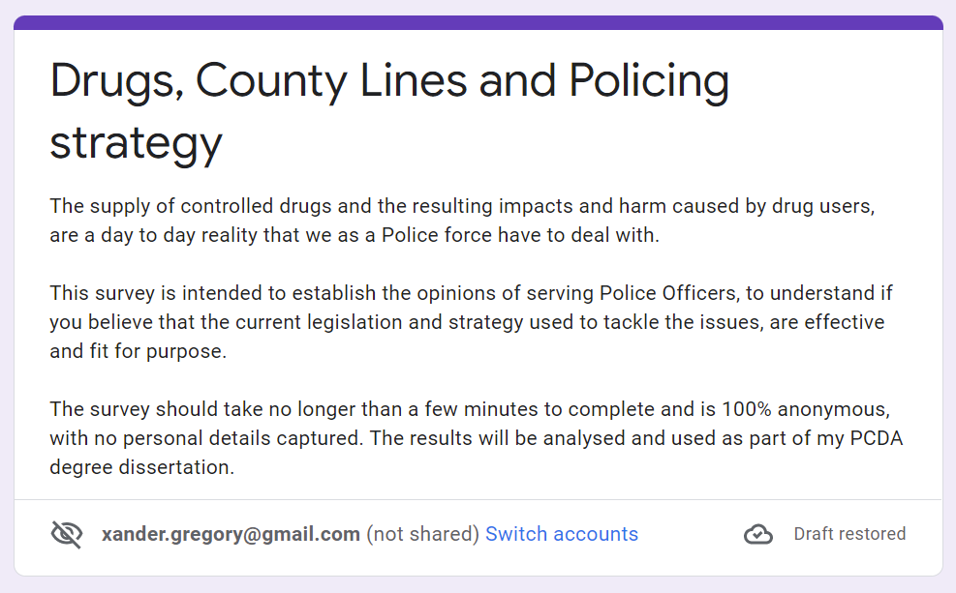

Survey results
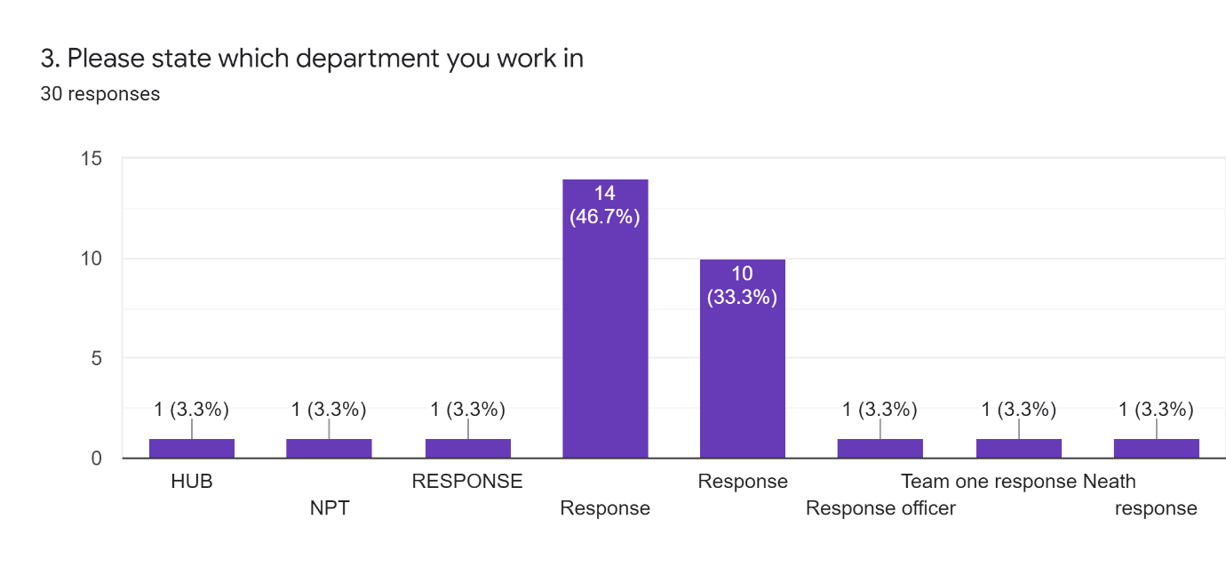
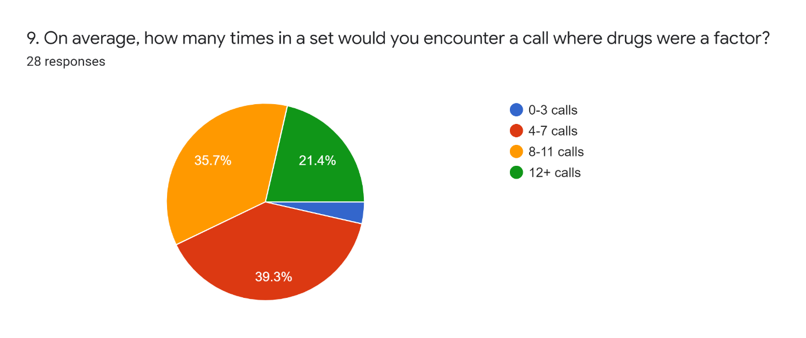
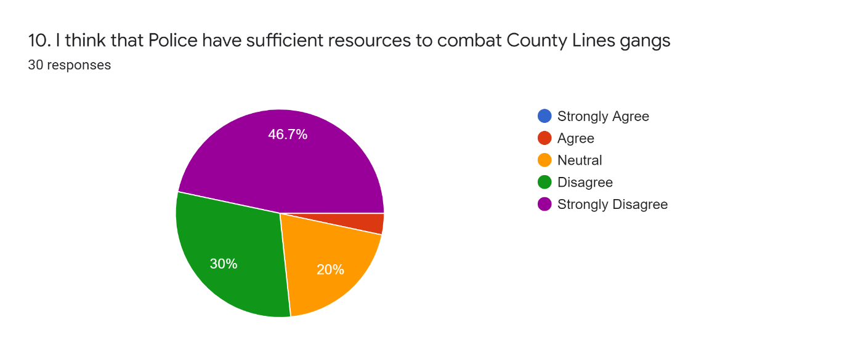
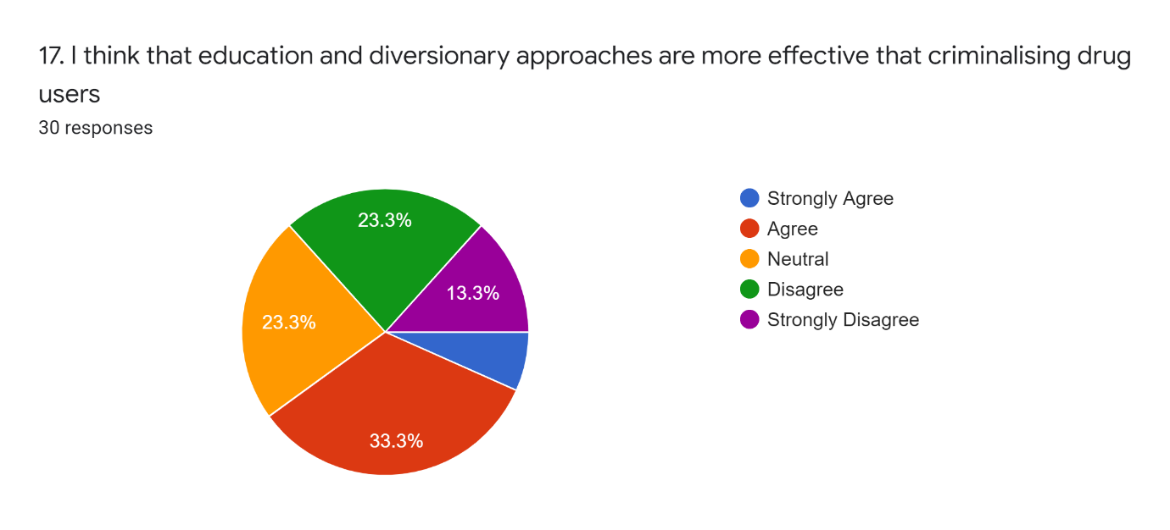

Ethics form

APPLICATION FOR ETHICAL APPROVAL

In order for research to result in benefit and minimise risk of harm, it must be conducted ethically. A researcher may not be covered by the University’s insurance if ethical approval has not been obtained prior to commencement.

The University follows the OECD Frascati manual definition of research activity: “creative work undertaken on a systematic basis in order to increase the stock of knowledge, including knowledge of man, culture and society, and the use of this stock of knowledge to devise new applications”. As such this covers activities undertaken by members of staff, postgraduate research students, and both taught postgraduate and undergraduate students working on dissertations/projects.

The individual undertaking the research activity is known as the “principal researcher”.

Ethical approval is not required for routine audits, performance reviews, quality assurance studies, testing within normal educational requirements, and literary or artistic criticism.

Please read the notes for guidance before completing ALL sections of the form.

This form must be completed and approved prior to undertaking any research activity. Please see Checklist for details of process for different categories of application.

Delete the Guidance Notes at the end of the form BEFORE submitting your application

SECTION A: About You (Principal Researcher)
Full Name: |  | Alex Rees Gregory
Tick all boxes which apply: |  | Member of staff: | ☐ | Honorary research fellow: | ☐
Undergraduate Student | ☒ | Taught Postgraduate Student | ☐ | Postgraduate Research Student | ☐

Institute/Academic Discipline/Centre: | UWTSD/Bachelor of Science
Campus: | Swansea
E-mail address: | 1910666@student.uwtsd.ac.uk
Contact Telephone Number: | 07940329574
For students:
Student Number: | 1910666
Programme of Study: | Professional Policing Practice
Director of Studies/Supervisor: | Jane Thomas

SECTION B: Approval for Research Activity
Has the research activity received approval in principle?  (please check the Guidance Notes as to the appropriate approval process for different levels of research by different categories of individual) |  | YES | ☐ | NO | ☒
 |  |  |  | Date
If Yes, please indicate source of approval (and date where known): Approval in principle must be obtained from the relevant source prior to seeking ethical approval | Research Degrees Committee |  | ☐
 | Institute Research Committee |  | ☐
 | Other (write in) |  | ☐

SECTION C: Internal and External Ethical Guidance Materials
Please list the core ethical guidance documents that have been referred to during the completion of this form (including any discipline-specific codes of research ethics, and also any specific ethical guidance relating to the proposed methodology). Please tick to confirm that your research proposal adheres to these codes and guidelines.
UWTSD Research Ethics & Integrity Code of Practice | ☒
UWTSD Research Data Management Policy | ☒
 | ☐

SECTION D: External Collaborative Research Activity
Does the research activity involve collaborators outside of the University? |  | YES | ☒ | NO | ☐
If Yes, please provide the name of the external organisation and name and contact details for the main contact person and confirmation this person has consented to their personal data being shared.as part of this collaboration.
Institution | South Wales Police
Contact person name | Sgt Gary Humphreys
Contact person e-mail address | Gary.humphreys@south-wales.police.uk
Has this individual consented to sharing their details on this form? |  | YES | ☒ | NO |  |  | ☐
Are you in receipt of a KESS scholarship? |  | YES | ☐ | NO |  |  | ☒
Is your research externally funded |  | YES | ☐ | NO |  |  | ☒
Are you specifically employed to undertake this research in either a paid or voluntary capacity? | Voluntary | YES | ☐ | NO |  | ☒
 | Employed | YES | ☐ | NO |  | ☒
Is the research being undertaken within an existing UWTSD Athrofa Professional Learning Partnership (APLP) | If YES then the permission question below does not need to be answered. | YES | ☐ | NO |  |  | ☒
Permission to undertake the research has been provided by the partner organisation | (If YES attach copy)  If NO the application cannot continue | YES | ☐ | NO |  |  | ☒

Where research activity is carried out in collaboration with an external organisation
Does this organisation have its own ethics approval system? | YES | ☐ | NO | ☒
If Yes, please attach a copy of any final approval (or interim approval) from the organisation

SECTION E: Details of Research Activity
Indicative title: | County Lines and vulnerability: A critical examination of strategies used in fighting the so called “War on Drugs”
Proposed start date: | 15/11/21 | Proposed end date: | 27/06/22
Introduction to the Research (maximum 300 words)
Ensure that you write for a Non-Specialist Audience when outlining your response to the three points below:
- Purpose of Research Activity
- Proposed Research Question
- Aims of Research Activity
- Objectives of Research Activity
Demonstrate, briefly, how Existing Research has informed the proposed activity and explain
- What the research activity will add to the body of knowledge
- How it addresses an area of importance.
Purpose of Research Activity

- To determine the effectiveness of current law enforcement strategy in tackling County Lines drugs gangs
- To assess the harm caused to young and vulnerable people by these groups
- To examine the effectiveness of the current disposal methods and diversionary services available to offenders
- To determine the effectiveness of current legislation and critically assess it is fit for purpose in reducing the prevalence of harm caused by drugs, also including the current classification of drugs and the criminalisation of cannabis users.
- Conduct surveys with perceived subject matter experts in the field of drugs law enforcement, to ascertain the thoughts, ideas and recommendations of those individuals operating at the coal face.

(this box should expand as you type)
Research Question

- To determine the effectiveness of current law enforcement strategy in tackling County Lines drugs gangs
- To assess the harm caused to young and vulnerable people by these groups
- To examine the effectiveness of the current disposal methods and diversionary services available to offenders
- To determine the effectiveness of current legislation and critically assess it is fit for purpose in reducing the prevalence of harm caused by drugs, also including the current classification of drugs and the criminalisation of drug dealers and users.

(this box should expand as you type)
Aims of Research Activity

To establish effectiveness of current policy and process and to examine the benefits of reform

(this box should expand as you type)
Objectives of Research Activity

To suggest changes that may be effective in tackling the issues raised

(this box should expand as you type)
Proposed methods (maximum 600 words)
Provide a brief summary of all the methods that may be used in the research activity, making it clear what specific techniques may be used. If methods other than those listed in this section are deemed appropriate later, additional ethical approval for those methods will be needed.
Primary Research will comprise of a questionnaire to NPT, PPT and Response teams across the Western Division of South Wales Police, extended to other divisions if the sample set returned was low. This questionnaire will consist of a combination of closed questions to generate a yes/no response centred around binary questions of choice and open questions where I would hope to encourage a more generalised debate or establish the participants thoughts or feelings around a specific topic element related to the subject matter. I will remain aware of participants potential bias with the target group being police officers and will consider extending some questions from the survey (where suitable) to participants outside of the police to see if opinion differs in this regard.

(this box should expand as you type)

Location of research activity
Identify all locations where research activity will take place.
South Wales Police – Email to participant group
Fellow Students on this course – Email to participant group

(this box should expand as you type)
Research activity outside of the UK
If research activity will take place overseas, you are responsible for ensuring that local ethical considerations are complied with and that the relevant permissions are sought. Specify any local guidelines (e.g. from local professional associations/learned societies/universities) that exist and whether these involve any ethical stipulations beyond those usual in the UK (provide details of any licenses or permissions required). Also specify whether there are any specific ethical issues raised by the local context in which the research activity is taking place, for example, particular cultural and/or legal sensitivities or vulnerabilities of participants.
N/A

(this box should expand as you type)
Use of documentation not in the public domain: Are any documents NOT publicly available? | NO | ☒
 | YES | ☐
If Yes, please provide details here of how you will gain access to specific documentation that is not in the public domain and that this is in accordance with prevailing data protection law of the country in question and England and Wales.

(this box should expand as you type)

SECTION F: Scope of Research Activity
Will the research activity include: | YES | NO
Use of a questionnaire or similar research instrument? | ☒ | ☐
Use of interviews? | ☐ | ☒
Use of diaries? | ☐ | ☒
Participant observation with their knowledge? | ☐ | ☒
Participant observation without their knowledge? | ☐ | ☒
Use of video or audio recording? | ☐ | ☒
Access to personal or confidential information without the participants’ specific consent? | ☐ | ☒
Administration of any questions, test stimuli, presentation that may be experienced as physically, mentally or emotionally harmful / offensive? | ☐ | ☒
Performance of any acts which may cause embarrassment or affect self-esteem? | ☐ | ☒
Investigation of participants involved in illegal activities? | ☐ | ☒
Use of procedures that involve deception? | ☐ | ☒
Administration of any substance, agent or placebo? | ☐ | ☒
Working with live vertebrate animals? | ☐ | ☒
Other primary data collection methods, please explain in this box  For example, ‘focus groups’. Please indicate the type of data collection method(s) in this box and tick the accompany box. | ☐ | ☒
Details of any other primary data collection method:  N/A  (this box should expand as you type) | ☐ | ☒
If NO to every question, then the research activity is (ethically) low risk and may be exempt from some of the following sections (please refer to Guidance Notes).

If YES to any question, then no research activity should be undertaken until full ethical approval has been obtained.

SECTION G: Intended Participants
Who are the intended participants: | YES | NO
Students or staff at the University? | ☒ | ☐
Adults (over the age of 18 and competent to give consent)? | ☒ | ☐
Vulnerable adults? | ☐ | ☒
Children and Young People under the age of 18? (Consent from Parent, Carer or Guardian will be required) | ☐ | ☒
Prisoners? | ☐ | ☒
Young offenders? | ☐ | ☒
Those who could be considered to have a particularly dependent relationship with the investigator or a gatekeeper? | ☐ | ☒
People engaged in illegal activities? | ☐ | ☒
Others (please identify specifically any group who may be unable to give consent) please indicate here and tick the appropriate box. | ☐ | ☒
Other – please indicate here:  N/A  (this box should expand as you type) | ☐ | ☒

Participant numbers and source
Provide an estimate of the expected number of participants. How will you identify participants and how will they be recruited?
How many participants are expected? | 20-30  (this box should expand as you type)
Who will the participants be? | SWP officers and possibly civilian staff  (this box should expand as you type)
How will you identify the participants? | From SWP systems. Targetted by group/team  (this box should expand as you type)

Information for participants: | YES | NO | N/A
Will you describe the main research procedures to participants in advance, so that they are informed about what to expect? | ☒ | ☐ | ☐
Will you tell participants that their participation is voluntary? | ☒ | ☐ | ☐
Will you obtain written consent for participation? | ☒ | ☐ | ☐
Will you explain to participants that refusal to participate in the research will not affect their treatment or education (if relevant)? | ☐ | ☐ | ☒
If the research is observational, will you ask participants for their consent to being observed? | ☐ | ☐ | ☒
Will you tell participants that they may withdraw from the research at any time and for any reason? | ☒ | ☐ | ☐
With questionnaires, will you give participants the option of omitting questions they do not want to answer? | ☒ | ☐ | ☐
Will you tell participants that their data will be treated with full confidentiality and that, if published, it will not be identifiable as theirs? | ☒ | ☐ | ☐
Will you debrief participants at the end of their participation, in a way appropriate to the type of research undertaken? | ☒ | ☐ | ☐
If NO to any of above questions, please give an explanation
(this box should expand as you type)

Information for participants: | YES | NO | N/A
Will participants be paid? | ☐ | ☒ | ☐
Is specialist electrical or other equipment to be used with participants? | ☐ | ☒ | ☐
Are there any financial or other interests to the investigator or University arising from this study? | ☐ | ☒ | ☐
Will the research activity involve deliberately misleading participants in any way, or the partial or full concealment of the specific study aims? | ☐ | ☒ | ☐
If YES to any question, please provide full details
(this box should expand as you type)

SECTION H: Anticipated Risks

Outline any anticipated risks that may adversely affect any of the participants, the researchers and/or the University, and the steps that will be taken to address them.

If you have completed a full risk assessment (for example as required by a laboratory, or external research collaborator) you may append that to this form.
Full risk assessment completed and appended? NOT REQUIRED |  | Yes | ☐
 |  | No | ☒
Risks to participants
For example: emotional distress, financial disclosure, physical harm, transfer of personal data, sensitive organisational information
Risk to Participant:  N/A – Activity does not require assessment  (this box should expand as you type) | How will you mitigate the Risk to Participant  N/A  (this box should expand as you type)
If research activity may include sensitive, embarrassing or upsetting topics (e.g. sexual activity, drug use) or issues likely to disclose information requiring further action (e.g. criminal activity), give details of the procedures to deal with these issues, including any support/advice (e.g. helpline numbers) to be offered to participants. Note that where applicable, consent procedures should make it clear that if something potentially or actually illegal is discovered in the course of a project, it may need to be disclosed to the proper authorities
N/A

(this box should expand as you type)
Risks to investigator
For example: personal safety, physical harm, emotional distress, risk of accusation of harm/impropriety, conflict of interest
Risk to Investigator:  N/A – Activity does not require assessment  (this box should expand as you type) | How will you mitigate the Risk to Investigator:  N/A  (this box should expand as you type)
University/institutional risks
For example: adverse publicity, financial loss, data protection
Risk to University:  N/A – Activity does not require assessment  (this box should expand as you type) | How will you mitigate the Risk to University:  N/A  (this box should expand as you type)

Disclosure and Barring Service
If the research activity involves children or vulnerable adults, a Disclosure and Barring Service (DBS) certificate must be obtained before any contact with such participants. | YES | NO | N/A
Does your research require you to hold a current DBS Certificate? | ☐ | ☒ | ☐

SECTION I: Feedback, Consent and Confidentiality
Feedback
What de-briefing and feedback will be provided to participants, how will this be done and when?
Not required. Participants will be notified when survey closes.

(this box should expand as you type)
Informed consent
Describe the arrangements to inform potential participants, before providing consent, of what is involved in participating. Describe the arrangements for participants to provide full consent before data collection begins. If gaining consent in this way is inappropriate, explain how consent will be obtained and recorded in accordance with prevailing data protection legislation.
The survey will be completed via surveymonkey with all consent requirements met before starting the process.

(this box should expand as you type)
Confidentiality / Anonymity
Set out how anonymity of participants and confidentiality will be ensured in any outputs. If anonymity is not being offered, explain why this is the case.
Questions will be predominantly check boxes. Any qualitative questions answered with sensitive data erroneously captured, will be sanitised.

(this box should expand as you type)

SECTION J: Data Protection and Storage
In completing this section refer to the University’s Research Data Management Policy and the extensive resources on the University’s Research Data Management web pages (http://uwtsd.ac.uk/library/research-data-management/).
Does the research activity involve personal data (as defined by the General Data Protection Regulation 2016 “GDPR” and the Data Protection Act 2018 “DPA”)? | YES | NO
“Personal data” means any information relating to an identified or identifiable natural person (‘data subject’). An identifiable natural person is one who can be identified, directly or indirectly, in particular by reference to an identifier such as a name, an identification number, location data, an online identifier or to one or more factors specific to the physical, physiological, genetic, mental, economic, cultural or social identity of that natural person. | ☐ | x
If YES, provide a description of the data and explain why this data needs to be collected:
(this box should expand as you type)
Does it involve special category data (as defined by the GDPR)? | YES | NO
“Special category data” means sensitive personal data consisting of information as to the data subjects’ –  (a) racial or ethnic origin,  (b) political opinions,  (c ) religious beliefs or other beliefs of a similar nature,  (d) membership of a trade union (within the meaning of the Trade Union and Labour Relations (Consolidation) Act 1992),  (e) physical or mental health or condition,  (f) sexual life,  (g) genetics,  (h) biometric data (as used for ID purposes), | ☐ | x
If YES, provide a description of the special category data and explain why this data needs to be collected:
(this box should expand as you type)
Will the research activity involve storing personal data and/or special category data on one of the following: | YES | NO
Manual files (i.e. in paper form)? | ☐ | ☒
University computers? | ☐ | ☒
Private company computers? | ☐ | ☒
Home or other personal computers? | ☐ | ☒
Laptop computers/ CDs/ Portable disk-drives/ memory sticks? | ☐ | ☒
“Cloud” storage or websites? | ☐ | ☒
Other – specify: | ☐ | ☒
For all stored data, explain the measures in place to ensure the security of the data collected, data confidentiality, including details of password protection, encryption, anonymisation and pseudonymisation:
N/A

(this box should expand as you type)
All Data Storage
Will the research activity involve any of the following activities: | YES | NO
Electronic transfer of data in any form? | ☒ | ☐
Sharing of data with others at the University? | ☐ | ☐
Sharing of data with other organisations? | ☐ | ☐
Export of data outside the European Union or importing of data from outside the UK? | ☐ | ☐
Use of personal addresses, postcodes, faxes, emails or telephone numbers? | ☐ | ☐
Publication of data that might allow identification of individuals? | ☐ | ☐
Use of data management system? | ☐ | ☐
Data archiving? | ☐ | ☐
If YES to any question, please provide full details, explaining how this will be conducted in accordance with the GDPR and DPA (and/or any international equivalent):
Anonymous data captured via data capture system. This will not require individual login etc. and personal data is not requested

(this box should expand as you type)
List all who will have access to the data generated by the research activity:
Myself only

(this box should expand as you type)
List who will have control of, and act as custodian(s) for, data generated by the research activity:
Myself only

(this box should expand as you type)
Give details of data storage arrangements, including security measures in place to protect the data, where data will be stored, how long for, and in what form. Will data be archived – if so how and if not why not.
Data secured via SSL protected website

(this box should expand as you type)
Please indicate if your data will be stored in the UWTSD Research Data Repository (see https://researchdata.uwtsd.ac.uk/ ). If so please explain. (Most relevant to academic staff)
No

(this box should expand as you type)
Confirm that you have read the UWTSD guidance on data management (see https://www.uwtsd.ac.uk/library/research-data-management/) | YES | ☒
 | NO | ☐
Confirm that you are aware that you need to keep all data until after your research has completed or the end of your funding | YES | ☒
 | NO | ☐

SECTION K: Declaration
The information which I have provided is correct and complete to the best of my knowledge. I have attempted to identify any risks and issues related to the research activity and acknowledge my obligations and the rights of the participants.

In submitting this application I hereby confirm that I undertake to ensure that the above named research activity will meet the University’s Research Ethics and Integrity Code of Practice which is published on the website: https://www.uwtsd.ac.uk/research/research-ethics/
Signature of applicant: | Alex Gregory | Date: 11/11/21

For STUDENT Submissions:
Director of Studies/Supervisor: |  | Date:
Signature: |  | Date:

For STAFF Submissions:
Academic Director/ Assistant Dean: |  | Date:
Signature: |  | Date:

Checklist: Please complete the checklist below to ensure that you have completed the form according to the guidelines and attached any required documentation:
☒ | I have read the guidance notes supplied before completing the form.
☒ | I have completed ALL RELEVANT sections of the form in full.
☒ | I confirm that the research activity has received approval in principle
☐ | I have attached a copy of final/interim approval from external organisation (where appropriate) N/A
☐ | I have attached a full risk assessment (and have NOT completed Section H of this form) (where appropriate) ONLY TICK IF YOU HAVE ATTACHED A FULL RISK ASSESSMENT
☒ | I understand that it is my responsibility to ensure that the above named research activity will meet the University’s Research Ethics and Integrity Code of Practice.
☒ | I understand that before commencing data collection all documents aimed at respondents (including information sheets, consent forms, questionnaires, interview schedules etc.) must be confirmed by the DoS/Supervisor, module tutor or Academic Director.
☒ | I have deleted the guidance notes before submitting the PG2 for consideration

RESEARCH STUDENTS AND STAFF ONLY
All communications relating to this application during its processing must be in writing and emailed to pgresearch@uwtsd.ac.uk , with the title ‘Ethical Approval’ followed by your name.
You will be informed of the outcome of your claim by email; therefore it is important that you check your University and personal email accounts regularly.

STUDENTS ON UNDERGRADUATE OR TAUGHT MASTERS PROGRAMMES should submit this form (and receive the outcome) via systems explained to you by the supervisor/module leader.

This form is available electronically from the Academic Office web pages: https://www.uwtsd.ac.uk/academic-office/appendices-and-forms/

Application Process

All staff research projects and all research students must submit the Ethical Approval Form to the University Research Ethics Committee via the Academic Office (pgresearch@uwtsd.ac.uk). Staff research directly in relation to personal study for taught undergraduate or Masters programmes should be submitted via the Institute procedures explained below.

Taught masters and taught undergraduate research Ethical Approval Forms are considered within Institutes. Institutes will provide details of the specific processes for this. Where the Ethical issues within any single ethical application are of particular concern the Institute will refer these to the University Research Ethics Committee. Any student activity that involves the collection of primary data needs to undergo Ethical approval, this includes assignment work as well as dissertations.

