Student Name: Mayuri Prajapati
Student ID: 2542276
Programme: Master of Business Administration
Module: Marketing Management
Module code: LCMB7024
Lecturer: Haoran Liu
Word count – 2550 words

Table of Contents
1.0 Element 1: Sustainable Brand Extension Poster Presentation 3
2.0 Element 2: Segmentation, Targeting, Differentiation and Positioning (STDP) Analysis 1
2.1 Introduction to STDP 1
2.2 Market Segmentation 1
2.3 Target Market and Targeting Strategy 3
2.4 Differentiation Strategy 4
2.5 Positioning Strategy 5
3.0 Element 3: Marketing Mix Strategy 6
3.1 Introduction to the Marketing Mix 6
3.2 Application of 7Ps 6
4.0 Element 4: Reflection 10
4.1 Reflection on Developing the Sustainable Brand Extension Strategy. 10
4.2 Preparing and Delivering the Poster Presentation 10
4.3 Skills, Knowledge and Personal and Professional Development 10
4.4 Future Skills and Improvement in Performance. 11
References 12

1.0 Element 1: Sustainable Brand Extension Poster Presentation
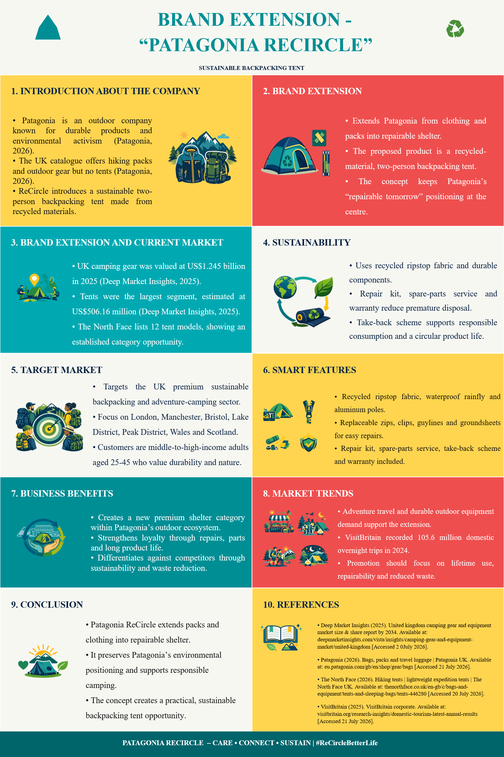

2.0 Element 2: Segmentation, Targeting, Differentiation and Positioning (STDP) Analysis

2.1 Introduction to STDP
Segmentation, targeting, differentiation and positioning (STDP) offer a marketing approach to finding attractive customers and developing a unique market position (Kotler et al., 2020). In the case of Patagonia ReCircle, STDP assists in recognising the sustainability-driven consumers in the UK outdoor market and positioning the offered backpacking tent based on the durability, repairability, and environmental responsibility.

2.2 Market Segmentation
Geographic Segmentation
Geographically, ReCircle must be able to cover the UK on the online platform of Patagonia but focus its campaigns in large urban markets and gateways in the outdoor sector. In 2025, VisitBritain registered 103 million domestic overnight visits to all parts of Great Britain with a spending amount of 35.1 billion. London and Manchester had 15.8 million and 5.3 million overnights respectively (VisitBritain, 2025). The Lake/Peak Districts, Scottish Highlands, Wales and Northern Ireland priority activation is a national coverage with an outdoor application.
Demographic Segmentation
Demographically, ReCircle must appeal to educated professionals and managers aged 25-44 years, middle-and-high-income households, regardless of gender. According to Sport England 2024/25 data, 73.2% of the wealthiest adults and 53.8% of the poorest adults are active and leisure walking is performed by 22.9 million adults (Sport England, 2025). This helps justify a premium price to an income-qualified and active customer base capable of affording it as opposed to targeting by the broad age group.
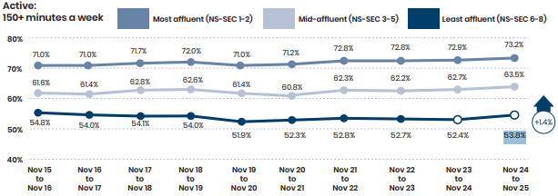
Fig 01: Adult Physical Activity by Socio-Economic Group, England
Source: (Sport England, 2025)
Psychographic Segmentation
Psychographically, ReCircle ought to position itself on nature-conscious consumers who associate outdoor recreation with environmental responsibility, focus more on durability, repair and less replacement. GOV.UK (2025) discovered that 68 % of adults frequented green or natural areas at least once a week. ONS (2025) discovered that 53% of adults saw climate change and the environment as a crucial issue in the UK, with the number increasing to 57% among women. These sentiments underpin the conservation-based, low-consumption proposal of ReCircle.
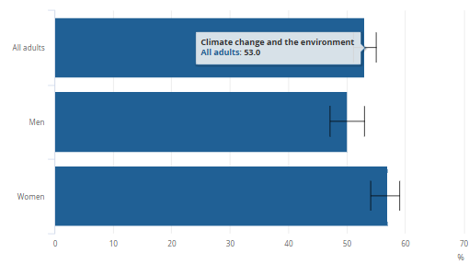
Fig 02: Environmental Concern by Gender in UK (2025)
Source: (ONS, 2025)
Behavioural Segmentation
In behavioural terms, ReCircle needs to aim at the repeat backpackers who are after low weight, easy pitching and weather dependability. This was reflected in the survey of the Camping and Caravanning Club (2025), where more than a third of the respondents camped two-three times on a yearly basis, 31% paid full price and more than 90% would repurchase the same brand of tent. WRAP (2025), discovered that 82.2% of repaired items replaced new ones, which proves the argument in favour of repair, spare-parts and take-back services of ReCircle.

2.3 Target Market and Targeting Strategy
ReCircle must consider focused targeting at UK 25;45-year-old, middle-to-high-income, frequent backpackers with concerns about reliability, longevity and environmental responsibility. The market is quite large: the UK camping/hiking equipment earned approximately US$0.65 billion in 2025, and two-person tents controlled more than 40% of the market worldwide. Affordable premium is feasible because 23.2% of jobs of employees in the UK were high-paid in 2025 (Fortune Business Insights, 2025; Singh and Singh, 2025). In the article by Fuchs, Bodet and Hovemann (2024), a separate European sportswear segment with a sustainability focus is found, which justifies a focus on concentration, rather than mass. Importantly, in the study of Czech outdoor customers, Voráček et al. (2026) identified a durability rating of 8.49/10 and a manufacturers repair rating of 6.67/10, but only a 1019% sustainability premium was accepted. ReCircle must thus focus on customers who purchase performance-based circular value and not the customers who only declare green sentiments.
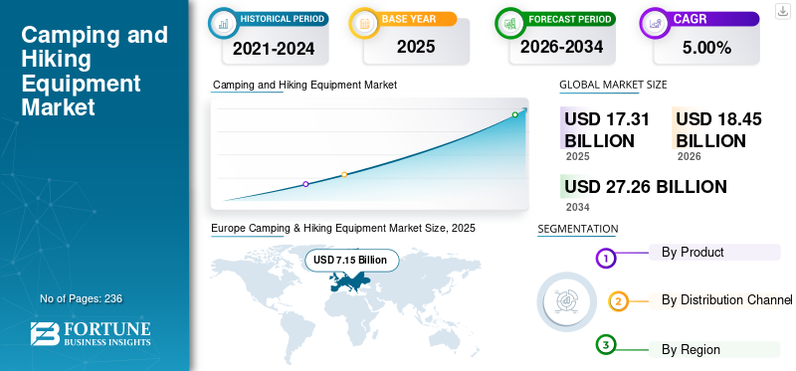
Fig 03: Global Camping and Hiking Equipment Market Growth, 2025–2034
Source: (Fortune Business Insights, 2025)

2.4 Differentiation Strategy
ReCircle would integrate recycled ripstop with repairability with replaceable zip, clips, guylines and groundsheets, guaranteed spares and take-back. NEMO (2026) offers recycled OSMO fabrics and parts, while Big Agnes (2024), takes back tents, making features imitable. The distinction is based on the combination of durability and circular services with the environmental credibility of Patagonia, as seen in its 166 B Impact Score (B Lab, 2023). According to Ruiz-Pastor and Mesa (2023), the drivers of repairability include parts availability and disassembly.

2.5 Positioning Strategy
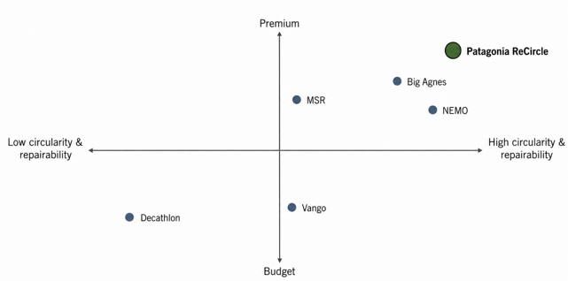
Fig 04: Patagonia ReCircle UK Tent Market Positioning Map
Source: (Self-Created)
The figure above puts ReCircle in the high circularity, premium category, between Decathlon and competing with NEMO, MSR and Big Agnes on technical merit. Nemo has 100% recycled OSMO yarns, and Vango has repairs, which means that Patagonia will have to compete on the basis of whole-life value, rather than just sustainability claims (Nemo, 2025; Vango, 2026). The positioning statement is “The repairable, take-back-ready two-person tent for UK backpackers expecting premium performance without disposable ownership.”

3.0 Element 3: Marketing Mix Strategy

3.1 Introduction to the Marketing Mix
The extended marketing mix integrates product, price, place, promotion, people, process and physical evidence to coordinate value creation (Booms and Bitner, 1981). It is appropriate for ReCircle because the physical tent is supported by repair, take-back and after-sales services. Collectively, the seven elements reinforce Patagonia’s premium, durable and circular positioning.
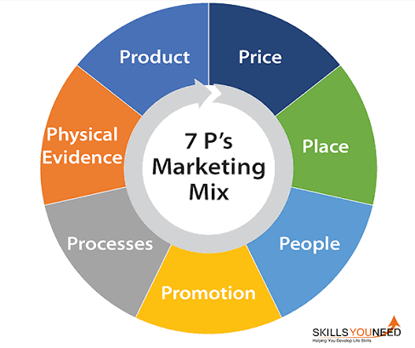
Fig 05: 7P’s Marketing Mix
Source: (SkillsYouNeed, 2022)

3.2 Application of 7Ps
Product Strategy
On a fundamental level, ReCircle will offer low impact shelter that allows the UK backpackers to travel light and not to consider tents as a one-off disposable item. The reality on the ground is a two-person backpacking tent made of recycled technical ripstop, aluminium poles and tried waterproof and wind-resistant fabrics. High-wear, such as the zips, clips, guylines and groundsheet, should be replaceable, and not built into the clothing. The augmented product would have a field-repair kit, spare parts, warranty-covered repairs, take-back to recover and recycle parts, and FSC-compliant recyclable packaging. Repair instructions with QRs ought to be transparent and not bulky with manuals and packaging. The extension service is already credible as Patagonia Worn Wear infrastructure has over 100 repair guides (Patagonia, 2025b). Differentiation is limited by competition, however. Hubba Hubba LT by MSR weighs 1.36 kg (MSR, 2026); Big Agnes states that the Copper Spur UL fabric is 25 % more water resistant and 50 % stronger than other fabrics (Big Agnes, 2026); NEMO announces 11 products made of Endless Promise are fully recyclable (Nemo, 2024). Thus, recycled material and Patagonia branding are not able to offset poor field performance. Co-creation of customer value can be achieved with facilitated repair (Bayraktaroğlu and İdemen, 2025). ReCircle must integrate quantifiable weather resistance and longevity with readily available component replacement, extended spares and plausible end of life recovery, and make sustainability functional lifetime worth.
Price Strategy
ReCircle must embrace premium pricing based on value by capitalising on the brand equity of Patagonia and the reduced lifetime replacement cost developed by repairability. UK prices are £384.99 for NEMO Hornet OSMO 2P, £475.95 for MSR Hubba Hubba LT2 and £494.95 for Big Agnes Copper Spur UL2 (Nemo, 2026; EMS, 2026). However, the sustainability premium is only 9.7% sustainability by consumers and price can increase the attitude-behaviour gap ((PWC, 2024; Munro et al., 2023). Premium quality cues would be undermined and repair services would be under-invested in through penetration pricing. Consequently, the optimal UK launch price is 499 which is a competitive parity, lifetime value and readiness to pay.
Place Strategy
ReCircle needs to employ selective distribution in omnichannel where the main direct channel will be the site of Patagonia UK and the trial of the product will be possible in the Manchester and Bristol stores. Both stores are listed there along with authorised dealers (Patagonia, 2025a). Specialized partners such as Ellis Brigham and Cotswold Outdoor already have Patagonia, which helps to reach London and outdoor gateways (Patagonia, 2026). Wales and Scotland: Nationwide e-commerce needs to embrace Wales and Scotland (and non-urban customers) extending the city-to-nature geography of Element 2. Prepaid returns and retailer collection should be used to repair and take-back European repair centres (Patagonia, 2025b). Premium positioning and control would be undermined by intensive mass distribution.

Promotion Strategy
ReCircle through its Integrated Marketing Communications (IMC) is supposed to align social media, email and Patagonia Stories/Films to evidence-based keep the tent in use (Purwati and Ariyani, 2025). Instead of repeating its sustainability arguments, expert-backpacker partnerships with backpacking communities should post field-test and tear-to-repair videos and include time taken to repair, components replaced and content recycled. Credible UGC is more helpful to the audience, and owners should be invited to record repairs and kilometres travelled, as user-generated content (UGC) (Zhuang et al., 2023). Open repair shops during the 1922 November 2026 Kendal Mountain Festival and Eryri or Cairngorm trail centres and amplified by Patagonia-sponsored grassroots environmental organisations (Patagonia, 2023). Traceable material, repair and take-back evidence should be published on paid media. This safeguards credibility since the UK advertising regulations stipulate the environmental claims to support product lifecycle and specify restrictions (ASA, 2025).
People
ReCircle’s people strategy should make frontline expertise part of the product, not a sales accessory. Patagonia retail employees and selected outdoor-retailer staff should complete ReCircle certification covering pitching, weatherproofing, component identification, recycled-material evidence, repair triage and take-back eligibility. This is practical because Ellis Brigham Manchester already offers customers demonstrations of two-person tents (Ellis Brigham, 2026). Repair technicians are to diagnose the need to repair the damage in the field or to replace parts or bring the case to the workshop, whereas customer-service staff members are to triage using photos and reserve the right route. The customers are expected to walk out with proven abilities in drying, seams, patching and component replacement. The relevance of training lies in the fact that retail knowledge can be more adaptive due to intentional learning (Taylor et al., 2026), and green training can enhance the environmental behaviour of employees (Renaningtyas and Kasmir, 2026). Inequally trained staff may falsify technical or circular claims and this will directly impact ReCircle credibility.
Process
Circularity should be a single tracked journey of ReCircle. A record linked to a QR is recorded at the point of purchase to capture materials and warranty and during usage provides maintenance instructions and order-spares. The portal should be photographed in the portal to triage 48 hours, warranty and repair booking. The repair-request review is 2-5 working days at Patagonia (Patagonia, 2025b).ReCircle should set a ten-day repair service target with tracking. Irreparable tents receive prepaid take-back, then inspection for reuse, parts harvesting or fibre recycling. Long waits and poor repair information reduce repair convenience (Güsser-Fachbach et al., 2023). Consequently, reverse logistics must be simpler than replacement, or circular intent risks becoming disposal.
Physical Evidence
The tangible evidence of ReCircle is supposed to be circular. It must have Global Recycled Standard certification on its ripstop and the %age of recycled content and the material origin should be marked. GRS uses third-party certification and chain-of-custody verification (Textile Exchange, 2026). The repair kit, component labels, warranty card and QR code to repairability information, spare-part instructions and material provenance must be included in packaging. ReCircle displays in stores should include a fixed tent displaying a repair next to recovered zips, poles and fabric used in take-back units and recorded recovery results. Long life should be solidified with reusable packaging. The perceived greenwashing and purchase risk can be reduced by certification and transparent supply-chain evidence that increase consumer trust (Damberg et al., 2024).

4.0 Element 4: Reflection

4.1 Reflection on Developing the Sustainable Brand Extension Strategy.
Creating ReCircle transformed my perspective of sustainable marketing by encouraging environmental goodness to creating a business-appropriate value system. First, I considered waste materials as the primary benefit. The application of STDP and 7Ps helped me to learn that the values of Patagonia become only meaningful when the tent also provides lightweight performance, durability, repair access and easy take-back. The decision of pricing at £499 was tough as I had to strike a balance between premium equity and price sensitivity with customers and rival tents. My belief that positive environmental attitudes necessarily would become purchases was also disputed by research since sustainable consumption is a contextual and behavioural constraint (Syed et al., 2024). I thus came to know how to back up certifications with material certification, repair evidence and traceability. This is important as perceived greenwashing may lead to confusion and brand distrust and brand loyalty (Daou et al., 2025).

4.2 Preparing and Delivering the Poster Presentation
Working on the poster compelled me to separate the information that was related to decision-making and the information that was only interesting. Space scarcity implied summarizing segmentation and 7ps research in brief statements, chosen statistics and graphics. The positioning map was effective as it conveyed the premium, high-repairability position of ReCircle as compared to NEMO, MSR, Big Agnes, Vango and Decathlon in less time than prose. Arranging the poster based on STDP, positioning and marketing mix enabled the argument to be followed more easily. I had been the most effective during the delivery explaining the decisions like the price of 499 and replaceable parts. Nonetheless, timing pressure revealed that I should have less time to transition and more accurate responses in defending assumptions.

4.3 Skills, Knowledge and Personal and Professional Development
The project enhanced my skills in determining whether evidence backs a marketing decision or merely providing citations. I also gained market-research, competitor-analysis and data-interpretation expertise through the evaluation of customer features, prices and circular-service propositions. The use of STDP and the 7Ps helped me improve my strategic thinking since every choice was to support the target and positioning. I was also more critical of the claims of the circular-economy, in particular the distinction between recyclable design and a system that can be repaired, returned and recovered. In academics, I have been able to develop in writing, reference and source assessment at Harvard. In professional terms, these capabilities are transferred to brand management, product marketing and sustainability positions where marketers need to transform evidence into justifiable recommendations and present them in a visual and verbal manner.

4.4 Future Skills and Improvement in Performance.
My initial step in primary research in a future project would be surveying the UK backpackers and interviewing the users to evaluate willingness to pay, expectations of repairing, and convenience of taking back. I would develop a competitor database of specifications, warranties, repair services and prices, model unit cost, margin and price sensitivity and then suggest the launch price. I would develop an evidence register which connects sustainability assertions to certification or evidence. In the case of the poster, I would delete the text of lower priority, experiment with the readability with colleagues and practice within the time constraint. I would prepare questions about pricing, feasibility, competitors and greenwashing and practice evidence-based answers.

References
Apostolova, V., Simeone, L. and Laursen, L.N., 2025. Service Design for Repair Practices in the Circular Economy: A Systematic Review Approach. World, 6(4), p.154.
ASA (2025). Environmental claims: General “green” claims. [online] www.asa.org.uk. Available at: https://www.asa.org.uk/advice-online/environmental-claims-general-green-claims.html [Accessed 4 Aug. 2026].
B Lab (2023). Patagonia works - certified B corporation - B lab global. [online] www.bcorporation.net. Available at: https://www.bcorporation.net/en-us/find-a-b-corp/company/patagonia-inc [Accessed 3 Aug. 2026].
Big Agnes (2024). Retiring used gear. [online] Big Agnes. Available at: https://www.bigagnes.com/blogs/support/retiring-your-gear [Accessed 6 Aug. 2026].
Big Agnes (2026). Copper spur UL2. [online] Big Agnes. Available at: https://www.bigagnes.com/products/copper-spur-ul-two [Accessed 1 Aug. 2026].
Damberg, S., Saari, U.A., Fritz, M., Dlugoborskyte, V. and Božič, K. (2024). Consumers” purchase behavior of cradle to cradle certified® products—The role of trust and supply chain transparency. Business Strategy and the Environment, 33(8). doi:10.1002/bse.3919.
Daou, L., Sayegh, E., Atallah, E., Maalouf, A. and Sarkis, N. (2025). Greenwashing as a barrier to sustainable marketing: Expectation disconfirmation, confusion, and brand–consumer relationships. Sustainability, [online] 17(22), p.9979. doi:10.3390/su17229979.
Ellis Brigham (2026). Ellis Brigham Manchester. [online] ellis_brigham. Available at: https://www.ellis-brigham.com/stores/manchester [Accessed 6 Aug. 2026].
EMS (2026). MSR Hubba Hubba LT 2-Person backpacking tent. [online] Elitemountainsupplies.co.uk. Available at: https://www.elitemountainsupplies.co.uk/camping-trekking-c4/tents-bivi-c15/msr-tents-c63/msr-hubba-hubba-lt-2-person-backpacking-tent-p1376ayh_access=OFRUIx4a3Qm28A1f [Accessed 2 Aug. 2026].
Fortune Business Insights. (2026). Camping and hiking equipment market size, share [2026-2034]. [online] Fortunebusinessinsights.com. Available at: https://www.fortunebusinessinsights.com/camping-and-hiking-equipment-market-115954 [Accessed 3 Aug. 2026].
GOV.UK (2025). Adults” year 5 annual report (april 2024 - march 2025). [online] GOV.UK. Available at: https://www.gov.uk/government/statistics/the-people-and-nature-surveys-for-england-adults-data-y5q4-january-2025-march-2025/adults-year-5-annual-report-april-2024-march-2025 [Accessed 2 Aug. 2026].
Güsser-Fachbach, I., Lechner, G., Ramos, T.B. and Reimann, M. (2023). Repair service convenience in a circular economy: The perspective of customers and repair companies. Journal of Cleaner Production, [online] 415, p.137763. doi:10.1016/j.jclepro.2023.137763.
MSR (2026). Hubba Hubba LT 2 tent | 2-Person backpacking tent | MSR. [online] Cascade Designs. Available at: https://cascadedesigns.com/products/hubba-hubba-lt-2-person-tent [Accessed 3 Aug. 2026].
Munro, P., Kapitan, S. and Wooliscroft, B. (2023). The sustainable attitude-behavior gap dynamic when shopping at the supermarket: A systematic literature review and framework for future research. Journal of Cleaner Production, [online] 426, p.138740. doi:10.1016/j.jclepro.2023.138740.
Nemo (2024). Sustainability. [online] Nemoequipment.com. Available at: https://www.nemoequipment.com/pages/sustainability [Accessed 6 Aug. 2026].
Nemo (2025). OSMOTM fabric technology. [online] Nemoequipment.com. Available at: https://www.nemoequipment.com/pages/osmo-fabric-technology [Accessed 6 Aug. 2026].
Nemo (2026). Hornet OSMO 2p tent. [online] Ultralight Outdoor Gear. Available at: https://ultralightoutdoorgear.co.uk/nemo-hornet-osmo-2p-tent [Accessed 6 Aug. 2026].
NEMO (2026). Repairs. [online] Nemoequipment.com. Available at: https://www.nemoequipment.com/pages/repairs [Accessed 6 Aug. 2026].
ONS (2025). Public opinions and social trends, Great Britain. [online] Ons.gov.uk. Office for National Statistics. Available at: https://www.ons.gov.uk/peoplepopulationandcommunity/wellbeing/bulletins/publicopinionsandsocialtrendsgreatbritain/may2025 [Accessed 6 Aug. 2026].
Patagonia (2023). How we fund - Patagonia. [online] eu.patagonia.com. Available at: https://eu.patagonia.com/gb/en/how-we-fund/ [Accessed 6 Aug. 2026].
Patagonia (2025a). Patagonia store locator: Find a Patagonia store near you. [online] eu.patagonia.com. Available at: https://eu.patagonia.com/gb/en/store-locator/ [Accessed 6 Aug. 2026].
Patagonia (2025b). Repairs. [online] Patagonia Worn Wear. Available at: https://wornwear.patagonia.com/pages/repairs [Accessed 6 Aug. 2026].
Patagonia (2026). Patagonia clothing, equipment & accessories. [online] ellis_brigham. Available at: https://www.ellis-brigham.com/brands/patagonia [Accessed 6 Aug. 2026].
Purwati, A. and Ariyani, N. (2025). Integrated Marketing Communication in building brand equity in the Social Media Era. Ilomata International Journal of Social Science, 6(2), pp.610–629. doi:10.61194/ijss.v6i2.1686.
PWC (2024). Consumers willing to pay 9.7% sustainability premium, even as cost-of-living and inflationary concerns weigh: PwC 2024 voice of the consumer survey. [online] PwC. Available at: https://www.pwc.com/gx/en/news-room/press-releases/2024/pwc-2024-voice-of-consumer-survey.html [Accessed 6 Aug. 2026].
Renaningtyas, A.P. and Kasmir, K., 2026. Green Culture and Training on Employee Green Behavior: The Mediating Environmental Awareness Role. Journal of Sustainable Economic and Business, 3(2), pp.371-383.
Ruiz-Pastor, L. and Mesa, J.A., 2023. Proposing an integrated indicator to measure product repairability. Journal of Cleaner Production, 395, p.136434.
Singh, S. and Singh, A. (2025). Camping tent market - by product type (dome tents, tunnel tents, geodesic tents, others), by capacity (2 person, 3-4 person, solo), by price range, by usage, by end-use, by distribution channel, forecast 2024 - 2032. [online] Global Market Insights Inc. Available at: https://www.gminsights.com/industry-analysis/camping-tent-market [Accessed 6 Aug. 2026].
SkillsYouNeed (2022). The 7 pS of marketing mix | SkillsYouNeed. [online] Skillsyouneed.com. Available at: https://www.skillsyouneed.com/lead/7-marketing-ps.html [Accessed 6 Aug. 2026].
Sport England (2025) Active Lives Adult Survey November 2024–25 Report. Available at: https://sportengland-production-files.s3.eu-west-2.amazonaws.com/s3fs-public/2026-04/Active%20Lives%20Adult%20Survey%20November%202024-25%20Report_.pdf
Syed, S., Acquaye, A., Khalfan, M.M., Obuobisa-Darko, T. and Yamoah, F.A. (2024). Decoding sustainable consumption behavior: A systematic review of theories and models and provision of a guidance framework. Resources Conservation & Recycling Advances, [online] 23(23), pp.200232–200232. doi:10.1016/j.rcradv.2024.200232.
Taylor, A., Jossberger, H. and Gruber, H. (2026). Examining expertise differences in retail sales: A script-based analysis of customer interactions. Vocations and Learning, 19(1). doi:10.1007/s12186-026-09393-w.
Textile Exchange (2025). Recycled claim standard (RCS) + global recycled standard (GRS) - textile exchange. [online] Textile Exchange. Available at: https://textileexchange.org/recycled-claim-global-recycled-standard [Accessed 1 Aug. 2026].
The Camping and Caravanning Club (2025). Tent Owner Satisfaction Awards - The Camping and Caravanning Club. [online] campandcaravan. Available at: https://www.campingandcaravanningclub.co.uk/advice/equipment/tent-owner-satisfaction-awards [Accessed 2 Aug. 2026].
Vango (2026). Earth day with vango. [online] Vango.co.uk. Available at: https://www.vango.co.uk/blog/earth-day-with-vango [Accessed 6 Aug. 2026].
VisitBritain (2025) England domestic tourism: regional and subregional data. Available at: https://www.visitbritain.org/research-insights/england-domestic-tourism-regional-and-subregional-data (Accessed: 1 August 2026).
WRAP (2025). Fast fashion could be left on the peg as preloved and repair displace new sales. [online] WRAP. Available at: https://www.wrap.ngo/media-centre/press-releases/fast-fashion-could-be-left-peg-preloved-and-repair-displace-new-sales [Accessed 6 Aug. 2026].
Zhuang, W., Zeng, Q., Zhang, Y., Liu, C. and Fan, W. (2023). What makes user-generated content more helpful on social media platforms? Insights from creator interactivity perspective. Information Processing & Management, [online] 60(2), p.103201. doi:10.1016/j.ipm.2022.103201.

