Changemakers: Creativity and Value Creation

Name: Ebong Obot
Student Number: 1915035
Lecturer: Robert Nartowski

Artefact Task 4: Flyer
Say
No To Drugs
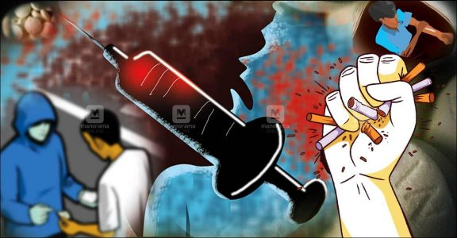
Harmful effects of drugs
- A weakening immune system, increasing the risk of infections and sickness.
- Heart conditions including abnormal and inconsistent heart rates and collapsed veins and blood vessel infections from drugs that are injected.
- Abdominal pain and nausea, which eventually lead to weight loss and reduced appetite.
- Mental confusion, seizures, stroke and brain damage.
- Lung disease
- Memory, attention, and decision-making challenges.
- Shrinking brain.
- Paranoia, aggressiveness, hallucinations, impaired judgment, impulsiveness, loss of self-control, addiction
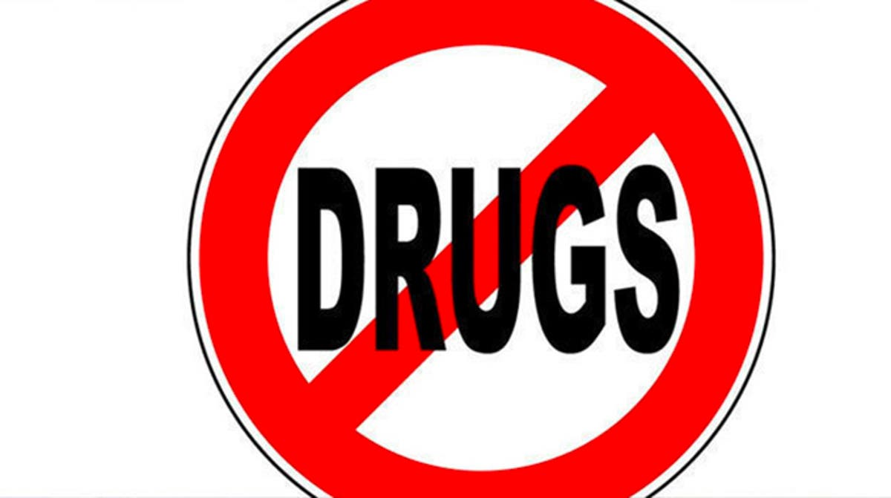

DRUGS DRAG YOU DOWN
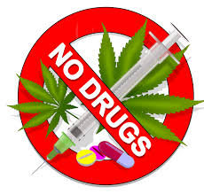

The flyer contains information on the harmful effects of drug abuse intended to caution everyone who sees it of the need to stop using drugs.
The different highlighted effects of drug abuse in the flyer have rather serious consequences and these include; missed work, accidents, injuries, and punishable offences. In most societies, alcohol and drugs are attributed as the cause for up to 80% of the committed offenses that lead to jail time. Examples of the offenses are domestic violence, driving under the influence and property damage.
Drugs are chemicals that have an effect on the human brain and body. Different drugs have different effects. Some of these effects are permanent and lasting, and continue even after the affected individual has ceased using the substance. There are several ways through which people take drugs, and these include injection, ingestion and inhalation. A drug’s effects on the body are dependent on the delivery mechanism used for the drug. For instance, direct injection of drugs into the bloodstream has almost immediate effects, while the effects of ingestion delay a little bit. However, all misused drugs have an effect on the brain. When one uses drugs, significant amounts of dopamine, a neurotransmitter responsible for regulation of emotions, feelings of pleasure, and motivation, floods the brain, leading to the production of a high (Possi, 2018). In the long run, use of drugs alters how the brain works and further interferes with an individual’s abilities to make choices, leading to compulsive drug use and intense cravings. In the long run, such behaviours progress into substance dependency and drug addiction (Kendler et al. 2014). Drug abuse also accounts for a significant number of deaths. Those who abuse alcohol and drugs are also at a higher risk of unintentionally getting injured, getting involved in accidents and involvement in domestic violence incidents.
Targeted prevention interventions against drug abuse could go a long way in helping with the protection of the next generation from experiencing the negative harmful effects of drug abuse (Muller et al. 2020). Prevention is a tried and tested and proven, and cost-effective evidence-based programs have the potential of dramatically reducing the rates of substance use. All efforts should be put to ensure that drug abuse is controlled to guarantee a prosperous and productive future.

Artefact Task 2: Blog
All of us are affected by drug use, and we must take all necessary actions geared towards preventing unnecessary deaths. The consequences of narcotic drug use are destructive and fatal. It should be a collective responsibility to make decisions and act on whatever can be done for purposes of containing the drug use epidemic (Read more about the harmful effects at https://www.unodc.org/pdf/technical_series_1995-03-01_1.pdf). It is possible to avert unnecessary deaths, and there is far much more that can be done for protection against the communal, family, personal and economic devastation that addictions bring on societies. I propose some actions that could be taken to contain the epidemic.
Problem drug and alcohol use screening should be made into a standard of care. As a universal practice, all adult patients in primary care settings should be subjected to abuse screening, to facilitate identification and early intervention before the setting in of addiction. Proven interventions include screening, brief intervention and referral for treatment and these are covered for by insurers.
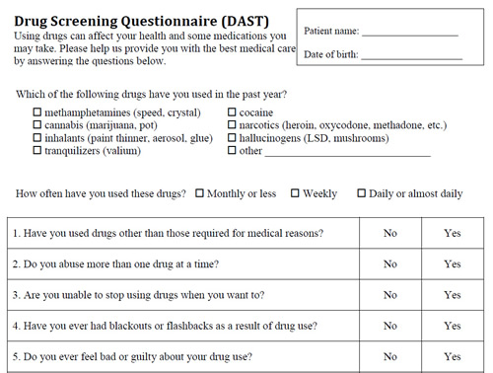
Sample Drug Screening Questionnaire adapted from https://www.indianasbirt.org/index.php?src=resources.php&seq=1103
It would also help to increase the availability, affordability and accessibility to drug treatment programs. There are estimations that about 80 to 90 percent of people who could benefit from treatment do not receive it. In line with the affordable care act, service element coverage and mental health and substance use parity should be provided, which means that the insurance benefits paid to addicts have to be equivalent to any other covered general medical condition. There has never been a better opportunity for proper reimbursement for substance disorder treatment. There is also need to educate doctors, patients and their families on what effective addiction treatment includes. It is important for medical providers and not just addiction specialists to appreciate the underlying addiction neuroscience and subsequently accordingly fashion their treatment (Read more about addiction neuroscience at https://ajp.psychiatryonline.org/doi/10.1176/appi.ajp.2018.17101174). When patients and families are increasingly informed consumers, they are better placed to advocate for more effective treatments.
In general, there is need to keep the hope alive. People who have substance use disorders can recover. That requires good treatment, working hard, continuous support and keeping hope alive. Individuals who have addictions do get on the path to recovery, even though it is difficult to predict when such would happen. There are some for whom it happens early, even after they have just gone through one or two rehabilitation programs. There are however, others for who it may take 5, 10 or 20 rehab programs, and is accompanied by immense pain and suffering of numerous relapses. It is essential that those who are affected, together with their families and clinical providers sustain the hope of recovery happening, even during protracted and dark times. The darkest moment comes about when all hope disappears.
It is for a fact that we have a drug problem. That said, the sooner we act, the more comprehensively we act, then the more lives and families that are eventually spared.

Discussion
I wrote a blog and prepared a flyer bordered on the fight against drug use. Drug and alcohol abuse remain serious problems affecting a large number of people. Substance abuse has significant health care costs, leads to loss in productivity, leads to increased cases of crime, and also has other social costs. For purposes of helping the affected address the devastating effects of drug and alcohol abuse, it is important to highlight best practices in prevention, and treatment. There has been extensive research carried out on drug abuse prevention over the last two decades that has identified key successful programming elements.
The flyer key message is the harmful effects of drugs. On the other hand, the blog focuses on highlighting actions that could be taken to control the epidemic of drug abuse. These actions are based on the principles of prevention advanced by the National Institute on Drug Abuse. NIDA developed the principles with the intention of helping parents, educators, and community leaders with thinking about, planning for, and delivering research-based drug abuse prevention programs at the community level (NIDA, 2020). The first principle is that prevention campaigns have to enhance protective factors and additionally reverse and reduce the risk factors. Prevention programs should also be designed in such a way that they address all forms of drug abuse, either combined or singularly, and this should be inclusive of the underage use of legal drugs among them alcohol and tobacco, the abuse of illegal drugs like heroin and marijuana, and the misappropriation of legally obtained substances like inhalants, over-the counter drugs and prescription medications. Campaigns also need to address the specific types of drug abuse in specific local communities, targeting modifiable risk factors, and strengthening the protective factors that have been identified (Sugihartati and Susilo, 2019). Prevention campaigns also, always have to be tailored for purposes of addressing risks that are specific to a particular population and audiences characteristics, and that includes age, gender, and ethnicity, for improvement of the program’s effectiveness. The other principle is that prevention programs that are targeted at general populations at key transition points, for instance, the transition to middle school, hold the potential of producing beneficial effects even among high-risk children and families. Interventions of this kind never single out the risk populations and therefore, go a long way in reducing labelling and promoting bonding to communities and schools (Siff, 2018).
It is worth noting that youth drug use is a reality that defies all stereotypes. The rates of drug use among youths are more or less consistently high across all gender, geographic, income, ethnic, and racial boundaries. Therefore, it is quite important that all primary prevention efforts address the young people and also the adults who have an influence on them. While it is a fact that prevention and treatment of drug abuse are both critically important when it comes to ensuring the health and well-being of the masses, a campaign attempting to accomplish both could fail in accomplishing either. For a communication campaign to succeed, then its purpose has to be highly defined. Our campaign is aimed at promoting the primary prevention of drug abuse, meaning, prevention of drug abuse before it’s onset.
The campaign’s focus on primary prevention is informed by three factors. The first one is that primary prevention targets the underlying causes of drug use, and as such, has a rather great potential of reducing the problem’s scope over the long term. The other factor is that a primary prevention campaign will over time reduce the need for drug treatment related services, whose supply is low. The third reason is that social campaigns are recognized widely as having great potential of affirming and reinforcing young people’s anti-drug attitudes, especially those who are not involved in the use of drugs, in comparison to persuading those who use drugs into stopping (Dunn et al. 2018).
It is important to note that the use of drugs among youths is largely influenced by the attitudes and beliefs held by young people on drugs and also by prevailing social norms, as compared to the drugs availability. Our campaign will therefore, be geared at altering the demand-related factors.
Marijuana is the most commonly used as the illicit drug of first use. The majority of young people who begin using marijuana while still young go on to use other drugs as they grow old. In contrast, those who have never tried marijuana and inhalants have a low likelihood of trying other drugs. The prevention of marijuana use, would therefore, be a good step towards prevention of other drug use. The other common substances of first use for a good number of adolescents are tobacco and alcohol.
Our campaign will also be keen to address other illicit drugs that represent immediate threats to those who use them from time to time. Among the young, intermittently, new drugs get developed and introduced to into the drug scene, and fresh ways of use of existing drugs have the potential of rapidly changing. In such cases, from time to time, adolescents do not have any factual information, or just have a little of it with regards to the involved risks, and they tend to make decisions on the basis of incorrect perceptions and assumptions. For instance, there are those who believe that marijuana in the form of cookies is not as harmful as rolled and smoked tobacco. Such emerging trends will be addressed in our campaign in a bid to prevent their spread.
It is prerequisite that communities with intentions of implementing sound anti-drug strategies, begin by assessing the areas of greatest need. There are some communities in which the most prominent problem could be underage drinking. In such a scenario, efforts need to be geared towards case prevention, treatment, and enforcement activities. There are other communities where violence emanating from illicit drug trafficking is the main problem, which would require heightened law enforcement activities targeting the hotspots with the highest cases of drug activity.
References
Dunn, H.K., Pearlman, D.N., Beatty, A. and Florin, P., 2018. Psychosocial determinants of teens’ online engagement in drug prevention social media campaigns: Implications for public health organizations. The journal of primary prevention, 39(5), pp.469-481.
Kendler, K.S., Maes, H.H., Sundquist, K., Ohlsson, H. and Sundquist, J., 2014. Genetic and family and community environmental effects on drug abuse in adolescence: a Swedish national twin and sibling study. American Journal of Psychiatry, 171(2), pp.209-217.
Müller, T.E., Fontana, B.D., Bertoncello, K.T., Franscescon, F., Mezzomo, N.J., Canzian, J., Stefanello, F.V., Parker, M.O., Gerlai, R. and Rosemberg, D.B., 2020. Understanding the neurobiological effects of drug abuse: Lessons from zebrafish models. Progress in Neuro-Psychopharmacology and Biological Psychiatry, 100, p.109873.
NIDA (2020) Preventing Drug Use among Children and Adolescents (In Brief): Prevention Principles, National Institutes of Drug Abuse. U.S. Department of Health and Human Services. Available at: https://nida.nih.gov/publications/preventing-drug-use-among-children-adolescents/prevention-principles (Accessed: October 18, 2022).
Possi, M.K., 2018. Effects of drug abuse on cognitive and social behaviours: A potential problem among youth in Tanzania. Utafiti Journal, 3(1).
Siff, S., 2018. “Why Do You Think They Call It Dope?”: Richard Nixon’s National Mass Media Campaign Against Drug Abuse. Journalism & communication monographs, 20(3), pp.172-247.
Sugihartati, R. and Susilo, D., 2019. Acts against drugs and narcotics abuse: Measurement of the effectiveness campaign on Indonesian narcotics regulator Instagram. Journal of Drug and Alcohol Research, 8, pp.1-4.

