04.12.2025

Artificial intelligence and Machine Learning

Jamie Richards (0852036)
ACCA6011 - Artificial intelligence and Machine Learning

Contents

Introduction Page 3
Problem Statement Page 3
Literature Support Page 4
Methodology Page 4
Experiments & Results Page 7
Recommendation Page 8
Conclusion Page 9
Demonstration Page 9
References Page 10

1. Introduction

The gaming industry has become increasingly competitive and understanding user behaviour is now essential for improving player retention, interaction and experience. Online gaming requires the users input and produces a vast amount of data, allowing developers to analyse this data and use for improvements.
This report aims to employ and evaluate two supervised learning models, Decision Tree and Support Vector Machine or SVM for short. Using these methods to predict user engagement. A further technique will be used from the unsupervised learning models to obtain behavioural patterns in users who play online.
To achieve this several objectives and tasks will be undertaken which can be found in the methodology section of this report. Comparing the supervised and unsupervised methods as well as generating research, this report will provide recommendation which will support user engagement strategies and player retention.
The dataset [1] will be used for this report, the dataset contains user activity, engagement levels and user demographics allowing the use both supervised learning methods and an unsupervised model to be used for this report.

2. Problem Statement

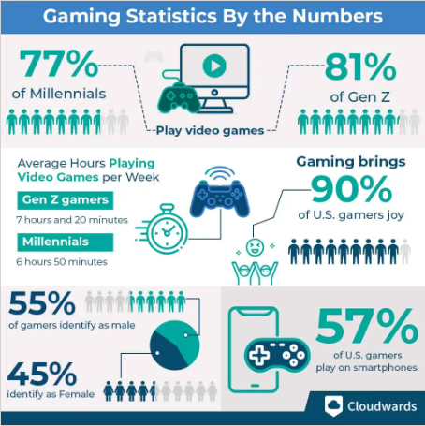
[2] Figure 1 on the left taken from cloudwards website illustrates numerous statistics regarding gaming in US, from the average hours played each week to what gender is playing the most.
User engagement is a clear factor in the sustainability of online games and the higher the engagement levels the stronger the retention and spending on a game. If users are not engaged then the fewer users are playing, less revenue made. Developers therefore need an insight into how to design better user experiences by predicting engagement.
The research in this report means to address the problem of the correctly showing the users engagement in online games by using supervised machine learning techniques, in particularly the Decision Tree and SVM classifiers. These methods will predict the engagement outcomes, furthermore by using an unsupervised methods which will be applied to discover any hidden behavioural features in users, this will allow a look at predictive modelling.
By integrating these approaches this report seeks to view the gap between predicting and discovery, providing an insight that will inform developers the pattern users take in retention, spending and engagement.

3 Literature Support

Predicting user engagement has been had a vast number of studies in relation to online gaming especially with machine learning approaches. In conference paper [3] these predictive models were used to effectively categorise user engagement stages by using behavioural and demographic figures, much like this report’s objectives.
Similarly, in journal [4] the authors point out that the complex aspects of user engagement and capturing user’s behavioural patterns strengthen the predictive models used for experiments.
[5] a journal by Rokach and Maimon produced a thorough survey about decision tree algorithms and the relevance of domains when making decision rules, more recently [6] a paper published in 2024 uses decision tree methods to predict the user engagement in massive multiplayer online games, the outcome discovers the users who are most likely to engage.
Aswell as decision tree methods, support vector machines have also been used in studies, in conference paper [7] the author explains that Support Vector Machine learning model can catalogue user engagement, collecting nonlinear data with demographics variables. These findings prove the power of Support Vector Machine learning techniques making them desirable in gaming environments and data collection.
A further conference paper [8] applied clustering techniques to analyse the user retention in online games, showing the user groups who are most likely to stay playing. Continuously in another journal [9] the authors demonstrate, using clustering to identify user behaviours allowing the developers to amend the games design and strategies to further their product. These two studies alone compliment the role of unsupervised learning and provide results that supervised learning cannot.

4. Methodology

This section of the report outlines the methodological framework that will be used to predict the online gaming behaviour dataset mentioned in the introduction.
Using a quantitative data driven approach that will combine supervised and unsupervised machine learning methods to understand and predict user engagement in online gaming. The workflow will consist of data exploration and preprocessing, development and evaluation of the supervised methods decision tree and support vector machine methods. Furthermore, parameter tuning and application of clustering will be used to predict exercise results.
Dataset – Upon analysis of the dataset there are over forty thousand user records and thirteen variables with features using demographics user behaviour and engagement.
Data Exploration & Preprocessing – Exploratory Data Analysis is an important step when dealing with data because it uncovers any hidden patterns, anomalies or verifies assumptions before using any predictive learning models. In a recent conference paper by S Dhummad [10] it was highlighted that this process is critical to ensure robust machine learning frameworks and effective decision making when handling data.
White obtaining an initial understanding of the dataset a few key points were uncovered such as a continuous use of features to collect statistics for example PlayTimeHours and AvgSessionDurationMinutes which provided the users play time in hours and average length of play respectively.
Data Cleaning – This is where the data would be combed to ensure its relevant to the aim and not missing any values, due to the data clearly defined by ranges minimal data cleaning was required. The removal of PlayerID from the exercises because it was a non-predictive identifier and did not serve a purpose. Further consistency checks in the value counts were done to confirm the labels such as gender and location, did not contain any abnormal data.
To prepare the data for machine learning algorithms several tasks needed to be done, the first was to categorise the variables, for example variables were transformed using one hot encoding to crate binary indicator variables for each category such as Gender_Male.
For the decision tree classifier an unscaled encoded dataset will be used for example engagmentLevel will be encoded into a numerical label from 0 to 2 instead of low to high. A scaled encoded data set will then be used for the SVM and clustering methods.
For generalisation and ensure performance the data will be train test split using 80% of the data for training and 20% of the data for testing, this also will ensure the exercises do not take so much time to produce results.
User Engagement – The two supervised algorithms used to predict the user engagement will be decision tree and SVM classifiers.
The Decision Tree can model a nonlinear interaction with the data, the implementation will use scikit-learn’s which is an open-source machine learning library.
The Support Vector Machine also implemented by the scikit-learn’s library will use the standardised features and either the linear kernel for a simpler foundation or the Radial Basis Function which captures nonlinear data.
Both techniques will be evaluated on accuracy, precision, recall and F1 score. While computed per class high to low using the reported macro averaging, allowing equal eight for each class. Auc-Roc will be used for the multi class results and one verse the rest strategy will be used to calculate the area under the curve.
User Behaviour – In addition to predicting the user engagement, a unsupervised learning method will be used to discover the users behavioural patterns and demographics.
For clustering the variable EngagementLevel will be excluded to ensure the learning method stays unsupervised, all other features will be used. The numeric features were limited using z score scaling to ensure no large numeric results messed with the clustering process.
K Means clustering will be the primary algorithm because of its scalability, implemented from the scikit-learn’s library and run using the optimal number of clusters. The elbow method will be used for a range of 2-10 and the sum of squares will be planned, the elbow point will return the guided choice.
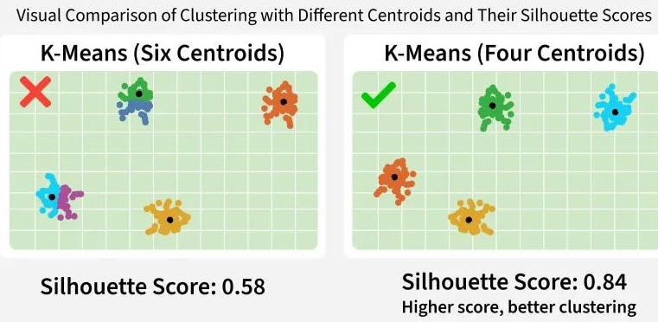Figure 2 [11] above taken from the geeks for geeks website by an unknown author illustrates a silhouette score using different centroids. This method will be used for each candidate k the average score will be calculated to determine the cohesion and distance, the highest silhouette score will be used for the interpretation.
Profiling the clusters will involve the final clustering solutions to distinct user segments such as using the descriptive variables like PlayTimeHours average and the distribution of demographic values. At this stage the EngagementLevel can be reintroduced to allow the examination of how the engagement was distributed across the clusters. Profiling here will help create meaning full statements such as casual low time users or hardcore players.
Finally, Decision Trees organise the data by splitting features into different rules which will maximise their class by using criteria such as impurity or entropy, this will be particularly suitable for user engagement prediction because decision trees handle different data type and capture nonlinear data.
SVM works differently and when combined with kernels such as Radial Basis Function or RBF for short, the model is Highley effective when using multi feature data.
Clustering in specific K means is the unsupervised technique that will be used, the model groups the users without predefined label, making it suitable to uncover the users behavioural segments.
Tools & Implementation – The analysis will be conducted on Anaconda, in python using Jypyter notebook the Pandas and NymPy libaraies will be used for data loading and preprocessing, where Matplotlib and Seaborn will be used for experimental and result images.

5. Experiments & Results

This section presents the experiments and results discussion of this report, obtained using the two supervised learning models and clustering analysis. The results for presented in the context of user engagement and their impact on game design.
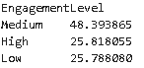
The engagement distribution produced a balanced result with medium coming out on top at 48.4% and both low and high at 25.8%, this balance favours the multiclass classification without the need for over testing or adjusting the class weight.
The users who where highly engaged all shower greater playtimes and longer sessions which resulted in higher user levels. The lower engaged users no surprisingly showed less time playing and less achievements in game.
These results fall in line with existing studies and links gameplay investment with user engagement.

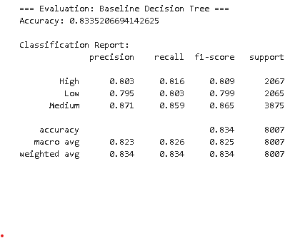
The Decision Tree illustrates a medium performance while discovering obvious user behavioural splits, especially in playtime and achievements. After adding parameters, the model did achieve improvements in both accuracy and performance.

The matrix displayed a medium engagement was predicted meaning the Dicision Tree effectivly identified behavioual rules such users with more than ten sessions a week were overwhelmingly classed as high engagment users. The model also showed signs of overfiting when bigger depths were used meaning a regularisation would be needed to maintain its simplification.
The SVM model did benefit from feature scaling and optimisation, the RBF over performed due to the dataset being non-linear. The key behaviouals that were found were again longer sessions and more achievements in users with high engagement and low play times with low engagement users,
The performance of SVM suggests that user engagement is driven by non linear interactions meaning user engagement cannot be put down to just one single factor but multiple.
Th best paramenter outcomes were:
Decision Tree – Depth between 10 and 15, using an entropy criterion and minimun 2 leaf sizes.
SVM – Using RBF, between 10 and 100 and small fixed values.
The elbow and silhouette scores of 3 clusters provided the best separation.

6 Recommendation

Based on the findings of this report the following practical recommendations are suggested to improve the user engagement and retention strategies.
- Use predictive engagement monitoring
- Enhance the recruitment of low active users
- Monetise the high-end engagement users

7. Conclusion

This report used three learning techniques to analyse user behaviour in online gaming and to predict the user engagement levels. Using the data sent containing over forty thousand records.
The results demonstrated that both supervised models were effective for user engagement prediction although the SVM method came out the better in all areas, indicating that engagement is influenced by complex nonlinear interactions. The decision tree did prove useful but didn’t compare due to its limited simpler decision boundaries.
The unsupervised method revealed clear behavioural sections mainly aligning with the users intensity levels, overall the combined applications of these methods produced a complex representation of user behaviour and supervised learning models allowed a reliable prediction of user engagement.

8. Demonstration

https://youtu.be/XfZd9MHPRBQ

9. References

[1] &. Kharoua and Rabie&nbsp. Predict Online Gaming Behavior Dataset. Available: https://www.kaggle.com/datasets/rabieelkharoua/predict-online-gaming-behavior-dataset?resource=download. DOI: https://doi.org/10.34740/kaggle/dsv/8742674.
[2] Anonymous 23 online gaming statistics, facts & trends for 2025. 23 online gaming statistics, facts & trends for 2025. 2022. Available: https://www.cloudwards.net/online-gaming-statistics/.
[3] T. Manju Usha Sree, P. Sasikumar, S. Ayesha, M. S. Amzad Basha and M. Martha Sucharitha. Predicting player engagement in online gaming: A machine learning approach. Presented at 2024 IEEE North Karnataka Subsection Flagship International Conference (NKCon). 2024, . DOI: 10.1109/NKCon62728.2024.10774748.
[4] A. Rashed, S. Shirmohammadi and M. Hefeeda. Descriptor: Multimodal dataset for player engagement analysis in video games (MultiPENG). IEEE Data Descriptions IEEE Data Descriptions 22pp. 17–25. pp. 17–25. 2025. . DOI: 10.1109/IEEEDATA.2025.3553097.
[5] I. D. Mienye and N. Jere. A survey of decision trees: Concepts, algorithms, and applications. IEEE Access IEEE Access 1212pp. 86716–86727. pp. 86716–86727. 2024. . DOI: 10.1109/ACCESS.2024.3416838.
[6] Y. -J. Han, J. Moon and J. Woo. Y. Prediction of churning game users based on social activity and churn graph neural networks. IEEE Access IEEE Access 1212pp. 101971–101984. pp. 101971–101984. 2024. . DOI: 10.1109/ACCESS.2024.3429559.
[7] G. Ruqeyya and S. M. U. Saeed. Player engagement classification in mobile games using MUSE headband. Presented at 2022 17th International Conference on Emerging Technologies (ICET). 2022, . DOI: 10.1109/ICET56601.2022.10004658.
[8] M. Kiguchi and P. Subramanian. Retention analysis and player segmentation based on gameplay data. Presented at 2023 International Conference on Integrated Intelligence and Communication Systems (ICIICS). 2023, . DOI: 10.1109/ICIICS59993.2023.10420913.
[9] C. Bauckhage, A. Drachen and R. Sifa. Clustering game behavior data. IEEE Transactions on Computational Intelligence and AI in Games IEEE 77(3), pp. 266–278. pp. 266–278. 2015. . DOI: 10.1109/TCIAIG.2014.2376982.
[10] A. S. Rao, B. V. Vardhan and H. Shaik. Role of exploratory data analysis in data science. Presented at 2021 6th International Conference on Communication and Electronics Systems (ICCES). 2021, . DOI: 10.1109/ICCES51350.2021.9488986.
[11] Anonymous What is silhouette score? What is silhouette score? 2025. Available: https://www.geeksforgeeks.org/machine-learning/what-is-silhouette-score/.

