
Certificate of Higher Education Skills for the Workplace
BMSW4001_BIRM: Academic and Employability Skills (TASK1)

DATE OF SUBMISSION:

Table of Contents
Introduction 2
Strategies of Motivating Staffs 2
Pay 2
Challenges with Pay in Organisations 3
Recognition and Awards 4
Challenges with Reward and Awards 7
Additional Holidays 7
Challenges with Offering Additional Holidays 8
Good Working Conditions 8
Challenges of Good Working Conditions 10
Conclusion 10
List of References 11

Introduction
Whether working as significant part of sales team, delivering customer service or even managing branch of major corporations, all professionals necessitate motivation for doing their best work. According to Kuvaas, Buch and Dysvik (2018), numerous organisations are engaging in dealing such affairs with incentivising employees intending to inspiring them for achieving more. However, this could sometimes be challenging find essential incentives, which will undoubtedly stimulate all teammates to perform at such high level, specifically for extremely large organisations having hierarchical organizational structures. Prioritising reinforcement theory, in case reward systems, holidays and working conditions are contingent with employees’ performance then this would encourage them in maintaining high level of efforts (Broeck, Carpini and Diefendorff, 2019). Following expectancy theory, money motivates extent to which employees perceive satisfaction on their own goals. In this report, the most effective ways of motivating staffs whereby providing good working conditions, additional holidays, recognition and awards and pay has been critically assessed.

Strategies of Motivating Staffs
This is easily recognisable highly motivated as well as engaged workforces. They are most productive as they never hold back and hence advance forward to go extra mile. As discussed by Skilbeck (2019), motivated employees are mostly stimulated by their work, as they have faith on their organisation as well as they feel intensely connected to what the organisation is attempting to attain. This is earnest to notify that strategic development as well as proper implementation of effective strategies to motivate employees could eventually make positive impact on overall workforces’ morale level as well as their productivity within the organisation.

Pay
Certain employers for instance concern paying market ratings as be-all-and-end-all of their payment systems whereas others organisations consider internal relativities to be more important. External competition in stances of retaining and attracting talents is a tremendous challenge, which companies necessitate compensating with salary package that is on par with competitors in sale location and industry. According to Brown (2018), there are numerous benefits of appropriate pay, which includes greater sensation of employee empowerment, increased business revenue that leads to upsurge in employee pay, high level of productivity, low turnover alongside greater job satisfaction, upsurge of positive organisational culture depending on achievement and betterment of recruitment opportunities. As opined by Shaaban (2018), organisational citizenship behaviour is benefited from performance and reward system for instance bonuses pay increments, work relevant welfares and promotions significantly motivates employees. Workforce believes success equivalents bigger paycheck and increased financial security to them and families and then they are more probable to work competently and produce results.

Challenges with Pay in Organisations
Pay for performance is essentially the foremost thing, which numerous organisations think when it is talked about financial motivation. Following this motivational strategy, staffs are rewarded with high salary and bonuses in accordance to their performance. Reward has always been a complex field, however this could be debated that there are few drivers to reward management system. As discussed by Brown (2018), firstly, internal deliberations of relativities as well as fairness are critical challenges, which is at prior necessitates support by grading structures and job evaluation systems. Secondly, outer considerations based on market rates of pay for serious challenges enabling the firm to retain as well as recruit talents being supported by internal pay ranges and levels. Third essentiality has been performance related challenges that are directly connected to guarantee the deliverance of strategic goals of organization and hence ensure paying budgets are within organisational means in addition to recognizing employee performance and accordingly rewarding.
At Morrisons, more than 1000 workers in distribution centres threatened industrial action during festive season. By the end of 2020, majority of staffs initially offered pay rise of around 3%, though Unite appealed that lowest-paid were offered 2% rise. Morrisons revealed that Company could not afford more hike (Holmes and Badger, 2021). However, after union initiated balloting process, management negotiations commenced again and new deal of 5% for every worker which was agreed by workforce.
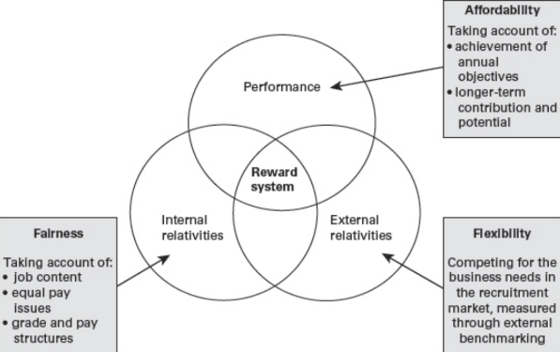
Figure 1: Key Drivers in Pay management
(Source: Brown, 2018)
Pay can be in certain stances very problematic in certain stances. Not every employee is best motivated with offering money; hence, organisation should take into account that a few employees are never motivated by the impression of offering larger salary or bonus (Kinsey, 2020). In addition, various other drawbacks include enhanced level of competition within employees, decreased sensation of teamwork, resentment towards those employees who are receiving or given rewards, confinements in view regarding what success looks like, less rewards for creativity outside existing business model and limited view of which is actually causing issues and effective ways of improvement. Mackenzie (2018) found that millennial age group that is 18-34 prefer additional benefits to pay raise by over 30% in comparison to those aged 35-64. However, women favour benefits to pay raise over men, by around 80% to 75%.

Recognition and Awards
Strategic employee recognition has been an effective management discipline, which goes way further than being the accurate thing to be done. This is worthy to be noted that recognition must never be regarded only as the feel-good and altruistic endeavour. As argued by Schindler (2019), never this has been the management discipline, which should always garnet promising return on investment. As opined by Phillips et al. (2017), recognition or reward program must essentially target at identification of desirable employee behaviour and their performance, without delay focus on capitalization of personal extrinsic as well as intrinsic motivators for achieving excellence. Most often companies fail to link rewards with labour market or strategies that their competitors are considering. Recognition act to showcase endeavours that are made by other leaders within organization as well as highlight their role.
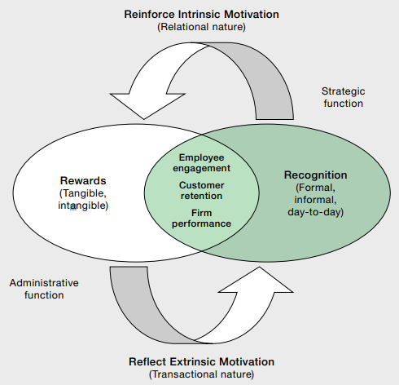
Figure 2: Complementary Recognition and Reward Relationship
(Source: Madhani, 2020)
This holds much significance to develop recognition program, which is consistent enough with culture of the department as well as the organization. This is actual fact that what seems to be perfectly well received in case of one organization might never work out at all in another firm due to some individual as well as organizational differences (Madhani, 2020). For instance, a number of folks are never as approachable to public recognition while attending large meetings and group settings however they are very comfortable in terms of public recognition by a bulletin board or a newsletter. According to Rodriguez (2021), thoroughly understanding the reward as well as recognition language of an employee through properly assessing their necessities actually provides leaders the essential opportunity of getting it accurate with their teams.
In today’s highly dynamic business environment, rewards and recognition is considered as the most optimal mix. As rewards and recognition programs are created, perfect criteria must be formed as well as shared with all staffs. According to Madhani (2020), in such as compelling working place, internal service quality of organisation is depending on employee engagement, satisfaction, retention and productivity. Affluence of being capable of nominating somebody for recognition acts as the vital variable in further creation of successful program. Hence, providing explicit criteria would definitely aid in perfectly ensuring reward and recognition opportunities, which could be consistently applied in future.
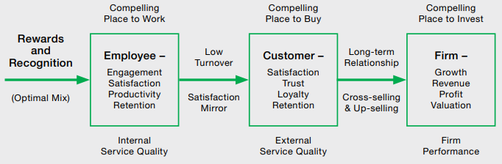
Figure 3: Application of Rewards and Recognition Program to Enhance Customer Retention, Staff Engagement and Organisational Performance
(Source: Madhani, 2020)
In present compelling place to purchase, external service quality delivered by the organisation depends on customer satisfaction, retention, loyalty and trust. Low turnover and satisfaction mirror of employees actually outcomes in customer deliverables. As stated by Phillips et al. (2017), recognition of staff has been an important piece for job satisfaction whether indirectly or directly to staff member. These dependencies in long-term relationship and cross selling or upselling pave the way for firm growth, revenue generation, profitability and high valuation. Once after strategic implemented, this holds much importance to appraise the success of programs and accordingly make modifications as desirable for ensuring that program supports present culture and employees’ necessities.

Challenges with Reward and Awards
The challenges in reward system is such that employees are never aware of overall process which goes behind planning, designing and delivering reward programs. Rewards that are not connected with company’s business outcome sin deficit of broad alignment between employers’ prior objectives and employees’ needs. In case of Tesco, challenges are found in terms of setting perfect reward based on dynamic nature of dynamic employee demand and changing business environment like double dip recession in UK (Alam and Raut-Roy, 2019).

Additional Holidays
In the dynamic and competitive business environment, pleasing employees has been an important aspect. Non-monetary rewards directly bring staffs to revelation that the organisation is recognising their accomplishments as well as appreciating their time and hard work (Cohen, 2006). Celebration of holiday season could be the biggest fun way for keeping the employees high focused as well as engaged. With offering additional holidays to employees are actually way of tanks giving for the job they has done well, which in turn makes them feel more motivated as well as inspired to perform more great work. The employees are actually driven for surpassing business goals and they feel happier as well as more committed towards their employer. The necessity for de-stressing especially becomes inevitable and hence with offering holidays the stress levels tends to be low.
Additional holidays must essentially be provided to elderly workers, considering as their rewards for the loyalty towards organisation or for having engaged in some new training courses. Staff members desiring to clinch on such organisational practice would definitely retain their employment, in such sector where employing new staff can never be that easy. As discussed by Martine and Jaussaud (2018), according to certain manager, the offering of additional holidays has turned out to be so successful in cases of retaining senior female employees that they decided for creating another holiday. Extending further this has been extended for male employees who want to take some time off to resolve their personal problems. As investigated by Zhang (2018), in hospitality industry Kimpton Hotels have maintained flexibility in working schedule for their staffs with offering paid vacations as well as holidays. Even though most organisations deal with paid holidays however only a few organisations can offer a paid time-off plan to their employees.

Challenges with Offering Additional Holidays
Two British giant retailers appeared to be sufferers this Christmas, which are Marks & Spencer and Tesco. This is very disappointing results due to past holidays, as both brands face significant challenges ahead being concerned about inflation that is eating on customer spending power and significant slowdown in demand (Felsted, 2022). As consequence shares fell.
While aspects of belongingness and security at work are taken as intangible motivational aspects on contrary holidays, bonus, and pay are recognised as tangible motivational factors (Mukhopadhyay and Chatwin, 2021). To maintain flexibility in work schedule has been other significant benefit for employee, and employers. Attendance as well as time oriented HR solutions could essentially be enforced by enterprises for ensuring enhancement in their benefits (Sreenath, Mohan and Lavanya, 2019). By thoroughly understanding such system would be supportive for employees with accepting offers like holidays for their employees on specifically low work demanding days. Such HR solutions would actually be helping employers in assessing as well as knowing the exact value of the current benefits.

Good Working Conditions
Tacit knowledge seems to be retained within the organisation, which in turn serves as the ground for business innovations as well as changes essential for competitive edge on the market. According to Basalamah and As’ad (2021), working environment should be inspirational and comfortable, which will keep the workforces motivated and highly engaged in assigned tasks.
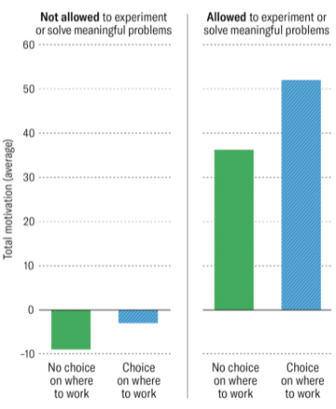
Figure 4: Motivation Level of Employees Empowered to Perform Experiment
(Source: McGregor and Doshi, 2020)
Work environment develops working conditions as well as flattering work conditions eventually serve as the fundamental factor for pleasing performance of workforces. However, unfavourable working conditions immediately cause dissatisfaction within the job that ultimately outcomes in reduced performance and hence consequently high turnover of staffs (Paais and Pattiruhu, 2020). In case working conditions are respectable, workforces could be obviously motivated by working environment, their performance becomes stable and even improves, and the workers do never have to find any other reason for leaving the organisation. This has been clearly clarified that employees working remotely are least motivated and those having no choice are least motivated. With no choice of working remotely, close to 20% of employees are motivated whereas around 25% are motivated with working in office (McGregor and Doshi, 2020). However, with choice of working remotely, approximately 35% are pleased and around 40% are motivated for working in office.

Challenges of Good Working Conditions
Tesco workers in recent times revealed demoralising work conditions since the outbreak of Covid-19 pandemic. Supermarket employees are working exceedingly hard for ensuring all shelves are well stocked and such that customers’ shopping experience becomes very easy. However, such demanding work is presently starting to take its toll for which a few staffs are feeling unhappy with present working conditions (Cunningham, 2020). Tesco must have tendency for thinking about improvement within working environments only at times of unavailability of labour force in the labour market. McGregor and Doshi (2020) have identified that providing workers essential freedom of experimenting and solving meaningful issues based on their roles outcomes in high motivation irrespective of the fact where they prefer to work it.

Conclusion
While drawing the inferences this is earnest to notify that employee motivation are the energy level, creativity and commitment that the employees bring in their jobs. Their motivational level is in turn the acute responsibility of the management irrespective of the fact that financial conditions of the organisation is shrinking or growing. Firstly, this is recommended to the organisation to upsurge pay of employee however; this should always be based on employee performance and years of experience. Secondly, management should be focused on market value. Creation of personal enrichment program would mean that organisation is offering tuition reimbursements or sending employees to seminars and workshops wherein they can bolster their motivation and skillsets. This would facilitate management to promote employees with higher responsibility and high pay besides a short holiday for professional development. Thirdly, by tactically offering profit-sharing program, staffs would recognize that they are having a stake within financial success of their organization, which in turn will motivate them.

List of References
Alam, S. and Raut-Roy, U., 2019. Evaluating the Effectiveness of Reward Strategy at Tesco: Evidence from Selected Stores in UK. Indian Journal of Industrial Relations, 55(1). http://publishingindia.com/GetBrochure.aspx?query=UERGQnJvY2h1cmVzfC81NDYzLnBkZnwvNTQ2My5wZGY=
Basalamah, M.S.A. and As’ad, A., 2021. The Role of Work Motivation and Work Environment in Improving Job Satisfaction. Golden Ratio of Human Resource Management, 1(2), pp.94-103. https://goldenratio.id/index.php/grhrm/article/download/54/59
Brown, D (2018) Fairness, Flexibility and Affordability: What are the lessons from pay and reward approaches and trends in the UK? Institute for Employment Studies, February, http://www.employment-studies.co.uk/resource/fairness-flexibility-and-affordability
Cohen, S., 2006. Compliment your staff with nonmonetary rewards. Nursing Management, 37(12), pp.10-14.
Cunningham, A., 2020. Herts Tesco worker reveals 'demoralising' working conditions. [online] HertsLive. Available at: <https://www.hertfordshiremercury.co.uk/news/hertfordshire-news/tesco-employee-reveals-demoralising-working-4132922> [Accessed 5 March 2022].
Felsted, A., 2022. Britain's Retail Giants Shouldn't Get Too Cozy. [online] BloombergQuint. Available at: <https://www.bloombergquint.com/gadfly/britain-s-retail-giants-tesco-m-s-shouldn-t-get-too-cozy-after-good-christmas> [Accessed 5 March 2022].
Holmes, H. and Badger, J., 2021. The inside story of Tesco’s strike action. [online] The Grocer. Available at: <https://www.thegrocer.co.uk/pay/the-inside-story-of-tescos-strike-action/662635.article> [Accessed 5 March 2022].
Kinsey, A., 2020. The Advantages of Using Money to Motivate Employees. [online] Small Business - Chron.com. Available at: <https://smallbusiness.chron.com/advantages-using-money-motivate-employees-22056.html> [Accessed 20 February 2022].
Kuvaas, B., Buch, R. and Dysvik, A., 2018, August. Individual variable pay for performance, incentive effects, and employee motivation. In annual meeting of the Academy of Management, Chicago, USA. https://www.researchgate.net/profile/Bard-Kuvaas/publication/326282127_Individual_Variable_Pay_for_Performance_Incentive_Effects_and_Employee_Motivation/links/5b49ab7045851519b4b8794a/Individual-Variable-Pay-for-Performance-Incentive-Effects-and-Employee-Motivation.pdf
Mackenzie, A., 2018. Workday BrandVoice: Pay-For-Performance And The Science Behind What Motivates Us. [online] Forbes. Available at: <https://www.forbes.com/sites/workday/2018/05/31/pay-for-performance-and-the-science-behind-what-motivates-us/> [Accessed 26 February 2022].
Madhani, P.M., 2020. Effective rewards and recognition strategy: Enhancing employee engagement, customer retention and company performance. The Journal of Total Rewards, 29(2), pp.39-48. https://www.researchgate.net/profile/Dr-Pankaj-Madhani/publication/343628153_Effective_Rewards_and_Recognition_Strategy_Enhancing_Employee_Engagement_Customer_Retention_and_Company_Performance/links/5f34f6e592851cd302f159ab/Effective-Rewards-and-Recognition-Strategy-Enhancing-Employee-Engagement-Customer-Retention-and-Company-Performance.pdf
Martine, J. and Jaussaud, J., 2018. Prolonging working life in Japan: Issues and practices for elderly employment in an aging society. Contemporary Japan, 30(2), pp.227-242. https://www.tandfonline.com/doi/pdf/10.1080/18692729.2018.1504530
McGregor, L. and Doshi, N., 2020. How to Keep Your Team Motivated, Remotely. [online] Harvard Business Review. Available at: <https://hbr.org/2020/04/how-to-keep-your-team-motivated-remotely> [Accessed 26 February 2022].
Mukhopadhyay, B. and Chatwin, C., 2021. 'Your Driver is Didi and Minutes Away from Your Pick-Up Point': Understanding Employee Motivation in the Gig Economy of China (No. 805). GLO Discussion Paper. https://www.econstor.eu/bitstream/10419/232258/1/GLO-DP-0805.pdf
Paais, M. and Pattiruhu, J.R., 2020. Effect of motivation, leadership, and organizational culture on satisfaction and employee performance. The Journal of Asian Finance, Economics, and Business, 7(8), pp.577-588. https://www.koreascience.or.kr/article/JAKO202026061031735.pdf
Phillips, H., Bogdanich, I., Carter, K., Holler, J., Smith, T., Ticehurst, E.H. and Wascher, M., 2017. Commentary: Exploring novel approaches to staff rewards and recognition. Hospital pharmacy, 52(11), pp.729-731. https://www.ncbi.nlm.nih.gov/pmc/articles/PMC5735769/
Rodriguez, T., 2021. Council Post: The Importance Of Recognition In The Workplace: Five Strategies To Engage And Motivate Teams. [online] Forbes. Available at: <https://www.forbes.com/sites/forbeshumanresourcescouncil/2021/08/25/the-importance-of-recognition-in-the-workplace-five-strategies-to-engage-and-motivate-teams/> [Accessed 20 February 2022].
Schindler, J., 2019. Council Post: Employee Motivation: It Really Does Matter. [online] Forbes. Available at: <https://www.forbes.com/sites/forbescoachescouncil/2019/12/16/employee-motivation-it-really-does-matter/> [Accessed 20 February 2022].
Shaaban, S., 2018. The impact of motivation on organisational citizenship behaviour (OCB): The mediation effect of employees’ engagement. https://buescholar.bue.edu.eg/cgi/viewcontent.cgi?article=1016&context=bus_admin
Skilbeck, R., 2019. Six Strategies To Maintain Employee Motivation. [online] Forbes. Available at: <https://www.forbes.com/sites/rebeccaskilbeck/2019/02/12/six-strategies-to-maintain-employee-motivation/> [Accessed 20 February 2022].
Sreenath, S., Mohan, P.A. and Lavanya, M.P., 2019. Employee Benefits and its Effect on Productivity at Semcon India Private Limited, Bangalore. SDMIMD Journal of Management, 10(1), pp.55-64. https://pdfs.semanticscholar.org/af30/8d229a3e9bfc13b8076c63c2e8f5b62c8dbd.pdf
Van den Broeck, A., Carpini, J. and Diefendorff, J., 2019. Work motivation: Where do the different perspectives lead us. The Oxford handbook of human motivation, 2, pp.354-372. https://www.researchgate.net/profile/Anja-Van-Den-Broeck/publication/335175029_Work_Motivation_Where_Do_the_Different_Perspectives_Lead_Us/links/5d5508bf299bf16f0738e6a6/Work-Motivation-Where-Do-the-Different-Perspectives-Lead-Us.pdf
Zhang, T., 2018. Employee wellness innovations in hospitality workplaces: Learning from high-tech corporations. Journal of Global Business Insights, 3(2), pp.52-66. https://digitalcommons.usf.edu/cgi/viewcontent.cgi?article=1003&context=globe

