

GRADUATE CERTIFICATE in Consolidation of Social Work Practice
LEVEL 6 - 60 Credits
BMPF6044

LEARNER PORTFOLIO
(PORTH AGORED and UNIVERSITY OF WALES TRINITY SAINT DAVID)

Learner’s name: Zoe Louise Roberts

Email address: zoe14louise@gmail.com

Learner’s University Registration Number:

Cohort: 21 onwards

Reference List
Information about referencing in written assignments and how to avoid plagiarism can be found on Moodle. It is important that you are aware of the importance of ensuring that the work submitted is your original work.

Social services and wellbeing act (Wales) 2014. Ar gael:
https://www.legislation.gov.uk/anaw/2014/4/contents Accessed 16th November 2023

Mental Health (Wales) Measure 2010. Ar gael:
http://www.legislation.gov.uk/mwa/2010/7/contents Accessed 16th of November 2023

Human Rights Act 1998. Available at:: https://www.legislation.gov.uk/ukpga/1998/42/contents
Accessed 17th of November 2023

Children Act 1989. Available at: Children Act 1989 (legislation.gov.uk) Accessed 17th of November 2023

NSPCC Learning (2019) Child protection system for Wales|NSPCC Learning. Ar gael:
https://learning.nspcc.org.uk/child-protection-system/wales/ Accessed 17th of November 2023

Morris, K (2008) Social Work and Multi-agency Working: Making a Difference. The Policy
Press: Bristol

Wales Safeguarding Procedures, available at:
http://www.myguideapps.com/projects/wales_safeguarding_procedures/default/adu/?nocache=
0.6197322086477466 Accessed 17th of November 2023

Mental Capacity Act, 2005. Code of Practice. Available at:
http://www.mental-capacity .com/abouttheact/depravationofliberty.html Mynediad 23eg Medi
2019

Davies, E. (1994) Social Work and the Welsh Language. University of Wales
GWYNEDD COUNCIL (2010-2013) WELSH LANGUAGE SCHEME
Prepared in accordance with the Welsh Language Act 1993

Cenus 2021, Wales Government. Available at: Search - Office for National Statistics (ons.gov.uk) Accessed 17th of November 2023.

Crawford, K (2012) Inter-professional collaboration in social work practice. London: SAGE
Publications

United Nations Convention for a Child. Available at: https://www.unicef.org.uk/what-we-do/un-convention-child-rights/ Accessed 17th of November 2023.

Davies, E. (1994) Social Work and the Welsh Language. University of Wales

Fowler, J. (2003). A Practitioner's Tool for Child Protection and the Assessment of Parents. United Kingdom: Jessica Kingsley Publishers.
Smale (2000) Assessment in social work: A guide for learning and teaching, Social Care Institute for Excellence. Available at: https://www.scie.org.uk/publications/guides/guide18/teaching/howtaught.asp#:~:text=The%20exchange%20model%20recognises%20social,%2C%202000%2C%20p%20140). (Accessed: 15 January 2024).
Losana Chan (2010) Intentional Interviewing and Counseling: Facilitating Client Development in a Multicultural Society, by Allen E. Ivey, Mary B. Ivey and Carlos P. Zalaquett, Asia Pacific Journal of Counselling and Psychotherapy, 1:2, 186-187, DOI: 10.1080/21507686.2010.493204
Davies,E. (2011) Different Words, Different Worlds? The Concept of language choice
in social work and social ca Korthagen, F. A., Nuijten, E. E. (2018). CORE REFLECTION.
International Handbook of Holistic Education.
Korthagen, F. A., Nuijten, E. E. (2018). CORE REFLECTION. International Handbook of
Holistic Education.
North Wales Safeguarding Board (2019). Accessed on 15.01/2024 Available at
https://www.northwalessafeguardingboard. O&#39;Connell, B. (2012). Solution-focused
therapy. London: Sage.
Safeguarding procedures (2019) Available at https://safeguarding.wales/ (Accessed
15th of January 2024).
Wales Safeguarding Procedures 2019. Available at: https://safeguarding.wales /
(Accessed 15 th of January 2024)
.Holton, J.A. (2015) ‘What grounded theory is…a critically reflective conversation among scholars’, Organizational Research Methods, 18(4), pp. 581–599. doi:10.1177/1094428114565028.
Public Health Wales (2020) Annual report, Public Health Wales. Available at: https://phw.nhs.wales/about-us/annual-report/ (Accessed: 15 January 2024).
Feeney, J., & Noller, P. (1996). Adult attachment. Sage Publications, Inc
Wonnacott (2012) Effective supervision in a variety of settings, Social Care Institute for Excellence. Available at: https://www.scie.org.uk/publications/guides/guide50/references.asp (Accessed: 15 January 2024).
Corcoran, N. (2013) Communicating health: Strategies for health promotion [Preprint]. doi:10.4135/9781526401588.
Thompson, N. (2012) Anti-discriminatory practice: Equality, diversity and Social Justice. Basingstoke: Palgrave Macmillan.
Greenway, R. (2014) The four FS of active reviewing, John Dabell. Available at: https://johndabell.com/2021/10/15/the-four-fs-of-active-reviewing/ (Accessed: 15 January 2024).
Working together to safeguard people: Code of safeguarding practice (2018) GOV.WALES. Available at: https://www.gov.wales/working-together-safeguard-people-code-safeguarding-practice (Accessed: 15 January 2024).
Evans,O. (2023) Bronfenbrenner’s Ecological Systems Theory. Available at: https://www.ilgateways.com/docman-docs/faculty-resources/itc-landing-pages/3101-fcr1-4-bronfenbrenner-s-ecological-systems-theory/file#:~:text=Bronfenbrenner's%20ecological%20systems%20theory%20views,values%2C%20laws%2C%20and%20customs. Accessed 18 January 2023.
Assessment in social work: A guide for learning and teaching (2003) Social Care Institute for Excellence. Available at: https://www.scie.org.uk/publications/guides/guide18/ (Accessed: 15 January 2024).
Welsh language (wales) measure 2011 | Law Wales. Available at: https://law.gov.wales/culture/welsh-language/welsh-language-wales-measure-2011 (Accessed: 15 January 2024).
More than just words (2023) WeCare. Available at: https://wecare.wales/morethanjustwords/ (Accessed: 12 January 2024).
More than just words: Welsh language plan in Health and Social Care (2022) GOV.WALES. Available at: https://www.gov.wales/more-just-words-welsh-language-plan-health-and-social-care (Accessed: 12 January 2024).
Rogers, C.R. (2020) On becoming a person: A therapist’s view of psychotherapy. London: Robinson.
National Association of Social Workers (NASW):https://www.socialworkers.org/ Accessed 20.01.24
The British Association of Social Workers (BASW): https://www.basw.co.uk/ Accessed 20.01.24
Social Work Today: https://www.socialworktoday.com/ Access 20.01.24

Detail of Workshops Attended

Please record in the table below the dates of each consolidation programme workshop you attended.

Consolidation workshop | Date Attended
1 Workshop 1 | 15.03.23
2 Workshop 2 | 17.05.23
3 Workshop 3 | 19.07.23
4 Workshop 4 | 21.11.23

Notes

Mentor’s report

With reference to the 3 learning outcomes please comment fully on the learner’s development over the duration of the whole programme. Reflect on information provided by the learner at the outset of the programme in Task 1 (Part a) and the later perspective given in Task 1 (Part b). Where you have seen or discussed feedback from individuals in need of care and support and/or their carers with whom the learner has worked, you are encouraged to comment on this with regard to the learner’s development and their future development.

As I am an external mentor, I had not met Z before our initial meeting which took place online in March 2023. During our meetings which have taken place on a regular basis since then, Z has shown a willingness to reflect on her practice and seek opportunities to further her professional development.
During our first meeting we considered Z’s learning needs as identified with her manager. She discusses these in Task 1 (Part a). Zoe identified at the beginning of the programme that she needed to increase her knowledge and develop her skills when working with families. In her discussions with me, Z clearly appreciated the support from her manager and also experienced members of her team and she sought out appropriate training opportunities. She also was able to reflect on the training that she attended.
When discussing her cases, Z showed that she recognised the importance of analysis when undertaking assessments, of having time to reflect and to apply theoretical knowledge in her practice. She was able to identify that pressures of
work and a heavy caseload can have an impact on the ability to reflect and apply
analysis. She said that she was able to discuss this with colleagues and her
manager.
Z discussed collaboration with children and families and also with other agencies that are involved with the children and families. In her new role with CAMHS, Z recognises the importance of working closely with colleagues from health and education whilst ensuring that her own identity, knowledge and value base as a social worker continue to strengthen and develop. In discussion and also in her written work, it is clear that Z has developed her assessment skills. She places emphasis on hearing the voice of the child and for striving to ensuring that children and families are central to her assessments.

In part b of Task 1, Z notes that her confidence as a practitioner has increased during the past year. This was reflected in our discussions when reflecting on her practice. She has been dealing with increasingly complex cases and has increased her knowledge about statutory work. Dealing with complex situations and attending training courses has meant that her skills in managing conflict have also developed. Z recognises that she needs to continue to develop her self-confidence when giving her opinion in professional meetings. She has presented as open to asking for and accepting advice and guidance from her manager and experienced colleagues and I am confident that she will continue to do this in the
future. She notes her future learning needs in her new role in Part b. There is no doubt that the knowledge, experience and skills that she has developed in the Children and Supporting Families Team are transferable and will be invaluable to her in her next role.
As I work as an external mentor it has not been possible for me to seek feedback from individuals about Z’s involvement with them. I wish her well in the future.

Note for Mentor – Please ensure that you provide a signature of verification of this report in the section titled ‘Signatures and Line Manager Verification’

Learner Details

Learner details, Signatures and Line manager verification.

It is the learner’s responsibility to ensure that their university learner number is correctly inserted wherever requested within the portfolio.

Learner Details
(NB it is essential that you inform your Workforce Development/Training Unit and the University of Wales Trinity Saint David if your name or your address for correspondence changes).

1. Name of Learner: Zoe Louise Roberts

2. Learner’s University Number:2236915

Address for Correspondence: Ground Floor Flat, Heddfan, Churton Street, Pwllheli, Gwynedd, LL53 5AD

Telephone Number:07487648757

E-mail address: zoe14louise@gmail.com
Student Email Address : 2236915@student.uwtsd.ac.uk

Date of Professional Qualification: 31/12/2021

Date of registration with Social Care Wales: 27/12/21

3. Name of Learner’s Agency

Agency Contact details: Children and Adolescents Mental Health Service – CAMHS Early Intervention, Prevention and Promotion Service.

Name: Dawn Roberts (Line Manager) email address – dawn.roberts@wales.nhs.uk

Address:
Talarfon Holyhead Road, Bangor LL57 2EE ·
Telephone Number: 0300 085 0037

E-Mail address: Zoe.Roberts10@wales.nhs.uk

4. The evidence I have provided within this portfolio is in:

Welsh only □ Welsh and English □ English only X

Mentor’s details

5. Mentor’s details

Name: Angharad Williams

Address:
℅ Uned Datblygu Gweithlu
Cyngor Gwynedd
Caernarfon

Telephone Number:07767638361

E-Mail address:Angharad.Roberts2022@outlook.com

6. Observer details

Name: Nia Mai Evans

Work Address:
Gwynedd Council Arfon Social Services Office
Children and Support Families Arfon
Penrallt
Caernarfon
Gwynedd
LL55 1BN

Professional Qualification and date of qualification: Dipsw Social Worker

Telephone number: 01286682640

Email address: NiaMaiEvans@gwynedd.llyw.cymru

Signatures and Line Manager Verification

CONFIDENTIALITY and PLAGIARISM – to be completed by the learner.

All information provided in this portfolio complies with guidance on confidentiality. I confirm that all work apart from comments by others (e.g. mentor, individuals in need of care and support and/or their carers) is all my original work and has not been copied. I understand that plagiarism is taken very seriously by the University and the programme.

Signed: _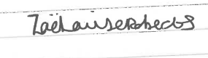 (Learner)

Date: 09.02.24

Feedback and comments from an individual using services, their family and/or carers (Task 2) - to be completed by the Observer.

I confirm that I am a registered social worker with knowledge of the learner’s area of practice and that the observation summary and the comments above from the individual in need of care and support and/or their carers are about the same piece of practice that I observed on the date given.

Signed: _ 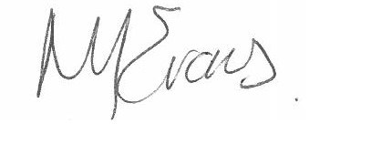_ (Observer)

Date: _ _09.02.23 _ _

Mentors Report (to be completed by the mentor)

I can confirm that I am a registered social worker and that in my role as mentor I have provided a written report of the learner’s progress over the duration of the programme.

Signed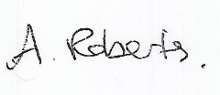 (Mentor)

Date 09.02.24

Line manager verification.
Guidance: This section must be completed and signed by the learner’s line manager and/or senior practitioner. Where the line manager is not a registered social worker, verification must also be provided by a social work practitioner in a senior position (this could be the mentor) who is familiar with the learner’s work and can verify that the learner has been involved with the safeguarding case evidenced in Task 3 of the portfolio and that the learner has met all the required criteria listed below.

In this section, please confirm that you have seen sufficient evidence of the learner’s work during the period they have been undertaking the Consolidation programme. If necessary, please consult with other managers who the learner has worked with. In signing this section, you are confirming that you are content with the:

- level of supervision and mentoring support received by the learner;
- learning and development undertaken;
- reading and personal research undertaken;
- level of knowledge and skills demonstrated;
- understanding shown of the Code of Professional Practice and National Occupational Standards;
- core values of the learner;
- work and commentary referred to within the portfolio, that it is the learner’s own work and based on current practice;
- completion of accurate, cogent, coherent and analytical recording skills;
- Line manager to verify the learner has been involved with safeguarding.
- Mentor’s report, and that it provides evidence of observations of Professional Practice that has been undertaken over the duration of the Graduate Certificate in the Consolidation of Social Work practice pathway (work-based practice which is equivalent to 7,000 words).

I confirm that this learner has achieved an appropriate level of professional practice.

LINE MANAGER VERIFICATION:

NAME OF LINE MANAGER: _ _ Dawn ROBERTS _
SIGNATURE OF LINE MANAGER: _ 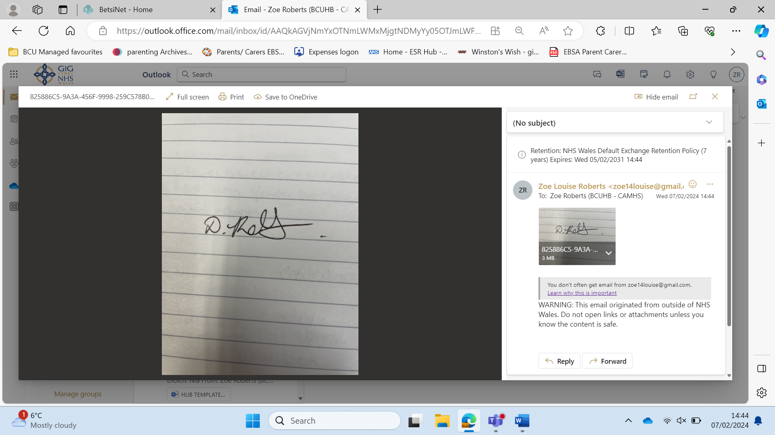
DATE: _ _ 09.02.2024

REGISTERED SOCIAL WORKER’S VERIFICATION (WHERE THE LINE MANAGER IS NOT A REGISTERED SOCIAL WORKER, THIS CAN BE THE MENTOR).

NAME OF SOCIAL WORKER:
SIGNATURE OF SOCIAL WORKER:
POSITION:
DATE:
Learning Agreement

PORTH AGORED AND UNIVERSITY OF WALES TRINITY SAINT DAVID

GRADUATE CERTIFICATE IN CONSOLIDATION OF SOCIAL WORK PRACTICE

LEARNER AND EMPLOYER’S LEARNING AGREEMENT

Name of Learner | Zoe Louise Roberts
Name of Team/Agency | CAMHS PRACTITIONER
Name of Mentor | Angharad Williams
Name of Line Manager | Dawn Roberts

Study Duty

The learner will undertake all elements of the Graduate Certificate programme diligently, including mandatory attendance at induction, four Consolidation Workshops, and participation in an evaluation survey or focus group on completion of the programme.

The learner’s full and effective participation on the Graduate Certificate is mandatory given that Social Care Wales has made completion of the programme a requirement within the first (three-year) period of registration as a Social Worker. This applies to social workers who qualified after April 2016.

Study Leave

The employer undertakes to support the learner by providing time within their normal contract of employment to attend all agreed mandatory elements of the programme which include; induction day and four Consolidation Workshops. Additional time may be provided for programme evaluation meetings and any training agreed as a requirement of the programme.
Three further study days will be provided by the employer as a contribution towards the time involved in personal research and developing the portfolio for submission. The study days can be taken on any week-day (or combination of days) as long this is (i) appropriate to the stage of portfolio preparation at the time, and (ii) agreed with the Team Manager who will take into account team and service needs. Where the learner works less than 37 hours a week, mandatory days and study leave will be approved in accordance with the employer’s local policies.

Resources

Learners are able to access learning and library materials from their employer’s existing resources or as described in the Programme Handbook, from the University. The employer understands that the Graduate Certificate is to be completed by newly qualified Social Workers in their first period of registration and will support this timescale. There is also an expectation that as it is a professional development programme, learners will take responsibility for their own learning and will also use their own time for personal study and portfolio preparation.

The employer’s training department agrees to:

- arrange for eligible staff to join the programme;
- pay course fees directly to the University;
- pay Porth Agored partnership fees for each learner;
- provide additional guidance and support by:

  - facilitating access to existing learning materials or library resources;
  - providing appropriate training opportunities from existing internal training programmes as agreed with the learner and mentor;
  - providing programme induction and Consolidation Workshops;
  - providing learners with guidance and support about programme requirements and portfolio completion;
  - helping to resolve any programme difficulties encountered by the learner, mentor or service managers.

The learner agrees to:

- work actively towards completing the qualification within the agreed timescale of 12 months from the date of registration on the programme;

identify with manager/mentor appropriate internal training and arrange to attend these courses;

identify with manager/mentor and Training Coordinator/Manager any special requirements e.g. dyslexia and contact the University’s Student Services office directly about additional support that may be required;
- attend induction and four Consolidation Workshops. These are mandatory components of the programme;
- produce work and evidence appropriate to the portfolio and learning outcomes within agreed timescales;
- make and keep agreed appointments with mentor/line manager;
- ensure they are prepared adequately and obtain all necessary consent for observed practice;
- inform mentor/line manager and training department immediately of any problems or changes in circumstances while undertaking the programme, especially where this may affect completion of the programme by the agreed deadline or ability to attend a mandatory workshop;
- liaise with their line manager/mentor to confirm study days and use their own time in addition for self-directed study, research and portfolio preparation;
- take personal responsibility for preparing and completing all work necessary to submit their portfolio;
- act at all times in accordance with the Code of Professional Practice and the employer’s and University’s policies, procedures and processes;
- ensure that they understand the need to complete the programme within the first (three year) period of registration with Social Care Wales. (Qualifying after April 2016).

Line Manager/Mentor agrees to:

Line-manager/mentor can be one in the same person or the role can be undertaken by two separate people. The mentor must be a registered SW with a minimum of 3 years post qualifying experience.

- attend an induction meeting to become familiar with the requirements of the programme;
- provide or arrange to provide sufficient assessment opportunities in order for the learner to evidence competency and undertake required observations. Where opportunities may not be immediately available within the team arrange to provide these elsewhere within the Service;
- guide and support the learner for the duration of the programme;
- release the learner for the programme induction and the four Consolidation Workshops, and any internal training courses agreed as being appropriate to meet agreed learning needs;
- agree with the learner, use of up to 3 additional study days over the whole duration of the programme, as an employer contribution towards time needed for personal study, research or portfolio development;
- ensure that regular formal supervision is provided to the learner by their line manager in line with organisational policy (line-manager);
- ensure that mentoring sessions are provided in line with Social Care Wales First 3 Three Years in Practice guidelines. Mentoring sessions, where possible, should be arranged as a separate event from supervision. A full record of when mentoring sessions are undertaken must be kept.

Completion and submission of portfolio

Learners are expected to complete the Graduate Certificate and will normally submit their portfolio within 12 months of attending induction to the programme. Any learner anticipating any difficulty in meeting this requirement should immediately discuss the matter with their Training Manager/Co-ordinator. It is the learner’s responsibility to inform the university if they are not going to meet the submission deadlines.

The portfolio submission process and dates for each programme cohort will be published on Moodle. Once registered on a programme, learners CANNOT change the due submission date without gaining agreement from the employer and University.

Pressure of work is not regarded as a reason for non-attendance at any Consolidation Workshop.

I understand and accept the terms and conditions of this learning agreement as stated above.

Signed: Print Name: Zoe Louise Roberts Date: 09.02.24
(Learner)

Signed: Print Name: Dawn Louise Roberts .Date: 09.02.24
(Line Manager/Mentor)

Signed: Print Name: Angharad Roberts Date: 09.02.24
(Mentor, if different to above)

PLEASE PLACE THE SIGNED COPY OF THIS LEARNING AGREEMENT IN THE PORTFOLIO.

