

PORTFOLIO OF THREE LITERATURE REVIEW ELEMENTS

Yitong Liu

Module Lead: Dr Emma Roberts
Director of Studies/Internal Verifier: Dr Caroline Jawad

LCDB7009 Critical Literature Review for Doctoral Research
Doctor of Business Administration
University of Wales Trinity Saint David

2022
contents
Part 1 3
1.1 Introduction 3
1.2 Purpose 3
1.3 Content 4
1.3.1 Collecting Information 4
1.3.2 Evaluating Sources 5
1.3.3 Theoretical Saturation 5
1.3.4 Critique Recommendations 5
1.4 Format 6
1.4.1 Title 6
1.4.2 Introduction 6
1.4.2.1 Transparency 6
1.4.2.2 Reproducibility 6
1.4.3 Main Body 7
1.4.3.1 Chronological 7
1.4.3.2 Thematic 7
1.4.3.3 Methodological 7
1.4.3.4 Theoretical 7
1.4.4 Conclusion 8
1.4.5 Bibliography 8
1.5 Conclusion 8
1.6 References 9
Part 2 11
Part 3 Literature Review 17
3.1 Classification of health misinformation 17
3.2 The transmission of health misinformation on social media 18
3.3 Current research on the governance of health misinformation 21
3.4 Theoretical framework adopted in the study 24
3.5 Research gap 24
3.6 References 26

Part 1

1.1 Introduction

The process of scientific research is essentially a process of continuous accumulation of human knowledge, i.e., a process of continuous innovation, application and re-accumulation of innovation based on existing research (Efron and Ravid, 2018). This requires researchers to understand and grasp the relevant scientific results that have already existed, especially whether the relevant results we have studied are more scientific and innovative than the previous ones, which is something that must be stated in the literature review (ibid). Dr Caroline, Director of Studies, and Dr Emma, Module Lead, often talk in class about how scientific research is about thinking on the shoulders of giants, making progress and reaching upwards (Massaro, Dumay and Guthrie, 2016). This is also something I agree with and appreciate. I will then critically explore the purpose, content and format of the literature review respectively.

1.2 Purpose

A literature review is a highly condensed collection of hundreds, thousands or even tens of thousands of relevant articles, but rather than listing every possible article that can be found, it is an in-depth analysis of past and present research findings based on the identification of relevant information, pointing to the current state of research, problems and future directions (Booth, Sutton and Papaioannou, 2016).

Firstly, literature reviews are essential to scientific research and studying them can help not just to find study ideas, but also to find alternative points of view on the problems being researched (Efron and Ravid, 2018). A study of publications will give essential information and instances of research feasibility since published research and academic papers are important sources of questions.

Secondly, a literature review allows the reader to become familiar with the advancement and challenges of research in related fields of study and to understand how far the research related to the topic under study has developed and what difficulties it has encountered (Booth, Sutton and Papaioannou, 2016).

Thirdly, a literature review could identify presuppositions between concepts through possible explanations of certain phenomena and behaviours to understand and learn from how others define and measure key concepts. Identifying aspects of others’ definitions that can be improved and critiqued (Cottrell, 2017), filling in gaps in existing research and introducing alternative studies, thereby uncovering new research methods and approaches and validating other relevant research.

With its systematic analytical evaluation and informed trend predictions, a thorough literature review may give significant support and justification for the formation of new subjects.

1.3 Content

A literature review is not only a summary of a series of unconnected contents but also a synthesis of ideas from previous related studies. A literature review has the following content.

1.3.1 Collecting Information

The information-gathering section can be divided into four steps as follows:

The first step is to write a few research questions about the intended research direction, which are only a draft and may not be the final research questions. Determine the research area based on the research questions.

The second step is to identify relevant databases. The University of Wales Trinity Saint David’s library resources are very useful for searching journals and publications, but of course, some are not included in the library, so you cannot forget Google Scholar, as well as EBSCO, Elsevier ScienceDirect, Emerald, Web of Science, etc. For my research area, which is cross-disciplinary, a lot of the literature refers to PubMed as well.

In the third step, identify the keywords in the area you wish to study, either by listing any synonyms or similar terms for each of the main topics or variables you are interested in. To help narrow the search, Boolean Operators can be used to combine terms as appropriate (Booth, Sutton and Papaioannou, 2016). As an example, my research uses the following:
OR: to locate sources that contain one of the varieties of synonyms (e.g. misinformation OR disinformation OR rumours)
AND: to locate sources that contain several keywords (e.g. social media AND misinformation AND health)

1.3.2 Evaluating Sources

When relevant sources are available, we can start by reading the abstract and summary of the publication to decide whether it is relevant to the study to be done and to determine whether it needs to be integrated into the literature review. The abstract is to let the reader know what research is being done in this article, what methods were used, where the research was done and what the main conclusions and findings are.

Furthermore, it is critical to sift through the literature already gathered by the needs of scientific theory and research, noting in a detailed and systematic manner the studies’ questions, aims, methodologies, findings, and conclusions, along with their problems, the shortcomings of their views and the questions yet to be raised. This is very important in a literature review.

1.3.3 Theoretical Saturation

The concept of data saturation often used to assess the adequacy of research data, originated from grounded theory and originally took the form of theoretical saturation (Strauss and Glaser, 1973). In qualitative research, as in quantitative research, sample adequacy is a fundamental guarantee of research validity (Curtis et al., 2000). Reaching data saturation means that further data collection based on the current data gathered and analysed will not contribute to the researcher's deeper understanding of the theory and therefore further data collection and analysis is not necessary (Strauss and Corbin, 2008).

A quantitative approach looks for comprehensiveness and makes sure that looked at all of the different variables. Whereas in qualitative terms looking for theoretical saturation(Rowlands, Waddell and McKenna, 2015). Transparency in data saturation reporting in qualitative research, where the researcher claims to have achieved data saturation, requires a more detailed description of the form, determination and basis of data saturation to facilitate reader assessment and further validation (Fusch and Ness, 2015; Hennink, Kaiser and Marconi, 2017; Kerr, 2010; Malterud, Siersma and Guassora, 2016).

1.3.4 Critique Recommendations

This refers mainly to what suggestions one has for new directions of research after having done a summary of previous research. It is common to write retrospectives and outlooks, analysing the developments and trends in a discipline. A list of all the problems and how to solve them is the trend. This can be in terms of methodology, which methods would be more appropriate to solve these problems; or theoretical predictions, what other research should be done in different areas of research (Efron and Ravid, 2018).

1.4 Format

The structure of a literature review generally consists of the following components: title, introduction, main body, conclusion and bibliography.

1.4.1 Title

The title of the literature review is usually followed by the title of the chosen topic (or, if the topic has not yet been finalised, by the name of the research direction) and the words ‘Research Review’ or ‘Literature Review’.

1.4.2 Introduction

This section does not necessarily need a specific title, but rather opens the whole literature review directly. It briefly describes the significance of the research; the main questions to be addressed; and finally, the scope of the data collected by the researcher and the sources. Two very important concepts have to be mentioned here, transparency and reproducibility.

1.4.2.1 Transparency
Transparency means you are being upfront and open about how you searched and what you found (Templier and Paré, 2018). It requires to be able to upfront exactly what searches you have used, to be able to upfront your search terms, to be able to upfront write that up as a literature search methodology, to be able to upfront this is how I write my literature, this is how I find the literature (Paré et al., 2016). In one sentence, there is a whole list of details to include: the sources searched, the search strategies, the number of references found, and the date searches were conducted.

1.4.2.2 Reproducibility
Reproducibility means the ability to reproduce what you have done. But it is not important to interpretive theoretical approach. This should include a description of the main works accessed, the databases searched on the internet (e.g. EBSCO, Scopus, ScienceDirect, PubMed, etc.) (Ćurković and Košec, 2018), how the search was conducted (e.g. by typing in ‘keywords’), the number of relevant papers searched, the number of papers of direct reference value to the researcher, the number of papers that are of direct reference value to you, etc (Cram, Templier and Pare, 2020). In a word, someone else can duplicate your research exactly.

1.4.3 Main Body

The literature review that follows can follow a chronological, thematic, methodological and theoretical format (Booth, Sutton and Papaioannou, 2016).

1.4.3.1 Chronological
The most straightforward way to summarise the literature is to follow the evolution of the subject over time. Pay attention to not limiting yourself to chronological identification and summary of sources. Analysing patterns, turnings and key debates that shaped the direction of the area, and critically explaining how and why certain things happened.

1.4.3.2 Thematic
You can take several recurring themes in the relevant literature and go by topic to divide the literature review by themes into sub-sections to tackle different aspects of the topic.

1.4.3.3 Methodological
If the sources are from various disciplines or areas, or if different research methods are used, then you probably wish to contrast the findings and conclusions resulting from the differing methodologies. Then use the methodology to do a literature review, for example, on the same issue, to see how the results of qualitative research differ from quantitative research. Also how empirical and theoretical studies have been explored separately for the same question, etc.

1.4.3.4 Theoretical
The theoretical framework is usually based on a literature review. It can be used to address different theories, models and key concept definitions. It can give a sample case for a specific theoretical methodology, as well as a mixture of different theoretical concepts to create a theoretical framework for a study.

1.4.4 Conclusion

The main features, research trends and values of the above-mentioned research results are summarised and evaluated. This section should focus on the existing research base of the topic (how the existing results have laid the foundation for your research or how you have been inspired by them) and the remaining research space (the gaps or weaknesses in the existing research of the topic).

1.4.5 Bibliography

As requested by the Director of Studies Dr Caroline, only literature with a high evaluation level is referred to, listed in Harvard’s refereed format according to the University’s requirements, with the author’s name, literature name, literature source and time fully indicated.

1.5 Conclusion

To summarise, the literature review provides a systemic and thorough narrative and review of research findings, problems and new trends that have been achieved in the issue under study over a certain period, based on a comprehensive collection and reading of a large amount of relevant research literature, selection, reading, classification, summarization, collation, comparison, analysis and synthesis. In brief, a literature review is a basis for all rational research.

1.6 References

Booth, A., Sutton, A. and Papaioannou, D. (2016) Systematic approaches to a successful literature review. Second edition. Los Angeles: Sage.

Cottrell, S. (2017) Critical thinking skills: effective analysis, argument and reflection. Third edition. London: Macmillan Education/Palgrave (Palgrave study skills).

Cram, W.A., Templier, M. and Pare, G. (2020) ‘(Re)considering the Concept of Literature Review Reproducibility’, Journal of the Association for Information Systems, 21(5). doi:http://dx.doi.org/10.17705/1jais.00630.

Ćurković, M. and Košec, A. (2018) ‘Bubble effect: including internet search engines in systematic reviews introduces selection bias and impedes scientific reproducibility’, BMC Medical Research Methodology, 18. doi:http://dx.doi.org/10.1186/s12874-018-0599-2.

Curtis, S. et al. (2000) ‘Approaches to sampling and case selection in qualitative research: examples in the geography of health’, Social Science, p. 14.

Efron, S.E. and Ravid, R. (2018) Writing the Literature Review: A Practical Guide. New York, UNITED STATES: Guilford Publications. Available at: http://ebookcentral.proquest.com/lib/trinity/detail.action?docID=5522670 (Accessed: 9 May 2022).

Fusch, P.I. and Ness, L.R. (2015) ‘Are We There Yet? Data Saturation in Qualitative Research’, The Qualitative Report, 20(9), pp. 1408–1416.

Hennink, M.M., Kaiser, B.N. and Marconi, V.C. (2017) ‘Code Saturation Versus Meaning Saturation: How Many Interviews Are Enough?’, Qualitative Health Research, 27(4), pp. 591–608. doi:10.1177/1049732316665344.

Kerr, C. (2010) ‘Assessing and demonstrating data saturation in qualitative inquiry supporting patient-reported outcomes research’, Expert Review of Pharmacoeconomics & Outcomes Research, 10(3), pp. 269–81. doi:https://doi.org/10.1586/erp.10.30.

Malterud, K., Siersma, V.D. and Guassora, A.D. (2016) ‘Sample Size in Qualitative Interview Studies: Guided by Information Power’, Qualitative Health Research, 26(13), pp. 1753–1760. doi:10.1177/1049732315617444.

Massaro, M., Dumay, J. and Guthrie, J. (2016) ‘On the shoulders of giants: undertaking a structured literature review in accounting’, Accounting, Auditing & Accountability Journal, 29(5), pp. 767–801. doi:http://dx.doi.org/10.1108/AAAJ-01-2015-1939.

Paré, G. et al. (2016) ‘Contextualizing the twin concepts of systematicity and transparency in information systems literature reviews’, European Journal of Information Systems, 25(6), pp. 493–508. doi:http://dx.doi.org/10.1057/s41303-016-0020-3.

Rowlands, T., Waddell, N. and McKenna, B. (2015) ‘Are We There yet? A Technique to Determine Theoretical Saturation’, The Journal of Computer Information Systems, 56(1), pp. 40–47.

Strauss, A.L. and Corbin, J.M. (2008) Basics of qualitative research: techniques and procedures for developing grounded theory. 3e [ed.]. London: SAGE.

Strauss, A.L. and Glaser, B.G. (1973) The discovery of grounded theory: strategies for qualitative research. 1st pbk. ed. Chicago: Aldine Pub. (Observations).

Templier, M. and Paré, G. (2018) ‘Transparency in literature reviews: an assessment of reporting practices across review types and genres in top IS journals’, European Journal of Information Systems, 27(5), pp. 503–550. doi:10.1080/0960085X.2017.1398880.

Part 2

In this part, I will demonstrate my literature browsing, documenting and learning process. In the first term, Dr Caroline showed us a doctoral student’s Review Matrix, which impressed me so much that I was tempted to create a Review Matrix for my own research area. But unfortunately, I was late in taking action and used the traditional way of taking notes on paper for the LCDB7007 Research Principle and Philosophy assignment and LCDB7008 Visions for the Future - Theoretical Perspectives on Management assignment, so much so that it took a lot of time and effort when I wanted to look back. I am also acutely aware of the need for electronic online software or functions to replace outdated ones.

At the beginning of the term, I listened to a RefWorks session from the university library, highly recommended by Dr Caroline, Director of Studies, and Dr Emma, Module Lead, and it was amazing and very informative. RefWorks is more than simply a ‘how’ to reference; it’s a programme that allows you to create your own academic database by extracting references from text documents, web databases, as well as other sources. Such references may be utilised in papers, and the paper and bibliography will be automatically formatted in seconds. I am determined to start building my own database from now on.

While I was exploring how RefWorks could be of use to me, I looked at various software from other companies with similar functionality. After carefully comparing RefWorks, EndNote, Zotero and others, I decided to go with Zotero, and although it was RefWorks that worked most closely with the University Library, I decided that Zotero was the best fit for me. There were five main personal considerations.

Firstly, I currently use a Mac system for writing assignments, an iPad Pro with an electronic pen for reading literature, and usually an iOS operating system for my phone, so it is the Apple ecosystem that I am building on my electronic devices. It just so happens that Zotero has an application that allows me to sync and collaborate across devices, keeping my reading and notes updated seamlessly. And it enables me to view the literature I want to go through whenever I want, whether I’m in the office, on my private computer or outdoors, with no restrictions.

Secondly, the browser I use works with Zotero’s plug-in, which enables one-click, automatic generation of the articles and books I want to browse directly from the web, including automatic download of their PDFs and full metadata. Even when I encounter PDFs that I can’t download directly, a snapshot can be generated automatically, which allows me to easily go back through the literature.

Thirdly, Zotero allows me to organise my literature the way I want to. I will create the folders I need, for instance, in this course, I will go through the literature in different categories for Part 1 and Part 2. Then the folders that appear on my far left are differentiated in this way. This makes my database look very elegant. There are also keywords that appear on the far left that automatically filter the literature out.

Fourthly, Zotero allows me to edit notes directly in my own database and with a double click of the mouse, it quickly takes me to the literature I need.

Fifthly, and this one is the most miraculous in my opinion, I have also installed the Zotero plug-in in my Microsoft Word, which allows me to add a citation and generate a bibliography in my database with one click. This has greatly improved productivity for using Microsoft Excel Review Matrix. Because after all, the literature that we are required to read for assignments and a thesis about a doctorate is enormous. Frankly, last term’s assignment took an incomprehensible amount of time just to put together the reference list.

These are just a few of the things that I have experienced with Zotero, and it is possible that it has much more to offer than that, and I will be using it as I experience the bonuses and convenience that technology can bring us. Next, I will show my 100 references (Screenshots 1, 2 and 3 add up to 100 references). These 100 references are real and valid, and every reference that appears in Part 3 of this assignment can be found in these three screenshots below.

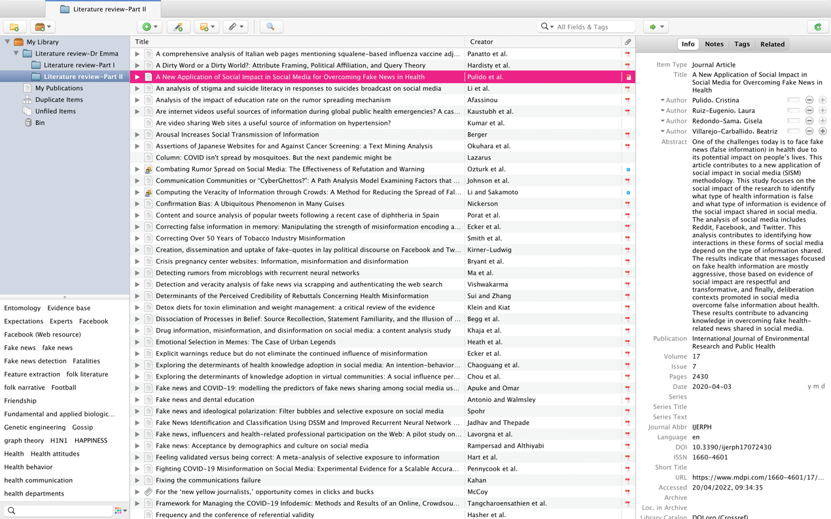
Screenshot 1

First of all, the leftmost part of Screenshot 1 shows the folders just mentioned, the selected folder is “Literature review-Part Ⅱ” under “Literature review-Dr Emma”. Exactly, above “Literature review-Part II” is “Literature review-Part I”, which is a record of all the references in Part 1. This gives me a neat interface to categorise my work. Looking down in the direction of the folders, all the keywords are extracted from the selected folder (Literature review-Part Ⅱ), and this section also helps me to quickly filter out the literature with the same keywords. Then the interface that takes up most of the screen is my ‘database’. The database is sorted by title, from a-z, on a sliding scale, which I think is an easy way for me to see. On the far right of Screenshot 1 is the basic information of my selected article (the third article from the top, also marked in red), which contains item type, title, authors, abstract, publication, volume, issue, pages, date, DOI, etc. This is also the foundation for the final bibliographic output of the article.

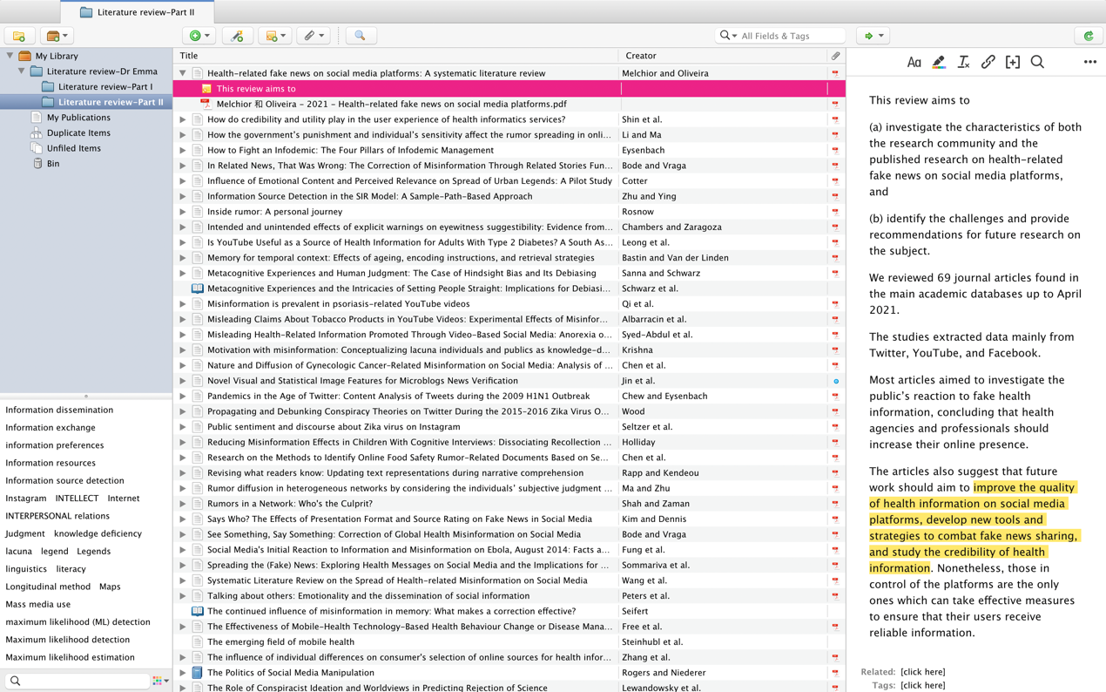
Screenshot 2

Secondly, the folders on the far left of Screenshot 2 are the same as in Screenshot 1 and are constant. The keywords at the bottom of the folder are scrollable and the middle section of Screenshot 2 shows dozens of documents that differ from Screenshot 1. On the far right-hand side of the screen are my notes on the selected documents in Screenshot 2. I made my notes as I read through the documents, especially the yellowed sections which were important for my ideas and thoughts on the paper.

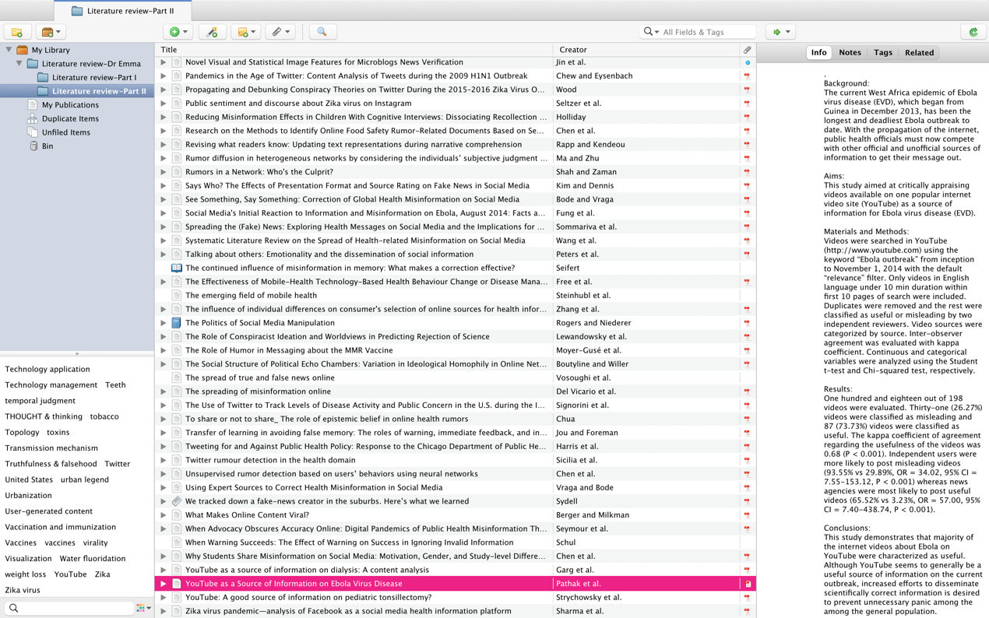
Screenshot 3

Finally, adding the dozens of literature lists from Screenshot 3 is all I have for 100. The left and middle of the screen are exactly the same as Screenshot 1 and Screenshot 2. On the far right-hand side of the screen are the background, aims, materials and methods, results, and conclusions of my selected papers.

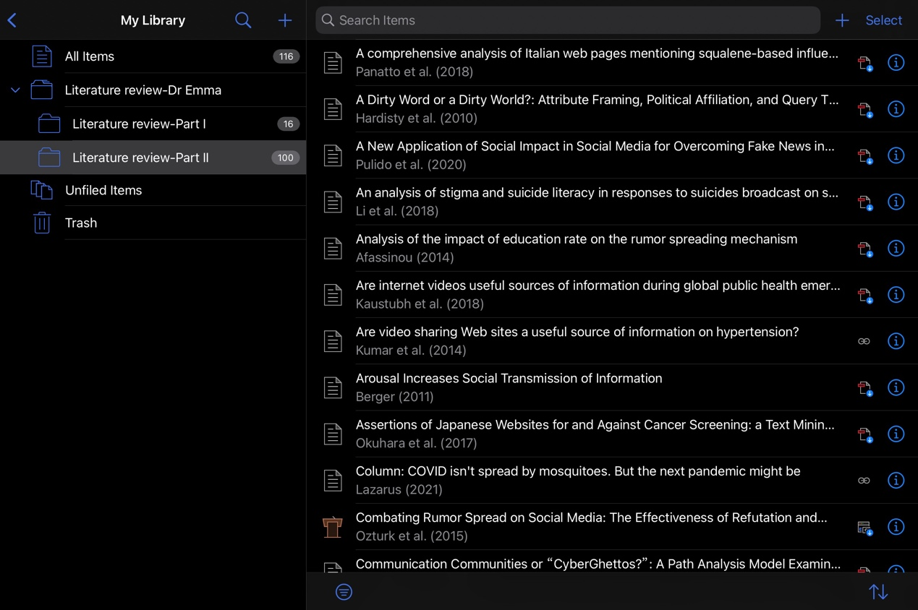
Screenshot 4
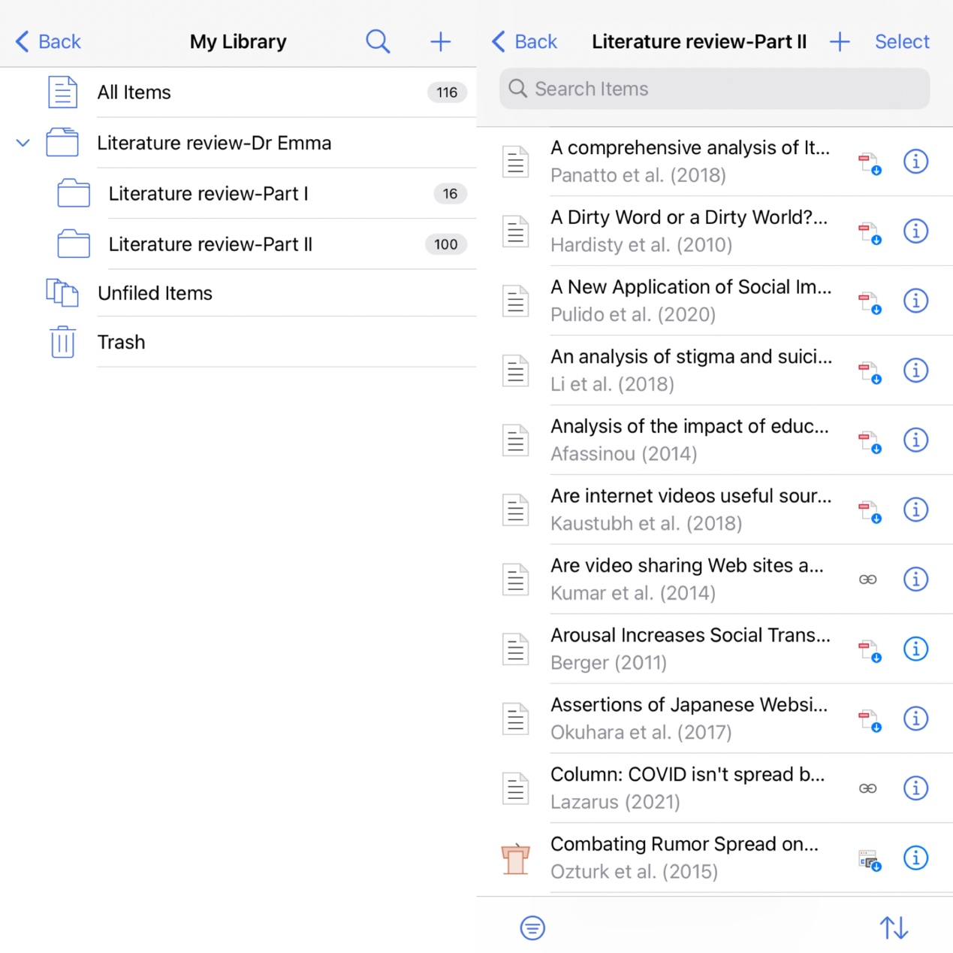
Screenshot 5

Screenshots 4 and 5 show how my iPad interface and iPhone interface look respectively, and the interface is very neat and presentable. This is the same ecosystem I mentioned before with the iOS operating system, it allows me to browse my database whenever and wherever I want and unbelievably it's all free of charge, which really couldn’t be more awesome!

Part 3 Literature Review

Social media is new in recent decades and the literature on social media is all relatively new. Communication, epidemiology, medical internet, psychology, and computational science are all included in the literature on health-related misinformation. Therefore, this study will review the relevant literature from China, the United States and other countries in the past decade to provide a comprehensive understanding of how health-related misinformation is governed in the context of social media, as well as the current status and gaps of research in each area, to provide a theoretical basis for further research. Focus on databases such as Elsevier ScienceDirect, Emerald, Web of Science, etc. in the context of the keywords “social media” and “social networks”, searching for “health misinformation”, “health fake news”, “health rumour”, etc. Develop a comprehensive understanding of academic developments so that research priorities can be set.

3.1 Classification of health misinformation
The current research on fake health information is divided into infectious diseases, chronic diseases, medicine, health and wellness, food safety, diet and weight loss, etc.

The majority of social media research on health misinformation has focused on infectious diseases such as COVID-19 (Lazarus, 2021), Zika, Ebola, H1N1, Measles, Mumps and Rubella (MMR). With the advent of the coronavirus pneumonia pandemic, a considerable volume of unsubstantiated material, such as mosquito bites conveying the virus, was shared over social media (Lazarus, 2021). Because officials were unable to give definite answers or guidance, the Zika outbreak generated a lot of discussion on Twitter and Facebook (Wood, 2018), and related news (Sommariva et al, 2018), photographs (Seltzer et al, 2017), and videos (Bora, 2018) were widely shared. During the Ebola outbreak, Twitter and Sina Weibo also helped disseminate rumours and speculative information (Fung et al, 2016), and a large number of misleading videos about the Ebola virus disease existed online (Pathak et al, 2015). According to a poll of H1N1 flu films on YouTube, 61.3% included relevant information on the disease, while 23% were deceptive (Pandey, 2010; Shigemura et al, 2015). Misinformation linking the Measles, Mumps, and Rubella (MMR) vaccination to autism was widely disseminated on social media, and it continues to have a strong influence among some groups (Wang et al, 2019; Hargreaves et al, 2003).

While the majority of misinformation research has focused on infectious diseases, misinformation concerning chronic diseases like cancer and cardiovascular disease is frequent on social media. Scholars in Japan analysed internet discussions with different viewpoints on cancer screening and discovered that anti-cancer screening material was the most widely shared (Okuhara et al, 2017). Other scholars have also studied false health messages about chronic diseases such as hypertension (Kumar et al, 2014), psoriasis (Qi et al, 2016), gynaecological oncology (Chen et al, 2018a) and diabetes (Leong et al, 2018).

Unsubstantiated information about diet and nutrition can have harmful effects on susceptible people. Consumers seeking to lose weight rapidly and enhance their health are becoming increasingly interested in items labelled “detox”, “superfoods”, and “all-natural” (Klein and Kiat, 2015). Anorexia has been pushed as a craze, and research has shown that it may acquire appeal among young female viewers when linked to the notion of beauty in YouTube videos (Syed-Abdul et al, 2013).

The tobacco industry has a long history of misleading consumers by misrepresenting scientific evidence. Federal courts in the United States have found major tobacco firms guilty of conspiring to deny, misrepresent, and minimize the dangers of smoking (Smith et al, 2011). Misleading depictions of the health effects of tobacco in YouTube videos can influence viewers’ attitudes toward tobacco products and motivate smoking (Albarracin et al, 2018). The advent of e-cigarettes has prompted scholars to examine the content of messages and tweeting patterns associated with local public health department e-cigarette campaigns, with part of the misinformation aimed at diverting public attention away from the product and onto messages attempting to undermine authority (Harris et al, 2014).

Other research on pseudo-health messages regarding medications (Al Khaja et al, 2018), paediatric diseases (Strychowsky et al, 2013), abortion (Bryant et al, 2014), dialysis (Garg et al, 2015), suicide (Li et al, 2018), and multiple sclerosis (Li et al, 2018) have been published in social media (Lavorgna et al, 2018). It has been argued that while there may be less pseudo-health information than true health information, it is often the case that pseudo-health information is more popular than evidence-based true information (Wang et al, 2019).

3.2 The transmission of health misinformation on social media
While social media platforms provide a wealth of opportunities for people to communicate, they also allow misinformation to spread rapidly across the globe, regardless of geographical location. In a globalised world, there is an in-depth discussion about fake health information on social media (Wang et al, 2019), studies have been conducted on several platforms, including Twitter, Facebook, and Sina Weibo (Kirner-Ludwig, 2020; Jin et al, 2017). According to a Council of Europe report, research and policy development on information disorder can be approached from three perspectives - the information itself, the disseminator and the recipient of the information (Wardle and Derakhshan, 2017). These three components can influence the spread of fake health information both individually and as an integral whole.

Firstly, the content of the information itself is the key to the continuation of the communication. Fake health information is usually described in the voice of an expert or authority, accompanied by images or videos to confuse the public (Zhang et al, 2019), and features a combination of graphics, use of numbers, integration with current hot topics (Wang, 2015), heavy emotional involved (Chua and Banerjee, 2017) or with political purposes (Harris et al, 2014), etc. (Lu, 2016). Videos with a high level of cultural relevance had a higher level of influence, and research in India revealed that diabetes videos targeted at South Asians were more likely to be deceptive than those that were not (Leong et al, 2018). In addition, information can be inadvertently oversimplified, misrepresented or exaggerated. Scientific health information is complex, and many details of scientific research are harder for laypeople to understand or less interesting, as a result, to be successful, scientific knowledge must be simplified, and any oversimplification might lead to misinterpretation. (Lewandowsky, 2012). Humorous messages make hesitant parents more aware of the seriousness of rubella, thus reducing resistance to the measles, mumps and rubella vaccine (Moyer-Gusé et al, 2018). Furthermore, the narrative of bogus health information has a personal, hostile, and self-righteous tone, which can frequently elicit negative feelings including dread, wrath, grief, anxiety, and distrust (Panatto et al, 2018; Porat et al, 2019). False information travels wider, quicker, and deeper than true information because false information’s content is more unique and generates greater contempt, terror, and surprise (Vosoughi et al, 2018), i.e., content that elicits strong emotions is more likely to be shared (Berger and Milkman, 2012; Peters et al, 2009).

Secondly, those who disseminate false health information can be divided into “good-faith disseminators” who believe the information to be true, and “malicious disseminators” who know it to be false. Most of those spreading false health information on social media are individuals who are not affiliated with official bodies, and “experienced patients”, for example, are increasingly challenging formal bodies, the border between authority and quasi-skillfulness is becoming blurred (Seymour et al, 2015). In the absence of an authoritative voice, some users may pass on medically unreliable information to other users, unwittingly becoming purveyors of false health information (Chua and Banerjee, 2017; Ozturk et al, 2015). Whereas rumour mongers may be motivated by a desire for attention, hatred of society, fun and amusement, more producers of fake health information are driven by profit (Wang et al, 2019). Even though some producers of disinformation said in interviews that they were partly driven by political or ideological goals, their websites and articles have proven to be a lucrative source of revenue in some situations (McCoy, 2016; Sydell, 2016). Some studies have investigated the psychology of people who spread misinformation. People appear to share knowledge that elicits an emotional response the most (Cotter, 2008), people’s readiness to share knowledge is frequently boosted by emotional excitement (Berger, 2011), and knowledge that might elicit feelings of revulsion, terror, or joy is more likely to spread from person to person than neutral information, especially in a social media environment (Peters et al, 2009; Heath et al, 2011). This may be because the public may be influenced by emotions and intend to share their feelings such as discomfort with others for comfort or empathy (Zhang et al, 2019). Individuals may be less likely to disseminate false health-related information if they are exposed to collective opinions via counting retweets and collective authenticity ratings (Li and Sakamoto, 2015). As a whole, the motivations for creating and spreading fake health information reflect individual and collective qualities, but their behaviour is harder to predict due to the complex psychological factors involved. Some scholars believe it is related to internet users’ risk perceptions of fake health information. After experiencing negative events such as food safety risks, people have a tendency to have a pessimistic bias and disseminate information accompanied by a high willingness to share and access information, as well as a low willingness to filter information (Lai and Yang, 2014).

Thirdly, scholars have studied the profile of susceptible people from various perspectives to understand the impact of differences in the characteristics of information recipients on their ability to recognise false information. Females (Chen et al, 2015; Liu and Kong, 2017), those with low levels of education (Liu and Kong, 2017; Afassinou, 2014), those of low age (Holliday, 2003), and those with little knowledge (Krishna, 2017), and those who do not pay attention to official misinformation are less likely to recognise false health information (Zhang and Su, 2019). In an analysis of cognitive beliefs and their effect on rumour acceptance, it was found that individuals with strong cognitive beliefs typically process information more vigilantly, while individuals with weaker cognitive beliefs are more inclined to believe false health information online (Chua and Banerjee, 2017), and that developing personal sensitivity can help prevent misinformation from spreading (Li and Ma, 2017). Furthermore, conspiracy theories play a key role in information recipients’ acceptance of misleading health information. On Twitter and Facebook, for example, the rumour that the Zika virus is a biological weapon and that a Zika vaccine is being created to lower the world’s population was extensively spread (Wood, 2018; Lewandowsky et al, 2013). Health literacy (Zhang et al, 2017), subjective judgement (Ma and Zhu, 2018), cultural background (Rampersad and Althiyabi, 2020), conspiracy thinking and emotions (Zhang et al, 2019) also influence the processing of information by the receiver of the message. Another related study has focused on key ideas like selective exposure and confirmation bias, as well as the wide spectrum of events that result from them. Selective exposure, in which people intentionally seek out information that supports their opinions and avoid information that contradicts those beliefs to lessen the discomfort or dissonance they feel when confronted with material that contradicts their beliefs (Johnson et al, 2009). The Internet, in particular, has resulted in the division of the information sphere into “echo chambers”, with bloggers primarily linking to other blogs with similar viewpoints rather than those with opposing points of view. More than half of blog readers look for sites that support their viewpoints, while just 22.2% look for blogs that oppose them (ibid). Prior views impact people’s perceptions of facts, and confirmation bias, or individuals seeking for or interpreting data in support of previous ideas, expectations, or assumptions (Nickerson, 1998), is one of the key reasons why people spread disinformation (Kim and Dennis, 2019). If people are already sceptical of health data, confirmation bias may cause them to seek to confirm information, which misinformation might supply in the absence of true proof, resulting in the construction of online echo chambers (Hart et al, 2009; Del Vicario et al, 2016). Confirmation bias is reinforced by social media, which generates and maintains social echo chambers where specific information is rarely disputed (Spohr, 2017). Some scholars have analysed anti-fluoride online networking groups and found that the strong ties between communities are a barrier to the acceptance of expert opinion (Seymour et al, 2015). Social media may contribute to the simultaneous emergence of these phenomena and thus have complex implications (Del Vicario et al, 2016; Boutyline and Willer, 2017).

3.3 Current research on the governance of health misinformation
Misinformation is easy to disseminate but difficult to govern (Wang et al, 2019), and its governance can be divided into three main ways. The first way (beforehand) is to allow the public to receive truthful information before being exposed to it, or to be warned about its potentially misleading nature when they are about to be exposed to it. The second way (halfway) is to apply technologies such as artificial intelligence to identify and stop the spread of false information wherever possible. The third way (afterwards) is to explain and correct it.

First and foremost, a forewarning. If people are expressly alerted ahead of time that what they are going to view may be untrue, the impact of disinformation may be reduced (Ecker et al, 2010; Jou and Foreman, 2007). Scholars have investigated various methods to prevent the spread of rumours on Twitter based on rumour psychology studies. Warnings (e.g., ‘this tweet appeared on a rumour site’) did reduce the likelihood of participants sharing rumours (Ozturk et al, 2015), and warnings before receiving false information appeared to be more effective than warnings afterwards (Ecker et al, 2010; Chambers and Zaragoza, 2001), possibly This may be because people have a default expectation that the information provided is valid, but a warning can alter this expectation and make the recipient doubt the truth of the information (Lewandowsky et al, 2012). Furthermore, when people are alerted that the information, they are receiving may be erroneous, they take longer to analyse it, implying that people are not quick to dismiss false information but cautious in determining whether it is real or false (Schul, 1993). While a healthy sense of scepticism or resulting mistrust also does not always protect people from false health information, they are still of great help when first exposed to false health information. The use of the Internet to communicate health-related information has been emphasised by researchers in the domains of health and public health (Signorini et al, 2011; Chew and Eysenbach, 2010), looking at ways to increase public acceptance of authentic information or scientific knowledge (Huo et al, 2018; Chou et al, 2015). And the full potential of social media is being used for preventive interventions using smartphones and other mobile technologies (Free et al, 2013; Steinhubl et al, 2015).

Secondly, halfway. Identifying and stopping the spread of misinformation to remove it helps to mitigate but is less likely to eliminate the impact of misinformation (Ecker et al, 2011). Rumours are reinforced and seen as believable when they are transmitted repeatedly (Rosnow, 1991), and the consequent high credibility boosts trust and readiness to propagate rumours (Shin et al, 2017). Repeated exposure to a statement can increase acceptance of its truthfulness (Begg et al, 1992; Hasher et al, 1977), even if the information is rejected in the initial exposure, but if a piece of information is seen multiple times, this may give it some credibility based on familiarity (Lewandowsky et al, 2012), and it may begin to be more convincing than evidence-based facts (Dias da Silva and Walmsley, 2019). Identifying and removing fake health information and reducing its number is thus indispensable. A range of research has focused on misinformation identification and stopping its spread in time (Vishwakarma et al, 2019; Sicilia et al, 2018), using artificial intelligence techniques like neural networks to detect bogus news and spam on social media sites like Twitter and Weibo, for example. (Jadhav and Thepade, 2019; Ma et al, 2016). Some scholars have designed an online document recognition method based on semantic co-linear matching to identify food safety misinformation (Chen et al, 2018b), as well as using neural network techniques based on user behaviour to improve the accuracy of rumour detection (Chen et al, 2018c). Some models also attempt to identify the sources of rumour propagation (Shah and Zaman, 2011; Zhu and Ying, 2016). The major impact of recognizing and removing erroneous health information is to lower the number of references to false information and to enhance the speed with which false health information is identified, hence maximizing the prevention of public inferences based on false data (Ecker et al, 2010; Ecker et al, 2011).

Third, afterwards. Misinformation can be remedied through corrections, albeit with some time delay, but clarifying the correction and providing a plausible causal explanation can cast doubt on the original false beliefs and thus mitigate the impact of the misinformation to some extent (Seifert, 2002; Sanna and Schwarz, 2006). The ‘Related News’ function on Facebook may be used to correct incorrect health information concerning a possible relationship between immunizations and autism (Bode and Vraga, 2015). The corrective sort of information, in an ideal world, would explain why the inaccurate information was first considered to be right and propose a solution (Lewandowsky et al, 2012; Rapp and Kendeou, 2007). The efficiency of the correction varies depending on the extent of engagement, personal literacy, and socio-demographic variables of each individual. In the United States, the Centers for Disease Control and Prevention (CDC) sent pamphlets to recipients to dispel false health information (e.g., “Flu vaccination side effects are worse than the flu”) and offer pertinent facts (e.g., “Flu vaccine side effects are infrequent and moderate”). When recipients were assessed immediately after reading these leaflets, they were able to discern between the truth and untruth of the information and expressed behavioural intentions that were compatible with the information presented (i.e., the intention to be vaccinated) (Schwarz et al, 2007). However, the warning effect was less pronounced in the elderly and children, possibly because they were more likely to confuse the true and false messages they received and retain only a sense of déjà vu (Bastin and Van Der Linden, 2005; Holliday, 2003). Messages that are consistent with worldviews can increase audience acceptance (Kahan, 2010), and even simple changes in wording can make messages more acceptable (Hardisty et al, 2010). Some researchers have demonstrated how expert organizations may correct disinformation without jeopardizing their reputation, implying an appealing strategy to limit misinformation propagation (Vraga and Bode, 2017). According to research, both algorithmic (by platforms) and social (by peers) corrections are equally successful in removing misinformation, and initiatives to urge users to reject inaccurate or misleading information are needed (Bode and Vraga, 2018).

3.4 Theoretical framework adopted in the study
Currently, it is difficult to choose a theory that can reasonably explain this phenomenon due to the relative lack of relevant research. This thesis uses the cultivation theory proposed by George Gerbner because it not only explains the mechanisms of information dissemination but also focuses on the effects it has.

American communication experts like Gerbner initiated a series of research on the substance of television violence in the 1960s and 1970s. They examined the influence of television on audience attitudes in addition to the content study of television violence, and finally developed the “Cultivation Theory” (Gerbner et al, 1986). The Cultivation Theory school of thought developed theories of ‘mainstream effects’ and ‘reverberation effects’. The mainstream effect is the belief that as a result of exposure to television, values that are meant to be various become similar to the mainstream of view provided by television. This coincides with the spiral of silence theory. As a medium of mass communication, television represents and directs the mainstream of social opinion, thus leading to a convergence of public opinion (ibid). The news media should aggressively steer public opinion using this notion. The cultivation theory’s central premise is that mass communication mediums subtly shape their audience’s viewpoint (Mosharafa, 2015). Audiences exposed to a lot of violent television shows, for example, have substantially higher estimations of the chance of violent assaults than those who have little or no exposure to such shows (West and Turner, 2014). This confirms empirically the long-term effects of the media, which has both positive and negative effects in terms of their impact on audiences’ worldviews and values. On the one hand, providing audiences with accurate information and providing an objective, true, and thorough reflection of the objective reality can have a good impact on the development of healthy and comprehensive worldview ideals. On the other hand, if the media delivers a skewed portrayal of reality, it can affect people’s perceptions of reality and lead to wrong worldview values (Bilandzic and Rössler, 2004).

3.5 Research gap
By reviewing the research on health-related misinformation in the context of social media found that the current literature, rather than considering the overall political, scientific and social impact of health-related misinformation, on the one hand, the current literature focuses on exploring the mechanisms and patterns of dissemination of misinformation, and on detecting and preventing the dissemination of health-related misinformation with the help of computer technology-related tools; on the other hand, the current literature focuses on exploring the relationship between health-related misinformation and certain human traits, explaining people’s cognitive responses to misinformation and rumours in social networks at an individual level, so as to understand the mechanisms behind health-related misperceptions in social networks. This study will not focus on the psychological and cognitive characteristics of people’s reception of health-related misinformation, but rather on how to counteract health-related misinformation with corrective information, the effectiveness of health-related corrective information is reflected in whether it can change the recipients’ original misconceptions, how to avoid or reduce the negative effects of health-related misinformation, and to explore the credibility of health-related corrective information.

3.6 References

Afassinou, K. (2014). ‘Analysis of the impact of education rate on the rumor spreading mechanism.’ Physica A: Statistical Mechanics and its Application, 414: 43-52.

Albarracin, D., Romer, D., Jones, C., et al. (2018). ‘Misleading claims about tobacco products in YouTube videos: experimental effects of misinformation on unhealthy attitudes.’ Journal of medical Internet research, 20 (6), e229.

Al Khaja, K. A. J., AlKhaja, A. K. and Sequeira, R. P. (2018). ‘Drug information, misinformation, and disinformation on social media: a content analysis study.’ Journal of Public Health Policy, 39: 343-357.

Bastin, C. and Van Der Linden, M. (2005). ‘Memory for temporal context: Effects of ageing, encoding instructions, and retrieval strategies.’ Memory, 13 (1), 95-109.

Begg, I. M., Anas, A. and Farinacci, S. (1992). ‘Dissociation of processes in belief: Source recollection, statement familiarity, and the illusion of truth.’ Journal of Experimental Psychology: General, 121 (4): 446-458.

Berger, J. (2011). ‘Arousal increases social transmission of information.’ Psychological Science, 22 (7): 891-893.

Berger, J. and Milkman, K. L. (2012). ‘What makes online content viral?’ Journal of Marketing Research, 49 (1): 192-205.

Bode, L. and Vraga, E. K. (2015). ‘In related news, that was wrong: the correction of mis-information through related stories functionality in social media.’ Journal of Communication, 65 (4): 619-638.

Bode, L. and Vraga, E. K. (2018). ‘See something, say something: correction of global health misinformation on social media.’ Health Communication, 33 (9): 1131-1140.

Bora, K., Das, D., Barman, B., et al. (2018). ‘Are internet videos useful sources of information during global public health emergencies? A case study of YouTube videos during the 2015-16 Zika virus pandemic.’ Pathogens and Global Health, 112(6): 320-328.

Boutyline, A. and Willer, R. (2017). ‘The social structure of political echo chambers: variation in ideological homophily in online networks.’ Political Psychology, 38 (3): 551-569.

Bryant, A. G, Narasimhan, S., Bryant-Comstock, K., et al. (2014). ‘Crisis pregnancy center websites: information, misinformation and disinformation.’ Contraception, 90(6), 601-605.

Chambers, K. L. and Zaragoza, M. S. (2001). ‘Intended and unintended effects of explicit warnings on eyewitness suggestibility: Evidence from source identification tests.’ Memory & Cognition, 29: 1120-1129.

Chen, X., Sin, S. C. J., Theng, Y. L., et al. (2015). ‘Why students share misinformation on social media: Motivation, gender, and study-level differences.’ The Journal of Academic Librarianship, 41 (5): 583-592.

Chen, L., Wang, X. and Peng, T. (2018a). ‘Nature and diffusion of gynecologic cancer-related misinformation on social media: analysis of tweets.’ Journal of Medical Internet Research, 20 (10): e11515.

Chen, Y. F., Zhou, X. Y. and Zhang, L. (2018b). ‘Research on the Methods to Identify Online Food Safety Rumor-Related Documents Based on Semantic Co-occurrence Matching.’ Information studies: Theory & Application, 41 (06): 130-136+142.

Chen, W. L., Zhang, Y., Yeo, C. K., et al. (2018c). ‘Unsupervised rumor detection based on users’ behaviors using neural networks.’ Pattern Recognition Letters, 105 (1): 226-233.

Chew, C. and Eysenbach, G. (2010). ‘Pandemics in the age of twitter: content analysis of tweets during the 2009 H1N1 outbreak.’ PLoS One, 5 (11): e14118.

Chou, C. H., Wang, Y. S. and Tang, T. I. (2015). ‘Exploring the determinants of knowledge adoption in virtual communities: A social influence perspective.’ International Journal of Information Management, 35 (3): 364-376.

Chua, A. and Banerjee, S. (2017). ‘To share or not to share: The role of epistemic belief in online health rumors.’ International Journal of Medical Informatics, (48): 36-41.

Cotter, E. M. (2008). ‘Influence of emotional content and perceived relevance on spread of urban legends: A pilot study.’ Psychological Reports, 102 (2): 623-629.

Del Vicario, M., Bessi, A., Zollo, F., et al. (2016). ‘The spreading of misinformation online.’ Proceedings of the National Academy of Sciences, 113 (3): 554-559.

Dias da Silva, M. and Walmsley, A. (2019). ‘Fake news and dental education.’ British Dental Journal, 226: 397-399.

Ecker, U. K. H., Lewandowsky, S. and Tang, D. T. W. (2010). ‘Explicit warnings reduce but do not eliminate the continued influence of misinformation.’ Memory & Cognition, 38 (8): 1087-1100.

Ecker, U. K. H., Lewandowsky, S., Swire, B., et al. (2011). ‘Correcting false information in memory: Manipulating the strength of misinformation encoding and its retraction.’ Psychonomic Bulletin & Review, 18: 570-578.

Free, C., Phillips, G., Galli, L., et al. (2013). ‘The effectiveness of mobile-health technology-based health behavior change or disease management interventions for health care consumers: a systematic review.’ PLoS medicine, 10 (1): e1001362.

Fung, I. C., Fu, K., Chan, C., et al. (2016). ‘Social media’s initial reaction to information and misinformation on Ebola, August 2014: facts and rumors.’ Public Health Reports, 131(3), 461-473.

Garg, N., Venkatraman, A., Pandey, A., et al. (2015). ‘YouTube as a source of information on dialysis: a content analysis.’ Nephrology, 20 (5), 315-320.

Heath, C., Bell, C. and Sternberg, E. (2001). ‘Emotional selection in memes: The case of urban legends.’ Journal of Personality and Social Psychology, 81 (6), 1028-1041.

Hardisty, D. J., Johnson, E. J. and Weber, E. U. (2010). ‘A dirty word or a dirty world? Attribute framing, political affiliation, and query theory.’ Psychological Science, 21 (1): 86-92.

Harris, J. K., Moreland-Russell, S., Choucair, B., et al. (2014). ‘Tweeting for and against public health policy: response to the Chicago Department of Public Health’s electronic cigarette Twitter campaign.’ Journal of medical Internet research, 2014, 16 (10): e238.

Hart, W., Albarracin, D., Eagly, A. H., et al. (2009). ‘Feeling validated versus being correct: A meta-analysis of selective exposure to information.’ Psychological Bulletin, 135 (4): 555-588.

Hasher, L., Goldstein, D. and Toppino, T. (1977). ‘Frequency and the conference of referential validity.’ Journal of Verbal Learning and Verbal Behavior, 16 (1): 107-112.

Holliday, R. E. (2003). ‘Reducing misinformation effects in children with cognitive interviews: Dissociating recollection and familiarity.’ Child Development, 74 (3), 728-751.

Huo, C., Ma, F., Qiu, Y. and Wang, Y. (2018). ‘Exploring the determinants of health knowledge adoption in social media: An intention-behavior-gap perspective.’ Information Development, 34 (4): 346-363.

Jadhav, S. S. and Thepade, S. D. (2019). ‘Fake news identification and classification using DSSM and improved recurrent neural network classifier.’ Applied Artificial Intelligence, 33 (12): 1058-1068.

Jin, Z., Cao, J., Zhang, Y., et al. (2017). ‘Novel visual and statistical image features for microblogs news verification.’ IEEE Transactions on Multimedia, 19(3): 598-608.

Johnson, T. J., Bichard, S. L., and Zhang, W. (2009). ‘Communication communities or “cyberghettos?”: A path analysis model examining factors that explain selective exposure to blogs.’ Journal of Computer-Mediated Communication, 15 (1), 60-82.

Jou, J. and Foreman, J. (2007). ‘Transfer of learning in avoiding false memory: The roles of warning, immediate feedback, and incentive.’ Quarterly Journal of Experimental Psychology, 60 (6): 877-896.

Kahan, D. M. (2010). ‘Fixing the communications failure.’ Nature, 463: 296-297.

Kim, A. and Dennis, A. R. (2019). ‘Says who? The effects of presentation format and source rating on fake news in social media.’ MIS Quarterly, 43 (3): 1025-1039.

Kirner-Ludwig, M. (2020). ‘Creation, dissemination and uptake of fake-quotes in lay political discourse on Facebook and Twitter.’ Journal of Pragmatics, 157: 101-118.

Klein, A. V. and Kiat, H. (2015). ‘Detox diets for toxin elimination and weight management: a critical review of the evidence.’ Journal of Human Nutrition and Dietetics, 28(6): 675-686.

Krishna, A. (2017). ‘Motivation with misinformation: conceptualizing lacuna individuals and publics as knowledge-deficient, issue-negative activists.’ Journal of Public Relations Research, 29 (4): 176-193.

Kumar, N., Pandey, A., Venkatraman, A., et al. (2014). ‘Are video sharing Web sites a useful source of information on hypertension?’ Journal of the American Society of Hypertension, 8(7), 481-490.

Lai, Z. D. and Yang, J. Z. (2014). ‘Why are food rumours easy to generate? An empirical study of communication behaviour in the context of food safety risk perception.’ Impact of Science On Society, 4 (1): 112-125.

Lavorgna, L., De Stefano, M., Sparaco, M., et al. (2018). ‘Fake news, influencers and health-related professional participation on the Web: a pilot study on a social-network of people with Multiple Sclerosis.’ Multiple Sclerosis and Related Disorders, 25: 175-178.

Lazarus, D. (2021). ‘COVID isn’t spread by mosquitoes. But the next pandemic might be.’ Los Angeles Times, https://www.latimes.com/business/story/2021-06-25/column-california-mosquitoes

Lewandowsky, S., Gignac, G. E. and Oberauer, K. (2013). ‘The role of conspiracist ideation and worldviews in predicting rejection of science.’ PLoS One, 8(10): e75637.

Leong, A. Y., Sanghera, R., Jhajj, J., et al. (2018). ‘Is YouTube useful as a source of health information for adults with type 2 diabetes? A South Asian perspective.’ Canadian Journal of Diabetes, 42(4): 395-403. e4.

Li, A., Huang, X., Jiao, D., et al. (2018). ‘An analysis of stigma and suicide literacy in responses to suicides broadcast on social media.’ Asia-Pacific Psychiatry, 10 (1): e12314.

Li, D. and Ma, J. (2017). ‘How the government’s punishment and individual’s sensitivity affect the rumor spreading in online social networks.’ Physica A-Statistical Mechanics and Its Application, 469: 284-292.

Li, H. and Sakamoto, Y. (2015). ‘Computing the veracity of information through crowds: a method for reducing the spread of false messages on social media.’ 48th Hawaii International Conference on System Sciences, Kauai, HI: 2003-2012, doi:10.1109/HICSS.2015.240.

Liu, M. Z. and Kong, Z. M. (2017). ‘An empirical study on the public’s ability to distinguish rumours and its influencing factors in the context of media literacy.’ Journalism Research, (04): 102-109.

Lu, J. N. (2016). A study of food safety rumours circulating in the WeChat friend moments. Suzhou: University of Suzhou, PCCSU.

Ma, J., Gao, W., Mitra, P., et al. (2016). ‘Detecting rumors from microblogs with recurrent neural networks.’ In Proceedings of the Twenty-Fifth International Joint Conference on Artificial Intelligence (IJCAT'16). AAAI Press: 3818-3824.

Ma, J. and Zhu, H. (2018). ‘Rumor diffusion in heterogeneous networks by considering the individuals’ subjective judgment and diverse characteristics.’ Physica A: Statistical Mechanics and its Application, 499: 276-287.

McCoy, T. (2016). ‘For the ‘new yellow journalists,’ opportunity comes in clicks and bucks.’ The Washington Post, https://www.washingtonpost.com/national/for-the-new-yellow-journalists-opportunity-comes-in-clicks-and-bucks/2016/11/20/d58d036c-adbf-11e6-8b45-f8e493f06fcd_story.html

Moyer-Gusé, E., Robinson, M. J. and Mcknight, J. (2018). ‘The Role of Humor in Messaging about the MMR Vaccine.’ Journal of Health Communication, 23(6): 514-522.

Nickerson, R. S. (1998). ‘Confirmation bias: a ubiquitous phenomenon in many guises.’ Review of General Psychology, 2 (2): 175-220.

Okuhara, T., Ishikawa, H., Okada, M., et al. (2017). ‘Assertions of Japanese websites for and against cancer screening: a text mining analysis.’ Asian Pacific Journal of Cancer Prevention, 18(4), 1069-1075.

Ozturk, P., Li, H. and Sakamoto, Y. (2015). ‘Combating rumor spread on social media: the effectiveness of refutation and warning.’ 48th Hawaii International Conference on System Sciences, Kauai, HI: 2406-2414, doi: 10.1109/HICSS.2015.288.

Panatto, D., Amicizia, D., Arata, L., et al. (2018). ‘A comprehensive analysis of Italian web pages mentioning squalene-based influenza vaccine adjuvants reveals a high prevalence of misinformation.’ Human Vaccines & Immunotherapeutics, 14 (4): 969-977.

Pathak, R., Poudel, D. R., Karmacharya, P., et al. (2015). ‘YouTube as a source of information on Ebola virus disease.’ North American Journal of Medical Sciences, 7(7), 306-309.

Peters, K., Kashima, Y. and Clark, A. (2009). ‘Talking about others: emotionality and the dissemination of social information.’ European Journal of Social Psychology, 39 (2): 207-222.

Porat, T., Garaizar, P., Ferrero, M., et al. (2019). ‘Content and source analysis of popular tweets following a recent case of diphtheria in Spain.’ European Journal of Public Health, 2019, 29(1): 117-122.

Qi, J., Trang, T., Doong, J., et al. (2016). ‘Misinformation is prevalent in psoriasis-related YouTube videos.’ Dermatology Online Journal, 22 (11): 13030/qt7qc9z2m5. PMID:28329562.

Rampersad, G. and Althiyabi, T. (2020). ‘Fake news: Acceptance by demographics and culture on social media.’ Journal of Information Technology & Politics, 17 (1): 1-11.

Rapp, D. N. and Kendeou, P. (2007). ‘Revisiting what readers know: Updating text representations during narrative comprehension.’ Memory & Cognition, 35 (8): 2019-2032.

Rosnow, R. L. (1991). ‘Inside rumor: a personal journey.’ American Psychologist, 46 (5): 484-496.

Sanna, L. J. and Schwarz, N. (2006). ‘Metacognitive Experiences and Human Judgment: The Case of Hindsight Bias and Its Debiasing.’ Current Directions in Psychological Science, 15 (4): 172-176.

Schul, Y. (1993). ‘When warning succeeds: The effect of warning on success in ignoring invalid information.’ Journal of Experimental Social Psychology, 29 (1): 42-62.

Schwarz, N., Sanna, L. J., Skurnik, I., et al. (2007). ‘Metacognitive experiences and the intricacies of setting people straight: Implications for debiasing and public information campaigns.’ Advances in Experimental Social Psychology, 39 (6), 127-161.

Seifert, C. M. (2002). ‘The continued influence of misinformation in memory: What makes a correction effective?’ Psychology of Learning and Motivation, 41: 265-292.

Seltzer, E. K., Horst-Martz, E., Lu, M., et al. (2017). ‘Public sentiment and discourse about Zika virus on Instagram.’ Public Health, 150: 170-175.

Seymour, B., Getman, R., Saraf, A., et al. (2015). ‘When advocacy obscures accuracy online: digital pandemics of public health misinformation through an antifluoride case study.’ American Journal of Public Health, 105 (3): 517-523.

Shah, D. and Zaman, T. (2011). ‘Rumors in a network: Who’s the culprit?’ IEEE Transactions on information theory, 57 (8): 5163-5181.

Shin, D., Lee, S. and Hwang, Y. (2017). ‘How do credibility and utility play in the user experience of health informatics services?’ Computers in Human Behavior, 67 (C): 292-302.

Sicilia, R., Lo Giudice, S., Pei, Y., et al. (2018). ‘Twitter rumour detection in the health domain.’ Expert Systems with Applications, 110: 33-40.

Signorini, A., Segre, A. M. and Polgreen, P. M. (2011). ‘The use of twitter to track levels of disease activity and public concern in the U.S. During the influenza a HIN1 pandemic.’ PLoS One, 6 (5): e19467.

Smith, P., Bansal-Travers, M., O’Connor, R., et al. (2011). ‘Correcting over 50 years of tobacco industry misinformation.’ American Journal of Preventive Medicine, 40(6): 690-698.

Sommariva, S., Vamos, C., Mantzarlis, A., et al. (2018). ‘Spreading the (fake) news: exploring health messages on social media and the implications for health professionals using a case study.’ American Journal of Health Education, 49(4): 246-255.

Spohr, D. (2017). ‘Fake news and ideological polarization: Filter bubbles and selective exposure on social media.’ Business Information Review, 34 (3): 150-160.

Steinhubl, S. R., Muse, E. D. and Topol, E. J. (2015). ‘The emerging field of mobile health.’ Science Translational Medicine, 7 (283): 283rv3.

Strychowsky, J. E., Nayan, S., Farrokhyar, F., et al. (2013). ‘YouTube: a good source of information on pediatric tonsillectomy?’ International Journal of Pediatric Otorhinolaryngology, 77 (6): 972-975.

Sydell, L. (2016). ‘We tracked down a fake-news creator in the suburbs. Here’s what we learned.’ NPR. https://www.npr.org/sections/alltechconsidered/2016/11/23/503146770/npr-finds-the-head-of-a-covert-fake-news-operation-in-the-suburbs

Syed-Abdul, S., Fernandez-Luque, L., Jian, W., et al. (2013). ‘Misleading health-related information promoted through video-based social media: anorexia on YouTube.’ Journal of medical Internet research, 15 (2), e30.

Vishwakarma, D. K., Varshney, D. and Yadav, A. (2019). ‘Detection and veracity analysis of fake news via scrapping and authenticating the web search.’ Cognitive Systems Research, 58 (Dec.): 217-229.

Vosoughi, S., Roy, D. and Aral, S. (2018). ‘The spread of true and false news online.’
Science, 359 (6380): 1146-1151.

Vraga, E. K. and Bode, L. (2017). ‘Using expert sources to correct health misinformation in social media.’ Science Communication, 39 (5): 621-645.

Wang, Y. C. (2015). ‘The logic behind the spread of food safety rumours on WeChat.’ Youth Journalist, (05): 52-53.

Wang, Y., McKee, M., Torbica, A., et al. (2019). ‘Systematic literature review on the spread of health-related misinformation on social media.’ Social Science & Medicine, 240: 112552.

Wardle, C. and Derakhshan, H. (2017). ‘Information Disorder: Toward an interdisciplinary framework for research and policymaking.’ Council of Europe report.

Wood, M. J. (2018). ‘Propagating and debunking conspiracy theories on twitter during the 2015-2016 Zika virus outbreak.’ Cyberpsychology, Behavior, and Social Networking, 21(8), 485-490.

Zhang, W. D., Luan, B. Y. and Li, S. T. (2019). ‘Influence of online false information dissemination behavior based on information risk perception factor research.’ Information studies: Theory & Application, 42 (09): 93-98+110.

Zhang, X. X., Liu, H. Y. and Hu, Y. (2014). ‘An empirical study on the formation mechanism and influencing factors of social network information ecological chain.’ Library and Information Service, (16), 36-41. doi:10.13266/j.issn.0252-3116.2014.16.005.

Zhang, Y. and Su, Y. T. (2019). ‘A study of audience recognition of WeChat health rumors - based on individual user differences.’ Radio & TV Journal, (10): 228-230.

Zhang, Y., Sun, Y. and Kim, Y. (2017). ‘The influence of individual differences on consumer’s selection of online sources for health information.’ Computers in Human Behavior, 67: 303-312.

Zhu, K. and Ying, L. (2016). ‘Information source detection in the SIR model: A sample-path-based approach.’ IEEE/ACM Transactions on Networking, 24 (1): 408-421.

