Teaching toolkit 2
Catherine Salter
2009547
Teaching toolkit 2
[Document title]
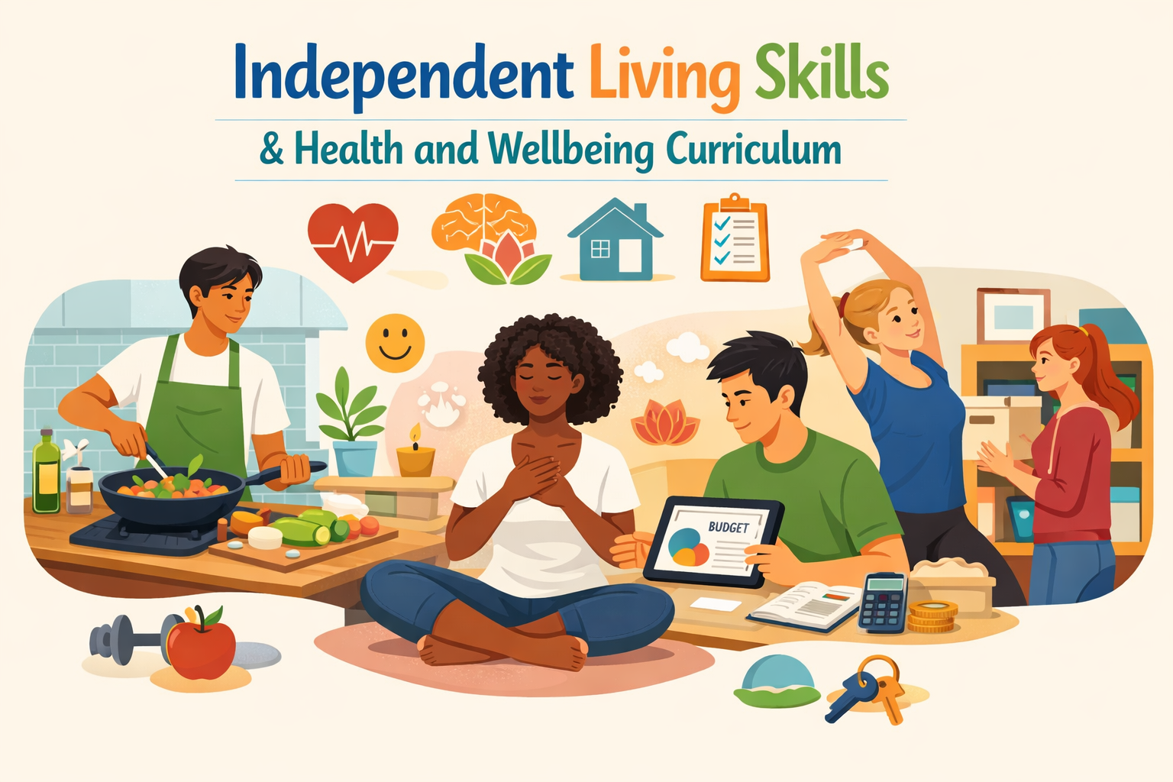

Contents
Cover page 2
Independent living skills & Health and wellbeing curriculum 2
Who the curriculum serves. 3
What the curriculum covers 3
When learning takes place 3
Where the curriculum is delivered 4
How support and planning work 4
Why is this curriculum needed? 5
Professional standards 6
18 week Scheme of work 8
Weeks 1–6: Me & My Hygiene 8
Weeks 7–12: Home & Kitchen Hygiene 9
Weeks 13–18: Healthy Lifestyle & Simple Food 11
Assessment 13
Reading List 14
Subject skills and wider transferable skills 15
Reference list 16
Appendix 18
Appendix A Week 4 Hand Hygiene planning 18
Appendix A1 Worksheet used in Appendix A planning. 22
Appendix B Week 5 Germs planning 23
Appendix B1 Worksheet used in Appendix B planning 27
Appendix B2 Wordsearch used in Appendix B planning 28
Appendix C Week 6, An example of summative assessment. 29

Cover page

MODULE CODE: ECPT6007
ASSESSMENT COMPONENT: A1 Curriculum Development Project
STUDENT NAME: Catherine Salter
STUDENT NUMBER: 2000547
Use of Generative AI in Assessment
RESEARCH | For this assessment, you can use Generative AI to support you in research, including searching for bibliography, using tools to summarise, compare and interrogate materials. | Yes ☒  No ☒
STRUCTURE | For this assessment, you can use Generative AI to support you in structuring your submission, including creating a draft argument structure, identifying parts and headings, etc. | Yes ☒  No ☐
PROOFREADING | For this assessment, you can use Generative AI to check your own text/creation for grammatical and syntactical mistakes, including rephrasing of your own work within specific standards. | Yes ☒  No ☐
WRITING | For this assessment, you can use Generative AI to create text for submission. | Yes ☐  No ☒
CREATIVE | For this assessment, you can use Generative AI to create creative materials, such as images. | Yes ☐  No ☐
PROGRAMING | For this assessment, you can use Generative AI to create and check code. | Yes ☐  No ☒
NONE | For this assessment, you are not allowed to use any type of Generative AI support. This includes research support, structure support, writing/proofreading support, and creative support. | Yes ☐  No ☒

AI Acknowledgement
I confirm that I have not used any AI tools in the research and creation of this assignment.
I confirm that I have not presented any AI generated materials as my own work.
I confirm that I have copies of my drafts, notes, and other resources I used, which I may be asked to provide in evidence.

Independent living skills & Health and wellbeing curriculum

Who the curriculum serves.
The curriculum is designed for young adults attending Bevan College a specialist further education college aged 16–25 who have severe learning difficulties and disabilities and require high levels of support to access learning (Bevan College, n.d.-a, in line with Estyn’s description of Independent Living Skills (ILS) provision for learners with moderate to severe and profound learning difficulties and disabilities, autism and complex needs (Estyn, 2025b). Learners are likely to have Additional Learning Needs (ALN) and Individual Development Plans (IDPs) that identify priorities around communication, self-care, health, daily living, and community participation, as highlighted in Further education (FE) ILS guidance on personalised, outcome-focused planning (Estyn, 2025a; Welsh Government, 2025).
All students will receive tailored support in class and around the college, typically through enhanced staffing ratios such as 1:1 or 1:2, to ensure safety, engagement and meaningful participation in all activities, reflecting sector guidance that high-needs learners in ILS pathways require additional learning support and intensive staff input to access learning, communication and personal care safely (Estyn, 2025b; Welsh Government, 2025; ColegauCymru, 2025).

What the curriculum covers
The overarching focus is on good health and independent living skills that prepare learners for as much autonomy as possible in adult life, consistent with Estyn’s identification of health and well-being and independent living as key pillars of ILS curricula in further education (Estyn, 2025b). Core content includes personal care and hygiene, healthy eating, and food preparation, managing a home environment safely, and developing routines that support physical and emotional well-being (Estyn, 2025a; Estyn, 2025b).
Learning is person-centred, with individual targets drawn from each learner’s goals and future aspirations, so that activities such as personal care routines, kitchen skills and community tasks are directly linked to real-life outcomes, reflecting Welsh Government’s emphasis on person-centred planning and the use of IDPs to shape meaningful, independence-focused provision (Welsh Government, 2025).

When learning takes place
The programme would normally run over a full academic year (36 weeks) from September to July for the purpose of this assignment it has been shortened to 18 weeks. The purpose of the full year is to give learners time to revisit and embed key routines and skills through repetition and gradual progression, in line with the way FE ILS programmes are timetabled over full academic years to allow sustained, iterative learning (Estyn, 2025b; ColegauCymru, 2025). Sessions are timetabled across the week to balance classroom-based learning, practical tasks in realistic environments, and opportunities to generalise skills in the wider community, which reflects good practice descriptions of ILS where learners move between classroom, life-skills, and community settings to apply learning in real-life contexts (Estyn, 2025a; Estyn, 2025b).
This year-long structure allows for thorough baseline assessment at the start of the year, ongoing review, and end-of-year evaluation of progress towards independence-focused targets, as recommended in Estyn’s personalised, outcome-focused model for ILS curricula (Estyn, 2025a; Welsh Government, 2025).

Where the curriculum is delivered
Teaching and support take place in a specialist college setting in Bridgend that is dedicated to students with additional learning needs and disabilities, consistent with Natspec’s description of Bevan College as an independent specialist college in Bridgend for learners with additional learning needs and disabilities (Natspec, 2026a; Bevan College, n.d.-a). The college provides accessible teaching spaces, specialist personal care facilities, adapted kitchens, and other practical environments needed for independent living and health-focused learning (Bevan College, n.d.-b), reflecting sector expectations that specialist colleges offer adapted environments and facilities to support complex learning and personal care needs (Estyn, 2025b).
Learners benefit from a safe, nurturing environment where movement between classroom, personal care areas, and practical learning spaces is carefully supported by staff who understand complex needs, which aligns with descriptions of specialist FE settings combining education, care and therapeutic support to promote safety, dignity and independence for learners with ALN (Estyn, 2025b; Welsh Government, 2025).

How support and planning work
The curriculum is delivered by specialist staff experienced in working with learners with severe and complex needs, supported by learning support assistants providing 1:1 or 1:2 assistance where required, which reflects Estyn’s findings that effective ILS provision is characterised by skilled specialist teachers and high levels of additional learning support (Estyn, 2025a; Estyn, 2025b). Support includes help with communication, mobility, personal care, understanding instructions, and staying safe during practical activities such as personal hygiene routines or kitchen tasks, as recommended in Welsh Government and sector guidance on supporting learners with ALN in FE (Welsh Government, 2025; ColegauCymru, 2025).
Each learner follows a personalised timetable within the overall curriculum framework, with progress monitored through individual learning plans that link clearly to health, independence and future destination goals, in keeping with the use of Individual Development Plans and outcome-focused planning to track progress towards preparation for adulthood outcomes in ILS programmes (Estyn, 2025a; Welsh Government, 2025).

Why is this curriculum needed?
Bevan College structures its provision around four key pillars of learning: independent life skills, health and wellbeing, employability, and community engagement. The Independent Life Skills and Health and Wellbeing curriculum primarily addresses the first two pillars, but it also naturally connects with employability and community engagement by building the foundational skills learners need to access work-related and community-based opportunities. This is particularly important for students at Bevan College, as many are young adults with severe learning difficulties and disabilities who need intensive support to prepare for adult life (Bevan College, n.d.-b). For these learners, traditional academic routes are often inaccessible or unsuitable, so meaningful progress is instead seen in areas such as communication, self-care, personal autonomy, and participation in community life, reflecting Vygotsky’s view that development is best supported through scaffolded, socially mediated learning in real-world contexts (Vygotsky, 1978). This curriculum offers a structured, highly individualised framework that enables learners to develop these outcomes in a purposeful, coherent way, drawing on experiential learning principles where practical, concrete experiences are used as the basis for reflection, adaptation, and further practice (Kolb, 1984; Natspec, 2026a).
It responds directly to Welsh Government and Estyn priorities around inclusive post-16 provision, ensuring that all learners, including those with profound and multiple learning difficulties, have meaningful access to further education (Welsh Government, 2025; Estyn, 2025b). Estyn highlights that Independent Living Skills (ILS) pathways play a critical role in preparing learners for adulthood by promoting autonomy, health, and wellbeing, aligning closely with person-centred planning approaches that place individual aspirations, choice, and community participation at the heart of curriculum design (Sanderson, 2000; Claes et al., 2010). Without specialist programmes like this, many young people with complex needs risk educational and social exclusion, leading to poorer long-term health and life outcomes (Estyn, 2025b; Welsh Government, 2025). Additionally, the curriculum meets statutory responsibilities under the Additional Learning Needs and Education Tribunal (Wales) Act 2018, which requires providers to deliver person-centred, outcome-focused learning (Welsh Government, 2025). Through the use of Individual Development Plans (IDPs), this programme ensures that learning is aligned with each student’s personal goals, such as managing self-care routines, engaging in community activities or developing confidence in daily living tasks, thereby operationalising person-centred and constructivist principles in everyday practice (Claes et al., 2010; Vygotsky, 1978).

Professional standards
This curriculum aligns closely with the Welsh professional standards for further education teachers, work-based learning, and adult learning practitioners, particularly in relation to commitment to learners, inclusive practice, and effective pedagogy (Welsh Government, 2017). The strong emphasis on safety, wellbeing, dignity, and independence reflects the standard that requires practitioners to place learners, their learning, and their wellbeing at the centre of practice, creating supportive and inclusive environments in which all learners are respected and valued (Welsh Government, 2017). Person-centred planning, through the use of IDPs and learner-focused targets, also embodies the expectation that learners should be actively involved in their own learning, contributing to decisions about goals, activities, and review of progress (Welsh Government, 2017).
The design and delivery of the programme demonstrate clear alignment with the standard on planning and delivering effective learning, teaching, and assessment (Welsh Government, 2017). The curriculum deliberately combines classroom learning, practical life-skills sessions, and community-based activities, showing thoughtful use of varied methods and contexts to meet the diverse needs of learners with ALN (Welsh Government, 2017). Systematic use of baseline assessment, ongoing formative assessment and end-of-programme evaluation reflects the requirement to use assessment of and for learning to monitor progress and inform next steps, ensuring that teaching remains responsive and evidence-based (Welsh Government, 2017).
The curriculum also reflects the professional expectation to promote inclusive practice and maintain high aspirations for all learners (Welsh Government, 2017). By providing a specialist ILS pathway for 16–25-year-olds with severe and complex needs, the programme exemplifies the standard that calls for a wide range of teaching, learning and assessment strategies to be used to meet diverse learner needs, rather than expecting learners to fit into generic provision (Welsh Government, 2017). Its focus on progression in communication, self-care, independent living and community participation illustrates an ambitious view of what learners with complex needs can achieve, in line with the standards’ emphasis on challenging low expectations and supporting meaningful progression into adult life (Welsh Government, 2017).
Collaboration and professional learning are also embedded within the way this curriculum operates. Close teamwork between specialist teachers, learning support assistants, therapists, families, and external agencies reflects the standard that practitioners should build positive and collaborative relationships with colleagues and stakeholders to enhance learner outcomes (Welsh Government, 2017). The explicit use of Estyn and Welsh Government guidance on Independent Living Skills to shape programme content and structure shows engagement with current policy and research, in keeping with the standard that requires practitioners to reflect critically on their own values, knowledge and skills and to engage in ongoing professional learning to improve teaching and support for learners (Welsh Government, 2017).

18 week Scheme of work

Weeks 1–6: Me & My Hygiene
Week | Focus / Content | Learning Outcome (LO) | Example RARPA Target (can be individualised)
1 | Getting to know you; group rules and routines | Learner can share at least one piece of information about themselves and begin to follow class routines. | Starting: With verbal and visual prompts, learner will state their name and one like/dislike to a peer or staff. Intermediate: Learner will participate in creating and following at least one agreed group rule (e.g. raise hand, listen). Stretch: Learner will greet peers appropriately at start of session without adult prompt in 3 of 4 sessions.
2 | All about me; my daily routines | Learner can identify at least two daily self-care tasks they already do or would like to do. | Starting: With a choice board, learner will select pictures of 2 self-care tasks they do (e.g. brush teeth, shower). Intermediate: Learner will place 2–3 self-care tasks in approximate order on a simple daily routine strip. Stretch: Learner will explain why oneself-care task is important to health in their own words or symbols.
3 | What is personal hygiene? | Learner can name or point to at least three personal hygiene items. | Starting: Learner will match 3 hygiene items (toothbrush, soap, deodorant) to pictures with verbal/gestural prompts. Intermediate: Learner will sort items into “hygiene” vs “not hygiene” with minimal prompts. Stretch: Learner will choose a hygiene item independently when shown a related scenario card (e.g. “smelly armpits” → deodorant).
4 | Hand washing routine.  (Appendix A) | Learner can demonstrate key steps of correct hand washing with support. | Starting: With picture prompts, learner will complete at least 3 of the 6 handwashing steps. Intermediate: Learner will wash hands following the full visual sequence in correct order in 3 of 4 trials. Stretch: Learner will recognise when hands need washing in a real context (e.g. after toilet, before food) and initiate washing with a reminder prompt.
5 | Germs and how they spread.  (Appendix B) | Learner can state that germs can make people ill and that washing hands helps. | Starting: With modelling and pictures, learner will indicate that “germs can make us sick” by pointing or verbal response. Intermediate: Learner will identify at least 2 ways germs spread (e.g. dirty hands, sneezing) from picture options. Stretch: Learner will suggest 2 ways to stop germs spreading (e.g. tissue, bin, hand washing) and apply one in class.
6 | Healthy vs unhealthy hygiene habits (Summative 1)  Appendix C | Learner can distinguish between at least two healthy and two unhealthy hygiene habits. | Starting: Learner will sort pictures into “healthy” and “unhealthy” piles with adult support. Intermediate: Learner will correctly label 4 out of 6 hygiene habits as healthy/unhealthy in a quiz or game. Stretch: Learner will set one personal hygiene goal (e.g. “I will brush my teeth every morning”) and review progress at next block.

Weeks 7–12: Home & Kitchen Hygiene
Week | Focus / Content | LO | Example RARPA Target
7 | Kitchen rules and hazards | Learner can identify at least two basic kitchen safety rules. | Starting: With visual prompts, learner will choose 2 safe behaviours in the kitchen (e.g. no running, careful with knives). Intermediate: Learner will point out or label 2–3 hazards in a kitchen picture. Stretch: Learner will explain why one rule is important (e.g. “No wet floor because you can slip”).
8 | Wiping surfaces & washing up | Learner can participate in cleaning a table/work surface. | Starting: With hand-over-hand or physical prompts, learner will wipe a small area of table. Intermediate: Learner will clean a whole table following a 3-step visual sequence (spray–wipe–dry). Stretch: Learner will check and repeat wipe-down if staff prompts that the surface is still dirty.
9 | Sweeping and mopping | Learner can attempt a simple floor-cleaning task. | Starting: With support, learner will hold and move a broom or mop across a small area. Intermediate: Learner will complete a designated section of floor (e.g. around table) using broom or mop with verbal prompts only. Stretch: Learner will identify when floor is visibly dirty and suggest sweeping/mopping as a solution.
10 | Food safety: dates and storage | Learner can sort foods by storage area (fridge/cupboard/bin). | Starting: With a sorting board, learner will place 3 foods in correct category with prompts. Intermediate: Learner will correctly identify at least 4 out of 6 items for “fridge” vs “cupboard” vs “bin (out of date)”. Stretch: Learner will explain what “use by” means in their own words/symbols and choose to discard one unsafe item in a role-play.
11 | Promoting healthy living at home | Learner can link at least one home hygiene action to staying healthy. | Starting: Learner will match 2 hygiene actions (e.g. cleaning, food storage) to “healthy home” pictures. Intermediate: Learner will state or sign 2 ways to keep the home healthy (e.g. open windows, clean kitchen). Stretch: Learner will choose one home hygiene action as a personal target and reflect on it in next review.
12 | Travel skills: public transport (Summative 2) | Learner can follow at least two travel rules on a supported journey. | Starting: On a short, accompanied trip, learner will stay with group and hold rail when standing. Intermediate: Learner will recognise the bus they need using number/colour and get on with verbal prompt. Stretch: Learner will indicate when to get off (e.g. recognising landmark or stop name) with minimal adult prompt.

Weeks 13–18: Healthy Lifestyle & Simple Food
Week | Focus / Content | LO | Example RARPA Target
13 | Leisure activities and health | Learner can choose at least one active leisure activity they like or will try. | Starting: Learner will select an activity picture/card when asked “What do you like to do?” Intermediate: Learner will sort activities into “good for health” vs “ok sometimes.” Stretch: Learner will add one active leisure activity to their weekly or weekend plan.
14 | Planning and making shopping list | Learner can help plan a shopping list for a simple cold snack. | Starting: With choice boards, learner will select 2–3 ingredients for a snack. Intermediate: Learner will copy or tick items on a simple shopping list template. Stretch: Learner will think of an extra healthy item to add (e.g. fruit, water) and justify choice.
15 | Food shopping trip | Learner can take part in a supervised food shopping trip. | Starting: Learner will stay with staff/group and help put 2–3 items into basket. Intermediate: Learner will locate at least one item in the shop using shelf labels or staff hints. Stretch: Learner will manage a simple payment interaction (handing over money or card and taking receipt/change).
16 | Preparing cold drinks & snacks | Learner can prepare a simple cold snack/drink with support. | Starting: With adult support, learner will complete one step (e.g. spreading, pouring) in snack preparation. Intermediate: Learner will follow a 3–4 step picture recipe to prepare a simple snack safely. Stretch: Learner will check for hygiene (washed hands, clean surface) before starting, with a single reminder.
17 | Personal safety in the community | Learner can name or show two personal safety rules. | Starting: Learner will choose correct safety picture for “stay with group” and “don’t go with strangers.” Intermediate: Learner will role-play what to do if separated from group (stay still, ask safe adult). Stretch: Learner will identify at least 3 safe adults/places in their local environment.
18 | Personal appearance & travel recap (Summative 3) | Learner can show awareness of clean, suitable clothing for activities and recap travel rules. | Starting: Learner will match clothing to activity/weather (e.g. coat for rain). Intermediate: Learner will select a full outfit for a given scenario and state one travel rule. Stretch: Learner will check own appearance (e.g. tuck in, adjust) after a visual prompt and independently state two travel rules.

Assessment
Assessment of Independent Living Skills within this 18-week scheme of work is continuous, practical, and learner-centred, and is framed within the RARPA (Recognising and Recording Progress and Achievement) process used widely in post-16 provision in the UK (Natspec, 2019). Rather than relying on a single, high-stakes test, the focus is on how learners develop independence, confidence and consistency in real-life tasks such as hygiene, cooking, travel and personal safety over time, which is particularly appropriate in specialist and foundation learning where progress is often demonstrated through changes in participation, reduced support and generalisation of skills (Education and Training Foundation, 2025; Department for Education, 2019).
The assessment cycle begins with an initial baseline stage in Weeks 1 and 2, where the teacher uses “getting to know you” activities and simple practical tasks in hygiene and self-care to establish what each learner can do and what level of prompting they need. Structured observation in authentic tasks, such as seeing how a learner washes their hands or manages simple classroom routines, is recorded using life-skills checklists and brief narrative notes focused on independence level (for example, full physical assistance, gestural prompts, verbal prompts or independent). Establishing this baseline is essential for meaningful RARPA because it allows staff to evidence distance travelled against the learner’s own starting point rather than an abstract norm (Natspec, 2023).
Once the baseline is established, curriculum learning outcomes for each week are translated into individual RARPA targets. Programme-level outcomes (for example, “learner can demonstrate key steps of correct handwashing” or “learner can participate in planning a simple budget”) are broken down into personalised, measurable goals that reflect learners’ priorities, communication styles, and support needs, as recommended in national RARPA guidance (Education and training foundation, 2025). Targets are differentiated by specificity and support level: one learner might aim to follow a four-step visual sequence with verbal prompts, while another focuses on recognising when to wash hands autonomously or applying the routine in different environments.
Formative assessment is embedded in every weekly session. Each lesson has a practical focus such as wiping tables, sweeping floors, planning shopping lists, preparing snacks, travelling on public transport, cooking meals, or practising road safety, which naturally lends itself to observation-based assessment (Natspec, 2023; Education and training foundation, 2025). Teachers record what learners can do, the prompts required and the consistency of performance using simple checklists and rating scales that break complex tasks into observable components, allowing small increments of progress to be tracked (Zorzi, S. et al. 2023). Alongside these tools, the scheme encourages the collection of rich evidence such as weekend planners, budgeting sheets, posters and, where appropriate consent is in place, photographs of learners completing key tasks, which provide a visual record of progress over time (Natspec, 2023; Zorzi, S. et al. 2023).
At the end of each six-week block, summative review weeks function as mini RARPA checkpoints. These sessions revisit core skills, offering learners the chance to re-demonstrate them in authentic contexts, such as repeating handwashing with fewer prompts or rehearsing online-safety rules, and teachers compare current performance with baseline and earlier observations, looking for increased independence, improved sequencing, better safety awareness and the learner’s ability to explain the reasons behind rules ( Education and training foundation, 2025). Learner reflection is also emphasised: at their own communication level, learners are supported to identify what they can do now that they could not do previously and to choose one achievement of which they are proud, reinforcing motivation and ownership of progress.

Reading List
This reading list has been created for support staff, to deepen their knowledge of the learners and the curriculum, rather than for the students themselves, because those on an Independent Living Skills pathway often experience significant cognitive, communication and literacy difficulties, meaning traditional text-based study is neither the most accessible nor the most effective way for them to develop new skills.
- Engaging Learners with Complex Learning Difficulties and Disabilities: A Resource Book for Teachers and Teaching Assistants. Carpenter, B., Egerton, J. & Brooks, T. 2011
- Excellent for LSAs working with PMLD/complex needs; focuses on engagement, communication, and meaningful learning in real contexts.

- Learning Disability Today: The Essential Guide for Support Staff, Service Providers, Families and Students: The essential handbook for carers, service providers, support staff, families, and students, 4th Ed. Chaplin, E. 2018
- Gives LSAs a solid grounding in learning disability, person-centred practice, risk, active support, and inclusion in adult life.

- Understanding and Responding to Behaviour that Challenges in Intellectual Disabilities: A Handbook for Those Who Provide Support: A Handbook for Those who Provide Support, 2nd Ed. Baker, P and Osgood, T. 2019
- Useful for LSAs when teaching personal care, food prep, and community skills where anxiety or behaviour that challenges can be a barrier.

- Supporting People with Profound and Multiple Learning Disabilities: A self-study guide. Reid, K. and Wheatland, E. 2019
- Strong on communication, dignity, intensive interaction and active support in personal care and daily living.

Subject skills and wider transferable skills
Given the diverse range of students attending Bevan College, many with profound and multiple learning difficulties and disabilities, severe communication challenges, and complex health needs, it is realistic to acknowledge that independent functioning in mainstream society remains unlikely for most. These learners often require lifelong, high-level support to navigate daily life, from personal care to community participation. However, this reality does not diminish the critical role of educators at Bevan College in equipping them with foundational skills for meaningful societal inclusion, enhanced quality of life, and potential pathways to supported employment or vocational tasters.
This curriculum is purposefully designed to deliver accessible, functional competencies that build resilience, problem-solving, communication, and relationship-building capacities. Resilience develops through repeated practice where learners persist despite initial challenges, gradually reducing reliance on prompts. Problem-solving emerges in practical decisions fostering confidence in breaking down real-world tasks. Communication skills are strengthened, enabling authentic expression of preferences, choices, and emotional needs, which in turn promotes self-advocacy and autonomy. Relationship-building occurs naturally in peer group work, enabling collaboration, empathy, and mutual respect in safe, supported contexts.
Crucially, the curriculum also embraces a holistic, person-centred approach that values progress in all its forms, academic, emotional, social, and physical. Through differentiated teaching methods, sensory learning experiences, and consistent routines, tutors promote engagement and foster trust, helping learners internalise small but significant achievements. By focusing on these skills within an aspirational yet realistic framework, the curriculum empowers learners to maximise independence, contribute meaningfully within family or community settings, and access work-related activities where feasible, ultimately affirming their right to fulfilling, dignified adult lives.

Reference list

Bevan College (n.d.-a) About us. Available at: https://www.bevancollege.org/about-us (Accessed: 4 January 2026).
Bevan College (n.d.-b) Learn with us. Available at: https://www.bevancollege.org/learn-with-us (Accessed: 4 January 2026).
Claes, C.et al (2010) ‘Person-centred planning: Analysis of research and effectiveness’, Intellectual and Developmental Disabilities, 48(6), pp. 432–453.
ColegauCymru (2025) Independent Living Skills (ILS). Available at: https://www.colleges.wales/en/page/independent-living-skills-ils (Accessed: 4 January 2026).
Department of education (2025) Guidance16 to 19 study programmes guidance: 2025 to 2026 academic year. Available at:16 to 19 study programmes guidance: 2025 to 2026 academic year - GOV.UK (Accessed: 5 January 2026).
Education and training foundation (2025) Developing and quality assuring RARPA programmes for learners with special educational needs and disabilities. Available at: rarpa-guidance_natspec_etf_2025-1.pdf )Accessed: 4 January 2026).
Estyn (2025a) The Independent Living Skills (ILS) curriculum in further education: building a personalised and outcome-focused model. Available at: The Independent Living Skills (ILS) Curriculum in Further Education: Building a person-centred skills-based curriculum - Estyn. (Accessed: 4 January 2026).
Estyn (2025b) The Independent Living Skills Curriculum in Further Education. Available at: The Independent Living Skills Curriculum in Further Education. (Accessed: 4 January 2026).
Kolb, D.A. (1984) Experiential Learning: Experience as the Source of Learning and Development. Englewood Cliffs, NJ: Prentice Hall.
Natspec (2023) Recognising and recording progress and achievement (RARPA) Recognising and recording progress and achievement (RARPA) Guidance for learners with additional learning needs. Available at: Natspec_English-Welsh-RARPA-Guidance.pdf (Accessed: 4 January 2026).
Natspec (2026a) Bevan College. Available at: https://natspec.org.uk/colleges/specialist-colleges/bevan-college/ (Accessed: 4 January 2026).
Natspec (2026b) Specialist colleges. Available at: https://natspec.org.uk/colleges/specialist-colleges/ (Accessed: 4 January 2026).
Sanderson, H. (2000) Person Centred Planning: Key Features and Approaches. Available at: Person Centred Planning (Accessed: 3 January 2026).
Vygotsky, L.S. (1978) Mind in Society: The Development of Higher Psychological Processes. Cambridge, MA: Harvard University Press.
Welsh government (2017) Professional standards for further education teachers and work-based learning practitioners in Wales. Available at: professional-standards-further-education-teachers-work-based-learning-practitioners-wales.pdf (Accessed: 4 January 2026).
Welsh Government (2025) The Independent Living Skills (ILS) curriculum in further education: Welsh Government response. Available at: The Independent Living Skills (ILS) Curriculum in Further Education: Welsh Government response [HTML] | GOV.WALES (Accessed: 4 January 2026).
Zorzi, S. et al. (2023) 'Adult Independence Living Measurement Scale: Development and validation', Journal of Intellectual Disability Research, 67(8), pp. 1234–1245. Available at: https://onlinelibrary.wiley.com/doi/abs/10.1111/jir.13028 (Accessed: 5 January 2026).

Appendix

Appendix A Week 4 Hand Hygiene planning


Lesson Plan
Topic: Hand Hygiene  (Good Health and independent living) |  | Class: Pathway two
Date:  1st October 2025 | Length of lesson: 1hour |  | Number of students: Six  All students have learning difficulties
Resources required:
- UV GlitterBug Potion and UV torch.
- Images or cards illustrating each step of handwashing (mix up for worksheet).
- Bowls, water, black pepper, soap, towels for experiment.
- Pens, scissors, and glue.
- Support staff

Aim of Lesson
- To explain the reasons why effective handwashing is important for preventing the spread of infection and protecting personal and public health.
- To help learners identify key times when handwashing should take place, such as after using the toilet, before eating, and when hands are visibly dirty.
- To enable learners to demonstrate and sequence the correct handwashing technique, including using soap and water.
- To provide practical experience with tools and experiments (e.g., UV GlitterBug potion, pepper, and soap activity) to visually show how germs spread and how soap removes them.

Learning Outcomes – The Learners Should Be Able To:
- Recognise why effective handwashing prevents infection.
- Demonstrate handwashing technique using UV GlitterBug Potion.
- Understand how soap removes germs via the pepper and soap experiment.
- Sequence the correct steps of hand hygiene using an ordering worksheet.

Previous student knowledge required for the session:
- Awareness that regular handwashing is a common health recommendation, even if not all learners practice it thoroughly.
- Familiarity with general personal hygiene activities, such as washing hands after using the toilet or before eating.
- Some experience of using soap and water independently in daily life settings.
- Ability to follow simple instructions, observe demonstrations, and participate safely in group practical activities.

Anticipated difficulties (if applicable):
- Students have learning difficulties and will need extra processing time and support.
- One student is def will need visual instructions and support.
- Learners may react strongly to the feel of soap, water, or pepper/UV gel, which can affect participation.
- Explaining invisible ideas like “germs” or infection control could be more difficult.

Professional Standards (where are these being met within the session)

- Demonstrate commitment to learners, their learning, safety, and well-being.
The lesson emphasises the importance of hand hygiene to prevent infection, supporting learners’ personal and public health, which aligns with safeguarding and promoting well-being standards.
- Value and promote diversity, equality of opportunity and inclusion.
The plan accounts for learners with learning difficulties by including clear, visual instructions, practical activities, and support staff involvement, meeting standards related to adapting teaching to learner needs.
- Plan and deliver effective learning, teaching, and assessment.
Mixing discussions, practical experiments (UV GlitterBug, pepper & soap), worksheets, and reflection engages learners in diverse ways, satisfying standards for using a range of approaches to learning and assessment.
- Plan and deliver effective learning, teaching, and assessment.
Formative assessments are integrated throughout, such as observing handwashing technique during UV activities, peer and teacher review of worksheets, and reflective oral questioning, addressing standards on assessing learning to inform practice.

Lesson Detail:

Stage | Focus | Strategy | Time
Introduction and Learning Objectives  Development  Pepper and Soap Experiment  UV GlitterBug Activity  Image Order Worksheet  Plenary/conclusion  Reflection & Q&A | Explain importance of hand hygiene and lesson objectives.  Show how soap disperses germs.  Demonstrate missed germs on hands.  Learn and sequence proper handwashing steps.  Consolidate learning and clarify doubts. | Discuss when and why handwashing is necessary (e.g., toileting, food prep, illness prevention); set clear aims for the session.  In small groups or pairs, use pepper and soap on water; observe and explain effect of soap breaking germ barrier.  Apply UV GlitterBug potion, learners wash hands, check under UV light to see missing spots.  Explain how to wash hands properly and send learners to rewash hands and check under UV light to see if hands are clean.  Discuss results.  Learners arrange images of handwashing steps in correct order, review, and recap procedures.  Recap key points, answer questions, link hygiene practices to wellbeing and safety. | 5 Minutes  10 minutes  15 minutes  10 minutes  15 minutes  5 minutes

Assessment Strategies: when and how are they included within the lesson?
- During the UV GlitterBug Activity: Learners’ handwashing technique is visually assessed by checking for missed spots under the UV light, providing immediate feedback on effectiveness and areas needing improvement.
- During the Pepper and Soap Experiment: Informal assessment occurs through observation and learner explanations of how soap disperses pepper, checking their conceptual grasp of how handwashing removes germs.
- Image Order Worksheet: Formative assessment through peer review and teacher observation on learners’ ability to correctly sequence handwashing steps; this checks cognitive understanding of procedure.
- Reflection & Q&A: Oral questioning consolidates learning, clarifies misunderstandings, and encourages learners to articulate key hygiene concepts, facilitating informal assessment of knowledge retention.

Informal reflection (to be completed after the session)

- The lesson went well, but it covered too much for one session.
- I had to repeat instructions several times, which made the session longer and feel rushed.
- It would have worked better as two separate sessions.
- One student did not want to join the glitter bug activity, so I let him hold the torch and watch.
- Another student was upset because the light showed he hadn’t washed his hands properly and he refused to do the task. He stayed and watched while the others finished the task.
- I saw that the students did not understand what germs were, so I have planned to focus on this in the next lesson.

Appendix A1 Worksheet used in Appendix A planning.
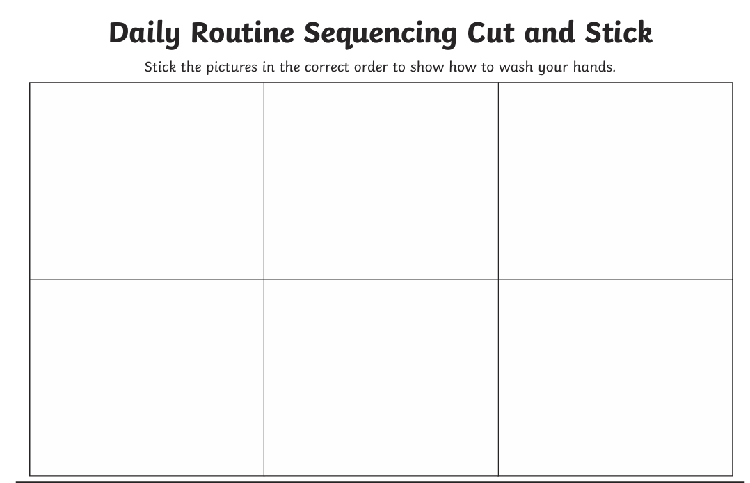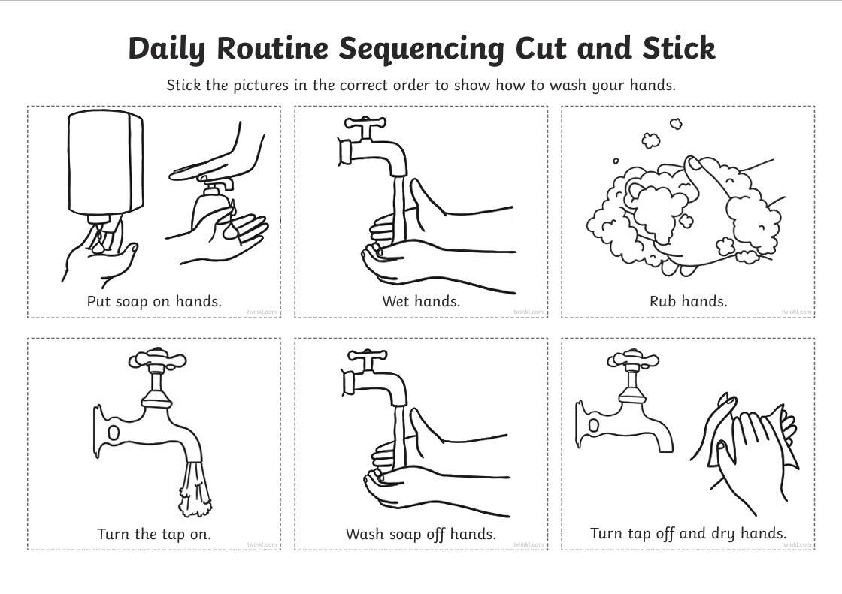

Appendix B Week 5 Germs planning

Lesson Plan

Topic: Germs and continuation from hand washing |  | Class:  Pathway two
Date: 8th October 2025 | Length of lesson: 1 hour and 10 minutes |  | Number of students: Eight  All learners have learning difficulties and disabilities
Resources required: White board, white board pens, pencils, coloured pencils, worksheets stickers.
Aim of Lesson
- Help students understand what germs are, including that germs are tiny living things that can cause illness.
- Explain how germs can spread from person to person or via surfaces in everyday environments.
- Highlight key moments when hand washing is needed to prevent germ transmission.
- Encourage students to observe and think about ways germs spread, using the sticker demonstration activity.
- Develop students’ ability to recognise and name hygiene-related vocabulary through the wordsearch task.
- Promote awareness of personal responsibility for hygiene and health to reduce the spread of germs.
- Engage students in hands-on learning and active participation to reinforce the importance of germs and hand washing.

Learning Outcomes – The Learners Should Be Able To:
- Identify what germs are.
- Recognise situations when hand washing is important.
- Understand and visually demonstrate how germs can spread.
- Complete a simple wordsearch using key vocabulary.

Previous student knowledge required for the session:
- Awareness that regular handwashing is a common health recommendation, even if not all learners practice it thoroughly.
- Familiarity with general personal hygiene activities, such as washing hands after using the toilet or before eating.
Basic vocabulary related to hygiene (soap, water, clean, wash)
- Experience with simple classroom discussions or activities about health and germs

Anticipated difficulties (if applicable):
- Hearing impaired student, extra visual resources to aid in understanding.
- Difficulty in reading some of the words, Support staff to assist with reading.

Professional Standards (where are these being met within the session)

- Value and Promote Diversity, Equality, and Inclusion
The lesson embraced diversity by using differentiated materials and teaching strategies for students with a wide range of needs.
- Commitment to Learners, Learning, Safety, and Well-being
Support staff assist learners with reading, and visual accommodations made for a hearing-impaired student, ensuring every learner is fully supported in a safe and inclusive environment.
- Plan and Deliver Effective Learning, Teaching, and Assessment
The lesson is clearly structured with defined aims, varied activities, and assessment methods (worksheets, observations, Q&A), showing effective planning and delivery.

Lesson Detail:

Stage | Focus | Strategy | Time
Introduction  Recap previous lesson.  Development  Worksheet when we should wash our hands.  Discussion  Discussion  Sticker demonstration  (Worksheet  Wordsearch  If there is enough time)  Plenary/conclusion | Recap hand washing lesson.  Identify when to wash hands.  What are germs?  How do germs spread?  Demonstrate the spread.  How can we prevent the spread of germs.  Germs wordsearch for students to understand and learn some of the key vocabulary.  Recap and Q&A | Remind students of hand washing session and ask why it is important to wash our hands.  Ask students to identify when to was hands and get them to draw in each of the bubbles on worksheet.  Begin with a simple question: "What do you think germs are?" Use pictures to introduce germs as tiny organisms that can make us sick. Link to everyday experiences of illness.  Ask how germs spread can the students give examples: coughing, sneezing not washing hands…  Before the start of session big green stickers to be placed around classroom to show spread. Students spot where I spread my germs around the classroom and did, they touch them.  Students give ideas on how to prevent spread of germs.  Give out a simple word search sheet with hygiene-related words. Support students with word list if needed.  Review learning by asking students to share something new they learned about germs and hand washing. | 5 Minutes  10 Minutes  10 minutes  10 minutes  5 Minutes  10 Minutes  10 Minutes  10 Minutes

Assessment Strategies: when and how are they included within the lesson?
- Observe participation and discussion answers.
- Review drawings on worksheet for accuracy.
- Check wordsearch completion.
- Question students during the demo and plenary

Informal reflection (to be completed after the session)

The lesson was successful, with all students engaging and participating fully throughout the session.

On reflection, I recognise that I included too many lesson aims and will focus on streamlining objectives in future sessions to concentrate on one or two key learning outcomes.

The use of visual aids, particularly the visual spots, proved highly effective in demonstrating how germs can spread and supported learners’ understanding of the topic.

Actions for Next Session:
- Refine and reduce the number of lesson aims to strengthen focus on core learning objectives.
- Continue to integrate visual resources to enhance comprehension and engagement.

Appendix B1 Worksheet used in Appendix B planning
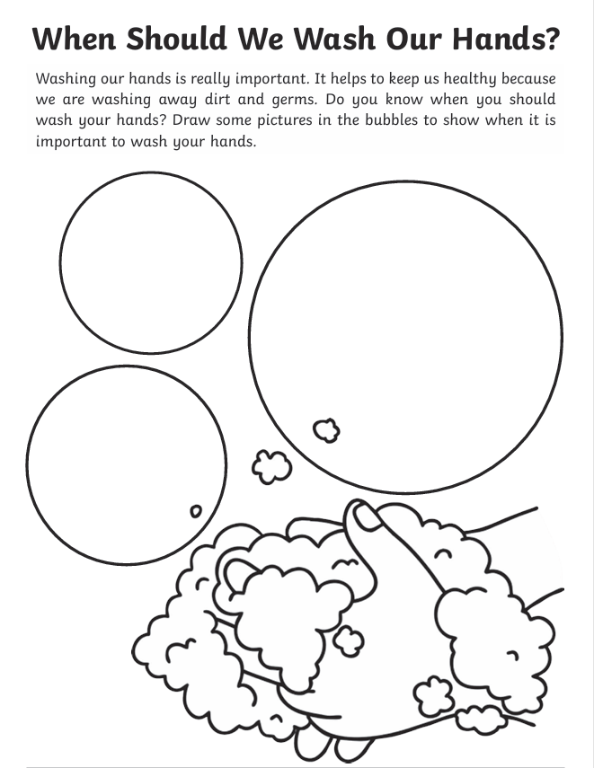

Appendix B2 Wordsearch used in Appendix B planning
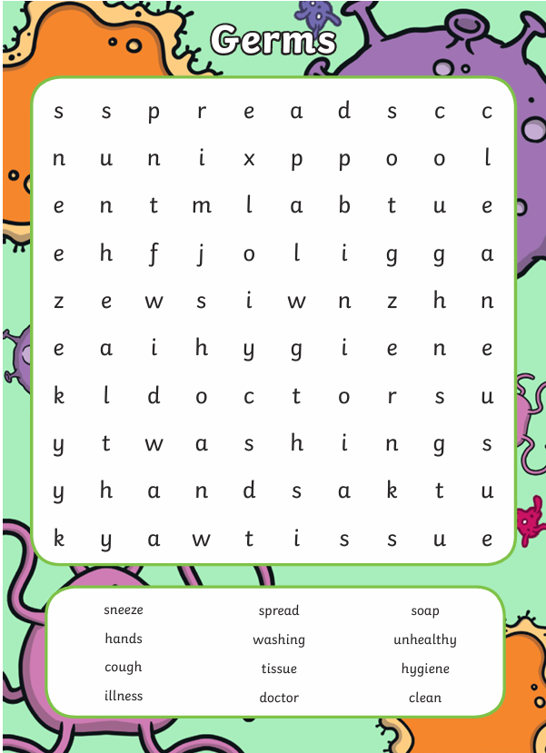

Appendix C Week 6, An example of summative assessment.
Good Hygiene Quiz
- Can you name three different times when should you wash your hands?
1……………………………………………………………………………………………………………..
2……………………………………………………………………………………………………………..
3……………………………………………………………………………………………………………..
- What 2 things should you use to wash your hands?
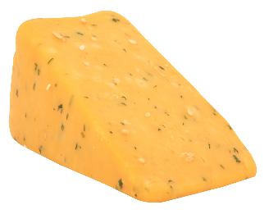

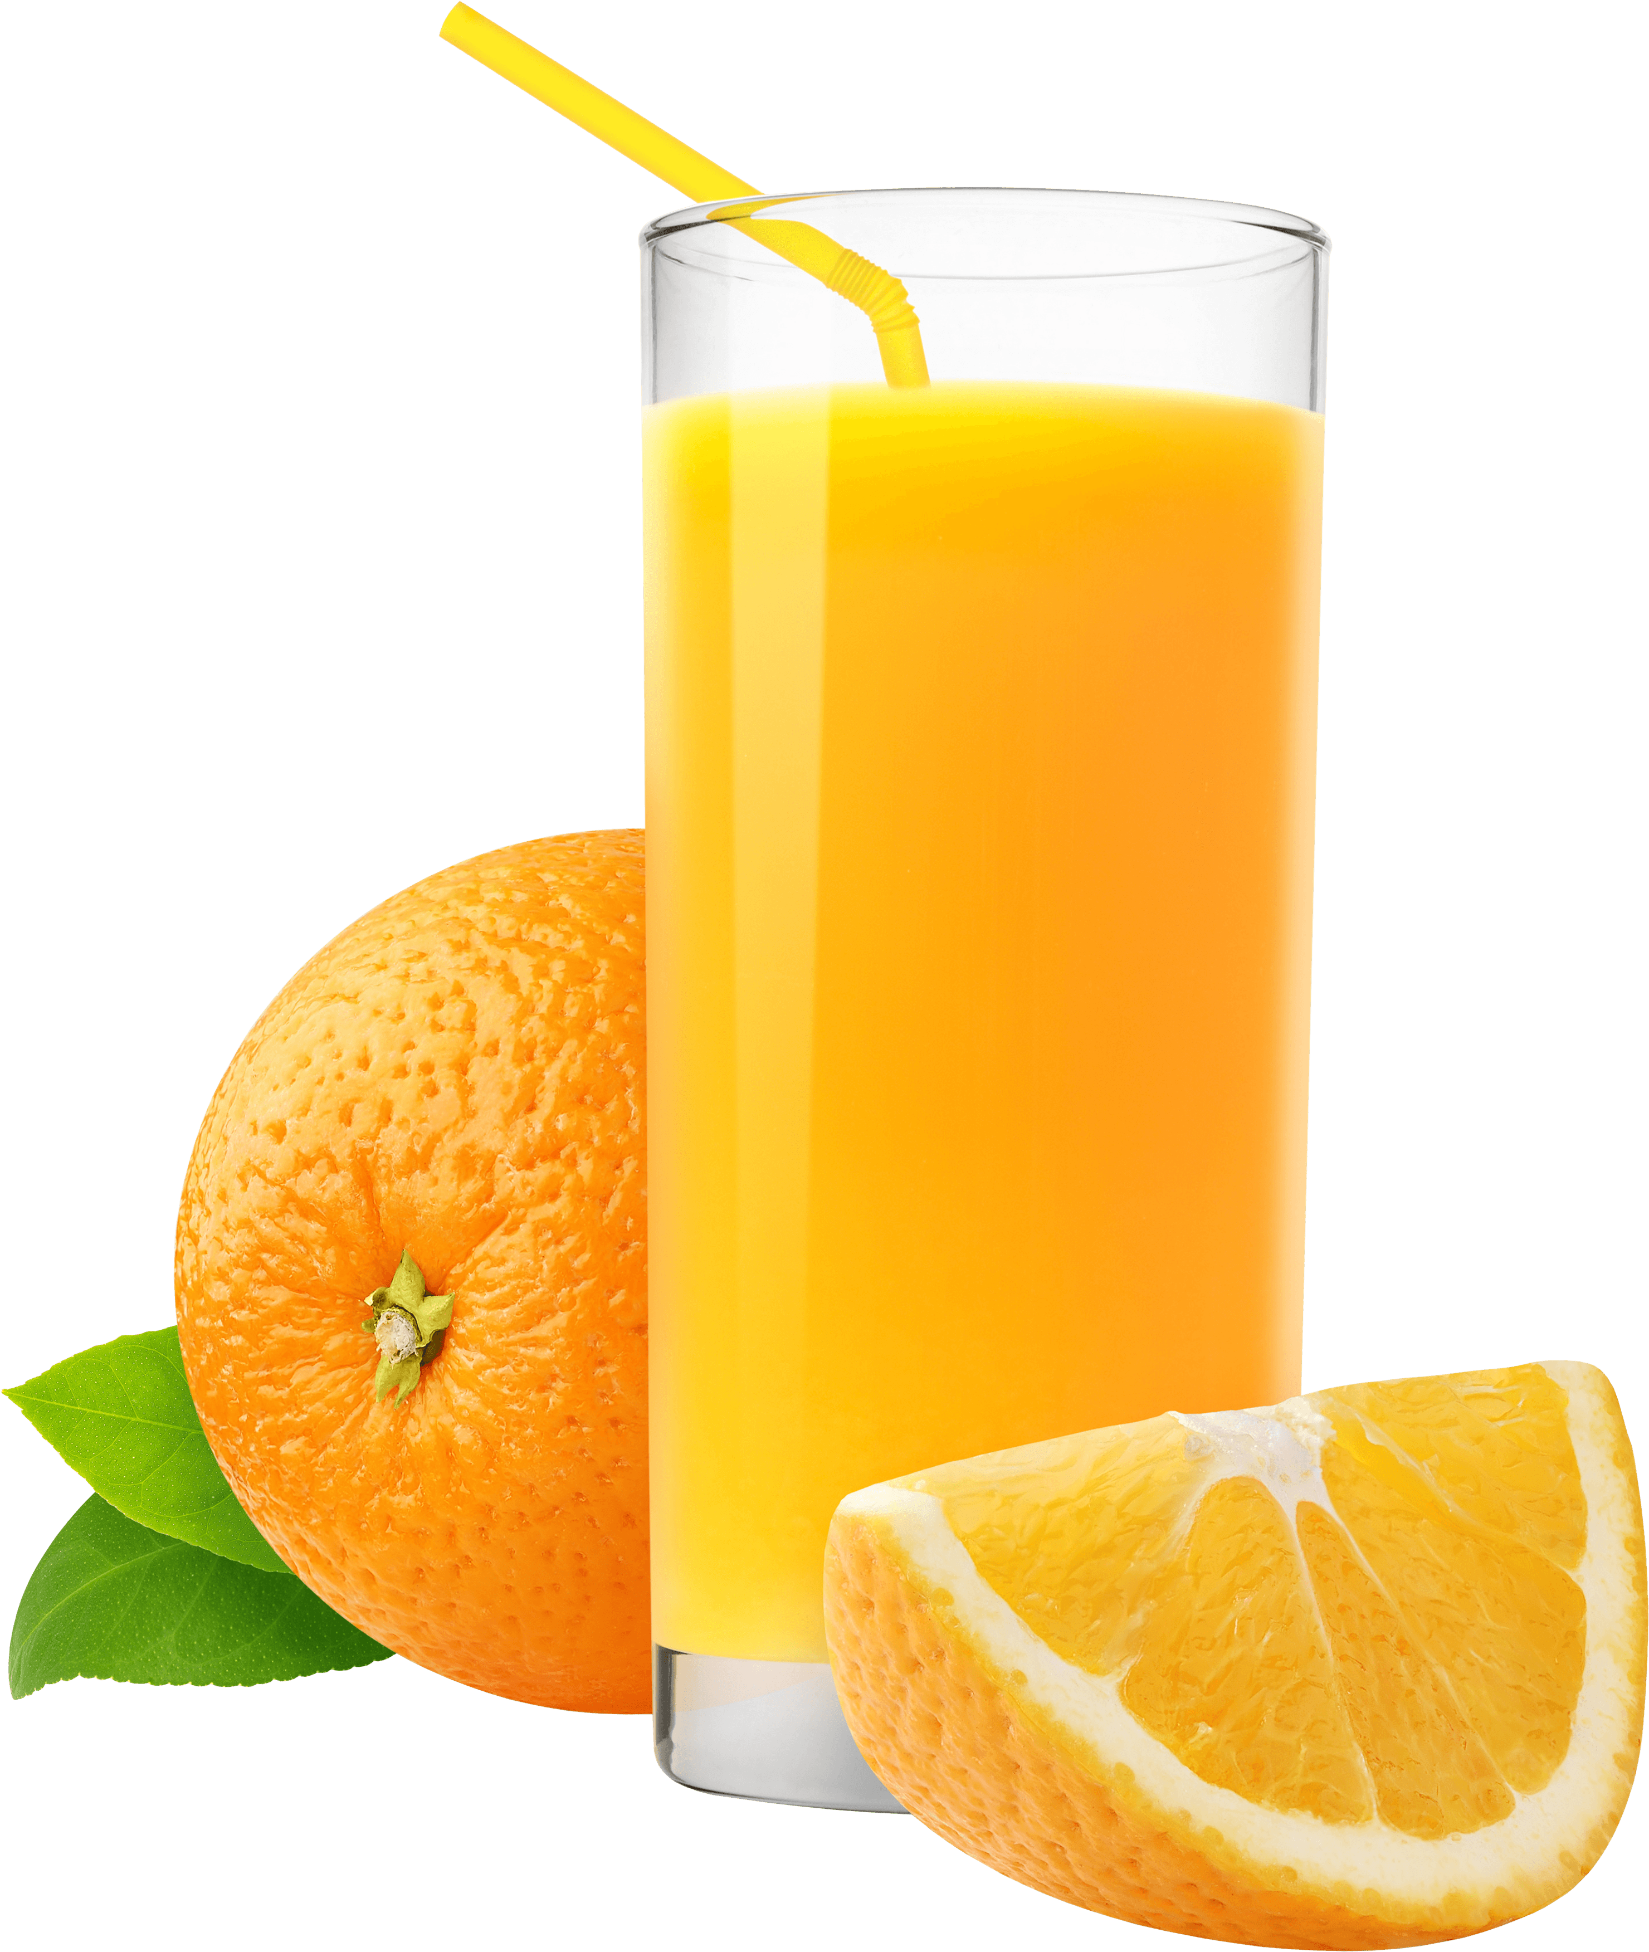
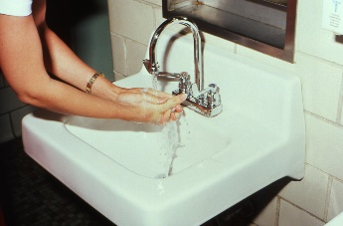
This Photo by Unknown Author is licensed under CC BY-NC
This Photo by Unknown Author is licensed under CC BY-NC

- Put these in order…
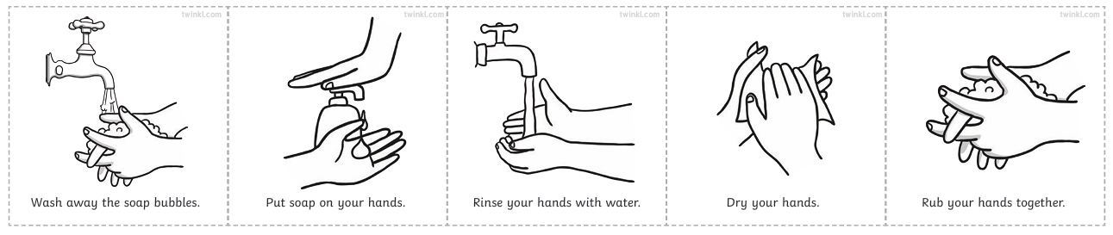
_____ _____ _____ _____ _____

- When cooking what do we put on to keep our clothes clean?
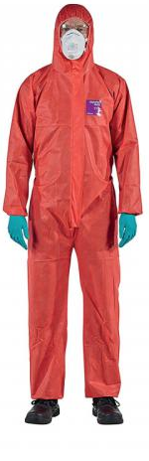
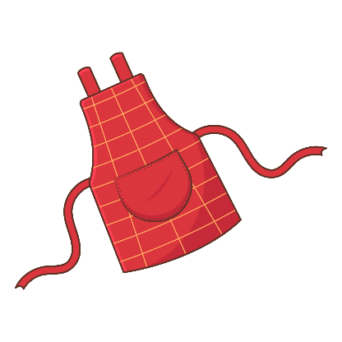



- What can we pass on if we don’t wash our hands?
G __ __ __ __
- Why do we wash the tables before we do cooking?

………………………………………………………………………………………………..
- What do we put on our hands when cooking?
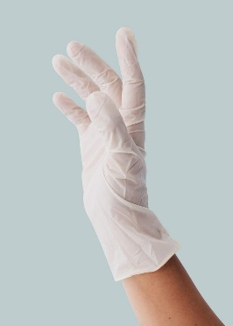
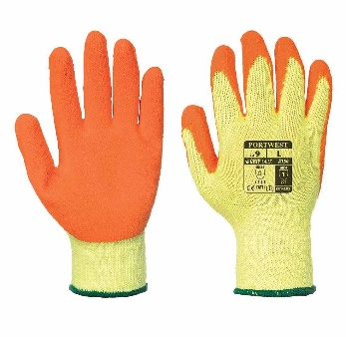
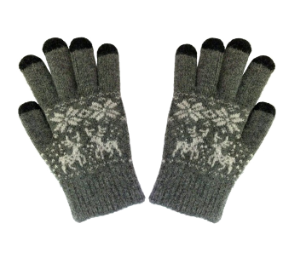

- Which do we use to chop vegetables?
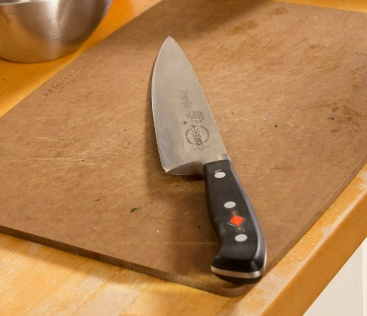
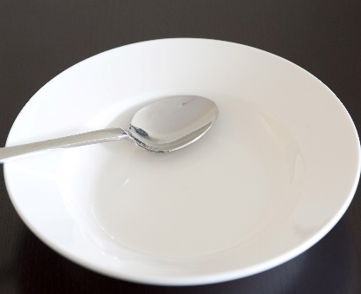

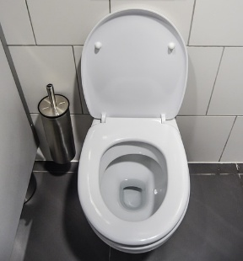
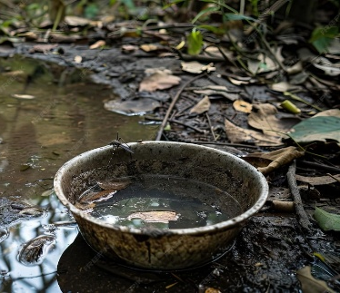
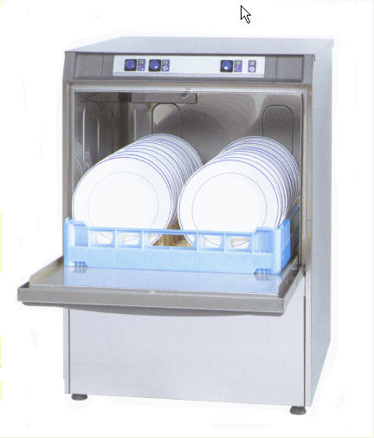

- What do we do with our dirty dishes?

