Task 1 - Report

“Effective Teamworking for team success”

Author: Corina Radu
Student ID: 2117956
Title: Effective Teamworking for team success
Module: Effective Team Working and Communication (BMSV4002)
Lecturer: Joanne Davies

Abstract

This report focuses on finding and suggesting the best approach for developing an effective team for the manager Steve Brookes. Team working as a concept and complementing it with established theories and models such as the Tuckman’s FSNP Model to be considered for implementation by Steve Brookes for team working needs. This report also discusses the team roles required and would also be needed at Pelsall Hall Care Home for creating a cohesive team using Belbin’s Team Roles. Finally, it concludes by evaluating the advantages of effective team working, the attributes of a successful team, the barriers to effective team working, particularly at Pelsall Hall Care Home and the impacts of the same with reference to Coyle's Code and Team Composition.

Table of Contents

Abstract 2
Introduction 4
Overview of Team Working 4
Models of team development 5
Team Roles 7
Discussion 10
Conclusion and recommendations 11
Reference List 12

Introduction

The main goal of this report is to research effective teamwork and help Steve Brookes. He happens to be a recently employed manager in developing an effective team-working for overseeing the daily operations of a care home named Pelsall Hall Care Home. There happens to be a considerable lack of proper team-working structure and environment which has had a detrimental influence on the overall quality of care provided at Pelsall Hall Care Home; thus, the findings of this report would be of immense importance to them. This report would begin the discussion by giving an overview of the team working as a concept and complementing it with established theories and models such as the Tuckman's Model (1965), which Pelsall Hall Care Home can consider for their team working needs. It would be followed by discussions on the essential team roles and would also be needed at Pelsall Hall Care Home to create a cohesive team using Belbin's Team Roles. The report would eventually conclude with discussions on the advantages of effective team working, the attributes of a successful team, the barriers to effective team working, particularly at Pelsall Hall Care Home and the impacts of the same regarding Coyle's Code and Team Composition.

Overview of Team Working

A team can simply be a group of people working together in harmony to achieve a unified goal and objective for their organisation. There happen to be several factors and attributes which contribute to the development and operation of a team efficiently. Some key characteristics include clear goals and plans, firm and fair leadership, transparent and open communication and presence of support and understanding of each team member's roles and responsibilities and a high motivation level (Cook, 2009). A team can also be defined as a group of people working together to accomplish a common objective (Geraghty, 2018). Usually, the members share a set of goals, resources, and responsibilities. A group be an unplanned social gathering with the sole purpose of socialising (Martin and Rogers, 2004). A visual illustration of the same has been attached below:

Figure 1. Difference Between Team and Group
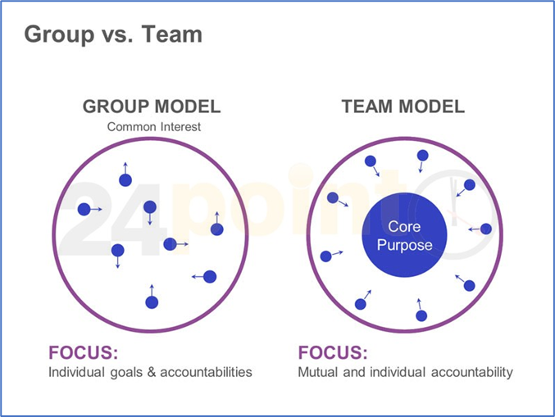
(Reiter-Palmon, 2017)

According to Ghaye (2005) in his book ‘Developing the reflective healthcare team’, teamwork and learning via reflection are both essential components of high-quality healthcare. This is the first book to investigate the application of reflection methods in developing health care teams capable of providing long-term, high-quality, individualised care. The course Developing the Reflective Healthcare Team is divided into three sections: fresh perspectives on reflective practice, strengthening teamwork, and using the TA2LK facilitative reflective process to produce high-performing teams.

Models of team development

Tuckman's Model
After analysing the team working environment at Pelsall Hall Care Home and their individual needs, the Tuckman’s Model would be preferred as it is one of the most widely used and adopted team development models, which also happens to be quite intuitive and straightforward to understand and implement. The key reasons for this preference have been explained and discussed below:
In Tuckman's Model, there are five stages that are part of this theory. The five stages implicated in this model are forming, storming, norming, performing, and adjourning. This theory proposes that most groups go through these stages although not all of them do this smoothly and some groups may get stuck in one stage (Griffith, 2014).

Figure 2. The five stages of Tuckman's Model

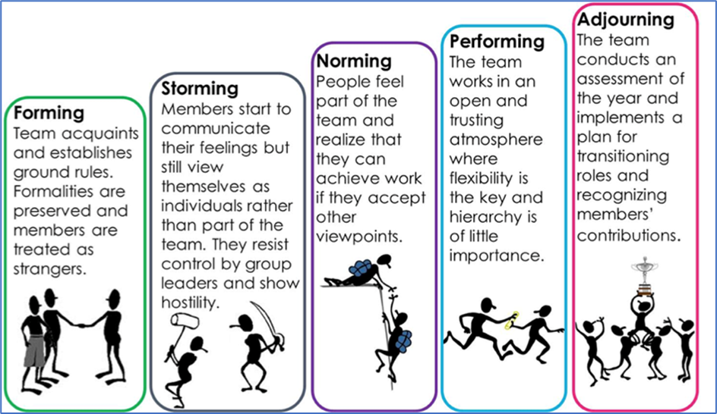
(NS4B, 2019)

Jones (2019) found that there is a tendency for groups to have certain personality types and this tendency also depends on the characteristics of the group's members. He compared these stages to a human growing into a grown person and how they are like the characteristics of humans’ development. First found that the most common type of group is characterized by high performance and low cohesion.
The groups with high cohesiveness were manageable but had low performance. The groups with low cohesiveness are not manageable and have low performances. The FSNP also categorizes the behaviours of an individual into four separate personality types as well. This demonstrates that each group has its own personality, which Tuckman states should be just like people's personalities (Rickards and Moger, 2020). He believes that everyone has a different personality, so each group of people will be different from the other based on their personalities. The way a group is structured and how the members interact with one another would also change its personality.
Gersick (1988) discovered that teams completed three stages of development: stable phase, instability phase and stability phase. According to Gersick (1988) the Stable Phase, established at the end of the first meeting, is the initial phase of group development. Establishing the group's culture, direction, and tone is crucial during the initial meeting. Next, the group passes through a time of instability and transition before entering phase two, known as the Instability Phase. The third phase, known as the Stability Phase, is when groups fully transform into a functioning team with precise objectives and a commitment to achieving them.
It would be recommended that Steve use the Tuckman model for effective teamwork as it is more directed towards people.

Team Roles

Identifying the Roles Using Belbin’s Team Roles Theory.
When it comes to creating or developing an efficient team, one of the most crucial components happens to be the presence of a role-based structure which needs to be implemented and used during the formation of the team and maintained all along whilst working as a team. According to Cook (2009), it was found that some of the critical roles required in an efficient team include content generator, procedure roles responsible for maintaining the structure and processes and lastly, the individuals responsible for maintaining the team working environment. A visual illustration of the same has been attached below:

Figure 3: Content, procedure, team working
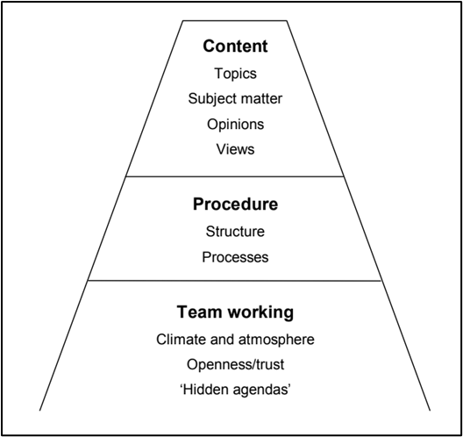
(Cook, 2009)

These roles have been further explained and justified in the theory formulated by Belbin, consisting of nine key roles required in an efficient and successful team. According to the opinions of Bednar (2020), this theory goes back to the 1940s when Belbin developed his team roles theory. This theory is mainly used in management and organisations to improve performance. It is used to analyse the performance of a team or organisation and offer insights into how to improve its effectiveness. The theory identifies nine specific roles and then explains how these different types work together to get the best results possible. According to this theory, there are nine different types of team members, each of which plays an essential part in the success of a company or organisation (Lynch and Clemens, 2019). Each of these roles makes up a team, and each one is needed to get the desired results. The key roles as highlighted by Belbin have been listed below:

Figure 4: Belbin's Team Roles Circle
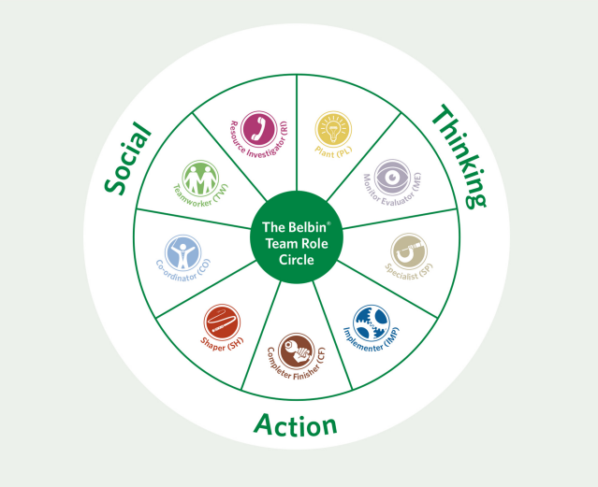
(Belbin, 2016)

Explaining the Roles and their Importance
Moving forward it would be crucial to explain the nine roles formulated by Belbin in his theory so that the new manager Steve Brookes can better understand them for improving the team working environment at Pelsall Hall Care Home.
The use of a rules-based approach in a team is of great importance since team members must have clear boundaries and responsibilities to succeed. For example, you may assign one person to be a project manager or add this role as a rotating responsibility. There is no set designation for who fills the role of team leader. Usually, the team members take turns in this position, and it rotates from meeting to meeting.
It is important to note that one person may have two or more of the characteristics of each role, and nine people are not always needed to fill all positions (Bednar, 2020).

Discussion

Discussing the advantages of having an Effective Team.
The effects of having an effective team are beneficial for the project and organisations.
Figure 5. Efficient Teamworking Environment
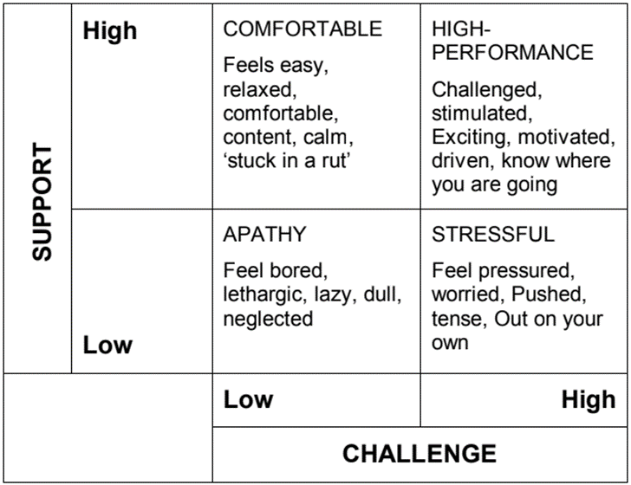
(Cook, 2009)
The information expressed in the figure above shows that when it comes to effective team working, one of the key environments happens to be the climate or environment developed and offered by the leaders to the team members. For example, in an environment where the challenge level of the tasks to be done by the team members is high and the support is low, it creates a stressful environment which degrades teamworking; however, if a high challenge level is supported by high levels of support from the leaders and other members of the team, it results in a very high-performance team working environment with high motivation and productivity levels (Geraghty, 2018). Similarly, low support and low challenge environments result in an apathetic environment, and high support and low challenge create a comfortable environment for teamwork and growth, which can be helpful during times of high challenge (Cook, 2009).
According to Bednar and Ljudvigova (2020) leadership at start-ups has distinct characteristics related to significant unpredictability, pushing existing boundaries, remarkable flexibility, and endurance of the leader. The report's principal purpose is to determine the role of a leader in a successful beginning.

It is crucial for this report to discuss the key barriers that act as obstacles to effective teamwork and the possible cause of inefficiencies at Pelsall Hall Home Care. According to Etherington, C. et al. (2021), teams are a great way to achieve success. However, some barriers can hinder the teams from being effective, and one of these is the lack of trust between team members. There have been many studies on how trust plays a significant role in understanding why good teams cannot be formed easily and, therefore, is not as successful as they could be (Griffith, 2014). This idea is mentioned when they say trust is essential to effective teamwork.
Coyle (2018) highlights the characteristics of effective teams and discusses how this happens in his book The Culture Code. A strong sense of safety and purpose are essential for building outstanding teams. Having a facilitator, someone with the ability to counteract negativity and foster creativity, also greatly aids in this process.
Three significant obstacles can influence the trust between team members: perception of equality, fear of project failure and ostracization. The result shows that barriers somehow affect the team members as they are internal factors and, as such, cannot be changed easily or without much effort (Cook, 2009). Another result was that those obstacles could be passed by providing training on building trust between team members based on the relationships between these three factors. These challenges are very similar to those faced by individuals when interacting with others.

Conclusion and recommendations

After performing comprehensive research and analysis on the concept of team working from both practical and theoretical perspectives, evaluating a variety of established theories and models, it can be concluded that team working is indeed a critical component of productivity and efficiency, without which teams would not be able to function to their full potential.
Based on the discoveries of this study, it is recommended that the manager Steve Brookes at Pelsall Halls Home Care investigate using Tuckman's technique for establishing teams in an organised and structured method and integrating it with the roles approach as outlined in Belbin's Team roles. They must identify everyone's skill set in a team and give them a role following Belbin's theory's nine key sets of functions.

Reference List

Bednár, R. and Ljudvigová, I. (2020) ‘Belbin team roles in a start-up team’, SHS Web of Conferences, Vol. 83, p. 01002, EDP Sciences.
Belbin, R.M. (2016) Team role circle, Available: https://www.belbin.com/media/2302/belbin-team-role-circle.pdf (Accessed: 1 July 2022).
Cook, S. (2009) ‘Building a High-Performance Team: Proven techniques for effective team working. IT Governance Ltd.
Coyle, D. (2018) The Culture Code, London: Random House Business.
Etherington, N. et al. (2021) ‘Barriers and enablers to effective interprofessional teamwork in the operating room: A qualitative study using the Theoretical Domains Framework’, PloS one, 16(4), pp. e0249576–e0249576.
Geraghty, A. and Paterson-Brown, S. (2018) ‘Leadership and working in teams’, Surgery (Oxford), 36(9), pp. 503–508.
Gersick, C.J.G. (1988) ‘Time and Transition in Work Teams: Toward a New Model of Group Development’, Academy of Management journal, 31(1), pp. 9–41.
Ghaye, T. (2005) Developing the reflective healthcare team. Oxford: Blackwell.
Griffith, B.A. and Dunham, E.B. (2014) Working in Teams: Moving from High Potential to High Performance, Working in Teams: Moving from High Potential to High Performance. Thousand Oaks: SAGE Publications, Incorporated.
Jones, A. (2019) The Tuckman’s Model Implementation, Effect, and Analysis & the New Development of Jones LSI Model on a Small Group. Journal of Management, 6(4).
Lynch, D.S., Lynch, M.J. and Clemens, C.M. (2019) Belbin team roles. In The handbook of communication training: a best practices framework for assessing and developing competence. Routledge.
Martin, V. and Rogers, A., (2004) Leading interprofessional teams in health and social care. Routledge.
NS4B (2019) ‘Tuckman's Stages of Group Development. Available at: https://ns4business.com.br/tuckmans-stages-of-group-development/ (Accessed: 28 June 2022).
Reiter-Palmon, R., Sinha, T., Gevers, J., Odobez, J.M. and Volpe, G. (2017) ‘Theories and models of teams and groups’, Small Group Research, 48(5), pp.544-567.
Rickards, T. and Moger, S. (2020) ‘Creative leadership processes in project team development: an alternative to Tuckman's stage model’, British journal of Management, 11(4), pp.273-283.
Tuckman, B. W. (1965) ‘Developmental sequence in small groups’, Psychological Bulletin, 63(6), pp. 384–399.

