ECAD6009/7003 2306058
How a school develops one aspect of its SDP: a report that critically reflects on the actions, impact and evidence base.
Introduction
The purpose of this essay is to critically evaluate the effectiveness of an aspect of an Unnamed Secondary school’s School Development Plan (henceforth SDP). The author has opted to analyse Field 1 of the development plan, specifically Section 2 of Field 1, raising Literacy Standards. The school aims to achieve this by creating tasks that allow all students to increase their skills, they aim to track this through refining their use of data obtained from National Tests and Literacy Interventions (where required). The school also collects evidence from marking pupil’s work and books. The author has opted to analyse this aspect of the SDP due to the author being a current PGCE English Secondary student. The school was chosen due to the author having completed their first placement at the unnamed school. Following this brief introduction the author will discuss the school context, then they will provide a review of the current literature surrounding literacy and SDPs, before moving on to a brief outline of the school’s action plan, followed by a section of reflection and recommendation, and finally a conclusion will be made.

School Context
The Unnamed Welsh Language School is located in South East Wales. It is a 3-19 School, with roughly 700 pupils. According to Estyn the majority (59%) of the pupils come from non-Welsh Speaking backgrounds. (p.1). Roughly 7% of pupils are entitled to Free School Meals compared to the national average of 18.4% as stated by the Sutton Trust. The average Literacy Score at School X is 44.4 and the average Numeracy Score is 41 compared to the national averages of 39.7 and 37.1 respectively. School X is a pioneer school and works closely with Welsh Assembly Government to implement the Curriculum for Wales (henceforth CfW or CiG).
Literature Review
Welsh Assembly Government defines an SDP as a ‘school’s plan for improvement’ Following the Education (School Development Plans) (Wales Regulation) 2014, a statutory duty was placed on a school’s governing body to create an SDP (Regulation 3). Regulation 4 outlines the fields that an SDP must be centred around, and Regulation 6 imposes a duty to monitor, review and revise an SDP on the governing body. The Regulation also provides guidance on how a school may wish to begin with drafting their SDP. Please see appendix A for a graph demonstrating this.
Blanchard (2009, p.197) posits a simple series of questions to answer when looking at school improvement:
- What strategies are being used?
- What are the benefits?
- What is the evidence?
We will turn in due course at attempting to answer these questions in the following chapters Dissection and Reflection. Our developmental point, as discussed is concerned with improving literacy. The first mention of such a school / curriculum wide language improvement policy can be seen in the Bullock Report (1975), which first made use of the phrase ‘language policy across the curriculum’ (Inglis and Aers, 2008, p.128). This refers to the need for literacy across all subjects, and not just English (and Welsh) lessons. This lack of mention of Welsh and other native Celtic languages in the majority of Anglo-Centric literature, shows just how far Welsh still has to go to be viewed as a language of education within the confines of some academic literature.
Crawford (2003) views school development as a localised effort, trusting that those with their boots on the ground know what is best for their school. They caveat this with the idea that this does not mean that schools have total autonomy, they must still consider national policy. This they dub the external forces of school improvement, which Crawford argues are imposed from ‘outside’ of the school/education ecosystem.
We can see that school X in its development follows this argument. Tailoring and crafting literacy policy, which also considers National Aims. Please see appendix B for Crawford’s school development organiser.
When considering school improvement, we often encounter the theory of Vygotsky. Appearing in texts from Lewis (2000), Gibbons (2002) and Bridges (2009). The main reason for this is because learners are viewed as progressing through a variety of stages, with the assistance of a More Knowledgeable Other (MKO). They begin as a spectator and move from novice learner, to experienced learner and finally to expert/teacher. According to Mercer there are 3 classroom concepts, which work under the Vygotskian theory of a more knowledgeable other, they are as follows Scaffolding, Appropriation, and utilisation of the Zone of Proximal Development.
Bruner (1978) helped to propagate this now nigh-on universally accepted practice. Bruner (p.19) defined Scaffolding as ‘the steps taken to reduce the degrees of freedom in carrying out some tasks so that the child can concentrate on the difficult skill she is in the process of acquiring’. One, can see where this fits in with school X and its SDP, through their use of the aforementioned book-monitoring.
Appropriation is viewed as culturally based quality of learning and was termed such by Vygotsky’s Colleague Leont’ev (1984). Although Mercer argues for the adoption of these three Neo-Vygotskian techniques, they confess that only scaffolding has been ‘formulated’ for classroom research. The author agrees with this statement, and like much like of educational academia, we encounter theoretical underpinnings but no practical applications.
Lewis and Wray (2000) explain the Vygotskian method of proximal development as ‘pupils first experience a particular cognitive activity in collaboration with expert practitioners.’ The Zone of Proximal Development, then refers to what a pupil cant learn without assistance or guidance, but they can achieve with the help of a More Knowledgeable Other. It is this balance of ensuring that tasks are not too simplistic and not too challenging for pupils to complete, in order to allow them to meet this proximal development.
Although the role of teacher has changed in recent years, moving from the traditional role of the teacher imparting their knowledge to a more faciliatory role, this model is still applicable to teachers.
We now turn our focus to the literature surrounding literacy. Hall (1994, p.15) discusses how the notion of literacy in recent years has had a ‘redefining’, despite the fact this source is 30 years old, this corresponds with the ideas within School X’s approach to literacy. With literacy being a central aspect of all lessons, not just within the confines of English and Welsh Lessons.
Paulson (p.58) suggests that there is ‘no universally agreed way of defining literacy’. The Oxford Concise Dictionary (p.692) defines literacy as ‘the ability to read and write’. Although, this is accurate in a literal sense, it does not go far enough in describing the poignancy of literacy. Barton & Wooley (p.2) state that ‘literacy is a dynamic phenomenon that impacts on people’s everyday lives’. We will now turn our focus to defining and dissecting the exact contents of the school’s developmental plan.
Dissection of the Development Point.
As previously stated, the author has opted to focus on Field 1, Section 2 of the SDP, improving literacy. As such we will now turn our attention to the various elements and procedures put forward by School X for Improving Literacy.
The school aims to improve literacy with a range of strategies, they are as follows:
- Crafting lessons and tasks which improve literacy.
- Increase data collection and monitoring.
- Implementation of literacy tasks once a week in registration, which focus on the 4 literacy skills, reading, writing, listening and speaking.
- Utilising voice 21.
- Advertising what book said teacher is reading on each teachers’ door.
- Creation of a website by the literacy lead, with literacy ideas for staff.
- Staff can also update this website with their own ideas.
We shall now turn our focus to addressing these points and their effectiveness, alongside offering some practical suggestions for improvement.
Reflection and Recommendations.
Zwozdiak-Myers believes that ‘reflective practice…is in the foreground of attempts to raise education standards and maximise the learning potential of all students’ (Andrew Green, 2011, p.26). This they argue is best achieved through a concentrated and overt analysis of evidence. Indeed, reflection is a central part of Kolb’s (1984) Experiential Learning model (appendix C). It is to this evidence-based reflection which we now turn. Unfortunately, School X did not have any concrete data at hand regarding their literacy improvement. However, we can critique the steps taken under the SDP and offer suggestions for further improvement for the school.
It is important to note that although the school has listed improving literacy within their plan, they do not have any direct written formulated policy for improvement.
Indeed, according to Harris (2002) in order for school improvement to take hold ‘there must be the will undertake change, the skill to make it happen and the persistence to see it through’ (p.112).
From this we can see that although the school does have honest intentions to improve learner performance, they have not committed sufficient resources and are not offering clear guidance to all staff. As such, our first suggestion for improvement would be to bring together heads of department and create a document which provides guidance across the whole school. However, we do not want to get ahead of ourselves and first need to decide WHAT goes into our Literacy Development scheme.
Our preliminary stage would involve utilising a whole pupils survey to ascertain what the pupils would like to see included within this literary strategy. The school has used these surveys to great effect previously in deciding various school matters. As we have already discussed, the school has dedicated literacy sessions for all Year Groups which take place during morning registration, they also implement numeracy sessions. The author was placed with a Year 7 group for these sessions, and much of the content did not seem to have an impact on the pupils. If we are to inspire greater command and reverence of literacy-based skills, we need to engage with pupils at this base level. This argument finds support under the Literacy What Matters Statements, namely Literature Fires Imagination and Inspires Creativity.
However, that is not to say that pupils did not use their literacy skills during the execution of these tasks, on the contrary they often wrote about, discussed, and debated the topic at hand with varying levels of enthusiasm and skill. It is however, worth noting that the observed registration teacher was an experienced and enthusiastic teacher, who managed to inspire the pupils to engage with the task at hand, subsequently, the effectiveness of these tasks will differ from class to class. Regarding record collection, all classes do engage with these tasks, as the progress of the pupils is monitored and done so on a weekly basis by the Literature Lead. As stated previously, no concrete data was provided for this essay and as such we cannot effectively answer one of Blanchard’s (2009) key questions for analysing the effectiveness of the SDP.
The central argument of this pupil survey (which have been used before at School X in helping to decide school policy i.e. uniform and bullying policy) is to allow for greater pupil involvement in crafting these tasks, allowing for a more appealing and bespoke offering to pupils. This autonomy certainly complies with the CiG what matters statement of creating enterprising, creative contributors who are ready to play a full part in life and work. Currently, this responsibility rests solely on the Literacy Lead, which may explain some of the slightly less inspiring tasks that the author witnessed, this is not to critique the Literacy Lead, but as this is an additional responsibility for a teacher with a full-time table, it is clear to see that workload can often get in the way of these duties.
Another complex facet of the Literacy Improvement strategy is the fact that all of the witnessed tasks, were done through the medium of Welsh. There was no focus at all on English Literacy skills, evidently School X being a Welsh Language Comprehensive, with a majority from Non-Welsh Speaking Homes, the school needs to improve the pupils’ Welsh Literacy Skills, but each of the pupils lessons with the exception of English are conducted entirely through Welsh, as such there is a plethora of exposure to well modelled Welsh Literacy Skills and only 3-4 hours a week on improving their English Literacy Skills.
Much of the below argument was inspired by Literacy Saves Lives (1996) and the ideas contained therein. The author noted during their placement that pupils were not encouraged to write about their lives. The primary reasoning behind this was a conscious effort to avoid comparisons between pupils and more importantly to avoid the reliving of past or present trauma. Despite the merits of this being evident, we should cautiously encourage such literate exploration of self. From a practical point of view, it may lead to safeguarding concerns, which can then be dealt with within the confines of the usual channels. From a more esoteric perspective, literature often mask some autobiographical truths and has their roots in this exploration of self. It may also serve to create greater teacher-student and student-student bonds. Moreover, if we truly wish to champion diversity then we should encourage pupils to explore themselves and their world. We can find support for this statement in the ever-relevant what matters statement, ‘literacy helps us to understand the world around us’, not allowing a thorough exploration of self arguably does not confirm with this lofty ambition.
Another recommendation for improving literacy, is to implement 5-10 minutes of each lesson dedicated to reading. Each pupil could either bring or be provided with a book, teachers could then implement a few minutes of each lesson to quiet, independent reading. This would serve to conform to the what matters statements and the embedded ideas within the CfW. Reading programs such as this do exist and can cost money (please see Accelerated Reading Program), however there is nothing to stop a school from simply implementing 5-10 minutes of each lesson dedicated to their own type of program.
Another facet of education that has developed in recent years is the concept of gamification, teachers might opt to utilise quizzes, digital or analogue, and these again can be done for little to no cost. School X could also choose to implement points on class charts for pupils who do well in these tests, rather than just providing points for effective use of literacy. School X could also capitalise on the spirit of competition that is already inherent due to the Eisteddfod and opt to create an English Literacy competition. The roots for such a competition already exist and the Eisteddfod Ysgol proves to be very popular at School X, therefore they could easily build on this to implement a dedicated English Language Competition. A possible name for this could be the “ ‘Stadleuaeth Saesneg”, a corruption of the word Cystadleuaeth meaning competition and Saesneg meaning English.

Conclusion
The purpose of this essay was to critically analyse an unnamed school’s school development plan. We have discussed the literature surrounding both SDPs and Literacy and have discussed the details of School X’s SDP. Unfortunately, despite requests for evidence of the scheme and its effectiveness, none was available. However, we have discussed the minutia of the plan and have provided some suggestions for improvement. To reiterate our recommendations, we would first utilise a pupil wide survey, then move to creating a written literacy plan, which could be continuously used and improved upon, we would utilise more English language literacy skills within registration lessons, we would also implement a reading plan, and attempt greater gamification and establish the Stadleuaeth Saesneg. These measures would not cost much other than time investment. We can conclude that although school X has attempted to improve literacy, the plan does not go far enough and with the assistance of our suggestions, more can be done.
Word Count:2625

Appendix A
Vision

Taken from School Development Plans Guidance Document 2014. P7
Welsh Assembly Government.
://efaidnbmnnnibpcajpcglclefindmkaj/https://www.gov.wales/sites/default/files/publications/2018-03/school-development-plans.pdf.

Stage 4:
Reviewing Impact
Stage 3:
Making improvement/action
Raising standards and improving learner outcomes
Stage 2:
Strategic Planning
Stage 1:
Self-Evaluation
Appendix B
Crawford’s Table of School Improvement.
p.140.
External Associates
LEA, DfES, TTA, QCA, other educational establishments, local businesses, Church Authorities.
School Leadership
Internal Associates
Parents, and the wider community, pupils governors, all members of staff.

Appendix C
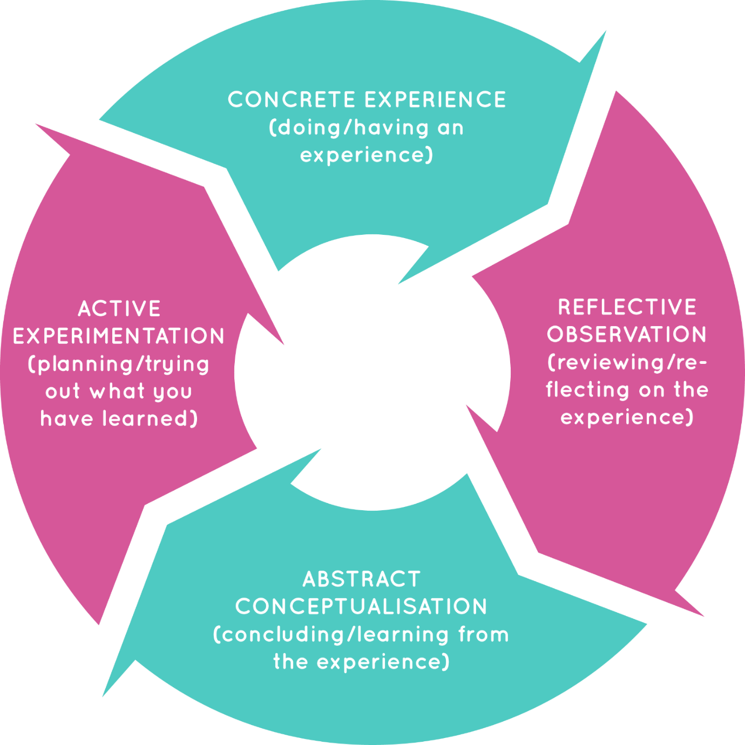

Kolb’s 1984 Cycle.
KOLBS EXPERNETIAL LEARNING MODEL - Search Images (bing.com)

Bibliography
A., Cooze (2007) 100+ Ideas for Teaching English. 2nd Edition. Continuum International Publishing Group.
A., Goodwyn & C., Fuller (2011) The Great Literacy Debate: A critical response to the literacy strategy and the framework for English. Routledge.
A., Green (2011) Becoming a Reflective English Teacher. McGraw Hill, Open University Press, p.26.
A., Harris & N., Bennett (2001) School Effectiveness and School Improvement: Alternative Perspectives. Continuum. London.
A., Harris (2002) School Improvement: What’s in it for schools? Routledge Falmer.
A., Haworth, C., Turner & M., Whiteley (2004) Secondary English & Literacy: A Guide for Teachers. Paul Chapman Publishing.
A., Keane (2022) Watchdogs or Visionaries? Perspectives on the History of the education inspectorate in Wales. University of Wales Press.
A., Miller (2016) Six strategies for Differentiated Instruction in Project Based Learning. 8th ed. Edutopia.
Accelerated Reading Program. https://www.renaissance.com/products/accelerated-reader/ first accessed 03/01/2024
B., Stierer, J., Maybin and N., Hall. (1994) Language, Literacy and Learning in Educational Practice. Multilingual Matters. p.15-28.
D., Bridges, P., Smyers, & R., Smith. (2009) Evidence-based Education policy. What evidence? What basis? Whose policy? Wiley and Blackwell.
D., Hopkins (2001) School Improvement for Real. London. Fulmer Press.
E., Bearne, H., Dombey & T., Grainger (2003) Classroom Interactions in Literacy. Open University Press.
Education (School Development Plans) (Wales Regulation) 2014
Estyn Report (2017) https://www.estyn.gov.wales/system/files/2020-08/Ysgol%2520Llanhari%2520en.pdf first accessed 01/01/2024.
F., Inglis & L., Aers (2008) Key Concepts in Education. SAGE Key Concepts. p.128.
G., Barton & G., Wooley (2017) Developing Literacy in the Secondary School. SAGE Publishing Ltd.
https://mylocalschool.gov.wales/School/6745500 - first accessed 01/01/2024
https://www.gov.wales/examination-results-september-2022-august-2023-html#:~:text=The%20average%20Literacy%20indicator%20is,36.9%20points%20(Figure%202) first accessed 01/01/2024.
https://www.gov.wales/sites/default/files/publications/2018-03/school-development-plans.pdf first accessed 25/01/2024 p.3.
J., Blanchard (2009) Teaching, Learning and Assessment. Open University Press. p. 9-206.
J., Davidson (2011) Debates in English Teaching. Routledge.
J., S., Bruner (1978) The Role of Dialogue in Language Acquisition: The Child’s Concept of Language. New York: Springer-Verlag.
J., Van den Brande, J., Hillary & C., Cullinane (2019) Selective Comprehensives: Wales: Access to top performing schools for disadvantaged pupils in Wales. p.5
K., Crawford (2003) Contemporary Issues in Education. An Introduction. Peter Francis Publishers. p.137
M., Lewis & D., Wray (2000) Literacy in the Secondary School. David Fulton. Ch. 2,3,6,9,10.
Oxford English Dictionary (1990) Clarendon Press. Oxford.
R., Neate (1996) Literacy Saves Lives. United Kingdom Reading Association.
R., Steward (2020) The Gradual Art of School Improvement: A Practical Guide. David Fulton. Abingdon.
Sir A., Bullock (1975) A Language for Life. London. DES.

