The Facebook page has been created:
https://www.facebook.com/War-is-Fun-2486014454957872/
I’ve added the following description:
A UWTSD student-led conference focusing on different aspects of war from both literary and historical perspectives.
I can change this at any time and the images, I’ve just put those up as a start point.

Since Face book responds well to Memes this may be a good way to generate quick easy content. You can create memes here: http://www.memes.com/generator

I’ve made these three as examples on the theme of recruitment:

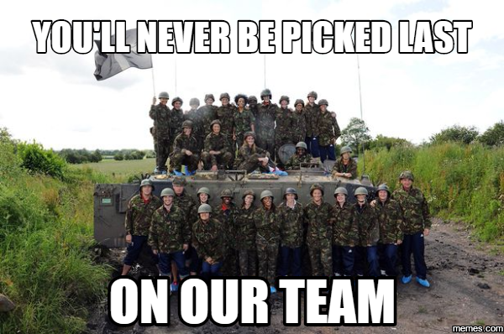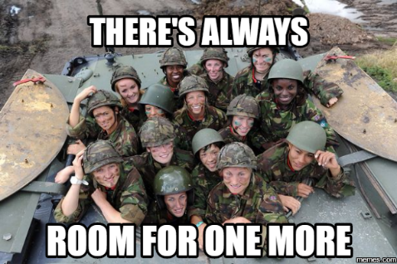
Images from:
https://www.mirror.co.uk/news/uk-news/team-gb-womens-football-team-1140206

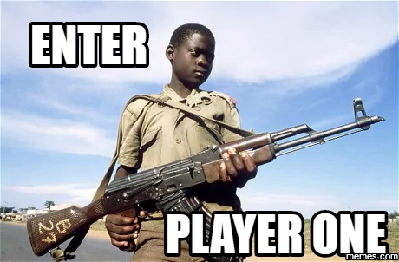
Image from:
http://www.telegraph.co.uk/news/worldnews/africaandindianocean/uganda/10621792/Konys-child-soldiers-When-you-kill-for-the-first-time-you-change.html
I’m not sure how copyright works for Memes, I think linking the newspaper article with it may help? Perhaps that’s something to discuss. I chose the above image of the child because it is from 1985, it doesn’t feel right to be using something current just for the gratuitous shock value that meme has. I think we have to keep in mind that the visuals that accompany our topic may be problematic.

Short choice A or B questions are good for generating conversations on FB too. EG
- Is it better to live a short free life or a long oppressed life?
- Would you rather fight and lose or run and lose?

Or just provocative questions/opinions:
- War has no place in today’s school.
- Should we stop commemorating War? It’s hardly stopping war.

Dare I say we could generate a bit of fake news and propaganda like:
- Politicians use news of overseas war to subdue the population!
- Military tactics taught to seven-year-olds to combat bullying in schools! (I’m not sure how that one would go!)

I think the page needs a purpose, a direction that the conference is taking. That could be a bit too precise for the moment but I think without a focus point the FB page could get a bit random!! The easiest way is to all come up with a question our papers will pose and focus the FB content around those questions. We could add the hashtag #askkiri #askruth #askspencer etc to try to get a buzz going around our topics.
EG
Does the rural economy need war to survive?
#askkiri

You could link your hashtags to other trending hashtags:
Since WWII XX number of dairy farms have closed. The war killed more than just our enemies. #februdairy #askkiri

I could attach a blog of our journey from random university class to conference dream team – but I’m not sure if it would get much traffic!

So there are some preliminary thoughts. I won’t put any content up until we meet again and discuss where we go from here.

