

Student name : shekinah mala Biasala

Student number : 1914922

Assignment title : BMHP6009- living with care the older person

Lecture: Diola Bijlhout

Assessment 2

Table of Contents
Introduction 3
Standpoint in the debate 3
Opposite views and main arguments 3
Government support for elderly people 5
Impact of Covid-19 on older persons and services 6
Conclusion 7
References 8

Introduction
Ageing population refers to the increased median age gap between generations included in an area’s population (McPhee et al., 2016). The concerned paper has highlighted, in detail, the argument around the given question which is: Does population ageing pose challenges for health and social care systems? In this regard, the paper has discussed the main standpoints supporting its views and the potential opposing debate points. It has also analysed the government’s support towards the elderly population in the UK and how they have been impacted during the pandemic caused by the outbreak of the Covid-19.

Standpoint in the debate
The elderly population has increased by 1.6% during 2021 and 2022 to reach upto 12.7 million of people over the age of 65 years in the UK, accounting for 18.9% of the total UK population. The gap has been caused because of decreased fertility and increased life expectancy of people. However, the increased life expectancy is celebrated by the NHS and the UK government, establishing prima facie that the eldely population is not a “Challenge” for the public systems (Kingston et al., 2018). Moreover, there are various other challenges that pose a threat against the health and social care systems in the UK, such as the pandemic, reduced staff, reduced or static government budget, inequality and other social issues and so on. Among these reasons, an increased elderly population is not one of the challenges against the system. On the contrary, not only the NHS has been changing its work approach for supporting the elderly population, the increased life expectancy has been also boosting the morale of the workers (Abdi et al., 2019).

Opposite views and main arguments
It can be argued that the eldely population suffer more from diseases which create a burden on the organisations of health and social care. People over the age of 65 years need the most space in the health and social care organisations, require more person-centred care from the staff including capital spending and pharmaceutical services (Wittenberg et al., 2019); but most of the beds are occupied because of lack of responsibility taken by the NHS and to some extent the social care services as well (Figure 1).
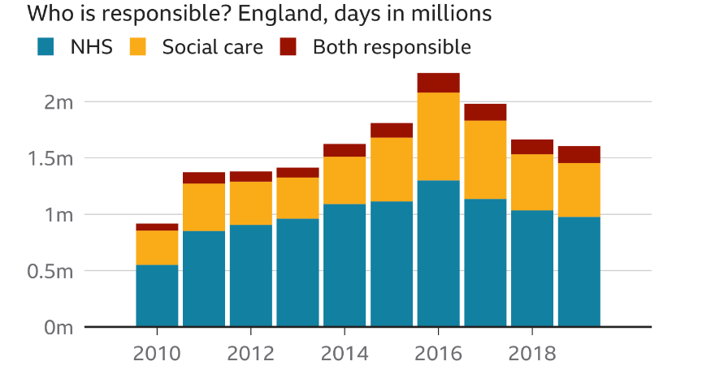
Figure 1: Responsible authorities for hospital bed occupancies
Source: (Holt and Butcher, 2021)
Nonetheless, the local authorities in the UK have reduced their spending on social care over the years; in 2019, the spending was 20% less than the previous decade (Figure 2). Hence, the issue is not the increasing life expectancy but the lack of support from the government and other public bodies towards preserving life.
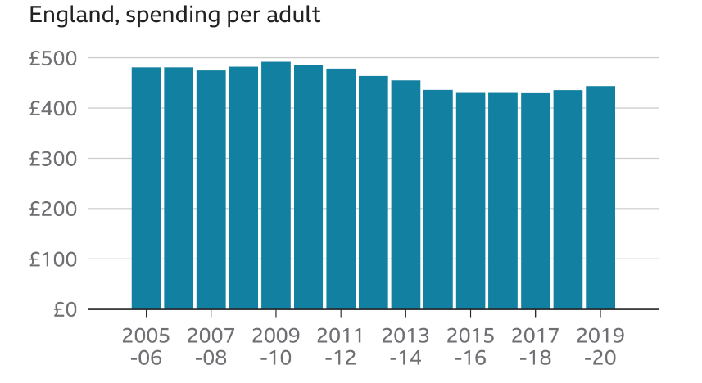
Figure 2: Local authority’s spending on social care
Source: (Holt and Butcher, 2021)
The UK gets £138.9 billion as an annual budget to spend on healthcare; but the number of people receiving long-term support from the council has also reduced significantly over the past years (Figure 3). It can be also argued that the issue is not elderly people’s requirement of health and social care staff but the actual problem is the increasing vacancy in the health and social care sector (Figure 4) (Schofield, 2018).
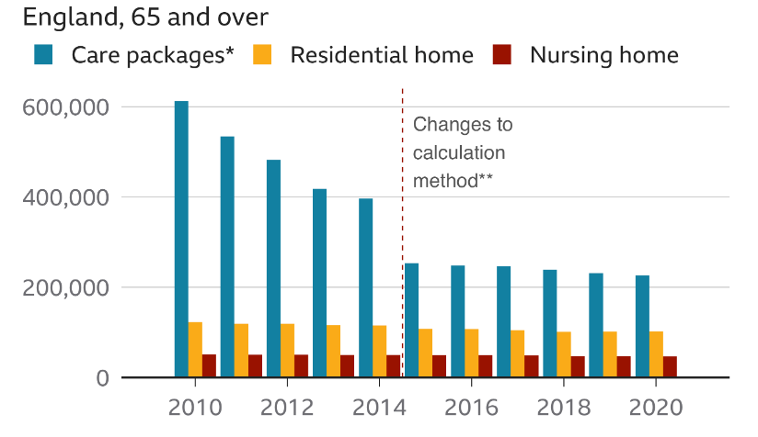
Figure 3: People receiving long-term care support from councils
Source: (Holt and Butcher, 2021)
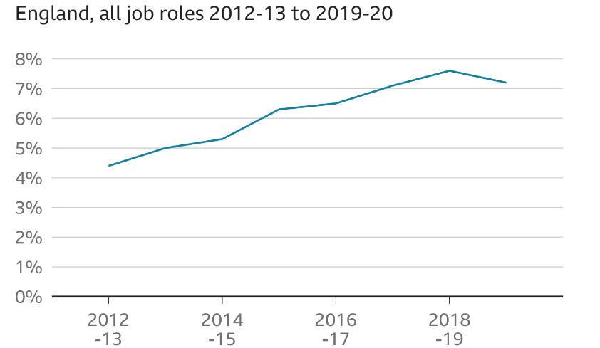
Figure 4: Vacancy rate in health and social care in the UK
Source: (Holt and Butcher, 2021)

Government support for elderly people
The government has offered various services for the eldely people; such as the NHS provides free sight test for people over the age of 65 years. It has also extended free cataract services for people over 60 and free breast screening programmes for women over the age of 70 years. The government also provided ‘Promoting Independence Grant supports’ to elderly people so that they can retain their independence for a longer period of time. It further provided ‘Free influenza immunisation’ to people over the age of 65 years (Gov, 2021). However, the NHS has reported that poor quality housing costs the NHS £2.5 billion per year even after its efforts of increased quality of care. The employment rate of eldelry has decreased at a rate of 86% for 50 years, 65% for 60 years and 31% for 65 years old people in the UK. The NHS also promotes personalised care planning for preventing long term ill health of individuals in the future (NHS, 2021).

Impact of Covid-19 on older persons and services
The pandemic impacted the care homes and other organisations in the social and health care sector quite negatively. The care home residents accounted for one third of the deaths due to coronavirus (Figure 5). Thus, the pandemic had a devastating impact on the quality of care in the UK. However, it was not caused because of the increased elderly population in the care homes but because of the lack of staff and PPE supply in the care homes (Zaninotto et al., 2022).
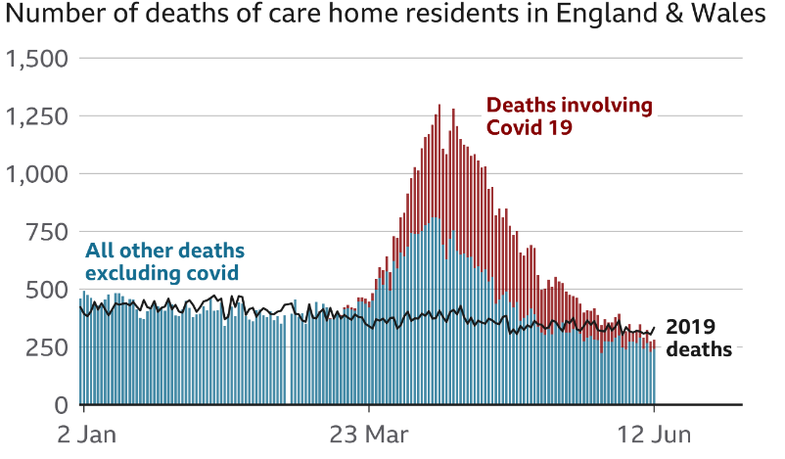
Figure 5: Care home deaths in the UK during pandemic
Source: (Holt and Butcher, 2021)
Moreover, the higher costs of the PPE were imposed upon the clients due to the lack of local as well as government’s support. Only 58,000 PPE kits were provided to different health and social care workers during the pandemic including GPs, care homes, hospices and so on. Among the demand of a billion products, 780 million items were provided by the government, which was not ‘enough’ (Figure 6) (Islam, 2020).
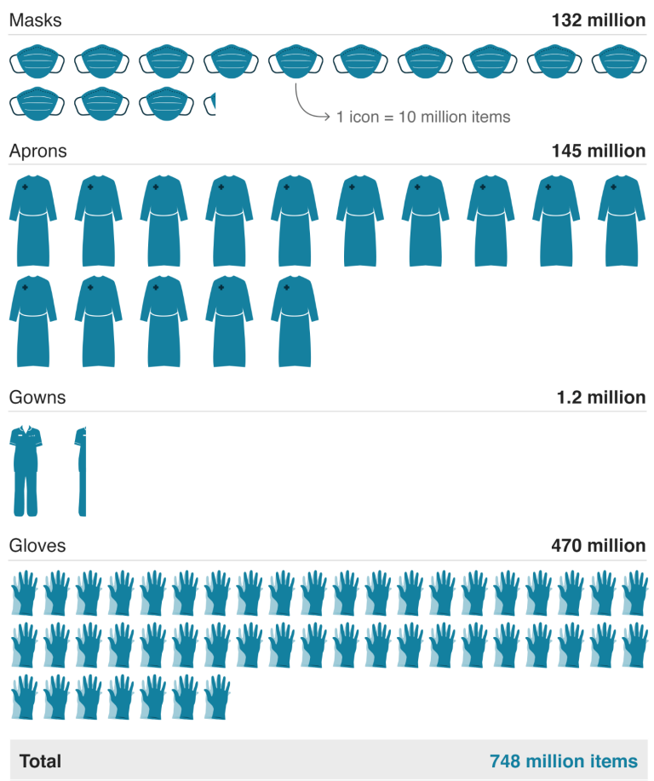
Figure 6: Government’s PPE supply
Source: (Islam, 2020)

Conclusion
The paper has supported the debate around whether the ageing population of the UK pose a challenge against the system and since it has been established herein statistically that the UK government is lacking in other spectres, such as reduced budget and staff, etc., it can be concluded that the ageing population does not pose a threat against the health and social care systems in the UK.

References
Abdi, S., Spann, A., Borilovic, J., de Witte, L. and Hawley, M., 2019. Understanding the care and support needs of older people: a scoping review and categorisation using the WHO international classification of functioning, disability and health framework (ICF). BMC geriatrics, 19(1), pp.1-15.
Gov. (2021). Future of an Ageing Population. [online] Available at: <https://assets.publishing.service.gov.uk/government/uploads/system/uploads/attachment_data/file/816458/future-of-an-ageing-population.pdf> [Accessed 10 August 2022].
Holt, A. and Butcher, B., (2021). Social care: What are the challenges facing the system?. [online] BBC News. Available at: <https://www.bbc.com/news/health-50377846> [Accessed 10 August 2022].
Islam, F., (2020). Why a billion items of PPE is not enough. [online] BBC News. Available at: <https://www.bbc.com/news/business-52362707> [Accessed 10 August 2022].
McPhee, J.S., French, D.P., Jackson, D., Nazroo, J., Pendleton, N. and Degens, H., (2016). Physical activity in older age: perspectives for healthy ageing and frailty. Biogerontology, 17(3), pp.567-580.
nhs. (2021). NHS England » Improving care for older people. [online] Available at: <https://www.england.nhs.uk/ourwork/clinical-policy/older-people/improving-care-for-older-people/> [Accessed 10 August 2022].
Schofield, P., 2018. The assessment of pain in older people: UK national guidelines. Age and ageing, 47(suppl_1), pp.i1-i22.
Wittenberg, R., Knapp, M., Hu, B., Comas‐Herrera, A., King, D., Rehill, A., Shi, C., Banerjee, S., Patel, A., Jagger, C. and Kingston, A., 2019. The costs of dementia in England. International journal of geriatric psychiatry, 34(7), pp.1095-1103.
Zaninotto, P., Iob, E., Demakakos, P. and Steptoe, A., (2022). Immediate and longer-term changes in the mental health and well-being of older adults in England during the COVID-19 pandemic. JAMA psychiatry, 79(2), pp.151-159.

