Computer Aided Manufacturing and Design for Additive Manufacturing Technologies
Adam Sheppard
Manufacturing Design & Technology
6/24/20

Contents
Introduction 2
Appraisal of the Original System 3
Quality Function Deployment (QFD) Chart 3
Failure Mode and Effects Analysis (FMEA) chart 5
Design and Development Work 7
Jaws Modifications (Precision) 7
Worm Thread Modifications 9
Drive Plate and Joint(s) Modifications 10
Cylinder Modifications 11
Joining Mechanisms 11
Manufacturing Process Proposal 13
Conclusion 15

Introduction

During this assignment I will be carrying out an appraisal of a current 3 Jaw gripper design. My key focus during the assignment is to design and develop the 3-jaw gripper in a way that gives it a competitive edge against similar products in this field. I will be assessing potential manufacturing methods and potential materials for the development of this product.

Appraisal of the Original System

Before making any alterations to the original Gripper design it was important to carry out an appraisal of the original system. An important step in any product development, to source any implications that the current design may have. During this section, I will be using a Quality Function Deployment (QFD) chart and a Failure Mode and Effects Analysis (FMEA) chart to analyse the current “3 Jaw Gripper”.

Quality Function Deployment (QFD) Chart (Figure 1)

For my appraisal, I have decided that a QFD chart would be an ample tool for the analysis of the current design and in what areas especially it needs improvement. This system is used to effectively identify ‘what’ the customer requirements are and ‘how’ these needs can be implemented into the manufacture of a product to satisfy customer wants.
The purpose of the chart is to highlight in which of the functional requirements the biggest improvements can be made by identifying where the strongest relationships are between these and the customer requirements. The chart also uses a comparison between other competitors as a visual aid to show where the current design falls short. This will pay dividends during the re-designing of the gripper as I will have the advantage of seeing what concepts best suit customer demanded qualities.
Using the QFD chart to compare the current design to that of competitors, it was clear that in terms of customer requirements the current design fell short in all categories except one. The current development was the most affordable in comparison. However, this would not prove sufficient if placed on the market. This is made clear when reviewing the top three qualities that are demanded by customers, these qualities are:

- Ability to pick up various objects of different size/ shape – This is the most highly requested feature. Most customers require the grippers to be adaptable, as their processes contain objects varying in shape and size.

- Does not damage part when gripping – For obvious reasons this is a top customer priority, the damaging or permanent marking of objects during handling is not ideal. An important factor to consider during the development process.

- Precise/ Long Lasting – Both of these Demanded Qualities shared a score of 4 in terms of Weight/ Importance. Precision is a highly demanded quality as the need for the handling of intricate products is ideal in many companies.

Customers require long lasting equipment as the investment must prove to be valuable over time.

The QFD chart demonstrated three main areas in which I should concentrate to best achieve customer satisfaction. These areas were:
- The Shape and Size of the Jaws – The shaping and size of the jaws has a direct impact on the capabilities of the gripper. This aspect governs what type of items can be pick and placed, ranging through a variation of sizes.

- The Precision of the product – An Important quality for any ‘Pick and Place’ gripper, the precision determines what sized objects the gripper can handle and the intricacy of tasks it can carry out.

- The Material of the Jaws – This is an important consideration for two reasons. One of the reasons being that the material of the jaw has a major effect on the weight that the gripper is capable of lifting. The second is to reduce the amount of damage that the jaws are physically capable of incurring.

The next step in completing the QFD chart was the comparison of different Quality Characteristics. For this step, I assessed the relationship between each of the characteristics and the correlations between them.
Each characteristic was marked with a desired direction of improvement prior to the comparisons. Desired improvements included, maximising, minimising or hitting a set target. However, these desired improvements were not always achievable. This is because positive and negative correlations between different characteristics sometimes contradict one another, preventing further improvements.
For example, minimising the ‘Manufacturing Cost’ is a desired direction of improvement. When manufacturing costs are minimised the overall price of the product can be reduced and made more affordable for customers, affordability being another customer requirement. Both ‘Product Life’ and ‘Precision’ have positive correlations with the manufacturing cost, this creates a conflict. An example of this is when increasing the product life, typically stronger and more durable materials tend to be more expensive. So overall manufacturing costs tend to rise to accommodate the improvement of product life.
Alternatively, maximising the precision of the product also correlated positively with the ‘Action of the Jaws’. However, in this instance both qualities are in harmony with one another. The action of the jaws and the precision of the product both have the same desired direction of improvement, so as the action of the jaws is increased so too is the precision.
The QFD process has highlighted key areas that I should take into consideration during the re-design and development of the 3-Jaw Grippers. These key areas are:
- The size and shape of the Jaws – There is a positive correlation between the design of the Jaws and the level of precision achievable by the gripper when carrying out intricate task. Therefore, when the design of the Jaw is improved the precision of the gripper is also improved.

- The Material of the Jaws – This has a direct impact on the grippers capability of picking up items without damaging them, also the life span of the gripper. Both are demanded qualities for the benefit of the customer making this a key feature.
Both improvements have positive correlations with the manufacturing cost. However, without these improvements the grippers competitiveness will suffer on the market.

Failure Mode and Effects Analysis (FMEA) chart (Figure 2)

The FMEA chart is an effective tool when carrying out design analysis. This Chart works by using a scoring system to analyse the likelihood of a failure during the operation of the product in question. Each process function of the design was assessed using the following criteria:
- Potential failure modes and the potential effects of these failures – these were rated on severity of failure should it occur.

- The Potential Cause/ Mechanism of Failure – Rated on the likelihood of the occurrence.

- The Current Process Controls – Measured on how effective the current process controls are in preventing a failure.

- Risk Priority Number (RPN) – The final calculation, this determines the problems that require the most attention.
During this process I found there to be constant reoccurring failures that were likely to present themselves during the operation of the Gripper. 4 failures presented themselves as high scorers on the RPN calculation, scoring well in to triple digits. These four failures were:
- Jaws Damaging/ Crushing the Object – This is a fault which occurs during the operations of the drive plate running excessively on the worm thread. With no mechanical stop available at the top of the worm thread, there is a likelihood that the jaws will apply too much pressure resulting in damage or crushing of the part. The current design of the Jaws increases the likelihood of damage occurring, due to sharp edges.

- Jaws clashing and become damaged – As there is no mechanical stop at the top of the worm thread, there is nothing preventing the jaws from clashing together once closed. The design of the Jaws and the sharp edges makes it difficult to grasp small objects. As a result, it is easier to cause serious damage to opposing jaws.

- Drive plate travels off the worm thread –When the worm is turning to retract the jaws, there is no physical stop preventing the drive plate from traveling off the thread. This failure is the most likely to reoccur if left undealt with, scoring 7 on the occurrence factor.

- Joints clashing/ obstructing – In the current design there is a clear obstruction being caused between two joints that are used to connect the jaws to the drive plates. This will cause unwanted friction and additional problems during all the process functions of the gripper. This fault reoccurred 7 times during the FMEA.
During the FMEA I found additional failures that, although not serious (each scoring an RPN below 100), I will take into consideration when re-designing. This is because each cause reoccurred numerous times. These include:
- Worm or Drive Plate threads being dirty or corroded (5 recurrences).
- Worm or Drive Plate threads being damaged (8 recurrences)
In conclusion, during the Design and Development of the product I will be looking on improving the following areas:
- The Size and Shape of the Jaws (Precision)

- The Materials of the Jaws (Prevent Damage/ Increase Product Life)

- Implementing a mechanical stop at top of Worm Thread

- Implementing mechanical stop at bottom of Worm Thread

- Prevent clashing/ obstruction of Joints

- Limit corrosion, dirt and damage sustained by Worm Thread

Design and Development Work

The initial appraisal of the original system raised many concerns regarding the current design. During the design and development process I used different methodologies to mitigate the failures and carry out the improvements that were identified in the QFD and FMEA charts.
In this process Design For Manufacture (DFM) technique will be used to incorporate improvements to the original design. According to (Quality-One, 2020) DFM is the method of designing individual components in such a way that complex or unnecessary features are avoided. This makes the product less expensive and easier to manufacture.
Like the DFM technique is the Design for Assembly (DFA) technique. This method was also used during the design of the new Gripper, the DFA emphasises on the reduction of unnecessary parts and components in the overall product design. By optimising the part count of the product to a minimum, errors during the assembly, handling and fault diagnosis of the product are substantially lowered (K.G. Swift, 2013). For obvious reasons, this will also influence the overall manufacturing cost.
The final method used in this section was the Poka Yoke technique or otherwise known as ‘mistake proofing’. The name of this technique is self-explanatory, as its sole purpose is to prevent a mistake from ever happening (The Lean SIx Sigma Company, 2020). An important tool to be used during the design process, helping to aid component selection.

Jaws Modifications (Precision)

As clearly identified in both the QFD and FMEA charts, the Jaws were a clear point for concern. Although functional, the initial design of the jaws presented the following problems:
- Jaws did not fully close – Impacting the precision and capability to handle smaller objects effectively.

- Sharp Edges present on Jaw tips – Presented potential for object being handled to be damaged or damage to the jaws.

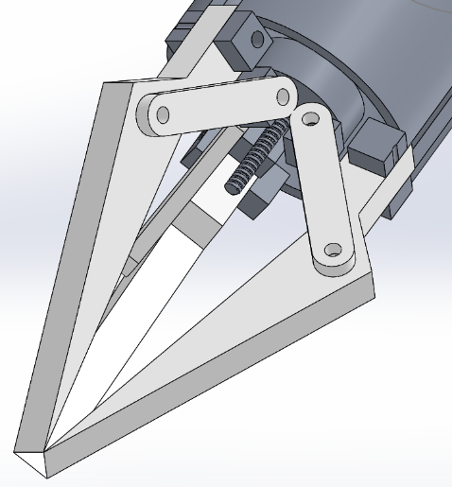

Image of Initial Jaw Concept
For the modification of the jaw design the DFM technique was implemented. Although the Jaws were problematic as they were not precise and had the capability to cause damage, they were capable of being manufactured in one piece, a feature I wanted to keep.
I decided to implement into the design an additional tip that that could also be manufactured in unison. This tip would allow the jaws to come to a complete close increasing the precision of the gripper.
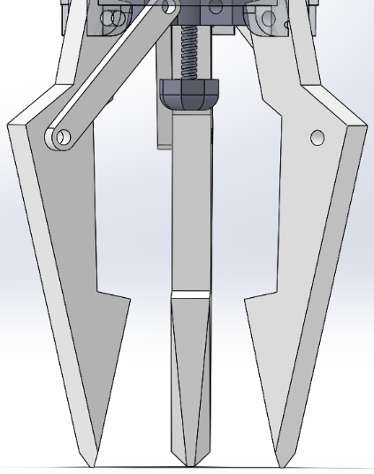
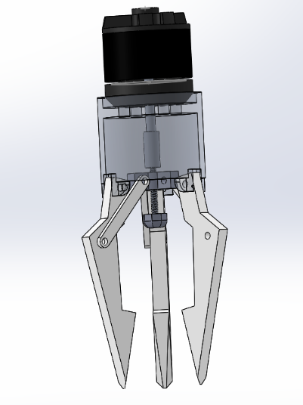
Although substantial for the precision of the gripper there would still be an element of failure where the sharp edges on the claws were still capable of causing damage. Chamfers were incorporated in the design on the jaw tip edges, these chamfers are used to considerably decrease the potential for damage on an object being handled. Although competitors tended to use rubber moulds for their jaws, I concluded that using one material would be beneficial in preventing mistakes during assembly and minimizing cost (DFA).
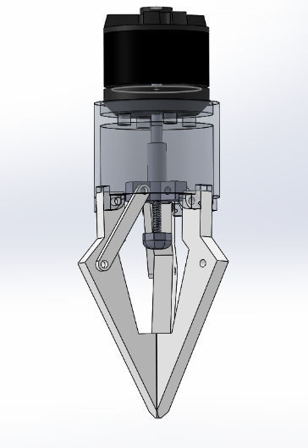

New Jaw Design

Worm Thread Modifications

The appraisal of the gripper identified the Worm Thread as a problematic component, with no mechanical stops the Drive Plate was free to over travel. Creating the following problems:
- Drive Plate travelling too far up the thread – Resulting in the Jaws overexerting pressure on the object. This would result in harm on the object and damage to the jaws.

- Drive Plate travelling off thread end – This would cause a complete failure of the gripper resulting in maintenance and down time.

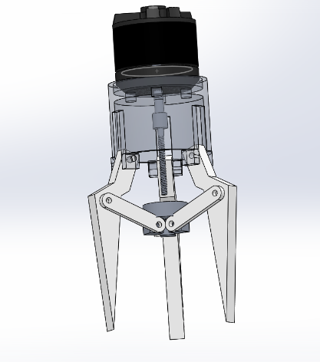
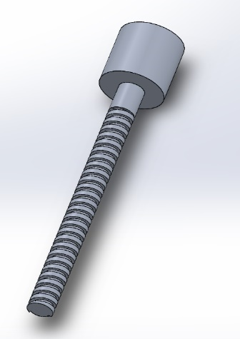

Images of original Worm Thread Concept
Although a conscious effort was made to avoid the use of additional parts to implement the DFA technique, the need for a bottom mechanical stop was essential. An additional repetitive failure of the worm threads becoming damaged or corroded influenced my decision to make the bottom ‘mechanical stop’ removable. This mechanical stop was designed with the access for maintenance as a priority, a 6mm spanner can be used for the removal of the stop granting access for said thread maintenance. The depth of the mechanical stop also limits the amount of showing thread limiting damage and corrosion.
To implement DFA in to the Worm Wheel and using Poka Yoke to prevent any mistakes being made when assembling, it was decided that the stop would instead be an extension of the coupling already visible on the top of the worm thread.
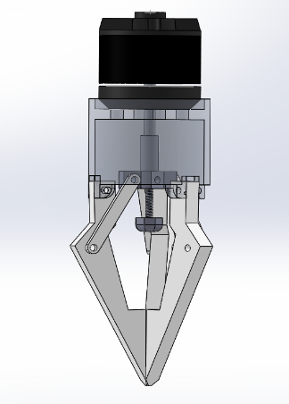
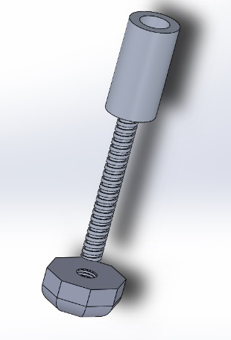
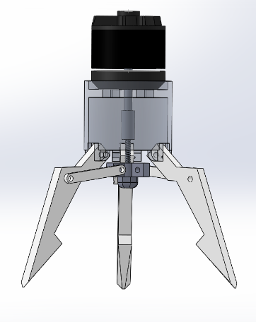

New Worm Thread and ‘Stopping Nut’ Designs

Drive Plate and Joint(s) Modifications

The FMEA identified a reoccurring fault of the Joints either clashing or obstructing one another. Also scoring high on the RPN (336 Max), this problem was a definite priority. Closer inspection into the design drew me to the manufacturing of the current Drive Plate, the component appeared to be made up of two separate entities fixed to one another.

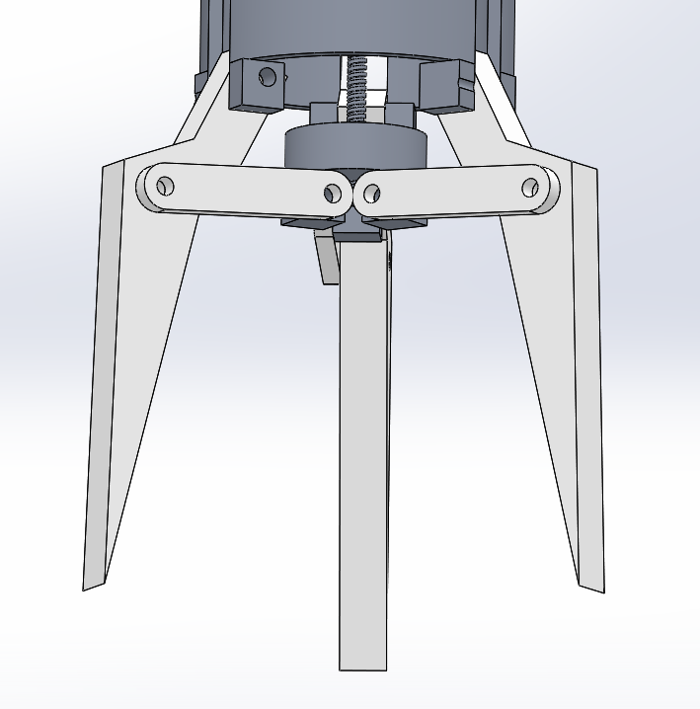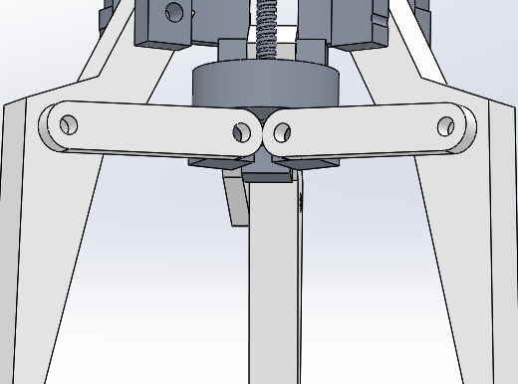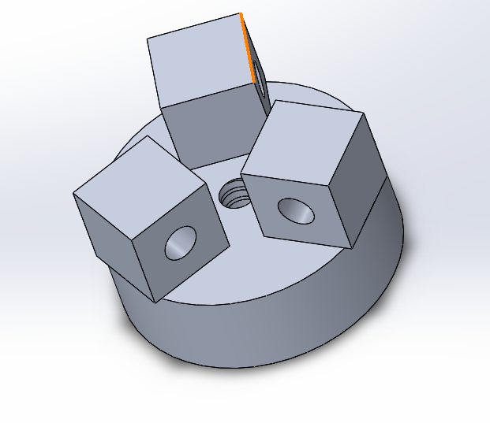
Clashing of Joints & Original Drive Plate
This flaw in the design could have been easily been avoided by re-positioning one of the joints. However, this would leave the opportunity for the mistake to occur still possible on assembly. To resolve this, the new Drive Plate design prevents this from occurring, even when the Joints are connected next to each other (Poka Yoke). As exhibited below:

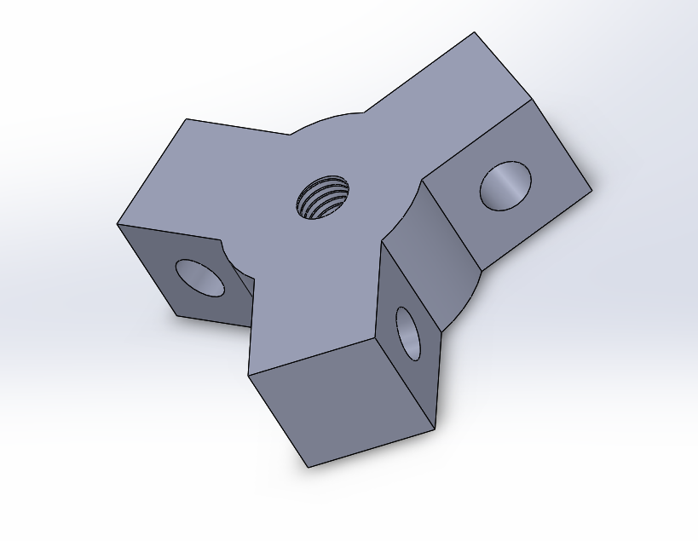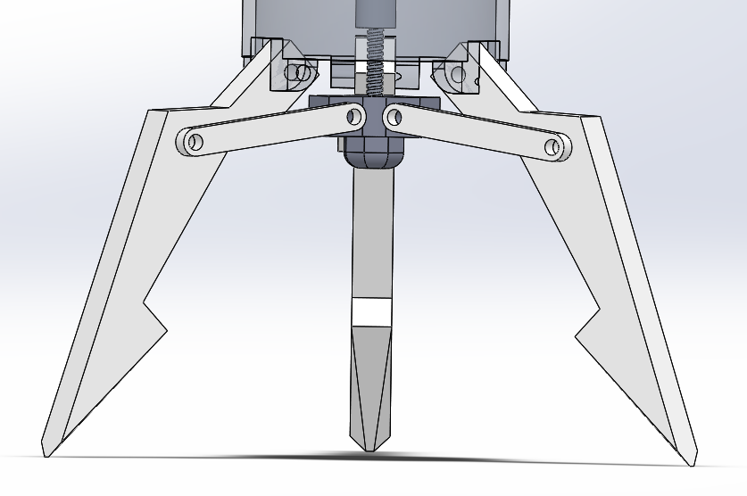
New Hinge and Drive Plate Design
The new design of the Drive Plate makes the component one entity and can be manufactured as one part, satisfying both the DFM and DFA techniques. The breadth of the joints is reduced to 3.5mm and the length increased to 23mm. Overall not having a minute effect on the amount of material used for manufacture, but increasing the action and satisfying Customer Demands indicated by the QFD.

Cylinder Modifications

Despite the Cylinder Shape not being highlighted in either the QFD or FMEA chart, I found that there were areas which could be improved to satisfy both the DFM and DFA techniques. Like the Drive Plate, the original Cylinder design appeared to be two separate components attached to make one unit. The ‘Lugs’ used to connect the jaws to the Cylinder appeared to be separate from the unit. During my evaluation of the cylinder it was clear to see unnecessary large amounts of material missing from above the jaws. This appeared to achieve nothing other than weaken the structural integrity of the cylinder.

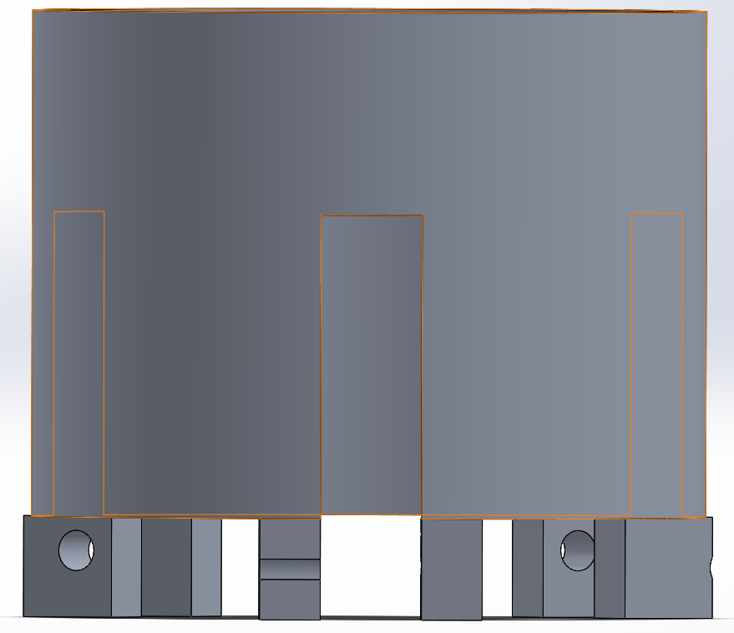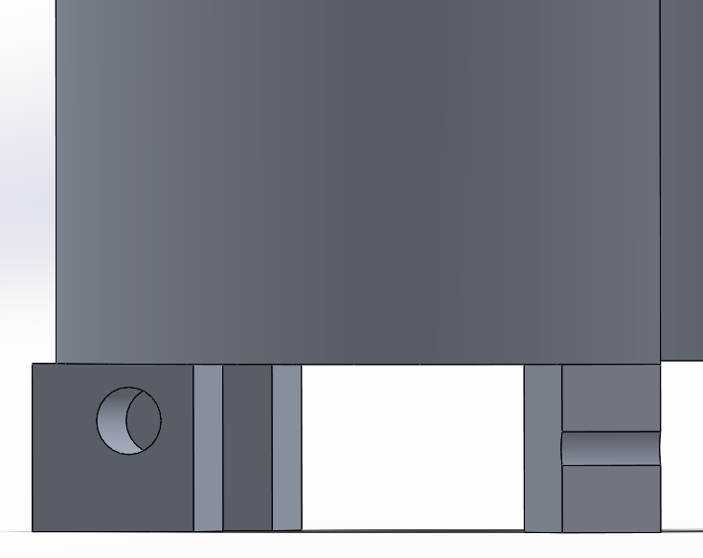
Original Cylinder Lugs
The cylinder was redesigned for ease of manufacturing so that it could be manufactured in fewer steps without the need for assembly (DFM). The lugs were also modified so that the Joints could manoeuvre freely around them without catching on the sharp edges.
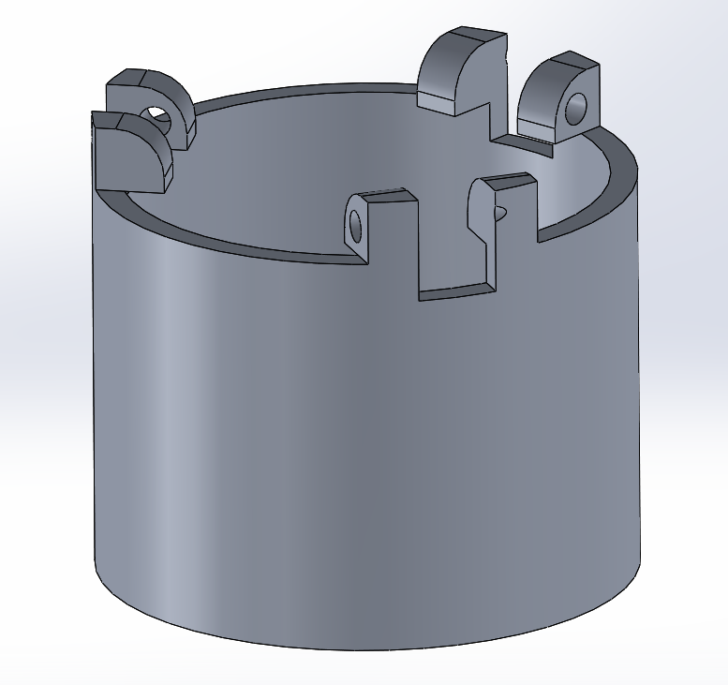
New Cylinder Design

Joining Mechanisms

In a bid to keep the design as simple as possible and refrain from confusion when assembling the Gripper, it was decided that the same joining mechanisms would be used to join each moving part to its required position. Universal Pins will be used in this instance, as they require no alignment and can be purchased as standard, this will prevent maintenance problems.

Reflecting FMEA (Figure 3)

On the completion of the FMEA chart, it was clear that the RPN had dropped significantly. With all RPN dropping below triple figures, this is a clear reflection that the design modifications that have been made have greatly improved the functionality of the gripper. The only targeted Failure that did not improve was the corrosion and cleanliness of the Worm Thread. However, due to the low scoring nature and unlikelihood of occurrence this is not catastrophic.

Manufacturing Process and Material Proposal

Die Casting

Due to the nature of the new Cylinder design, I have decided that the best manufacturing process to take would be die casting. The lugs that were designed as a part of the development process limit the amount of processes that can manufacture the cylinder as a single unit. I am also intending to use the same process in the manufacturing of the stopping nut. According to (Butler, 2001), the die casting method uses ‘moulds’ which are in the shape of the desired component. Molten metal is then injected into this mould and either left to cool or put through a cooling process. Once this step is completed, the mould is opened, and the finished component is removed and checked for imperfections. Any imperfections that are identified are removed leaving the desired component shape.

CNC Machining

I intend to use CNC machining for the following parts:
- Jaws

- Drive Plate

- Joints

- Worm
The reasoning behind this is because CNC is efficient when it comes to the production of intricate parts, as well as the capability of producing identical duplicates with ease. CNC compatible software is used to create the relative programmes for the manufacture of individual components. It can use multiple machining processes including milling and turning, it can cycle through these processes without any substantial delay or error.
The main benefits of using the CNC machine is it is fast and accurate, creating detailed components with extreme efficiency.
I have decided to use aluminium as the desired material for this product. Die casts usually incorporate this material but also the material has the desired qualities for its intended use in the design. (AZoM, 2019) indicates that aluminium contains the following relevant properties:
- Light Weight

- Strong

- Corrosion resistant

- Ductile

- 100% Recyclable
The Material of the jaw was a key factor to consider when designing the new 3 - Jaw gripper. The Materials of the Jaws needs to have malleable properties to further prevent damage occurring to the object. Therefore, I have decided aluminium would be the ideal material as it is both strong and malleable enough to apply pressure to a lifted object without damaging it.
As aluminium is also corrosion resistant, it minimises the likelihood of corrosion occurring on the Worm Thread, making it an ideal material for manufacture.

Conclusion

In conclusion I believe that I have used appropriate methods for the appraisal of the original design. Using the QFD to pinpoint key customer demands, identifying areas in which the original work piece lacked in comparison to its competitors. This also helped me identify key manufacturing areas that correlated between one another and effect this would have on my new design.
The FMEA aided in highlighting the current process failures that would occur during the operation of the Gripper. Giving critical analysis of key failures that would continue to occur had they not been repaired.
Using both appraisal methods allowed me to manufacture a new design capable of competing against existing products in the market, without the appraisal I may have missed some critical design flaws which could have potentially caused failures on the users end.
Using research, I was able to investigate the potential manufacturing processes capable of producing my components to the highest quality and at the greatest efficiency.
The design was completed to a high level of satisfaction although I did incur some problems during the redesign which also needed amendment.
If I were to carry out the redesign process again, I would take in to consideration further methods of appraisal which will allow me to achieve optimum customer satisfaction.

References

AZoM. (2019, June 25). Aluminum - Advantages and Properties of Aluminum. Retrieved from azom.com: https://www.azom.com/article.aspx?ArticleID=1446
Butler, W. (2001). Encyclopedia of Materials: Science and Technology, . Elsevier .
K.G. Swift, J. B. (2013). Manufacturing Process Selection Handbook . Elsevier .
Quality-One. (2020). Design for Manufacturing / Assembly (DFM/DFA). Retrieved from Quality-one.com: https://quality-one.com/dfm-dfa/
The Lean SIx Sigma Company. (2020). Poka Yoke. Retrieved from theleansixsigmacompany.co.uk: https://www.theleansixsigmacompany.co.uk/poka-yoke/

Appendices

Figure 1
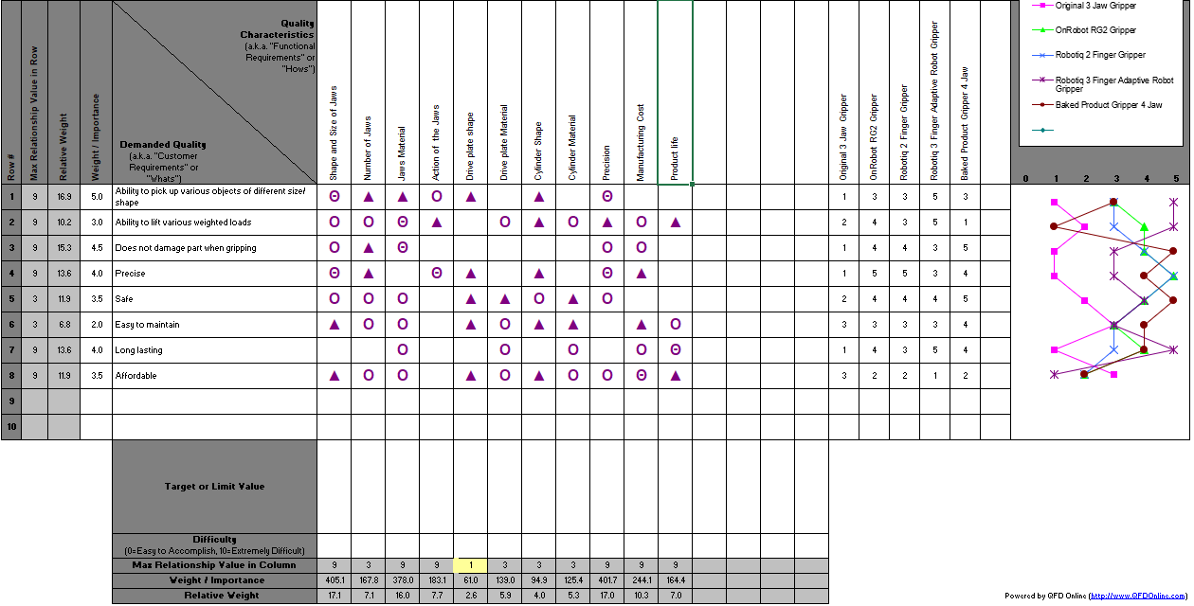
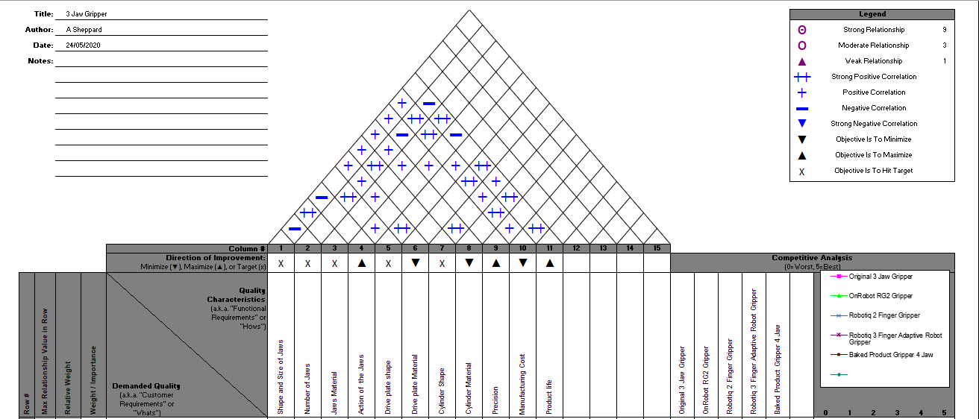

Figure 2

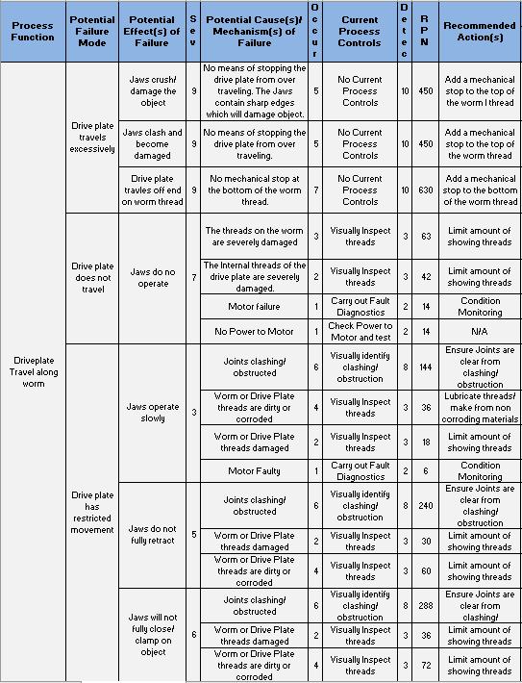

Figure 2
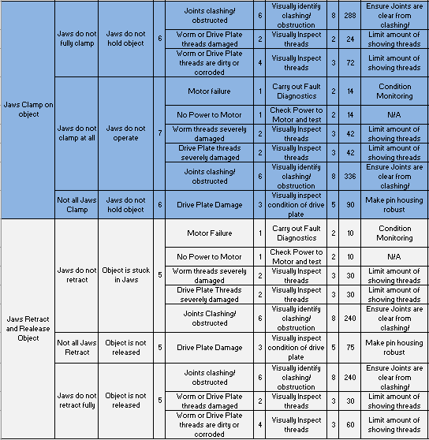

Figure 3

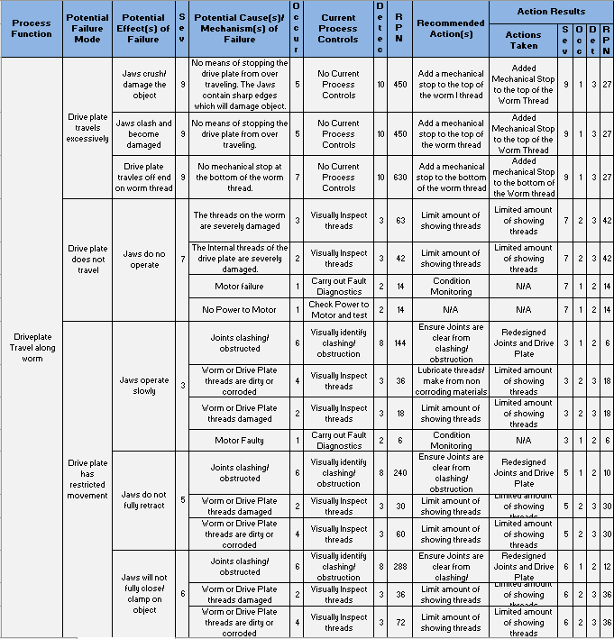

Figure 3



