BMIH5007
Financial Management for the Hotel Industry
Student name : Bianca Negreanu
Student id :2244613
Module leader : Tristan Hawkins

I confirm that I have not used any AI tools in the research and creation of this
assignment. I confirm that I have not presented any AI generated materials as my own
work. I confirm I have copies of my drafts, notes, and other resources I used, which I may be asked to provide in evidence.

Table of Contents
4
Assignment 2 12
1. Introduction 12
2. Evaluation of the trends in the financial performance of the past three years of The City Hotel 12
2.1 Revenue and Expenses Trends of the City Hotel 12
2.2 Profitability Trends of the City Hotel 13
2.3 Patterns of Liquidity 15
2.4 Trends of Solvency 16
3. Determination of the key reasons for the decline in profit to focus on real-world events and the current economy 16
3.1 Economic Challenges 17
3.2 Changing Consumer Behavior 18
3.3 Labor Costs and Staff Shortages 18
3.4 Increased Competition 18
4. Turnaround strategy to revitalise the financial health and develop a brand reputation of the Hotel 19
4.1 Delivering Personalised Services 19
4.2 Promoting Digital Presence and Innovation 19
4.3 Controlling Operational Costs 19
5. Conclusion 20
References 21
Assignment 2 22

Assignment 2

1. Introduction
This case study explores The City Hotel, an urban formation featuring a bar, restaurant and event amenities, which has handled significant tasks in current years, counting occupancy rates, deteriorating revenue and customer gratification. Worried about the hotel’s future feasibility, the owner pursues expert valuation to control if a turnaround plan can reestablish its monetary health and standing. The objectives of this study comprise assessing the hotel’s monetary performance tendencies over the past three years, classifying key issues contributing to its success decline, and suggesting a complete strategy to revive the business or attain the most feasible monetary outcome for the owner.

2. Evaluation of the trends in the financial performance

2.1 Revenue and Expenses Trends of the City Hotel
Trend analysis is a significant part of financial management. It involves assessing the financial records of previous financial years and producing appropriate reports that provide accurate forecasts in financial management (Haralayya, 2021). Throughout 2021-2023, The City Hotel has experienced major volatility in its revenue and expenditure. These fluctuations are the prime reasons behind the financial instability of the City Hotel. Analysing the financial records of the organisation, it was established that the inflow of funds from hotel operations has been inconsistent, while expenses, which include both direct and indirect operational costs, have experienced major increments. This financial instability has affected the organisations' pursuit of financial prosperity, which has been primarily driven by changes in consumer demand, unforeseen economic circumstances, extensive competition, and rising operational costs. The decline in revenue has been catalysed by reduced occupancy rates of hotel rooms and lower customer satisfaction, which are responsible for affecting the hotel's financial stability.
Analysing trends in revenue and expenses is crucial for making informed financial decisions (Olayinka, 2022). It allows business firms to identify opportunities to reduce costs and better manage resources to enhance financial stability. The image displayed below shows a declining trend in both revenue and expenses, but rising costs in areas like depreciation, amortisation, and provisions have further reduced operational profits. Moreover, the shift in consumer alignment toward other hotels has negatively impacted the City Hotel’s occupancy rates and overall revenue generation.
The factor of low occupancy rates has led to a significant decline in turnover and profitability, and customer dissatisfaction with service quality has damaged the hotel's brand value. These financial challenges have facilitated a steep declining financial performance despite deriving positive changes in the cost levels. To mitigate these challenges of accumulating expenses, the City Hotel must focus on attaining efficiency in service quality, building customer-focused experiences, and taking initiatives that aid in segregating itself from the rest of the competition. These initiatives will help the management in lowering the operational expenses, and simultaneously improve its financial position. Enhancing these aspects of the hotel service is key to reversing the negative financial trends and stabilising the hotel's fiscal health.
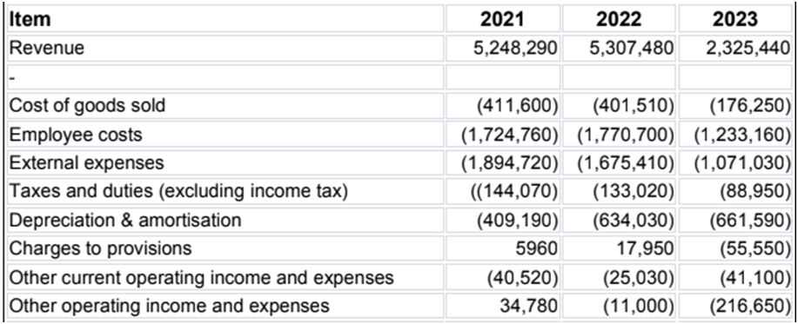
Figure 6: Revenue and Expenses of the City Hotel

2.2 Profitability Trends of the City Hotel
Analysing the profitability trend is a common practice in modern businesses as it provides a dedicated financial forecast that serves as a benchmark of performance for respective businesses (Palepu et al., 2020). In this section, the profit margins of the City Hotel were assessed to generate an overview of the financial stability within the operations of the organisation. The graph displayed below reflects the profitability ratio of the City Hotel for different operational years. The profitability trends denote variations in terms of the profit levels across financial years, which subsequently enables businesses to evaluate the revenue generated from operations. The City Hotel has experienced a steep decline in revenue, largely due to ineffective pricing strategies, which have driven customers to choose alternative accommodations (El-Said, 2020). Continuing on this trajectory may result in financial loss for the organisation. Thus, in order to remain competitive within its operational market, the management of the City Hotel must focus on reducing costs and implementing a competitive pricing strategy that seeks to undercut the prices of competitors. This initiative will attract more customers while improving occupancy rates and boosting profitability.
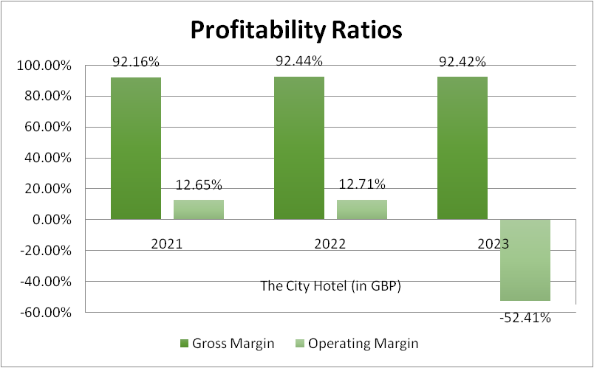
Figure 2: Profitability Ratio of the City Hotel
The data portrayed on the graph reveals the decline in profitability for The City Hotel between 2021 and 2023, as indicated by the negative trend in its operating margin. However, the gross profit of the City Hotel remains relatively stable, but rising costs and low customer engagement have caused the operating margin to turn negative. On the other hand, the availability of additional accommodation options has changed consumer preferences, which has led to intense competition within the hospitality industry.
Therefore, the City Hotel needs to manage concurrent consumer demand, gather feedback, and enhance its quality of service in order to regain market share and improve profitability. By enhancing service delivery and aligning pricing strategies with market requirements, the concerned staff of the City Hotel can improve its financial performance and cultivate long-term financial prosperity and sustenance.

2.3 Patterns of Liquidity
The liquidity data of the City Hotel has exhibited a steady decline, which has led to a negative impact on its cash flow. In this case, the hotel experienced a decline in liquidity due to low revenue and profit, which reduced cash flow and obstructed the ability to meet emergency financial requirements. Thus, maintaining optimal capital resources is pivotal for improving liquidity and overall financial performance.
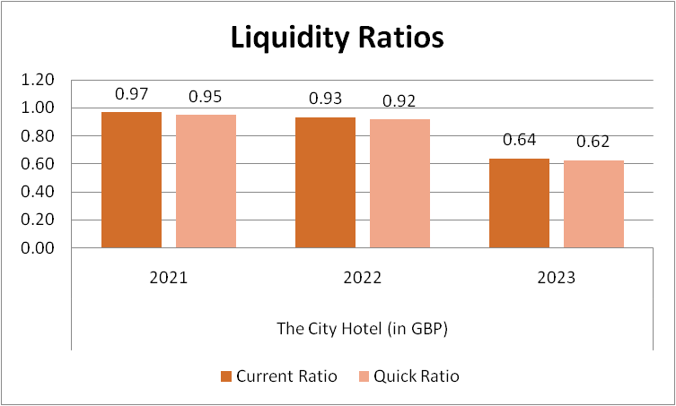
Figure 3: Liquidity Ratio of the City Hotel
The liquidity ratios indicate a declining trend from 2021 to 2023, primarily because the hotel lacks sufficient current assets to cover its short-term liabilities. To enhance the liquidity of the City Hotel, the management needs to manage cash flow more efficiently and optimise the use of its short-term assets.

2.4 Trends of Solvency
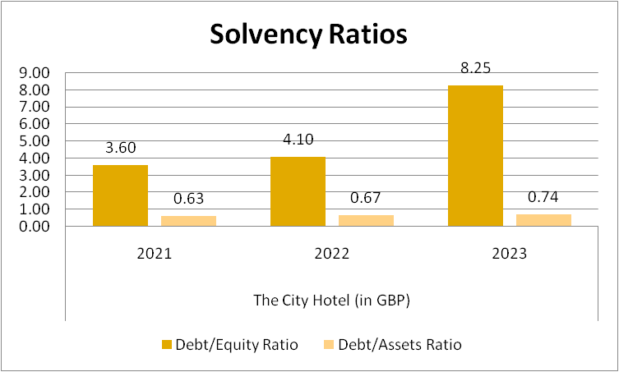
Figure 4: Solvency Ratio of the City Hotel
Solvency refers to an organisation's ability to meet its long-term debt obligations without compromising its financial stability (Enyi, 2022). The graph above displays the solvency ratio of the City Hotel, and it exhibits a positive change in debt usage, while low reliance on equity and assets over the past three years has negatively impacted The City Hotel's solvency. To optimise the solvency, the hotel needs to reduce its debt levels and optimise the utility of the organisational assets and equity in its capital structure. By obtaining long-term investments, the hotel can lower its financial risk. Furthermore, structuring operations to prioritise customer engagement will also drive the hotel's brand value, attracting more equity capital and improving its state of solvency.

3. Determination of the key reasons for the decline in profit to focus on real-world events and the current economy
The deterioration in profitability for The City Hotel can be credited to numerous interconnected features deeply knotted to present financial conditions and changes in customer behaviour.

3.1 Economic Challenges
The continuing cost of living crisis has meaningfully obstructed consumer expenditure. With inflation rates flying around 10%, throwaway income has been reduced, forcing customers to prioritise vital expenditures over optional spending (statista, 2024). This heaviness is chiefly relevant in the hospitality sector, where facilities like hotel stays are repeatedly seen as non-essential. Therefore, The City Hotel has experienced a noticeable deterioration in occupancy rates, as probable guests are progressively cautious to assign their limited capital to hotel rooms. This decrease in bookings and dining practices has strictly affected the hotel’s income streams.
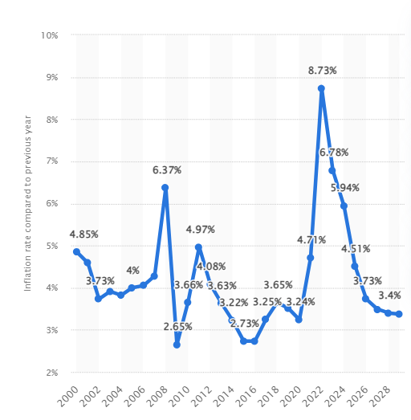
Figure 5: Global inflation rate
(Source: Statista, 2024)

3.2 Changing Consumer Behaviour
COVID-19 pandemic has directed to permanent alterations in customer preferences. Today’s explorers prioritise safety, health and elasticity when selecting accommodations. Improved hygiene procedures, contactless facilities, and flexible reservation options have become vital factors in customer decision-making. Moreover, the increase of leisure travel, which associates business journeys with leisure events, has shifted prospects for hotel contributions. Guests now pursue unique involvements that improve their stay, such as wellness facilities or local cultural events. If The City Hotel has not modified its services to meet these developing preferences, it hazards distancing potential clients. Undesirable reviews rising from unmet hopes can further harm the hotel’s standing and occupancy rates.

3.3 Labor Costs and Staff Shortages
The hospitality sector is presently facing increasing labour charges and important staff shortages. In the UK alone, the hotel industry is short around 400,000 workers, leading to pay inflation and enlarged working costs (ft, 2022). For The City Hotel, these increasing labour expenditures confuse efforts to uphold high-quality facility and operational competence. The incapability to entice and recall skilled staff can lead to a deterioration in service quality, further lessening customer satisfaction and faithfulness. As labour costs upsurge, the hotel may struggle to persist competitively valued, making it less attractive to possible guests.

3.4 Increased Competition
The modest landscape for hotels has strengthened, with recognised brands and other accommodations, such as Airbnb, competing for market share. The short-term rental market saw a development of 23% in 2022, illustrating budget-conscious explorers looking for unique knowledges at lesser prices (vantagemarketresearch, 2023). Outmoded hotels that quickly adapt to market variations, by improving hygiene procedures, contributing flexible booking choices or making gorgeous packages, are better placed to seize market share. If The City Hotel flops to efficiently strive with these offerings, it hazards trailing both occupancy and income.
In summary, The City Hotel's weakening in profitability outcomes from a mixture of economic challenges, shifting consumer behaviour, increasing labour costs, and enlarged competition. To converse with this trend, the hotel must grow a complete turnaround plan that lectures these challenges, improves its service contributions, and relocates itself in the market. By familiarising to the developing landscape, The City Hotel can work to restoring its monetary health and refining customer satisfaction.

4. Turnaround strategy to revitalise the financial health and develop a brand reputation of the Hotel
To revitalise The City Hotel's economic health and increase its brand standing, three planned areas should be prioritised: promoting a robust digital presence, delivering personalised services and monitoring operational costs.

4.1 Delivering Personalised Services
Improving customer experience through personalised services is vital. The City Hotel can apply tailored contributions, such as customised welcome posts based on guest partialities and special events. Utilising customer information to antedate needs, like dining choices or room preferences can make memorable stays (Pelet et al., 2021). Training workers to involve genuinely with guests will make them feel appreciated, leading to helpful reviews and augmented loyalty.

4.2 Promoting Digital Presence and Innovation
A robust online occurrence is dynamic for enticing guests and creating brand value. The City Hotel should capitalise in a user-friendly website that shows its unique contributions and local charms. Appealing with possible guests on social media can influence perceptibility and foster community influences (Lee and Hsieh, 2022). Ground-breaking technologies, such as mobile booking apps and contactless check-in, improve suitability and security, enticing health-conscious tourists.

4.3 Controlling Operational Costs
To enhance profitability, The City Hotel must emphasise on monitoring operational costs. A complete review of costs can classify areas for decreases, such as supply chain efficiencies and energy use. Applying inventory administration systems can rationalise operations and diminish waste (Vaka, 2024). Cross-training employee deliver suppleness during peak and off-peak periods, optimising labour prices.
By concentrating on these plans, personalised guest involvements, a strong online presence, and cost switch, The City Hotel can efficiently revitalise its monetary health and find a strong brand standing.

5. Conclusion
In summary, The City Hotel faces important challenges that impend its monetary health and brand standing. To discourse these subjects, a complete turnaround plan is vital. By prioritising modified services, the hotel can improve the guest knowledge and nurture customer faithfulness. Emerging a durable digital occurrence will not only entice new guests but also endorse the hotel’s sole offerings and local charms, leveraging social media for assignation. Moreover, the implementation advanced technologies, like contactless services, will increase suitability and safety. Monitoring operative costs over efficient observes, such as staff cross-training and inventory management will maximise profitability. By executing these planned initiatives, The City Hotel can revive its processes, reinforce its competitive situation, and ensure lasting sustainability in the hospitality marketplace.

References

Assignment 2
El-Said, O.A., 2020. Impact of online reviews on hotel booking intention: The moderating role of brand image, star category, and price. Tourism Management Perspectives, 33, p.100604.
Enyi, E., 2022. Corporate Financial Stability: An Immutable Link between Going Concern and Earning Capacity of Firms. Current Aspects in Business, Economics and Finance, p.88.
ft(2022)UK hospitality industry loses nearly 200,000 overseas workers[online]Available at:https://www.ft.com/content/027ea2e9-d6c3-4a18-a735-87f92ace95a4[Accessed on: October 15, 2024]
Haralayya, B., 2021. Study on trend analysis at John Deere. Iconic Research And Engineering Journals, 5(1), pp.171-181.
Lee, C.T. and Hsieh, S.H., 2022. Can social media-based brand communities build brand relationships? Examining the effect of community engagement on brand love. Behaviour & Information Technology, 41(6), pp.1270-1285.
Olayinka, A.A., 2022. Financial statement analysis as a tool for investment decisions and assessment of companies’ performance. International Journal of Financial, Accounting, and Management, 4(1), pp.49-66.
Palepu, K.G., Healy, P.M., Wright, S., Bradbury, M. and Coulton, J., 2020. Business analysis and valuation: Using financial statements. Cengage AU.
Pelet, J.É., Lick, E. and Taieb, B., 2021. The internet of things in upscale hotels: its impact on guests’ sensory experiences and behavior. International Journal of Contemporary Hospitality Management, 33(11), pp.4035-4056.
statista(2024)Global inflation rate from 2000 to 2022, with forecasts until 2028[online]Available at:https://www.statista.com/statistics/256598/global-inflation-rate-compared-to-previous-year/#:~:text=Despite%20the%20economic%20impact%20of%20the%20coronavirus%20pandemic%2C,prices%2C%20before%20the%20Russia-Ukraine%20war%20exacerbated%20this%20further[Accessed on: October 15, 2024]
Vaka, D.K., 2024. Integrating Inventory Management and Distribution: A Holistic Supply Chain Strategy. the International Journal of Managing Value and Supply Chains, 15(2), pp.13-23.
vantagemarketresearch(2023)Short-term Rental Market- Global Industry Assessment & Forecast[online]Available at:ttps://www.vantagemarketresearch.com/industry-report/shortterm-rental-market-2178[Accessed on: October 15, 2024]

