Student Name: Ratna Begum  Student ID: 1919090  Module Title: Financial Managment for Hotel Industry  Module Code: BMIH5007& BHIH5002  Lecturer: Jaliya De Silva  Date: 28/02/2024 | 
ASSIGNMENT 1: PORTFOLIO
(4 Components)

Component 1: Professional Reflection (500 words +/- 10%)

Weighting: 25%
Scenario:
I am a waiter at a hotel restaurant during dinner. A stranger from a different culture shows the money by waving their hand. However, in my culture, waving is a gesture of greeting or attention, not asking for money. As a result, I find myself misunderstanding the guest’s point of view and adore it, leading to frustration on their part.
Explanation of cultural misunderstandings:
Cultural misunderstandings can occur due to differences in gestures, customs, and communication norms among individuals from diverse cultures in this case, I interpret the handshake to indicate a guest’s fare differently due to for my cultural upbringing. I take that as a friendly gesture instead of asking for a donation, which leads to miscommunication and frustration.

Concept of skills and behaviour change:
I need to develop cross-cultural communication skills and cultural sensitivity to deal with such cultural misunderstandings in the future. First, I need to educate myself on common cross-cultural gestures and communication norms, especially with frequent guests at the hotel. This can be achieved through cultural training or resource counselling on intercultural communication.

Secondly, I must take an incredibly careful and cautious approach when communicating with strangers, especially when it comes to interpreting non-verbal cues. Instead of relying solely on my traditional lens, I can keep my mind open and consider the sources of the strangers I serve. This may include listening intently to the guests’ verbal requests and observing their body language to ensure accurate interpretation.

Also, I must be willing to adapt my communication style and behaviour according to the guest’s culture. For example, if a particular gesture or phrase is commonly used to ask for money in a culture, I need to recognize it and respond accordingly Flexibility and empathy are key to bridging cultural differences to build relationships with guest good relationships.

In conclusion, I need to develop cross-cultural communication skills, cultural awareness, and adaptability to prevent future cultural misunderstandings. By being proactive in learning about multicultural values ​​and paying attention to guest cues, I can improve service delivery and avoid mistreatment in a multicultural hospitality setting.

References:
Hofstede, G. (2001). Culture's Consequences: Comparing Values, Behaviours, Institutions, and Organizations Across Nations. Thousand Oaks, CA: SAGE Publications.
Ting-Toomey, S., & Chung, L. C. (2012). Understanding Intercultural Communication. New York, NY: Oxford University Press.

Hall, E. T. (1976). Beyond Culture. New York, NY: Anchor Books.

Component 2: Training Plan (500 words +/- 10%)

Weighting: 25%

Identified cultural misunderstanding (in a few words):
Cultural misunderstanding occurred when guest religious dietary restrictions F&B staff conflicted with the idea of ​​accepting bacon-based dishes This misunderstanding stems from a lack of cultural awareness and sensitivity, as staff may not be properly trained or the different dietary needs of guests from different ethnic backgrounds are not reported Violations were the result, highlighting the importance of cultural competence and awareness in hospitality to prevent such misunderstandings.
Training plan (Why/What//Who/Where/When):

Cultural Sensitivity Training:

Duration: 1 workshop day
Content:
- An introduction to the cultures of hospitality
Understand cultural assumptions and their effects on guest behaviour (e.g., individualism vs. collectivism, power distance, uncertainty avoidance);
- Use of case studies and activity to simulate intercultural communication and identify potential challenges
- Strategies to promote cultural sensitivity and inclusiveness in stranger interactions

Effective communication skills:
Duration: Ongoing, integrated into daily operations
Content:
- Active listening techniques to understand guest needs and wants
- Clear and accurate verbal communication, avoiding jargon and vague language
- Using visual cues and nonverbal cues to enhance communication with visitors from diverse cultures
- Provide clear ingredient descriptions, including ingredients and potential allergens

Empathy and Respect Training:

Duration: 1 workshop day
Content:
- Empathy for foreign cultural norms and values
- By identifying and challenging personal biases and stereotypes
- Role-playing activity to practice empathetic responses to guest concerns or complaints about cultural differences
- To promote a culture of respect and appreciation for cultural diversity in the workforce.

Continuous learning and feedback strategies:
Duration: Ongoing, integrated into daily operations
Content:
- To encourage employees to share their experiences and insights on cross-cultural communication
- Regular feedback sessions are held to identify areas for improvement and address any emerging challenges or misunderstandings
- Provide resources and opportunities for continuing education about cultural competence, such as online courses or guest speaker sessions.
References:
Dovidio, J. F., & Gaertner, S. L. (2004). Aversive Racism. In M. P. Zanna (Ed.), Advances in Experimental Social Psychology (Vol. 36, pp. 1-52). Academic Press.
Hofstede, G., Hofstede, G. J., & Minkov, M. (2010). Cultures and Organizations: Software of the Mind. New York, NY: McGraw-Hill.
Martin, J. N., & Nakayama, T. K. (2017). Intercultural Communication in Contexts. New York, NY: McGraw-Hill Education.

Component 3: Student Self-Reflection (500 words +/- 10%)

Weighting: 25%
Self-Reflection on Cultural Awareness in Hospitality

Model: Gibbs Reflective Cycle

Description:
At first, all I knew about cultural competency in the hospitality sector was the bare minimum of information about various cultures and their traditions. Through interactions with various hosts and colleagues, I have encountered a variety of cases where cultural differences influenced host preferences, behaviours, and expectations.
For example, serving pork-based dishes to Muslim guests without considering their dietary restrictions highlighted the importance of cultural sensitivity in meeting guests’ needs.
Feelings:
At first, I felt confident that I could provide excellent service regardless of cultural differences. But running into situations that resulted in miscommunication due to cultural differences made me aware of my internal weaknesses and how they can affect guest satisfaction.
This insight made me feel uncomfortable and allowed me to develop my cultural awareness so that I could better accommodate guests from diverse backgrounds.
Evaluation:
Over time, I realized how important cultural sensitivity is in providing a great tourist experience and building relationships with visitors.
I learned that cultural competence is more than just knowing the basics; It requires continuous learning, empathy, and consideration of cultural perspectives.
For example, my interest in seeking input from clients and colleagues enabled me to understand specific cultural practices and values ​​in the hospitality industry.
analysis:
After some reflection on my experiences, I realized that it would require proper training and self-directed learning to improve my cultural understanding. Participation in training programs on cultural sensitivity and intercultural communication provided participants with insightful knowledge on how to manage cultural differences.
I was able to gain hands-on skills and confidence in applying cultural competence concepts in authentic situations to actively seek out opportunities to interact with visitors from diverse cultures.
conclusion:
The hospitality industry must be culturally sensitive while providing outstanding service and promoting inclusive environments where all guests feel appreciated and respected.
Hoteliers can reduce cultural misunderstandings and increase tourist satisfaction by embracing cultural diversity and continually working to improve cultural competence.
My quest to improve myself in cultural awareness has demonstrated the value of humility, sensitivity, and a commitment to lifelong learning in providing first-class hospitality.
Action Plan:
I am committed to increasing my cultural awareness going forward by continuing my education, reflecting on my life, and applying the concepts of cultural competence.
This includes actively exploring possibilities for intercultural communication, engaging in advanced cultural sensitivity training, and incorporating feedback from colleagues and strangers to give me an understanding of a about cultural diversity has always been effective

References:

Cox, T. (1994). Cultural Diversity in Organizations: Theory, Research, and Practice. San Francisco, CA: Berrett-Koehler Publishers.
Hofstede, G. (2001). Culture's Consequences: Comparing Values, Behaviors, Institutions, and Organizations Across Nations. Thousand Oaks, CA: SAGE Publications.
Ineson, E. M., & Vogt, C. A. (2011). Cultural competence in hospitality: A research journey. International Journal of Hospitality Management, 30(4), 815-822.

Component 4: Training Presentation (6 Slides)

Weighting: 25%
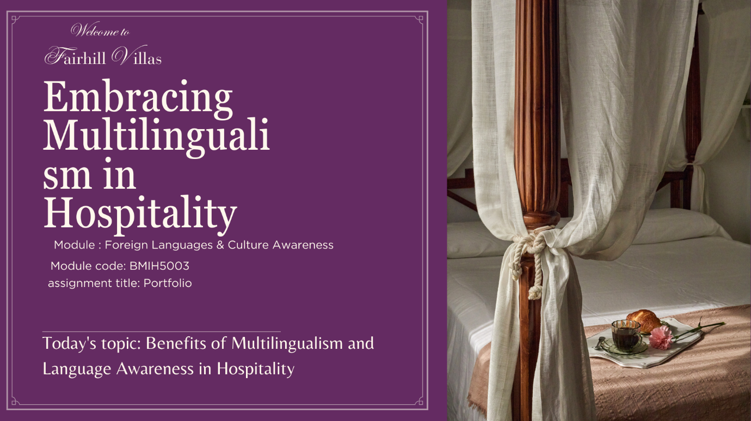

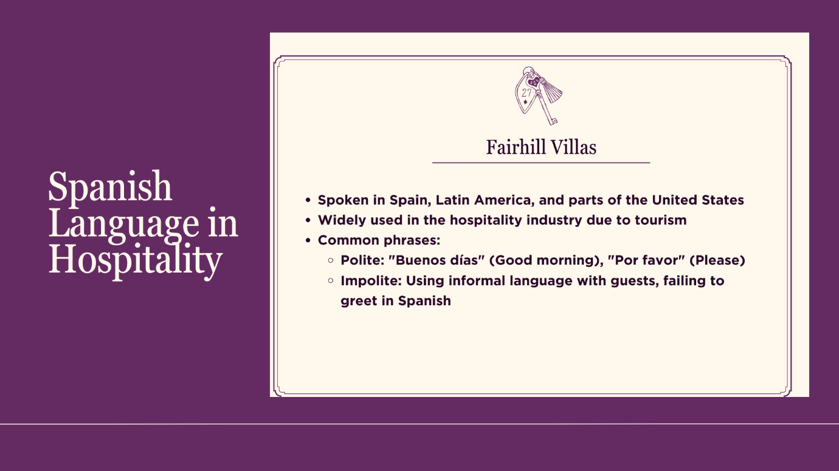
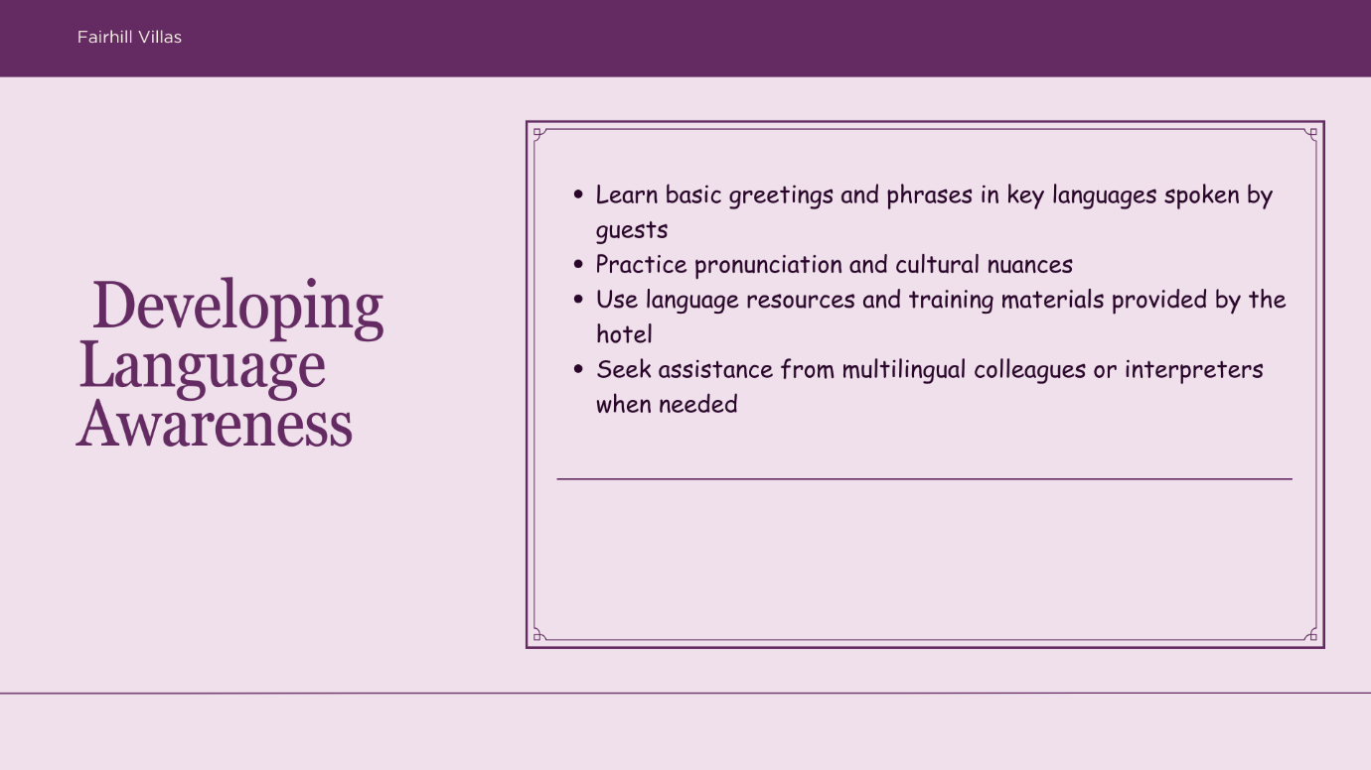
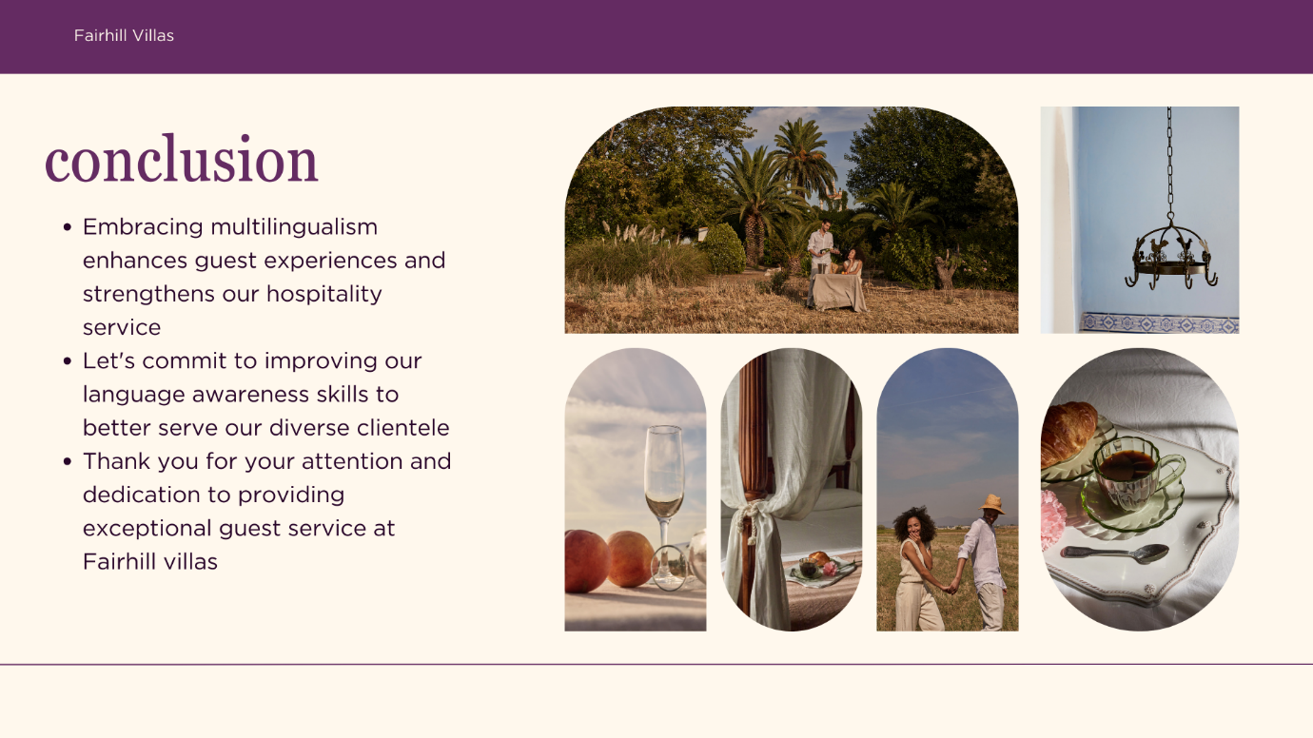
References (no screenshots):

Baker, C. (2011). Foundations of Bilingual Education and Bilingualism. Multilingual Matters.
Cenoz, J., & Gorter, D. (2011). Focus on Multilingualism: A Study of Trilingual Writing. Multilingual Matters.
Oller, J. W., & Pearson, B. Z. (2002). Assessing the Effects of Bilingualism: A Background. In V. Cook (Ed.), Portraits of the L2 User (pp. 89-113). Multilingual Matters.
Crystal, D. (2013). English as a Global Language. Cambridge University Press.
Grosjean, F. (2010). Bilingual: Life and Reality. Harvard University Press.

