

MSc Public Health and Social Care in Practice

Quality Assurance and Service Improvements
LCHS7006
Component 2: Service Improvement Report
Lecturer’s Name: Dr Fahad Khan
Student Name: Ramani Krupali Hasmukhbhai
Student Number: 2520812
Southern Health NHS Foundation Trust — Learning Disability and Mental Health Deaths
https://www.theguardian.com/society/2015/dec/09/southern-health-nhs-trust-failed-investigate-patient-deaths-inquiry

[Word Count: 3297]
Table of Contents
1. Introduction 3
1.1. Background Context 3
1.2. Problem Identification 3
1.3. Evidential Support 3
1.4. Report Objectives 4
2. Critical Evaluation of Theories 4
2.1 Fishbone Diagram (Cause-and-Effect Analysis) & 5 Whys 4
2.2 Donabedian Model [Structure-Process-Outcome] 7
2.3 SWOT Analysis 8
2.4 PDSA Cycle 10
2.5 Kotter’s 8-Step Change Model 13
3. Recommendations 14
3.1 Centralise and Professionalize Mortality Investigations 14
3.2 Implement a Mandatory Family Integration Framework 15
3.3 Automate Incident Triage for Vulnerable Demographics 15
3.4 Benchmark Table - Before vs After 15
4. Conclusion 16
Reference List 18

1. Introduction

1.1. Background Context
This report is based on an investigation into a large public sector provider, Southern Health NHS Foundation Trust; a large organisation in the public sector that delivers community, specialist mental health and learning disability services in England. The Trust has faced significant attention due to its inconsistent and flawed practices highlighted by external audits, including the deaths of patients being ignored or under investigated with no opportunity for learning to take place (Baker et al., 2023).

1.2. Problem Identification
The central issue around issues of quality in Southern Health was a devastating failure in the areas of clinical governance, incident reporting, and executive leadership in relation to capacity around 'unexpected mortality'. NHS governance studies have revealed that there has often been a focus on the need for consistency of NHS processes and staffing for successful incident reporting and serious incident investigations (Baker et al., 2023). The critical patient safety incidents that happened as a result of unexpected deaths were not being appropriately identified as such and therefore not fully investigated as such within Southern Health.

1.3. Evidential Support
This is a serious concern as the Trust investigated less than 1% of patients with learning disabilities who died unexpectedly as a serious incident (Baker et al., 2023). This was subsequently followed by the national policy of ‘Learning from Deaths' which sought to make compulsory the standard of mortality investigations in all NHS Trusts to correct for these geographically isolated shortcomings (Lalani et al., 2022). Lately, though, studies of statutory reporting in the NHS reveal that adherence to patient safety regulatory systems continues to be inconsistent, with poor organisational learning and transparency in governance persisting as a national public health issue (Brummell et al., 2023). In addition, there is a need for good policies that enable patient safety incidents to be transparently investigated, upskill staff and foster a true patient safety culture (Hibbert et al., 2023).

1.4. Report Objectives
The aim of this report is to critically analyse the root causes of the governance and reporting failures at Southern Health. This report will use theoretical frameworks such as Fishbone Diagram and the Donabedian Model to disaggregate systemic issues. A SWOT analysis will feed into strategy for action and actionable recommendations will include an implementation strategy based on the Plan-Do-Study-Act (PDSA) cycle for sustainable service improvement.

2. Critical Evaluation of Theories

2.1Fishbone Diagram (Cause-and-Effect Analysis) & 5 Whys
The Root Cause Analysis (RCA) is a core method in quality management in healthcare to look beyond the human error and at a systemic vulnerability (Wiegmann et al., 2022).
Fishbone Diagram (Ishikawa) Analysis
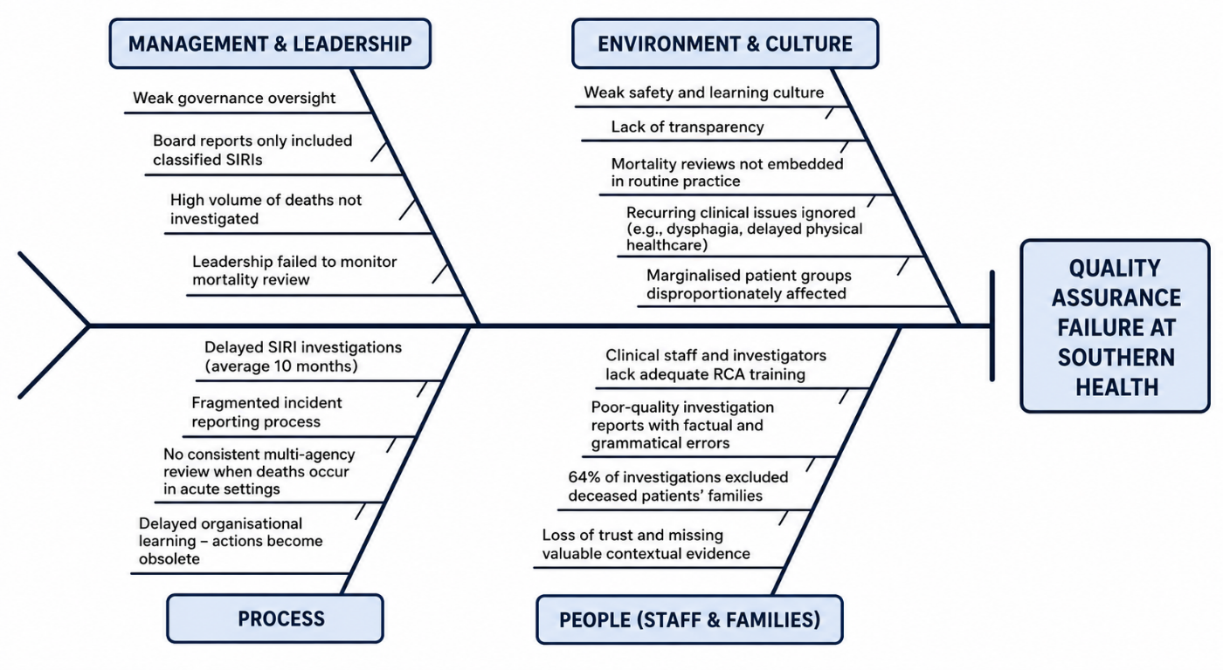
Figure 1: Fishbone Diagram
(Source: Self-developed)
The Fishbone Diagram lists the many contributing causes that contributed to failure of quality assurance at Southern Health.It is used to map and break down into parts the various contributing factors, relating to leadership, process, people and culture that lead to the failure of the quality assurance system at the Trust.
- Management and Leadership: The governance framework was largely disconnected from frontline realities. The extent of the problem was minimised by only showing the data about deaths that were already “SIRIs” i.e. already investigated rather than large numbers of un-investigated deaths.
- Process: Incident reporting was fragmented and highly delayed. A SIRI report would on average wait for 10 months to get to external Clinical Commissioning Group (CCG) closure panels and thereby be entirely out of date with regard to any learning that could have been acted upon. In addition, there was no well-defined protocol for multi-agency review of patients who passed away outside of an acute hospital.
- People (Staff and Families): Poor training of clinical staff and investigators leading to poor and careless quality reports, which included grammatical and factual errors. Most crucially, there was a total failure to have engaged stakeholders: 64% of investigations failed to involve the families of the deceased patients at all, resulting in loss of public confidence and important contextual information.
- Environment and Culture: Normalised absence of mortality review pervaded the thinking of the organisation in matters of Environment and Culture. There was an inward-looking culture within the Trust, which did not facilitate transparency, resulting in failure to recognise recurrent clinical themes, such as the need for increased care for learning disabled patients with respect to dysphagia management or delayed interventions for poor physical health (Barrell et al., 2024; Hibbert et al., 2023).
The 5 Whys Analysis
In this section, this analysis is used to identify the series of failures that circulates from the top surface-level issue, lack of response to the mortality reports, to the bottom level root cause, poor executive leadership and the Trust culture (Tsamasiotis et al., 2024).
- Problem Statement: Investigations were routinely ignored and/or poorly carried out concerning the unexpected death of potentially vulnerable patients (Learning Disability (LD) and Older People Mental Health (OPMH) patients).
Analysis Level | Description
Why 1? | There was considerable "leaking" from the reporting box; for example, only two of the 157 reported LD deaths were identified in the internal Ulysses system as Serious Incidents Requiring Investigation (SIRIs).
Why 2? | There was a lack of enforcement of due process at divisional and local area panels, with many incidents being misunderstood or downgraded in order to prevent such cases moving up to formal SIRI status.
Why 3? | The Trust adopted a very decentralised and fragmented investigation practice, with more than 110 different local leads, where no independent, standardised mortality review could be set up.
Why 4? | The executive board did not have a strategic interest in mortality data, and failed to review and question the standardisation of investigations throughout the Trust.
Why 5? (Root Cause) | The Trust's culture was defensive, closed, and narrowed on reputation management to the point where patient safety was sidelined and ignored, and all the early signals from coroners, family members and commissioners were ignored.
In the end, a lack of in executive leadership was the cause, and there was an atmosphere of "organised irresponsibility", meaning that lessons were not learnt from death incidents and that they were not woven into operational practice (Baker et al., 2023).

2.2 Donabedian Model [Structure-Process-Outcome]
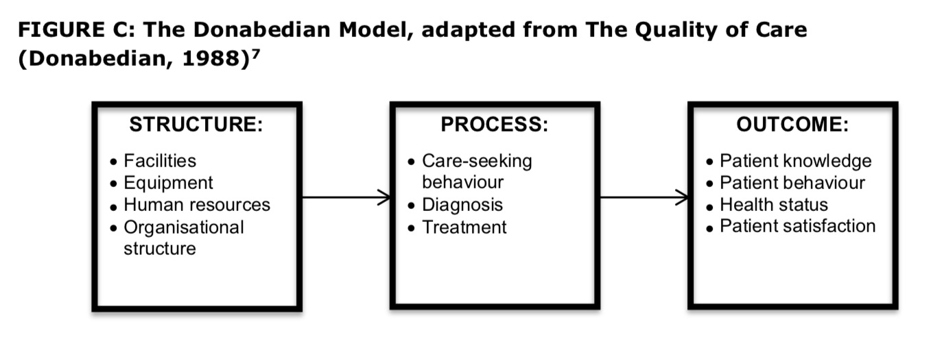
Figure 2: Donabedian Model
(Source: Ogilvie, 2017)
The Donabedian Model offers a solid foundation for evaluating health care quality by linking the inputs, processes, and outcomes in a linear fashion (Tsamasiotis et al., 2024). It is used to systematically assess any contributing factors and the degree to which Southern Health's structural shortcomings and inaccurate incident reporting system directly led to the devastating outcome of patient deaths that were unaddressed.
Structure
Structural quality captures the organisation structure, resource allocation and governance board effectiveness (Tsamasiotis et al., 2024). The organisational structure at Southern Health was extremely weak. Strategic oversight over mortality data was missing from the Trust's executive board and there was not an active and dedicated Mortality Review Group which would have overseen patient deaths. Moreover, there was a very diffused staffing pattern for incident reviews. Instead of having a team of patient safety experts who could be independent and trained appropriately, the Trust used more than 110 different local investigators, not all of whom were well trained in Root Cause Analysis. This structural fragmentation resulted in a lack of uniform and strict monitoring of Patient Groups at Risk (PGRs).
Process
Process focuses on operational procedures and reporting systems of health care and administrative functions (Tsamasiotis et al., 2024). The Trust's incident reporting processes were very much flawed. While deaths occurred on the internal Ulysses system, protocol for determining whether that death had met the criteria for being classified as triggering an Initial Management Assessment (IMA) or a Serious Incident Requiring Investigation (SIRIs) for school grounds was completely inconsistent. Less than 1% of unexpected deaths in Learning Disability services progressed to a formal SIRI for example. In addition, the investigation timeline was seriously flawed, with reports that frequently ignored the 45-day national requirement for investigation and took an average of 127 elapsed days for CCG internal sign off only and a further nine months for CCG closure panels. This prevented any learning in the clinical setting in a timely fashion.
Outcomes
Outcomes are the end goal of how healthcare systems influence patient outcomes, patient safety, and reputation of the health organisation (Tsamasiotis et al., 2024). The collapse of the structure and processes of Southern Health caused and led to the devastating outcomes (Agius et al., 2025). This opacity of institutions, along with systemic exclusion of families in 64% of investigations, led to the breakdown of public confidence, great distress for grieving family, and the need for regulatory action (Khan, 2025).

2.3 SWOT Analysis
It is important to have strategic planning to move from a reactive/defensive mindset to a proactive safety culture (Almohaisen et al., 2023). A SWOT (Strengths, Weaknesses, Opportunities, Threats) analysis is a useful framework to assess Southern Health's ability to make comprehensive quality improvement (Smith et al., 2025).This is used to strategically consider the Trust's internal weaknesses, such as a culture for defence and outside opportunities such as the new national patient safety policies.
Strengths | Weaknesses
Even though there are governance issues, the Trust has full raw patient data through the RiO system and the Ulysses system. Such rich data is a building block of strength and vital for robust quality improvement (QI) and mortality surveillance initiatives (O’Deaet al., 2025). Moreover, the recent inclusion of a new safety culture (Maercker et al., 2022) in the form of a new dedicated Mortality Review Group, including the Medical Director, shows an emerging executive commitment is a prerequisite for embedding a new safety culture (Melino, 2025). | The Trust's internal weaknesses are significant. The model for investigations is broken; in fact, evidence suggests the investigations rely on more than 110 different and largely unqualified leads, ultimately affecting the integrity of Root Cause Analysis. When investigation teams are dispersed in the field and do not have specialist human factors training, they will necessarily generate outputs that are low fidelity and inconsistent (Machen, 2023). In addition, this longstanding, entrenched defensive organisational culture and lack of Board level oversight of non-suicide deaths is a huge deficiency, the transparent leadership to foster psychological safety in healthcare (Pinheiro and Pulkkinen, 2023).
Opportunities | Threats
External Policy changes can be a real game-changer. The accompanying National Mandate on Patient Safety, the NHS Patient Safety Incident Response Framework (PSIRF), is a response to this, giving a national mandate for trusts to move away from a 'one-size-fits-all' approach to investigating every patient safety incident and towards proportionate and system-focused learning (El-Haddad et al., 2026). Additionally, there is a crucial opportunity to link these reporting procedures with multi-agency processes and liaise closely with Clinical Commissioning Groups (CCGs) and acute treatment providers, so as to ensure the safety of very vulnerable Learning Disability (LD) patients. This dovetails into the strata of modern concepts of healthcare with a resilient, cross-boundary approach (Kislov et al., 2021). | The highest priority issue is ongoing loss of trust from the public and regulators due to high-profile fatalities not investigated. Unacceptably long delays in reporting, taking an average of 10 months to close a CCG, leaves opportunities for punitive regulatory interventions from the Care Quality Commission (CQC) (Almohaisen et al., 203). Lastly, resistance to some of the new transparency requirements in the local area and chronic staff burnout can easily become a stumbling block in the deployment of these quality improvement strategies (Smith et al., 2025).

2.4 PDSA Cycle
The PDSA approach is well suited for contexts within healthcare contexts, with the advantage that it involves testing in an iterative fashion, thereby reducing risk, and making modification from what is learned on the fly (Manandi et al., 2023).It is selected to offer a low-risk, iterative strategy for trial, research and development of the automated Ulysses triage system in a pilot ward prior to full implementation.
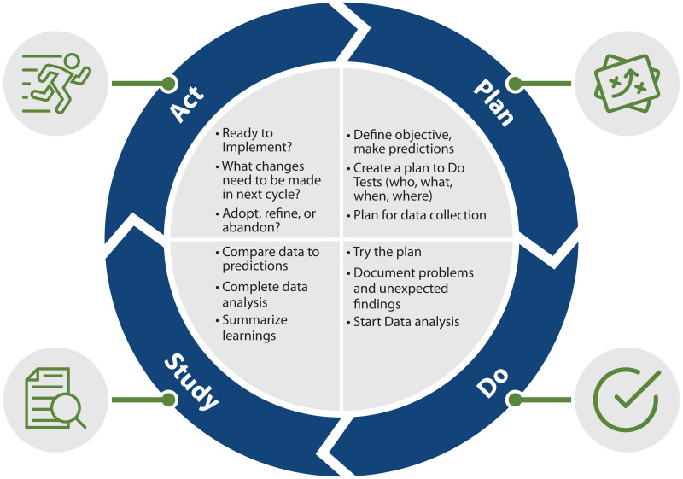
Figure 4: PDSA Cycle
(Source: Gromerand Kopp, 2020)
Plan:The first step is to carefully document the implementation of the new measures and in this case the creation of an independent Corporate Mortality Review Board and the automated Ulysses triage system. Executive leadership needs to set clear operational goals and review internal governance processes and policies to ensure that family involvement is required(Kynoch et al., 2026). In this stage, extensive training program modules should be set up for the new central investigative team on issues of Human Factors and Root Cause Analysis (RCA). Additionally, IT systems need to be updated to notify executives when a patient with a Learning Disability (LD) or Older People Mental Health (OPMH) finally has passed on, as existing systems allow middle managers to downgrade patients to ‘Extensive Care’ should this be appropriate. A key awareness during this phase is staff apprehension and driving psychological safety to mitigate staff resistance to the new culture of transparent reporting (Thomas et al. 2025).
Do:The new protocols will not be undertaken as a high-risk, Trust-wide rollout, but rather will be undertaken as a high priority, targeted department rollout (Tyler et al., 2023). The OPMH in the North and West Hampshire area is ideally located to host the pilots because it is where there are historically high numbers of inpatient deaths and low numbers of investigations, only investigating 0.3% deaths as serious incidents.
Study:After the pilot, the Trust needs to be very careful in assessing the effectiveness of the intervention by using a detailed clinical audit (Dimitropoulos et al., 2024). Success will be assessed based on specific Key Performance Indicators (KPIs). The audit will evaluate the Ulysses data to ensure that 100% of all LD/OPMH deaths in the pilot ward that were not expected activated executive alerts without any hindrances. Second, timeliness in investigations will be assessed to measure the efficiency of the centralised model and alleviate the long-standing difficulty with reporting, which has historically taken a maximum of 10 months to close, but with the imposition of the 45-day CCG closure target, it is required to be done much quicker. Family engagement compliance shall also be tracked with the goal of achieving a 100% attempted family engagement (Subramony et al., 2024), moving away from the previous 64% of families excluded.
Act:The Trust will improve the protocols from the audit findings. The Trust executive board will make these processes mandatory policy if the pilot is successful in streamlining the processes in the reporting and improve the fidelity of the RCA (Harrison et al., 2025). This automated Ulysses flagging and the centralised Corporate Mortality Review Board will then be rolled out consistently and effectively for all the other remaining Trust divisions.

2.5 Kotter’s 8-Step Change Model
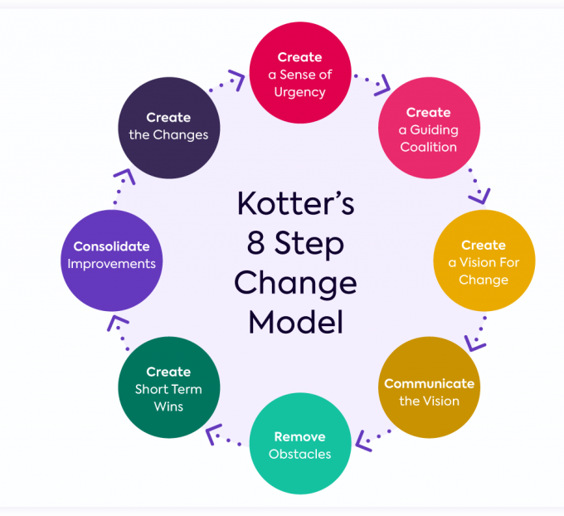
Figure 3: Kotter’s Change Model
(Source: Sales Training International,2023)
Kotter’s 8 Steps | Strategic Application to Southern Health Trust
1. Create Urgency | Executive leadership needs to shine a light on the serious problem of the un-investigated deaths and make it clear that it is a non-negotiable right of action.
2. Build a Coalition | Set up the new Corporate Mortality Review Board (CMRB) to provide leadership and support by those with expertise and influence.
3. Form a Vision | Form a clear vision and strategy with a sole goal of transparency and patient safety and learning from unexpected deaths.
4. Communicate Vision | Communicate the clear future vision on an ongoing basis throughout the organization and, ensure that all staff members are aware of the new direction.
5. Empower Action | Dismantle structural obstacles with specific Root Cause Analysis (RCA) training for local personnel, enabling them to conduct proper investigations.
6. Short-Term Wins | Achieve and celebrate measurable wins in initial ward pilot to create momentum and demonstrate viability of system.
7. Consolidate Gains | Apply this credibility, from the pilot, to roll out automated triage and detailed investigations in all the Trust departments.
8. Anchor in Culture | Integrate this proactive patient safety culture into the day to day business, and into mandated Trust policy to stop it sliding back.

3. Recommendations
Based on the evidence presented in Section 2, the following solutions are recommended for the management of systemic governance failure, defensive culture and poor investigative fidelity in Southern Health NHS Foundation Trust:

3.1 Centralise and Professionalize Mortality Investigations
The Trust will have to give up its very decentralised approach to dealing with over 110 untrained local investigators of serious incidents. Rather, an independent dedicated Corporate Mortality Review Board should be appointed to the Trust. This board should be filled with individuals who have formal Human Factors training and expertise in advanced Root Cause Analysis (RCA)(Groot et al., 2025). A centralised investigation process creates objective quality reviews that have fidelity, are standardised, and free from local area panel bias or defensive minimisation (Tsamasiotis et al., 2024).

3.2 Implement a Mandatory Family Integration Framework
The Trust has a strict 'Duty of Candour' and Family Engagement Protocol to rectify the unacceptable exclusion of families from 64% of investigations. The best practices in quality healthcare care require that bereaved families be seen not only as peripheral parties but, equally, as central partners in the investigations, with the possibility of a unique longitudinal picture of the patient's care pathway. Formal closure should be taken / planned if family is not contacted despite no exceptional documented reasons.

3.3 Automate Incident Triage for Vulnerable Demographics
This means the need for a revamped Ulysses risk management system to stop middle managers' discretionary downgrade of incidents, under the Trust. The system should be updated to automatically alert to executive to any unexpected death of a Learning Disability (LD) patient or an Older People Mental Health (OPMH) patient, that can't be ignored (Simms-Ellis et al., 2025). Misinterpretation of the definition of a serious incident (SIRI) by local area panels is part of a process that involves a triage process waste and an average reporting journey period lasting 10 months (El-Haddad et al., 2026) and yet being reported correctly and immediately, in the case of the Trust, in real-time.

3.4 Benchmark Table - Before vs After
Performance Metric | Before Implementation (Current State) | After Implementation (Target Benchmark)
Investigation Timeframe | 10-month delay in closing CCG panels on average. | Implementing the 45-day investigation national obligation.
Family Involvement | 64% of investigations failed completely to involve the family of deceased patients. | 100% tried to engage family using Mandatory Family Protocol.
Vulnerable Death Triage | The percentage of unexpected deaths in LD progression to a formal SIRI was less than 1%. | For all unexpected deaths the LD/OPMH Executive Alerts were automatically triggered with a100% return rate.
Investigation Quality | More than 110 diverse local, mostly untrained investigators was used. | 1 Corporate Mortality Review Board with RCA training (Centralised)

4. Conclusion
Summary of Findings
The detailed review of Southern Health NHS Foundation Trust identified significant deficits in systems and processes of clinical governance and patient. The main reasons were identified using the 5 Whys and the Donabedian model and were rooted in a defensive culture, a process of local investigations with local staff and a critical lack of executive supervision in mortality data. This resulted in significant attrition in incident reporting, especially concerning patients with Learning Disability (LD) and patients with Older People Mental Health (OPMH), whose sudden death was often overlooked and not investigated.
Impact Statement
The governance barriers will be progressively eliminated through the proposed quality improvement strategies. An independent and centralised Corporate Mortality Review Board (CMRB) and the automated Ulysses triage system based on the Plan-Do-Study-Act (PDSA) cycle eliminates the discretionary downgrade and provides instant executive visibility of vulnerable patient deaths. In addition, a compulsory Family Engagement Protocol helps to stand away from a dark history of incident opaque practices that alienated bereaved relatives by integrating restorative and inclusive practices into the work of incident reviews. Ensuring the application of targeted, repeatable Root Cause Analysis in the daily operations of the Trust will help to move beyond an environment of "organised irresponsibility" towards one that is truly transparent, psychologically safe and accountable.

Reference List
Agius, S., Cassar, V., Bezzina, F., and Topham, L. (2025). Leveraging digital technologies to enhance patient safety. Health and Technology, 15(6), 1053-1063. https://link.springer.com/content/pdf/10.1007/s12553-025-01001-6.pdf
Almohaisen, N. A., Alsayari, N. M., Abid, M. H., Al Subhi, N. F., Al Masoudi, A., AlGhazali, O. S., and Woodman, A. (2023). Improving patient experience by implementing an organisational culture model. BMJ Open Quality, 12(2). https://bmjopenquality.bmj.com/content/bmjqir/12/2/e002076.full.pdf?trk=public_post_comment-text
Baker, D., Norris, D., Newman, L., and Cherneva, V. (2023). Organisational learning, or organised irresponsibility? Risk, opacity and lesson learning about mental health related deaths. Health, Risk & Society, 25, 268-284. https://www.tandfonline.com/doi/pdf/10.1080/13698575.2023.2201292
Barrell, A. M., Johnson, L., Dehn Lunn, A., and Ford, J. A. (2024). Do primary care quality improvement frameworks consider equity?.BMJ Open Quality, 13(3), e002839. https://bmjopenquality.bmj.com/content/bmjqir/13/3/e002839.full.pdf
Brummell, Z., Braun, D., Hussein, Z., Moonesinghe, S. R., and Vindrola-Padros, C. (2023). National statutory reporting: not even ticking the boxes? The quality of ‘Learning from Deaths’ reporting in quality accounts within the NHS in England 2017–2020. BMJ Open Quality, 12, e002092. https://bmjopenquality.bmj.com/content/bmjqir/12/1/e002092.full.pdf
Dimitropoulos, G., Lindenbach, D., Potestio, M., Mogan, T., Richardson, A., Anderson, A., ... and Arnold, P. D. (2024). Using a rapid learning health system for stratified care in emerging adult mental health services: protocol for the implementation of patient-reported outcome measures. JMIR Research Protocols, 13(1), e51667. https://www.researchprotocols.org/2024/1/e51667
El-Haddad, G., Gardner, L., Kim, H., and Soares, H. P. (2026). Occurrence and Management of Acute, Subacute, and Delayed Toxicities in Patients with GEP-NETs Following Treatment with Radioligand Therapy. Cancers, 18(5), 742. https://pmc.ncbi.nlm.nih.gov/articles/PMC12984351/
Gromer, T. and Kopp, B. (2020) Figure 3.7: The PDSA cycle (Plan-Do-Study-Act) is a common quality improvement tool used in healthcare. Available at: https://www.ncbi.nlm.nih.gov/books/NBK566217/figure/ch3.fig7/
Groot, W., Meertens, C., and Winkelaar, T. (2025). An empirical model for root cause analysis in the audit profession. Maandbladvoor Accountancy enBedrijfseconomie, 99(3), 155-161. https://mab-online.nl/article/148806/download/pdf/
Harrison, H., Shah, B. K., Khan, F., Batley, C., Re, C., Rossi, S. H., ... and Stewart, G. D. (2025). A systematic review comparing surveillance recommendations for the detection of recurrence following surgery across 16 common cancer types. https://www.repository.cam.ac.uk/bitstreams/b50aa839-98c1-4df9-a072-a37b6374f374/download
Hibbert, P. D., Stewart, S., Wiles, L. K., Braithwaite, J., Runciman, W. B., and Thomas, M. J. W. (2023). Improving patient safety governance and systems through learning from successes and failures: qualitative surveys and interviews with international experts. International Journal for Quality in Health Care, 35, 0-0. https://pmc.ncbi.nlm.nih.gov/articles/PMC10656601/pdf/mzad088.pdf
Khan, M. (2025). Relationship between Transformational Leadership and Employees' Psychological Safety. https://ir.iba.edu.pk/cgi/viewcontent.cgi?article=1362&context=sslace
Kislov, R., Harvey, G. and Jones, L., (2021). Boundary organising in healthcare: theoretical perspectives, empirical insights and future prospects. Journal of Health Organization and Management, 35(2), pp.133-140. https://research.bangor.ac.uk/files/38400257/OBHC_Editorial_final_submitted.pdf
Kynoch, K., Liu, X., Tan, J. Y. B., Teus, J. K., and Ramis, M. A. (2026). Contemporary clinical incident analysis methods used within acute care settings: a scoping review. JBI Evidence Synthesis, 24(5), 926-971. https://eprints.qut.edu.au/264188/
Lalani, M., Morgan, S., Basu, A., and Hogan, H. (2022). Understanding the factors influencing implementation of a new national patient safety policy in England: Lessons from ‘learning from deaths’. Journal of Health Services Research & Policy, 28, 50-57. https://journals.sagepub.com/doi/pdf/10.1177/13558196221096921
Machen, S. (2023). Thematic reviews of patient safety incidents as a tool for systems thinking: a quality improvement report. BMJ Open Quality, 12(2). https://bmjopenquality.bmj.com/content/bmjqir/12/2/e002020.full.pdf
Maercker, A., Cloitre, M., Bachem, R., Schlumpf, Y. R., Khoury, B., Hitchcock, C., and Bohus, M. (2022). Complex post-traumatic stress disorder. The lancet, 400(10345), 60-72. https://scholarworks.aub.edu.lb/bitstreams/d7d16966-125d-46d7-954c-fe97d620f517/download
Manandi, D., Tu, Q., Hafiz, N., Raeside, R., Redfern, J., and Hyun, K. (2023). The evaluation of the Plan–Do–Study–Act cycles for a healthcare quality improvement intervention in primary care. Australian journal of primary health, 30(1), PY23123. https://connectsci.au/py/article-pdf/doi/10.1071/PY23123/586598/py23123.pdf
Melino, K. (2025). An Institutional Ethnography of Community Mental Health Care for Patients Facing Structural Barriers (Doctoral dissertation, University of Alberta). https://ualberta.scholaris.ca/server/api/core/bitstreams/52ace0ce-4d6f-4600-907d-50fa58c43e86/content
O’Dea, A., Sharafkhani, M., Codd, M., Browne, M., O’Connor, P., and Ward, M. E. (2025). Principles for the conduct of human factors/ergonomics in healthcare: a scoping study of the published evidence. BMJ Open Quality, 14(2). https://bmjopenquality.bmj.com/content/bmjqir/14/2/e003222.full.pdf
Ogilvie, F. (2017) Principles underlying the development of clinical guidelines, clinical effectiveness and quality standards, and their application in health and social care. Health Knowledge. Available at: https://www.healthknowledge.org.uk/content/principles-underlying-development-clinical-guidelines-clinical-effectiveness-and-quality
Pinheiro, R. and Pulkkinen, K., (2023). Collaborating for competition?: Unpacking ambiguities and paradoxes across the academic profession. Scandinavian Journal of Public Administration, 27(1), pp.53-73.https://publicera.kb.se/sjpa/article/download/11206/10741
Ramsey, L., McHugh, S., Simms-Ellis, R., Perfetto, K., and O’Hara, J. K. (2022). Patient and family involvement in serious incident investigations from the perspectives of key stakeholders: a review of the qualitative evidence. Journal of patient safety, 18(8), e1203-e1210. https://journals.lww.com/journalpatientsafety/_layouts/15/oaks.journals/downloadpdf.aspx?an=01209203-202212000-00019
Simms-Ellis, R., Harrison, R., Sattar, R., Sweeting, E., Hartley, H., Morys-Edge, M., and Lawton, R. (2025). Avoiding ‘second victims’ in healthcare: what support do staff want for coping with patient safety incidents, what do they get and is it effective? A systematic review. BMJ open, 15(2), e087512. Available at: https://journals.lww.com/journalpatientsafety/fulltext/2025/08000/how_were_patient_safety_incidents_responded_to,.11.aspx
Smith, B. M., Bhowmik, P. K., Yoshiura, R. K., Whiting, E. T., Anderson, M. W., Sgambati, M. R., and Cafferty, K. G. (2025). Accelerating Nuclear-Integrated Data Center Pursuits in the USA: SWOT Analysis, Power-Thermal Management Strategies and Demonstration Plan. Nuclear Engineering and Design, 446(INL/JOU-25-83648). https://www.osti.gov/pages/servlets/purl/3013183
Subramony, M., Vogus, T. J., Chadwick, C., Gowen III, C., and McFadden, K. L. (2024). Workload, nurse turnover, and patient mortality: Test of a hospital-level moderated mediation model. Health care management review, 49(1), 23-34. https://www.researchgate.net/profile/Mahesh-Subramony/publication/376029641_Workload_nurse_turnover_and_patient_mortality_Test_of_a_hospital-level_moderated_mediation_model/links/65675806ce88b870311f7ff9/Workload-nurse-turnover-and-patient-mortality-Test-of-a-hospital-level-moderated-mediation-model.pdf
Thomas, B., et al. (2025) 'Overcoming resistance to change in healthcare governance and risk management', Health Policy, 129(1), pp. 88-97. Available at: https://www.sciencedirect.com/science/article/pii/S016885102500010X
Tsamasiotis, C., Fiard, G., Bouzat, P., François, P., Fond, G., Boyer, L., and Boussat, B. (2024). From Reporting to Improving: How Root Cause Analysis in Teams Shape Patient Safety Culture. Risk Management and Healthcare Policy, 1847-1858. Available at: https://www.tandfonline.com/doi/pdf/10.2147/RMHP.S466852%4010.1080/tfocoll.2024.0.issue-Advancing_Patient
Tyler, N., Hodkinson, A., Planner, C., Angelakis, I., Keyworth, C., Hall, A., ... and Panagioti, M. (2023). Transitional care interventions from hospital to community to reduce health care use and improve patient outcomes: a systematic review and network meta-analysis. JAMA network open, 6(11), e2344825. Available at: https://jamanetwork.com/journals/jamanetworkopen/articlepdf/2812390/tyler_2023_oi_231308_1700251898.18185.pdf
Wiegmann, D. A., Wood, L. J., Cohen, T. N., and Shappell, S. A. (2022). Understanding the “Swiss Cheese Model” and its application to patient safety. Journal of Patient Safety, 18(2), 119-123. https://pmc.ncbi.nlm.nih.gov/articles/PMC8514562/pdf/nihms-1651282.pdf

